

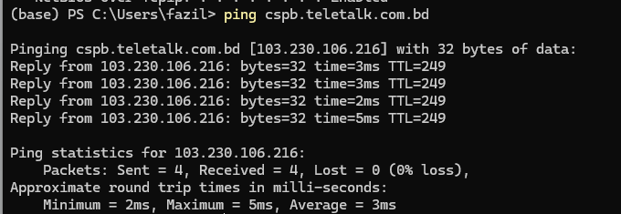

**Request:**

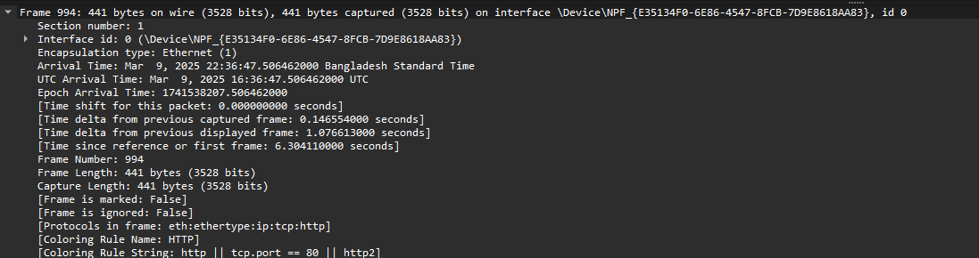

The frame is in Data Link layer of OSI model.

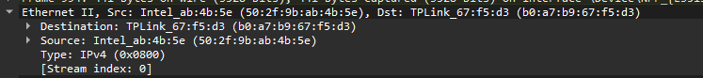

Here, Ethernet II describes about the destination and source mac addresses and the type which is IPv4. This is also takes place in data link layer.

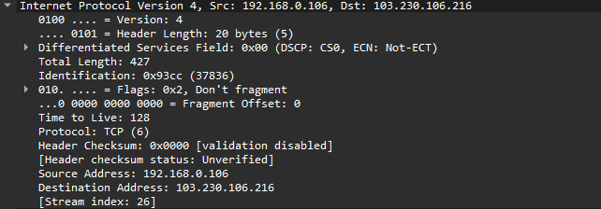

It helds in the network layer, where the IPv4 packet with source and destination Ip addresses are showing. It is a part of TCP protocol.

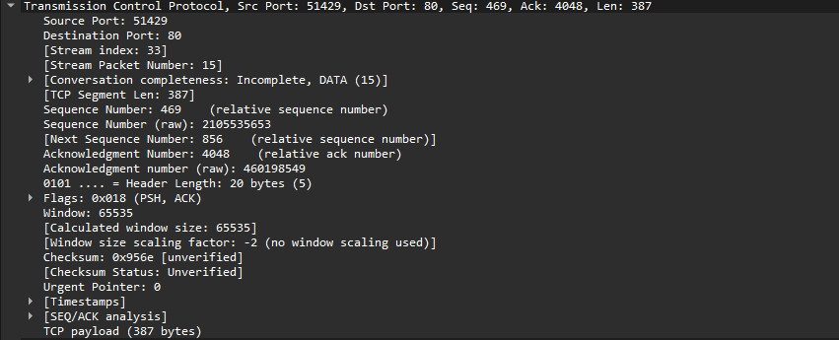

This data segment is part of an ongoing communication stream, indicating that the conversation is not yet complete. It carries a payload of 387 bytes. The source port is 51429, while the destination port is 80, and it corresponds to index 33 in the sequence. The acknowledgement number is 4048 (relative) and 460198549 (raw), which are essential for maintaining the correct order of data transmission. The header length is 20 bytes, which is standard. The window size is set to 65535, representing the receiver's current buffer capacity for incoming data. The urgent point value is 0, meaning there is no urgent data in this segment. As part of a larger communication exchange, its incomplete status suggests that additional packets are expected.

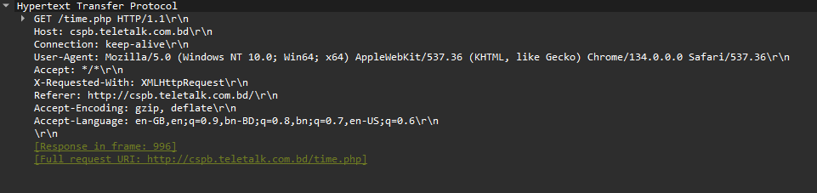

This is an HTTP request with a keep-alive connection, meaning the connection remains open for additional requests. The accept type allows all content types, while the encoding parameter specifies no preference for compression. The User-Agent identifies the client making the request. The response to this request can be found in frame 996, and the full request URL is also included.

**Response:**

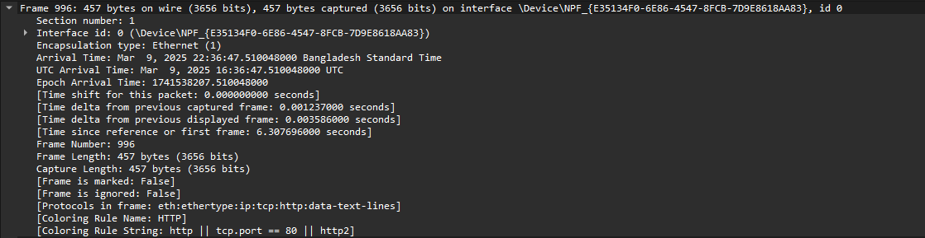

This frame is part of an HTTP communication and has not been marked or ignored. It includes metadata such as the timestamp, date, frame length, and other details. The transmission occurs at the data link layer.

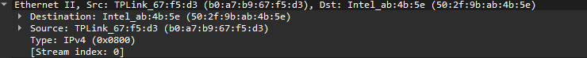

This operates at the data link layer and includes both source and destination MAC addresses. It also contains a stream index, indicating that it is part of an ongoing communication stream.

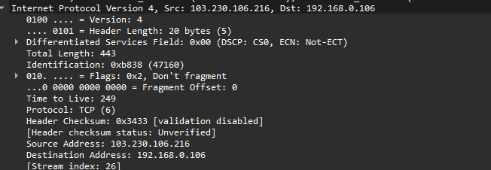

This is an IPv4 packet that includes source and destination IP addresses, along with details such as total length, time to live (TTL), and other relevant information. It operates at the network layer. Flags like "Don’t Fragment" and TTL offer guidance on how the packet should be managed during transmission.

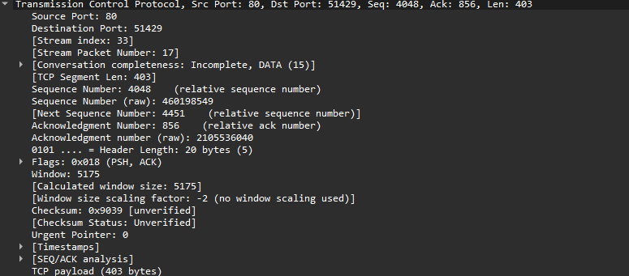

This belongs to the transport layer protocol and includes source and destination ports for managing application-to-application communication. It features both relative and raw sequence numbers to maintain the correct transmission order, along with an acknowledgment number to confirm data reception. The header length is 20 bytes, which is standard, and the window size represents the available buffer capacity.

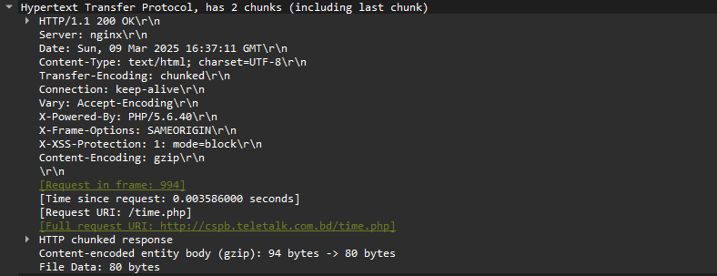

This is an HTTP response functioning at the Application layer of the OSI model. It includes details such as the HTTP version and a status code of 200, indicating a successful response to the client’s request. The connection is set to keep-alive, meaning it remains open for further communication. Additionally, it contains information on content length, caching mechanisms, last modified timestamp, date and time, request frame number, and the time elapsed since the request. These details offer deeper insight into the packet’s behavior. The full request URL is also included.