Fight Blocks

Submitted by: Rie Kumar • [rie.kumar@oit.edu](mailto:rie.kumar@oit.edu) • December 3, 2017 • Release: 1.1



# General Comments

Proposal will be attached to the email that is sent with this document. The CRUD matrix is incomplete since a UML diagram has not been created yet. Low-fidelity UI do not represent in-game content for Senior Project, this includes the ability to gain experience/level up, different versions of skill-trees, a sophisticated options menu, enhanced enemy AI, better HUD, etc. Extended features are personal features that are on this project as personal features, but not as a requirement for the project.

# Signature Page

This document accepted by:

|  |  |  |
| --- | --- | --- |
|  |  |  |
| Signature (Calvin Caldwell) |  | Date |

|  |  |  |
| --- | --- | --- |
|  |  |  |
| Signature (Rie Kumar) |  | Date |

This document submitted by:

# Revision History

|  |  |  |  |  |  |
| --- | --- | --- | --- | --- | --- |
| **Author** | **Company** | **Date** | **Version** | **File Name** | **Comments** |
| Rie Kumar | All Blocks Development | 10/19/17 | 1.0 | RieKumarUseCaseModel | None |
| Rie Kumar | All Blocks Development | 12/3/17 | 1.1 | RieKumarUseCaseModel | None |

Table of Contents

General Comments 2

Signature Page 3

Revision History 4

Context Diagram 8

Use Case Catalog 10

Actor Catalog 11

Features Verification Matrix 12

Use Cases 13

Attack Use Case 13

Choose Menu Item 16

Complete Quest 19

Display Inventory 24

Display Quest 27

Display Skill Tree 30

Enemy Attack 34

Equip Weapon 37

Follow 41

Give Quest 44

Kill Enemy 48

Losing 52

Move 55

Pause 59

Pickup Item 63

Quitting 66

Reset Skills 70

Retreat 73

Take Quest 77

Unlock Skills 80

Use Potion 84

Winning 87

Use Case Scenarios 92

UC 1 – Move 92

UC 2 – Pause 92

UC 3 – Attack 92

UC 4 – ChooseMenuItem 92

UC 5 – Display Inventory 93

UC 6 – Display Skill Tree 93

UC 7 – Equip Weapon 93

UC 8 – Use Potion 93

UC 9 – Unlock Skill 94

UC 10 – Reset Skills 94

UC 11 – Kill Enemy 95

UC 12 – Take Quest 95

UC 13 – Complete Quest 96

UC 14 – Display Quest 96

UC 15 – Pickup Item 97

UC 16 – Follow 97

UC 17 – Enemy Attack 97

UC 18 – Give Quest 98

UC 19 – Winning 99

UC 20 – Losing 99

UC 21 – Quitting 99

UC 22 – Retreat 100

Scenarios 101

Attack 101

Choose Menu Item 101

Complete Quest 102

Display Enemy Attack 102

Display Inventory 103

Display Quest 103

Display Skill Tree 104

Enemy Attack 104

Equip Weapon 105

Follow 105

GiveQuest 106

Kill Enemy 106

Losing 107

Move 108

Pause 109

Pickup Item 110

Quitting 110

Reset Skills 111

Retreat 112

Take Quest 112

Unlock Skills 113

Use Potion 114

Winning 115

CRUD Matrix 116

Low Fidelity UI 118

Glossary 123

Appendix A 123

Business Rules 123

# Context Diagram

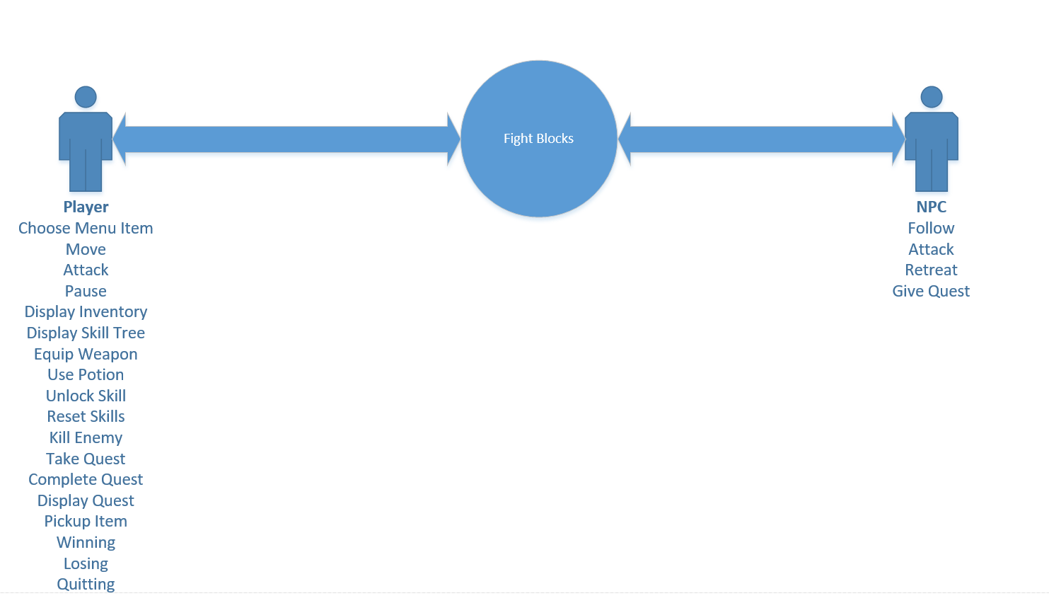

# Use Case Catalog

|  |  |  |
| --- | --- | --- |
| Use Case ID | Use Case Name | Description |
| SP-003 | Attack | User wants to attack. |
| SP-004 | Choose Menu Item | User wants to choose a menu item. |
| SP-013 | Complete Quest | User wants to complete a quest. |
| SP-005 | Display Inventory | User wants to display inventory. |
| SP-014 | Display Quest | User wants to display current quest. |
| SP-006 | Display Skill Tree | User wants to display the skill tree. |
| SP-017 | Enemy Attack | NPC attacks player. |
| SP-007 | Equip Weapon | User wants to equip a weapon. |
| SP-016 | Follow | NPC follows player. |
| SP-018 | Give Quest | NPC gives quest to player. |
| SP-011 | Kill Enemy | User wants to kill an enemy. |
| SP-020 | Losing | User loses. |
| SP-001 | Move | User wants to move. |
| SP-002 | Pause | User wants to pause. |
| SP-015 | Pickup Item | User wants to pick up a weapon. |
| SP-021 | Quitting | User quits. |
| SP-010 | Reset Skills | User wants to reset all skills. |
| SP-022 | Retreat | NPC retreats from player. |
| SP-012 | Take Quest | User wants to take a quest. |
| SP-009 | Unlock Skill | User wants to unlock a skill. |
| SP-008 | Use Potion | User wants to use a potion. |
| SP-019 | Winning | User wins. |

# Actor Catalog

|  |  |  |
| --- | --- | --- |
| Name | Type | Description |
| Player | Person | Has started a game. |
| NPC | System | Enemy, dedicated to trying to kill the player either by attacking you or giving you quests. Very evil! |

# Features Verification Matrix

|  |  |  |
| --- | --- | --- |
| Funcational Req # | Use Case ID | Use Case Name |
| 2.2.1, 2.2.2,2.7.1.3 | SP-003 | Attack |
| 1.1,1.2,1.3,1.4 | SP-004 | Choose Menu Item |
| 2.4.5,2.4 | SP-013 | Complete Quest |
| 2.6 | SP-005 | Display Inventory |
| 2.4.4 | SP-014 | Display Quest |
| 1.3 | SP-006 | Display Skill Tree |
| 2.3.2, 2.7.1.1 | SP-017 | Enemy Attack |
| 2.2.3 | SP-007 | Equip Weapon |
| 2.3.1 | SP-016 | Follow |
| 2.3.4,2.4.6,2.4.7 | SP-018 | Give Quest |
| 2.3.3 | SP-011 | Kill Enemy |
| 3, 3.2 | SP-020 | Losing |
| 2.1, 2.7.1.2 | SP-001 | Move |
| 1.1,2.8,2.6 | SP-002 | Pause |
| 2.5 | SP-015 | Pickup Item |
| 1.4 | SP-021 | Quitting |
| 2.8.5 | SP-010 | Reset Skills |
| 2.3.1 | SP-022 | Retreat |
| 2.4 | SP-012 | Take Quest |
| 2.8.1,2.8.2,2.8.3,2.8.4,2.8.6 | SP-009 | Unlock Skill |
| 2.6.3.4 | SP-008 | Use Potion |
| 3, 3.1, 3.2 | SP-019 | Winning |

# Use Cases

## Attack Use Case

|  |  |
| --- | --- |
| General Information | |
| Use Case Name\Number : Attack SP-003  Subject Area : Gameplay  Description : User want to attack. | Responsible Analyst : Kumar |

|  |  |
| --- | --- |
| Requirements/Feature Trace | |
| REQ# | Requirements Name and / or Short Description |
| 2.2.1 | Ability to hold and swing weapons (LMB to attack). |
| 2.2.2 | Ability to deal damage to enemy AI. |
| 2.7.1.3 | Ability to increase dealt damage. |
|  |  |

|  |  |  |
| --- | --- | --- |
| Revision History | | |
| Author | **Date** | **Comments** |
| Kumar | 10/14/17 | Initial Draft |
|  |  |  |
|  |  |  |
|  |  |  |

|  |  |  |
| --- | --- | --- |
| **Insertion Points in other Use Cases** | | |
| Use Case Name | **Use Case Number** | **Step Inserted After** |
| N/A |  |  |
|  |  |  |

|  |  |  |
| --- | --- | --- |
| **Actors** | | |
| **Actor Name** | **Person/System** | **Brief Description** |
| Player | Person/Character | Has started a game. |
| NPC | System | Enemy, dedicated to trying to kill the player either by attacking you or giving you quests. Very evil! |
|  |  |  |

|  |  |
| --- | --- |
| **Pre-Conditions** | |
| # | Description |
| 1 | Player must be in-game. |

|  |
| --- |
| **Start Stimulus** |
| User hits LMB |

|  |  |  |  |
| --- | --- | --- | --- |
| **Use Case Main Course Steps** | | | |
| **Number** | **Description** | **Adds/Alt Name/Number** | **Bus Rule#** |
| 1 | User presses LMB. |  |  |
|  |  |  |  |
|  |  |  |  |

|  |  |  |
| --- | --- | --- |
| **Exception Conditions** | | |
| **Exception Situations** | **Action(s) on Exception** | **Adds\Alt UC #** |
| User Pauses | User must unpause. | SP-002 |
|  |  |  |

|  |  |
| --- | --- |
| Post-Conditions | |
| **#** | **Description** |
| 1 | User deals damage to enemy. Damage is based on weapon. |
|  |  |

|  |  |  |
| --- | --- | --- |
| **Candidate Objects** | | |
| **Class/Object Name** | **Descriptions** | **Possible**  **attributes** |
| Movement | Determines player’s key pressed and activates necessary animation. | Direction, Speed |
|  |  |  |

|  |  |  |  |  |  |
| --- | --- | --- | --- | --- | --- |
| **Assumptions** | | | | | |
| **#** | **Assumption** | **Date**  **Raised** | **Raised**  **By** | **Date**  **Verified** | **Verified By** |
| 1 | User can use a keyboard. | 10/9/17 |  |  |  |
| 2 | User knows the keys. | 10/9/17 |  |  |  |

|  |  |  |  |  |  |
| --- | --- | --- | --- | --- | --- |
| **Issues** | | | | | |
| **#** | **Issue** | **Date**  **Raised** | **Raised**  **By** | **Date**  **Verified** | **Verified By** |
| 1 | N/A |  |  |  |  |
|  |  |  |  |  |  |

|  |  |  |
| --- | --- | --- |
| **Other Comments** | | |
| **Author** | **Comment** | **Date** |
| N/A |  |  |
|  |  |  |

|  |
| --- |
| Frequency of Execution |
| **Frequency:**  Minimum: 1 Maximum: N/A Average: N/A (OR)Fixed:  **Per:** Hour: **X** Day:  Week:  Month:  Other: |

|  |  |  |  |  |  |  |  |
| --- | --- | --- | --- | --- | --- | --- | --- |
| **Timing Information** | | | | | | | |
| **#** | **At/**  **Between** | **Step(s)** | **Timing**  **Unit** | **Minimum** | **Average** | **Maximum** | **Comments** |
| 1 | At | 1 | ms |  |  | 100 |  |
|  |  |  |  |  |  |  |  |
|  |  |  |  |  |  |  |  |
|  |  |  |  |  |  |  |  |

|  |  |  |  |  |  |  |
| --- | --- | --- | --- | --- | --- | --- |
| **Volume Information** | | | | | | |
| **#** | **Step #** | **Unit of**  **Measure** | **Minimum** | **Average** | **Maximum** | **Comments** |
| 1 | N/A |  |  |  |  | Movement does not store data. |
|  |  |  |  |  |  |  |
|  |  |  |  |  |  |  |
|  |  |  |  |  |  |  |

## Choose Menu Item

|  |  |
| --- | --- |
| General Information | |
| Use Case Name\Number : Choose Menu Item SP-004  Subject Area : Main Menu  Description : User want to choose menu item. | Responsible Analyst : Kumar |

|  |  |
| --- | --- |
| Requirements/Feature Trace | |
| REQ# | Requirements Name and / or Short Description |
| 1.1 | Ability to choose game mode. |
| 1.2 | Ability to adjust in-game settings. |
| 1.3 | Ability to win by killing all enemies. |
| 1.4 | Ability to quit mid-game and keep progress. |

|  |  |  |
| --- | --- | --- |
| Revision History | | |
| Author | **Date** | **Comments** |
| Kumar | 10/14/17 | Initial Draft |
|  |  |  |
|  |  |  |
|  |  |  |

|  |  |  |
| --- | --- | --- |
| **Insertion Points in other Use Cases** | | |
| Use Case Name | **Use Case Number** | **Step Inserted After** |
| N/A |  |  |
|  |  |  |

|  |  |  |
| --- | --- | --- |
| **Actors** | | |
| **Actor Name** | **Person/System** | **Brief Description** |
| Player | Person/Character | Has started a game. |
|  |  |  |
|  |  |  |

|  |  |
| --- | --- |
| **Pre-Conditions** | |
| # | Description |
| 1 | Player has paused or launched the game. |

|  |
| --- |
| **Start Stimulus** |
| User launches the game or pauses. |

|  |  |  |  |
| --- | --- | --- | --- |
| **Use Case Main Course Steps** | | | |
| **Number** | **Description** | **Adds/Alt Name/Number** | **Bus Rule#** |
| 1 | User’s mouse hovers over menu item. |  |  |
| 2 | User clicks. |  |  |
| 3 | Necessary window opens. |  |  |

|  |  |  |
| --- | --- | --- |
| **Exception Conditions** | | |
| **Exception Situations** | **Action(s) on Exception** | **Adds\Alt UC #** |
| N/A |  |  |
|  |  |  |

|  |  |
| --- | --- |
| Post-Conditions | |
| **#** | **Description** |
| 1 | If resume is clicked, resume starts a new game or current game. |
| 2 | If skills is clicked, skill tree of current game pops up. |
| 3 | If options is clicked, options of current game pops up. |
| 4 | If quit is clicked, game exits and saves. |

|  |  |  |
| --- | --- | --- |
| **Candidate Objects** | | |
| **Class/Object Name** | **Descriptions** | **Possible**  **attributes** |
| UIWindow | Contains all the information regarding the window. | Name, Position, Rotation, Load Order |
|  |  |  |

|  |  |  |  |  |  |
| --- | --- | --- | --- | --- | --- |
| **Assumptions** | | | | | |
| **#** | **Assumption** | **Date**  **Raised** | **Raised**  **By** | **Date**  **Verified** | **Verified By** |
| 1 | User can use a mouse | 10/14/17 |  |  |  |
| 2 | User knows the mouse keys. | 10/14/17 |  |  |  |

|  |  |  |  |  |  |
| --- | --- | --- | --- | --- | --- |
| **Issues** | | | | | |
| **#** | **Issue** | **Date**  **Raised** | **Raised**  **By** | **Date**  **Verified** | **Verified By** |
| 1 | N/A |  |  |  |  |
|  |  |  |  |  |  |

|  |  |  |
| --- | --- | --- |
| **Other Comments** | | |
| **Author** | **Comment** | **Date** |
| N/A |  |  |
|  |  |  |

|  |
| --- |
| Frequency of Execution |
| **Frequency:**  Minimum: 1 Maximum: N/A Average: N/A (OR)Fixed:  **Per:** Hour: **X** Day:  Week:  Month:  Other: |

|  |  |  |  |  |  |  |  |
| --- | --- | --- | --- | --- | --- | --- | --- |
| **Timing Information** | | | | | | | |
| **#** | **At/**  **Between** | **Step(s)** | **Timing**  **Unit** | **Minimum** | **Average** | **Maximum** | **Comments** |
| 1 | Between | 2,3 | ms | 0 |  | 100 |  |
|  |  |  |  |  |  |  |  |
|  |  |  |  |  |  |  |  |
|  |  |  |  |  |  |  |  |

|  |  |  |  |  |  |  |
| --- | --- | --- | --- | --- | --- | --- |
| **Volume Information** | | | | | | |
| **#** | **Step #** | **Unit of**  **Measure** | **Minimum** | **Average** | **Maximum** | **Comments** |
| 1 | N/A |  |  |  |  | Data is preloaded before reaching the menu. |
|  |  |  |  |  |  |  |
|  |  |  |  |  |  |  |
|  |  |  |  |  |  |  |

## Complete Quest

|  |  |
| --- | --- |
| General Information | |
| Use Case Name\Number : Complete Quest SP-013  Subject Area : Gameplay  Description : User wants to complete a quest. | Responsible Analyst : Kumar |

|  |  |
| --- | --- |
| Requirements/Feature Trace | |
| REQ# | Requirements Name and / or Short Description |
| 2.4.5 | Ability to complete a quest. |
| 2.4 | The ability to take and complete quest. |
|  |  |
|  |  |

|  |  |  |
| --- | --- | --- |
| Revision History | | |
| Author | **Date** | **Comments** |
| Kumar | 10/15/17 | Initial Draft |
|  |  |  |
|  |  |  |
|  |  |  |

|  |  |  |
| --- | --- | --- |
| **Insertion Points in other Use Cases** | | |
| Use Case Name | **Use Case Number** | **Step Inserted After** |
| **N/A** |  |  |
|  |  |  |

|  |  |  |
| --- | --- | --- |
| **Actors** | | |
| **Actor Name** | **Person/System** | **Brief Description** |
| Player | Person/Character | Has started a game. |
|  |  |  |
|  |  |  |

|  |  |
| --- | --- |
| **Pre-Conditions** | |
| # | Description |
| 1 | Player must be in-game. |
| 2 | Player has accepted a quest. |
|  |  |

|  |
| --- |
| **Start Stimulus** |
| Player moves within 2m of quest giving NPC. |

|  |  |  |  |
| --- | --- | --- | --- |
| **Use Case Main Course Steps** | | | |
| **Number** | **Description** | **Adds/Alt Name/Number** | **Bus Rule#** |
| 1 | Indicated key to talk to NPC pops up (“E”). |  |  |
| 2 | Player presses “E” key. |  |  |
| 3 | Quest dialog pops up. |  |  |
| 4 | Player clicks accept button at the bottom of dialog. |  |  |

|  |  |  |
| --- | --- | --- |
| **Exception Conditions** | | |
| **Exception Situations** | **Action(s) on Exception** | **Adds\Alt UC #** |
| Player exits accept window without accepting. | Quest is not turned in. |  |
|  |  |  |

|  |  |
| --- | --- |
| Post-Conditions | |
| **#** | **Description** |
| 1 | Quest is turned in. |
|  |  |

|  |  |  |
| --- | --- | --- |
| **Candidate Objects** | | |
| **Class/Object Name** | **Descriptions** | **Possible**  **attributes** |
| Movement | Determines player’s key pressed and activates necessary animation. | Direction, Speed |
| Manager | Contains player health and status. | Health, IsDead |
| QuestManager | Contains quests information and if the quest is accepted | Quests, CurrentQuest |
| Quest | Contains quest information. | Name, Objective, Type, Description, InitialAmount, MaxAmount |

|  |  |  |  |  |  |
| --- | --- | --- | --- | --- | --- |
| **Assumptions** | | | | | |
| **#** | **Assumption** | **Date**  **Raised** | **Raised**  **By** | **Date**  **Verified** | **Verified By** |
| 1 | User can use a keyboard. | 10/15/17 | Kumar |  |  |
| 2 | User knows the keys. | 10/15/17 | Kumar |  |  |
| 3 | Users can use a mouse. | 10/15/17 | Kumar |  |  |
| 4 | User knows mouse keys. | 10/15/17 | Kumar |  |  |

|  |  |  |  |  |  |
| --- | --- | --- | --- | --- | --- |
| **Issues** | | | | | |
| **#** | **Issue** | **Date**  **Raised** | **Raised**  **By** | **Date**  **Verified** | **Verified By** |
| 1 | N/A |  |  |  |  |
|  |  |  |  |  |  |

|  |  |  |
| --- | --- | --- |
| **Other Comments** | | |
| **Author** | **Comment** | **Date** |
| N/A |  |  |
|  |  |  |

|  |
| --- |
| Frequency of Execution |
| **Frequency:**  Minimum: 1 Maximum: 2 Average: N/A (OR)Fixed:  **Per:** Hour: **X** Day:  Week:  Month:  Other: |

|  |  |  |  |  |  |  |  |
| --- | --- | --- | --- | --- | --- | --- | --- |
| **Timing Information** | | | | | | | |
| **#** | **At/**  **Between** | **Step(s)** | **Timing**  **Unit** | **Minimum** | **Average** | **Maximum** | **Comments** |
| 1 | Between | 2,3,4 | ms | 1500 |  |  |  |
|  |  |  |  |  |  |  |  |
|  |  |  |  |  |  |  |  |
|  |  |  |  |  |  |  |  |

|  |  |  |  |  |  |  |
| --- | --- | --- | --- | --- | --- | --- |
| **Volume Information** | | | | | | |
| **#** | **Step #** | **Unit of**  **Measure** | **Minimum** | **Average** | **Maximum** | **Comments** |
| 1 | N/A |  |  |  |  | None of the candidate objects are storing or transferring data. |
|  |  |  |  |  |  |  |
|  |  |  |  |  |  |  |
|  |  |  |  |  |  |  |

## Display Inventory

|  |  |
| --- | --- |
| General Information | |
| Use Case Name\Number : Display Inventory SP-005  Subject Area : Menu  Description : User wants to display inventory. | Responsible Analyst : Kumar |

|  |  |
| --- | --- |
| Requirements/Feature Trace | |
| REQ# | Requirements Name and / or Short Description |
| 2.6 | The ability to use an inventory system. |
|  |  |
|  |  |
|  |  |

|  |  |  |
| --- | --- | --- |
| Revision History | | |
| Author | **Date** | **Comments** |
| Kumar | 10/14/17 | Initial Draft |
|  |  |  |
|  |  |  |
|  |  |  |

|  |  |  |
| --- | --- | --- |
| **Insertion Points in other Use Cases** | | |
| Use Case Name | **Use Case Number** | **Step Inserted After** |
| **N/A** |  |  |
|  |  |  |

|  |  |  |
| --- | --- | --- |
| **Actors** | | |
| **Actor Name** | **Person/System** | **Brief Description** |
| Player | Person/Character | Has started a game. |
|  |  |  |
|  |  |  |

|  |  |
| --- | --- |
| **Pre-Conditions** | |
| # | Description |
| 1 | Player must be in-game. |

|  |
| --- |
| **Start Stimulus** |
| User hits tab key. |

|  |  |  |  |
| --- | --- | --- | --- |
| **Use Case Main Course Steps** | | | |
| **Number** | **Description** | **Adds/Alt Name/Number** | **Bus Rule#** |
| 1 | User presses “tab” key. |  |  |
|  |  |  |  |
|  |  |  |  |

|  |  |  |
| --- | --- | --- |
| **Exception Conditions** | | |
| **Exception Situations** | **Action(s) on Exception** | **Adds\Alt UC #** |
| User has inventory up. | Removes inventory. |  |
|  |  |  |

|  |  |
| --- | --- |
| Post-Conditions | |
| **#** | **Description** |
| 1 | Inventory is displayed. |
|  |  |

|  |  |  |
| --- | --- | --- |
| **Candidate Objects** | | |
| **Class/Object Name** | **Descriptions** | **Possible**  **attributes** |
| UIWindow | Contains all the information regarding the window. | Name, Position, Rotation, Load Order |
|  |  |  |

|  |  |  |  |  |  |
| --- | --- | --- | --- | --- | --- |
| **Assumptions** | | | | | |
| **#** | **Assumption** | **Date**  **Raised** | **Raised**  **By** | **Date**  **Verified** | **Verified By** |
| 1 | User can use a keyboard. | 10/14/17 |  |  |  |
| 2 | User knows the keys. | 10/14/17 |  |  |  |

|  |  |  |  |  |  |
| --- | --- | --- | --- | --- | --- |
| **Issues** | | | | | |
| **#** | **Issue** | **Date**  **Raised** | **Raised**  **By** | **Date**  **Verified** | **Verified By** |
| 1 | N/A |  |  |  |  |
|  |  |  |  |  |  |

|  |  |  |
| --- | --- | --- |
| **Other Comments** | | |
| **Author** | **Comment** | **Date** |
| N/A |  |  |
|  |  |  |

|  |
| --- |
| Frequency of Execution |
| **Frequency:**  Minimum: 1 Maximum: N/A Average: N/A (OR)Fixed:  **Per:** Hour: **X** Day:  Week:  Month:  Other: |

|  |  |  |  |  |  |  |  |
| --- | --- | --- | --- | --- | --- | --- | --- |
| **Timing Information** | | | | | | | |
| **#** | **At/**  **Between** | **Step(s)** | **Timing**  **Unit** | **Minimum** | **Average** | **Maximum** | **Comments** |
| 1 | At | 1 | ms |  |  | 100 |  |
|  |  |  |  |  |  |  |  |
|  |  |  |  |  |  |  |  |
|  |  |  |  |  |  |  |  |

|  |  |  |  |  |  |  |
| --- | --- | --- | --- | --- | --- | --- |
| **Volume Information** | | | | | | |
| **#** | **Step #** | **Unit of**  **Measure** | **Minimum** | **Average** | **Maximum** | **Comments** |
| 1 | N/A |  |  |  |  | UIWindow does not store data. |
|  |  |  |  |  |  |  |
|  |  |  |  |  |  |  |
|  |  |  |  |  |  |  |

## Display Quest

|  |  |
| --- | --- |
| General Information | |
| Use Case Name\Number : Display Quest SP-014  Subject Area : Gameplay  Description : User wants to display current quest. | Responsible Analyst : Kumar |

|  |  |
| --- | --- |
| Requirements/Feature Trace | |
| REQ# | Requirements Name and / or Short Description |
| 2.4.4 | Current quest is viewable by pressing the “T” button. |
|  |  |
|  |  |
|  |  |

|  |  |  |
| --- | --- | --- |
| Revision History | | |
| Author | **Date** | **Comments** |
| Kumar | 10/15/17 | Initial Draft |
|  |  |  |
|  |  |  |
|  |  |  |

|  |  |  |
| --- | --- | --- |
| **Insertion Points in other Use Cases** | | |
| Use Case Name | **Use Case Number** | **Step Inserted After** |
| N/A |  |  |
|  |  |  |
|  |  |  |

|  |  |  |
| --- | --- | --- |
| **Actors** | | |
| **Actor Name** | **Person/System** | **Brief Description** |
| Player | Person/Character | Has started a game. |
|  |  |  |
|  |  |  |

|  |  |
| --- | --- |
| **Pre-Conditions** | |
| # | Description |
| 1 | Player must be in-game. |
| 2 | Player has accepted a quest. |
|  |  |

|  |
| --- |
| **Start Stimulus** |
| Player hits “T” key. |

|  |  |  |  |
| --- | --- | --- | --- |
| **Use Case Main Course Steps** | | | |
| **Number** | **Description** | **Adds/Alt Name/Number** | **Bus Rule#** |
| 1 | Player presses “T” key. |  |  |

|  |  |  |
| --- | --- | --- |
| **Exception Conditions** | | |
| **Exception Situations** | **Action(s) on Exception** | **Adds\Alt UC #** |
| N/A |  |  |
|  |  |  |

|  |  |
| --- | --- |
| Post-Conditions | |
| **#** | **Description** |
| 1 | Quest is information is displayed on top-right corner. |
|  |  |

|  |  |  |
| --- | --- | --- |
| **Candidate Objects** | | |
| **Class/Object Name** | **Descriptions** | **Possible**  **attributes** |
| Movement | Determines player’s key pressed and activates necessary animation. | Direction, Speed |
| QuestManager | Contains quests information and if the quest is accepted | Quests, CurrentQuest |
| Quest | Contains quest information. | Name, Objective, Type, Description, InitialAmount, MaxAmount |

|  |  |  |  |  |  |
| --- | --- | --- | --- | --- | --- |
| **Assumptions** | | | | | |
| **#** | **Assumption** | **Date**  **Raised** | **Raised**  **By** | **Date**  **Verified** | **Verified By** |
| 1 | User can use a keyboard. | 10/15/17 | Kumar |  |  |
| 2 | User knows the keys. | 10/15/17 | Kumar |  |  |
| 3 | Users can use a mouse. | 10/15/17 | Kumar |  |  |
| 4 | User knows mouse keys. | 10/15/17 | Kumar |  |  |

|  |  |  |  |  |  |
| --- | --- | --- | --- | --- | --- |
| **Issues** | | | | | |
| **#** | **Issue** | **Date**  **Raised** | **Raised**  **By** | **Date**  **Verified** | **Verified By** |
| 1 | N/A |  |  |  |  |
|  |  |  |  |  |  |

|  |  |  |
| --- | --- | --- |
| **Other Comments** | | |
| **Author** | **Comment** | **Date** |
| N/A |  |  |
|  |  |  |

|  |
| --- |
| Frequency of Execution |
| **Frequency:**  Minimum: 1 Maximum: N/A Average: N/A (OR)Fixed:  **Per:** Hour: **X** Day:  Week:  Month:  Other: |

|  |  |  |  |  |  |  |  |
| --- | --- | --- | --- | --- | --- | --- | --- |
| **Timing Information** | | | | | | | |
| **#** | **At/**  **Between** | **Step(s)** | **Timing**  **Unit** | **Minimum** | **Average** | **Maximum** | **Comments** |
| 1 | At | 1 | ms | 100 |  |  |  |
|  |  |  |  |  |  |  |  |
|  |  |  |  |  |  |  |  |
|  |  |  |  |  |  |  |  |

|  |  |  |  |  |  |  |
| --- | --- | --- | --- | --- | --- | --- |
| **Volume Information** | | | | | | |
| **#** | **Step #** | **Unit of**  **Measure** | **Minimum** | **Average** | **Maximum** | **Comments** |
| 1 | N/A |  |  |  |  | None of the candidate objects are storing or transferring data. |
|  |  |  |  |  |  |  |
|  |  |  |  |  |  |  |
|  |  |  |  |  |  |  |

## Display Skill Tree

|  |  |
| --- | --- |
| General Information | |
| Use Case Name\Number : Display Skill Tree SP-006  Subject Area : Menu  Description : User wants to display skill tree. | Responsible Analyst : Kumar |

|  |  |
| --- | --- |
| Requirements/Feature Trace | |
| REQ# | Requirements Name and / or Short Description |
| 1.3 | Ability to choose in-game skills through a skill tree. |
|  |  |
|  |  |
|  |  |

|  |  |  |
| --- | --- | --- |
| Revision History | | |
| Author | **Date** | **Comments** |
| Kumar | 10/14/17 | Initial Draft |
|  |  |  |
|  |  |  |
|  |  |  |

|  |  |  |
| --- | --- | --- |
| **Insertion Points in other Use Cases** | | |
| Use Case Name | **Use Case Number** | **Step Inserted After** |
| N/A |  |  |
|  |  |  |

|  |  |  |
| --- | --- | --- |
| **Actors** | | |
| **Actor Name** | **Person/System** | **Brief Description** |
| Player | Person/Character | Has started a game. |
|  |  |  |
|  |  |  |

|  |  |
| --- | --- |
| **Pre-Conditions** | |
| # | Description |
| 1 | Player must be in-game. |

|  |
| --- |
| **Start Stimulus** |
| User hits “t” key. |

|  |  |  |  |
| --- | --- | --- | --- |
| **Use Case Main Course Steps** | | | |
| **Number** | **Description** | **Adds/Alt Name/Number** | **Bus Rule#** |
| 1 | User presses “t” key. |  |  |
|  |  |  |  |
|  |  |  |  |

|  |  |  |
| --- | --- | --- |
| **Exception Conditions** | | |
| **Exception Situations** | **Action(s) on Exception** | **Adds\Alt UC #** |
| User has skill tree up. | Removes skill tree. |  |
|  |  |  |

|  |  |
| --- | --- |
| Post-Conditions | |
| **#** | **Description** |
| 1 | Skill tree is displayed. |
|  |  |

|  |  |  |
| --- | --- | --- |
| **Candidate Objects** | | |
| **Class/Object Name** | **Descriptions** | **Possible**  **attributes** |
| UIWindow | Contains all the information regarding the window. | Name, Position, Rotation, Load Order |
|  |  |  |

|  |  |  |  |  |  |
| --- | --- | --- | --- | --- | --- |
| **Assumptions** | | | | | |
| **#** | **Assumption** | **Date**  **Raised** | **Raised**  **By** | **Date**  **Verified** | **Verified By** |
| 1 | User can use a keyboard. | 10/14/17 |  |  |  |
| 2 | User knows the keys. | 10/14/17 |  |  |  |

|  |  |  |  |  |  |
| --- | --- | --- | --- | --- | --- |
| **Issues** | | | | | |
| **#** | **Issue** | **Date**  **Raised** | **Raised**  **By** | **Date**  **Verified** | **Verified By** |
| 1 | N/A |  |  |  |  |
|  |  |  |  |  |  |

|  |  |  |
| --- | --- | --- |
| **Other Comments** | | |
| **Author** | **Comment** | **Date** |
| N/A |  |  |
|  |  |  |

|  |
| --- |
| Frequency of Execution |
| **Frequency:**  Minimum: 1 Maximum: N/A Average: N/A (OR)Fixed:  **Per:** Hour: **X** Day:  Week:  Month:  Other: |

|  |  |  |  |  |  |  |  |
| --- | --- | --- | --- | --- | --- | --- | --- |
| **Timing Information** | | | | | | | |
| **#** | **At/**  **Between** | **Step(s)** | **Timing**  **Unit** | **Minimum** | **Average** | **Maximum** | **Comments** |
| 1 | At | 1 | ms |  |  | 100 |  |
|  |  |  |  |  |  |  |  |
|  |  |  |  |  |  |  |  |
|  |  |  |  |  |  |  |  |

|  |  |  |  |  |  |  |
| --- | --- | --- | --- | --- | --- | --- |
| **Volume Information** | | | | | | |
| **#** | **Step #** | **Unit of**  **Measure** | **Minimum** | **Average** | **Maximum** | **Comments** |
| 1 | N/A |  |  |  |  | UIWindow does not store data. |
|  |  |  |  |  |  |  |
|  |  |  |  |  |  |  |
|  |  |  |  |  |  |  |

## Enemy Attack

|  |  |
| --- | --- |
| General Information | |
| Use Case Name\Number : Enemy Attack SP-017  Subject Area : Gameplay  Description : NPC attacks player. | Responsible Analyst : Kumar |

|  |  |
| --- | --- |
| Requirements/Feature Trace | |
| **REQ#** | Requirements Name and / or Short Description |
| 2.3.2 | AI Combat |
| 2.7.1.1 | Player has 100 life points by default, can be up to 130 life points. |
|  |  |
|  |  |

|  |  |  |
| --- | --- | --- |
| Revision History | | |
| Author | **Date** | **Comments** |
| Kumar | 10/16/17 | Initial Draft |
|  |  |  |
|  |  |  |
|  |  |  |

|  |  |  |
| --- | --- | --- |
| **Insertion Points in other Use Cases** | | |
| Use Case Name | **Use Case Number** | **Step Inserted After** |
| **N/A** |  |  |
|  |  |  |

|  |  |  |
| --- | --- | --- |
| **Actors** | | |
| **Actor Name** | **Person/System** | **Brief Description** |
| NPC | NPC, Computer | Enemy, dedicated to trying to kill the player. Very evil! |
|  |  |  |
|  |  |  |

|  |  |
| --- | --- |
| **Pre-Conditions** | |
| # | Description |
| 1 | Player must be in-game. |
| 2 | Player must not be paused. |
|  |  |

|  |
| --- |
| **Start Stimulus** |
| Player reaches within 2m of enemy. |

|  |  |  |  |
| --- | --- | --- | --- |
| **Use Case Main Course Steps** | | | |
| **Number** | **Description** | **Adds/Alt Name/Number** | **Bus Rule#** |
| 1 | Enemy checks distance from player. |  |  |
| 2 | Enemy rotates towards player. |  |  |
| 3 | Enemy starts attack animation at player. |  |  |
| 4 | Enemy deals damage. |  |  |
| 5 | Enemy finishes animation. |  |  |
| 6 | Enemy waits fours seconds before starting back at step 1. |  |  |

|  |  |  |
| --- | --- | --- |
| **Exception Conditions** | | |
| **Exception Situations** | **Action(s) on Exception** | **Adds\Alt UC #** |
| User pauses. | Enemy keeps location and rotation intact. |  |
| Player moves out of range. | Enemy stops attacking. |  |

|  |  |
| --- | --- |
| Post-Conditions | |
| **#** | **Description** |
| 1 | Enemy deals damage to player’s health. |
|  |  |

|  |  |  |
| --- | --- | --- |
| **Candidate Objects** | | |
| **Class/Object Name** | **Descriptions** | **Possible**  **attributes** |
| EnemyManager | Determines player’s key pressed and activates necessary animation. | Direction, Speed, Health, Attack Damage, Animator, IsDead |

|  |  |  |  |  |  |
| --- | --- | --- | --- | --- | --- |
| **Assumptions** | | | | | |
| **#** | **Assumption** | **Date**  **Raised** | **Raised**  **By** | **Date**  **Verified** | **Verified By** |
| 1 | User can use a keyboard. | 10/16/17 | Kumar |  |  |
| 2 | User knows the keys. | 10/16/17 | Kumar |  |  |
| 3 | Users can use a mouse. | 10/16/17 | Kumar |  |  |
| 4 | User knows mouse keys. | 10/16/17 | Kumar |  |  |

|  |  |  |  |  |  |
| --- | --- | --- | --- | --- | --- |
| **Issues** | | | | | |
| **#** | **Issue** | **Date**  **Raised** | **Raised**  **By** | **Date**  **Verified** | **Verified By** |
| 1 | N/A |  |  |  |  |
|  |  |  |  |  |  |

|  |  |  |
| --- | --- | --- |
| **Other Comments** | | |
| **Author** | **Comment** | **Date** |
| N/A |  |  |
|  |  |  |

|  |
| --- |
| Frequency of Execution |
| **Frequency:**  Minimum: 1 Maximum: N/A Average: N/A (OR)Fixed:  **Per:** Hour: **X** Day:  Week:  Month:  Other: |

|  |  |  |  |  |  |  |  |
| --- | --- | --- | --- | --- | --- | --- | --- |
| **Timing Information** | | | | | | | |
| **#** | **At/**  **Between** | **Step(s)** | **Timing**  **Unit** | **Minimum** | **Average** | **Maximum** | **Comments** |
| 1 | Between | 3,4,5 | ms | 1200 |  |  | Every 4 seconds. |
|  |  |  |  |  |  |  |  |
|  |  |  |  |  |  |  |  |
|  |  |  |  |  |  |  |  |

|  |  |  |  |  |  |  |
| --- | --- | --- | --- | --- | --- | --- |
| **Volume Information** | | | | | | |
| **#** | **Step #** | **Unit of**  **Measure** | **Minimum** | **Average** | **Maximum** | **Comments** |
| 1 | N/A |  |  |  |  | None of the candidate objects are storing or transferring data. |
|  |  |  |  |  |  |  |
|  |  |  |  |  |  |  |
|  |  |  |  |  |  |  |

## Equip Weapon

|  |  |
| --- | --- |
| General Information | |
| Use Case Name\Number : Equip Weapon SP-007  Subject Area : Gameplay  Description : User wants to equip weapon. | Responsible Analyst : Kumar |

|  |  |
| --- | --- |
| Requirements/Feature Trace | |
| **REQ#** | Requirements Name and / or Short Description |
| 2.2.3 | Ability to change weapon through inventory. |
|  |  |
|  |  |
|  |  |

|  |  |  |
| --- | --- | --- |
| Revision History | | |
| Author | **Date** | **Comments** |
| Kumar | 10/14/17 | Initial Draft |
|  |  |  |
|  |  |  |
|  |  |  |

|  |  |  |
| --- | --- | --- |
| **Insertion Points in other Use Cases** | | |
| Use Case Name | **Use Case Number** | **Step Inserted After** |
| **N/A** |  |  |
|  |  |  |

|  |  |  |
| --- | --- | --- |
| **Actors** | | |
| **Actor Name** | **Person/System** | **Brief Description** |
| Player | Person/Character | Has started a game. |
|  |  |  |
|  |  |  |

|  |  |
| --- | --- |
| **Pre-Conditions** | |
| # | Description |
| 1 | Player must be in-game. |

|  |
| --- |
| **Start Stimulus** |
| User has inventory open. |

|  |  |  |  |
| --- | --- | --- | --- |
| **Use Case Main Course Steps** | | | |
| **Number** | **Description** | **Adds/Alt Name/Number** | **Bus Rule#** |
| 1 | User hovers over weapon in inventory slot. |  |  |
| 2 | User double clicks (LMB) on slot. |  |  |
|  |  |  |  |

|  |  |  |
| --- | --- | --- |
| **Exception Conditions** | | |
| **Exception Situations** | **Action(s) on Exception** | **Adds\Alt UC #** |
| N/A |  |  |
|  |  |  |

|  |  |
| --- | --- |
| Post-Conditions | |
| **#** | **Description** |
| 1 | Weapon is equipped by the character. |
|  |  |

|  |  |  |
| --- | --- | --- |
| **Candidate Objects** | | |
| **Class/Object Name** | **Descriptions** | **Possible**  **attributes** |
| UIWindow | Contains all the information regarding the window. | Name, Position, Rotation, Load Order |
| Weapon | Contains information regarding the weapon. | UIItem, AltDamage, AltName |
| UIItem | Contains information gathered from the item database (internal object) | Name, Damage, Durability, Attack Speed, Stamina, Block, event delegates, AssignedSlotID, UISlot, Icon |

|  |  |  |  |  |  |
| --- | --- | --- | --- | --- | --- |
| **Assumptions** | | | | | |
| **#** | **Assumption** | **Date**  **Raised** | **Raised**  **By** | **Date**  **Verified** | **Verified By** |
| 1 | User can use a keyboard. | 10/14/17 | Kumar |  |  |
| 2 | User knows the keys. | 10/14/17 | Kumar |  |  |
| 3 | Users can use a mouse. | 10/14/17 | Kumar |  |  |
| 4 | User knows mouse keys. | 10/14/17 | Kumar |  |  |

|  |  |  |  |  |  |
| --- | --- | --- | --- | --- | --- |
| **Issues** | | | | | |
| **#** | **Issue** | **Date**  **Raised** | **Raised**  **By** | **Date**  **Verified** | **Verified By** |
| 1 | N/A |  |  |  |  |
|  |  |  |  |  |  |

|  |  |  |
| --- | --- | --- |
| **Other Comments** | | |
| **Author** | **Comment** | **Date** |
| N/A |  |  |
|  |  |  |

|  |
| --- |
| Frequency of Execution |
| **Frequency:**  Minimum: 1 Maximum: N/A Average: N/A (OR)Fixed:  **Per:** Hour: **X** Day:  Week:  Month:  Other: |

|  |  |  |  |  |  |  |  |
| --- | --- | --- | --- | --- | --- | --- | --- |
| **Timing Information** | | | | | | | |
| **#** | **At/**  **Between** | **Step(s)** | **Timing**  **Unit** | **Minimum** | **Average** | **Maximum** | **Comments** |
| 1 | At | 1 | ms |  |  | 100 |  |
|  |  |  |  |  |  |  |  |
|  |  |  |  |  |  |  |  |
|  |  |  |  |  |  |  |  |

|  |  |  |  |  |  |  |
| --- | --- | --- | --- | --- | --- | --- |
| **Volume Information** | | | | | | |
| **#** | **Step #** | **Unit of**  **Measure** | **Minimum** | **Average** | **Maximum** | **Comments** |
| 1 | N/A |  |  |  |  | None of the candidate objects are storing or transferring data. |
|  |  |  |  |  |  |  |
|  |  |  |  |  |  |  |
|  |  |  |  |  |  |  |

## Follow

|  |  |
| --- | --- |
| General Information | |
| Use Case Name\Number : Follow SP-016  Subject Area : Gameplay  Description : NPC follows player. | Responsible Analyst : Kumar |

|  |  |
| --- | --- |
| Requirements/Feature Trace | |
| **REQ#** | Requirements Name and / or Short Description |
| 2.3.1 | AI Movement |
|  |  |
|  |  |
|  |  |

|  |  |  |
| --- | --- | --- |
| Revision History | | |
| Author | **Date** | **Comments** |
| Kumar | 10/16/17 | Initial Draft |
|  |  |  |
|  |  |  |
|  |  |  |

|  |  |  |
| --- | --- | --- |
| **Insertion Points in other Use Cases** | | |
| Use Case Name | **Use Case Number** | **Step Inserted After** |
| **N/A** |  |  |
|  |  |  |

|  |  |  |
| --- | --- | --- |
| **Actors** | | |
| **Actor Name** | **Person/System** | **Brief Description** |
| NPC | NPC, Computer | Enemy, dedicated to trying to kill the player. Very evil! |
|  |  |  |
|  |  |  |

|  |  |
| --- | --- |
| **Pre-Conditions** | |
| # | Description |
| 1 | Player must be in-game. |
| 2 | Player must not be paused. |
|  |  |

|  |
| --- |
| **Start Stimulus** |
| Player reaches within 10m of enemy. |

|  |  |  |  |
| --- | --- | --- | --- |
| **Use Case Main Course Steps** | | | |
| **Number** | **Description** | **Adds/Alt Name/Number** | **Bus Rule#** |
| 1 | Enemy checks distance from player. |  |  |
| 2 | Enemy rotates towards player. |  |  |
| 3 | Enemy walks towards player. |  |  |
| 4 | Enemy repeats steps 1 & 4, until within 2m of player. |  |  |

|  |  |  |
| --- | --- | --- |
| **Exception Conditions** | | |
| **Exception Situations** | **Action(s) on Exception** | **Adds\Alt UC #** |
| User pauses. | Enemy keeps location and rotation intact. |  |
| Enemy reaches 2m of player. | Enemy stops and attacks. | SP-017 |

|  |  |
| --- | --- |
| Post-Conditions | |
| **#** | **Description** |
| 1 | Enemy follows the player. |
|  |  |

|  |  |  |
| --- | --- | --- |
| **Candidate Objects** | | |
| **Class/Object Name** | **Descriptions** | **Possible**  **attributes** |
| EnemyManager | Determines player’s key pressed and activates necessary animation. | Direction, Speed, Health, Attack Damage, Animator, IsDead |

|  |  |  |  |  |  |
| --- | --- | --- | --- | --- | --- |
| **Assumptions** | | | | | |
| **#** | **Assumption** | **Date**  **Raised** | **Raised**  **By** | **Date**  **Verified** | **Verified By** |
| 1 | User can use a keyboard. | 10/16/17 | Kumar |  |  |
| 2 | User knows the keys. | 10/16/17 | Kumar |  |  |
| 3 | Users can use a mouse. | 10/16/17 | Kumar |  |  |
| 4 | User knows mouse keys. | 10/16/17 | Kumar |  |  |

|  |  |  |  |  |  |
| --- | --- | --- | --- | --- | --- |
| **Issues** | | | | | |
| **#** | **Issue** | **Date**  **Raised** | **Raised**  **By** | **Date**  **Verified** | **Verified By** |
| 1 | N/A |  |  |  |  |
|  |  |  |  |  |  |

|  |  |  |
| --- | --- | --- |
| **Other Comments** | | |
| **Author** | **Comment** | **Date** |
| N/A |  |  |
|  |  |  |

|  |
| --- |
| Frequency of Execution |
| **Frequency:**  Minimum: 1 Maximum: N/A Average: N/A (OR)Fixed:  **Per:** Hour: **X** Day:  Week:  Month:  Other: |

|  |  |  |  |  |  |  |  |
| --- | --- | --- | --- | --- | --- | --- | --- |
| **Timing Information** | | | | | | | |
| **#** | **At/**  **Between** | **Step(s)** | **Timing**  **Unit** | **Minimum** | **Average** | **Maximum** | **Comments** |
| 1 | Between | 1,2,3 | ms | 100 |  |  |  |
|  |  |  |  |  |  |  |  |
|  |  |  |  |  |  |  |  |
|  |  |  |  |  |  |  |  |

|  |  |  |  |  |  |  |
| --- | --- | --- | --- | --- | --- | --- |
| **Volume Information** | | | | | | |
| **#** | **Step #** | **Unit of**  **Measure** | **Minimum** | **Average** | **Maximum** | **Comments** |
| 1 | N/A |  |  |  |  | None of the candidate objects are storing or transferring data. |
|  |  |  |  |  |  |  |
|  |  |  |  |  |  |  |
|  |  |  |  |  |  |  |

## Give Quest

|  |  |
| --- | --- |
| General Information | |
| Use Case Name\Number : Give Quest SP-018  Subject Area : Gameplay  Description : NPC gives quest to player. | Responsible Analyst : Kumar |

|  |  |
| --- | --- |
| Requirements/Feature Trace | |
| **REQ#** | Requirements Name and / or Short Description |
| 2.3.4 | AI Passive Interactions |
| 2.4.6 | Only one NPC can give quests and will be placed near castle gate. |
| 2.4.7 | Ability to see dialogue from quest giver. |
|  |  |

|  |  |  |
| --- | --- | --- |
| Revision History | | |
| Author | **Date** | **Comments** |
| Kumar | 10/16/17 | Initial Draft |
|  |  |  |
|  |  |  |
|  |  |  |

|  |  |  |
| --- | --- | --- |
| **Insertion Points in other Use Cases** | | |
| Use Case Name | **Use Case Number** | **Step Inserted After** |
| **N/A** |  |  |
|  |  |  |

|  |  |  |
| --- | --- | --- |
| **Actors** | | |
| **Actor Name** | **Person/System** | **Brief Description** |
| NPC | NPC, Computer | Enemy, dedicated to trying to kill the player. Very evil! |
| Player | Character, Person | Player has started a game. |
|  |  |  |

|  |  |
| --- | --- |
| **Pre-Conditions** | |
| # | Description |
| 1 | Player must be in-game. |
| 2 | Player must not be paused. |
| 3 | Quest giving NPC must have quests available. |
| 4 | Player must not have a quest currently. |
| 5 | Player must be within 2m of quest giving NPC. |

|  |
| --- |
| **Start Stimulus** |
| Player talks to quest giving NPC. |

|  |  |  |  |
| --- | --- | --- | --- |
| **Use Case Main Course Steps** | | | |
| **Number** | **Description** | **Adds/Alt Name/Number** | **Bus Rule#** |
| 1 | Quest dialog information is filled by NPC. |  |  |
| 2 | NPC displays dialog. |  |  |
| 3 | Player accepts quest. |  |  |
| 4 | NPC checks if quest is completed or not started. |  |  |
| 5 | NPC increments to next quest if completed. |  |  |
|  |  |  |  |

|  |  |  |
| --- | --- | --- |
| **Exception Conditions** | | |
| **Exception Situations** | **Action(s) on Exception** | **Adds\Alt UC #** |
|  |  |  |

|  |  |
| --- | --- |
| Post-Conditions | |
| **#** | **Description** |
| 1 | Player is given quest. |
|  |  |

|  |  |  |
| --- | --- | --- |
| **Candidate Objects** | | |
| **Class/Object Name** | **Descriptions** | **Possible**  **attributes** |
| Movement | Determines player’s key pressed and activates necessary animation. | Direction, Speed |
| QuestManager | Contains quests information and if the quest is accepted | Quests, CurrentQuest |
| Quest | Contains quest information. | Name, Objective, Type, Description, InitialAmount, MaxAmount |
| Manager | Contains player health and status. | Health, IsDead |

|  |  |  |  |  |  |
| --- | --- | --- | --- | --- | --- |
| **Assumptions** | | | | | |
| **#** | **Assumption** | **Date**  **Raised** | **Raised**  **By** | **Date**  **Verified** | **Verified By** |
| 1 | User can use a keyboard. | 10/16/17 | Kumar |  |  |
| 2 | User knows the keys. | 10/16/17 | Kumar |  |  |
| 3 | Users can use a mouse. | 10/16/17 | Kumar |  |  |
| 4 | User knows mouse keys. | 10/16/17 | Kumar |  |  |

|  |  |  |  |  |  |
| --- | --- | --- | --- | --- | --- |
| **Issues** | | | | | |
| **#** | **Issue** | **Date**  **Raised** | **Raised**  **By** | **Date**  **Verified** | **Verified By** |
| 1 | N/A |  |  |  |  |
|  |  |  |  |  |  |

|  |  |  |
| --- | --- | --- |
| **Other Comments** | | |
| **Author** | **Comment** | **Date** |
| N/A |  |  |
|  |  |  |

|  |
| --- |
| Frequency of Execution |
| **Frequency:**  Minimum: 1 Maximum: N/A Average: N/A (OR)Fixed:  **Per:** Hour: **X** Day:  Week:  Month:  Other: |

|  |  |  |  |  |  |  |  |
| --- | --- | --- | --- | --- | --- | --- | --- |
| **Timing Information** | | | | | | | |
| **#** | **At/**  **Between** | **Step(s)** | **Timing**  **Unit** | **Minimum** | **Average** | **Maximum** | **Comments** |
| 1 | Between | 1,2 | ms | 500 |  |  |  |
|  |  |  |  |  |  |  |  |
|  |  |  |  |  |  |  |  |
|  |  |  |  |  |  |  |  |

|  |  |  |  |  |  |  |
| --- | --- | --- | --- | --- | --- | --- |
| **Volume Information** | | | | | | |
| **#** | **Step #** | **Unit of**  **Measure** | **Minimum** | **Average** | **Maximum** | **Comments** |
| 1 | N/A |  |  |  |  | None of the candidate objects are storing or transferring data. |
|  |  |  |  |  |  |  |
|  |  |  |  |  |  |  |
|  |  |  |  |  |  |  |

## Kill Enemy

|  |  |
| --- | --- |
| General Information | |
| Use Case Name\Number : Kill Enemy SP-011  Subject Area : Gameplay  Description : User wants to kill an enemy. | Responsible Analyst : Kumar |

|  |  |
| --- | --- |
| Requirements/Feature Trace | |
| **REQ#** | Requirements Name and / or Short Description |
| 2.3.3 | AI Attributes |
|  |  |
|  |  |
|  |  |

|  |  |  |
| --- | --- | --- |
| Revision History | | |
| Author | **Date** | **Comments** |
| Kumar | 10/15/17 | Initial Draft |
|  |  |  |
|  |  |  |
|  |  |  |

|  |  |  |
| --- | --- | --- |
| **Insertion Points in other Use Cases** | | |
| Use Case Name | **Use Case Number** | **Step Inserted After** |
| Attack | SP-003 | 1 |
|  |  |  |

|  |  |  |
| --- | --- | --- |
| **Actors** | | |
| **Actor Name** | **Person/System** | **Brief Description** |
| Player | Person/Character | Has started a game. |
|  |  |  |
|  |  |  |

|  |  |
| --- | --- |
| **Pre-Conditions** | |
| # | Description |
| 1 | Player must be in-game and engaging an enemy. |

|  |
| --- |
| **Start Stimulus** |
| Player is within attack distance of enemy. |

|  |  |  |  |
| --- | --- | --- | --- |
| **Use Case Main Course Steps** | | | |
| **Number** | **Description** | **Adds/Alt Name/Number** | **Bus Rule#** |
| 1 | Player repeatedly attacks enemy. |  |  |
| 2 | Enemy’s health reaches 0. |  |  |

|  |  |  |
| --- | --- | --- |
| **Exception Conditions** | | |
| **Exception Situations** | **Action(s) on Exception** | **Adds\Alt UC #** |
| Player dies. | Player is placed back to the main menu. |  |
|  |  |  |

|  |  |
| --- | --- |
| Post-Conditions | |
| **#** | **Description** |
| 1 | Enemy dies. |
|  |  |

|  |  |  |
| --- | --- | --- |
| **Candidate Objects** | | |
| **Class/Object Name** | **Descriptions** | **Possible**  **attributes** |
| Movement | Determines player’s key pressed and activates necessary animation. | Direction, Speed |
| Manager | Contains player health and status. | Health, IsDead |

|  |  |  |  |  |  |
| --- | --- | --- | --- | --- | --- |
| **Assumptions** | | | | | |
| **#** | **Assumption** | **Date**  **Raised** | **Raised**  **By** | **Date**  **Verified** | **Verified By** |
| 1 | User can use a keyboard. | 10/15/17 | Kumar |  |  |
| 2 | User knows the keys. | 10/15/17 | Kumar |  |  |
| 3 | Users can use a mouse. | 10/15/17 | Kumar |  |  |
| 4 | User knows mouse keys. | 10/15/17 | Kumar |  |  |

|  |  |  |  |  |  |
| --- | --- | --- | --- | --- | --- |
| **Issues** | | | | | |
| **#** | **Issue** | **Date**  **Raised** | **Raised**  **By** | **Date**  **Verified** | **Verified By** |
| 1 | N/A |  |  |  |  |
|  |  |  |  |  |  |

|  |  |  |
| --- | --- | --- |
| **Other Comments** | | |
| **Author** | **Comment** | **Date** |
| N/A |  |  |
|  |  |  |

|  |
| --- |
| Frequency of Execution |
| **Frequency:**  Minimum: 2 Maximum: 4 Average: N/A (OR)Fixed:  **Per:** Hour: **X** Day:  Week:  Month:  Other: |

|  |  |  |  |  |  |  |  |
| --- | --- | --- | --- | --- | --- | --- | --- |
| **Timing Information** | | | | | | | |
| **#** | **At/**  **Between** | **Step(s)** | **Timing**  **Unit** | **Minimum** | **Average** | **Maximum** | **Comments** |
| 1 | At | 1 | ms |  |  | 100 |  |
| 2 | Between | 1,2 | ms | 1000 |  |  |  |
|  |  |  |  |  |  |  |  |
|  |  |  |  |  |  |  |  |

|  |  |  |  |  |  |  |
| --- | --- | --- | --- | --- | --- | --- |
| **Volume Information** | | | | | | |
| **#** | **Step #** | **Unit of**  **Measure** | **Minimum** | **Average** | **Maximum** | **Comments** |
| 1 | N/A |  |  |  |  | None of the candidate objects are storing or transferring data. |
|  |  |  |  |  |  |  |
|  |  |  |  |  |  |  |
|  |  |  |  |  |  |  |

## Losing

|  |  |
| --- | --- |
| General Information | |
| Use Case Name\Number : Losing SP-020  Subject Area : Gameplay  Description : User loses. | Responsible Analyst : Kumar |

|  |  |
| --- | --- |
| Requirements/Feature Trace | |
| **REQ#** | Requirements Name and / or Short Description |
| 3 | Winning or losing the game will send the player back to the main menu. |
| 3.2 | Either condition, resets the game with the exception of user settings and skill points. |
|  |  |
|  |  |

|  |  |  |
| --- | --- | --- |
| Revision History | | |
| Author | **Date** | **Comments** |
| Kumar | 10/18/17 | Initial Draft |
|  |  |  |
|  |  |  |
|  |  |  |

|  |  |  |
| --- | --- | --- |
| **Insertion Points in other Use Cases** | | |
| Use Case Name | **Use Case Number** | **Step Inserted After** |
| **N/A** |  |  |
|  |  |  |

|  |  |  |
| --- | --- | --- |
| **Actors** | | |
| **Actor Name** | **Person/System** | **Brief Description** |
| Player | Person/Character | Has started a game. |
| NPC | Computer | Enemy, dedicated to trying to kill the player either by attacking you or giving you quests. Very evil! |
|  |  |  |

|  |  |
| --- | --- |
| **Pre-Conditions** | |
| # | Description |
| 1 | Player must be in-game. |
|  |  |
|  |  |

|  |
| --- |
| **Start Stimulus** |
| Player dies. |

|  |  |  |  |
| --- | --- | --- | --- |
| **Use Case Main Course Steps** | | | |
| **Number** | **Description** | **Adds/Alt Name/Number** | **Bus Rule#** |
| 1 | Losing dialog pops up. |  |  |
| 2 | Player is put back into the main menu. |  |  |

|  |  |  |
| --- | --- | --- |
| **Exception Conditions** | | |
| **Exception Situations** | **Action(s) on Exception** | **Adds\Alt UC #** |
| N/A |  |  |
|  |  |  |

|  |  |
| --- | --- |
| Post-Conditions | |
| **#** | **Description** |
| 1 | Player is in main menu. |
| 2 | Player has all of their skill points. |
| 3 | Player still has all of their settings. |

|  |  |  |
| --- | --- | --- |
| **Candidate Objects** | | |
| **Class/Object Name** | **Descriptions** | **Possible**  **attributes** |
| GameManager | Determines player’s key pressed and activates necessary animation. | DialogText, Window, KillCount |

|  |  |  |  |  |  |
| --- | --- | --- | --- | --- | --- |
| **Assumptions** | | | | | |
| **#** | **Assumption** | **Date**  **Raised** | **Raised**  **By** | **Date**  **Verified** | **Verified By** |
| 1 | User can use a keyboard. | 10/18/17 | Kumar |  |  |
| 2 | User knows the keys. | 10/18/17 | Kumar |  |  |
| 3 | Users can use a mouse. | 10/18/17 | Kumar |  |  |
| 4 | User knows mouse keys. | 10/18/17 | Kumar |  |  |

|  |  |  |  |  |  |
| --- | --- | --- | --- | --- | --- |
| **Issues** | | | | | |
| **#** | **Issue** | **Date**  **Raised** | **Raised**  **By** | **Date**  **Verified** | **Verified By** |
| 1 | N/A |  |  |  |  |
|  |  |  |  |  |  |

|  |  |  |
| --- | --- | --- |
| **Other Comments** | | |
| **Author** | **Comment** | **Date** |
| N/A |  |  |
|  |  |  |

|  |
| --- |
| Frequency of Execution |
| **Frequency:**  Minimum: 1 Maximum: N/A Average: N/A (OR)Fixed:  **Per:** Hour: **X** Day:  Week:  Month:  Other: |

|  |  |  |  |  |  |  |  |
| --- | --- | --- | --- | --- | --- | --- | --- |
| **Timing Information** | | | | | | | |
| **#** | **At/**  **Between** | **Step(s)** | **Timing**  **Unit** | **Minimum** | **Average** | **Maximum** | **Comments** |
| 1 | At | 1 | ms | 100 |  |  |  |
|  |  |  |  |  |  |  |  |
|  |  |  |  |  |  |  |  |
|  |  |  |  |  |  |  |  |

|  |  |  |  |  |  |  |
| --- | --- | --- | --- | --- | --- | --- |
| **Volume Information** | | | | | | |
| **#** | **Step #** | **Unit of**  **Measure** | **Minimum** | **Average** | **Maximum** | **Comments** |
| 1 | N/A |  |  |  |  | None of the candidate objects are storing or transferring data. |
|  |  |  |  |  |  |  |
|  |  |  |  |  |  |  |
|  |  |  |  |  |  |  |

## Move

|  |  |
| --- | --- |
| General Information | |
| Use Case Name\Number : Move SP-001  Subject Area : Main Menu  Description : User want to move. | Responsible Analyst : Kumar |

|  |  |
| --- | --- |
| Requirements/Feature Trace | |
| **REQ#** | Requirements Name and / or Short Description |
| 2.1 | Movement System |
| 2.7.1.2 | Player movement speed can be up to 30% faster. |
|  |  |
|  |  |

|  |  |  |
| --- | --- | --- |
| Revision History | | |
| Author | **Date** | **Comments** |
| Kumar | 10/9/17 | Initial Draft |
|  |  |  |
|  |  |  |
|  |  |  |

|  |  |  |
| --- | --- | --- |
| **Insertion Points in other Use Cases** | | |
| Use Case Name | **Use Case Number** | **Step Inserted After** |
| N/A |  |  |
|  |  |  |

|  |  |  |
| --- | --- | --- |
| **Actors** | | |
| **Actor Name** | **Person/System** | **Brief Description** |
| Player | Person/Character | Has started a game. |
|  |  |  |
|  |  |  |

|  |  |
| --- | --- |
| **Pre-Conditions** | |
| # | Description |
| 1 | Player must be in-game. |

|  |
| --- |
| **Start Stimulus** |
| User hits A/S/D/W |

|  |  |  |  |
| --- | --- | --- | --- |
| **Use Case Main Course Steps** | | | |
| **Number** | **Description** | **Adds/Alt Name/Number** | **Bus Rule#** |
| 1 | User presses W/A/S/D |  |  |
| 2 | If user presses shift, user speeds increases. |  |  |
| 3 | If user presses space, user jumps. |  |  |
| 4 | User moves North/West/South/East |  |  |

|  |  |  |
| --- | --- | --- |
| **Exception Conditions** | | |
| **Exception Situations** | **Action(s) on Exception** | **Adds\Alt UC #** |
| User Pauses | User must unpause. | SP-002 |
|  |  |  |

|  |  |
| --- | --- |
| Post-Conditions | |
| **#** | **Description** |
| 1 | User moves North/West/South/East |
|  |  |

|  |  |  |
| --- | --- | --- |
| **Candidate Objects** | | |
| **Class/Object Name** | **Descriptions** | **Possible**  **attributes** |
| Movement | Determines player’s key pressed and activates necessary animation. | Direction, Speed |
|  |  |  |

|  |  |  |  |  |  |
| --- | --- | --- | --- | --- | --- |
| **Assumptions** | | | | | |
| **#** | **Assumption** | **Date**  **Raised** | **Raised**  **By** | **Date**  **Verified** | **Verified By** |
| 1 | User can use a keyboard. | 10/9/17 |  |  |  |
| 2 | User knows the keys. | 10/9/17 |  |  |  |

|  |  |  |  |  |  |
| --- | --- | --- | --- | --- | --- |
| **Issues** | | | | | |
| **#** | **Issue** | **Date**  **Raised** | **Raised**  **By** | **Date**  **Verified** | **Verified By** |
| 1 | N/A |  |  |  |  |
|  |  |  |  |  |  |

|  |  |  |
| --- | --- | --- |
| **Other Comments** | | |
| **Author** | **Comment** | **Date** |
| N/A |  |  |
|  |  |  |

|  |
| --- |
| Frequency of Execution |
| **Frequency:**  Minimum: 1 Maximum: N/A Average: N/A (OR)Fixed:  **Per:** Hour: **X** Day:  Week:  Month:  Other: |

|  |  |  |  |  |  |  |  |
| --- | --- | --- | --- | --- | --- | --- | --- |
| **Timing Information** | | | | | | | |
| **#** | **At/**  **Between** | **Step(s)** | **Timing**  **Unit** | **Minimum** | **Average** | **Maximum** | **Comments** |
| 1 | Between | 1,2 | ms |  |  | 100 |  |
|  |  |  |  |  |  |  |  |
|  |  |  |  |  |  |  |  |
|  |  |  |  |  |  |  |  |

|  |  |  |  |  |  |  |
| --- | --- | --- | --- | --- | --- | --- |
| **Volume Information** | | | | | | |
| **#** | **Step #** | **Unit of**  **Measure** | **Minimum** | **Average** | **Maximum** | **Comments** |
| 1 | N/A |  |  |  |  | Movement does not store data. |
|  |  |  |  |  |  |  |
|  |  |  |  |  |  |  |
|  |  |  |  |  |  |  |

## Pause

|  |  |
| --- | --- |
| General Information | |
| Use Case Name\Number : Pause SP-002  Subject Area : Menu  Description : User wants to pause. | Responsible Analyst : Kumar |

|  |  |
| --- | --- |
| Requirements/Feature Trace | |
| **REQ#** | Requirements Name and / or Short Description |
| 1.1 | Ability to choose game mode. |
| 2.8 | Skill Tree Menu |
| 2.6 | The ability to use an inventory system. |
|  |  |

|  |  |  |
| --- | --- | --- |
| Revision History | | |
| Author | **Date** | **Comments** |
| Kumar | 10/14/17 | Initial Draft |
|  |  |  |
|  |  |  |
|  |  |  |

|  |  |  |
| --- | --- | --- |
| **Insertion Points in other Use Cases** | | |
| Use Case Name | **Use Case Number** | **Step Inserted After** |
| Choose Menu Item | SP-004 | 1 |
|  |  |  |

|  |  |  |
| --- | --- | --- |
| **Actors** | | |
| **Actor Name** | **Person/System** | **Brief Description** |
| Player | Person/Character | Has started a game. |
|  |  |  |
|  |  |  |

|  |  |
| --- | --- |
| **Pre-Conditions** | |
| # | Description |
| 1 | Player must be in-game. |

|  |
| --- |
| **Start Stimulus** |
| User hits escape. |

|  |  |  |  |
| --- | --- | --- | --- |
| **Use Case Main Course Steps** | | | |
| **Number** | **Description** | **Adds/Alt Name/Number** | **Bus Rule#** |
| 1 | User presses “esc” key. |  |  |
|  |  |  |  |
|  |  |  |  |

|  |  |  |
| --- | --- | --- |
| **Exception Conditions** | | |
| **Exception Situations** | **Action(s) on Exception** | **Adds\Alt UC #** |
| User is in menu. | Unpause |  |
|  |  |  |

|  |  |
| --- | --- |
| Post-Conditions | |
| **#** | **Description** |
| 1 | User enters menu and can choose an item. |
|  |  |

|  |  |  |
| --- | --- | --- |
| **Candidate Objects** | | |
| **Class/Object Name** | **Descriptions** | **Possible**  **attributes** |
| UIWindow | Contains all the information regarding the window. | Name, Position, Rotation, Load Order |
|  |  |  |

|  |  |  |  |  |  |
| --- | --- | --- | --- | --- | --- |
| **Assumptions** | | | | | |
| **#** | **Assumption** | **Date**  **Raised** | **Raised**  **By** | **Date**  **Verified** | **Verified By** |
| 1 | User can use a keyboard. | 10/14/17 |  |  |  |
| 2 | User knows the keys. | 10/14/17 |  |  |  |

|  |  |  |  |  |  |
| --- | --- | --- | --- | --- | --- |
| **Issues** | | | | | |
| **#** | **Issue** | **Date**  **Raised** | **Raised**  **By** | **Date**  **Verified** | **Verified By** |
| 1 | N/A |  |  |  |  |
|  |  |  |  |  |  |

|  |  |  |
| --- | --- | --- |
| **Other Comments** | | |
| **Author** | **Comment** | **Date** |
| N/A |  |  |
|  |  |  |

|  |
| --- |
| Frequency of Execution |
| **Frequency:**  Minimum: 1 Maximum: N/A Average: N/A (OR)Fixed:  **Per:** Hour: **X** Day:  Week:  Month:  Other: |

|  |  |  |  |  |  |  |  |
| --- | --- | --- | --- | --- | --- | --- | --- |
| **Timing Information** | | | | | | | |
| **#** | **At/**  **Between** | **Step(s)** | **Timing**  **Unit** | **Minimum** | **Average** | **Maximum** | **Comments** |
| 1 | At | 1 | ms |  |  | 100 |  |
|  |  |  |  |  |  |  |  |
|  |  |  |  |  |  |  |  |
|  |  |  |  |  |  |  |  |

|  |  |  |  |  |  |  |
| --- | --- | --- | --- | --- | --- | --- |
| **Volume Information** | | | | | | |
| **#** | **Step #** | **Unit of**  **Measure** | **Minimum** | **Average** | **Maximum** | **Comments** |
| 1 | N/A |  |  |  |  | Movement does not store data. |
|  |  |  |  |  |  |  |
|  |  |  |  |  |  |  |
|  |  |  |  |  |  |  |

## Pickup Item

|  |  |
| --- | --- |
| General Information | |
| Use Case Name\Number : Pickup Item SP-015  Subject Area : Gameplay  Description : User wants to pickup a weapon. | Responsible Analyst : Kumar |

|  |  |
| --- | --- |
| Requirements/Feature Trace | |
| **REQ#** | Requirements Name and / or Short Description |
| 2.5 | The ability to pick up weapons and potions when within 1m of them by pressing “E”. |
|  |  |
|  |  |
|  |  |

|  |  |  |
| --- | --- | --- |
| Revision History | | |
| Author | **Date** | **Comments** |
| Kumar | 10/15/17 | Initial Draft |
|  |  |  |
|  |  |  |
|  |  |  |

|  |  |  |
| --- | --- | --- |
| **Insertion Points in other Use Cases** | | |
| Use Case Name | **Use Case Number** | **Step Inserted After** |
| **N/A** |  |  |
|  |  |  |

|  |  |  |
| --- | --- | --- |
| **Actors** | | |
| **Actor Name** | **Person/System** | **Brief Description** |
| Player | Person/Character | Has started a game. |
|  |  |  |
|  |  |  |

|  |  |
| --- | --- |
| **Pre-Conditions** | |
| # | Description |
| 1 | Player must be in-game. |
| 2 | Player is standing over and touching desired item. |
|  |  |

|  |
| --- |
| **Start Stimulus** |
| Player hits “F” key. |

|  |  |  |  |
| --- | --- | --- | --- |
| **Use Case Main Course Steps** | | | |
| **Number** | **Description** | **Adds/Alt Name/Number** | **Bus Rule#** |
| 1 | Player presses “F” key. |  |  |

|  |  |  |
| --- | --- | --- |
| **Exception Conditions** | | |
| **Exception Situations** | **Action(s) on Exception** | **Adds\Alt UC #** |
| Inventory is filled. | Item is not picked up. |  |
|  |  |  |

|  |  |
| --- | --- |
| Post-Conditions | |
| **#** | **Description** |
| 1 | Quest is information is displayed on top-right corner. |
|  |  |

|  |  |  |
| --- | --- | --- |
| **Candidate Objects** | | |
| **Class/Object Name** | **Descriptions** | **Possible**  **attributes** |
| Movement | Determines player’s key pressed and activates necessary animation. | Direction, Speed |
| InventoryManager | Contains list of items that the user has picked up. | ItemList, MaxSpace |
| UIItem | Contains information gathered from the item database (internal object) | Name, Damage, Durability, Attack Speed, Stamina, Block, event delegates, AssignedSlotID, UISlot, Icon |

|  |  |  |  |  |  |
| --- | --- | --- | --- | --- | --- |
| **Assumptions** | | | | | |
| **#** | **Assumption** | **Date**  **Raised** | **Raised**  **By** | **Date**  **Verified** | **Verified By** |
| 1 | User can use a keyboard. | 10/15/17 | Kumar |  |  |
| 2 | User knows the keys. | 10/15/17 | Kumar |  |  |
| 3 | Users can use a mouse. | 10/15/17 | Kumar |  |  |
| 4 | User knows mouse keys. | 10/15/17 | Kumar |  |  |

|  |  |  |  |  |  |
| --- | --- | --- | --- | --- | --- |
| **Issues** | | | | | |
| **#** | **Issue** | **Date**  **Raised** | **Raised**  **By** | **Date**  **Verified** | **Verified By** |
| 1 | N/A |  |  |  |  |
|  |  |  |  |  |  |

|  |  |  |
| --- | --- | --- |
| **Other Comments** | | |
| **Author** | **Comment** | **Date** |
| N/A |  |  |
|  |  |  |

|  |
| --- |
| Frequency of Execution |
| **Frequency:**  Minimum: 1 Maximum: N/A Average: N/A (OR)Fixed:  **Per:** Hour: **X** Day:  Week:  Month:  Other: |

|  |  |  |  |  |  |  |  |
| --- | --- | --- | --- | --- | --- | --- | --- |
| **Timing Information** | | | | | | | |
| **#** | **At/**  **Between** | **Step(s)** | **Timing**  **Unit** | **Minimum** | **Average** | **Maximum** | **Comments** |
| 1 | At | 1 | ms | 100 |  |  |  |
|  |  |  |  |  |  |  |  |
|  |  |  |  |  |  |  |  |
|  |  |  |  |  |  |  |  |

|  |  |  |  |  |  |  |
| --- | --- | --- | --- | --- | --- | --- |
| **Volume Information** | | | | | | |
| **#** | **Step #** | **Unit of**  **Measure** | **Minimum** | **Average** | **Maximum** | **Comments** |
| 1 | N/A |  |  |  |  | None of the candidate objects are storing or transferring data. |
|  |  |  |  |  |  |  |
|  |  |  |  |  |  |  |
|  |  |  |  |  |  |  |

## Quitting

|  |  |
| --- | --- |
| General Information | |
| Use Case Name\Number : Quitting SP-021  Subject Area : Menu  Description : User quits. | Responsible Analyst : Kumar |

|  |  |
| --- | --- |
| Requirements/Feature Trace | |
| **REQ#** | Requirements Name and / or Short Description |
| 1.4 | Ability to quit the game and save game properties. |
|  |  |
|  |  |
|  |  |

|  |  |  |
| --- | --- | --- |
| Revision History | | |
| Author | **Date** | **Comments** |
| Kumar | 10/18/17 | Initial Draft |
|  |  |  |
|  |  |  |
|  |  |  |

|  |  |  |
| --- | --- | --- |
| **Insertion Points in other Use Cases** | | |
| Use Case Name | **Use Case Number** | **Step Inserted After** |
| **N/A** |  |  |
|  |  |  |

|  |  |  |
| --- | --- | --- |
| **Actors** | | |
| **Actor Name** | **Person/System** | **Brief Description** |
| Player | Person/Character | Has started a game. |
|  |  |  |
|  |  |  |

|  |  |
| --- | --- |
| **Pre-Conditions** | |
| # | Description |
| 1 | Player must be in-menu. |
|  |  |
|  |  |

|  |
| --- |
| **Start Stimulus** |
| Player dies. |

|  |  |  |  |
| --- | --- | --- | --- |
| **Use Case Main Course Steps** | | | |
| **Number** | **Description** | **Adds/Alt Name/Number** | **Bus Rule#** |
| 1 | Data is stored onto server. |  |  |
| 2 | App ends. |  |  |

|  |  |  |
| --- | --- | --- |
| **Exception Conditions** | | |
| **Exception Situations** | **Action(s) on Exception** | **Adds\Alt UC #** |
| Fails to save data. | None, you are screwed. |  |
|  |  |  |

|  |  |
| --- | --- |
| Post-Conditions | |
| **#** | **Description** |
| 1 | Game ended. |

|  |  |  |
| --- | --- | --- |
| **Candidate Objects** | | |
| **Class/Object Name** | **Descriptions** | **Possible**  **attributes** |
| UIWindow | Contains all the information regarding the window. | Name, Position, Rotation, Load Order |
| SaveData | Contains all player references. | Player Health, Enemy Healths, Player Location, Enemy Location, Current Quests, In-game Settings, In-game Skills |

|  |  |  |  |  |  |
| --- | --- | --- | --- | --- | --- |
| **Assumptions** | | | | | |
| **#** | **Assumption** | **Date**  **Raised** | **Raised**  **By** | **Date**  **Verified** | **Verified By** |
| 1 | User can use a keyboard. | 10/18/17 | Kumar |  |  |
| 2 | User knows the keys. | 10/18/17 | Kumar |  |  |
| 3 | Users can use a mouse. | 10/18/17 | Kumar |  |  |
| 4 | User knows mouse keys. | 10/18/17 | Kumar |  |  |

|  |  |  |  |  |  |
| --- | --- | --- | --- | --- | --- |
| **Issues** | | | | | |
| **#** | **Issue** | **Date**  **Raised** | **Raised**  **By** | **Date**  **Verified** | **Verified By** |
| 1 | N/A |  |  |  |  |
|  |  |  |  |  |  |

|  |  |  |
| --- | --- | --- |
| **Other Comments** | | |
| **Author** | **Comment** | **Date** |
| N/A |  |  |
|  |  |  |

|  |
| --- |
| Frequency of Execution |
| **Frequency:**  Minimum: 1 Maximum: N/A Average: N/A (OR)Fixed:  **Per:** Hour: **X** Day:  Week:  Month:  Other: |

|  |  |  |  |  |  |  |  |
| --- | --- | --- | --- | --- | --- | --- | --- |
| **Timing Information** | | | | | | | |
| **#** | **At/**  **Between** | **Step(s)** | **Timing**  **Unit** | **Minimum** | **Average** | **Maximum** | **Comments** |
| 1 | At | 1 | ms | 100 |  |  |  |
|  |  |  |  |  |  |  |  |
|  |  |  |  |  |  |  |  |
|  |  |  |  |  |  |  |  |

|  |  |  |  |  |  |  |
| --- | --- | --- | --- | --- | --- | --- |
| **Volume Information** | | | | | | |
| **#** | **Step #** | **Unit of**  **Measure** | **Minimum** | **Average** | **Maximum** | **Comments** |
| 1 | 1 | Bytes | 2k | 4k | 10k | None of the candidate objects are storing or transferring data. |
|  |  |  |  |  |  |  |
|  |  |  |  |  |  |  |
|  |  |  |  |  |  |  |

## Reset Skills

|  |  |
| --- | --- |
| General Information | |
| Use Case Name\Number : Reset Skill SP-010  Subject Area : Gameplay  Description : User wants to reset all skills. | Responsible Analyst : Kumar |

|  |  |
| --- | --- |
| Requirements/Feature Trace | |
| **REQ#** | Requirements Name and / or Short Description |
| 2.8.5 | Skill points can be reset by clicking the reset button at the bottom of the tree. |
|  |  |
|  |  |
|  |  |

|  |  |  |
| --- | --- | --- |
| Revision History | | |
| Author | **Date** | **Comments** |
| Kumar | 10/15/17 | Initial Draft |
|  |  |  |
|  |  |  |
|  |  |  |

|  |  |  |
| --- | --- | --- |
| **Insertion Points in other Use Cases** | | |
| Use Case Name | **Use Case Number** | **Step Inserted After** |
| **N/A** |  |  |
|  |  |  |

|  |  |  |
| --- | --- | --- |
| **Actors** | | |
| **Actor Name** | **Person/System** | **Brief Description** |
| Player | Person/Character | Has started a game. |
|  |  |  |
|  |  |  |

|  |  |
| --- | --- |
| **Pre-Conditions** | |
| # | Description |
| 1 | Player must have skill tree open. |

|  |
| --- |
| **Start Stimulus** |
| User opens skill tree. |

|  |  |  |  |
| --- | --- | --- | --- |
| **Use Case Main Course Steps** | | | |
| **Number** | **Description** | **Adds/Alt Name/Number** | **Bus Rule#** |
| 1 | User clicks ”Reset” button. |  |  |
|  |  |  |  |

|  |  |  |
| --- | --- | --- |
| **Exception Conditions** | | |
| **Exception Situations** | **Action(s) on Exception** | **Adds\Alt UC #** |
| N/A |  |  |
|  |  |  |

|  |  |
| --- | --- |
| Post-Conditions | |
| **#** | **Description** |
| 1 | First level skills become available. |
| 2 | Skillpoints are returned. |

|  |  |  |
| --- | --- | --- |
| **Candidate Objects** | | |
| **Class/Object Name** | **Descriptions** | **Possible**  **attributes** |
| UIWindow | Contains all the information regarding the window. | Name, Position, Rotation, Load Order |
| UITalent | Contains information gathered from the talent database (internal object) | Name, Type, Amount, event delegates, AssignedSlotID, UISlot, Icon |

|  |  |  |  |  |  |
| --- | --- | --- | --- | --- | --- |
| **Assumptions** | | | | | |
| **#** | **Assumption** | **Date**  **Raised** | **Raised**  **By** | **Date**  **Verified** | **Verified By** |
| 1 | User can use a keyboard. | 10/15/17 | Kumar |  |  |
| 2 | User knows the keys. | 10/15/17 | Kumar |  |  |
| 3 | Users can use a mouse. | 10/15/17 | Kumar |  |  |
| 4 | User knows mouse keys. | 10/15/17 | Kumar |  |  |

|  |  |  |  |  |  |
| --- | --- | --- | --- | --- | --- |
| **Issues** | | | | | |
| **#** | **Issue** | **Date**  **Raised** | **Raised**  **By** | **Date**  **Verified** | **Verified By** |
| 1 | N/A |  |  |  |  |
|  |  |  |  |  |  |

|  |  |  |
| --- | --- | --- |
| **Other Comments** | | |
| **Author** | **Comment** | **Date** |
| N/A |  |  |
|  |  |  |

|  |
| --- |
| Frequency of Execution |
| **Frequency:**  Minimum: 1 Maximum: N/A Average: N/A (OR)Fixed:  **Per:** Hour: **X** Day:  Week:  Month:  Other: |

|  |  |  |  |  |  |  |  |
| --- | --- | --- | --- | --- | --- | --- | --- |
| **Timing Information** | | | | | | | |
| **#** | **At/**  **Between** | **Step(s)** | **Timing**  **Unit** | **Minimum** | **Average** | **Maximum** | **Comments** |
| 1 | At | 2 | ms |  |  | 100 |  |
|  |  |  |  |  |  |  |  |
|  |  |  |  |  |  |  |  |
|  |  |  |  |  |  |  |  |

|  |  |  |  |  |  |  |
| --- | --- | --- | --- | --- | --- | --- |
| **Volume Information** | | | | | | |
| **#** | **Step #** | **Unit of**  **Measure** | **Minimum** | **Average** | **Maximum** | **Comments** |
| 1 | N/A |  |  |  |  | None of the candidate objects are storing or transferring data. |
|  |  |  |  |  |  |  |
|  |  |  |  |  |  |  |
|  |  |  |  |  |  |  |

## Retreat

|  |  |
| --- | --- |
| General Information | |
| Use Case Name\Number : Retreat SP-022  Subject Area : Gameplay  Description : NPC retreats from player. | Responsible Analyst : Kumar |

|  |  |
| --- | --- |
| Requirements/Feature Trace | |
| **REQ#** | Requirements Name and / or Short Description |
| 2.3.1 | AI Movement |
|  |  |
|  |  |
|  |  |

|  |  |  |
| --- | --- | --- |
| Revision History | | |
| Author | **Date** | **Comments** |
| Kumar | 10/16/17 | Initial Draft |
|  |  |  |
|  |  |  |
|  |  |  |

|  |  |  |
| --- | --- | --- |
| **Insertion Points in other Use Cases** | | |
| Use Case Name | **Use Case Number** | **Step Inserted After** |
| **N/A** |  |  |
|  |  |  |

|  |  |  |
| --- | --- | --- |
| **Actors** | | |
| **Actor Name** | **Person/System** | **Brief Description** |
| NPC | NPC, Computer | Enemy, dedicated to trying to kill the player. Very evil! |
|  |  |  |
|  |  |  |

|  |  |
| --- | --- |
| **Pre-Conditions** | |
| # | Description |
| 1 | Player must be in-game. |
| 2 | Player must not be paused. |
|  |  |

|  |
| --- |
| **Start Stimulus** |
| Player creates 11m worth of distance between enemy. |

|  |  |  |  |
| --- | --- | --- | --- |
| **Use Case Main Course Steps** | | | |
| **Number** | **Description** | **Adds/Alt Name/Number** | **Bus Rule#** |
| 1 | Enemy checks distance from player. |  |  |
| 2 | Enemy rotates towards start position. |  |  |
| 3 | Enemy proceeds to walk back towards start. |  |  |
| 4 | Enemy reaches 1m to start position. |  |  |
| 5 | Enemy rotates back to original spot. |  |  |
|  |  |  |  |

|  |  |  |
| --- | --- | --- |
| **Exception Conditions** | | |
| **Exception Situations** | **Action(s) on Exception** | **Adds\Alt UC #** |
| User pauses. | Enemy keeps location and rotation intact. |  |
| Player moves in range. | Enemy follows player. | SP-016 |

|  |  |
| --- | --- |
| Post-Conditions | |
| **#** | **Description** |
| 1 | Enemy retreated to starting position. |
|  |  |

|  |  |  |
| --- | --- | --- |
| **Candidate Objects** | | |
| **Class/Object Name** | **Descriptions** | **Possible**  **attributes** |
| EnemyManager | Determines player’s key pressed and activates necessary animation. | Direction, Speed, Health, Attack Damage, Animator, IsDead |

|  |  |  |  |  |  |
| --- | --- | --- | --- | --- | --- |
| **Assumptions** | | | | | |
| **#** | **Assumption** | **Date**  **Raised** | **Raised**  **By** | **Date**  **Verified** | **Verified By** |
| 1 | User can use a keyboard. | 10/16/17 | Kumar |  |  |
| 2 | User knows the keys. | 10/16/17 | Kumar |  |  |
| 3 | Users can use a mouse. | 10/16/17 | Kumar |  |  |
| 4 | User knows mouse keys. | 10/16/17 | Kumar |  |  |

|  |  |  |  |  |  |
| --- | --- | --- | --- | --- | --- |
| **Issues** | | | | | |
| **#** | **Issue** | **Date**  **Raised** | **Raised**  **By** | **Date**  **Verified** | **Verified By** |
| 1 | N/A |  |  |  |  |
|  |  |  |  |  |  |

|  |  |  |
| --- | --- | --- |
| **Other Comments** | | |
| **Author** | **Comment** | **Date** |
| N/A |  |  |
|  |  |  |

|  |
| --- |
| Frequency of Execution |
| **Frequency:**  Minimum: 1 Maximum: N/A Average: N/A (OR)Fixed:  **Per:** Hour: **X** Day:  Week:  Month:  Other: |

|  |  |  |  |  |  |  |  |
| --- | --- | --- | --- | --- | --- | --- | --- |
| **Timing Information** | | | | | | | |
| **#** | **At/**  **Between** | **Step(s)** | **Timing**  **Unit** | **Minimum** | **Average** | **Maximum** | **Comments** |
| 1 | Between | 1,2,3 | ms | 1200 |  |  | Every 4 seconds. |
|  |  |  |  |  |  |  |  |
|  |  |  |  |  |  |  |  |
|  |  |  |  |  |  |  |  |

|  |  |  |  |  |  |  |
| --- | --- | --- | --- | --- | --- | --- |
| **Volume Information** | | | | | | |
| **#** | **Step #** | **Unit of**  **Measure** | **Minimum** | **Average** | **Maximum** | **Comments** |
| 1 | N/A |  |  |  |  | None of the candidate objects are storing or transferring data. |
|  |  |  |  |  |  |  |
|  |  |  |  |  |  |  |
|  |  |  |  |  |  |  |

## Take Quest

|  |  |
| --- | --- |
| General Information | |
| Use Case Name\Number : Take Quest SP-012  Subject Area : Gameplay  Description : User wants to take a quest. | Responsible Analyst : Kumar |

|  |  |
| --- | --- |
| Requirements/Feature Trace | |
| **REQ#** | Requirements Name and / or Short Description |
| 2.4 | Take Quest |
|  |  |
|  |  |
|  |  |

|  |  |  |
| --- | --- | --- |
| Revision History | | |
| Author | **Date** | **Comments** |
| Kumar | 10/15/17 | Initial Draft |
|  |  |  |
|  |  |  |
|  |  |  |

|  |  |  |
| --- | --- | --- |
| **Insertion Points in other Use Cases** | | |
| Use Case Name | **Use Case Number** | **Step Inserted After** |
| **N/A** |  |  |
|  |  |  |

|  |  |  |
| --- | --- | --- |
| **Actors** | | |
| **Actor Name** | **Person/System** | **Brief Description** |
| Player | Person/Character | Has started a game. |
|  |  |  |
|  |  |  |

|  |  |
| --- | --- |
| **Pre-Conditions** | |
| # | Description |
| 1 | Player must be in-game. |
| 2 | Player does not have a current quest. |
| 3 | Quest giving NPC currently has a quest to give. |

|  |
| --- |
| **Start Stimulus** |
| Player moves within 2m of quest giving NPC. |

|  |  |  |  |
| --- | --- | --- | --- |
| **Use Case Main Course Steps** | | | |
| **Number** | **Description** | **Adds/Alt Name/Number** | **Bus Rule#** |
| 1 | Indicated key to talk to NPC pops up (“E”). |  |  |
| 2 | Player presses “E” key. |  |  |
| 3 | Quest dialog pops up. |  |  |
| 4 | Player clicks accept button at the bottom of dialog. |  |  |

|  |  |  |
| --- | --- | --- |
| **Exception Conditions** | | |
| **Exception Situations** | **Action(s) on Exception** | **Adds\Alt UC #** |
| Player exits accept window without accepting. | Quest is not accepted. |  |
|  |  |  |

|  |  |
| --- | --- |
| Post-Conditions | |
| **#** | **Description** |
| 1 | Quest is accepted. |
|  |  |

|  |  |  |
| --- | --- | --- |
| **Candidate Objects** | | |
| **Class/Object Name** | **Descriptions** | **Possible**  **attributes** |
| Movement | Determines player’s key pressed and activates necessary animation. | Direction, Speed |
| Manager | Contains player health and status. | Health, IsDead |
| QuestManager | Contains quests information and if the quest is accepted | Quests, CurrentQuest |
| Quest | Contains quest information. | Name, Objective, Type, Description, InitialAmount, MaxAmount |

|  |  |  |  |  |  |
| --- | --- | --- | --- | --- | --- |
| **Assumptions** | | | | | |
| **#** | **Assumption** | **Date**  **Raised** | **Raised**  **By** | **Date**  **Verified** | **Verified By** |
| 1 | User can use a keyboard. | 10/15/17 | Kumar |  |  |
| 2 | User knows the keys. | 10/15/17 | Kumar |  |  |
| 3 | Users can use a mouse. | 10/15/17 | Kumar |  |  |
| 4 | User knows mouse keys. | 10/15/17 | Kumar |  |  |

|  |  |  |  |  |  |
| --- | --- | --- | --- | --- | --- |
| **Issues** | | | | | |
| **#** | **Issue** | **Date**  **Raised** | **Raised**  **By** | **Date**  **Verified** | **Verified By** |
| 1 | N/A |  |  |  |  |
|  |  |  |  |  |  |

|  |  |  |
| --- | --- | --- |
| **Other Comments** | | |
| **Author** | **Comment** | **Date** |
| N/A |  |  |
|  |  |  |

|  |
| --- |
| Frequency of Execution |
| **Frequency:**  Minimum: 1 Maximum: 2 Average: N/A (OR)Fixed:  **Per:** Hour: **X** Day:  Week:  Month:  Other: |

|  |  |  |  |  |  |  |  |
| --- | --- | --- | --- | --- | --- | --- | --- |
| **Timing Information** | | | | | | | |
| **#** | **At/**  **Between** | **Step(s)** | **Timing**  **Unit** | **Minimum** | **Average** | **Maximum** | **Comments** |
| 1 | Between | 2,3,4 | ms | 1500 |  |  |  |
|  |  |  |  |  |  |  |  |
|  |  |  |  |  |  |  |  |
|  |  |  |  |  |  |  |  |

|  |  |  |  |  |  |  |
| --- | --- | --- | --- | --- | --- | --- |
| **Volume Information** | | | | | | |
| **#** | **Step #** | **Unit of**  **Measure** | **Minimum** | **Average** | **Maximum** | **Comments** |
| 1 | N/A |  |  |  |  | None of the candidate objects are storing or transferring data. |
|  |  |  |  |  |  |  |
|  |  |  |  |  |  |  |
|  |  |  |  |  |  |  |

## Unlock Skills

|  |  |
| --- | --- |
| General Information | |
| Use Case Name\Number : Unlock Skill SP-009  Subject Area : Gameplay  Description : User wants to unlock a skill. | Responsible Analyst : Kumar |

|  |  |
| --- | --- |
| Requirements/Feature Trace | |
| **REQ#** | Requirements Name and / or Short Description |
| 2.8.1 | Three columns and three rows. |
| 2.8.2 | Available skills will have a silverish border. |
| 2.8.3 | Ability to gain the skill by LMB on an available skill. |
| 2.8.4 | Player has three skill points by default. |
| 2.8.6 | Skill effects stack on top of another. |

|  |  |  |
| --- | --- | --- |
| Revision History | | |
| Author | **Date** | **Comments** |
| Kumar | 10/15/17 | Initial Draft |
|  |  |  |
|  |  |  |
|  |  |  |

|  |  |  |
| --- | --- | --- |
| **Insertion Points in other Use Cases** | | |
| Use Case Name | **Use Case Number** | **Step Inserted After** |
| **N/A** |  |  |
|  |  |  |

|  |  |  |
| --- | --- | --- |
| **Actors** | | |
| **Actor Name** | **Person/System** | **Brief Description** |
| Player | Person/Character | Has started a game. |
|  |  |  |
|  |  |  |

|  |  |
| --- | --- |
| **Pre-Conditions** | |
| # | Description |
| 1 | Player must have skill tree open. |
| 2 | Player must have skill points. |
| 3 | Skill must be avalaible. |

|  |
| --- |
| **Start Stimulus** |
| User opens skill tree. |

|  |  |  |  |
| --- | --- | --- | --- |
| **Use Case Main Course Steps** | | | |
| **Number** | **Description** | **Adds/Alt Name/Number** | **Bus Rule#** |
| 1 | User hovers over available skill. |  |  |
| 2 | User double clicks on skill slot. |  |  |
|  |  |  |  |

|  |  |  |
| --- | --- | --- |
| **Exception Conditions** | | |
| **Exception Situations** | **Action(s) on Exception** | **Adds\Alt UC #** |
| N/A |  |  |
|  |  |  |

|  |  |
| --- | --- |
| Post-Conditions | |
| **#** | **Description** |
| 1 | User unlocks skill. |
| 2 | User loses skill point. |

|  |  |  |
| --- | --- | --- |
| **Candidate Objects** | | |
| **Class/Object Name** | **Descriptions** | **Possible**  **attributes** |
| UIWindow | Contains all the information regarding the window. | Name, Position, Rotation, Load Order |
| UITalent | Contains information gathered from the talent database (internal object) | Name, Type, Amount, event delegates, AssignedSlotID, UISlot, Icon |

|  |  |  |  |  |  |
| --- | --- | --- | --- | --- | --- |
| **Assumptions** | | | | | |
| **#** | **Assumption** | **Date**  **Raised** | **Raised**  **By** | **Date**  **Verified** | **Verified By** |
| 1 | User can use a keyboard. | 10/15/17 | Kumar |  |  |
| 2 | User knows the keys. | 10/15/17 | Kumar |  |  |
| 3 | Users can use a mouse. | 10/15/17 | Kumar |  |  |
| 4 | User knows mouse keys. | 10/15/17 | Kumar |  |  |

|  |  |  |  |  |  |
| --- | --- | --- | --- | --- | --- |
| **Issues** | | | | | |
| **#** | **Issue** | **Date**  **Raised** | **Raised**  **By** | **Date**  **Verified** | **Verified By** |
| 1 | N/A |  |  |  |  |
|  |  |  |  |  |  |

|  |  |  |
| --- | --- | --- |
| **Other Comments** | | |
| **Author** | **Comment** | **Date** |
| N/A |  |  |
|  |  |  |

|  |
| --- |
| Frequency of Execution |
| **Frequency:**  Minimum: 1 Maximum: N/A Average: N/A (OR)Fixed:  **Per:** Hour: **X** Day:  Week:  Month:  Other: |

|  |  |  |  |  |  |  |  |
| --- | --- | --- | --- | --- | --- | --- | --- |
| **Timing Information** | | | | | | | |
| **#** | **At/**  **Between** | **Step(s)** | **Timing**  **Unit** | **Minimum** | **Average** | **Maximum** | **Comments** |
| 1 | At | 2 | ms |  |  | 100 |  |
|  |  |  |  |  |  |  |  |
|  |  |  |  |  |  |  |  |
|  |  |  |  |  |  |  |  |

|  |  |  |  |  |  |  |
| --- | --- | --- | --- | --- | --- | --- |
| **Volume Information** | | | | | | |
| **#** | **Step #** | **Unit of**  **Measure** | **Minimum** | **Average** | **Maximum** | **Comments** |
| 1 | N/A |  |  |  |  | None of the candidate objects are storing or transferring data. |
|  |  |  |  |  |  |  |
|  |  |  |  |  |  |  |
|  |  |  |  |  |  |  |

## Use Potion

|  |  |
| --- | --- |
| General Information | |
| Use Case Name\Number : Use Potion SP-008  Subject Area : Gameplay  Description : User wants to use potion. | Responsible Analyst : Kumar |

|  |  |
| --- | --- |
| Requirements/Feature Trace | |
| **REQ#** | Requirements Name and / or Short Description |
| 2.6.3.4 | Highlight and RMB on the slot users/consumes the item. |
|  |  |
|  |  |
|  |  |

|  |  |  |
| --- | --- | --- |
| Revision History | | |
| Author | **Date** | **Comments** |
| Kumar | 10/14/17 | Initial Draft |
|  |  |  |
|  |  |  |
|  |  |  |

|  |  |  |
| --- | --- | --- |
| **Insertion Points in other Use Cases** | | |
| Use Case Name | **Use Case Number** | **Step Inserted After** |
| **N/A** |  |  |
|  |  |  |

|  |  |  |
| --- | --- | --- |
| **Actors** | | |
| **Actor Name** | **Person/System** | **Brief Description** |
| Player | Person/Character | Has started a game. |
|  |  |  |
|  |  |  |

|  |  |
| --- | --- |
| **Pre-Conditions** | |
| # | Description |
| 1 | Player must be in-game. |

|  |
| --- |
| **Start Stimulus** |
| User has inventory open. |

|  |  |  |  |
| --- | --- | --- | --- |
| **Use Case Main Course Steps** | | | |
| **Number** | **Description** | **Adds/Alt Name/Number** | **Bus Rule#** |
| 1 | User hovers over potion in inventory slot. |  |  |
| 2 | User double clicks (LMB) on slot. |  |  |
|  |  |  |  |

|  |  |  |
| --- | --- | --- |
| **Exception Conditions** | | |
| **Exception Situations** | **Action(s) on Exception** | **Adds\Alt UC #** |
| User has max health. | Potion has no effect. |  |
|  |  |  |

|  |  |
| --- | --- |
| Post-Conditions | |
| **#** | **Description** |
| 1 | Potion is used by the character. |
| 2 | User is healed b; amount specified by potion. |
|  |  |

|  |  |  |
| --- | --- | --- |
| **Candidate Objects** | | |
| **Class/Object Name** | **Descriptions** | **Possible**  **attributes** |
| UIWindow | Contains all the information regarding the window. | Name, Position, Rotation, Load Order |
| Potion | Contains information regarding the potion. | UIItem, Amount |
| UIItem | Contains information gathered from the item database (internal object) | Name, Health Amount, event delegates, AssignedSlotID, UISlot, Icon |

|  |  |  |  |  |  |
| --- | --- | --- | --- | --- | --- |
| **Assumptions** | | | | | |
| **#** | **Assumption** | **Date**  **Raised** | **Raised**  **By** | **Date**  **Verified** | **Verified By** |
| 1 | User can use a keyboard. | 10/14/17 | Kumar |  |  |
| 2 | User knows the keys. | 10/14/17 | Kumar |  |  |
| 3 | Users can use a mouse. | 10/14/17 | Kumar |  |  |
| 4 | User knows mouse keys. | 10/14/17 | Kumar |  |  |

|  |  |  |  |  |  |
| --- | --- | --- | --- | --- | --- |
| **Issues** | | | | | |
| **#** | **Issue** | **Date**  **Raised** | **Raised**  **By** | **Date**  **Verified** | **Verified By** |
| 1 | N/A |  |  |  |  |
|  |  |  |  |  |  |

|  |  |  |
| --- | --- | --- |
| **Other Comments** | | |
| **Author** | **Comment** | **Date** |
| N/A |  |  |
|  |  |  |

|  |
| --- |
| Frequency of Execution |
| **Frequency:**  Minimum: 1 Maximum: N/A Average: N/A (OR)Fixed:  **Per:** Hour: **X** Day:  Week:  Month:  Other: |

|  |  |  |  |  |  |  |  |
| --- | --- | --- | --- | --- | --- | --- | --- |
| **Timing Information** | | | | | | | |
| **#** | **At/**  **Between** | **Step(s)** | **Timing**  **Unit** | **Minimum** | **Average** | **Maximum** | **Comments** |
| 1 | At | 1 | ms |  |  | 100 |  |
|  |  |  |  |  |  |  |  |
|  |  |  |  |  |  |  |  |
|  |  |  |  |  |  |  |  |

|  |  |  |  |  |  |  |
| --- | --- | --- | --- | --- | --- | --- |
| **Volume Information** | | | | | | |
| **#** | **Step #** | **Unit of**  **Measure** | **Minimum** | **Average** | **Maximum** | **Comments** |
| 1 | N/A |  |  |  |  | None of the candidate objects are storing or transferring data. |
|  |  |  |  |  |  |  |
|  |  |  |  |  |  |  |
|  |  |  |  |  |  |  |

## Winning

|  |  |
| --- | --- |
| General Information | |
| Use Case Name\Number : Winning SP-019  Subject Area : Gameplay  Description : User win. | Responsible Analyst : Kumar |

|  |  |
| --- | --- |
| Requirements/Feature Trace | |
| **REQ#** | Requirements Name and / or Short Description |
| 3 | Winning or losing the game will send the player back to the main menu. |
| 3.1 | Winning provides a winning screen prior to sending player back to the main menu. |
| 3.2 | Either condition, resets the game with the exception of user settings and skill points. |
|  |  |

|  |  |  |
| --- | --- | --- |
| Revision History | | |
| Author | **Date** | **Comments** |
| Kumar | 10/18/17 | Initial Draft |
|  |  |  |
|  |  |  |
|  |  |  |

|  |  |  |
| --- | --- | --- |
| **Insertion Points in other Use Cases** | | |
| Use Case Name | **Use Case Number** | **Step Inserted After** |
| **N/A** |  |  |
|  |  |  |

|  |  |  |
| --- | --- | --- |
| **Actors** | | |
| **Actor Name** | **Person/System** | **Brief Description** |
| Player | Person/Character | Has started a game. |
| NPC | Computer | Enemy, dedicated to trying to kill the player either by attacking you or giving you quests. Very evil! |
|  |  |  |

|  |  |
| --- | --- |
| **Pre-Conditions** | |
| # | Description |
| 1 | Player must be in-game. |
|  |  |
|  |  |

|  |
| --- |
| **Start Stimulus** |
| Player kills last enemy. |

|  |  |  |  |
| --- | --- | --- | --- |
| **Use Case Main Course Steps** | | | |
| **Number** | **Description** | **Adds/Alt Name/Number** | **Bus Rule#** |
| 1 | Winning dialog pops up. |  |  |
| 2 | Player is put back into the main menu. |  |  |

|  |  |  |
| --- | --- | --- |
| **Exception Conditions** | | |
| **Exception Situations** | **Action(s) on Exception** | **Adds\Alt UC #** |
| N/A |  |  |
|  |  |  |

|  |  |
| --- | --- |
| Post-Conditions | |
| **#** | **Description** |
| 1 | Player is in main menu. |
| 2 | Player has all of their skill points. |
| 3 | Player still has all of their settings. |

|  |  |  |
| --- | --- | --- |
| **Candidate Objects** | | |
| **Class/Object Name** | **Descriptions** | **Possible**  **attributes** |
| GameManager | Determines player’s key pressed and activates necessary animation. | DialogText, Window, KillCount |

|  |  |  |  |  |  |
| --- | --- | --- | --- | --- | --- |
| **Assumptions** | | | | | |
| **#** | **Assumption** | **Date**  **Raised** | **Raised**  **By** | **Date**  **Verified** | **Verified By** |
| 1 | User can use a keyboard. | 10/18/17 | Kumar |  |  |
| 2 | User knows the keys. | 10/18/17 | Kumar |  |  |
| 3 | Users can use a mouse. | 10/18/17 | Kumar |  |  |
| 4 | User knows mouse keys. | 10/18/17 | Kumar |  |  |

|  |  |  |  |  |  |
| --- | --- | --- | --- | --- | --- |
| **Issues** | | | | | |
| **#** | **Issue** | **Date**  **Raised** | **Raised**  **By** | **Date**  **Verified** | **Verified By** |
| 1 | N/A |  |  |  |  |
|  |  |  |  |  |  |

|  |  |  |
| --- | --- | --- |
| **Other Comments** | | |
| **Author** | **Comment** | **Date** |
| N/A |  |  |
|  |  |  |

|  |
| --- |
| Frequency of Execution |
| **Frequency:**  Minimum: 1 Maximum: N/A Average: N/A (OR)Fixed:  **Per:** Hour: **X** Day:  Week:  Month:  Other: |

|  |  |  |  |  |  |  |  |
| --- | --- | --- | --- | --- | --- | --- | --- |
| **Timing Information** | | | | | | | |
| **#** | **At/**  **Between** | **Step(s)** | **Timing**  **Unit** | **Minimum** | **Average** | **Maximum** | **Comments** |
| 1 | At | 1 | ms | 100 |  |  |  |
|  |  |  |  |  |  |  |  |
|  |  |  |  |  |  |  |  |
|  |  |  |  |  |  |  |  |

|  |  |  |  |  |  |  |
| --- | --- | --- | --- | --- | --- | --- |
| **Volume Information** | | | | | | |
| **#** | **Step #** | **Unit of**  **Measure** | **Minimum** | **Average** | **Maximum** | **Comments** |
| 1 | N/A |  |  |  |  | None of the candidate objects are storing or transferring data. |
|  |  |  |  |  |  |  |
|  |  |  |  |  |  |  |
|  |  |  |  |  |  |  |

# Use Case Scenarios

## UC 1 – Move

User presses W/A/S/D

• Frame is updated and Movement class handles animation, move-based key inputs, and other movement factors.

User moves North/West/South/East

• Frame ends, and user moves towards their desired direction.

## UC 2 – Pause

User presses “esc” key

• Frame updates and automatically invokes the update in GameController class.

• GameController class changes the Unity scene to main menu.

## UC 3 – Attack

User presses LMB

• Frame updates, and invoke update in Movement class.

• Movement class checks for attack animation.

• Movement class checks for a valid hit. Valid being if its within range, during the animation, etc.

• Movement class alerts PlayerManager class to deal damage.

• PlayerManager class grabs requests weapon information from the Weapon class.

• Weapon class sends back weapon information.

• PlayerManager class invokes the dealt damage with any modifiers from the Talents class and alerts the GameController class to update the enemies health and UI.

• Game Controller class updates the enemy UI.

• PlayerManager class returns to update in Movement.

• Movement continues update process.

## UC 4 – ChooseMenuItem

User’s mouse hovers over menu item.

• Unity checks UI element for hover over.

User clicks.

• Unity changes scene based on pre-loaded UI element reference.

Necessary window opens.

• Scene is changed.

## UC 5 – Display Inventory

User presses “tab” key

• Unity updates frame and calls frame update for GameController class.

• GameController class displays the window using the UIWindow class properties.

## UC 6 – Display Skill Tree

User presses “t” key.

• Unity updates frame and calls GameController class update.

• The GameController class checks if the key was pressed and uses the UIWindow class properties to display the skill tree.

## UC 7 – Equip Weapon

User hovers over weapon in inventory slot.

• Unity checks mouse hover over UI Element.

• MonoBehaviour outputs UIItemInfo class information for the indicated slot by generating a tooltip. Unity displays the tooltip over the specified slot.

User double clicks (LMB) on slot.

• Unity updates frame for all classes with MonoBehavior, and in particular the GameController class’ update.

• GameController class alerts the PlayerManager class to equip the weapon and passes the UIItemInfo provided by the script of the game object that the player clicked on.

• PlayerManager class requests weapon information from the Weapon class.

• Weapon class returns the UIItemInfo of the weapon.

• PlayerManager returns nothing to the GameController class.

• GameController continues with update.

## UC 8 – Use Potion

User hovers over potion in inventory slot.

• Unity checks for the player hovering over the UI element.

• Unity update class UIItemInfo class’ update and provides a tooltip with the UIItemInfo class listed information.

User double clicks (LMB) on slot.

• Unity update class stores the UIItemInfo script attached to the game object and proceeds to do an update for GameController class.

• GameController class update alters PlayerManager class to attempt to use the item given a UIItemInfo class information from the game object.

• PlayerManager class checks for the item type and then proceeds to apply the potion using the information given by the GameController class.

• PlayerManager returns nothing to GameController class.

• GameController class proceeds to finish update.

## UC 9 – Unlock Skill

User hovers over available skill.

• Unity checks for hover over UI element.

• TalentDatabase (internal Unity object type) outputs tooltip with talent information provided by the ID set for the UI element script.

User double clicks on skill slot.

• Unity updates VerifyTalent class.

• VerifyTalent class update checks for requirements and the talent information provided by Unity’s database object the TalentDatabase.

• VerifyTalent class sends the type of skill and it’s magnitude to the Talents class.

•Talents class updates the skill and then returns to the VerifyTalent class.

• VerifyTalent proceeds to update.

• VerifyTalent checks internal bool for lock status and then requests Unity to change the border of the game object (UI element).

## UC 10 – Reset Skills

User clicks “Reset” button.

• Unity invokes ResetSkills method in PlayerManager class after the user clicks on the reset button.

• PlayerManager class requests Talents to reset all skills.

• Talent resets all skills and returns control to PlayerManager class.

• PlayerManager returns Unity request.

## UC 11 – Kill Enemy

User presses LMB

• Frame updates, and invoke update in Movement class.

• Movement class checks for attack animation.

• Movement class checks for a valid hit. Valid being if its within range, during the animation, etc.

• Movement class alerts PlayerManager class to deal damage.

• PlayerManager class grabs requests weapon information from the Weapon class.

• Weapon class sends back weapon information.

• PlayerManager class invokes the dealt damage with any modifiers from the Talents class and alerts the GameController class to update the enemies health and UI.

• Game Controller class updates the enemy UI.

• PlayerManager class returns to update in Movement.

• Movement class continues update process and repeats all the above until the target game object’s health reaches 0 or the player’s health reaches 0.

## UC 12 – Take Quest

Indicated key to talk to NPC pops up (“E”)

• Unity checks trigger location and provides onscreen notification to the user.

Player presses “E” key.

• GameController class update checks for key pressed and then requests GiveQuest class using the PlayerManager class property to check for a player quest.

• GiveQuest class returns to GameController class indicating that it has successfully either found a quest or not.

• GameController class requests GiveQuest class to output a quest.

• GiveQuest class attempts to output the quest information provided by the Quest Class and the reward information provided by the UIItemInfo.

• GiveQuest class populates the dialog information.

• GiveQuest class returns to GameController class.

Quest dialog pops up.

• GameController class uses UIWindow properties to display the quest dialog window.

• GameController class proceeds with update.

Player clicks accept button at the bottom of the dialog.

• Unity requests GiveQuest class to accept the current quest.

• GiveQuest class returns to Unity

## UC 13 – Complete Quest

Indicated key to talk to NPC pops up (“E”)

• Unity checks trigger location and provides onscreen notification to the user.

Player presses “E” key

• GameController class update checks for key pressed and then requests GiveQuest class using the PlayerManager class property to check for a player quest.

• GiveQuest class returns to GameController class indicating that it has successfully either found a quest or not.

• GameController class requests GiveQuest class to output a quest.

• GiveQuest class attempts to output the quest information provided by the Quest Class and the reward information provided by the UIItemInfo.

• GiveQuest class populates the dialog information.

• GiveQuest class returns to GameController class.

Quest dialog pops up

• GameController class uses UIWindow properties to display the quest dialog window.

• GameController class proceeds with update.

Player clicks accept button at the bottom of the dialog

• Unity requests GiveQuest class to accept the current quest.

• GiveQuest class requests PlayerManager class to add reward items to the player’s inventory until all reward items have been added.

• When the final rewarded item is added, the GiveQuest class returns to Unity.

## UC 14 – Display Quest

User presses “T” key.

• GameController class update checks for “T” key pressed.

• If “T” key is pressed, GameController class requests GiveQuest class to display the quest tracker.

• GiveQuest class changes the information in the quest tracker and turns on visibility and then returns to the GameController class.

• GameController class proceeds to finish update.

## UC 15 – Pickup Item

Player hits “F” key

• Unity checks for trigger collision and executes the internal OnTriggerStay function for the PickupItem class attached to the game object.

• The PickupItem class requests the PlayerManager class to add the item that its attached to, to the player’s inventory.

• PlayerManager class attempts to add the item, if there is room in the inventory and then returns control to the PickupItem class.

• PickupItem class terminates the object (if its been picked up) and thus goes back to Unity.

## UC 16 – Follow

Enemy checks distance from player.

• EnemyManager class update is called and checks for nearby player.

Enemy rotates towards player.

• Player distance is calculated and if the player is within min follow distance and max follow distance, then the enemy executes the follow procedure.

• EnemyManager class begins by rotating towards the player’s direction.

Enemy walks towards player.

• EnemyManager class triggers walk animation (which uses root motion).

Enemy repeats steps 1 – 4, until within 2m of player.

• EnemyManager class continues to do this within the update call, so long as the player’s distance is within the min follow and max follow range.

## UC 17 – Enemy Attack

Enemy checks distance from player.

• EnemyManager class update is called and checks for nearby player.

Enemy rotates toward player.

• Player distance is calculated and if the player is below min follow distance, then the enemy executes the attack procedure.

• EnemyManager class begins by rotating towards the player’s direction.

Enemy starts attack animation.

• EnemyManager class attack procedure checks for attack cooldown timer and if the timer has been reset to 0, then triggers the attack animation and checks for collisions.

Enemy deals damage.

• If collision occurs, the EnemyManager class’s attack procedure requests damage to be dealt by the PlayerManager class by passing in the enemy’s health and damage.

• PlayerManager class requests GameController class to update Player’s health bar.

• GameController class updates health bar and returns to PlayerManager class.

• PlayerManager class returns to attack procedure.

Enemy finishes animation.

• Once animation is finished on some several hundred frames later, the attack procedure adds 0.01 to timer.

Enemy waits four seconds before starting back at step 1.

• DisableAttack checks if timer is greater than 0, and continues to add a second to it.

• If timer is greater than 4, timer is reset to 0.

• Update continuously runs through, at least 30 times a second.

## UC 18 – Give Quest

Quest dialog is filled by NPC.

• The GameController class requests GiveQuest class to populate the quest dialog window with the current quest information.

NPC displays dialog.

• GameController class uses UIWindow properties to display the quest dialog window.

• GameController class proceeds with update.

Player accepts quest.

• Unity requests GiveQuest class to accept the current quest.

NPC checks if quest is completed.

• GiveQuest class checks if the quest if completed already when accepting.

NPC increments to next quest if completed.

• GiveQuest class accept quest procedures increments to the next quest.

• GiveQuest class returns to Unity

## UC 19 – Winning

Winning dialog pops up.

• PlayerManager class update is called and checks if all enemies on map have been killed.

• PlayerManager class alerts GameController class that game has been won.

• GameController class uses UI Window properties and displays a winning dialog.

Player is put back into the main menu.

• GameController class launches main menu scene.

• GameController class returns to PlayerManager class.

• PlayerManager class returns to Unity and scene is launched.

## UC 20 – Losing

Losing dialog pops up.

• PlayerManager class update is called and checks if player has been killed.

• PlayerManager class alerts GameController class that game has been lost.

• GameController class uses UI Window properties and displays a losing dialog.

Player is put back into the main menu.

• GameController class launches main menu scene.

• GameController class returns to PlayerManager class.

• PlayerManager class returns to Unity and scene is launched.

## UC 21 – Quitting

Data is stored onto server.

• Unity executes application quit routine in GameController class when user either closes the window or clicks the Quit UI button.

• GameController class calls PlayerManager class save to save all PlayerManager properties to DB.

• PlayerManager class calls Movement class save to save player’s currently location and rotation to DB.

• PlayerManager class calls Talents class save to save player’s talent tree and Skillpoints, in addition to all their buffs.

• PlayerManager class calls ThirdPersonCamera class save to save player’s camera location, direction, and rotation.

• PlayerManager returns to GameController class once all other player related classes have finished saving.

• GameController class calls EnemyManager class save to save enemy’s location, health, attack cooldown, rotation, aggression, and their own personal buffs.

• GameController class calls GiveQuest class save to save current quests, future quests, and completed quests.

• GameController quits application and returns control back to Unity once the game related classes save functions are finished.

App ends.

• Unity gains control and quits the application.

## UC 22 – Retreat

Enemy checks distance from player.

• EnemyManager class update is called and checks for nearby player.

Enemy rotates towards start position.

• Player distance is calculated and if the player is above max follow distance, then the enemy executes the retreat procedure.

• EnemyManager class begins by rotating towards the start position.

Enemy proceeds to walk back towards start.

• EnemyManager class triggers walk animation (which uses root motion).

Enemy reaches 1m to start position.

• EnemyManager class repeats steps 1 – 3, until within 1m of start position.

Enemy rotates back to the original spot.

• EnemyManager class checks for start position vs current position in update and then proceeds to rotate the game object to the original spot.

# Scenarios

## Attack

## 

## Choose Menu Item

## 

## Complete Quest

## 

## Display Enemy Attack

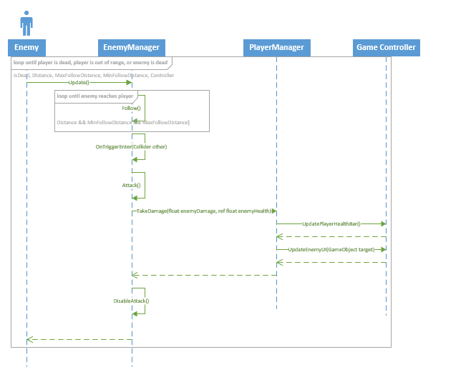

## Display Inventory

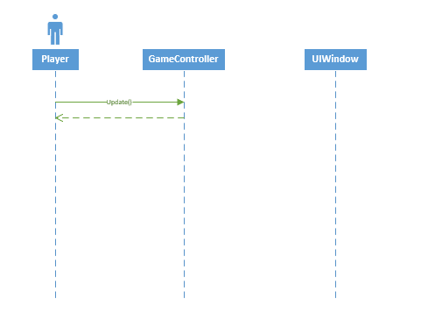

## Display Quest

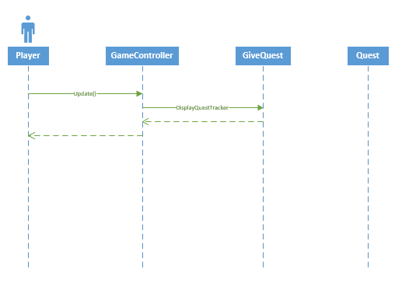

## Display Skill Tree

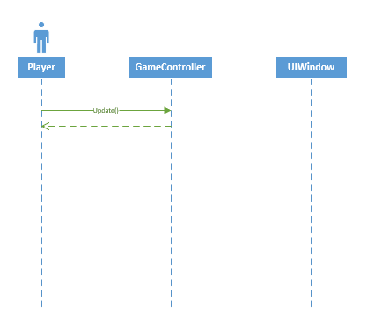

## Enemy Attack

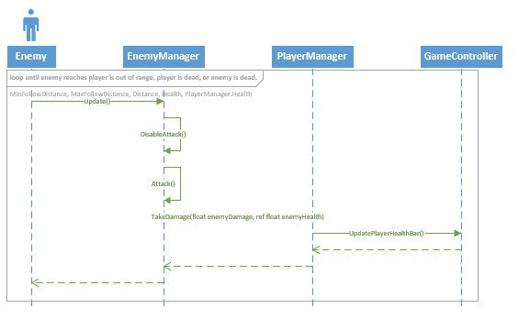

## Equip Weapon

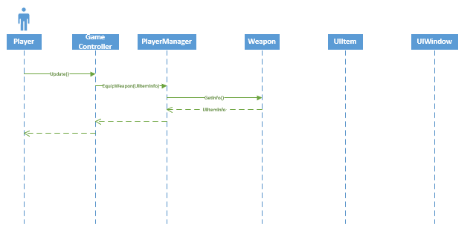

## Follow

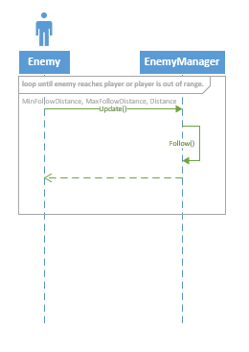

## GiveQuest

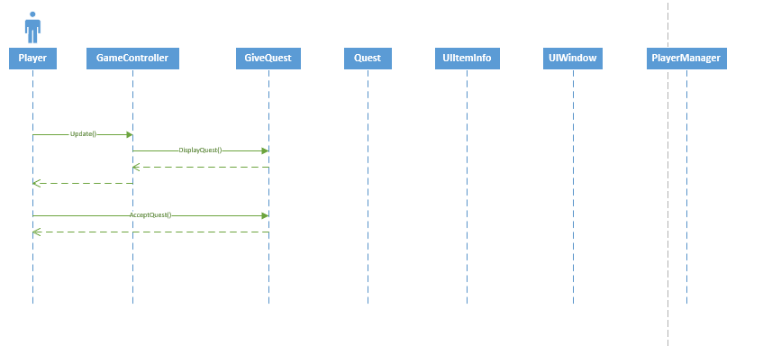

## Kill Enemy



## Losing



## Move



## Pause



## Pickup Item



## Quitting



## Reset Skills



## Retreat



## Take Quest



## Unlock Skills



## Use Potion



## Winning



# CRUD Matrix

|  |  |  |  |  |  |  |  |  |  |  |  |  |  |  |
| --- | --- | --- | --- | --- | --- | --- | --- | --- | --- | --- | --- | --- | --- | --- |
| Use Case ID | Use Case Name | Pickup_  Item | Quest | UIItem  Info | Enemy  Manager | Weapon | Give  Quest | Game  Controller | Player  Manager | Third  Person  Camera | UIWindow | Talents | VerifyTalent | Movement |
| SP-003 | Attack |  |  |  | RU | RU |  | R |  |  |  |  |  | RU |
| SP-004 | Choose Menu Item |  |  |  |  |  |  | CRD |  |  | RD |  |  |  |
| SP-013 | Complete Quest |  | RUD |  |  |  | CRUD |  | RU |  |  |  |  | R |
| SP-005 | Display Inventory |  |  |  |  |  |  | CRUD |  |  | CRUD |  |  |  |
| SP-014 | Display Quest |  | RU |  |  |  | R |  |  |  |  |  |  | R |
| SP-006 | Display Skill Tree |  |  |  |  |  |  |  |  |  | CRUD | CRUD |  |  |
| SP-017 | Enemy Attack |  |  |  | RU |  |  | RU | RU |  |  |  |  |  |
| SP-007 | Equip Weapon |  |  | RUD |  | RUD |  |  |  |  | UD |  |  |  |
| SP-016 | Follow |  |  |  | RU |  |  |  |  |  |  |  |  |  |
| SP-018 | Give Quest |  | R |  |  |  | CRUD |  | RU |  |  |  |  | R |
| SP-011 | Kill Enemy |  |  |  |  |  |  |  | RUD |  |  |  |  | RU |
| SP-020 | Losing |  |  |  |  |  |  | CRUD | CRUD |  |  |  |  |  |
| SP-001 | Move |  |  |  |  |  |  |  |  |  |  |  |  | RU |
| SP-002 | Pause |  |  |  |  |  |  | CRD |  |  | C |  |  | R |
| SP-015 | Pickup Item | CRUD |  | CRUD |  | R |  |  | RU |  |  |  |  | U |
| SP-021 | Quitting |  |  |  |  |  |  | CD |  |  | D |  |  |  |
| SP-010 | Reset Skills |  |  |  |  |  |  |  |  |  | U | RU |  |  |
| SP-018 | Retreat |  |  |  | RU |  |  |  |  |  |  |  |  |  |
| SP-012 | Take Quest |  | RU |  |  |  | CRUD |  | UD |  |  |  |  | R |
| SP-009 | Unlock Skill |  |  |  |  |  |  |  |  |  | U | RU | RU |  |
| SP-008 | Use Potion |  |  | CRD |  |  |  |  |  |  | U |  |  |  |
| SP-019 | Winning |  |  |  |  |  |  | CRUD | CRUD |  |  |  |  |  |

# Low Fidelity UI

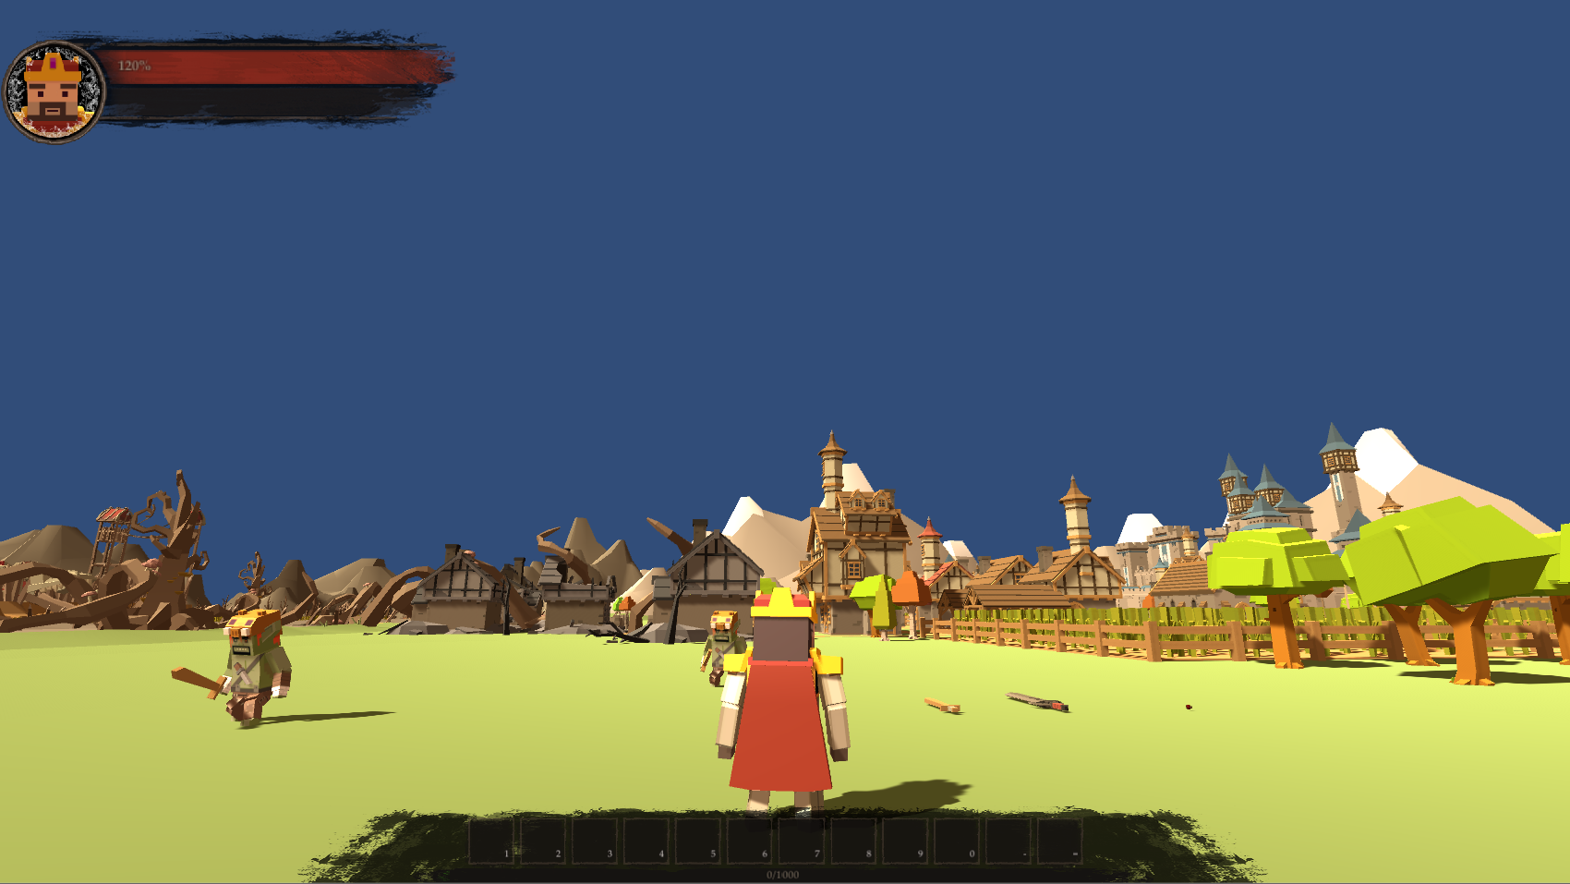

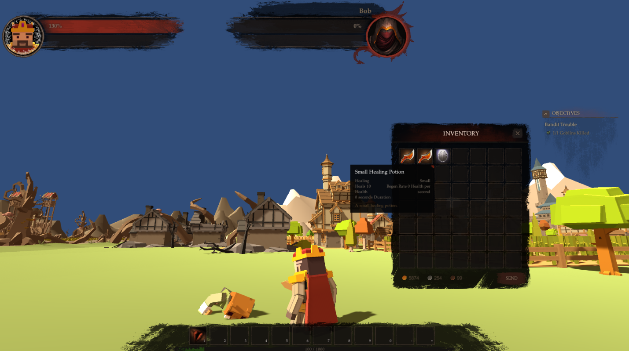

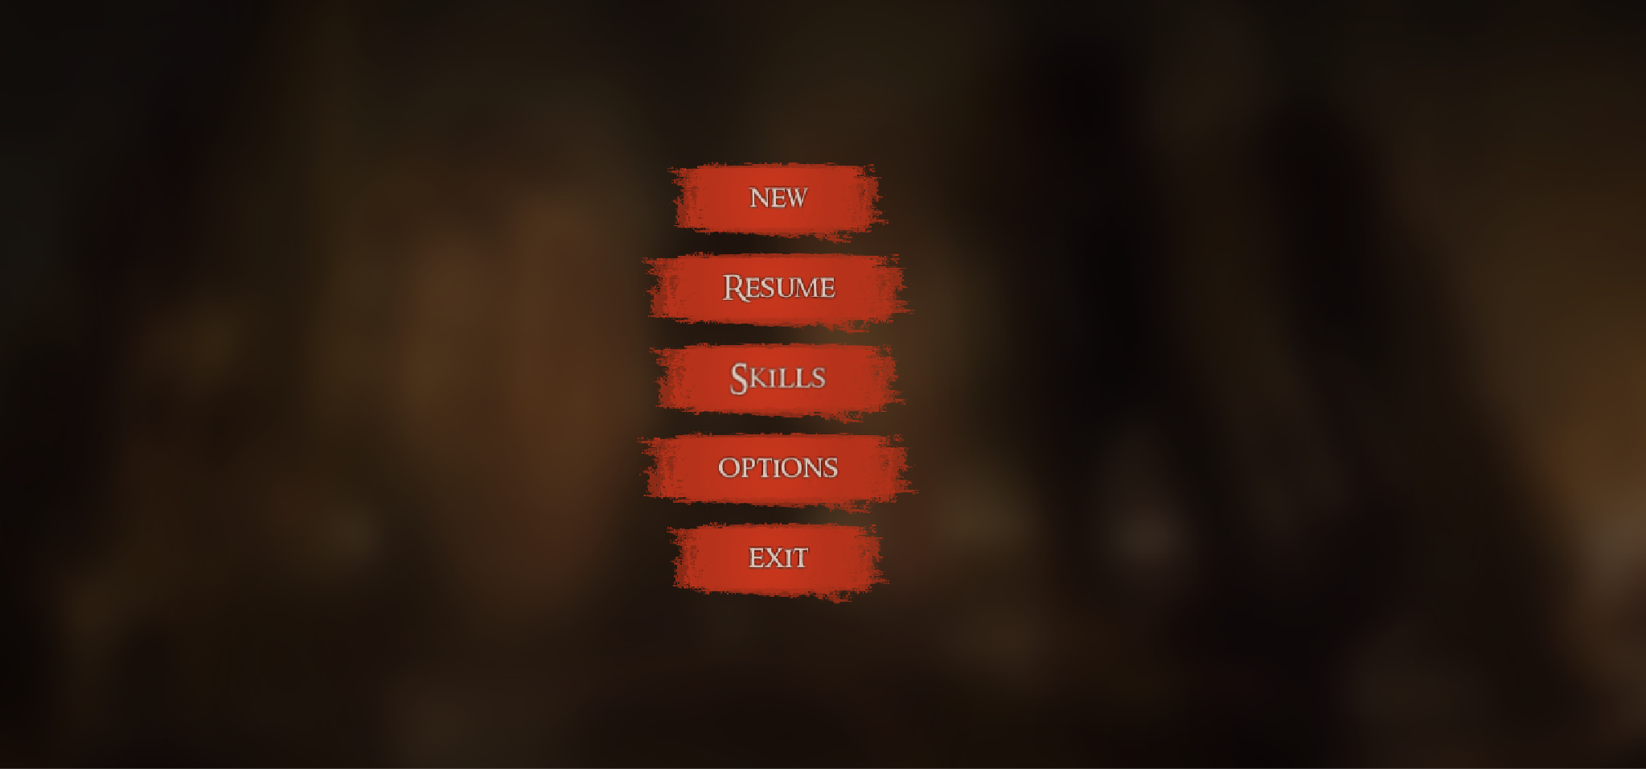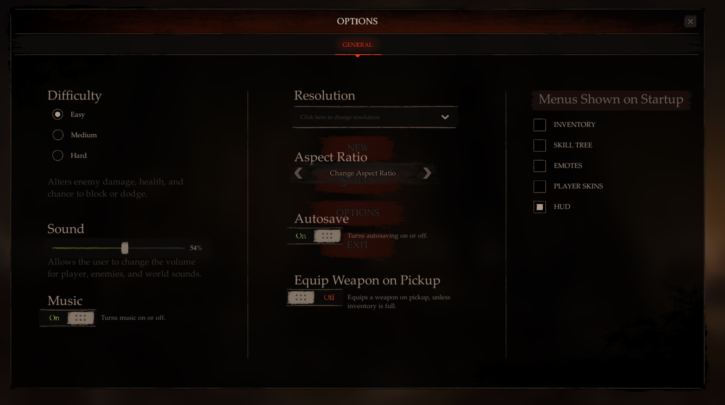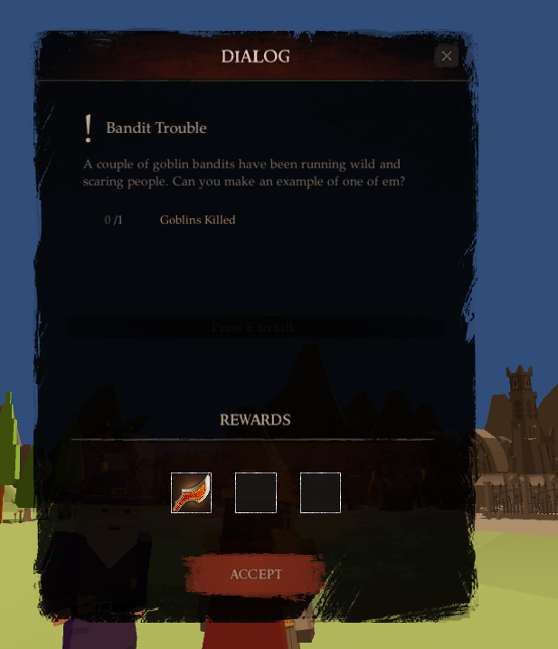

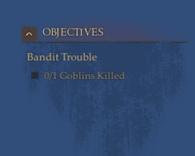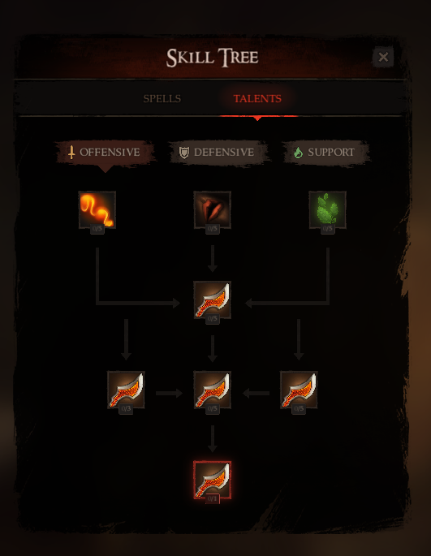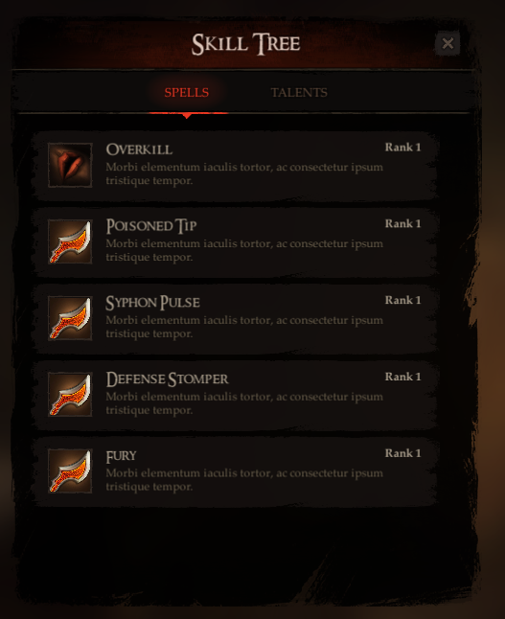

# Glossary

**NPC:** A non-playable character that can be either an ally, or enemy. In the case of my game, he is strictly an enemy. There is an NPC that provides quests, but let’s be honest, quests put the player’s life in danger, so I would classify him as an enemy.

# Appendix A

## Business Rules

#1: Player cannot attack while walking or running. (limited by animations)

#2: Player cannot walk on water or swim.

#3: Player dies if health reaches below 0.

#4: Player can only have one quest at a time.

#5: Player can complete up to two quests.

#6: There are only eight enemies in the game.

#7: Player wins if he kills the enemies.

#8: Player loses if he dies.

#9: Player can save current in-game progress if he quits via menu.

#10: Player’s skills and options are saved if player wins or loses.

#11: Player can move in eight directions.

#12: Inventory has only 10 slots.

#13: Inventory cannot stack items.

#14: If inventory is filled, another item cannot be picked up.

#15: Items are used if the player double clicks on the slot.

#16: Enemy can only attack once every four seconds.

#17: Enemy dies if his health falls below 0.

#18: Enemy will follow player if he is within 10m.

#19: Enemy will attack player if he is within 2m.

#20: Enemy will retreat if player is out of range.

#21: An enemy has only a single-handed weapon.

#22: A player can have a two-handed and one-handed weapon.

#23: A two-handed weapon is two seconds slower.

#24: Player must talk to quest giving NPC to get a quest.

#25: A quest can only be accepted if player has no current quests and clicks the accept button on the quest dialog.

#25: Player cannot harm quest giving NPC.

#26: Player can pickup weapons by standing over them and pressing “E”.

#27: Player can talk to quest giving NPC by pressing “F” near him (5m).

#28: Camera will rotate around the player.

#29: A skill can only be gained once, if its locked.

#30: An locked skill will have a silver border.

#31: An unlocked skill will have a gold border.

#32: Skill effects stack on top of one another.

#33: Clicking new game will erase all progress on current game, even skill tree data.

#34: Clicking resume game will continue the game exactly where the player left off, including current enemies, positions, and rotations.

#35: Equipping a weapon when a current one is in-hand will replace that weapon.

#36: Potions have no effect on health that is already at max.

#37: Hovering over skill will provide tooltip with their information.