|  |  |
| --- | --- |
| **Project Case** |  |
| COMP6683 | COMP6683001  Introduction to Artificial Intelligence |
| **Computer Science** | **E232-COMP6683-SU01-00** |
| ***Valid on*** *Even Semester Year 2022/2023* | **Revision 00** |

1. Kelompok tidak diperkenankan untuk:

*Members of the group are prohibited from:*

* + - Melihat sebagian atau seluruh jawaban kelompok lain,

*Seeing a part or the whole answer from other groups,*

* + - Menyadur sebagian atau seluruh jawaban dari buku, catatan, video, dan jenis referensi lainnya,

*Retell a part or the whole answer from books, notes, videos, and other references,*

* + - Menyadur sebagian atau seluruh jawaban dari internet,

*Retell a part or the whole answer from the internet,*

* + - Mengumpulkan jawaban yang tidak sesuai dengan tema soal,

*Submitting an answer with a different theme from the given case,*

* + - Melakukan tindakan yang menyebabkan jawaban dicontek oleh orang lain atau kelompok lain, baik disengaja maupun tidak disengaja,

*Doing action that could result the answer being copied by someone or other groups, intentionally or unintentionally,*

* + - Melakukan tindakan kecurangan lainnya.

*Committing other dishonest actions.*

1. Jika kelompok terbukti melakukan tindakan seperti yang dicantumkan pada butir ke-1, maka nilai mahasiswa dan/atau kelompok yang melakukan kecurangan, baik menyontek atau dicontek, akan dinolkan sesuai dengan peraturan yang berlaku.

*If it has been proven that a group has committed dishonest actions outlined in point 1 above, the whole groups related to the incident, regardless of which one copies or has their answer copied, will be issued a score of zero according to the regulation.*

1. Jawaban yang dapat diterima dan dinilai adalah jawaban yang dikumpulkan sebelum batas waktu yang telah ditentukan.

*The answer must be submitted before the designated deadline to be accepted and graded,*

1. Jawaban akan dinilai berdasarkan teknik atau metode yang diajarkan pada kelas praktikum dengan menggunakan software yang sudah ditentukan.

*The scoring will be based on the materials taught during the practicum classes using the designated software. Using different software than requested may result in your answer not being graded.*

1. Jika Anda tidak membaca peraturan ini, maka Anda dianggap sudah membaca dan menyetujuinya.

*By taking this exam, you agree to these regulations, regardless of whether you have read it or not.*

1. Persentase penilaian untuk matakuliah ini adalah sebagai berikut:

*The score will be distributed as follows:*

|  |  |  |
| --- | --- | --- |
| **Tugas Mandiri**  *Assignment* | **Proyek**  *Project* | **UAP**  *Final Exam* |
| 40% | 60% | - |

1. Perangkat lunak yang digunakan pada matakuliah ini adalah sebagai berikut:

*This course uses the following software:*

|  |
| --- |
| **Software**  *Software* |
| NLTK 3.4.5  Python 3.7.6  Visual Studio Code |

1. Ekstensi file yang harus dikumpulkan untuk matakuliah ini adalah sebagai berikut:

*Your answers must be in the following file extensions:*

|  |  |  |
| --- | --- | --- |
| **Tugas Mandiri**  *Assignment* | **Proyek**  *Project* | **UAP**  *Final Exam* |
| PY | PY | - |

1. File yang harus dikumpulkan adalah keseluruhan jawaban beserta dengan aset yang digunakan (gambar, audio, video, dll) dan dokumentasi proyek yang berisikan link referensi aset dan penjelasan mengenai aplikasi yang dibuat (terlampir bersama dengan soal).

*Include other files that can support your project, such as: all files in your project, other files (image, audio, video, etc.) used in your project, *.doc file (documentation of your project) that contains all pages in your project, reference links of additional files (image, audio, video, etc.) used in your project, the description about how to use your application, etc.*

## Soal

*Case*

**SUtify**

**SUtify** is an application that is designed **to analyze and classify music reviews**. You as a programmer are asked to build the program. There are some requirements that must be fulfilled:

* First, the application will check whether there is **“model.pickcle” file** in the application directory or not.
* If the file **exists**, then the application will **read and load** the data training from the file.

**Figure 1. Load Model**

* If the file **does not exist**, then the application will **train the review data using Naïve Bayes Classifier from NLTK**. The review data sample is provided in **“dataset.csv**”. The data training will be following these rules:
  + - Preprocess the dataset by **tokenizing the words, remove stopwords, remove symbols and numbers, stemming, and lemmatizing the words.**
    - Compare the reviews with the words in list of **dictionaries**.
* If the review is in **positive** category, then set the review to **Positive**
* If the review is in **negative** category, then set the review to **Negative**
  + - Train the model using **Naïve Bayes Classification**.
    - Show **10 most informative features** and the **training accuracy.**
    - **Save training model into a pickle file** with format name **“model.pickle”** and **load** the file.

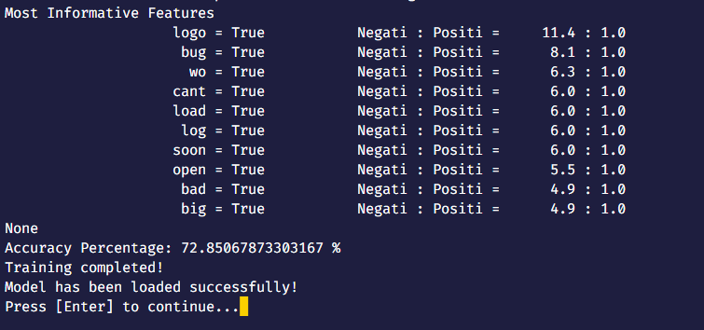

**Figure 2. Train Model**

* Then, the **loaded “model.pickle”** file will be used for the application menu as follows:
  + There will be **3 menus**, validate that can only **choose the number in the range of menu provided (1 to 3):**

1. **Write new review**
2. **Analyze review**
3. **Exit**

**Figure 3. Menu (Without review)**

**Figure 4. Menu (With review)**

* If user **choose menu 1 (“Write new review”)**, then the application will:
* Ask the user to **input new review**. Validate that the input must **at least contain 3 words**.

**Figure 5. Write new review**

* After that, the application will **change the current review accordingly**.
* If user **choose menu 2 (“Analyze review”)**, then the application will:
* **Check whether there is a review or not**.
* If there is **no review**, then ask the user to **write a new review first** and **show the error message**.

**Figure 6. No review error message**

* If there is a **review**, then the application will do following procedures:
* **Show Part of Speech (POS) Tagging.**

**Figure 7. POS Tagging**

* **Show Named Entity Recognition (NER)**

**Figure 8. NER**

* **Show the synonyms and antonyms** of the words in the review. If the word does not have any synonym or antonym, **show message to notify the user**.

**Figure 9.1. Synonym & Antonym**

**Figure 9.2. Synonym & Antonym**

* **Predict and show the result of the review category.**

**Figure 10. Sentiment Analysis (Prediction)**

* + - If user **choose menu 3 (“Exit”)**, then **terminate** the application.



**Figure 11. Closing message**