//MAIN FORM

2 buttons:

Button1 Calendar which can go to the calendar

// can save here this   
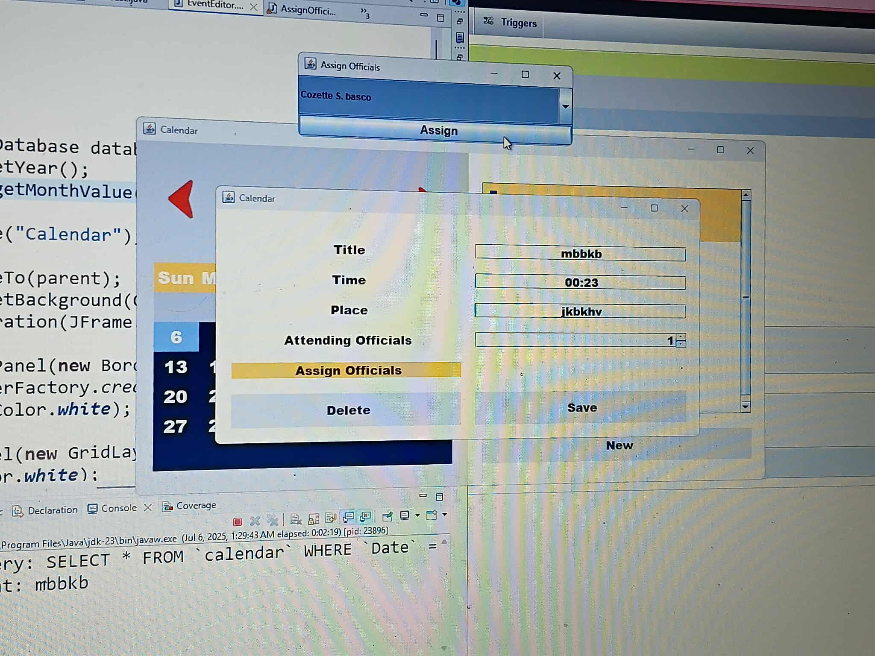

Makapag save ng title ng event, time, place, attending officials (ilan, 10 only, kasamas sec and treasurer) tapos pagkasave is nakikita ulit details nung event.

Yung nilagay na attending officials dapat ang lalabas ilan ang pwede niyang iinput

//combo box of sk members

//IN TERMS OF OFFICIAL ATTENDEES, refer to the sk

-sk chairman, sk1-7 kagawads, treasurer, secretary.

Magkakaron lang ng details ng sk members by inputting in the SK Profiles, dun sa button sa main form

Dito nakakpag crud lang na napasok lang dun sa table ng db.

* Then problem po is pano makikita and edit yung mga nainput ng events sa day nay un after isave