**Citation report from ISI Web of knowledge**

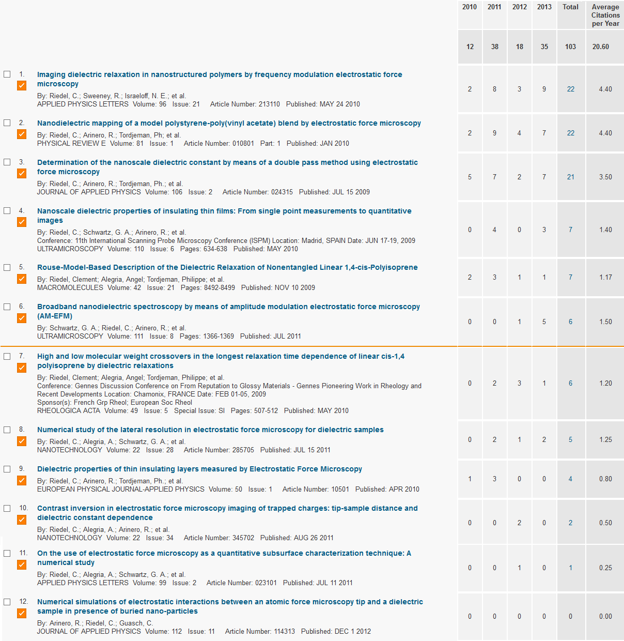

|  |  |
| --- | --- |
| Number of publications: 12  Sum of the Times Cited: 103  Sum of Times Cited without self-citations: 80 | Citing Articles: 57  Citing Articles without self-citations: 48  Average Citations per Item: 8.58 |