Exposee

The Elisa shopping list is a useful application that helps you buy products at the cheapest prices, at the nearest stores, in the perfect order and in cooperation with your friends and family! Never miss a special offer or forget to buy important products.   
Elisa will take care of you.

ELISA

Fairy Shopping

Stefan Cimander, Phillip Riedmann, Thomas Weber, Markus Schnappinger

# Vision

Shopping can be fun. We all know that. And shopping can be costly, nerve-wracking, time-intensive and annoying. And we all know that, too. We do not want this. We want to have fun.

But unfortunately it is usually the other way round. If you have to go shopping, there are two approaches how to handle that. The first possibility is to empty your mailbox every day, collect and study all leaflets and advertisements and make lists. Lists of special offers, lists of your daily needed supplies, lists of shops nearby or around your working place. After spending half of a day filling these lists, it is time to consider whether to buy butter at the nearest shop or drive two miles to a second shop in order to save 12 ct per piece because of special offers. After spending the second half of the day merging your lists and making plans where to buy what products and how to make the best of all the special offers, you are very proud of the result: A master plan that saves you a total of 5 euros. We all like the good feeling that we get by being so clever and saving money. But we do not like the thoughts of spending a whole day looking at special offers and planning.

The second possibility is to just enter a shop, buy products you consider attractive, get angry over the bill which is much higher than expected, being plagued by a guilty conscience all the way home because there clearly might have been healthier alternatives to the frozen pizza you just bought – just to experience that, once again, you forgot to reach for toilet paper. We do not like this scenario either.

Wouldn’t it be great to have the good feeling of saving money without spending so much time? Wouldn’t it be great to get a perfectly optimized masterplan in an effortless way? What a fairy experience that would be!

The Elisa shopping list app grants you this experience. All you have to do is to add items you want to buy to a list on your smartphone. Than the magic begins.

Elisa is performing all the nerve-wracking and time-intensive work for you. She traverses all special offers of your most frequented shops, looks up products in her huge database and automatically sorts your wishes following several optimization criteria. Whether you want to buy products at the cheapest prices, at the lowest time investment or stores of the shortest distance, or even a mix of all that - Elisa is there to do all the work for you. Elisa wants to make you feel good. Elisa does not want you to run out of toilet paper again. She remembers what products you buy regularly and reminds you to buy them again after a certain period of time. If there is a really cheap special offer of an article you might need, Elisa keeps you informed about the great opportunity.

As a female, Elisa is of course capable of multitasking. So don’t be selfish, invite others to use Elisa, and you will experience her multi user features. Sharing and cooperative editing of lists is supported and an ideal opportunity for all household members to keep on track with the other persons’ needs. You can share your whole list or just entries that are e.g. related to your next holiday. Elisa does not only make your life easier, but also your life with others.

# Challenges

The main purpose of the Elisa application is to optimize both time investment and money spent during your weekly shopping. The complex application breaks down to three main aspects:

* A widespread database with up to date articles, product prices and availabilities has to be developed and maintained.
* Multi-user functionalities, authentication and data confidentiality issues have to be addressed.
* Special offers are identified and forwarded to the user due to his experienced habits.

Apart from the technical challenges, the biggest challenge is identified in the User Experience context. It is mandatory to configure Elisa in order to get best optimization results. List entries should be augmented with attributes concerning amount, category or purpose, multi-user data, a due date etc. Forcing the user to answer so many questions every time he enters a new item is not acceptable. Hence, we identified a set of research questions we want to focus on during this project:

* How much time do users want to spend on entering new items to a list?
* What other input possibilities are there apart from typing into textboxes?
* To what extend are users willing to provide information necessary for best optimization?
* Under which circumstances are notifications about special offers considered useful or annoying?
* How are user studies performed, given there is no comparable technology on the market?
* What roles have optimization criteria like nutrition facts, vegetarian labels, distance to the shop or favorite stores?
* To what extend are they dominated by the wish to save money?
* How does an efficient and entertaining frontend look like?
* What process is best to follow solving these questions?

In order to focus on the user experience aspects, we take the following assumptions: The prizes provided by our database backend are correct. Special offers are identified in a correct way. Every market of an enterprise has the same offers and availability of articles. No data confidentiality guideline is violated.

# Research Methods

There are several research methods going to be applied in order to collect information about the user’s needs and habits. Basic methods like use cases will not be described in this chapter, as they are considered as a widely known technique.

## Proto-Personas

As there is neither time nor money to create true research based personas, proto-personas will be used instead. These are personas that are created based on the team’s idea of users. (Ilama, 2015)

## IDEO method cards

Method cards contain several methods meant to give developers a better understanding of the user and inspire good designs. These methods are usually printed onto cards which are drawn to determine which technique to use next. As this project is limited both in money and in time, we chose the following sample of 16 cards out of 51 which are going to be applied.

|  |  |
| --- | --- |
| **Activity Analysis**  List in detail all tasks, actions, objects, interactions and performers involved in the process. | **Five Whys**  Ask five ‘Why’ questions in response to five consecutive answers. |
| **Cognitive Task Analysis**  List and summarize all of a user’s sensory inputs, decision points, and actions. | **Survey & Questionnaires**  Ask a series of targeted questions. |
| **Error Analysis**  List all the things that can go wrong when using the product and determine the various causes. | **Card Sort**  Name possible features or design attributes on different cards and ask people to organize the cards. |
| **Flow Analysis**  Represent the flow of information or activity. | **Be your customer**  Ask the client to describe, outline, or enact their typical customer’s experience. |
| **A day in the life**  Catalog the activities and contexts that users experience during a whole day. | **Experience Prototype**  Prototype a concept and learn from a simulation of the experience while using the product. |
| **Fly on the wall**  Observe and record behavior within its context without any interaction. | **Paper Prototype**  Rapid sketch and layout of interaction designs for basic usability. |
| **Still-photo survey**  Follow a planned shooting script and capture pictures of specific situations or objects. | **Scenarios**  Character-rich stories describing the context. |
| **Unfocus group**  Workshop with a diverse group. | **Try it yourself**  Use the product yourself. |

Table 1 - IDEO methods used in this project

The techniques are divided into the four categories Learn, Look, Ask and Try. (IDEO, 2003)

## GOMS

To evaluate the results of the prototyping, a technique called Goals, Operators, Methods and Selection rules is applied. This approach divides user interaction into smaller actions. Goals are thereby the user’s aims, operators the actions allowed by the application. Methods are meant to consist of multiple milestones and operators on the way to fulfill the goal. Selection rules characterize how users determine which action they want to apply. (Card, 1980)

## KLM

To predict how long experienced users need to accomplish a common task without errors, the keystroke-level model is used. It is very similar to GOMS, as it consists of six operators: K means a certain key or button to be pressed, while P describes the action of pointing to a screen element with the mouse. H(oming) is the movement between two input devices. Other operators are D(rawing) and M(entally) preparing for the next action. (Card, 1980) (Li, 2010)

## Heuristic Evaluation

This method examines the usability of a frontend using a list of common usability problems. This evaluation should be done by domain and usability experts.

## Think aloud analysis

Study participants are asked to describe their actions and share their thoughts.

# Project management

The Elisa project is a pushing-the-limits project hosted by the Software Engineering elite graduate program. Students examining the research questions in the user experience context are Stefan Cimander, Philipp Riedmann, Thomas Weber and Markus Schnappinger. Roles among the students are defined later in the project. The upcoming process and schedule follow concepts and research methods presented in the above chapter ‘research methods’.

## Overall Process

The overall process is based on the double diamond process shown in the following picture.

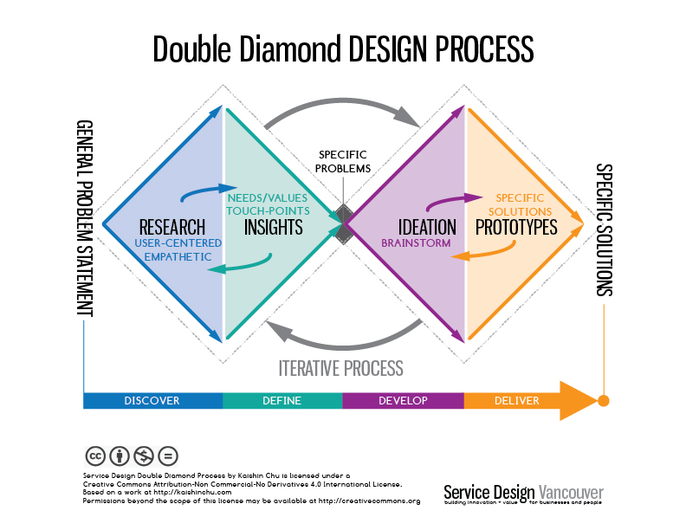

Image 1 - Double Diamond Process [1]

Based on this cyclic user-centered design process the first month of the project will be spent on problem definition and filed-research with the intent of understanding domain and problem. The research will follow the IDEO methodology using their method cards (IDEO, 2003). Due to time reasons, not all methods cards can be applied. We therefore chose the most promising 16 and described them in the chapter on research methods. With a firm grasp of the problem at hand we then perform iterative prototyping with a tight feedback loop (Dix, 2009) (Benyon, 2010) (Rogers, 2011). The evaluation uses observational techniques, analytical tools and general empirical methods.

## Schedule

As feedback meetings with the academic supervisor are scheduled regularly on Thursday, the weeks in the following schedule begin Friday and end Thursday. Please note that the period between 23th December and 12th January is regarded as one week. For information on what double diamond phase a schedule entry belongs to, please see left row.

|  |  |  |  |  |
| --- | --- | --- | --- | --- |
|  |  |  | **4.11 - 10.11** | **Strategy** |
| **Kickoff** |  |  |  | * Goal description * Literature research * Evaluation of related work * Defining of an HCD Process |
|  |  |  |  |  |
|  |  |  | **11.11 – 17.11** | **Requirements** |
| **Discover** |  |  |  | * Functional Requirements * Usability Requirements * Defining of Use Cases * Defining of Proto-Personas (Ilama, 2015) |
|  |  |  |  |  |
|  |  |  | **18.11 – 1.12** | **Research via IDEO cards** |
| **Discover** |  |  |  | * Activity Analysis * Cognitive Task Analysis * Error Analysis * Flow Analysis * A day in the life * Fly on the wall * Still-photo survey * Card Sort * Five Whys * Survey & Questionaires * Unfocus Group (Saffer, 2010) * Be your customer * Experience Prototype * Paper Prototype * Scenarios * Try it yourself |
|  |  |  |  |  |
| **Define** |  |  | **2.12 – 8.12** | **Research continued** |
|  |  |  | * Design Personas (Ilama, 2015) * Design Brief (Saffer, 2010) * Problem Definition (Norman, 2013) |
|  |  |  |  |  |
| **Develop** |  |  | **9.12 – 15.12** | **Begin of Prototyping** |
|  |  |  | * Paper prototypes * Think aloud analysis |
|  |  |  |  |
|  |  | **16.12 – 22.12** | **Incremental Prototyping** |
|  |  |  | * Technical implementation |
|  |  |  |  |  |
| **Discover Develop** |  |  | **23.12 – 12.1** | **Analytic Evaluation** |
|  |  |  | * GOMS KLM (Card, 1980) (Li, 2010) * Heuristic Evaluation (Nielsen, Heuristic evaluation of user interfaces, 1990) (Nielsen, Heuristic Evaluation, 1994) |
|  |  |  |  |
|  |  |  |  |  |
| **Develop Deliver** |  |  | **13.1 – 19.1** | **Empirical Evaluation** |
|  |  |  | * Lab experiments * Demo runs |
|  |  |  |  |
| **Deliver** |  |  |  |  |
|  |  | **20.1 – 3.2** | **Refinement** |
|  |  |  | Apply evaluation insights to the prototype |
|  |  |  |  |
|  |  |  |  |

# Literature

Benyon, D. (2010). *Designing interactive systems: a comprehensive guide to HCI and interaction design . cf: 8 Envisonment.*

Card, S. K. (1980). *The keystroke-level model for user performance time with interactive systems.* Commun. ACM 23.

Dix, A. (2009). *Human-computer interaction.* Springer US.

IDEO. (2003). *method cards: 51 ways to inspire design.* Palo Alto.

Ilama, E. (2015). *Creating Personas.* http://www.uxbooth.com/articles/creating-personas/, retrieved 06.11.2016.

Li, H. (2010). *Extended KLM for mobile phone interaction: a user study result.* CHI'10 Extended Abstracts on Human Factors in Computing Systems: ACM.

Nielsen, J. (1990). *Heuristic evaluation of user interfaces.* Proceedings of the SIGCHI conference on Human factors in computing systems: ACM.

Nielsen, J. (1994). *Heuristic Evaluation.* Usability inspection methods 17.1 .

Norman, D. (2013). *he design of everyday things: Revised and expanded edition.* Basic books.

Rogers, Y. (2011). *H. Interaction Design.* Wiley & Sons.

Saffer, D. (2010). *Designing for interaction: creating innovative applications and devices.* New Riders.

1. Picture from: http://servicedesignvancouver.ca/wp-content/uploads/2014/11/DoubleDiamond.jpg