**FLOWCHART & PSEUDOCODES**

1. **FLOWCHART**

-is diagram presented by different shapes that are connected by arrows to present a program flow. Using the arrows, shows the order of the action. While each shape, represents different actions depending on its symbols.

-it can be used in business process analysis. Boxes with texts in it are considered as the step in the process. While the diamond with text represents the decision point.

1. 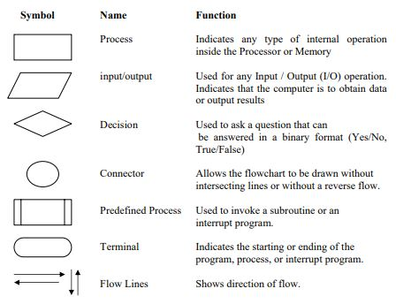**The** **following** **are** **the** **flowcharting** **symbols**:

From <http://ceng.eskisehir.edu.tr/emrekacmaz/bil158/Algorithms3.pdf>

**ii. General Rules for flowcharting**

1. All boxes of the flowchart are connected with Arrows. (Not lines)

2. Flowchart symbols have an entry point on the top of the symbol with no other entry points. The exit point for all flowchart symbols is on the bottom except for the Decision symbol.

3. The Decision symbol has two exit points; these can be on the sides or the bottom and one side.

4. Generally a flowchart will flow from top to bottom. However, an upward flow can be shown as long as it does not exceed 3 symbols.

5. Connectors are used to connect breaks in the flowchart. Examples are:

• From one page to another page.

• From the bottom of the page to the top of the same page.

• An upward flow of more then 3 symbols

6. Subroutines and Interrupt programs have their own and independent flowcharts.

7. All flow charts start with a Terminal or Predefined Process (for interrupt programs or subroutines) symbol.

8. All flowcharts end with a terminal or a contentious loop. Flowcharting uses symbols that have been in use for a number of years to represent the type of operations and/or processes being performed. The standardised format provides a common method for people to visualise problems together in the same manner. The use of standardised symbols makes the flow charts easier to interpret, however, standardising symbols is not as important as the sequence of activities that make up the process.

1. **PSEUDOCODES**

-is one of the tools that can be used to write a preliminary plan that can be developed into a computer program.

**The sequence structures**

The first type of control structures is called the sequence structure. This structure is the most elementary structure. The sequence structure is a case where the steps in an algorithm are constructed in such a way that, no condition step is required. The sequence structure is the logical equivalent of a straight line.

For example, suppose you are required to design an algorithm for finding the average of six numbers, and the sum of the numbers is given. The pseudocode will be as follows:

*Start*

*Get the sum*

*Average = sum / 6*

*Output the average*

*Stop*

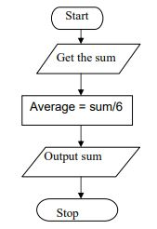 The corresponding flowchart will appear as follows:

REFERENCES:

<http://ceng.eskisehir.edu.tr/emrekacmaz/bil158/Algorithms3.pdf>

<http://cdn.robotc.net/pdfs/nxt/reference/hp_pseudo_flow.pdf>