BantayAralan: A Web-Based Classroom Monitoring and Orderliness System
Prototype Paper — Revised Direction from the Original Research Proposal
Chloe Lane B. Jose
Raynier Ronn G. Santos
Justin Rieko S. Tolentino

Bachelor of Science in Computer Engineering
School of Engineering and Architecture
Holy Angel University

October 2, 2026

Note on This Document
This document is a prototype paper: a revised conceptual direction for the BantayAralan system, written as a working draft for the project team and thesis adviser to review. It is a separate document from, and does not replace, the original research proposal (“BantayAralan: Real-Time Student Behavior and Classroom Orderliness System,” dated March 29, 2026), which remains the proposal of record. This paper has not been reviewed or approved by the thesis adviser. It does not report implementation results, test data, or survey findings, because none of the features described here have been built or evaluated yet. Where a detail has not been finalized by the project team, this paper marks it explicitly (e.g., “Under consideration,” “Open implementation question”) rather than assuming an answer.

Introduction
Classroom management is an important part of education, as how teachers manage their classrooms can influence students' academic success as well as their social development. Everyday, teachers face unique challenges when trying to manage or observe multiple students simultaneously, especially when managing large classes or students with varying attention spans and behavioral tendencies. Disruptive behaviors, if not addressed promptly, can affect not only the student engaged in the behavior but also their classmates, reducing overall classroom efficiency and learning experience of students.
Effective classroom management directly influences the students' academic performance. Research indicated that good management of classroom environments, a calendar for activities/releasing students from class, and a consistent approach to disciplinary practices were linked with higher performance (Çalı et al., 2024). In comparison, students who behaved poorly exhibited decreases in academic achievement, including lower levels of participation in class and shorter time periods of attention while in class (Hamidi et al., 2024). The findings highlight how classroom management is directly connected with academic performance, influencing not only individual student outcomes but also overall classroom dynamics, teacher effectiveness, and the quality of instruction.
While classroom management is important, many teachers struggle balancing teaching responsibilities with managing disruptive student behavior. A study among 130 Philippine teachers found that handling student misbehavior, such as fighting and attention-seeking, is a frequent and ongoing issue, with only selected management strategies showing significant effectiveness (Dilabayan & Sambo, 2024). This indicates that even experienced teachers must constantly divide their attention between instruction and behavior control. Additionally, repetitive administrative tasks and paperwork further distract teachers from classroom duties, reducing instructional time and increasing stress (Magsambol, 2025). These factors collectively highlight the need for systems or interventions that can support teachers in both managing student behavior and delivering quality instruction.
Aside from monitoring student action, classroom management also means ensuring a clean classroom in which teachers in the Philippines also encourage students to practice cleanliness and orderliness as part of student discipline. Clean, properly organized classrooms are essential for effective learning, according to the Department of Education (2023). Teachers are expected to assist students with keeping classrooms clean. Many of these items remain in classrooms at the completion of class and contribute to cluttering the environment. Reyes et al. (2024) discussed in their recent research study that 49% of the respondents believed their school's cleanliness did not have an impact on the classroom environment; therefore, the cleanliness and overall condition of class influences the overall quality of education a student receives during their attendance at the school. The findings from this research indicate that to improve student academic performance and engagement while attending school, teachers should promote cleanliness and organizational skills as part of the classroom management process.
In order to successfully manage a classroom, teachers need to know what influences students' behaviour and how to respond correctly to that influence. Students' behaviour is affected by psychological, social and environmental factors that teachers need to identify to be able to react correctly (Dagdag and Bandera, 2021). Furthermore, the results of this study indicate that it is not enough to just respond to inappropriate behaviour but that teachers also require an understanding of behaviours' root causes in order to promote student engagement and lessen classroom disruptions. A comprehensive meta-analysis involving over 93,000 participants found that student engagement is strongly affected by both internal factors, such as motivation, and external factors, including teacher behavior and classroom environment quality (Li & Xue, 2023). Also, positive teacher-student interactions and organized, supportive environments were shown to significantly enhance engagement, while negative behaviors and poor environmental conditions were linked to reduced participation and learning outcomes. These studies collectively emphasize that effective management must integrate behavioral understanding with conducive learning environments, highlighting the need for interventions that support teachers in maintaining order and maximizing student engagement.
Recent studies have developed automated classroom behavior recognition systems that can assist teachers in monitoring student behavior efficiently, reducing reliance on manual observation and workload of teachers. Integrating artificial intelligence in classrooms has the potential to transform traditional learning and management practices by automation (Li et al., 2023). Computer vision can identify student actions, allowing teachers to monitor learning environments more efficiently while being able to instruct lessons. However, the adoption of these technologies also presents challenges and areas for further research, such as ensuring reliability, ethical use, and seamless integration into everyday classroom workflows (Dimitriadou & Lanitis, 2023).
A study developed by Lin et al. (2021) uses computer vision techniques to detect student actions in real time. The system achieved 15.15% high precision and 12.15% high recall, indicating accurate reading of behaviors occurred. Another study by Yang (2024) introduced a dual-stream classroom behavior capture and analysis system that integrates AlphaPose keypoint detection with image data to monitor student behavior in online teaching environments, achieving a 97.3% accuracy on student behaviors indicating its potential for behavior analysis. These advancements suggest such technologies can support teachers in monitoring classroom dynamics more effectively, allowing them to focus attention on instruction and overall classroom management rather than manual behavior observation.
Computer vision involves the challenge of detecting cluttered objects in an environment where the objects can overlap one another, have no fixed form, or have limited context, all of which lead to a significant decrease in the accuracy of the visual recognition system's detection ability. According to Bashkirova et al. (2021), the lack of appropriate datasets or models that can accommodate heavily cluttered scenes is a limitation to existing methodologies because of the researchers' use of a dataset that was designed to make researchers aware of the limitations of their methods to detect 'real-world' objects in real-world conditions. The same challenges that exist in detecting cluttered objects in the environment are also applicable to the classroom setting, where clutter from scattered items (ex. paper, trash, learning materials) can result in a negative impact on classroom cleanliness and organization. Liu et al. (2024) developed a model to enhance the performance of object detection by using advanced object detection techniques, such as attention mechanisms and multi-scale feature fusion, to achieve an mAP increase of 4.7% while maintaining real-time performance at an average of 39 FPS (frame/s). Although there has been much improvement, there are still deficiencies in the ability to detect randomly distributed overlapping items and visually similar entities; thus, additional research is needed to create more effective systems for the classroom environment to monitor cleanliness and manage classrooms effectively. For this prototype, clutter and trash detection are treated as part of a broader out-of-place-object concept: classroom items — including notebooks, pens, pencils, and other classroom materials — that are found in inappropriate locations, not only conventional waste items.
Recent advancements in deep learning and computer vision have enabled real-time monitoring of classroom behavior, providing teachers with continuous and objective data on student activities. Real-time detection and classification of various student behaviors have been demonstrated with a vision-based deep neural network system that has demonstrated that automated monitoring will eliminate the requirement for constant manual observation (L. Lin et al., 2024). An improved YOLOv8-based computer vision model specifically designed for classroom environments demonstrated the ability to achieve 95% accuracy in the real-time detection of student behavior, confirming that the implementation of automated monitoring within an educational environment is a feasible option (Sheng et al., 2025). These studies provide a solid foundation for integrating automated behavior detection with continuous classroom monitoring, making it possible for teachers to review recorded events and evidence of disruptive behaviors or critical incidents through accessible reports rather than instant alerts. Together, such an integration supports a classroom management system that does more than simply monitor student behavior; it also provides teachers with organized, reviewable information that can improve engagement, discipline, and education.
Automated systems for analyzing student behavior in classroom settings have gained increasing attention as tools to support traditional observation methods and enhance instructional effectiveness. A vision-based behaviour tracking system has shown that the use of pose estimation and deep learning is capable of automatically detecting engaged or disengaged behaviours by the use of AI models to be capable of objectively interpreting, in real-time, behaviours within the classroom environment (Alruwais & Zakariah, 2023). Traditional classroom management research has also reaffirmed the value of structured procedures, consistent expectation and reinforcement methodologies, in promoting engagement and reducing disruption (Kayhan, 2022). Similarly, there has been considerable promise in using smart classroom management methods that leverage IoT sensors and machine learning to assist teachers by monitoring conditions of their environment and students in a real-time management framework (Djami, 2022). Collectively, these referenced studies suggest that effective behaviour monitoring and managing practices have the potential to enhance engagement and improve student outcomes; however, there is an ongoing need for an automated system that integrates the automated detection of behaviours with the educational strategies to effectively and collegially support teachers in their practise.
Although research has examined various aspects of classroom management, significant gaps remain in understanding how teachers navigate the complex demands of behavior management, student engagement, and instructional delivery in real classroom contexts (Marquez & Oropa, 2025). Research has also identified challenges that teachers face when it comes to managing students' disruptive behaviours, keeping students engaged in learning, and communicating with students in both online and face-to-face environments. However, the literature contains few examples of how technology and pedagogy can be combined to provide holistic solutions for these problems (Adsiz & Dinçer, 2025). While there has been some investigation of AI-supported systems that capture and analyze student behavior, little empirical evidence exists regarding how these systems can be utilized in conjunction with teachers' regular teaching practices to support their ongoing decision making and decrease their cognitive load (Ling, 2022). Further, there are limited studies that combine elements of classroom management with detecting displaced objects, and, to the researchers' knowledge, none that examine classroom head counting, manual detection controls, or the statistical analysis of accumulated classroom monitoring data to generate suggestions — features this prototype paper proposes but which are not yet supported by dedicated literature (see the accompanying change-tracking document for this gap). Therefore, there is a need for studies to examine classroom-specific challenges related to managing student behaviors, and to develop and evaluate combination systems for monitoring student behavior, supporting teachers' instruction, and providing usability for teachers in order to improve the overall effectiveness of the classroom and educational outcomes for students.
Disruptive behavior remains an ongoing issue for teachers, as they must provide instructional delivery while continuously observing student behavior and maintaining classroom cleanliness at the same time. Teachers manually observe student behavior while teaching, which can delay or overlook necessary responses to students demonstrating disruptive behavior, as well as the timely identification of out-of-place objects in the classroom. With the advancement of computer vision and artificial intelligence, there is a need for an ethical and practical system that can continuously monitor a classroom to detect disruptive behaviors and out-of-place objects, capture event-based visual evidence, record an aggregate count of students present at the beginning and near the end of class, and make this information available to teachers through accessible reports and statistical summaries of recurring classroom conditions, while ensuring student privacy is protected throughout.
This study seeks to answer the following research questions:
- How can a computer vision-based classroom monitoring system be designed and developed to continuously detect disruptive student behaviors and out-of-place objects in a classroom?
- How effectively can the system determine an aggregate count of students present at the beginning and near the end of a class session?
- How does a manual detection enable/disable control support teachers in managing the system's monitoring during classroom activities where standard detection conditions may not apply?
- How effective is the system in capturing and recording event-based evidence that supports teachers in reviewing detected classroom conditions?
- How can accumulated classroom monitoring data be statistically analyzed to identify recurring classroom conditions and generate corresponding suggestions for teachers?
- How can privacy and ethical considerations, including parental/guardian consent, be ensured in the monitoring, capture, and storage of classroom data without identifying individual students?
The purpose of this study is to design and develop a computer vision-based classroom monitoring system capable of continuously observing classroom conditions, including disruptive student behavior and out-of-place objects, within a classroom setting, while supporting teachers with recorded evidence, aggregate head-count information, and data-driven insights. To achieve the main goal, the following objectives have been established:
- To develop a continuously operating classroom monitoring model: Create a system using computer vision to continuously detect disruptive behaviors and out-of-place objects as classroom conditions occur.
- To incorporate an aggregate student head-count function: Implement a feature that determines the number of students present at the beginning and near the end of class sessions without identifying individual students.
- To implement a manual detection enable/disable control: Provide teachers or authorized users the ability to temporarily suspend the system's detection and event-generation logic during classroom activities where standard detection conditions do not apply.
- To build an event-based evidence capture: Build a function that records screenshot and video evidence of specific detected conditions to assist teachers in reviewing classroom events.
- To develop a statistical classroom analysis and suggestion function: Analyze accumulated classroom monitoring data to identify recurring classroom conditions and generate corresponding suggestions for teachers.
- To establish ethical data protocols, including parental/guardian consent: Develop a method for capturing and storing classroom data that prioritizes student privacy, follows ethical guidelines, and requires parental/guardian consent prior to classroom implementation.
This study addresses the challenges of classroom management by integrating technology to support both teachers and students. Using the Triple Bottom Line framework and aligning with Sustainable Development Goals (SDGs), the importance of the study is presented in terms of social, economic, and environmental impact.
The main benefit of this system is the improvement of the classroom environment for both teachers and students. It aids teachers in classroom management by reducing manual observation, especially in large classes or in situations where students have varying attention spans. By continuously monitoring classroom conditions and recording disruptive behaviors and out-of-place objects for teacher review, the system aims to support a more focused and organized learning environment, improving students' learning experience. In addition, the system is designed to address ethical concerns by collecting event-based data without identifying individual students, requiring parental/guardian consent prior to classroom implementation, and thus protecting student data privacy.
The proposed system improves efficiency and productivity within educational environments. Automated monitoring allows teachers to allocate more time to providing lessons rather than behavior management and administrative tasks, increasing productivity and reducing workload. Because effective classroom management correlates with enhanced academic achievement, the system could potentially foster improved student outcomes over an extended period. Furthermore, the implementation of AI and computer vision presents a financially advantageous approach, diminishing the requirement for staff dedicated to classroom oversight.
Although primarily software-based, the system aids in preserving a tidy and structured learning environment. Through the detection of out-of-place objects, including classroom clutter and misplaced materials, it bolsters school efforts focused on cleanliness and organization. Consequently, this promotes student discipline and accountability in upholding their environment, thereby cultivating a more favorable and agreeable learning environment.
This study aligns with the Sustainable Development Goals (SDG), particularly SDG 4 (Quality Education) and SDG 9 (Industry, Innovation, and Infrastructure). It supports SDG 4 by improving classroom management, which is vital for improving student engagement and academic performance. Moreover, by introducing artificial intelligence and computer vision technologies into education, the study contributes to SDG 9 by fostering innovation and modernizing educational infrastructure.
The scope of this research covers the design and technical development of the BantayAralan system as a continuously operating, web-based classroom monitoring system, which includes features for disruptive-behavior detection, out-of-place-object detection, aggregate student head counting at the beginning and before the end of class, a manual detection enable/disable control, event-based evidence capture, statistical analysis of accumulated classroom data, and classroom suggestions generated from that analysis. The system is developed to support teachers in managing classroom dynamics by recording classroom conditions as reviewable events and reports rather than real-time alerts, and by capturing event-based screenshots and video as visual evidence for behavioral review. This study is specifically intended for implementation within a single public grade school classroom, focusing on the interactions between the technology and the educators, and requires parental/guardian consent prior to implementation in any classroom involving students. By automating these observations, the project aims to reduce the manual workload of teachers during instructional delivery.
However, the study is subject to several limitations and exclusions to maintain a focused research approach. The system is not designed to replace the teacher's authority or decision-making but serves strictly as a support tool for classroom management. It excludes long-term psychological profiling of students and individual attendance identification, focusing instead on continuously monitored, event-based classroom conditions and aggregate student head counts. Technical constraints include the potential for reduced detection accuracy in highly cluttered environments or when objects overlap significantly. The exact mechanism for avoiding duplicate head counts or distinguishing individual students within a camera frame, the precise scope of what continues to operate while detection is disabled, and the specific statistical methodology used for pattern analysis are not yet finalized and remain open implementation considerations for the project team. The choice between a web application and the project's existing desktop-based implementation direction is likewise an open project decision that this paper does not resolve. Finally, the study is constrained by strict ethical requirements, including parental/guardian consent prior to classroom implementation, ensuring that captured data is used for review without identifying individual students to protect their privacy.

Figure 1. Conceptual Framework
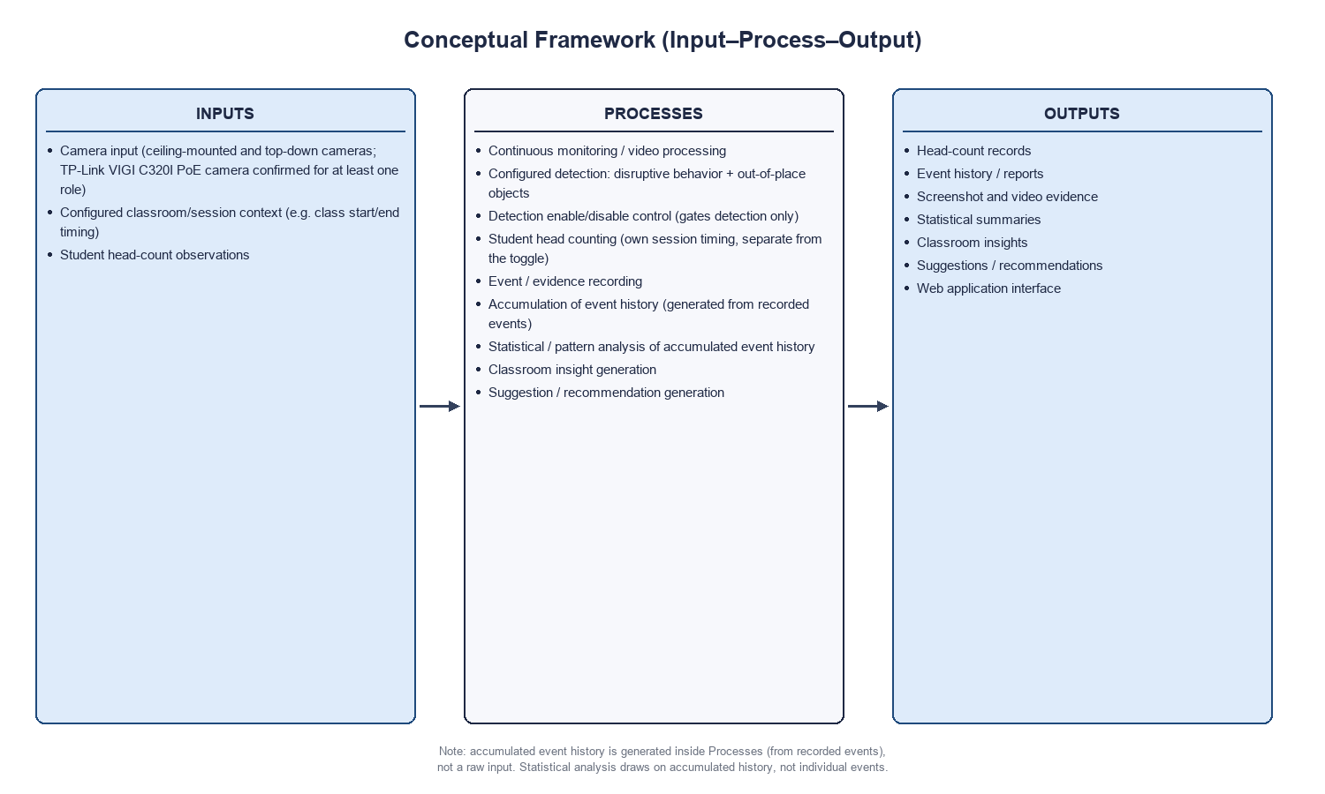
The conceptual framework presents the revised system using an Input–Process–Output (IPO) model. Inputs consist of camera input from ceiling-mounted and top-down cameras (at least one role confirmed as a TP-Link VIGI C320I PoE camera), configured classroom/session context such as class start and end timing, and student head-count observations. The process involves continuous monitoring and video processing, configured detection of disruptive behavior and out-of-place objects (gated by a detection enable/disable control that affects detection only), student head counting on its own session timing, event and evidence recording, accumulation of event history, statistical and pattern analysis of that accumulated history, and the generation of classroom insights and suggestions. These processes generate outputs such as head-count records, event history and reports, screenshot and video evidence, statistical summaries, classroom insights, suggestions and recommendations, and a web application interface, demonstrating how raw monitoring data is transformed into reviewable classroom information rather than real-time alerts.

Figure 2. Block Diagram
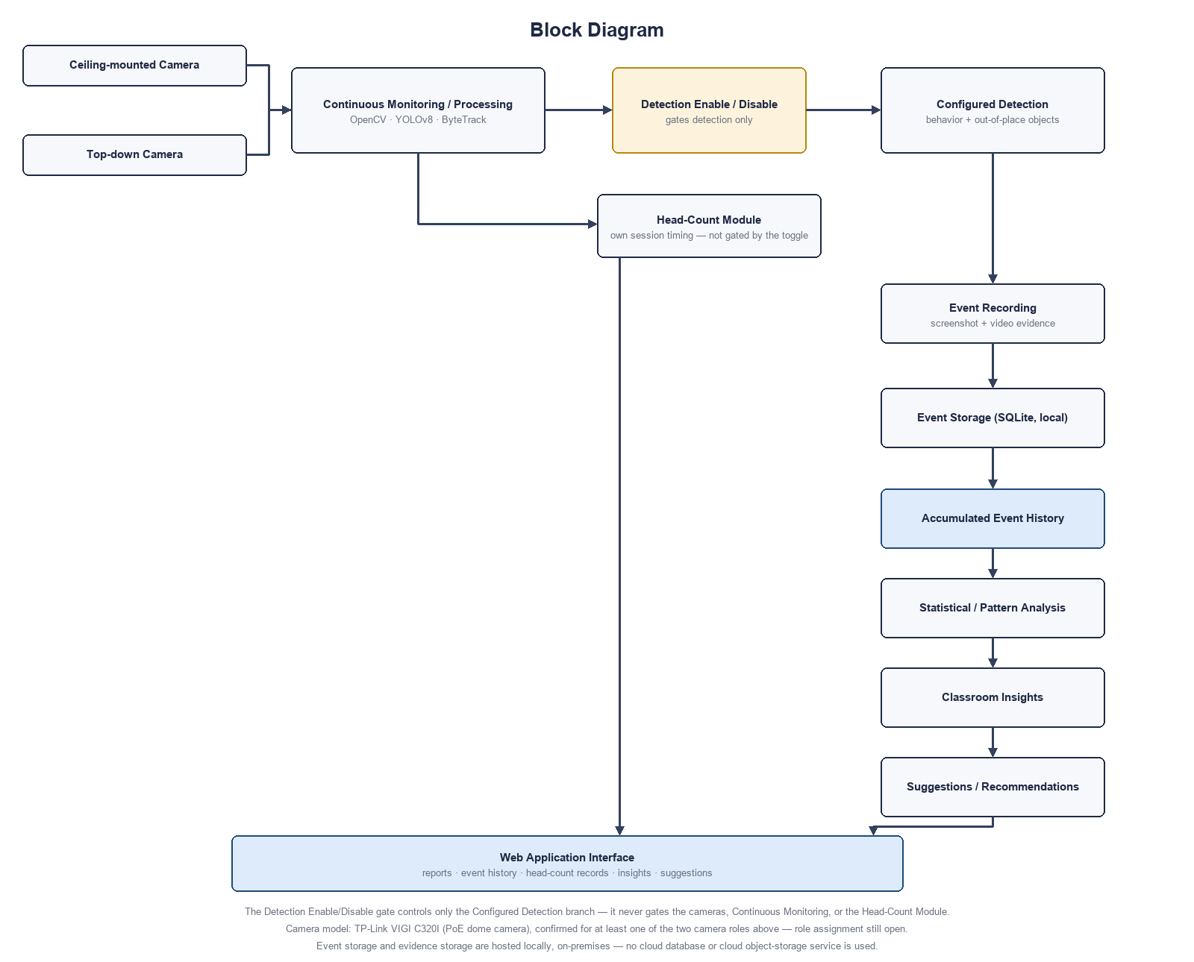
The block diagram shows the overall structure and data flow between the revised system's components. Video input from the ceiling-mounted and top-down cameras (at least one confirmed as a TP-Link VIGI C320I PoE dome camera; the exact role assignment remains an open implementation decision) is processed continuously through OpenCV, YOLOv8, and ByteTrack for behavior and out-of-place-object detection, gated by a detection enable/disable control that affects only the configured-detection branch. The head-count module is fed directly by the cameras and operates on its own session timing, independent of the detection toggle. Detected conditions are recorded as events with screenshot and video evidence into locally-hosted SQLite-based storage — the database and evidence storage both run on-premises rather than on a cloud database or cloud object-storage service — where they accumulate into event history. That accumulated history is then analyzed statistically to identify recurring classroom conditions, generating classroom insights and suggestions. Head-count records, event history, statistical summaries, insights, and suggestions are all made available through a web application interface. This diagram emphasizes the modular design and how data moves between hardware, processing units, and the reporting interface — not as real-time alerts, but as continuously accumulated, reviewable information.

Figure 3. System Flowchart
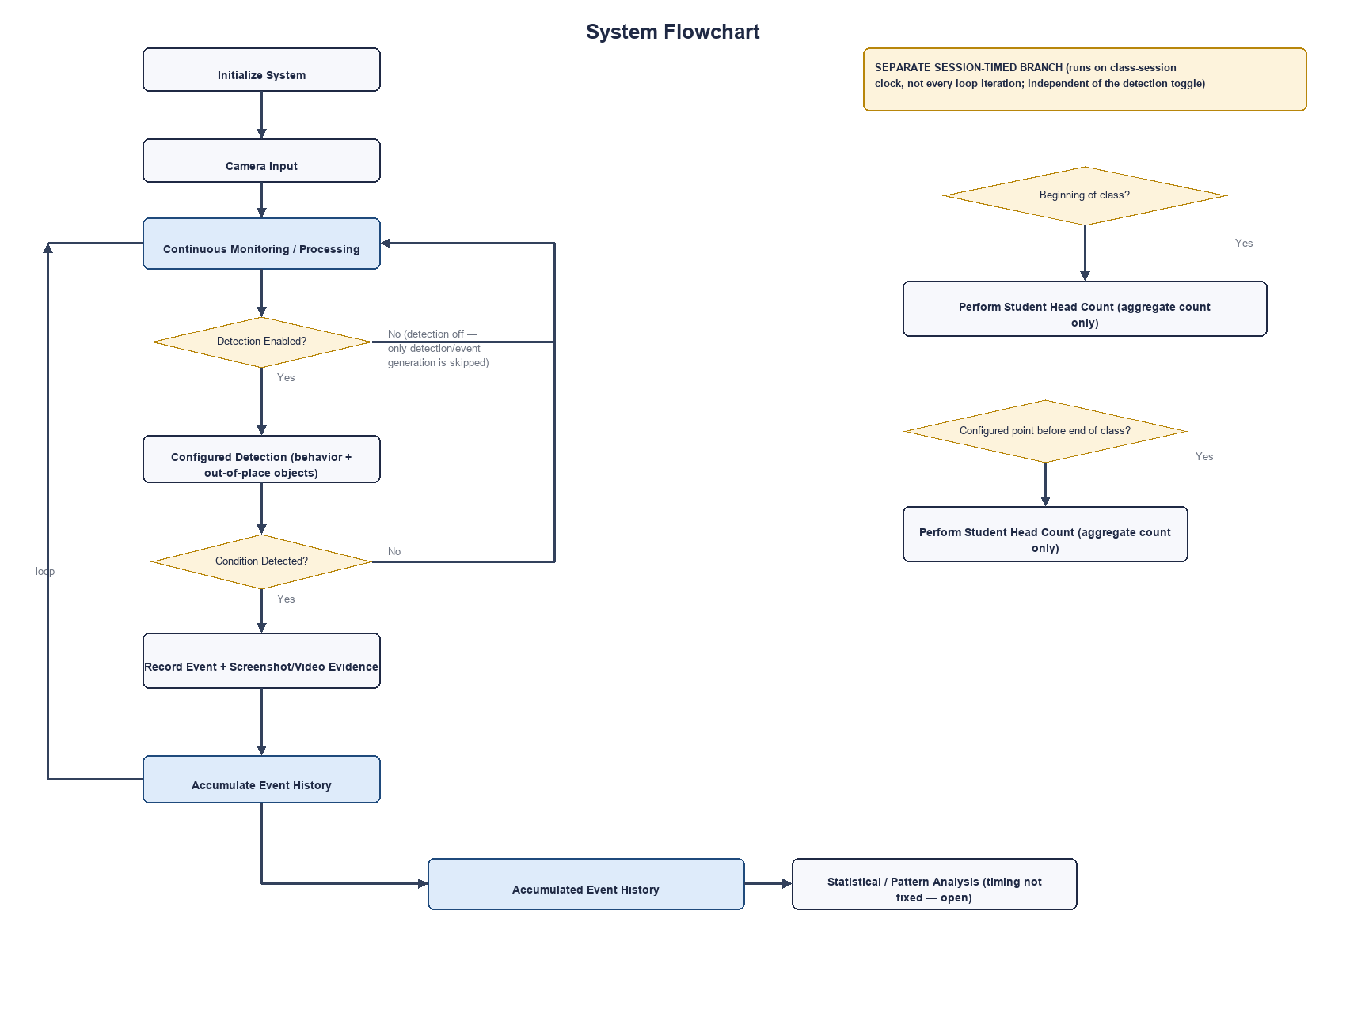
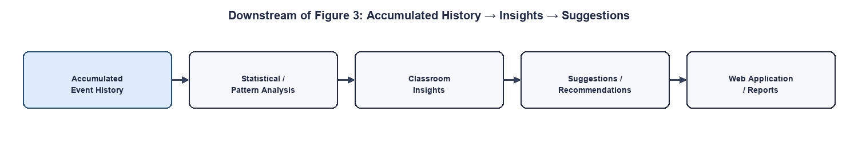
The system flowchart illustrates the step-by-step execution of the revised system, starting with system initialization and continuous camera input. Each cycle of the continuous monitoring loop checks whether detection is enabled; when enabled, frames are analyzed for configured conditions (disruptive behavior and out-of-place objects), and detected conditions are recorded as events with screenshot and video evidence before the loop continues. When detection is disabled, only this detection/event-generation branch is skipped — the cameras and the rest of the system continue operating. Student head counting is shown as a separate, session-timed branch that runs only at the beginning of class and at a configured point before the end of class, independent of both the per-frame loop and the detection toggle. As shown in the continuation of Figure 3, recorded events accumulate into event history, which is later analyzed statistically — at a frequency not fixed by this paper — to generate classroom insights and suggestions, made available through the web application. The flowchart shows continuous operation, not real-time alerting: no step in the diagram produces an instant notification or live warning.

Methods

Research Design
This study adopts a Developmental Research Design (also known as Design and Development Research or DDR) integrated with a Quantitative Experimental Evaluation. This combined approach is appropriate because the study does not merely observe phenomena but creates, implements, and evaluates a technological solution, the BantayAralan system (Richey & Klein, 2005; Wang, 2025). Developmental research is specifically suited for studies that aim to design, build, and assess innovative systems or models, particularly in engineering and technology-related fields, as demonstrated in studies developing instructional design practices (Richey & Klein, 2005), IoT-enabled smart classroom management frameworks (Wang, 2025), and real-time classroom air quality monitoring systems (Rawat et al., 2025). In this study, the primary goal is to develop a monitoring system for classroom behavior based on computer vision, making the developmental approach the most appropriate methodological choice, akin to DDR applications in recent educational technology prototypes (Wang, 2025). To complement this study, a quantitative evaluation component is incorporated to objectively measure the system's performance using numerical indicators such as accuracy, detection rate, response time, and system efficiency, mirroring metrics like usability scores, system effectiveness, and environmental parameter reductions in prior tech development research (Rawat et al., 2025; Wang, 2025). This ensures that the evaluation is objective, replicable, and statistically analyzable (Richey & Klein, 2005).

Procedure
The study will be conducted through four major phases: system development, system testing, system implementation, and evaluation, which aligns according to the standard Developmental Research Design (DDR) procedures that emphasize iterative design, prototyping, testing, and validation (Sahrir et al., 2012; Jaya et al., 2021). In the system development phase, researchers will design and develop the BantayAralan system, integrating hardware like cameras with Python-based computer vision models for continuously detecting disruptive behaviors and out-of-place objects, an aggregate student head-count function, a manual detection enable/disable control, event-based imaging, database logging, a statistical/pattern-analysis module for accumulated event history, and a web application interface, similar to hardware-software integration in IoT smart classroom prototypes (Jaya et al., 2021; Smart Classroom Control System Design, 2024). This is followed by a testing phase using controlled scenarios of normal, disruptive, and unclean classroom conditions to measure detection accuracy. The response time, stability, and reliability were assessed through multiple runs with refinements, mirroring unit testing and scenario validation in DDR for educational technologies (Sahrir et al., 2012; Smart Educational Environment Monitoring, n.d.). After testing, implementation occurs in an actual or simulated classroom with optimized camera positioning for continuous monitoring, head counting, imaging, and teacher orientation, consistent with real-setting deployment in DDR frameworks (Jaya et al., 2021; Smart Classroom Control System Design, 2024); implementation in any classroom involving students is conditional on obtaining parental/guardian consent beforehand. Finally, evaluation involves pre-implementation surveys on teachers' classroom management challenges and needs, followed by post-implementation surveys on usability and effectiveness, supplemented by system-generated data like logs, timestamps, images, and metrics (accuracy, latency, speed), using formative and summative methods akin to those achieving high accuracies in comparable studies (Sahrir et al., 2012; Smart Educational Environment Monitoring, n.d.).

Instruments/Tools
The study will make use of hardware and software, as well as data collection instruments in developing and evaluating the BantayAralan system. These hardware and software tools play an important role in data collection and system evaluation.
The study will utilize essential hardware components such as cameras and a computer system to collect data necessary for continuously monitoring classroom conditions. The following are the components to be used:
- Ceiling-mounted camera – captures student behavior across the classroom
- Top-down camera – detects out-of-place objects and monitors desk alignment
- Camera model – TP-Link VIGI C320I, a PoE (Power over Ethernet) dome network camera, confirmed for at least one of the two camera roles above; the final role assignment (ceiling-mounted vs. top-down) remains an open implementation decision for the project team
- Computer/Laptop – processes video input and runs the system
The study will make use of a combination of programming tools and frameworks to develop, process, and analyze data, which will allow for accurate detection, tracking, and evaluation of activities in the classroom through the BantayAralan system. The following are the components to be used:
- Python – main programming language
- OpenCV – video and image processing
- YOLO-based model (YOLOv8) – object and behavior detection
- ByteTrack – object tracking
- SQLite – database for event logging
- Web application framework (e.g., Flask, as already used in the project's existing browser-based admin prototype) – user interface, presented as a web application rather than a desktop GUI; this differs from the project's separate desktop-based prototype direction, and reconciling the two remains an open project decision
- Local hosting – the database (SQLite) and evidence object storage (screenshots and video clips) are hosted locally, on-premises, on the processing computer rather than on a cloud database or cloud object-storage service, avoiding recurring cloud hosting costs
The primary method for data collection will be through the administration of a structured survey questionnaire to the participating teachers. The questionnaire will have two sections. One will be administered prior to the actual use of the system, while the other will be administered after the actual use. The first part will aim to measure the need for a behavior management system by examining teachers about their difficulties in monitoring students, dealing with behavioral problems, keeping the classroom clean, and the difficulties associated with manual observation. The second part will aim to measure the usability and effectiveness of the BantayAralan system, including ease of use, system clarity, detection accuracy, head-count accuracy, the usefulness of generated suggestions, and overall usefulness of the web application. The scale will range from Strongly Disagree (1) to Strongly Agree (5) using a 5-point Likert scale with five points.
Apart from the survey, the system will also function as a data collection instrument through the production of quantified data. This includes detected behavior, detected objects, head-count records, time stamps of recorded events, logs of events, images captured, statistical summaries, and system performance data such as accuracy, precision, recall, frames per second (FPS), and latency. This data will represent objective measures of system performance.
To ensure the validity of the instrument, the questionnaire will be reviewed by selected experts, such as teachers or IT professionals, to establish its clarity, appropriateness, and relevance. This will ensure that it is adequately modified prior to its administration to ensure that it adequately captures the necessary information for the research.

Sources of Data
The primary source of data used in this research is the qualitative interviews and surveys carried out on teachers. The qualitative interviews aim to obtain data on the experiences of teachers in handling classroom management issues like controlling disruptive behaviors among students and ensuring classroom cleanliness, while the survey aims to obtain data on how effective and useful the BantayAralan system is. The data used in this research will be primarily on the experiences of teachers in handling student engagement and how useful the BantayAralan system is in a real-world scenario. The research will also include system-generated logs and metrics on how accurate and fast the computer vision model is in its responses as a secondary data source. The secondary data used in this research includes gathering related literature and studies on a particular topic that is related to this research, such as classroom management and computer vision. Data collection involving students — including camera-based monitoring, head counting, and event-based evidence capture — will only take place in a classroom where parental/guardian consent has been obtained beforehand.

Participants
The participants in this study will include public grade school teachers, as they are the ones that manage the classroom and the students. These individuals are selected because they are the ones that are challenged by the task of managing the classroom and the students. They will determine the system's ability to effectively observe the student's behavior and the role that the system plays in the decision-making process. The researchers will utilize a purposive sampling method because the participants are involved in the management of the classroom and student instruction. All participants will be informed to ensure the system design continues to be helpful and respects the ethical standards of the classroom environment. Because the system also monitors the classroom environment in which students are present, parental/guardian consent is a required condition before the system is implemented in any classroom involving students.

Data Analysis Plan
The data collected from teacher interviews and survey questionnaires will be grouped based on recurring themes related to system functionality, usability, reliability, and performance. The responses will be used to collect insights on classroom management and determine the effectiveness of the BantayAralan system. The survey questionnaire will also be used for teacher feedback. The questionnaire will use a 5-point Likert scale ranging from Strongly Disagree (1) to Strongly Agree (5). Each of the responses will be reviewed to identify patterns in teacher experience and system effectiveness. Frequency of similar responses will be recorded to support consistency in findings. Additionally, data generated from the system will also be collected which shows how the system detects behavior, tracks objects, counts students, and responds to events. The results will be interpreted to determine overall system acceptability and identify areas for improvement, as well as determining if objectives of the study are met and accomplished.
In addition to teacher feedback analysis, the system's accumulated event history will be used to identify recurring classroom conditions over time, such as repeated out-of-place-object events, through statistical or pattern analysis of that accumulated data. Where such recurring conditions are identified, the system may generate corresponding classroom insights and suggestions for teachers. Statistical analysis, classroom insights, and suggestions are treated as distinct, related stages rather than a single feature. The exact statistical methodology for this analysis, including how often it runs, has not yet been finalized and remains an open implementation decision for the project team; no specific formula, threshold, or expected result is assumed at this stage.

Standard Set
The researchers used internationally recognized standards to measure software quality and system performance. Such standards offer specific parameters to measure system accuracy in terms of functionality, speed in terms of processing, usability in terms of interfaces, and artificial intelligence in terms of computer vision. The selected standards include ISO/IEC 25010 for software quality characteristics, ISO/IEC 23053:2022 for artificial intelligence system frameworks, and ISO/IEC 25023:2016 for measurable quality indicators. Each standard provides a systematic approach to measure the system and obtain reliable results. For the revised prototype, the same standards additionally frame the evaluation of head-count accuracy, detection-toggle usability, the clarity and usefulness of statistically generated suggestions, and the usability of the web application interface; no specific numerical targets are set for these areas at this stage.
Table 1. Product Quality of BantayAralan (ISO/IEC 25010)
Characteristics | Sub-characteristics | Description
Functional Suitability | Accuracy | Measures how accurately the system performs required functions, ensuring correct detection and reporting of classroom behavior.
Performance Efficiency | Response Time | Assesses system speed and resource usage during video processing and AI detection, providing measurable performance metrics.
Usability | Learnability | Evaluates how easy it is for teachers to navigate the interface and interact with system features without extensive training.
Reliability | Fault Tolerance | Measures the system's ability to operate under normal and unexpected conditions, maintaining continuous behavior monitoring.
Security | Data Protection | Verifies the system's ability to protect student data against unauthorized access and data breaches.

ISO/IEC 25010 is a standard that describes a product quality model that divides software into various quality characteristics and sub-characteristics. These are the qualities that determine the level of satisfaction that the software system provides in meeting the requirements and expectations of the user. The qualities include functional suitability, performance efficiency, usability, reliability, security, compatibility, maintainability, and portability. These are the specific criteria that the software system is evaluated against. This standard provides a basis for evaluating the functions of the software in terms of accuracy, the response of the system, the user interface, and the stability of the system. In the case of the BantayAralan System, the ISO/IEC 25010 standard provides a basis for evaluating the functions of the system in terms of user interaction and the quality of the system (ISO 25010, n.d.).

Table 2. Quality Measurement Focus Areas of BantayAralan (ISO/IEC 23053:2022)
Characteristics | Sub-characteristics | Description
Functional Suitability | Detection Accuracy | Quantifies the percentage of classroom behaviors correctly identified by the AI component.
Performance Efficiency | Processing Speed | Measures average frame processing time, CPU load, and memory usage during system operation.
Reliability | Failure Rate | Counts system failures during extended operation to evaluate consistency and stability.
Resource Utilization | System Load | Assesses computational resource use during AI detection tasks, ensuring efficient operation.

ISO/IEC 23053:2022 establishes a framework and terminology to express artificial intelligence systems using machine learning technology. The standard establishes the fundamental components, functional requirements, and processes of machine learning systems. The standard allows evaluators and developers to have a shared understanding of the behavior of the system, the training of the models, and the system's integration. The standard is applicable to software that receives input from cameras, recognizes behavior patterns, and classifies the behavior. For the Classroom Behavior Management System, ISO/IEC 23053 provides guidelines on how to express the documentation of the AI system, the training data, and the outputs of the system, ensuring that all aspects of the system's evaluation are consistent in their measurement and verification of the detection and the integration of the system into the software interface (ISO/IEC 23053:2022, 2025).

Table 3. Prototype Quality of BantayAralan (ISO/IEC 25023:2016)
Characteristics | Sub-characteristics | Description
AI Model | Training / Output Accuracy | Details the dataset preparation, training process, and model updates for behavior recognition; evaluates how well the model predicts or classifies classroom behaviors based on video input.
System Integration | Interface Compatibility | Assesses how the AI module communicates with the main software, including input handling and output display.
Lifecycle Management | Version Control | Tracks updates to AI models, software patches, and system improvements to maintain performance consistency.

ISO/IEC 25023:2016 offers quantitative metrics for assessing software quality attributes, as delineated in ISO/IEC 25010. This standard furnishes metrics applicable to both internal and external system characteristics, thereby facilitating an objective evaluation of software performance. It encompasses measurements including response time, failure rate, resource utilization, and processing efficiency. Regarding the Classroom Behavior Management System, this standard furnishes quantifiable indicators for AI detection performance, system processing speed, and overall reliability. Metrics such as average detection time, accuracy, and CPU or memory consumption provide tangible evidence of the system's efficacy. Consequently, the application of ISO/IEC 25023 enables evaluators to quantify software quality and compare outcomes against established benchmarks, thereby yielding dependable and replicable assessments (ISO/IEC 25023:2016, n.d.).

References
Adsiz, M., & Dinçer, S. (2025). The analysis of classroom management challenges faced by teachers in online classrooms. TechTrends, 69(2), 345–361. https://doi.org/10.1007/s11528-025-01042-8
Alruwais, N., & Zakariah, M. (2023). Student-Engagement detection in classroom using machine learning algorithm. Electronics, 12(3), 731. https://doi.org/10.3390/electronics12030731
Bashkirova, D., Abdelfattah, M., Zhu, Z., Akl, J., Alladkani, F., Hu, P., Ablavsky, V., Calli, B., Bargal, S. A., & Saenko, K. (2021). ZeroWaste Dataset: towards deformable object segmentation in cluttered scenes. arXiv (Cornell University). https://doi.org/10.48550/arxiv.2106.02740
Çalı, M., Lazimi, L., & Ippoliti, B. M. L. (2024). Relationship between student engagement and academic performance. International Journal of Evaluation and Research in Education (IJERE), 13(4), 2210. https://doi.org/10.11591/ijere.v13i4.28710
Dagdag, J. D., & Bandera, M. M. D. (2021). Understanding the Factors that Influence Students' Behavior: Key towards an Effective Teaching. Pedagogi Jurnal Ilmu Pendidikan, 21(2), 144–148. https://doi.org/10.24036/pedagogi.v21i2.1182
Department of Education. (2023). 2023 Brigada Eskwela Implementing Guidelines. DepEd Order, No. 021, s. 2023. https://www.deped.gov.ph/wp-content/uploads/DO_s2023_021.pdf
Dilabayan, N., & Sambo, T. (2024). Teachers classroom management and disciplinary practices towards learners' behavior. Zenodo (CERN European Organization for Nuclear Research). https://doi.org/10.5281/zenodo.11408353
Dimitriadou, E., & Lanitis, A. (2023). A critical evaluation, challenges, and future perspectives of using artificial intelligence and emerging technologies in smart classrooms. Smart Learning Environments, 10(1), 12. https://doi.org/10.1186/s40561-023-00231-3
Djami, C. B. N. (2022). Integrated technology for classroom management strategies in a Computer-Assisted Language learning. Jurnal Pendidikan Indonesia Gemilang, 2(2), 70–94. https://doi.org/10.53889/jpig.v2i2.121
Hamidi, H., Hejran, A. B., Sarwari, A., & Edigeevna, S. G. (2024). The effect of outcome based education on behavior of students. European Journal of Theoretical and Applied Sciences, 2(2), 764–773. https://doi.org/10.59324/ejtas.2024.2(2).68
ISO/IEC 23053:2022. (2025, December 1). ISO. https://www.iso.org/standard/74438.html
ISO 25010. (n.d.). https://iso25000.com/index.php/en/iso-25000-standards/iso-25010
ISO/IEC 25023:2016. (n.d.). ISO. https://www.iso.org/standard/35747.html
Jaya, S., Zaharudin, R., Hashim, S. N. A., Ithnin, M. A., Zaid, S. M., Mapjabil, J., & Nordin, M. N. (2021). Employing design and development research (DDR) approach in designing next generation learning spaces (NGLS) in teachers' pedagogy and technology tools. Review of International Geographical Education Online, 11(7). https://rigeo.org/menu-script/index.php/rigeo/article/view/1831
Kayhan, O. (2022). Understanding Teachers' Classroom Management Anxiety: The role of educational technology usage in Classrooms. Journal of Teacher Education and Lifelong Learning, 4(2), 51–64. https://doi.org/10.51535/tell.1148725
Li, J., & Xue, E. (2023). Dynamic Interaction between Student Learning Behaviour and Learning Environment: Meta-Analysis of Student Engagement and Its Influencing Factors. Behavioral Sciences, 13(1), 59. https://doi.org/10.3390/bs13010059
Li, L., Chen, C. P., Wang, L., Liang, K., & Bao, W. (2023). Exploring Artificial Intelligence in Smart Education: Real-Time Classroom Behavior Analysis with Embedded Devices. Sustainability, 15(10), 7940. https://doi.org/10.3390/su15107940
Lin, F., Ngo, H., Dow, C., Lam, K., & Le, H. L. (2021). Student Behavior recognition system for the classroom environment based on skeleton pose estimation and person detection. Sensors, 21(16), 5314. https://doi.org/10.3390/s21165314
Lin, L., Yang, H., Xu, Q., Xue, Y., & Li, D. (2024). Research on student classroom behavior detection based on the Real-Time Detection Transformer Algorithm. Applied Sciences, 14(14), 6153. https://doi.org/10.3390/app14146153
Ling, W. (2022). Automatic recognition of students' classroom behavior based on computer vision. Academic Journal of Computing & Information Science, 5(2). https://doi.org/10.25236/ajcis.2022.050205
Liu, S., Chen, R., Ye, M., Luo, J., Yang, D., & Dai, M. (2024). EcoDetect-YOLO: a lightweight, High-Generalization methodology for Real-Time detection of domestic waste exposure in intricate environmental landscapes. Sensors, 24(14), 4666. https://doi.org/10.3390/s24144666
Magsambol, B. (2025, February 4). 'Repetitive paperwork' distracts teachers from classroom focus. RAPPLER. https://www.rappler.com/philippines/repetitive-paperwork-distracts-teachers-classroom-focus-edcom-2-report/
Marquez, J., & Oropa, J. (2025). Effective classroom management for the modern learning environment. Journal of Interdisciplinary Perspectives, 3(6). https://doi.org/10.69569/jip.2025.205
Rawat, N., Kumar, P., Hama, S., Williams, N., & Zivelonghi, A. (2025). Improving classroom air quality and ventilation with IoT-driven acoustic and visual CO2 feedback system. The Science of the Total Environment, 980, 179543. https://doi.org/10.1016/j.scitotenv.2025.179543
Reyes, M. F., Escobal, J., Empron, A., Crispolon, A., Toca, J. M., Sepria, R., Bernadez, D., Fuguso, K., Bantilan, J., & Lamanilao, R. P. (2024). Perceptions and Impact of Students' Satisfaction on Cleanliness with School Environments. International Journal of Multidisciplinary Research and Growth Evaluation, 5(3), 877–885. https://doi.org/10.54660/.ijmrge.2024.5.3.877-885
Richey, R. C., & Klein, J. D. (2005). Developmental research methods: Creating knowledge from instructional design and development practice. Journal of Computing in Higher Education, 16(2), 23–38. https://doi.org/10.1007/bf02961473
Sahrir, M., Alias, N. A., Ismail, Z., & Osman, N. (2012). Employing design and development research (DDR) approaches in the design and development of online Arabic vocabulary learning games prototype. Turkish Online Journal of Educational Technology, 11(2), 108–119. https://files.eric.ed.gov/fulltext/EJ989018.pdf
Sheng, X., Li, S., & Chan, S. (2025). Real-time classroom student behavior detection based on improved YOLOv8s. Scientific Reports, 15(1), 14470. https://doi.org/10.1038/s41598-025-99243-x
Smart Classroom Control System Design. (2024). Cebu Technological University. https://www.scribd.com/document/959010486/Inbound-9034859713407568958
Smart Educational Environment Monitoring and Real-Time Analytics System. (n.d.). International Journal of Research in Engineering and Science. https://www.ijres.org/papers/Volume-13/Issue-10/1310120124.pdf
Wang, S. (2025). IoT-Enabled Remote Teaching Management and Interaction: A smart framework for Real-Time engagement and environment optimization. Internet Technology Letters, 8(5). https://doi.org/10.1002/itl2.70123
Yang, L. (2024). Application of online teaching-based classroom behavior capture and analysis system in student management. Journal of Intelligent Systems, 33(1). https://doi.org/10.1515/jisys-2023-0236

