Home Work

Menbers：19软工施展鹏Product managerGithub Address：https://github.com/riekstins504/test-game**Product vision：**It is a plot-based card-class game,you can experience real life as a player.At the beginning of the story,you are just an regular college student,and need to make the right choice in the face of difficulties ,temptations and various challenges.You may still encounter fierce monsters,including course (like higher mathematics),test(CET),and a wide variety of advanced programming languages(c++,java).Beat the monsters to gain their skills,and release the trick when needed(input “cout<<’hello word’;” to use C++-skill);You can constantly grow and learn in the game,and realize the way of the real society.eg:This product base is developed as a stand-alone game,network and database support is increased if conditions allow for later periods

During the Spring Festival in 2020, due to the epidemic, most users are in a long-term closed life, which has promoted the considerable growth of China's intenert entertainment market in many aspects, such as active users, revenue flow, online time and so on. According to the data, from January to March 2020, the mobile game market revenue reached nearly 55 billion yuan, a record high, with a year-on-year growth rate of more than 49%, and a significant growth month on month.

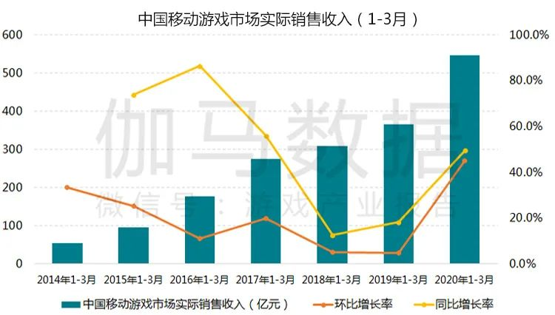

The survey shows that among the listed enterprises with game business, the number of enterprises with net profit growth of more than 30%, 50% and 100% has exceeded the level of last year, and the year-on-year growth rate of net profit of some enterprises has even exceeded 200%.

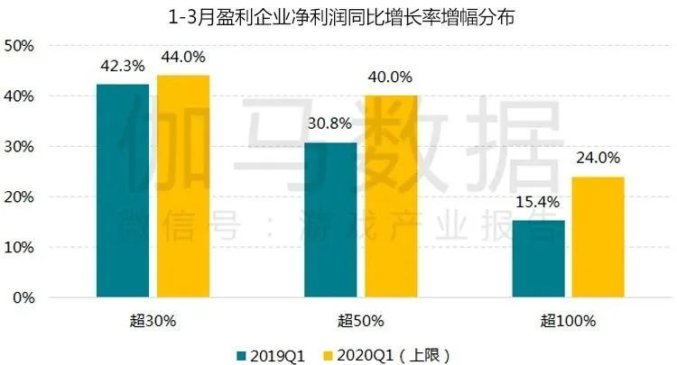

Why do we choose card games. During the epidemic, many types of games have become popular one after another, such as "growing games", "auto chess", "placement games" and so on. Card games are still relatively niche and more occupied by poker cards. We hope that more puzzle-oriented card games with plot oriented will appear on the market. Often the key to a game’s popularity lies in its gameplay and plot, which is more practical and easier to make than many 3A games.

（1）The global impact of the epidemic is continuing. Not long ago, the World Health Organization (WHO) jointly launched an activity called "playapart together" with a number of game companies to advocate game players to reduce going out and playing games at home as much as possible all over the world.

Sam, a college student, had to stay at home for online learning due to the epidemic. He intends to respond to the WHO's call to stay at home as much as possible. But in his spare time, he suffers from not having enough recreational activities. At this time, a simple and fast card game that does not require large equipment and can be fun can meet his needs.

（2）Tom spends about 1 hour on commuting every day. Subway is crowded, and standing is normal. It is so boring. Tom took out his mobile phone as usual, and opened our game(the name hasn't been figured out yet). Tom just waited a few seconds and the game opened. The game is a vertical screen. He could operate it with one hand, so that his other hand could be used to grasp the pull ring in the subway car.

（3）Anna is a college student. She is usually busy with her studies. But she likes playing games. She hopes to play games in her spare time. During the 10 minute break, she opened our game.

Anna is busy studying and doesn't have much mind to specialize in complex game systems. The UI of the game is very simple. She only needs to pay attention to the monster opposite and the cards in her hand. Anna only needs to drag the card onto the monster to activate the card skill. During the class, Anna soon defeated several monsters, met the boss and entered the battle. Halfway through the battle, the class bell rang and the game had the function of archiving. Anna withdrew from the game and played it again next time.

**Feature:**

Imitate the growth experience of college studentsClose to life scenesIt has a certain educational significanceBroaden your horizonEnrich social experienceExperience the fun of the gameDifferent choices lead to different endings

Vertical screen

Fast loading speed