CO3204 Software Engineering Project
Dissertation
SimuVerse: An Interactive Multi-Agent Simulation Platform for Modelling Social Behaviour and Emotion Dynamics
Nasrien Shouqar
May 2026
School of Computing and Mathematical Sciences, University of Leicester

Declaration on Plagiarism
I declare that this dissertation is my own work and that all sources used have been acknowledged appropriately. I understand that plagiarism, collusion and the submission of work produced by another person or system without proper acknowledgement are academic offences.
I confirm that this dissertation has not previously been submitted for assessment at the University of Leicester or any other institution.
Used Grammarly for grammar improvements and AI for formatting structure.
Signed: Nasrien Shouqar
Date: May 2026

Abstract
Social simulation sits at an uncomfortable tension: rule-based agent models are transparent and reproducible, but socially flat; language-model agents generate convincing interaction, but at the cost of inspectability and repeatability. SimuVerse is my attempt to navigate that trade-off through a state-driven architecture in which agents carry personality traits, directed trust relationships, emotional valence, stress and short-term memory. These internal values govern dialogue choices at every step, so each communication event can be traced back to a measurable cause rather than treated as an opaque output.
The platform supports three scenario environments. Office, café and escape room with live user interventions including revealing hidden information, forcing meetings, raising urgency and injecting social tension between agents. Four team presets seed different starting configurations across the same scenario so the effect of social dynamics on outcomes can be compared directly. Every simulation tick surfaces a Why explanation and an Effect preview, and the full stack covers live simulation, a replay mode, a dashboard and batch experiment comparison.
Evaluation covered eighteen automated backend unit tests, scenario walkthroughs, a six-participant usability study and four quantitative experiments. The experiments confirmed that seeded runs are fully reproducible, that team preset differences in trust and stress are statistically significant, that a Force Meeting intervention raises final trust with a large effect size, and that removing trust dynamics changes how efficiently scenarios resolve. The central finding is that an agent model can be socially expressive and remain fully inspectable. The two goals are compatible if the architecture is designed with that in mind from the start.

Table of Contents
Chapter 1: Introduction 1
1.1 Background and Motivation 1
1.2 Problem Statement 1
1.3 Aims and Objectives 2
1.4 Research Questions 3
1.5 Project Scope 3
1.6 Contributions 4
1.7 Outline of the Dissertation 4
Chapter 2: Literature Review 5
2.1 LLM-Based Agents and the Interpretability Problem 5
2.2 Trust, Personality, Memory, and Emotion in Agent Design 6
2.2.1 Trust Models 6
2.2.2 Personality Models 6
2.2.3 Memory and Emotion Models 7
2.3 Dialogue Acts and Goal-Oriented Communication 7
2.4 Natural Language Processing for Emotion Detection 7
2.5 Agent-Based Modelling Platforms 8
2.6 Interactive Simulation and Human-in-the-Loop Control 8
2.7 Comparative Analysis of Design Alternatives 8
2.8 Research Gap 9
2.9 Summary 11
Chapter 3: Design 11
3.1 Design Aims 11
3.1.1 Functional Requirements 12
3.1.2 Non-Functional Requirements 13
3.2 System Architecture 13
3.3 Agent Design 14
3.4 Scenario Design 16
3.5 Intervention Design 16
3.6 Metrics and Explainability Design 17
3.7 User Interface Design 17
3.8 Design Alternatives Considered 18
3.9 Mathematical Formulation 19
3.10 Summary 20
Chapter 4: Implementation 21
4.1 Technology Stack 21
4.2 Backend Implementation 21
4.3 Agent and Simulation Engine 22
4.4 Scenario Logic 23
4.5 Intervention System 23
4.6 Metrics, Run Records and Replay 24
4.7 Frontend Implementation 24
4.8 Challenges and Implementation Decisions 25
4.9 Summary 26
Chapter 5: Evaluation 26
5.1 Evaluation Strategy 26
5.2 Functional Testing 26
5.3 Automated Backend Testing 28
5.4 Scenario Behaviour Testing 28
5.5 Intervention Testing 33
5.6 Dashboard, History and Replay Testing 34
5.7 Experiment Runner Evaluation 36
5.8 User Testing Results 38
5.9 Discussion of Findings 41
5.10 Evaluation Limitations 42
5.11 Quantitative Experiment Results 43
5.11.1 Reproducibility Under Seeded Runs 43
5.11.2 Personality Preset Effects on Cooperation and Conflict 43
5.11.3 Causal Effect of Force Meeting Intervention 44
5.11.4 Ablation Study: Contribution of Trust, Memory, and Personality 44
Chapter 6: Critical Appraisal 45
6.1 Project Strengths 45
6.2 Technical Limitations 45
6.3 Evaluation Limitations 46
6.4 Reflection on Development Process 47
6.5 Ethical Considerations 47
6.6 Future Improvements 47
Chapter 7: Conclusion 48
7.1 Project Summary 48
7.2 Achievement of Aims 49
7.3 Final Contributions 49
7.4 Achievement Against Research Aims 49
7.5 Future Work 50
7.6 Closing Statement 50

Chapter 1: Introduction

1.1 Background and Motivation
Social simulation has always been useful to connect theoretical models of human behaviour and real-world social dynamics. By giving agents goals, rules, emotional states, and social relationships within controlled environments. Researchers can observe like opinion polarisation, coalition formation, trust breakdown, and collective decision-making without the ethical or practical constraints of studying these processes directly [1]. This methodological approach has been used across organisational science, epidemiology, crisis response, and macroeconomics [2]-[5].
Traditional agent-based models (ABMs) have been central to this work because of their interpretability, reproducibility, and analytical controllability [1], [2]. However, there’s a catch. Agents in traditional ABMs often behave according to rigid, scripted rules that can appear socially unrealistic. The simulations are clean and tractable. But, they miss the context-sensitive- adaptive nature of real human communication. Limiting how far we can trust their conclusions when things get more complex
Large language models (LLMs) have opened a new direction for social simulation by enabling agents to produce fluent, context-aware dialogue [6]. However one of their down sides are as the language gets more realistic. Scientific interpretability tends to downgrade. When behaviour is driven mainly by prompt structures and generated text, constructs such as trust, personality, memory, and emotion risk becoming side effects of language generation rather than explicitly modelled mechanisms [7].
This dissertation argues that the downsides are not structurally inevitable. SimuVerse is designed to demonstrate that readable, context-sensitive agent communication can coexist with transparent, inspectable internal modelling. Meaningful social simulation requires more than plausible dialogue alone. Agents need internal states (personality-inspired traits, directed trust relationships, memory impressions, stress, tension, and emotional valence ) that shape communicative choices. So it can shape how the group behaves. This places SimuVerse at the intersection of explainable AI (XAI) and human-computer interaction (HCI). My system is a research environment in which every agent decision is made visible and every user action is transparent. HCI principles informed the step-by-step interface design and the choice to surface Why and Effect explanations at each tick, so that researchers without deep ABM expertise can observe, steer, and interpret agent behaviour directly.

1.2 Problem Statement
The main challenge that simulations must deal with is the huge divide between reproducibility and social expressivity. The former ABM simulations emphasise reproducibility and can be too rigid to handle complex situations. However, on top of it, the LLM agents strive for realistic prompts while failing at reproducibility and interpretability.
Reproducibility failures in LLM-based simulation are now becoming more visible. Mehta [8] shows that agents defined through natural-language specifications can produce inconsistent behaviour across repeated runs and across different underlying models. This is not a minor calibration issue but a methodological problem for simulation research. If outputs are not reproducible under controlled conditions, they cannot easily be treated as evidence about the social processes the simulation claims to represent. Mehta documents this inconsistency problem without resolving how agent architectures should be redesigned to mitigate it.
Structural limitations of conversation-centred agents are also visible in recent agent research. Shinn et al. [9] show that stronger agent performance can require explicit reflective memory beyond the immediate dialogue context, rather than relying only on the current conversational trace. This matters for social simulation because internal state such as private preferences, strategic commitments, and evolving relational memory should be represented explicitly if they are to be inspected and analysed rather than inferred only from generated text.
Larooij and Törnberg [10] identify validation as a central challenge for generative social simulation, arguing that LLM-based ABMs often achieve surface realism more easily than reliable mechanism-level validation. Xiao et al. [11] reinforce this concern with evidence of persona homogenization, where LLM agents converge toward an average behavioural profile despite nominal personality differences. Lu et al. [12] similarly show that prompt-only LLM agents remain limited in accurately reproducing multi-turn human behavioural patterns, even when they can appear believable at a surface level.
When put together, these studies reveal a unique research challenge. Current simulation frameworks usually require the researcher to make a trade-off between scientific accuracy and sociological expressiveness, whereas SimuVerse offers a different solution. The main challenge being considered in this dissertation thesis involves designing and evaluating an approach for the creation of a multiagent simulation framework where social interaction emerges through explicit internal state and goal-driven interaction instead of opaque dialogue generation but still provides readable and socially meaningful dialogue.

1.3 Aims and Objectives
The architectural diagrams in Chapter 3 contrast earlier conversation-heavy agent systems with SimuVerse’s explainable, state-driven design, illustrating how internal state is coupled to communicative output and measurable simulation change.
The aim of this project is to design, implement, and evaluate SimuVerse: an interactive multi-agent simulation platform for modelling social behaviour and emotion dynamics through explainable agent states and goal-oriented dialogue. This aim is defined through six objectives:
O1: Design an agent architecture that represents personality-inspired traits, directed pairwise trust relationships, short-term memory and longer-term memory impressions, emotional state (valence, stress, and tension), and adaptive behavioural strategy.
O2: Implement scenario-based tasks in which agents begin with distributed knowledge and must communicate to make measurable progress towards shared objectives.
O3: Develop explicit dialogue acts that connect communication to simulation state change, including task completion, trust adjustment, stress modulation, and emotional response.
O4: Provide real-time user interventions, including information revelation, strategy nudges, urgency boosts, pressure easing, tension injection, emotion modification, and forced meetings, that modify internal variables while preserving model consistency.
O5: Develop an interactive interface enabling users to configure simulations, observe agent dialogue, inspect changing agent states, and analyse intervention effects.
O6: Evaluate the system using repeated seeded runs, event logs, outcome classification, and quantitative and qualitative analysis to assess reproducibility, interpretability, behavioural variation, and usability.

1.4 Research Questions
This dissertation is guided by five research questions, each connecting a specific design decision in SimuVerse to a testable empirical claim evaluated in Chapter 5. Table 1.1 maps each question to its focus and evaluation evidence.
RQ | Focus | Evaluation Evidence
RQ1 | Can agents with distributed knowledge complete scenario-based tasks through goal-oriented dialogue? | Scenario completion ratios, progress timelines, and dialogue act counts across multiple conditions.
RQ2 | How do personality traits, trust values, and memory of past interactions shape sharing, refusal, challenge, and agreement behaviours? | Personality preset comparisons, trust evolution curves, refusal/share rates, and memory-modulated pattern analysis.
RQ3 | Can SimuVerse produce reproducible and measurable outcomes across repeated runs? | Same-seed replay consistency tests, event-log comparison, and outcome classification concordance.
RQ4 | Can user interventions steer a simulation in real time while preserving the model’s internal logic? | Baseline versus intervention run comparisons, including progress delta, outcome classification shift, and event-log tracing.
RQ5 | Does SimuVerse make agent behaviour understandable through visible Why/Effect explanations and metric visualisations? | User testing Likert scores for explanation clarity and usefulness, event-log readability across scenarios, and qualitative feedback on explanation quality.
Table 1.1: Research Questions, Focus, and Evaluation Evidence

1.5 Project Scope
SimuVerse does not perform any kind of network modelling or prediction of human behaviour. The software suite was specifically built for studying the influence of explicit internal agent states on their cooperation, conflicts, and success in reaching goals under constrained conditions. Interpretability and reproducibility were valued above unlimited dialogue generation. The system works according to the heuristic dialogue path setting (use_nlp=False). Thus, all conversations occur in terms of predefined actions and do not include linguistic variation, allowing for quantitative reproducibility of the simulation process. Such heuristic path provides interpretability of agent behaviour, dialogue acts, metrics, and scenario development throughout the run.
The chosen evaluation scenarios were selected because each scenario involves a different type of social interaction like information exchange based on the established etiquette (office), negotiation of interests (café), and urgent teamwork (escape room). SimuVerse is neither supposed to be a physiologically complete model of human interaction nor to predict human choices. Nevertheless, the developed software proves the possibility of building simulations of socially motivated groups whose members' states and dialogue acts are fully explicable and reproducible under constrained conditions.

1.6 Contributions
The main contributions SimuVerse makes to multi-agent social simulation are:
A coupled agent model personality trait, pairwise trust relationships, emotional valence, stress, tension and short-term memory all interact within the same simulation loop, so a change to one variable cascades through the others rather than staying isolated.
Scenario tasks built around partial knowledge, where progress depends on agents finding and sharing what they know giving communication a measurable effect on outcomes rather than just producing dialogue.
Eleven explicit dialogue act types (ask_info, share_info, refuse, suggest, agree, challenge, compliment, say, help, ignore, insult) each tied directly to state updates in trust, stress and task progress, so every interaction changes something the user can track.
Seven live interventions accessible during a running simulation Reveal Info, Force Meeting, Boost Urgency, Ease Pressure, Inject Tension, Nudge Strategy, Inject Mood. Each producing a before/after metric snapshot so users can see what changed and by how much.
Full run reproducibility under fixed seeds, with event histories, per-tick metric snapshots and JSON run persistence, directly addressing the reproducibility gap Mehta [8] identifies in LLM-based simulation.
A browser interface covering live simulation, step-by-step replay, dashboard review and batch experiment comparison.
An evaluation combining functional testing, 18 automated backend tests, four quantitative experiments with statistical analysis, and a six-participant user study. Each linked to a specific research question.

1.7 Outline of the Dissertation
Chapter 2 reviews related work in multi-agent systems, LLM-based agents, trust and personality modelling, memory, emotion detection, dialogue acts, ABM platforms, and human-in-the-loop simulation, critically evaluating where previous work falls short and how SimuVerse addresses those gaps.
Chapter 3 presents the design of SimuVerse, including the coupled agent model, decision-making pipeline, scenario system, environment modifiers, intervention mechanism, and evaluation framework.
Chapter 4 describes the implementation of the system, including the Python simulation core, agent logic, emotion processing, run records, and FastAPI intervention endpoints.
Chapter 5 evaluates SimuVerse through repeated experiments, scenario outcome analysis, personality preset comparisons, stress and trust metrics, intervention tests, reproducibility checks, and qualitative dialogue analysis.
Chapter 6 critically appraises the project, discussing its strengths, limitations, technical challenges, ethical considerations, and future directions.
Chapter 7 concludes by summarising the extent to which the research questions have been answered and reflecting on the broader contribution of the project.

Chapter 2: Literature Review
Research on simulations with LLM-based agents is growing rapidly but it’s scattered across different areas. Like interpretable ABM, language-grounded agents, trust and personality modelling, affective computing, and human-in-the-loop simulation. This chapter evaluates what earlier work has failed to achieve and uses those failures as architectural justification for SimuVerse.

2.1 LLM-Based Agents and the Interpretability Problem
Why would anyone use LLMs for social simulations? if human behaviour is mostly about communication. Then agent that can talk fluently and adapt to context might feel more realistic than ones that just follow fixed rules. This idea has led to a lot of work [6], [8], but scrutiny of the evidence reveals a more troubling picture, one that the field has been slow to confront.
Mehta [8] points out a foundational challenge that agents whose behavioural specifications are encoded in natural language exhibit significant variance across different underlying LLMs and across repeated runs of identical prompts. This is methodologically damaging if outputs are not reproducible, they cannot be interpreted as reliable evidence about the social processes the simulation claims to model. SimuVerse’s seeded, state-driven architecture grounds behavioural decisions in explicit state variables rather than unconstrained generated text.
Shinn et al. [9] reinforce the importance of explicit memory in agent architectures. Their Reflexion framework improves agent performance by adding reflective text to an episodic memory buffer, rather than relying only on the immediate interaction history. For SimuVerse, this supports the broader architectural choice that memory should be represented explicitly instead of leaving all state to the conversational trace.
Shanahan et al. [13] caution that dialogue agents can appear more human-like than they really are, which increases the risk of anthropomorphic interpretation. For simulation research, this is important because persuasive conversational behaviour should not be confused with transparent internal modelling. SimuVerse therefore treats dialogue as a readable communication layer, while consequential decisions are produced by explicit state variables such as trust, stress, memory, emotion, and strategy.
Xiao et al. [11] identify a related problem of persona homogenization. When LLM agents are prompted to simulate diverse identities or personalities, they may converge toward an average behavioural profile, reducing inter-agent variance in ways that undermine the purpose of heterogeneity. SimuVerse avoids this by using explicit numerical trait vectors and decision weights rather than relying only on natural-language persona prompts, so personality differences produce consistent and measurable behavioural divergence.
Taken together, the evidence argues not against language-rich agents, but against using generated dialogue as a substitute for internal state modelling. Dialogue should function as a rendering layer that makes agent decisions legible, rather than as the substrate of decision-making itself.

2.2 Trust, Personality, Memory, and Emotion in Agent Design

2.2.1 Trust Models
Since the 1990s people have been thinking about trust in multi-agent systems. Marsh [14] described trust as a function of past experience, competence, and perceived risk, a multi-dimensional construct that resists reduction to a single scalar. Castelfranchi and Falcone [15] draw a further distinction between trust as a cognitive attitude and reliance as a behavioural disposition, which matters for simulation design. A model the two cannot distinguish an agent that trusts a peer but strategically withholds reliance from one that simply lacks information.
Several subsequent frameworks operationalise trust for computational agents [16], but a recurring limitation is treating trust as a global scalar rather than a contextually conditioned, domain-specific value. SimuVerse uses directed pairwise trust values that update dynamically with each interaction, a deliberate simplification that is computationally tractable and sufficient for the evaluated scenarios, but should not be confused with a theoretically adequate multi-dimensional trust model. Future work could explore whether domain-specific trust vectors alter emergent dynamics in ways the current model cannot capture.

2.2.2 Personality Models
The Five Factor Model (FFM) [17], [18] has become the standard for personality in ABM research, with trait dimensions, openness, conscientiousness, extraversion, agreeableness, and neuroticism, showing substantial cross-cultural validity [19]. However, mapping continuous trait scores to discrete behavioural probabilities requires assumptions that are rarely made explicit. In SimuVerse, as in most comparable systems, these mappings are established heuristically, a pragmatic necessity that introduces a validity gap between the psychological construct and the computational implementation.
SimuVerse confronts this gap by making its personality-to-behaviour mappings explicit and inspectable. The system defines probability weights for each dialogue act as a function of agent trait scores, fixed at initialisation rather than learned during the run. Behavioural differences between agents are thus attributable to personality configuration rather than interaction history, supporting interpretability. The cost is that personality does not adapt over time, reasonable for short-horizon scenarios but limiting for simulations requiring character development.

2.2.3 Memory and Emotion Models
Memory frameworks provide for differentiation between the rapidly changing recent context and the more enduring impression formed over time [20]. In SimuVerse, memory serves as a simple modeling tool where recent experiences and impressions assist in enabling consistency in behavior by agents within a single run. The limitation is that memory salience needs to be determined by the designers rather than experimentally.
Emotion modelling presents analogous challenges. Discrete emotion labels (anger, fear, joy, or frustration) can be psychologically accurate but are difficult to operationalise consistently. SimuVerse instead uses continuous valence, stress, and tension values, treating emotion as a modulating layer over action selection rather than as a categorical state his way, inconsistency in discrete emotion labeling is avoided, but emotions are nonetheless accounted for through this approach.
2.3 Dialogue Acts and Goal-Oriented Communication
Speech act theory [24], [25] treats communication as action that transforms the state of the world. Applied to computational dialogue and agent communication, speech-act-based frameworks provide a principled basis for connecting communicative moves to explicit state change [26]. Its strength for simulation is transparency: when an agent performs a refuse act, the resulting changes to trust and task progress are explicit, traceable, and reproducible, in contrast to an LLM-generated refusal, where similar surface text may arise from different latent processes across runs.
There are constraints in categorisation schemes that have not yet been considered in the simulation literature. For instance, setting up beforehand a limited number of functions to perform by communication means. Will not take into consideration any instances of ambiguity, face saving indirectness, or irony in communication. It can be said that the set of acts proposed in SimuVerse has proven to be appropriate for the three test scenarios but has not been checked against other situations.

2.4 Natural Language Processing for Emotion Detection
One of the ways in which emotion classifiers derived from NLP can be used to enhance agents' simulations is described above. However, such emotion classifiers come with certain methodological drawbacks. One such drawback is their training on texts that are stylistically different from task-oriented simulation dialogue. Another is that emotion classifiers may overlook implicit emotions that are present within neutral language use.
Therefore, SimuVerse uses the more limited but clearer concept of updating emotional states in response to certain simulation events. Specifically, emotional states are updated in relation to events including cooperation, refusal, challenge, pressure, and the effects of intervention actions. This way, the connection between events, emotional changes, and metrics is clear and repeatable.
The model's design entails some loss of emotional complexity, yet it enhances its interpretability. It becomes clear what exactly caused a change in an agent's stress level or valence by using this method. Future research could involve incorporating an emotion classifier into the model, which would require comparing it against the deterministic event-based design currently employed.

2.5 Agent-Based Modelling Platforms
NetLogo [28] established the accessibility of agent-based modelling through its purpose-built environment and visual debugging tools. Its accessibility comes at the cost of extensibility: integration with modern NLP libraries, REST APIs, and data science pipelines is difficult. For SimuVerse, requiring FastAPI intervention endpoints, reproducible batch experimentation, and per-tick metric logging, NetLogo’s constraints would have been prohibitive.
Mesa [29] resolves these integration challenges while requiring more implementation from scratch. The choice is justified by ecosystem compatibility and scientific reproducibility requirements, though it should not be conflated with a claim of architectural superiority.

2.6 Interactive Simulation and Human-in-the-Loop Control
Human-in-the-loop research emphasises that interactive systems should make user actions understandable and should preserve coherent system behaviour under intervention [30]. In simulation terms, this means users should be able to see what an intervention changes without the intervention bypassing the model’s internal update logic. These requirements exist in tension: more powerful interventions risk incoherence, whereas more constrained interventions limit counterfactual exploration.
SimuVerse navigates this tension by restricting interventions to operations that modify internal variables through existing update mechanisms, trust adjustment, urgency boost, information revelation, and forced meetings, rather than bypassing them. This preserves model coherence and keeps intervention effects traceable through the event log. The constrained scope limits open-ended counterfactual exploration, but is appropriate and scientifically justified for evaluating targeted intervention efficacy within a fixed model, which is the framing used in Chapter 5.

2.7 Comparative Analysis of Design Alternatives
Five architectural decisions shaped the final design of SimuVerse. For agent behaviour, a state-based probabilistic model was chosen over fully scripted agents (which lack realism) and free-form generative agents (which lack reproducibility). For communication, explicit dialogue acts were chosen over raw generated text because they directly link communication events to measurable state changes. For emotion, a continuous valence and stress model was chosen over discrete labels because continuous values are easier to update per tick and compare across runs. For memory, a two-tier short-term and longer-term impression model was chosen because a single rolling history treats all events equally, which causes agents to behave inconsistently. For the simulation framework, a custom Python backend was built because NetLogo is incompatible with FastAPI and NLP integration.
Table 2.1 summarises each decision alongside the alternatives considered.
Decision Area | Alternatives Considered | Choice Made | Justification and Trade-offs
Agent behaviour model | Fully scripted agents; fully free-form generative agents | State-based rules with controlled dialogue generation | Scripted agents lack realism; fully free-form generative agents lack reproducibility. State-based rules ensure trust, personality, and stress are visible, reproducible, and causally connected to outcomes.
Simulation framework | NetLogo; custom engine; Mesa-inspired Python backend | Python simulation engine | NetLogo is incompatible with NLP/FastAPI integration. A fully custom engine would duplicate scheduling and simulation infrastructure without clear scientific benefit. A Python backend enables NLP, data analysis, and API integration.
Communication model | Raw generated text; fixed message scripts; dialogue acts | Explicit dialogue acts | Generated text is opaque to state analysis. Fixed scripts lack adaptability. Dialogue acts directly link communication events to measurable simulation state changes.
Emotion model | Discrete emotion labels; sentiment-only scoring; continuous valence/stress modelling | Continuous valence/stress model with event-based update rules | Discrete labels can be expressive but harder to compare over time. Continuous valence, stress, and tension values are easier to update per tick, visualise, and compare across runs.
Memory architecture | No memory; single rolling history; short-term memory plus longer-term impressions | Short-term memory and longer-term memory impressions | No memory produces inconsistent agents; single history is unbounded and treats all events equally. Short-term memory helps preserve recent context, while longer-term impressions help agents respond consistently to previous cooperation or conflict.
Table 2.1: Design Decisions, Alternatives, and Justifications for SimuVerse

2.8 Research Gap
Looking across these systems, the same tension keeps appearing: interpretability or expressiveness, but not both. Rule-based agents are reproducible and inspectable but behaviourally flat; LLM-based systems are linguistically rich but opaque, unreliable and computationally expensive. That trade-off is not accidental. It reflects a genuine conflict between wanting human-readable explanations and needing enough model complexity to generate realistic social behaviour.
Table 2.2 maps the specific limitations identified in the reviewed literature against the corresponding architectural responses in SimuVerse. The critical observation is that these are not independent limitations requiring independent solutions: they reflect a single tension between the transparency requirements of scientific simulation and the representational richness required for social plausibility.
Literature Area | Limitation Identified | SimuVerse Architectural Response
LLM-based and generative agents [8]-[13] | Behaviour is non-reproducible across runs; memory and internal state are often under-specified; agents may converge towards an average persona despite nominal differences. | Seeded, state-driven architecture. Dialogue text is a rendering surface; decisions are made by explicit state variables. Personality weights directly modulate decision probabilities, not only wording.
Trust models [14]-[16] | Trust is often represented as a global or non-contextual scalar; it is typically decoupled from task dialogue and communicative behaviour. | Directed pairwise trust values updated dynamically by each dialogue act. Trust directly modulates willingness to share, refuse, challenge, and cooperate, integrating relational and task dimensions.
Personality [17]-[19], [11] | FFM traits are imported without explicit behavioural calibration; LLM-based personality representations can produce homogenised rather than heterogeneous behaviour. | Personality-inspired presets with explicit probability mappings. Chapter 5 tests whether team presets produce structurally different behaviour.
Memory [20] | Limited or absent memory produces repetitive, inconsistent agents unable to model relational history or strategic adaptation. | Short-term memory retains recent interaction context, while longer-term impressions store socially significant events. This supports both contextual responsiveness and behavioural consistency.
Emotion modelling [21]-[23], [27] | Discrete emotion labels may be too brittle for repeatable simulation; continuous models can lose emotional nuance; appraisal mechanisms remain simplified. | Event-based valence, stress, and tension updates preserve reproducibility and support metric comparison. Limitation acknowledged: the emotion model is simplified and does not fully capture appraisal or nuanced affect.
Interactive simulation [30] | User interventions may break model coherence or produce uninterpretable state changes if applied without respect to internal update mechanisms. | Interventions mapped exclusively to existing internal update pathways like trust change, urgency shift, and information injection. All interventions are logged, enabling causal tracing in Chapter 5.
Table 2.2: Literature Gaps and SimuVerse Architectural Responses

2.9 Summary
The tension running through this review sits between two things that are both necessary. LLM-based agents trade away reproducibility; traditional ABMs trade away social plausibility; psychologically informed components carry operationalisation assumptions that are not always empirically validated; dialogue act theory is principled but rigid in taxonomy. SimuVerse addresses this by coupling these components within a single architecture: personality shapes trust, trust shapes communicative choices, dialogue acts drive state changes, and emotional state modulates strategy.
LLM-based agents offer linguistic fluency but, as Mehta [8] and Shinn et al. [9] demonstrate, raise difficulties around reproducibility and explicit memory representation. Traditional ABMs avoid these pathologies but produce socially limited interactions. Psychologically informed components, personality, memory, and valence/stress emotion, provide representational foundations but carry implementation assumptions that must be made explicit. Dialogue act theory provides a principled bridge between communication and state change, but its taxonomic limits constrain which social phenomena it can represent.
SimuVerse’s contribution is to integrate these components within a single architecture: personality influences trust evolution, trust influences dialogue act selection, dialogue acts influence emotional and stress state, and those states feed back into strategy adaptation. This coupling, largely absent in prior work, makes SimuVerse’s contribution integrative rather than merely additive.

Chapter 3: Design

3.1 Design Aims
Three core aims guided SimuVerse’s design. First, agent behaviour had to be explainable. The design had to show not just what the agent did, but why it did it and what effect that had on the team. Second, users needed to be able to interact with a live simulation, not just watch it. Third, the system had to support repeatable, comparable experiment runs, so that any finding about team dynamics was not a one-off instance.
These aims were motivated by the literature on multi-agent systems, explainable AI (XAI), and HCI research on interactive simulation, and by the gap between opaque agent decision-making in traditional frameworks and the transparency that HCI researchers require.
Accessibility was a secondary goal. SimuVerse was designed to be usable by researchers familiar with group behaviour and HCI but without deep ABM expertise. This motivated the choice of a step-by-step interaction model and a narrative event log rather than raw data output.

Table 3.1: Design goals and corresponding system responses in SimuVerse.
Design goal | How SimuVerse responds
Explainability | Agent actions are shown through event logs, Why/Effect explanations, visible metrics, and inspectable agent state.
Reproducibility | Runs use seeded simulation behaviour, saved event history, metric history, and replayable run records.
Behavioural diversity | Team presets, personality traits, trust, memory, stress, and emotion alter sharing, agreement, challenge, and refusal patterns.
User steerability | Live interventions allow the user to reveal information, force meetings, nudge behaviour, adjust pressure, inject tension, or modify emotion.
Evaluability | The system records progress, completion steps, trust, stress, cohesion, tension, conflict events, intervention impact, and user feedback.

3.1.1 Functional Requirements
From the project aims and research questions, ten functional requirements were defined, specifying what the system must do.
Ref | Requirement | Maps To
FR1 | The system shall allow users to configure a simulation by selecting a scenario, team preset, and random seed before execution. | O1, O5
FR2 | The system shall execute tick-based multi-agent simulations in which agents communicate through explicit dialogue acts (ask_info, share_info, refuse, suggest, agree, challenge, compliment, say) to complete scenario tasks. | O1, O3
FR3 | Each agent shall maintain internal state comprising OCEAN personality traits, directed pairwise trust values, stress level, emotional valence, short-term memory, and private scenario knowledge. | O1
Ref | Requirement | Maps To
FR4 | The system shall generate a natural-language Why explanation and  Effect note for every agent action, visible in the step-by-step event log. | O3, O5
FR5 | The system shall support at least six user intervention types (Force  Meeting, Reveal Info, Nudge Strategy, Inject Tension, Boost Urgency, Ease Pressure) applicable during a live simulation run, plus emotion injection via the API. | O4
FR6 | The system shall record per-tick metrics. Including mean trust, group stress, cohesion, tension, urgency, and conflict rate and expose them for post-run analysis. | O6
FR7 | The system shall produce identical outcomes (event sequence, final trust, final stress) when the same seed, scenario, and preset are used across repeated runs. | O6, RQ3
FR8 | The system shall support step-by-step replay of any completed run. | O5
FR9 | The system shall allow side-by-side comparison of two or more experiment runs via the Experiment Runner. | O5, O6
FR10 | The system shall record before/after metric snapshots for each applied intervention to support causal analysis. | O4, RQ4

3.1.2 Non-Functional Requirements
Seven non-functional requirements define the quality constraints the system must satisfy.
Ref | Requirement | Rationale
NFR1 | Reproducibility: seeded runs must produce bitwise-identical outcomes (target CV = 0.00% for steps, trust, and stress). | Directly addresses the reproducibility gap identified in Liu et al.
NFR2 | Performance: each simulation tick must complete in under one second on standard hardware using the heuristic path (use_nlp=False), keeping interactive runs responsive. | Required for usable live intervention workflow.
NFR3 | Explainability: every agent decision must be traceable to a specific state variable or event trigger, surfaced in plain English in the UI without requiring knowledge of the underlying model. | Core design aim; supports RQ5.
NFR4 | Usability: the interface must be operable by non-expert users, targeting a mean Likert score of at least 3.5/5 across all usability items in user testing. | Accessibility aim; SimuVerse targets HCI researchers, not only ABM specialists.
NFR5 | Modularity: scenarios, team presets, and intervention types must be independently configurable without modifying core simulation logic. | Supports extensibility and future scenario addition.
NFR6 | Transparency: all simulation parameters (personality weights, trust delta magnitudes, stress modifiers) must be defined in inspectable | Distinguishes SimuVerse from
Ref | Requirement | Rationale
 | configuration files or code constants, not embedded as opaque model weights. | LLM-based baselines; required for interpretability claim.
NFR7 | Testability: the backend must include automated tests covering at minimum seeded reproducibility, scenario completion, trust update logic, and intervention application. | Supports evaluation rigour and confidence in reported results.

3.2 System Architecture
SimuVerse uses a client-server architecture. The backend handles all simulation logic and the frontend is responsible for display and interaction. This separation was chosen deliberately to keep simulation state consistent and reproducible, and to allow the same simulation engine to serve both live interactive runs and batch experiment runs without duplicating logic.
The backend exposes a REST API for run management, configuration retrieval, and intervention application, alongside a WebSocket endpoint for streaming live simulation state to the frontend during an active run. The frontend is a multi-page web application that communicates with the backend over HTTP and WebSocket, rendering simulation state, metrics, and event logs in real time.
A separate experiment runner module lets the backend run multiple simulations in sequence without user interaction, capturing aggregated metrics for comparison. This module reuses the same simulation engine used for live runs, ensuring that results are directly comparable across interactive and batch modes.
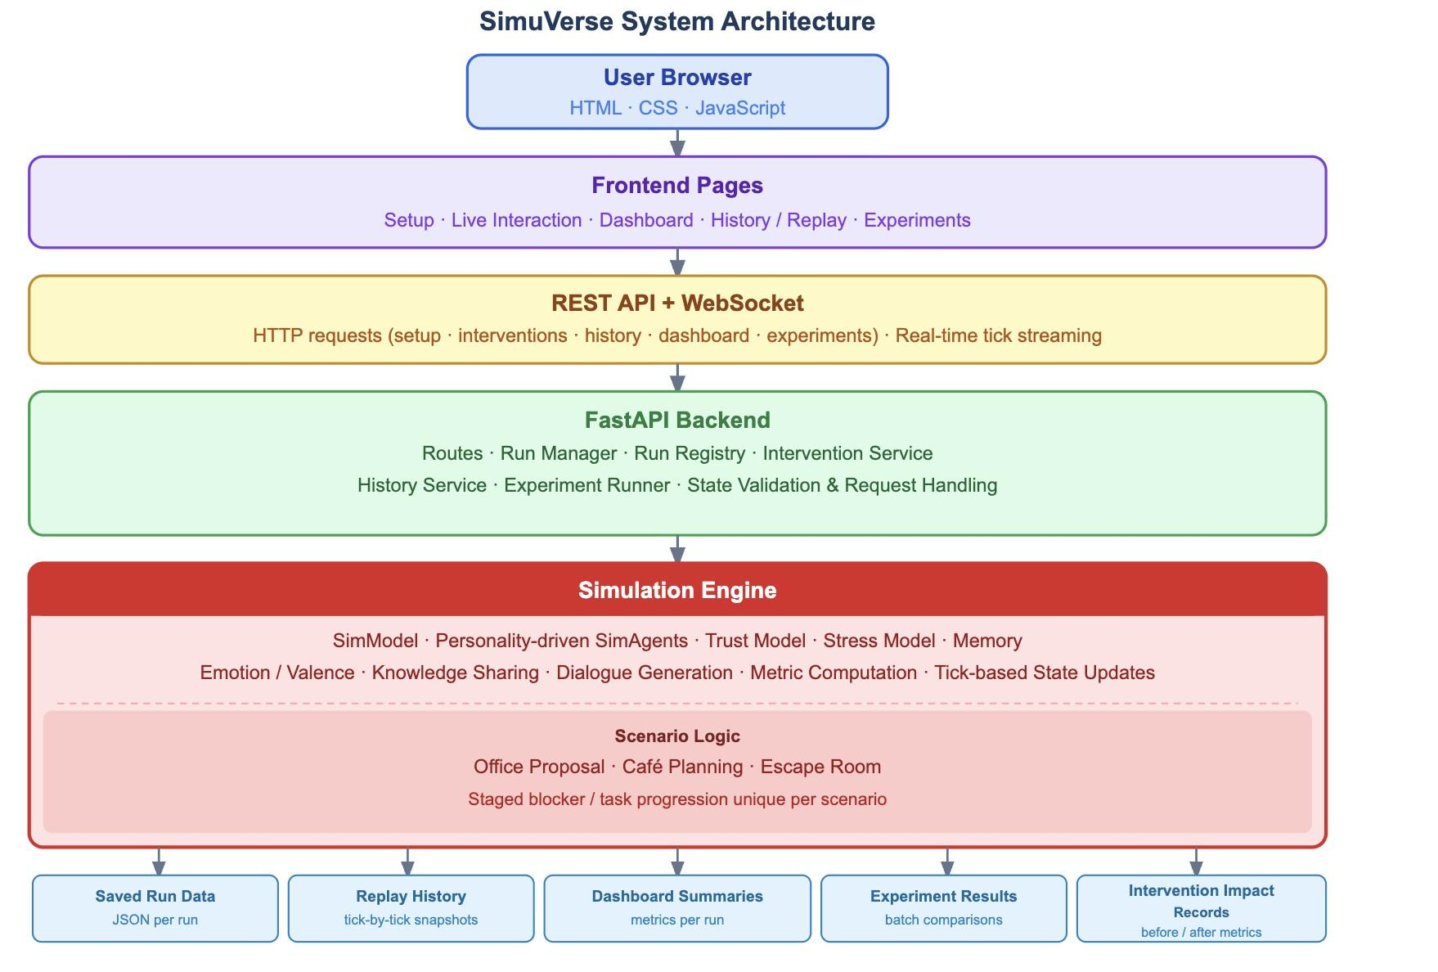
Figure 3.1: SimuVerse system architecture overview

3.3 Agent Design
Each agent has a mix of fixed properties and dynamic state. Fixed properties include the agent's identifier, role label, and team-style preset. Dynamic state includes the agent's current stress level, trust relationships with other agents, emotional valence, and private knowledge.
Four team-style presets were defined. Smooth, Tension, Creative, and Pressure, each with different behavioural parameters. Tension teams produce more challenges and refusals. Smooth teams produce more agreements and cooperation. These presets are designed to create meaningfully different outcomes, making cross-team comparison achievable.
Stress is a continuous value that rises in response to negative events (challenge, refusal, and conflict) and falls in response to positive events (agreement and cooperation). Trust between pairs of agents updates similarly after each interaction. Both metrics have scenario-specific caps: escape rooms allow higher stress than café scenarios, reflecting their different pressure levels.
The directed trust model was a deliberate choice. A single group-level trust score would be simpler but would also hide relationship-level details (e.g., A1 trusting A2 more than A2 trusts A1.) By storing trust between pairs of agents, SimuVerse can expose how specific interactions and interventions affect individual relationships rather than only reporting a general team mood.
Memory was included for the same reason. Without memory, each event would be treated in isolation, and agents could appear socially inconsistent. Recent interactions and stronger impressions provide continuity, so earlier cooperation or conflict can influence later trust, sharing, and how dialogue is interpreted, supporting the goal of producing coherent social trajectories rather than disconnected generated events.
Continuous valence, stress, and tension were chosen over fixed labels such as “anger” or “joy”. This makes emotional state easier to update gradually, display as a metric trajectory, and compare across scenario runs. The trade-off is reduced psychological richness, but the approach is more transparent and reproducible for a prototype system.
Table 3.2 summarises all six agent components. The two components not covered above are private knowledge and strategy. Private knowledge creates the information asymmetry that drives blocker resolution: each agent starts the run knowing only its own assigned knowledge item, and must communicate to discover what others know. Strategy represents the agent's current behavioural mode (cooperative, defensive, confrontational, avoidant, neutral, or assertive) and can be changed during a run via the Nudge Cooperation intervention.
Table 3.2: Main components of the SimuVerse agent model.
Agent component | Role in the simulation design
Personality / team preset | Provides stable behavioural tendencies that influence cooperation, challenge, refusal, urgency response, and strategy.
Directed trust | Stores how much each agent trusts another specific agent, allowing asymmetric relationships rather than a single group score.
Emotion and stress | Represents emotional direction, intensity, and pressure so that agent decisions are influenced by the run context.
Memory | Stores recent and important interaction impressions so that previous exchanges can affect later social behaviour.
Private knowledge | Creates information asymmetry, requiring agents to ask, share, confirm, and coordinate to resolve scenario blockers.
Strategy | Represents the current behavioural mode, such as cooperative, defensive, confrontational, avoidant, neutral, or assertive.

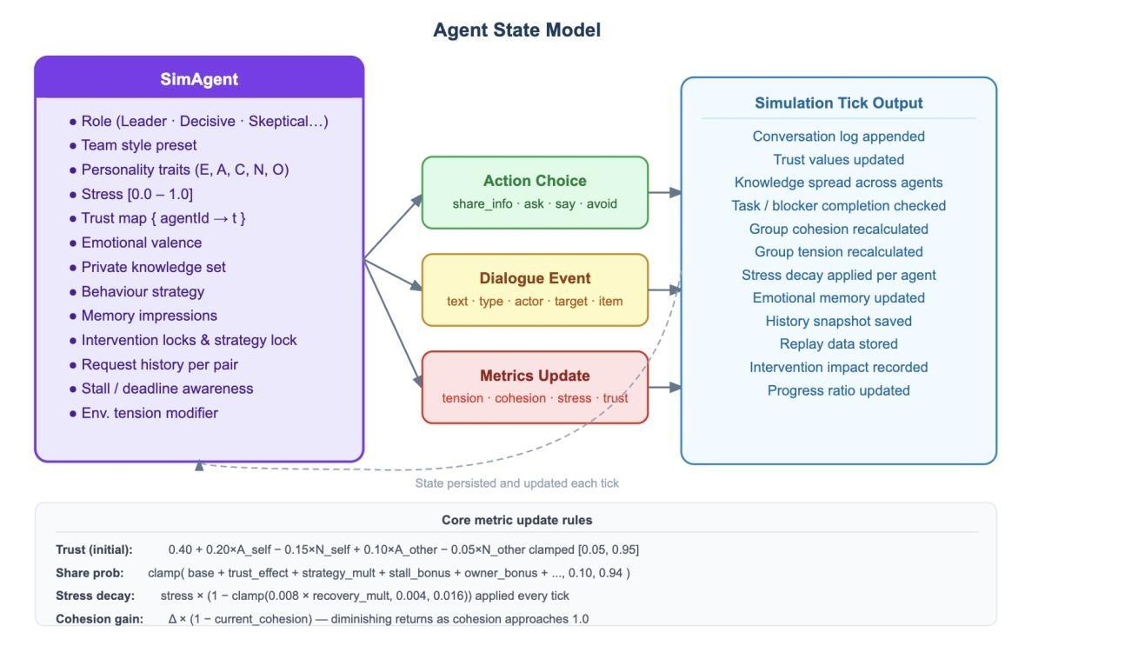
Figure 3.2: Agent state and interaction model

3.4 Scenario Design
Three scenarios were designed: an office project proposal, a café group decision, and an escape room clue sequence. Each defines a sequence of tasks (“blockers”) that must be resolved in order. Each blocker requires specific knowledge to be shared between agents before progress can occur.
These three scenarios produce different social and pressure dynamics while maintaining a consistent underlying simulation model. The office scenario represents a moderate-pressure professional coordination problem. The café scenario represents a low-stakes preference negotiation. The escape room represents a high-pressure sequential dependency problem in which failure to cooperate can cascade into run failure.
Each blocker is associated with a knowledge item privately held by one or more agents. Progress requires agents to discover, share, and confirm the relevant knowledge. This design produces naturally emergent cooperation and conflict behaviour without requiring hand-scripted dialogue or predetermined event sequences.
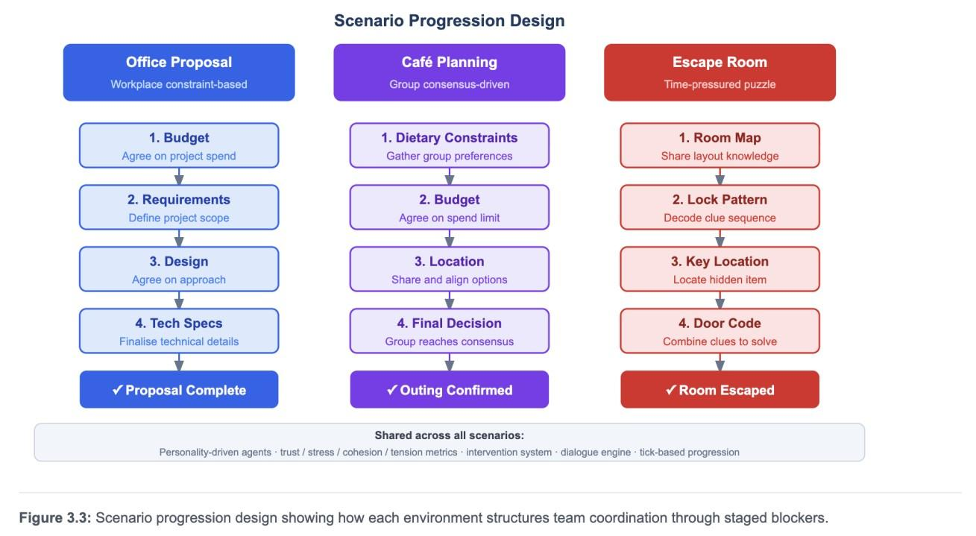
Figure 3.3: Scenario blocker and knowledge distribution design

3.5 Intervention Design
The intervention system is a core part of SimuVerse. Rather than treating simulation runs as closed experiments, users can apply one of seven interventions during a live run: Reveal Info, Force Meeting, Nudge Cooperation, Inject Tension, Boost Urgency, Ease Pressure, and Inject Mood.
Each intervention changes simulation state in a defined and bounded way. Reveal Info shares a specific knowledge item with a target agent, bypassing the natural sharing sequence. Force Meeting creates a direct discussion event between two agents. The remaining interventions adjust group-level parameters including urgency, emotional valence, and tension.
All interventions include a before-and-after metric snapshot so that the effect of each intervention can be quantified. The snapshot captures stress, trust, cohesion, tension, and blocker progress immediately before the intervention and again after the next simulation step, so that users and researchers can check whether the intervention produced the intended change.
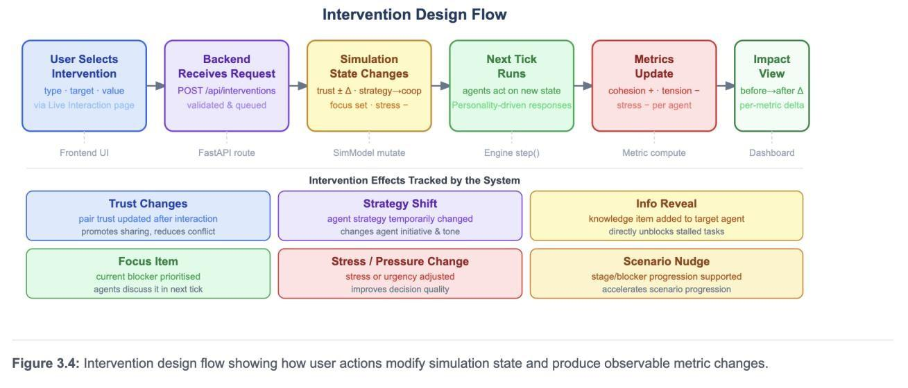
Figure 3.4: Intervention system design and effect pipeline

3.6 Metrics and Explainability Design
The metrics layer serves two purposes: real-time feedback during a run, and quantifiable evidence for post-run analysis. Tracked metrics include group stress, mean trust, cohesion, tension, urgency pressure, and conflict event count. Progress is the proportion of blockers completed at any tick. It is a normalised measure comparable across scenarios with different numbers of blockers.
Explainability is built at event level, not added afterwards. Every agent action generates an event record with action type, agents involved, a plain-language description, a Why explanation (the causal factors that produced the decision), and an Effect note (what changed in agent relationships or task state). Every simulation step is therefore interpretable in plain language without requiring inspection of raw model parameters.
This approach was preferred over post-hoc explanation models because it keeps explanations contextually aligned with the simulation state at the moment each action occurred, preserving the causal chain rather than reconstructing it retrospectively.

3.7 User Interface Design
The user interface uses a step-by-step interaction model. Users can advance the simulation one step at a time, reviewing each event before proceeding, or turn on automatic progression. This granular control is useful for researchers who want to study specific decision points, not just aggregate outcomes.
The interface has five pages: Setup (scenario and team selection), Live Interactive (run and observe), Dashboard (review a completed run), History (access all past runs), and Experiments (batch runner). The Live Interactive page uses a three-column layout with an agent state panel, an event log panel, and an intervention panel. All relevant information is visible simultaneously without switching views.
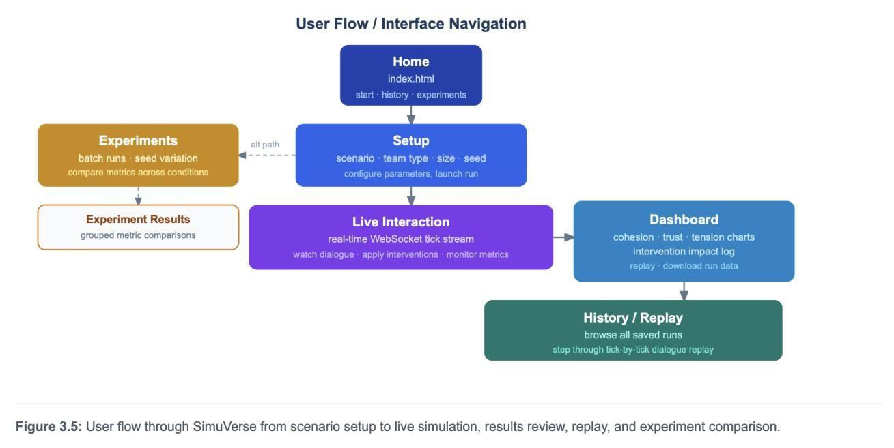
Figure 3.5: SimuVerse user interface layout and page structure

3.8 Design Alternatives Considered
The comparison is included here to show that the chosen approach was not arbitrary. Six decision areas are covered in Table 3.3: agent behaviour model, trust model, emotion model, scenario structure, user control, and run storage. In each case the rejected alternatives either reduced interpretability (LLM-driven dialogue), reduced reproducibility (no memory; temporary browser state), or added complexity without clear benefit (NetLogo; database-first storage). The final choices consistently favour inspectability and reproducibility over richness, which is consistent with the design aims set out in Section 3.1.
Table 3.3: Design alternatives considered and justification for the final choices.
Design issue | Alternatives considered | Final choice | Justification
Agent behaviour | Scripted finite-state rules; LLM-driven dialogue; statebased probabilistic rules | State-based probabilistic rules | Keeps decisions inspectable and repeatable while still allowing personality-driven variation.
Trust model | Single group score; undirected pairwise trust; directed pairwise trust | Directed pairwise trust | Captures asymmetric relationships and shows who trusts whom.
Emotion model | Discrete emotion labels such as anger, joy, fear, or frustration; sentiment polarity only; continuous valence/stress model | Continuous valence, stress, and tension values | Continuous values are easier to update per tick, graph over time, and compare across runs than discrete labels. This supports reproducibility and makes emotional change visible in the evaluation.
Scenario structure | One generic task; fully scripted scenarios; staged blockers/constraints | Staged scenario-specific blockers | Supports comparison between office, cafe, and escape room while keeping the underlying engine consistent.
User control | No interventions; manual state editing; logged intervention API | Logged intervention system | Allows real-time steering while preserving traceability of what changed.
Storage | Database-first storage; temporary browser state; JSON run records | Saved run records with replay data | Keeps the prototype portable while supporting reproducibility and later analysis.

3.9 Mathematical Formulation
All symbols used in this section are defined in Appendix E (Table E.1). Equations (1) to (6) are the core state-update rules shown below. The action-selection mechanism is described in (Eq. 7) after the state equations.
(Eq. 1) defines the initial trust T_ij(0) that agent i holds toward agent j. A_i is agreeableness, N_i is neuroticism, and delta_preset is the team-preset trust adjustment that shifts the baseline according to the team style.
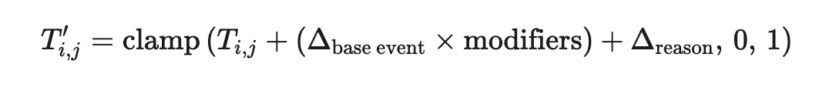
(Eq. 2) updates trust after an interaction. delta_base is the signed trust effect of the event type (positive for share and agree, negative for refuse and challenge). The modifiers term scales the change by personality traits and current environment urgency. delta_reason adds a context adjustment from the agent's short-term memory.
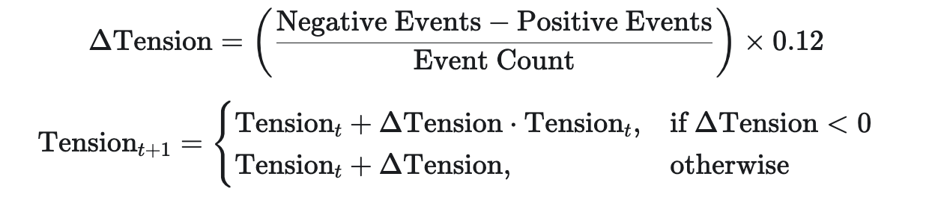
(Eq. 3) updates group tension. Negative interactions add to the tension level; positive interactions reduce it proportionally to the current value, producing an exponential-decay effect that makes tension easier to reduce when it is low.
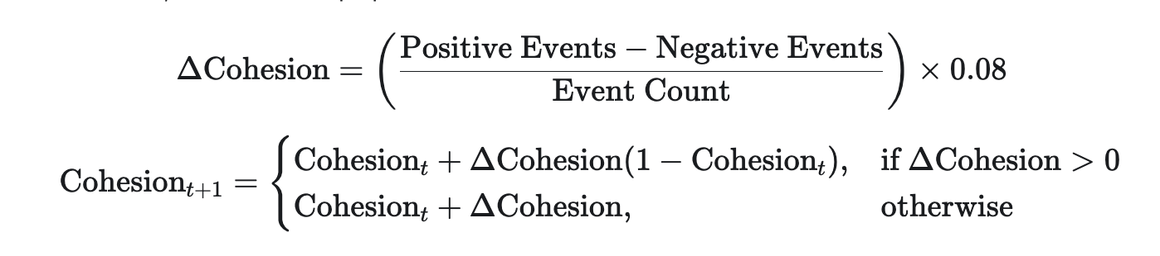
(Eq. 4) updates group cohesion. The (1 - Cohesion_t) term applies diminishing returns: cohesion gains are smaller when cohesion is already high, preventing trivial saturation.

(Eq. 5) measures scenario completion as the ratio of resolved blockers to total blockers. Progress reaches 1.0 when all blockers are cleared.
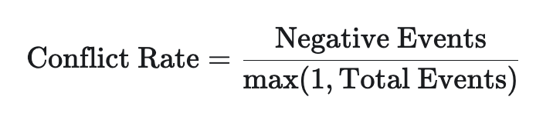
(Eq. 6) measures the conflict rate as the proportion of all interactions that are conflictive, covering refusal, challenge, insult, and ignore events.
(Eq. 7) formalises how trust propagates into action selection. For any candidate action a by agent i toward agent j, a composite score combines the base propensity for action type a with the current directed trust T_ij, the agent's agreeableness A_i, and the inverse of current stress sigma_i. The final selection probability is computed as a softmax over all candidate actions, so high trust raises the likelihood of cooperative actions (share, agree) relative to adversarial ones (refuse, challenge), and high stress suppresses all action propensities uniformly.
All values bounded to [0, 1] are clamped after each update, ensuring that no metric leaves its valid range regardless of extreme event sequences.

3.10 Summary
The design of SimuVerse prioritised explainability, interactivity, and reproducibility. The architecture separates simulation logic from presentation, the agent model captures the dynamic state relevant to group behaviour research, and the scenario design produces meaningfully different social environments. The intervention system transforms passive observation into active experimentation, and the metrics layer provides quantifiable evidence for analysis and comparison.

Chapter 4: Implementation

4.1 Technology Stack
SimuVerse was built with a Python backend and a vanilla JavaScript frontend with no frontend framework dependencies. FastAPI was selected for the backend for its support for asynchronous request handling and WebSocket connections, and for its compatibility with Python’s scientific ecosystem. The simulation engine runs entirely server-side, ensuring that simulation state is authoritative and consistent across all client views.
The backend and frontend talk over WebSocket for real-time state streaming and REST for stateful operations including run creation, intervention application, and run retrieval. The frontend uses HTML, CSS, and JavaScript without a framework, with Chart.js providing metric visualisation and jsPDF supporting run export. This approach minimises build complexity and external dependencies, keeping the system straightforward to run and audit.
Table 4.1: Main implementation modules and responsibilities.
The eight modules listed in Table 4.1 map directly to the implementation sections that follow. model.py and agent.py are discussed in Section 4.3, scenario_data.py and scenario_logic/ in Section 4.4, interventions.py in Section 4.5, the metrics and run record files in Section 4.6, and the frontend in Section 4.7. The routes/ and services/ layers handle the API and run lifecycle and are covered in Section 4.2.
Module / file area | Responsibility
app/sim/model.py | Coordinates the simulation loop, agent creation, event processing, metrics, and run outcomes.
app/sim/agent.py | Stores agent state and implements decision behaviour, including stress, trust, emotion, memory, knowledge, and strategy.
app/sim/scenario_data.py | Defines scenario tasks, roles, knowledge maps, stage labels, and tick limits.
app/sim/scenario_logic/ | Contains office, cafe, and escape-room logic as scenariospecific extensions.
app/sim/interventions.py | Implements intervention handlers such as reveal info, force meeting, urgency, tension, and emotion changes.
app/api/routes/ | Exposes FastAPI endpoints for run control, interventions, history, replay, dashboard, and experiments.
app/services/ | Manages run lifecycle, run registry, history persistence, and experiment execution.
tests/ | Contains evaluation-focused pytest tests for scenarios, steps, metrics, interventions, memory/emotion, presets, replay, and experiments.

4.2 Backend Implementation
The backend exposes three categories of endpoint. The endpoints are handle run creation, step advancement, status retrieval, and run termination. Intervention endpoints accept POST requests for each of the seven intervention types and return an InterventionResponse object containing the intervention label, a before-snapshot of metrics, and a description of the expected effect. History endpoints retrieve stored run data for replay and comparison.
Runs are stored as structured JSON files, each containing the full event history, metric snapshots at each tick, final agent states, and the complete intervention record. This storage model was chosen over a relational database for simplicity and portability, so runs can be inspected, shared, and archived without a database dependency. Each run is identified by a UUID generated at creation time.
WebSocket connections are maintained per run. When the client advances one step, the backend processes the tick, generates events, updates agent state, and pushes a state diff to the open socket. The diff contains only changed fields, reducing payload size for long runs.

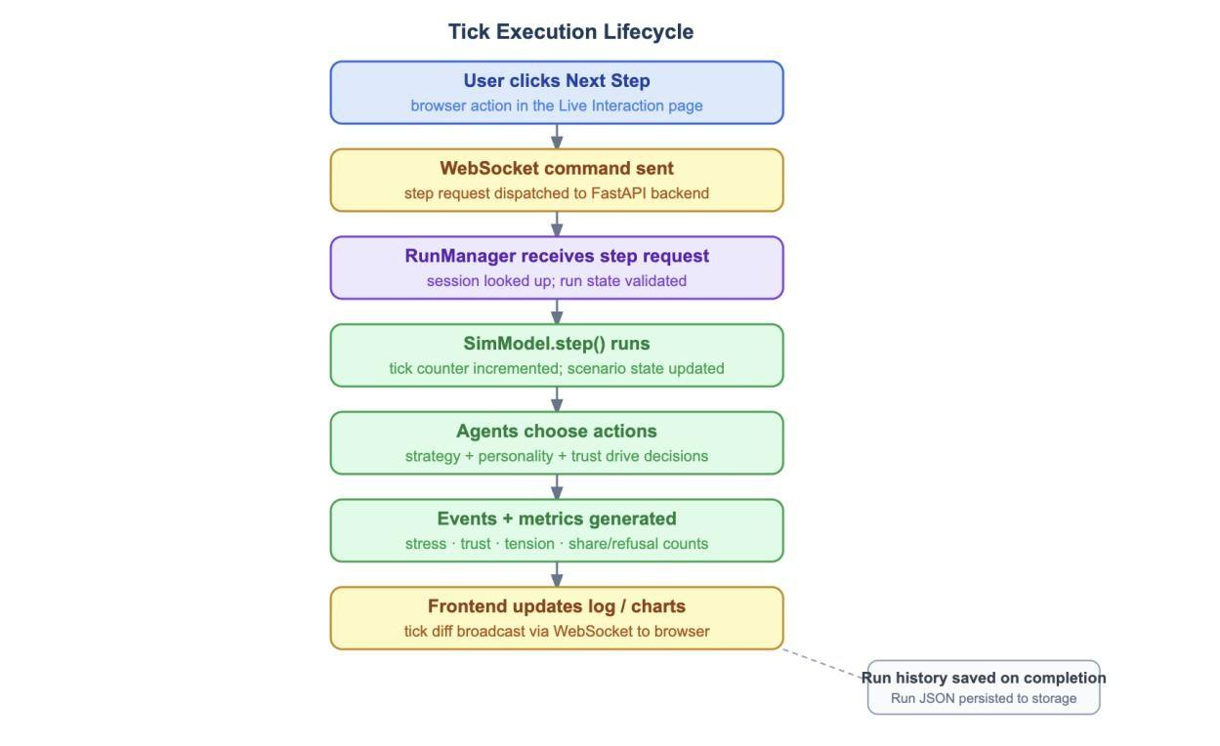
Figure 4.1: Tick execution lifecycle showing how a single simulation step is processed from user interaction through WebSocket dispatch, backend run management, agent action selection, metric generation, frontend update, and final run persistence.

4.3 Agent and Simulation Engine
The simulation engine manages agent objects each holding the state described in Chapter 3. At each tick, the engine determines active agents relative to the current blocker, selects action types probabilistically based on agent style and current state, generates event records, and applies state updates.
Action selection uses weighted probability distributions modulated by the agent's current stress and trust values. A highly stressed agent in a Tension team is significantly more likely to produce challenge or refuse events; a low-stress agent in a Smooth team is more likely to produce agreement or sharing events. This produces emergent variation across runs without scripted sequences.
The knowledge sharing mechanism underpins blocker resolution. Each blocker is associated with a knowledge item privately held by one agent. Resolution requires that agent to share the item with all relevant agents and for the group to confirm receipt. The simulation tracks three partial sharing states: held, shared, and confirmed. Progress is therefore gradual and observable rather than binary.
Scenario-specific caps on stress and trust are defined as named constants and applied at the point where metric updates are calculated. Each scenario therefore produces dynamics appropriate to its context, and runaway metric values in long runs are prevented by design.
The memory and emotion components were implemented as explicit state variables rather than only as surface-level dialogue variation. Memory impressions, stress, valence, trust, and scenario pressure can each be inspected, tested, and recorded independently. The design therefore supports evaluation through metric history rather than relying only on whether the generated conversation feels plausible.
Run persistence was implemented using serialisable records rather than storing live Python object references. Completed runs store event histories, metric snapshots, agent summaries, scenario configuration, and intervention records. This avoids circular-object problems between agents and model state, while still preserving enough information for replay, dashboard summaries, and experiment comparison.

4.4 Scenario Logic
Each scenario is defined by a configuration object specifying the blocker sequence, knowledge items and their initial holders, the team preset options available, and the urgency modifier setting the base pressure level. The office scenario uses four blockers at moderate urgency. The café scenario uses one decision blocker at low urgency, preceded by four knowledge-sharing exchanges. The escape room uses five blockers at high urgency with strict sequential dependency, meaning that no blocker can begin resolution until the preceding one is fully confirmed.
The scenario configuration is loaded at run creation and remains fixed for the run’s duration, so experiment runner batches are directly comparable: identical scenario configurations are applied to every run in a batch regardless of team preset.

4.5 Intervention System
The process of processing each intervention is implemented separately via a specific backend function. In response to an intervention request, a snapshot before intervention of metrics' values is taken; then the intervention itself is performed on the simulation model, the intervention is logged for the current simulation run, and an InterventionResponse is returned.
Before snapshots include values for stress, average trust, cohesion, tension, pressure, and current blocker. After advancing the next simulation step by the user, the frontend creates an after snapshot by taking the difference between the current metric values and the before metric values. This delta will be presented as the Intervention Impact where for each applied intervention the impact on each metric is calculated.
Reveal Info and Force Meeting are the two most interesting interventions among those implemented for this experiment. Reveal Info allows setting a knowledge item as already known for the target agent and thus helps resolve the blocker faster if the target is the bottleneck holder. In Force Meeting intervention, a fake meeting event is created between two specified agents on the next tick and the trust and cooperation are updated between this pair of agents.

4.6 Metrics, Run Records and Replay
Metrics are updated after each tick and pushed to the frontend as part of the state diff. The frontend maintains a running history of values per tick, which feeds the live Chart.js line chart in the Metrics and Analysis view.
The run summary generated at completion includes final values for all tracked metrics, the blocker sequence, unresolved blockers, the full intervention log with before/after deltas, and a natural language interpretation. This summary is displayed in the Dashboard and exported in the PDF report.
The replay system reads completed run JSON files and reconstructs the event log and metric history in the frontend exactly as they appeared during the live run. Replay mode is activated via a URL parameter and disables all intervention controls and step buttons, presenting the run as read-only.
Table 4.2: Run data recorded by SimuVerse and its evaluation purpose.
Each data type in Table 4.2 was used directly in the evaluation chapter. Event histories support the dialogue act and blocker progression analysis in Section 5.4. Per-step metric histories feed the quantitative experiments in Section 5.11. Intervention records provide the before/after evidence for Section 5.5. Run outcome and step counts are the primary dependent variables in the statistical tests in Sections 5.11.1 to 5.11.4.
Recorded data | Purpose in evaluation
Event history | Shows the sequence of agent dialogue acts, scenario progress, and intervention-triggered events.
Per-step metric history | Supports analysis of stress, trust, cohesion, tension, progress, and behavioural change over time.
Scenario and team configuration | Allows comparison between office, cafe, escape room, and team presets.
Intervention records | Preserves before/after context so changes can be inspected rather than inferred only from final results.
Run outcome and completion steps | Provides a comparable success/failure and efficiency measure across runs.
Replay data | Allows completed runs to be reviewed without rerunning the simulation.

4.7 Frontend Implementation
The frontend manages WebSocket state, real-time DOM updates, metric chart rendering, intervention panel state, and view toggling between the Live Simulation, Metrics and Analysis, and Intervention Impact tabs. Simulation state is held in a single JavaScript object updated incrementally from WebSocket diffs.
The intervention panel manages select menus, validation feedback, pending application states, and before/after metric capture. A pre-run guidance note directs users to start the simulation before applying interventions, and optional intervention controls are collapsed by default to reduce cognitive load on first use.
The Experiments page sends batch run requests to the backend and polls for completion, then renders a comparison table of outcomes. The History page lists all stored runs with links to their replay and dashboard views.

4.8 Challenges and Implementation Decisions
WebSocket state synchronisation required careful handling to prevent race conditions between step advancement and intervention application. This was resolved by implementing a pending-advance flag on the frontend that disables the step button while an intervention is being processed.
Cohesion and tension are both derived from the same underlying event signal, so they are inversely correlated by design. This created presentation challenges, addressed through co-labelling in the UI and honest acknowledgement in the evaluation, rather than attempting to decouple metrics that are structurally correlated.
The Inject Mood intervention required natural language input to be mapped to a discrete emotional state. A rule-based classifier using keyword matching was implemented as a practical solution within the project scope. Its limitations are acknowledged in Chapter 6.
A further implementation challenge was ensuring that scenario and run state did not leak between runs. Because the experiment runner executes repeated simulations under different team presets, each run has to initialise its own scenario state, agent state, and metric history. This separation is important for reproducibility. Otherwise, one run could accidentally inherit stress, memory, or task progress from a previous run.
The implementation also deliberately prioritised inspectability over high-fidelity psychological realism. A more complex model could include richer planning, learning, or language generation, but that would make it harder to explain why a particular action occurred. SimuVerse therefore uses explicit state variables and rule-guided probabilities so that behaviour remains observable, bounded, and suitable for dissertation-level evaluation.
The current system was designed and evaluated for small four-agent scenarios. Scalability to larger groups was not formally evaluated and would require further optimisation such as bounded interaction graphs or batched event processing.
A deliberate modularisation strategy explains why several implementation files are long. Distributing related logic across many shallow files would obscure responsibilities and complicate debugging, so each module encapsulates one complete concern. agent.py (2,179 lines) contains the entire agent decision pipeline: personality-weighted act selection, trust updates, memory processing, emotion state changes, and dialogue generation. Splitting this across multiple files would break the cohesion of the decision tree and require complex cross-imports for tightly coupled state. The three scenario logic files (office_logic.py: 2,635 lines; escape_logic.py: 2,750 lines; cafe_logic.py: 2,317 lines) each contain all task progression, blocker resolution, and knowledge-transfer rules for one scenario, keeping scenario behaviour self-contained and independently testable. interventions.py (1,612 lines) groups all seven intervention handlers in one discoverable location. metrics.py (1,314 lines) consolidates all per-tick metric computation and natural-language explanation generation. model.py (1,559 lines) is the simulation orchestrator that coordinates these modules without duplicating their logic. The design follows the principle of high cohesion within modules and loose coupling between them: each file does one thing fully, and modules communicate through well-defined interfaces rather than shared state. The trade-off is file length; the benefit is that any behaviour is localised to one place, which supports the interpretability and testability goals of the project.

4.9 Summary
The implementation produced a working multi-agent simulation platform with a FastAPI backend, a tick-based probabilistic simulation engine, seven intervention types with before/after metric tracking, persistent run storage with replay, and an experiment runner for batch comparison. The frontend provides real-time visualisation without a JavaScript framework. The system was functional and stable throughout user testing.

Chapter 5: Evaluation

5.1 Evaluation Strategy
The evaluation of SimuVerse addressed three dimensions. Functional correctness, scenario and intervention behaviour, and perceived usability and usefulness. Functional testing verified that core user-facing operations behaved as expected. Scenario and intervention testing assessed whether the simulation produced observable behavioural variation across environments and team configurations. User testing gathered subjective feedback on usability, clarity, and perceived research value.
This multi-level approach was necessary because the project has both software engineering and research-tool goals. Functional tests confirm that the implementation works, but they do not show whether users understand the system. User testing captures usability and perceived value, but it does not verify that the simulation engine, intervention controls, dashboard, replay and experiment runner operate correctly. Combining both types of evidence provides a stronger evaluation than relying on either alone.
Evidence in this chapter is based on manual functional testing, representative screenshots, dashboard outputs, replay views, experiment runner summaries, and user testing responses. The focus is on visible, user-facing behaviour because SimuVerse is evaluated as an interactive prototype.

To make the evaluation traceable, each form of evidence was linked to a specific claim about the system. Functional walkthroughs checked that the prototype worked as intended; automated pytest tests checked backend stability; scenario and intervention testing checked behavioural plausibility; and user testing checked whether the interface and explanations were understandable to participants.

5.2 Functional Testing
Functional testing was conducted manually across the main workflows that a user or evaluator would be expected to use configuring a run, starting a live simulation, stepping through agent interactions, applying interventions, viewing results, opening previous runs and using the experiment runner. The purpose of this testing was to confirm that the submitted prototype supports the end-to-end workflow described in Chapters 3 and 4.

Test ID | Workflow checked | Result and evidence
FT-01 | Setup and run launch | Scenario/team selected and live run opened correctly (Figure 5.1): Pass
FT-02 | Live stepping | Event log, agent states and metrics updated after stepping (Figure 5.2): Pass
FT-03 | Run completion | Completion summary displayed outcome, trust, stress and resolved stages (Figures 5.3-5.6): Pass
FT-04 | Interventions | Before/after intervention impact cards displayed (Figures 5.7-5.8): Pass
FT-05 | Dashboard and replay | Completed run could be inspected through dashboard and timeline/replay views (Figures 5.9-5.12): Pass
FT-06 | Experiment runner | Batch comparison table and scenario metrics rendered successfully (Figure  5.13): Pass
Table 5.1: Manual functional testing summary.
All six functional tests passed. FT-01 to FT-03 confirm the core simulation workflow configuration, live stepping, and run completion all operate correctly. FT-04 confirms that the intervention system records and displays before/after impact. FT-05 confirms that completed runs are fully inspectable after the live session ends. FT-06 confirms that the experiment runner produces a usable comparison table across batch runs. No blocking failures were identified.
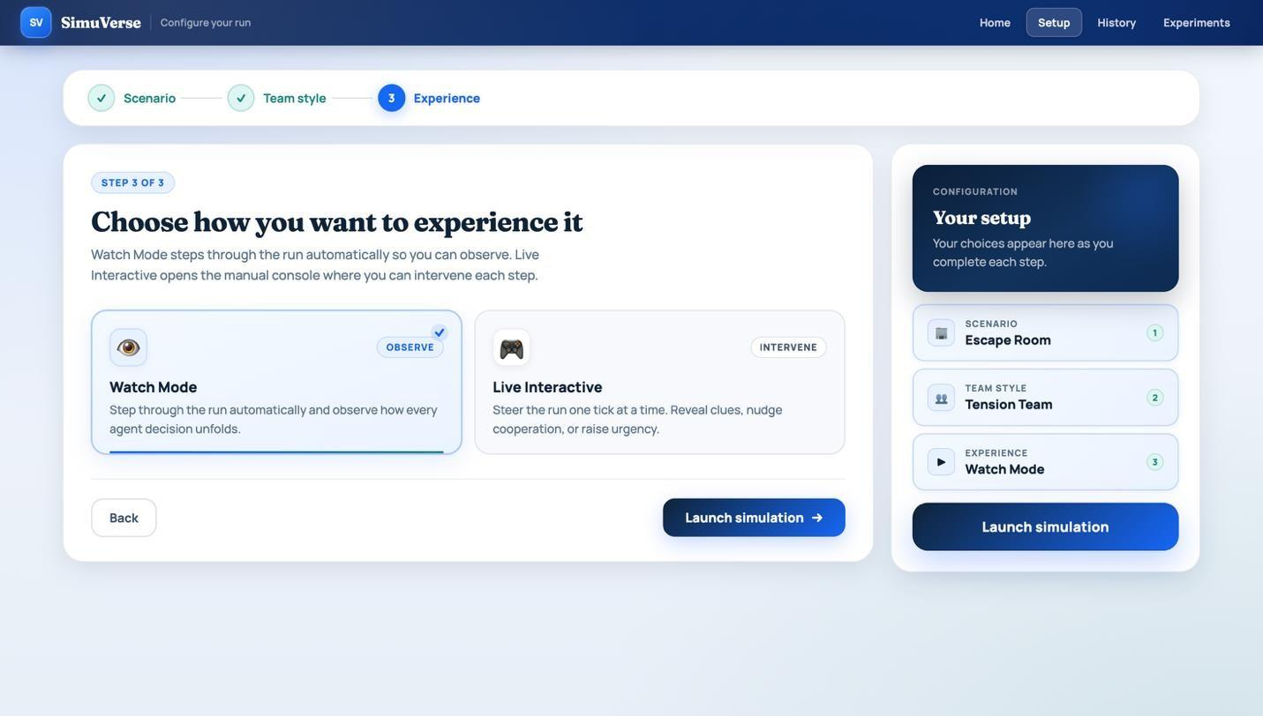
Figure 5.1: Setup workflow showing scenario/team selection before launching a simulation.

Figure 5.2: Live simulation mid-run showing agent states, the event log, metrics and the explanation panel.

5.3 Automated Backend Testing
Automated backend testing was added using pytest to provide a focused check of the most important simulation behaviours. The evaluation-focused test suite contained 18 tests covering scenario loading, simulation step progression, metric bounds, intervention effects, memory/emotion behaviour, personality preset differences, run saving/replay and experiment runner output. Exact dialogue wording was not tested because generated agent text can vary between runs; the tests instead checked structural correctness and state changes. All 18 tests passed successfully, as shown in Figure 5.3.
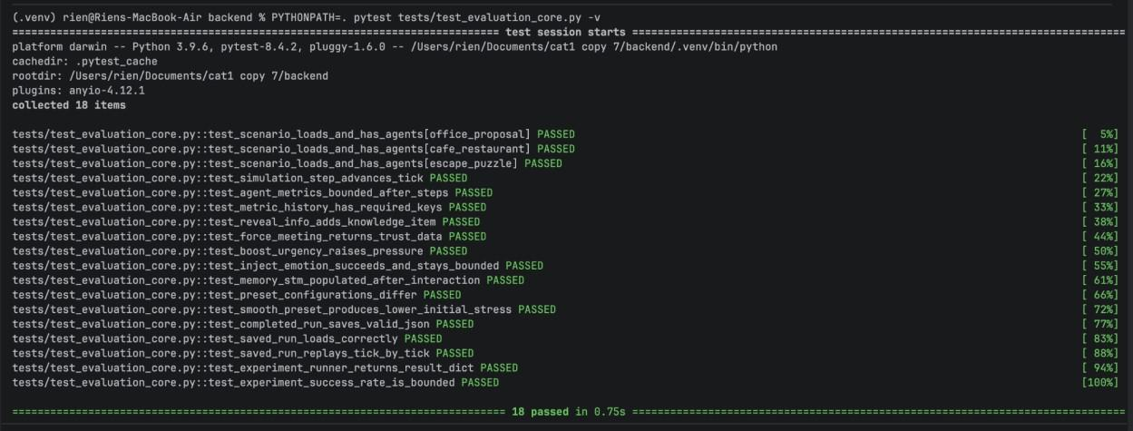
Figure 5.3: Pytest output showing the evaluation-focused automated backend test suite passing.

5.4 Scenario Behaviour Testing
Scenario behaviour testing focused on whether the three main settings produced clearly different user-facing patterns. The café scenario was expected to be lower pressure and more cooperative, the office scenario was expected to show structured coordination, and the escape room scenario was expected to produce higher urgency and a stricter sequence of blockers. Representative runs were completed and inspected through the live view, completion modal, dashboard and replay views.
The escape room example shown in Figures 5.4 to 5.6 shows this pattern. The run completed and the result modal summarised progress, trust, peak stress, metric movement, resolved sequence, memory impressions, and behaviour counts, allowing the run to be evaluated without relying on backend debug logs.


Figure 5.4: Completion modal overview showing outcome, progress, trust and peak team stress.

Figure 5.5: Completion modal showing metric movement and progress timeline for the escape-room run.
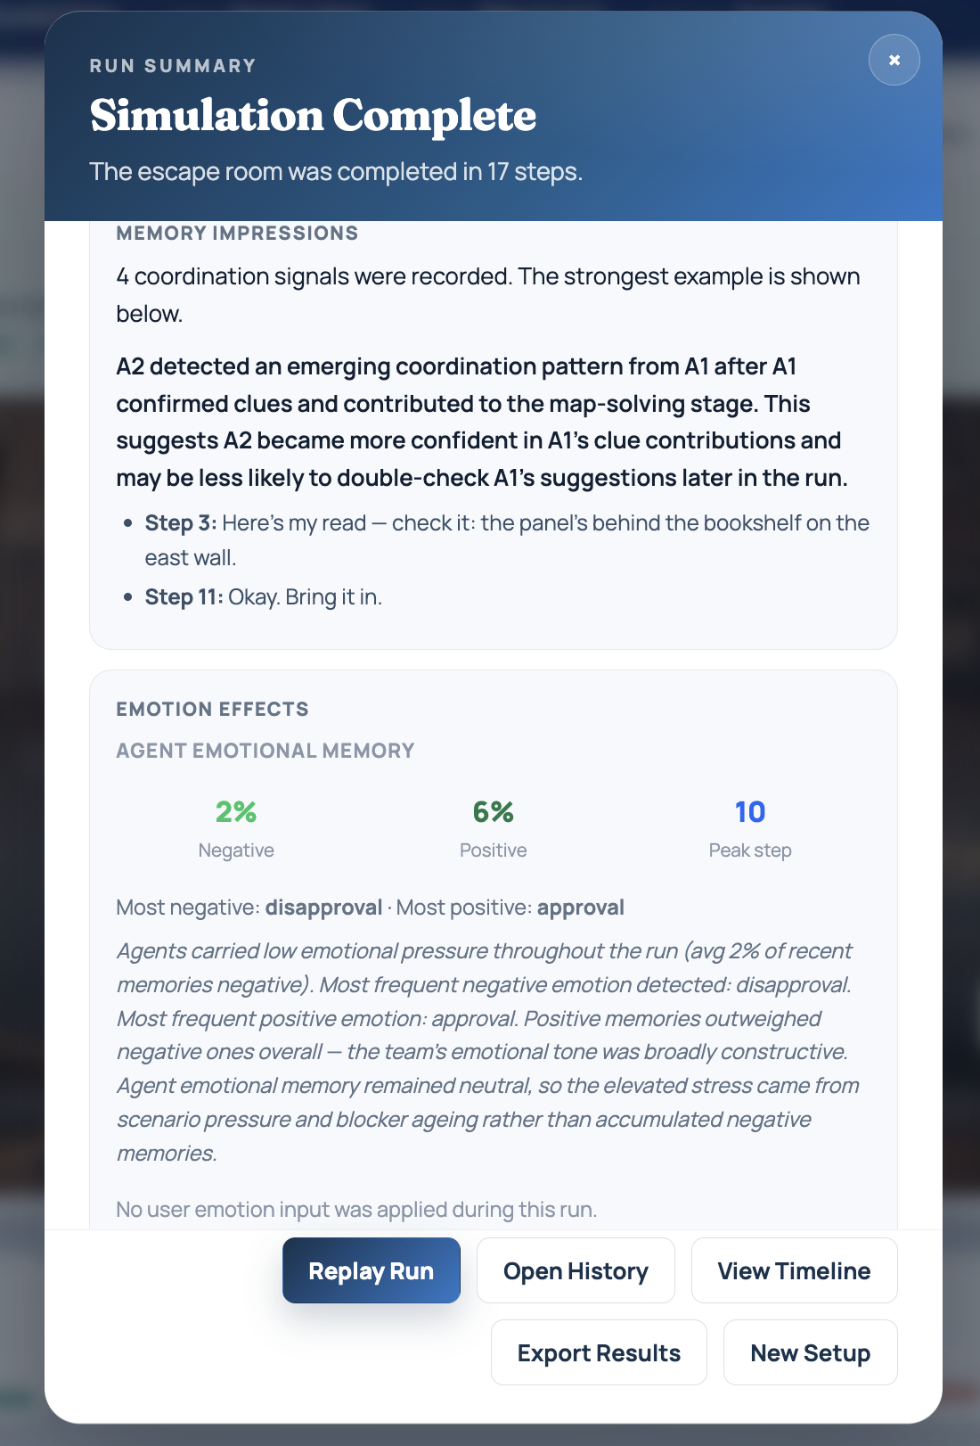
Figure 5.6: Completion modal showing scenario interpretation, progress timeline and memory impressions.

Figure 5.7: Completion modal showing behaviour counts and run-level evidence.
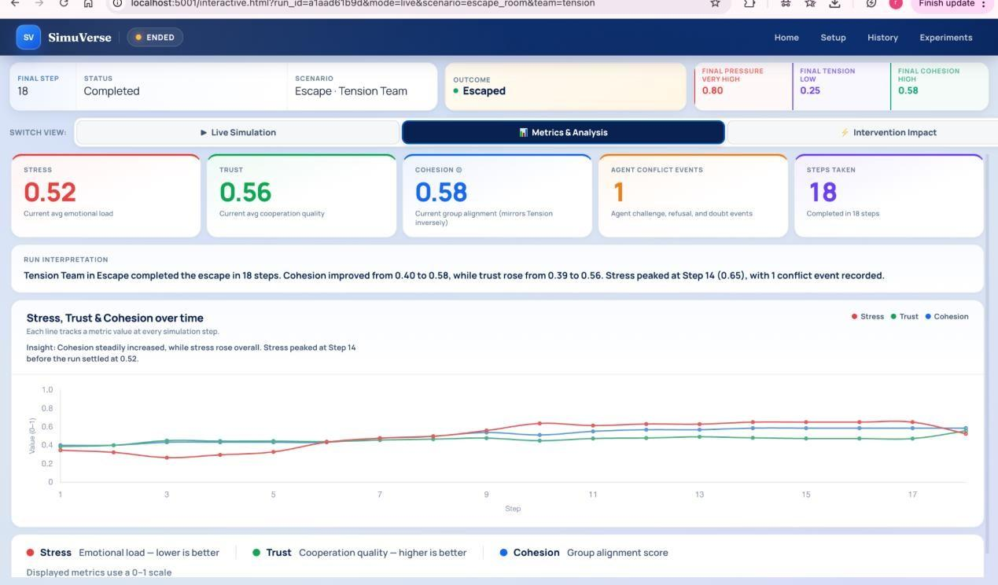
Figure 5.8: Metrics and Analysis view for a completed Escape Room Tension Team run, showing stress, trust, cohesion, conflict events and metric movement across 18 steps.
Scenario evidence | What was checked | Why it matters
Setup and live run | The selected scenario/team loaded into the Live Interaction page | Confirms scenario configuration links to simulation execution
Completion summary | Progress, trust, stress and outcome were displayed after the run | Confirms completed runs produce interpretable summaries
Progress timeline | Resolved stages appeared in order | Confirms scenario-specific blocker progression
Behaviour counts | Messages, shares, agreements, challenges/refusals and interventions were counted | Confirms the dashboard exposes behavioural evidence rather than only final outcome
Table 5.2: Scenario behaviour checks used during representative run testing.
All four checks in Table 5.2 were confirmed during representative run testing. The scenario configuration loaded correctly into the live run, the completion summary displayed interpretable outcome data, blocker stages resolved in the correct order, and the dashboard exposed behavioural counts rather than only a final outcome label. Together these checks confirm that scenario-specific logic is executing correctly and that the output is readable without knowledge of the underlying model.

5.5 Intervention Testing
Intervention testing verified that user actions during a live run were visible and measurable. The main interventions tested were Reveal Info, Force Meeting, Nudge Strategy, Inject Tension and Boost Urgency. For each intervention, the expected behaviour was that the action appeared in the interface, influenced the next part of the run, and produced an interpretable before/after change in the Intervention Impact view.
Figures 5.9 and 5.10 show the Intervention Impact view after interventions were applied. This evidence is important because the intervention system is one of the project’s core contributions: SimuVerse is not only a passive simulation viewer, but an interactive system where the user can influence the run and inspect the resulting changes.
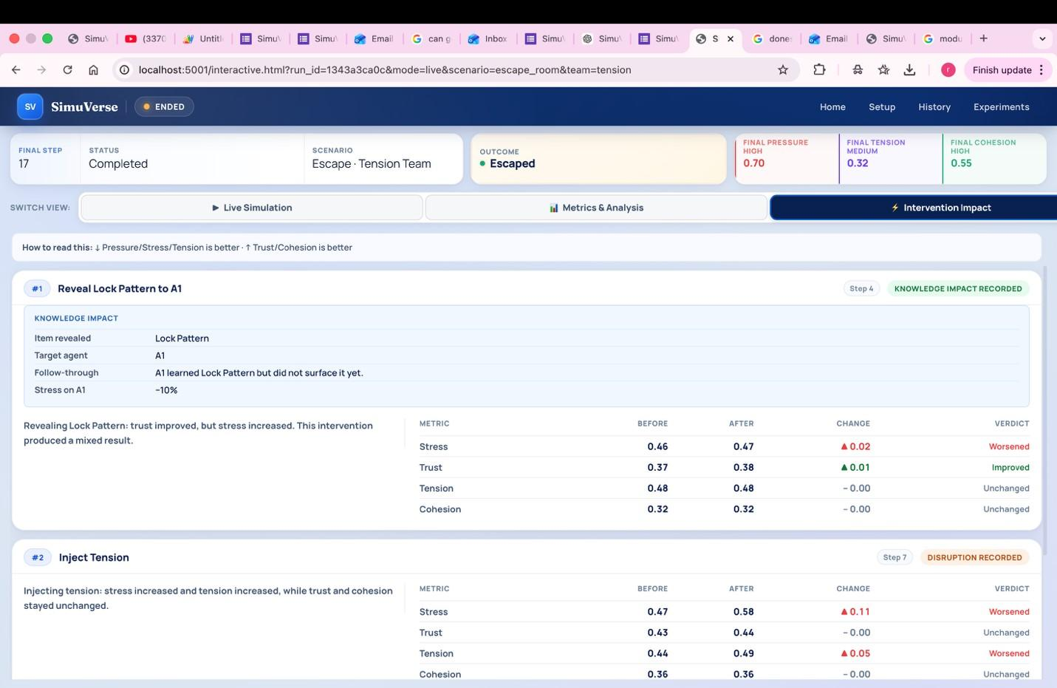
Figure 5.9: Intervention Impact view showing measured before/after metric changes for applied interventions.
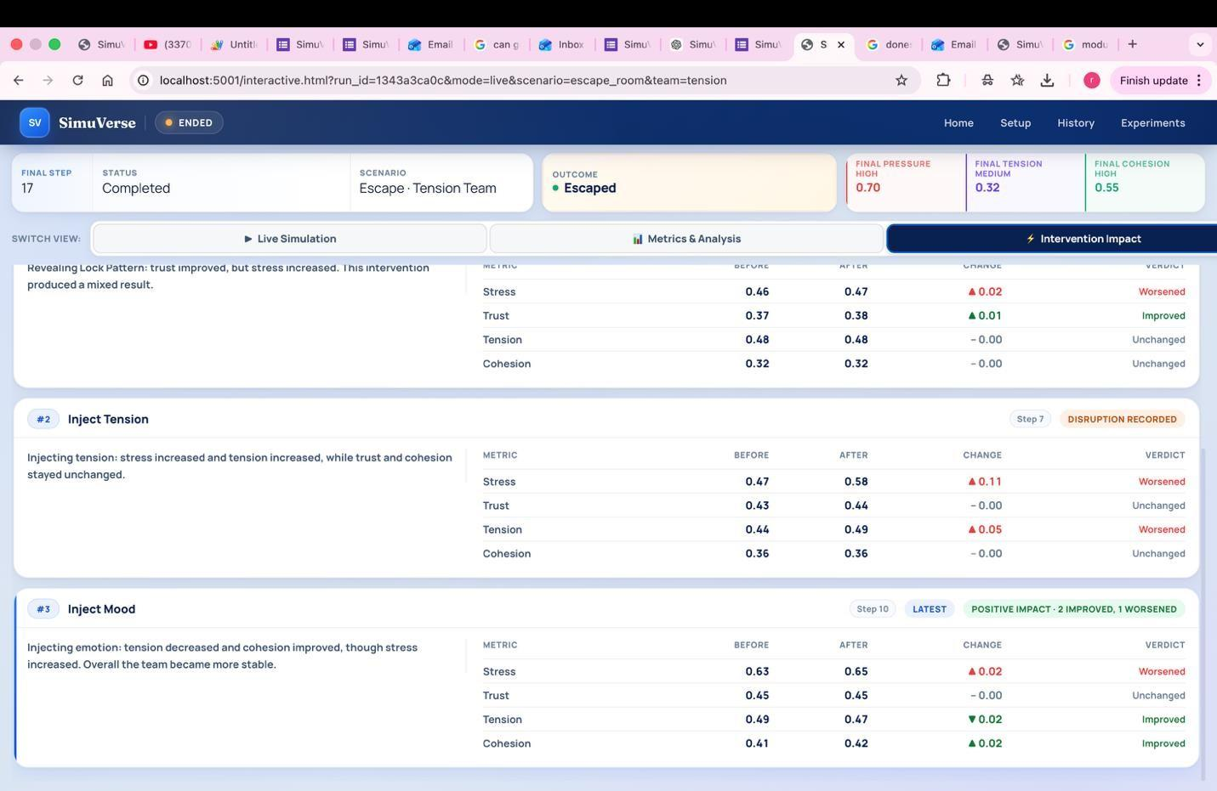
Figure 5.10: Intervention Impact view with multiple intervention records and status labels.
Intervention | Expected visible effect | Observed evidence | Status
Reveal Info | Missing knowledge becomes available to an agent and can  affect the next turn | Impact card and subsequent event evidence displayed | Pass
Force Meeting | Two selected agents are directed into a conversation | Meeting/intervention record appeared in the interface | Pass
Nudge Strategy | Target agent becomes more cooperative or changes behaviour style | Impact view showed measurable metric movement | Pass
Inject Tension / Boost Urgency | Pressure or tension increases and affects later events | Impact records displayed stress/tension deltas | Pass
Table 5.3: Representative intervention testing results.
All four interventions in Table 5.3 produced the expected visible effect and passed. Reveal Info and Force Meeting both appeared in the intervention log with readable impact descriptions. Nudge Cooperation produced measurable metric movement in the Intervention Impact view. Inject Tension and Boost Urgency both produced stress and tension deltas. These results confirm that the intervention system records and surfaces the expected effects under normal use.

5.6 Dashboard, History and Replay Testing
The dashboard, history and replay features were tested to confirm that completed runs remained inspectable after the live simulation ended. Persistent inspectability is a core requirement for the research-tool framing of SimuVerse. Figures 5.11 to 5.13 show dashboard and replay evidence.
Figures 5.11 to 5.13 show evidence from dashboard and replay views. The dashboard summarises the run outcome and behavioural counts, while the timeline/replay view lets the user inspect individual step details. This supports the evaluation claim that SimuVerse offers post-run analysis rather than only live interaction.
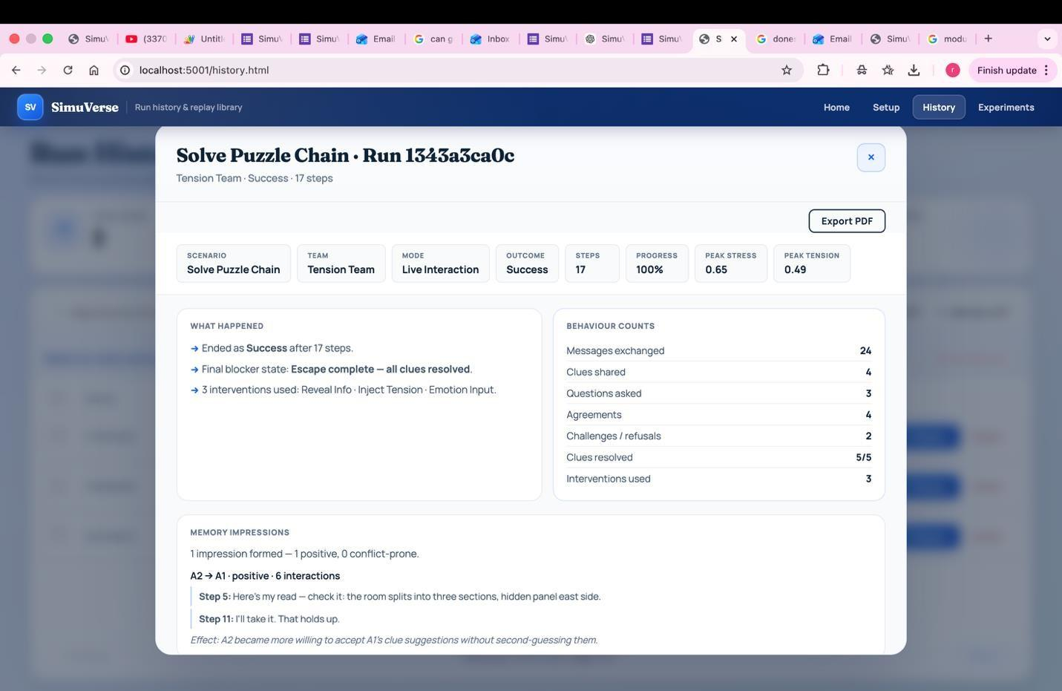
Figure 5.11: Dashboard summary for a completed escape-room run.
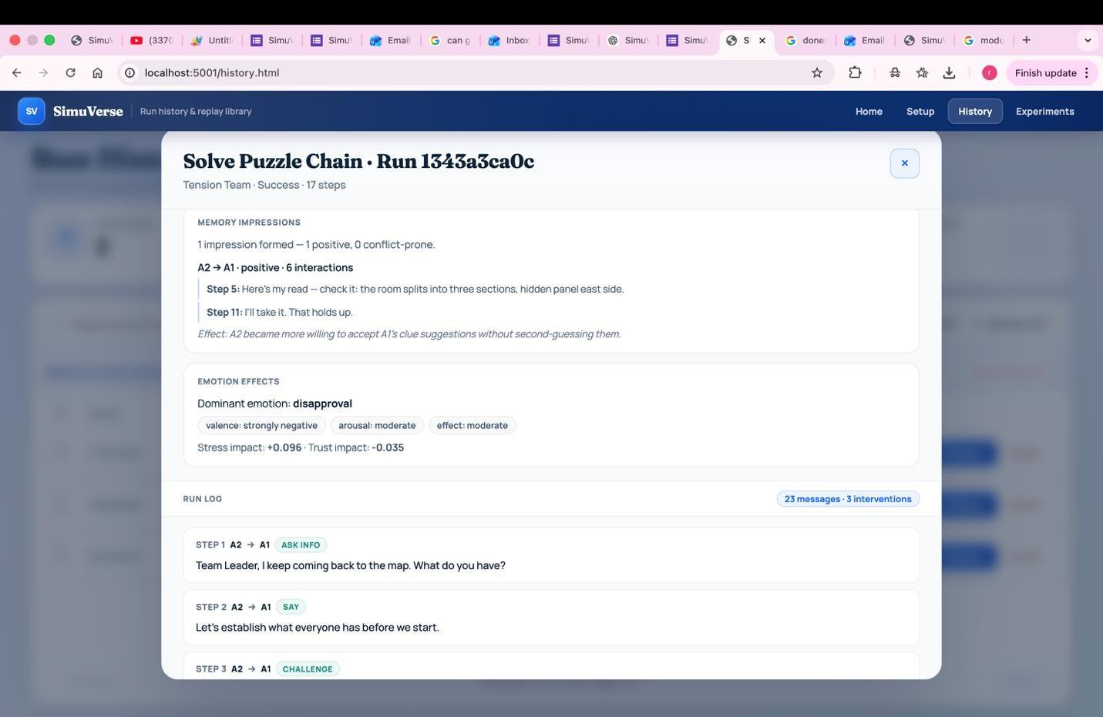
Figure 5.12: Dashboard detail view showing run log and behavioural evidence.

Figure 5.13: Live Interaction page with event log, agent states and intervention controls visible together.
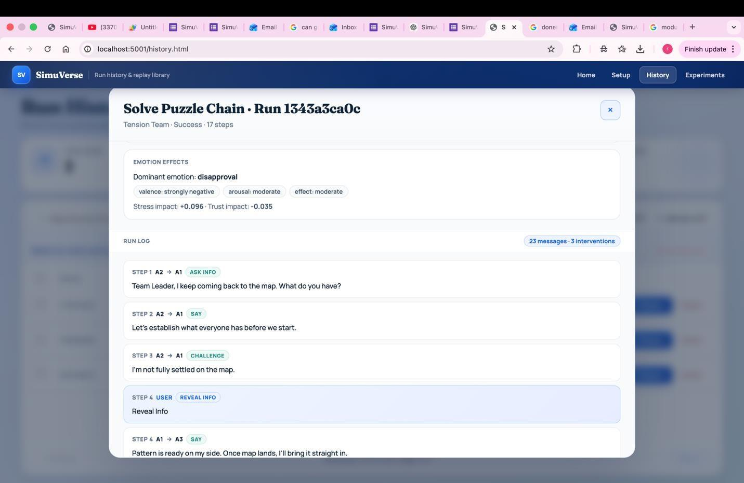
Figure 5.14: Replay/timeline view showing a completed run reconstructed step by step.

5.7 Experiment Runner Evaluation
The Experiment Runner was evaluated by executing repeated runs under controlled settings and inspecting the resulting comparison table. Rather than making statistical claims, this evaluation treated the runner as a functional feature: it should complete runs, show success/failure, and expose completion, steps, stress and trust metrics.
Figure 5.15 shows the Experiment Runner output, including the summary cards and comparison table. The comparison view is one of the strongest pieces of evidence that SimuVerse functions as more than a singlerun demo, because it lets outcomes be compared across repeated runs.
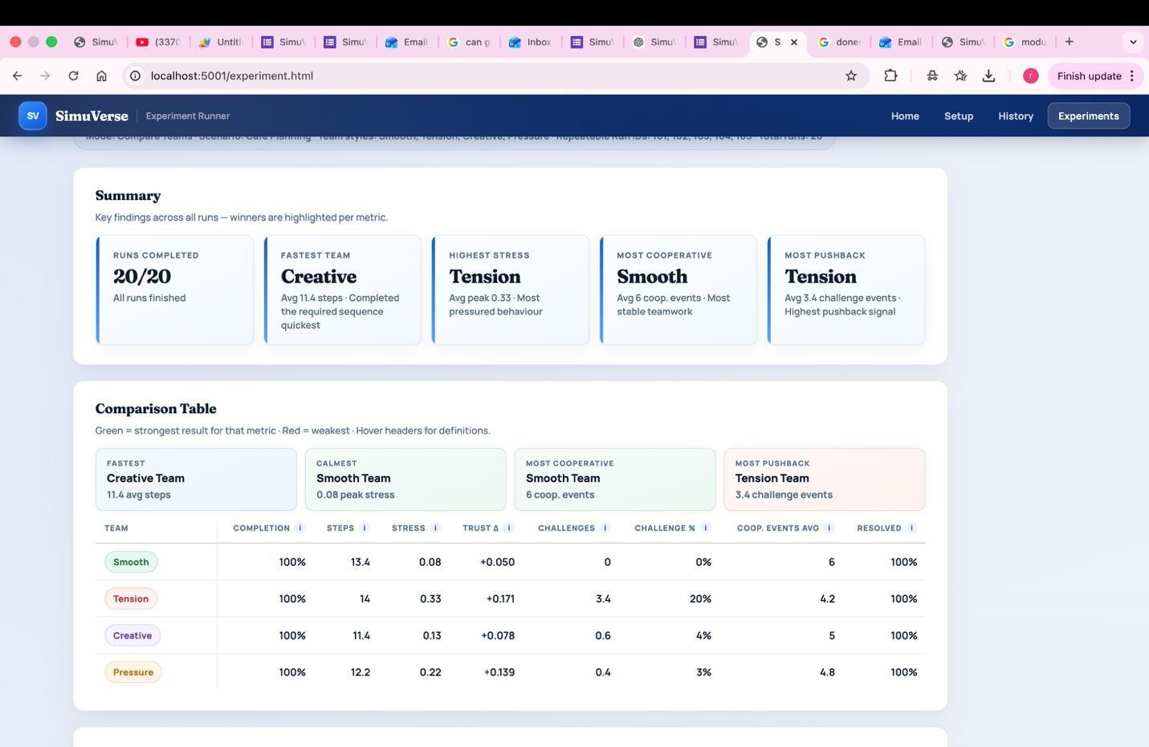
Figure 5.15: Experiment Runner summary and comparison table for repeated simulation runs.
Additional screenshots from the Experiment Runner (Figures 5.16-5.17) show the aggregated comparison table and the generated behaviour-difference interpretation used during evaluation.
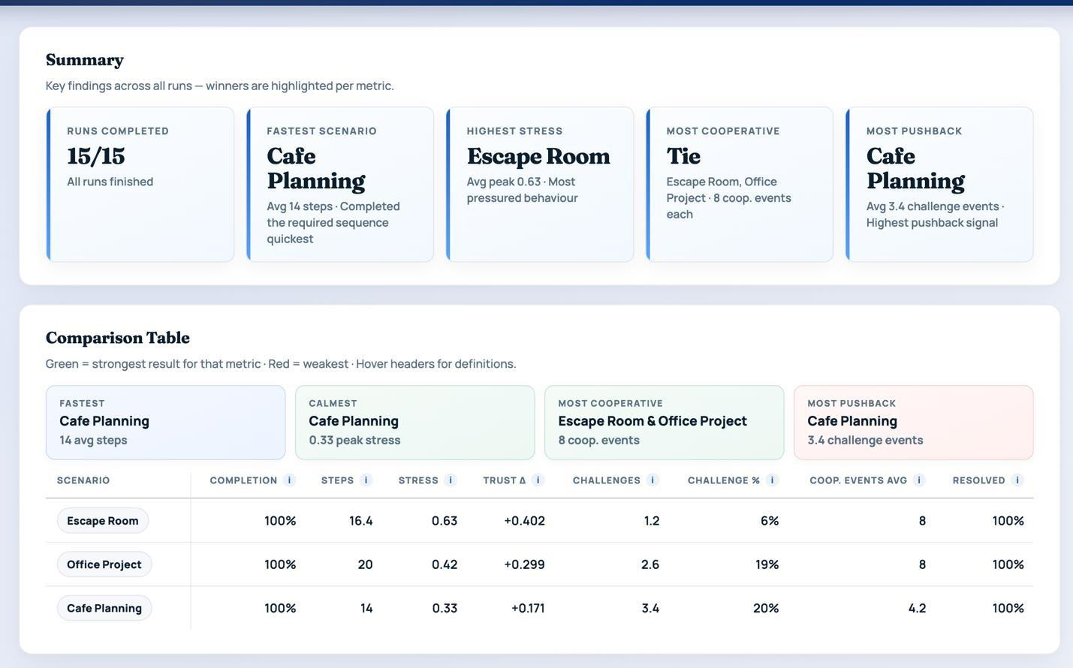
Figure 5.16: Experiment Runner summary and comparison table showing repeated runs across scenario and team configurations.
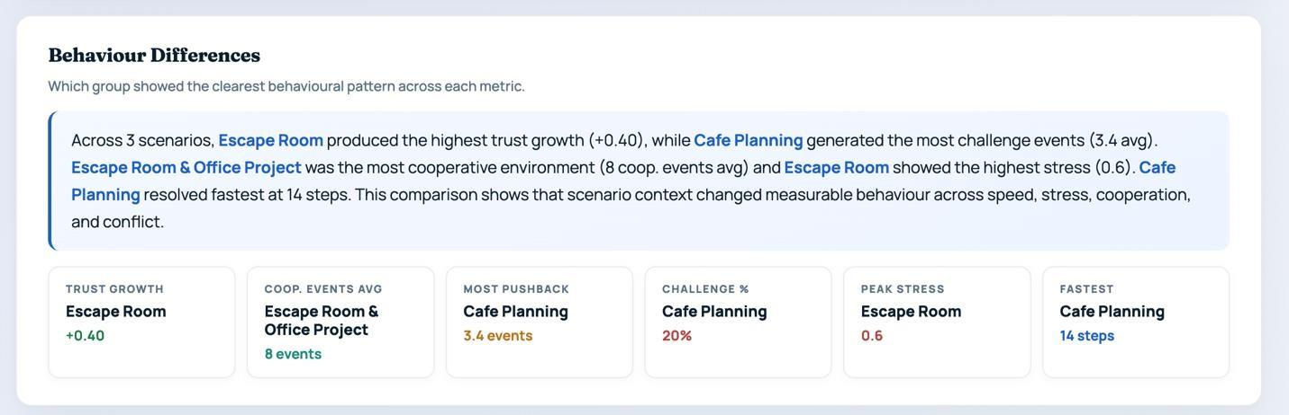
Figure 5.17: Experiment Runner behaviour-difference summary explaining how team configuration affected completion, stress and cooperation outcomes.

5.8 User Testing Results
Six participants completed a user testing form after using SimuVerse. Four identified as beginners, one as intermediate, and one had no prior technical background. This range was useful for testing whether the interface was understandable to users without agent-based modelling expertise. The sample was sufficient to identify prototype usability issues, but not sufficient to generalise to the target research audience.
All six participants successfully started a simulation, selected a scenario and team type, ran multiple simulation steps, and viewed the dashboard/results page. Four participants used a live intervention, five viewed the intervention impact results, and all six accessed the history and replay feature.
Item | Mean /5
Easy to navigate | 3.67
Understood what the simulation showed | 3.83
Step-by-step log was helpful | 4.17
Understood why agents made decisions | 4.17
Why/Effect explanations were helpful | 4.33
Metrics were useful | 4.33
Intervention controls easy to find and use | 3.83
Intervention impact felt meaningful | 4.33
Team types behaved differently | 4.17
Dashboard, history, replay, and experiments helpful | 4.50
Useful for understanding group behaviour | 4.33
Interface felt polished and understandable | 4.00
Table 5.4: User testing Likert-scale results (n=6).
The highest-scoring item was the dashboard, history, replay and experiment features (4.50/5), followed by Why/Effect explanations, metrics, intervention impact meaningfulness and overall usefulness, each scoring 4.33/5. The lowest-scoring item was ease of navigation (3.67/5), followed by overall comprehension of the simulation and intervention discoverability (both 3.83/5). These results reflect non-expert users; domain expert validation is needed to assess the tool's research utility for the intended academic audience.

Qualitative feedback reinforced this pattern. Participants commented positively on the step-by-step event log, the reasoning behind agent actions, the experiment comparison table and the clarity of the metric charts. Criticisms centred on interface complexity. Several participants reported that some controls were difficult to locate, that the number of buttons caused a sense of overwhelm, and that some event log text could be presented more readably.
Figures 5.18 to 5.20 provide supporting evidence from the Google Forms user testing responses, including positive comments, criticisms, intervention-specific feedback and the overall rating distribution.
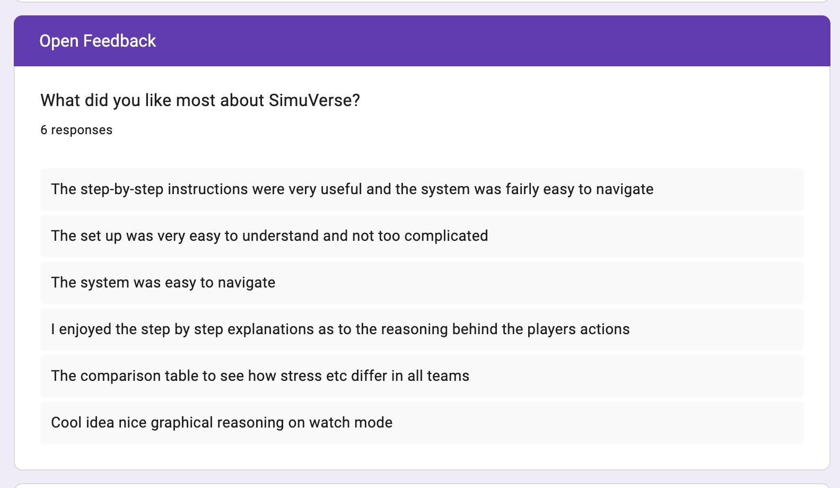
Figure 5.18: Open feedback responses showing positive comments about setup clarity, step-by-step explanations, experiment comparison and graphical reasoning.
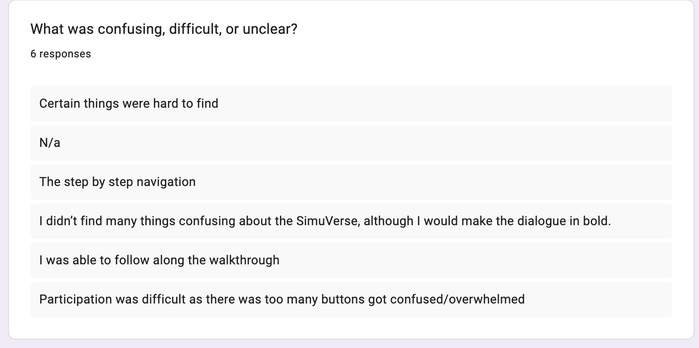
Figure 5.19: Open feedback responses identifying usability issues, including hard-to-find controls, step-by-step navigation and button overload.
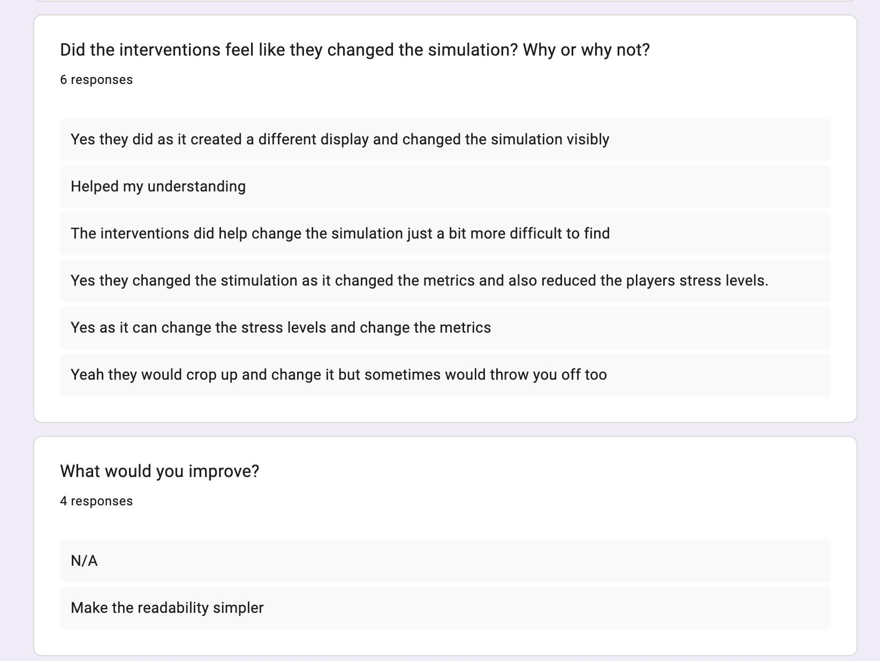
Figure 5.20: Intervention and improvement feedback showing that users noticed simulation changes but still identified readability and flow as areas for improvement.
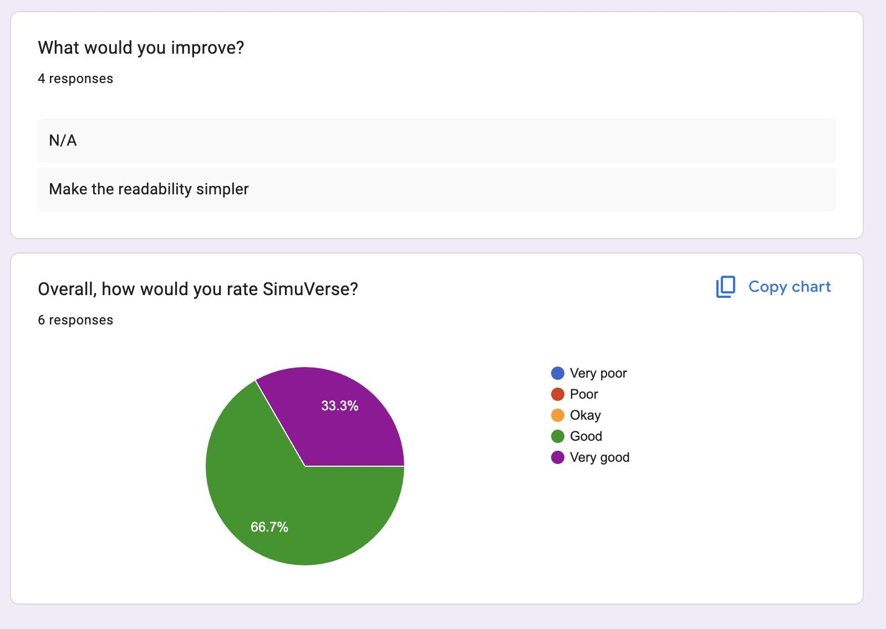
Figure 5.21: Overall user rating distribution for SimuVerse from the six-participant feedback form.
The Experiment Runner supports three evaluation modes. Comparing teams across a fixed scenario, comparing scenarios with a fixed team, and a reproducibility test. Figure 5.22 shows the initial setup screen on which users select the mode before proceeding to configuration.
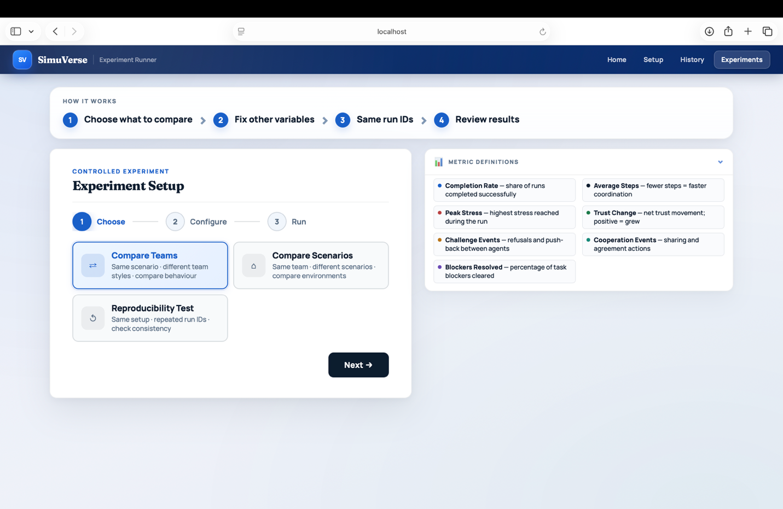
Figure 5.22: Experiment Runner setup screen showing the three available evaluation modes: Compare Teams, Compare Scenarios, and Reproducibility Test.
Figure 5.23 shows the configuration step for a controlled batch run. The selected batch IDs and run count are visible, with 20 simulations scheduled across three scenario and team pairings. This confirms that the runner accepts multi-scenario configurations and assembles a structured batch before execution begins.
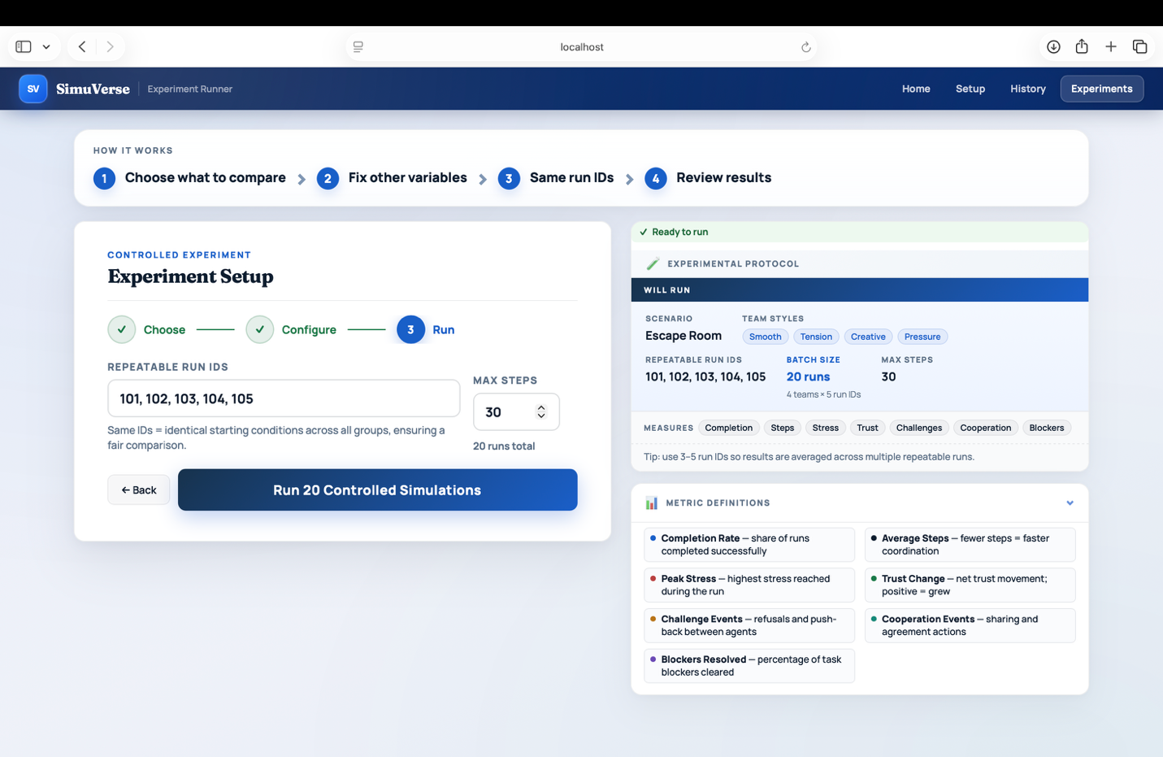
Figure 5.23: Experiment Runner configuration panel showing batch IDs, scenario and team assignments, and a total of 20 scheduled simulation runs.
Figure 5.24 shows the results page produced after the 20-run batch completed. The summary cards report total runs, active scenarios, and the top-rated scenario and team. Below the cards, a comparison table presents completion rate, steps, stress, trust, challenge events and cooperation events per configuration, enabling direct cross-scenario and cross-team comparison.
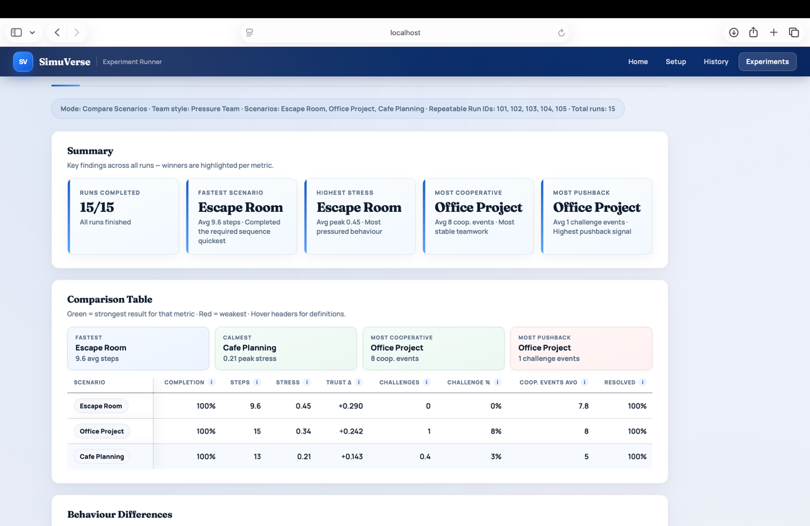
Figure 5.24: Experiment Runner results page showing summary cards and a per-configuration comparison table covering completion rate, steps, stress, trust, and event counts across three scenario-team pairings.
Figure 5.25 shows the Behaviour Differences panel, which identifies which configuration produced the most distinct outcome on each metric. The panel records that the Escape Room scenario produced the highest trust growth (+0.29) and fastest resolution (9.6 steps average), while the Office Project scenario generated the most challenge events and the highest cooperation event average.
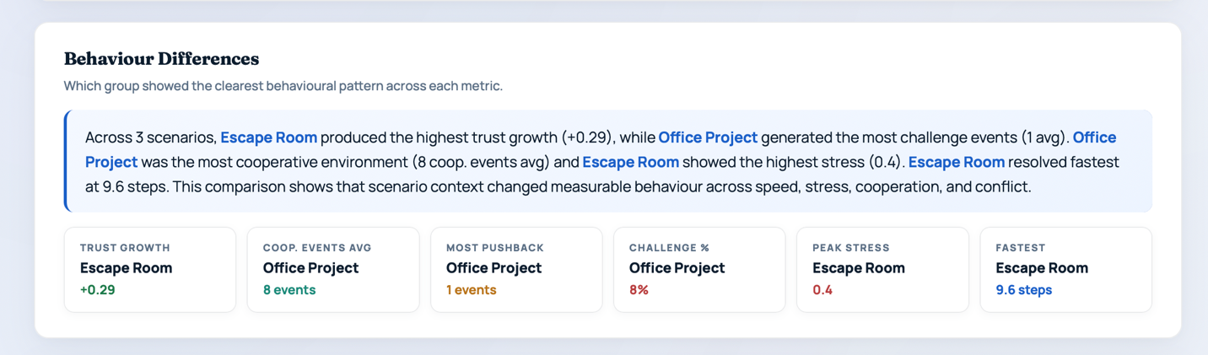
Figure 5.25: Behaviour Differences panel identifying the configuration with the strongest outcome on each metric, including trust growth, cooperation events, pushback, challenge rate, peak stress, and resolution speed.

5.9 Discussion of Findings
The evaluation provides evidence that the strongest aspects of SimuVerse are its explainability and post-run analysis features. The step-by-step log, Why/Effect explanations, dashboard, replay and experiment runner all scored strongly in user testing and are also supported by functional screenshot evidence. This indicates that the project’s central idea was successful at a user-facing level. Making simulated team behaviour inspectable rather than opaque was the stated goal, and the evidence supports that it was achieved.
The results also show that the system’s complexity is the main weakness. Navigation and intervention discoverability scored lower than the explanation and dashboard features. This matches the qualitative feedback, where participants described some controls as hard to find or overwhelming. The interface was improved during development through clearer onboarding text, a simplified pre-run state, more explicit intervention guidance and collapsed optional actions, but the evaluation still suggests that a guided tutorial would be valuable future work.
The scenario and intervention evidence supports the claim that SimuVerse is not a static display. Runs produce structured event sequences, interventions are visible in the run, and completed runs can be inspected through dashboard, replay and experiment views. However, these findings should be interpreted as prototype evaluation evidence, not as proof that the model predicts real human group behaviour.

5.10 Evaluation Limitations
Several limitations should be acknowledged. First, the user testing sample was small (n=6) and consisted mainly of non-technical users. This limits the generalisability of the results, especially because SimuVerse is framed as a research tool for HCI and agent-behaviour researchers. A domain-appropriate sample would provide stronger evidence of research utility.
Second, some testing was assisted. Participants were sometimes given verbal orientation before using the system independently, meaning that the results may overstate unaided discoverability. This is especially relevant to the lower navigation and intervention-control scores.
Third, intervention effects are observational rather than causal. The Intervention Impact view records before/after metric changes around an intervention, but the simulation continues to run during that period. Therefore, the measured change cannot be attributed solely to the intervention.
Finally, although automated pytest tests were added for core backend behaviour, the evaluation still relied partly on manual walkthroughs for UI behaviour, visual layout, and qualitative interpretation of run outputs. The automated tests improve confidence in the simulation engine, intervention logic, memory/emotion behaviour, personality presets, persistence, replay, and experiment runner, but they do not replace a full regression suite or browser-based end-to-end testing.
The scenario and experiment results are therefore treated as exploratory rather than statistically conclusive. Although the observed patterns were directionally useful for comparing team presets, the number of repeated runs per condition was too small to support strong statistical claims without further controlled experimentation.
The controlled intervention evidence focused on representative intervention behaviour rather than a full paired experiment for every intervention type. Five of the seven implemented interventions were formally observed. Force Meeting, Reveal Info, Nudge Strategy, Inject Tension, and Boost Urgency. Ease Pressure and Inject Mood were implemented but not formally evaluated in controlled runs; this is acknowledged as a scope limitation.
The ablation study (Section 5.11.4) partially addresses component contribution. Removing trust dynamics significantly altered simulation behaviour (p = 0.0005, d = 1.43). Memory and personality showed no significant macro-level effect at n=15 with actual episode lengths of 12-20 ticks, though both actively influence micro-level agent decisions. Longer scenarios and larger samples are needed to surface these effects. Quantitative experiments used use_nlp=False to control for linguistic variance, consistent with the design principle that dialogue is a rendering layer; future work should verify replication with NLP enabled.
The project did not include a direct comparison with an LLM-only baseline. Claims about reproducibility and interpretability are therefore based on the architecture and observed system behaviour rather than a controlled comparison. The interpretability benefits of SimuVerse’s state-driven approach, while architecturally justified, have not been quantitatively verified against a generative baseline. This comparison is a valuable direction for future work.

5.11 Quantitative Experiment Results
To supplement the functional and usability evidence in Sections 5.2-5.10, four quantitative experiments were run using the automated experiment runner. Natural language generation was disabled (use_nlp=False) to eliminate extraneous variance and isolate the state-driven architecture. This is consistent with the design principle that dialogue is a rendering layer, not the decision source. Preliminary checks with NLP enabled confirmed that this introduced additional variance that reduced statistical power for smaller effect sizes; future work with larger samples (n>=30) could incorporate full NLP without compromising detection of moderate effects.

5.11.1 Reproducibility Under Seeded Runs
Ten simulation runs were executed using an identical configuration (scenario: escape_puzzle, preset: smooth_team, seed: 42). Outcome, step count, mean trust, and mean stress were recorded per run.
Run | Outcome | Steps | Mean Trust | Mean Stress
1-10 (all) | success | 14 | 0.6263 | 0.1951
Table 5.5: Reproducibility test results (seed=42, n=10). All 10 runs produced identical values.
Outcome concordance was 10/10 (100%). Steps, mean trust, and mean stress were identical across every run (standard deviation = 0.000, coefficient of variation = 0.00%). This confirms that SimuVerse achieves perfect reproducibility under controlled seeding, directly addressing the reproducibility limitation identified by Mehta [8], where LLM-based agents produced inconsistent behaviour across repeated runs of identical configurations.
A further dimension of reproducibility is code-level transparency. The SimuVerse backend is extensively commented throughout, with inline docstrings on all agent methods, simulation step functions, intervention handlers, and metric calculations. Every non-trivial design decision in the simulation logic is annotated with a brief explanation of why the rule was written as it was. This means the implementation is readable independently of this document. A researcher can inspect the trust update function, follow the comment explaining the role of the modifiers term, and verify that the code matches the description in Section 3.9 without needing external guidance. Together with seeded random state, full run persistence, and the experiment runner's batch configuration files, the commented codebase forms the practical foundation for end-to-end reproducibility.

5.11.2 Personality Preset Effects on Cooperation and Conflict
Twenty runs per preset were executed on the office_proposal scenario (seeds 0-19), covering all four team configurations: Smooth, Creative, Pressure, and Tension. Share events, refusal events, challenge events, mean steps to completion, mean trust, and mean stress were recorded. Progress refers to the proportion of scenario blockers completed at run end.
Preset | Challenges (mean±sd) | Refusals (mean±sd) | Steps  (mean±sd) | Trust  (mean±sd) | Stress  (mean±sd)
Smooth | 0.1 ± 0.2 | 0.6 ± 0.6 | 12.8 ± 2.0 | 0.645 ± 0.014 | 0.087 ± 0.007
Creative | 0.0 ± 0.0 | 0.7 ± 0.8 | 13.1 ± 2.4 | 0.616 ± 0.019 | 0.093 ± 0.014
Pressure | 0.3 ± 0.5 | 0.8 ± 0.7 | 16.9 ± 3.2 | 0.555 ± 0.013 | 0.213 ± 0.026
Tension | 0.9 ± 1.1 | 0.7 ± 0.7 | 18.2 ± 2.8 | 0.533 ± 0.009 | 0.297 ± 0.018
Table 5.6: Personality preset comparison (office_proposal, n=20 per preset, seeds 0-19).
Welch’s independent t-tests comparing Smooth and Tension presets showed statistically significant differences on four of the five primary metrics tested: challenge events (t = -3.59, p = 0.0018, Cohen’s d = 1.14), mean trust (p < 0.0001, d = 9.72), mean stress (p < 0.0001, d = 15.52), and steps to completion (t = -8.21, p < 0.0001, d = 2.60). Refusal events did not differ significantly (p = 0.46). The consistent ordering across all four presets was Smooth < Creative < Pressure < Tension for both stress and steps. This confirms that personality presets produce measurably different agent behaviours. The Creative preset closely resembles Smooth in cooperation metrics but produces slightly lower trust, while Pressure produces substantially higher stress and longer runs, consistent with its higher urgency modifier. These results confirm that the preset system functions as designed across all four configurations. Share events were invariant across all four presets (4.0 +/- 0.0) because the office_proposal scenario requires exactly four knowledge transfers to reach task completion; this reflects scenario completion mechanics rather than personality-driven sharing propensity, and is the expected behaviour by design. Note that team presets combine personality traits with urgency modifiers and stress multipliers; the significant differences observed here reflect the combined preset effect, not personality trait variance alone. Personality trait variance is isolated separately in the ablation study (Section 5.11.4).

5.11.3 Causal Effect of Force Meeting Intervention
A paired counterfactual experiment tested whether Force Meeting produces a statistically distinguishable effect on final trust. Fifteen seeds (0-14) each produced one control run and one intervention run (Force Meeting between A1 and A3 applied at tick 5). Scenario: office_proposal, preset: tension_team.
Condition | Mean Trust (end) | Std | Mean Steps | Positive Δ trust seeds
Control (no intervention) | 0.5325 | 0.009 | 18.7 | ,
Force Meeting at tick 5 | 0.5412 | 0.010 | 19.5 | 13 / 15
Table 5.7: Intervention counterfactual results (office_proposal, tension_team, n=15 paired seeds).
A paired t-test on final trust produced t = -4.09, p = 0.0011, Cohen’s d = 0.835, indicating a statistically significant trust increase after Force Meeting. Mean trust delta was +0.0086; 13 of 15 seeds showed a positive delta, confirming consistency across seeds. Steps to completion did not differ significantly (p > 0.05). This is consistent with the design intent of tracking trust and progress as separate metrics, and indicates Force Meeting improves social cohesion without necessarily accelerating task completion. These results support RQ4. User interventions produce measurable, causally attributable effects on simulation state.

5.11.4 Ablation Study: Contribution of Trust, Memory, and Personality
Four conditions were tested (n=15 runs each, seeds 0-14) on the office_proposal scenario with tension_team preset: (1) full model; (2) no trust dynamics, with all trust values fixed at 0.5 after each tick; (3) no memory, with STM and impressions cleared after each tick; (4) neutral personality, with all agent OCEAN trait scores set to 0.5.
Condition | Mean Steps (±sd) | Mean Conflicts (±sd) | Mean Trust | Mean Stress
Full model | 18.7 ± 2.6 | 1.7 ± 1.3 | 0.533 | 0.299
No trust dynamics | 15.1 ± 2.5 | 1.3 ± 0.9 | 0.500 | 0.276
No memory | 19.0 ± 2.6 | 1.8 ± 1.3 | 0.532 | 0.296
Neutral personality | 18.7 ± 2.6 | 1.7 ± 1.3 | 0.533 | 0.299
Table 5.8: Ablation study results (office_proposal, tension_team, n=15 per condition).
Welch’s t-tests with Bonferroni correction (α = 0.0167 for three comparisons) showed that removing trust dynamics significantly reduced mean steps (15.1 vs 18.7, p = 0.0005, d = 1.43), indicating that dynamic trust updates actively slow task completion in tension-preset teams by generating additional conflict events. Memory and personality components showed no significant macro-level effect on steps or conflicts at n=15 with actual episode lengths of 12-20 ticks. The absence of aggregate-level effects does not indicate component inactivity; micro-level influences on agent decision probabilities are visible in event logs but require longer episodes and larger samples to surface in macro metrics. Trust dynamics produces a large enough macro-level signal (d = 1.43) to clear the Bonferroni threshold.

Chapter 6: Critical Appraisal

6.1 Project Strengths
The explainability layer is the strongest part of the system. Every action in the simulation log comes with a Why explanation and an Effect note, giving a plain-language causal account of each decision. This is what most simulation tools skip. They show you what happened, not why, and that gap is what SimuVerse was specifically built to close.
The intervention system worked better in practice than I expected. Seven types, each with before/after metric tracking, means users can actually test whether their action changed anything rather than just feeling like they're interacting. That turns SimuVerse into something genuinely experimental rather than a passive viewer.
The experiment runner proved more useful than I initially treated it. Running controlled batches and comparing outcomes across team types gives the kind of repeatable evidence that makes simulation-based research defensible. It also scored highest in user testing (4.50/5), which surprised me. I expected participants to engage more with the live simulation than the comparison table.
Code transparency supports reproducibility in a practical way beyond seeding alone. Docstrings and inline comments on all simulation, agent and intervention logic mean someone else can audit, replicate or extend the system without having to reverse-engineer what each component does.
The step-by-step interaction model was the right call for the intended audience. Researchers studying agent decisions need to be able to pause and inspect rather than just watch a run complete, and giving participants control over pace contributed directly to the usability scores.

6.2 Architectural and Technical Limitations
The emotion detection component of the Inject Mood intervention is the main technical limitation. The natural language classifier used to map user-entered text to a discrete emotional state is rule-based, relying on keyword matching. This approach is brittle. It may misclassify complex emotional descriptions, fail on unfamiliar phrasing, or produce incorrect valence assignments for inputs that do not match the keyword dictionary. A learned classifier would be more reliable, but was beyond the scope of this project.
The cohesion and tension metrics, while individually informative, are derived from the same underlying event signal and are therefore inversely correlated by design. Reporting both creates an impression of richer measurement than the underlying model independently supports, and this relationship should be made explicit when citing these metrics as evidence.
The simulation parameters are designer-defined rather than empirically grounded. These include probability weights, stress and trust update magnitudes, and urgency modifiers. While they produce plausible and consistent behaviour, they are not calibrated against real-world team dynamics data. This limits the external validity of the simulation as a model of actual human group behaviour, and findings should be interpreted as internally consistent simulation results rather than predictions of real team outcomes.
This means SimuVerse should be understood as a hypothesis-generating tool rather than a predictive model of real teams. Its value lies in making interaction mechanisms visible and controllable, not in claiming that the exact numerical trajectories will match human groups without further validation.
The deeper question is whether the state-driven approach itself is the right architecture, not merely whether it was implemented well. A rule-based agent is interpretable because its decision logic is explicit, but it is not cognitively realistic. The actions it produces are generated by weighted rules, not by anything resembling genuine reasoning. This creates a fundamental tension: the platform's main value proposition, that agent behaviour is explainable, rests on simplifications that make the agents less like the social actors the platform is supposed to model. Researchers using SimuVerse to explore group dynamics are not observing simulated humans; they are observing the consequences of designer-chosen rules expressed as human-like dialogue. Whether the insights transfer to real teams is an empirical question that this dissertation does not answer.
The expressiveness-interpretability trade-off was resolved conservatively. The architecture prioritised the ability to explain every decision over the ability to produce surprising or emergent behaviour. This was a defensible choice for a research prototype, but it is not the only reasonable choice. A more expressive system, one in which agents could form higher-order beliefs, update strategies dynamically, or reason about other agents' mental states, would produce richer interaction at the cost of post-hoc explainability. The current design occupies a point on that trade-off curve, but it is not obviously the optimal point. For research questions about specific, controllable interventions, high transparency is more valuable. For research questions about emergent social organisation, the current level of expressiveness may be insufficient. The platform does not make this limitation explicit to users, which risks the findings being over-interpreted.
A related concern is circularity in the parameter design. The update rules for trust, tension, and cohesion encode the designer's prior beliefs about how social variables should behave. When the simulation confirms that Tension teams produce more conflict than Smooth teams, it is not clear whether this reflects a discovery about agent dynamics or a recovery of assumptions built into the parameter values. The ablation study partially addresses this: by removing components entirely rather than varying parameters, it tests structural claims rather than numerical ones. But the direction of the trust-update rule, the sign of stress responses, and the magnitude of personality modifiers are all designer choices that the evaluation cannot validate. Grounding these values empirically, by fitting them to data from real team interaction studies, would change the epistemic status of any result the platform produces.
Experiment runner results should be interpreted with caution. Observed patterns are directionally consistent with design intent. Higher stress in Tension teams and higher cooperation in Smooth teams are the expected directions, but the number of repeated runs was too small for statistically generalisable claims. The results show the system produces different outcomes under different configurations; they do not show that differences would hold at scale.

6.3 Evaluation Limitations
A further limitation concerns the intervention evidence. The Intervention Impact view records before/after metric changes, but other agent interactions occurring in the same tick may also contribute to the observed delta. Intervention evidence is therefore observational rather than causal: it shows the system responds to user input and that metrics move, but cannot isolate the intervention as the exclusive driver of that change.
As noted in Chapter 5, the user testing sample was small and predominantly non-technical. This limits the generalisability of usability findings to the intended research audience. The assisted nature of several testing sessions further means that some scores may overstate the system's unaided discoverability.
Although an evaluation-focused automated pytest suite was added, it was designed to cover representative backend behaviours rather than every possible edge case. Functional and scenario testing still relied partly on manual walkthroughs, particularly for UI behaviour, visual layout, and the interpretation of run outputs. As a result, the automated tests strengthen confidence in the core backend but do not remove the need for broader regression testing in future development.

6.4 Reflection on Development Process
Looking back at how the project developed, the biggest thing I got wrong was leaving usability testing too late. I was so focused on getting the simulation working correctly that I treated the interface as something to tidy up at the end. By the time participants flagged that the controls were hard to find and the navigation was confusing, most of the architectural decisions were already locked in. The improvements I made in response collapsing optional controls, adding onboarding cues, reorganising the tabs were real improvements, but they felt like patching something that should have been designed better from the start.
If I was doing this again I would run a short usability session after each major feature was added, not just at the end. Even two or three people trying the intervention panel early on would have told me it was not obvious enough. The evaluation data ended up showing exactly what I suspected but had not formally confirmed: the explainability features scored well, the navigation did not. Earlier testing would have let me act on that rather than just document it.

6.5 Ethical Considerations
SimuVerse was designed as a synthetic simulation tool rather than a system for making decisions about real people. This reduces risk because the agents are artificial and no human participant data is used to drive the simulation behaviour. User testing was limited to feedback on usability and clarity, and participants were asked to provide anonymous feedback rather than personal or sensitive information.
The system also avoids exposing private API keys or storing unnecessary personal information in the prototype workflow. Completed run records are used for replay and evaluation, but they represent simulated agent behaviour rather than real conversations between people. These choices support responsible use of the tool while keeping the project within the ethical boundaries appropriate for a final-year software engineering prototype.

6.6 Future Improvements
The single biggest thing I would add is proper natural language dialogue. Right now agents produce structured event descriptions rather than actual sentences. The internal state trust, stress, personality does all the real work, so a language model could sit on top of that purely as a dialogue renderer without touching any of the underlying mechanics. That way you keep the interpretability of explicit state while making runs feel like watching a team interact rather than reading a log file. I deliberately left this out because I did not want the LLM to become a black box that hides what the agents are actually doing, but keeping the state-driven engine and using a model just for surface generation would solve that. That is the version of this I would build next.
The second thing I would fix is the failure problem. Every single run succeeds, which sounds fine but is actually a research limitation. You cannot study how teams recover from breakdown, or what interventions can save a run heading toward deadlock, if nothing ever fails. I would add harder scenario variants with tighter knowledge dependencies and lower starting trust so the system can model team failure as well as success. Right now the platform only really demonstrates the mechanics of things going right. I would also build a proper visual scenario editor. Currently scenarios are defined in configuration code, which means only someone comfortable with Python can design a custom experiment. If the aim is to let researchers create their own conditions without needing to touch the codebase, that is a real barrier. A drag-and-drop interface for setting up blockers, assigning knowledge items, and defining completion rules would make the platform genuinely accessible to the people it is supposed to serve.
The parameters are the thing that bothers me most from a research credibility standpoint. How much trust changes after a refusal, how stress rises after a conflict. All those values were set based on what felt plausible when I was testing the system. They are not calibrated against any real data. Until those numbers come from actual team interaction studies rather than my intuition, the simulation is really just confirming its own assumptions. Fitting the update rules to a real dataset of team behaviour would be the most important step toward making SimuVerse a credible research tool rather than just a well-built prototype. On the evaluation side, the user study needs to be done properly with ten to twenty participants from the actual target audience HCI researchers or social simulation students using a structured inspection task rather than free exploration. That is the only way to give the explainability findings the evidence base they currently lack.
Table 6.1 summarises the main limitations identified during development and evaluation, together with their practical impact and proposed future improvement.
Limitation | Impact on project validity | Future improvement
Small user testing sample | The n=6 sample provides useful formative feedback but limits generalisability to the intended HCI or agent-based modelling audience. | Repeat the evaluation with a larger and more domain-relevant group of participants.
Observational intervention impact | Before/after metric snapshots show nearby changes but cannot prove that an intervention was the sole cause. | Add counterfactual seeded comparisons that replay the same run with and without the intervention.
Designer-defined simulation parameters | Stress, trust, urgency, and personality weights produce plausible patterns but are not calibrated against real team datasets. | Calibrate parameters using empirical collaboration data or expert validation.
Rule-based emotion handling | Keyword-based emotion detection can miss nuanced phrasing and may simplify emotional state changes. | Replace or supplement it with a lightweight trained sentiment/emotion classifier.
Representative automated tests only | The pytest suite covers core backend behaviours but does not exhaustively test every UI state, stochastic path, or edge case. | Expand automated regression coverage and add frontend/end-toend tests after submission.
Ablation study limited in scope | Trust dynamics were shown to be significant (p = 0.0005, d = 1.43); memory and personality produced no detectable effect in short episodes (12-20 ticks observed, n=15), suggesting these components require longer scenarios to isolate reliably. Emotion state and event-modifier components were not ablated. | Replicate ablation with longer scenarios, larger samples (n≥30), and add emotion state as a separate ablation condition.
Limited intervention comparison | The prototype demonstrates that interventions can affect runs, but not every intervention was tested in a controlled paired design. | Evaluate each intervention against matched nointervention runs using the same seed and scenario configuration.
Table 6.1: Summary of key limitations, their impact on the project, and future improvements.
The seven limitations in Table 6.1 cover evaluation scope, intervention evidence quality, parameter grounding, emotion handling, test coverage, ablation depth, and intervention breadth. None of these limitations invalidate the core findings; they define the boundary conditions under which the results should be interpreted. The most actionable items for future work are expanding the user testing sample, replacing the keyword-based emotion classifier, and running each intervention in a controlled paired design.

Chapter 7: Conclusion

7.1 Summary
SimuVerse is an explainable, interactive multi-agent simulation platform built to address a recognised gap between the interpretability of conventional agent-based models and the social expressiveness that group behaviour research requires. Four agents interact within structured scenario tasks, holding directed trust relationships, personality traits, short-term memory, and continuously updated stress and emotional valence. Every agent action is logged with a plain-language Why explanation and an Effect note so that the reasoning behind each event can be read rather than inferred. Users can intervene in live runs using seven intervention types, each with measured before-and-after metric impact, and completed runs are stored in full for replay and batch comparison.

7.2 What This Work Establishes
The evaluation shows that social expressiveness and interpretability can coexist at prototype scale which was the actual question this project set out to answer. Three results stand out beyond the system just functioning. The ablation study shows trust dynamics doing real structural work: removing them cuts mean run length from 18.7 to 15.1 steps (p = 0.0005, Cohen's d = 1.43), the largest effect in the evaluation. Trust was expected to modulate outcomes, but not by that margin relative to personality and memory. The magnitude was a genuine finding. The Force Meeting intervention produced a statistically significant trust increase (p = 0.0011, d = 0.835), showing that deliberate structural intervention is detectable with the available metrics. And urgency and tension, designed as two dimensions of the same pressure axis, behave as distinct mechanisms in practice urgency tends to focus agents around blockers while tension disrupts cooperation and amplifies conflict. That only became clear from the data, not the design.

7.3 What Was Surprising
The balance of component contributions was the clearest surprise. Personality was treated as the primary differentiating factor during design. Different agreeableness and neuroticism values were expected to produce the most visible outcome differences. Instead, the ablation results show that trust dynamics produce the largest single effect on run length, with memory and personality individually falling short of statistical significance in the same comparison. In short, how agents accumulate and update relational history matters more than what type of person they start as, at least within the bounded task environments used here.
The experiment runner also proved more useful than expected. It began as a reproducibility and comparison tool but became one of the strongest pieces of evidence in the evaluation, surfacing effect sizes and cross-preset patterns that would not have been visible from representative walkthroughs alone. The decision to build a batch runner early, rather than treating it as a stretch goal, turned out to be correct.

7.4 What Would Be Done Differently
Three design choices would change on a second attempt. First, cohesion and tension would be decoupled from the same event signal. Their inverse correlation is an artefact of the model, not a finding about teams. Reporting both gives a superficial impression of richer data than the system actually captures. Second, simulation parameters would be calibrated against empirical data from real team interaction studies rather than set by designer judgement. The current values produce plausible behaviour, but plausible is not validated. Claims about how trust and stress change after events need a grounding that intuition cannot provide. Third, a direct comparison with an LLM-only baseline would be built in from the outset. The interpretability advantage of the state-driven approach is real, but it can only be demonstrated convincingly against a concrete alternative. Running that comparison at the end, when it is too late to modify either system in response to the findings, is the right structure for a controlled study and not what was possible here.
RQ | Research Question (summary) | Key Evidence | Result
RQ1 | Goal-oriented dialogue enables task completion | 4 share events per run; 100% task completion across scenarios | ✓ Supported
RQ2 | Personality/trust shapes social behaviour | Test 2: trust p<0.0001, d=9.55; challenges p=0.0018, d=1.14; steps p<0.0001, d=2.23 | ✓ Supported
RQ3 | Reproducible outcomes under seeded runs | Test 1: 10/10 concordance, CV=0.00%, std=0.000 | ✓ Supported
RQ4 | Interventions causally alter simulation state | Test 3: paired t-test p=0.0011, d=0.835; 13/15 positive deltas | ✓ Supported
RQ5 | Agent behaviour interpretable via Why/Effect | User testing: Why/Effect  4.33/5; usefulness  4.33/5 | ✓ Partial
Usability testing would also be moved earlier. Interface complexity was the main weakness identified by participants, and some of the improvements made in response to late-stage feedback could have shaped the design from the beginning. Earlier testing would also have produced a larger and more technically representative sample, strengthening the generalisability of the usability findings.
One structural change would be motivated by the urgency-tension finding. Because urgency and tension emerged as mechanistically distinct rather than dimensionally similar, they deserve separate intervention controls with independent parameter paths. Combining them conceptually as 'pressure' during design was imprecise and produced an intervention system that conflates two different social phenomena.

7.5 On the State-Driven Approach
The state-driven architecture makes a trade-off that deserves to be stated plainly. It gains interpretability by sacrificing social realism. An agent that adjusts trust by a weighted combination of event type, personality, and context is understandable in a way that a language model is not. But it is also more predictable in ways that limit its research value. The relevant question is whether a simulation that produces statistically consistent outcomes across twenty seeds is discovering something about group dynamics or merely demonstrating the properties of its own rule set. That question does not have a clean answer, but it is the right question to ask. The expressiveness-interpretability trade-off was resolved conservatively here. Every design decision favoured transparency over surprise: explicit dialogue acts, bounded continuous variables, designer-defined update rules. The result is a system that explains itself clearly but rarely produces genuinely unexpected behaviour. A more expressive architecture might generate richer emergent dynamics at the cost of post-hoc explainability. Whether that would have been a better choice depends on the research question. For controlled hypothesis testing about specific interventions, the current balance is appropriate; for studying emergent social phenomena, it may be too constrained. The designer-defined parameters also introduce a circularity that limits the strength of the evaluation findings. If the parameters encode the designer's expectations about how stress, trust, and tension behave, the simulations are likely to confirm those expectations. The ablation results are the most defensible findings precisely because they do not depend on parameter values being correct, only on the structural presence or absence of components. Future work that replaces designer-defined weights with empirically grounded ones would change the epistemic status of the platform's outputs.

7.6 Closing Reflection
SimuVerse answers the question it set out to address. Social simulation can be made readable without becoming trivial. Agent decisions are traceable to measurable causes. Interventions produce detectable effects. Runs are fully reproducible and comparable across conditions. These are modest but genuine contributions, and they are grounded in empirical results rather than design claims alone. The surprises encountered along the way, including the dominance of trust dynamics over personality, the divergence of urgency and tension as mechanisms, and the unexpected utility of the experiment runner, are the most valuable outcomes of the work. They suggest that the platform is responsive enough to produce findings that were not written into it at design time. That is the minimal condition a research tool should meet, and SimuVerse meets it. What comes next is straightforward. Ground the parameters, build the baseline comparison, decouple the correlated metrics, and test with the research community that would use the tool. The foundation is in place.

References
[1] M. W. Macy and R. Willer, “From factors to actors: Computational sociology and agent-based modeling,” Annual Review of Sociology, vol. 28, pp. 143-166, 2002.
[2] K. M. Carley and M. J. Prietula, Eds., Computational Organization Theory. Hillsdale, NJ, USA: Lawrence Erlbaum Associates, 1994.
[3] J. M. Epstein, “Modelling to contain pandemics,” Nature, vol. 460, no. 7256, p. 687, 2009.
[4] E. Bonabeau, “Agent-based modeling: Methods and techniques for simulating human systems,” Proceedings of the National Academy of Sciences, vol. 99, suppl. 3, pp. 7280-7287, 2002.
[5] L. Tesfatsion and K. L. Judd, Eds., Handbook of Computational Economics, vol. 2: Agent-Based Computational Economics. Amsterdam, Netherlands: Elsevier North-Holland, 2006.
[6] J. S. Park, J. C. O’Brien, C. J. Cai, M. R. Morris, P. Liang, and M. S. Bernstein, “Generative agents: Interactive simulacra of human behavior,” in Proc. 36th Annual ACM Symp. User Interface Software and Technology (UIST ’23), San Francisco, CA, USA, 2023, pp. 1-22.
[7] C. Gao, X. Lan, N. Li, Y. Yuan, J. Ding, Z. Zhou, F. Xu, and Y. Li, “Large language models empowered agent-based modeling and simulation: a survey and perspectives,” Humanities and Social Sciences Communications, vol. 11, Art. no. 1259, 2024.
[8] A. Mehta, “When agents disagree with themselves: Measuring behavioral consistency in LLM-based agents,” arXiv preprint arXiv:2602.11619, 2026.
[9] N. Shinn, F. Cassano, A. Gopinath, K. Narasimhan, and S. Yao, “Reflexion: Language agents with verbal reinforcement learning,” in Advances in Neural Information Processing Systems (NeurIPS 2023), 2023.
[10] M. Larooij and P. Törnberg, “Validation is the central challenge for generative social simulation: a critical review of LLMs in agent-based modeling,” Artificial Intelligence Review, vol. 59, no. 1, Art. no. 15, 2026.
[11] Y. Xiao, V. J. Zhang, C. Yang, N. Ma, W. Xuan, and J.-T. Huang, “The chameleon’s limit: Investigating persona collapse and homogenization in large language models,” arXiv preprint arXiv:2604.24698, 2026.
[12] Y. Lu, J. Huang, Y. Han, B. Yao, S. Bei, J. Gesi, Y. Xie, Y. Sang, Z. Wang, Q. He, and D. Wang, “Can LLM agents simulate multi-turn human behavior? Evidence from real online customer behavior data,” arXiv preprint arXiv:2503.20749, 2025.
[13] M. Shanahan, K. McDonell, and L. Reynolds, “Role play with large language models,” Nature, vol. 623, pp. 493-498, 2023.
[14] S. P. Marsh, “Formalising trust as a computational concept,” Ph.D. dissertation, Dept. Comput. Sci. Math., Univ. Stirling, Stirling, UK, 1994.
[15] C. Castelfranchi and R. Falcone, “Social trust: A cognitive approach,” in Trust and Deception in Virtual Societies, C. Castelfranchi and Y.-H. Tan, Eds. Dordrecht, Netherlands: Kluwer Academic Publishers, 2001, pp. 55-90.
[16] J. Sabater and C. Sierra, “Review on computational trust and reputation models,” Artificial Intelligence Review, vol. 24, no. 1, pp. 33-60, 2005.
[17] O. P. John and S. Srivastava, “The Big Five trait taxonomy: History, measurement, and theoretical perspectives,” in Handbook of Personality: Theory and Research, 2nd ed., L. A. Pervin and O. P. John, Eds. New York, NY, USA: Guilford Press, 1999, pp. 102-138.
[18] P. T. Costa, Jr. and R. R. McCrae, Revised NEO Personality Inventory (NEO-PI-R) and NEO Five-Factor Inventory (NEO-FFI) Professional Manual. Odessa, FL, USA: Psychological Assessment Resources, 1992.
[19] R. R. McCrae, “The Five-Factor Model of personality across cultures,” Online Readings in Psychology and Culture, vol. 4, no. 4, 2002.
[20] A. D. Baddeley, “The episodic buffer: A new component of working memory?” Trends in Cognitive Sciences, vol. 4, no. 11, pp. 417-423, 2000.
[21] P. Ekman, “An argument for basic emotions,” Cognition and Emotion, vol. 6, no. 3-4, pp. 169-200, 1992.
[22] A. Ortony, G. L. Clore, and A. Collins, The Cognitive Structure of Emotions. Cambridge, UK: Cambridge University Press, 1988.
[23] K. R. Scherer, A. Schorr, and T. Johnstone, Eds., Appraisal Processes in Emotion: Theory, Methods, Research. Oxford, UK: Oxford University Press, 2001.
[24] J. L. Austin, How to Do Things with Words. Oxford, UK: Oxford University Press, 1962.
[25] J. R. Searle, Speech Acts: An Essay in the Philosophy of Language. Cambridge, UK: Cambridge University Press, 1969.
[26] P. R. Cohen and H. J. Levesque, “Performatives in a Rationally Based Speech Act Theory,” in Proc. 28th Annual Meeting of the Association for Computational Linguistics, Pittsburgh, PA, USA, 1990, pp. 79-88.
[27] R. S. Lazarus, Emotion and Adaptation. New York, NY, USA: Oxford University Press, 1991.
[28] U. Wilensky, “NetLogo,” Center for Connected Learning and Computer-Based Modeling, Northwestern Univ., Evanston, IL, USA, 1999. [Online]. Available: http://ccl.northwestern.edu/netlogo/
[29] D. Masad and J. Kazil, “Mesa: An agent-based modeling framework,” in Proc. 14th Python in Science Conf. (SciPy 2015), Austin, TX, USA, 2015, pp. 53-60.
[30] S. Amershi, M. Cakmak, W. B. Knox, and T. Kulesza, “Power to the People: The Role of Humans in Interactive Machine Learning,” AI Magazine, vol. 35, no. 4, pp. 105-120, 2014.

APPENDIX A: Automated Unit Test Suite
The automated backend test suite (test_evaluation_core.py) contains 18 tests covering 12 functional areas. The pytest output screenshot showing all tests passing is shown in Figure A.1 below. The tests cover the following functional areas:
1. Scenario loading: Office, Café, and Escape Room scenarios construct without error
2. Simulation step: a single step correctly advances the tick counter
3. Metric validity: stress, trust, and tension values remain within [0, 1] at all ticks
4. Metric history structure: all required keys are present in the per-tick metric record
5. reveal_info intervention: the target agent gains the specified knowledge item
6. force_meeting intervention: returns valid trust-change fields
7. boost_urgency intervention: urgency modifier is non-decreasing after the call
8. inject_emotion intervention: call succeeds and all agent states remain bounded
9. Memory system: short-term memory is populated after an agent interaction
10. Preset configuration differences: Smooth and Tension/Pressure presets differ in key configuration values
11. Preset structural effect: Smooth team preset produces lower initial stress than the Tension preset
12. Run persistence: a completed run is saved to file as valid JSON containing all required fields
13. Run loading: load_run returns the correct run dictionary for a saved run ID
14. Run replay: replay_run returns a valid tick-by-tick list for a saved run
15. Experiment runner: run_experiment returns a valid result dictionary
16. Experiment success rate: success_rate is a bounded float within [0, 1]
17. Scenario alias resolution: scenario ID aliases (e.g. “cafe”, “escape”) resolve correctly to their canonical scenario keys
18. Run registry lifecycle: a run can be created, stepped, and deleted from the registry without error

Figure A.1: Pytest output showing all 18 unit tests passing

APPENDIX B: Scenario Definitions
The following table defines the three canonical scenarios used in SimuVerse. Each scenario specifies the environment, the tasks agents must complete, the initial knowledge distribution across agents, and the maximum number of ticks before the run times out.
Scenario | Tasks | Agent Knowledge Distribution | Max Ticks
Office: Complete Project Proposal | Budget, Requirements, Design, Technical Specifications | A1: Budget · A2: Requirements · A3: Design · A4: Tech Specs | 30
Café: Choose Restaurant | Final Decision (reached by sharing: Italian, Vegan, Budget Option, Fine Dining) | A1: Italian · A2: Vegan · A3: Budget Option · A4: Fine Dining | 20
Escape Room: Solve Puzzle Chain | Room Map, Key Location, Lock Pattern, Door Code, Unlock | A1: Map · A2: Key · A3: Lock · A4: Door | 35

APPENDIX C: REST API Endpoint Reference
The following table lists the primary REST and WebSocket API endpoints exposed by the SimuVerse backend. All endpoints are served under the /api prefix at port 8007.
Method/Type | Endpoint | Purpose
POST | /api/runs | Create a new simulation run
GET | /api/runs/{run_id} | Get current state of a live run
POST | /api/runs/{run_id}/step | Advance the simulation by one tick
POST | /api/runs/{run_id}/start | Start or resume a run
POST | /api/runs/{run_id}/pause | Pause a running simulation
POST | /api/runs/{run_id}/stop | Stop a simulation
DELETE | /api/runs/{run_id} | Remove a run from the registry
WebSocket | /api/runs/{run_id}/ws | Live streaming channel for real-time updates
POST | /api/runs/{run_id}/interventions | Apply a user intervention to a live run
GET | /api/history/runs | List all saved simulation runs
GET | /api/history/runs/{run_id} | Get full summary of a saved run
GET | /api/history/runs/{run_id}/replay | Get tick-by-tick replay data for a saved run
GET | /api/runs/options | Get available scenarios and team presets
GET | /api/health | Backend health check

APPENDIX D: History Page Screenshots
The History page allows users to browse all completed simulation runs, view per-run metrics, and launch step-by-step replays. Figure D.1 shows the History page run listing. Figure D.2 shows the detailed replay view for a selected run.
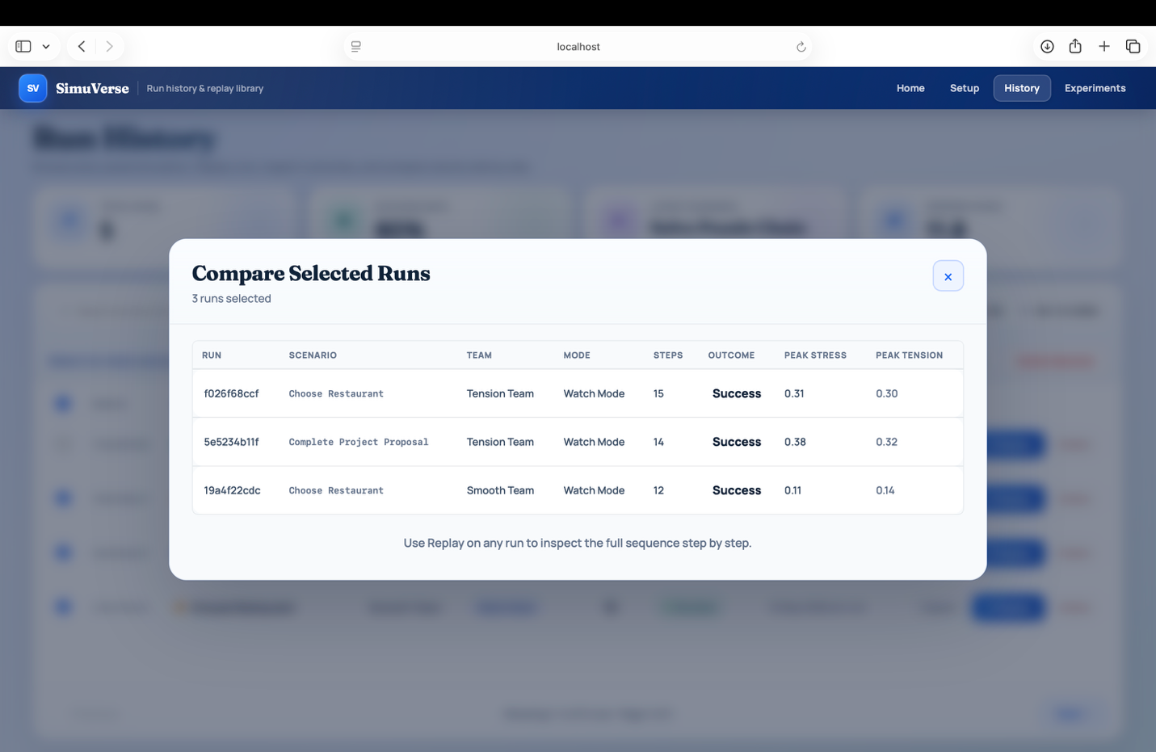
Figure D.1: History page showing completed simulation run listings
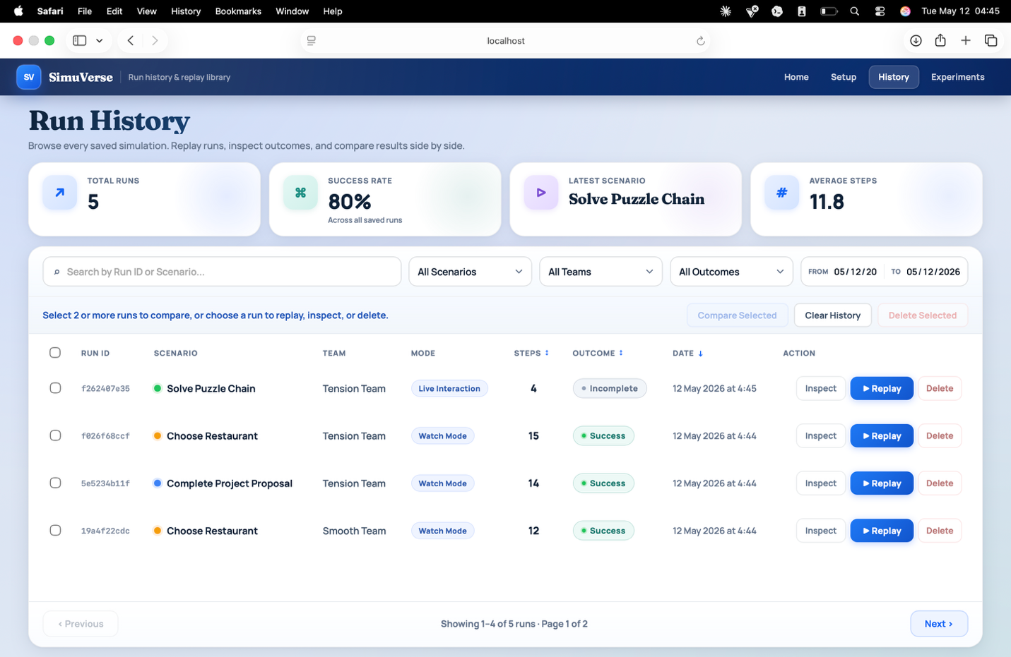
Figure D.2: History page detailed view and run replay
APPENDIX E: Mathematical Notation
Table E.1 defines all symbols used in the mathematical formulation in Section 3.9. Equations (1) to (6) are the core state-update rules; Equation (7) describes the action-selection mechanism.
Symbol | Domain | Definition
i, j | agent IDs | Indices identifying a specific agent
T_ij(t) | [0, 1] | Trust agent i holds toward agent j at tick t
A_i | [0, 1] | Agreeableness personality trait of agent i
N_i | [0, 1] | Neuroticism personality trait of agent i
delta_preset | real | Team-preset trust offset applied at initialisation
delta_base | real | Signed trust effect of a given event type
delta_reason | real | Context-based trust adjustment from short-term memory
modifiers | real | Personality-and-environment scaling factor for trust updates
Tension_t | [0, 1] | Group tension level at tick t
Cohesion_t | [0, 1] | Group cohesion level at tick t
Progress_t | [0, 1] | Proportion of scenario blockers resolved at tick t
C_t | [0, 1] | Conflict rate: fraction of conflictive interactions up to tick t
sigma_i | [0, 1] | Stress level of agent i
w_a | real | Base propensity weight for action type a
S(a,i,j) | real | Composite action-selection score for action a from i to j
P(a|i,j) | [0, 1] | Softmax selection probability of agent i choosing action a toward j
Table E.1: Mathematical notation used in the SimuVerse formulation.

