Food and Water Monitoring
Implemented and written by Rokas.
The RPI gets the data from HX711 pressure sensor, with help of HX711 PCB which converts analog-to-digital signal. For this module to work it needs power from RPI, I am giving 5V line.
Here how the scheme looks.
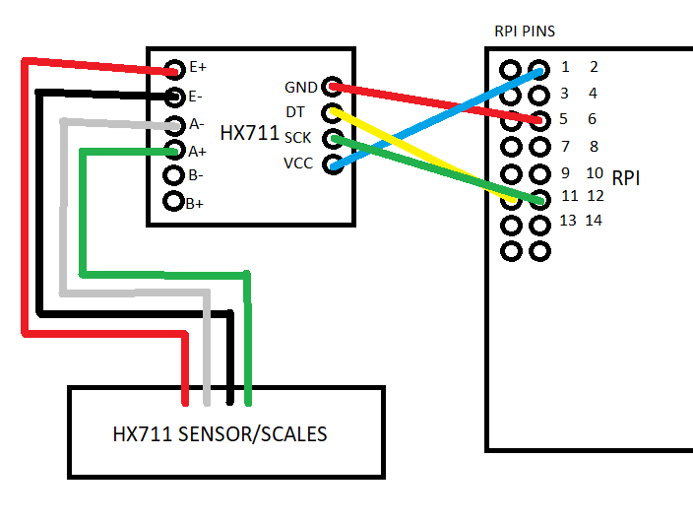
A script called weight.py is used to get reading from pressure sensor every hour. If pressure sensor data received by RPI is lower than 20% of 3KG(which I used), system prints message as "Low food and water levels”, if its more than 20% it will say “Food is more than enough”. After each message there will be rounded number to 1 decimal place of weight on pressure sensor.
The libraries that I am using is HX711 library which is for communication with pressure sensor.

