R Markdown Output

Last run on: 2023-07-08 06:16:07

# Overview

This document has code embedded throughout. In the next section we will create a visualization using the already loaded dataset eth_data:

datatable(eth_data)

# Price Chart - Ethereum

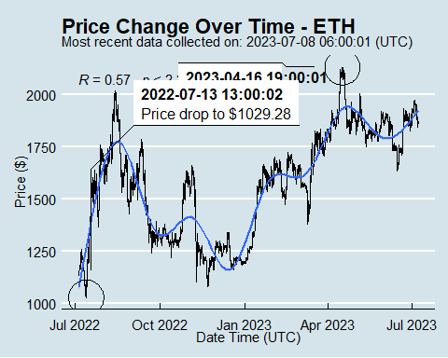

# Python Code Example

removed for now because of package install automation issues