**PURBANCHAL UNIVERSITY**

**DEPARTMENT OF COMPUTER ENGINEERING**

**KHWOPA ENGINEERING COLLEGE  
LIBALI-8, BHAKTAPUR**

**A PROJECT REPORT**

**ON**

**KASHIMALA PAAYA**

Project work submitted in partial fulfillment of requirements for the award of the degree of Bachelor of Engineering in Computer Engineering (Third Semester)

**SUBMITTED BY**

Jatin Bhusal (750315)

Dipen Boyaju (750313)

Nir Ratna Shakya (750318)

Sonia Dhaubhadel (750343)

**UNDER THE GUIDANCE OF**

Er. Shiva Kumar Shrestha

November 4, 2020

**DEPARTMENT OF COMPUTER ENGINEERING**

**KHWOPA ENGINEERING COLLEGE  
LIBALI-8, BHAKTAPUR**

**CERTIFICATE**

This is to certify that the project entitled "**Kashimala Paaya**" submitted by Mr. Jatin Bhusal, Mr. Dipen Boyaju, Mr. Nir Ratna Shakya & Ms. Sonia Dhaubhadel in a partial fulfillment of the requirements for the award of the Degree of Bachelor of Engineering in Computer Engineering of Purbanchal University, is a Bonafede work to the best of our knowledge and may be placed before the examination Board for their consideration.

**Panel of Examiners:**

|  |  |  |
| --- | --- | --- |
| **Name** | **Signature** | **Date** |
|  |  |  |
|  |  |  |
| **External Examiner** |  |  |
|  |  |  |
| Er. …………………… |  |  |
|  |  |  |
| **Project Supervisor** |  |  |
|  |  |  |
| Er. Shiva Kumar Shrestha |  |  |
|  |  |  |
| **Head of Department** |  |  |
|  |  |  |
| Er. Reena Manandhar |  |  |

**ACKNOWLEDGEMENT**

**” If your dream doesn’t scare you, it isn’t big enough”**.

For this team, engineering or project or team work whatever we term it, it has always been about doing something that impact the society in a positive manner, no matter how small. To stand out, you always have to leave out your comfort zone and think outside the box. This was the same on this project of developing “**Kashimala Paaya**” for the first time ever in this IDE. And it’s a fact that presentation, inspiration and motivation have always played a key role in the success of any venture.

We express our sincere thanks to **Er. Reena Manandhar** (HOD) of Computer Department, Khwopa Engineering College, Purbanchal University for encouraging us to the highest peak and providing us the opportunity to prepare the project.

We express our sincere thanks to **Er. Shiva Kumar Shrestha** (Project Supervisor) for his guidance in every phase of this project.

We feel to acknowledge our indebtedness and deep sense of gratitude to **Er. Bikash Chawal**, (DHOD) of Computer Department, Khwopa Engineering College whose valuable guidance and kind supervision given to us helped to the present work as its show.

We are immensely obliged to **Mr. Shyam Krishna Basukala** (Sports In charge) of Khwopa Engineering College and **Mr. Roshan Raj Tuitui** (Principal of Sharada Secondary School) for their elevating inspiration, encouraging guidance, and kind support.

Last but not the least, gratitude goes to the Bhaktapur Municipality and all our friends who directly or indirectly helped us in this project.

Any omission in this brief acknowledgement does not mean lack of gratitude.

**ABSTRACT**

The old and unique game, Kashimala Paaya is a double player board game played in the Newari community in Bhaktapur, Nepal. This game has never been created digitally in this format. The C\C++ compiler is being used to prepare it. In this, players race their token to capture the opponent’s token. Four rectangular sticks are used to determine the number of boxes a token is allowed to move. One side of the stick is of black color while the other one is white. For the count, all of the 4 sticks are dropped together. If one of the sticks faces white being all other black, the token gets activated. The activated token can now be moved further. Similarly, when the two faces are white and the other two are black, the activated token now can move 2 steps. When there are 3 white faces and 1 black, the token can move 3 steps. When all faces are white, the token can move 4 steps and all black faces let the token move 5 steps. The player gets a chance to drop the stick one more time if the sticks face all white and all black. The game comes to an end, once the token of a player is captured by the opponent or any of the players quits the game.

Keyword: Gaming, Laayag, Paaya, Token, Bars

|  |
| --- |
|  |
|  | |  |  |
|  | |  |  |

**Table of Contents**

|  |  |  |
| --- | --- | --- |
| **Chapter** | **Title** | **Page** |
|  | Title Page | i. |
|  | Certificate | ii. |
|  | Acknowledgement | iii. |
|  | Abstract | iv. |
|  | Table of Contents | v- vi. |
|  | List of Figures | vii. |
|  |  |  |
| 1 | Introduction 1-2  1.1 Background  1.2 Problem Statement  1.3 Objectives  1.4 Scopes & Limitations  1.5 Applications | 1  1  1  1  1  1 |
|  |  |  |
| 2 | Literature Review | 2-3 |
|  |  |  |
| 3 | Methodology  3.1 Overview  3.2 Problem Analysis  3.2.1 Research  3.2.2 Data Collection  3.2.3 Rules of the game  3.3 Algorithm  3.4 Flowchart  3.5 Program Coding  3.6 Program Compilation and Execution  3.7 Program Debugging and testing  3.8 Documentation | 4-7  4  4  4  4  4  5  6  7  7  7  7 |
|  |  |  |
|  |  |  |
|  |  |  |
|  |  |  |
| 4 | Results & Discussions  4.1 Overview  4.2 Screenshots of Results  4.2.1 Instructions Set  4.2.2 Game Page  4.2.3 Random Bars Generation  4.2.4 Step-Oriented Screenshots | 8-15  8  8  9  9  10  13-15 |
| 5 | Conclusions & Recommendations  5.1 Conclusions  5.2 Future Recommendations | 16  16  16 |
|  |  |  |
| 6 | References | 17 |
|  |  |  |
|  |  |  |

**List of Figures**

|  |  |  |
| --- | --- | --- |
| **Figure No.** |  | **Page No.** |
|  |  |  |
| 2(a) | Example of board game | 2 |
| 2(b) | Kashimala Paaya | 3 |
| 3(a) | Flowchart of the game | 6 |
| 4(a) | Welcome Screen | 8 |
| 4(b) | Instruction Set | 9 |
| 4(c) | Game Page | 9 |
| 4(d) | Bars generating 1 | 10 |
| 4(e) | Bars generating 2 | 10 |
| 4(f) | Bars generating 3 | 11 |
| 4(g) | Bars generating 4 | 11 |
| 4(h) | Bars generating 5 | 12 |
| 4(i) | Token outlet I | 13 |
| 4(j) | Token outlet II | 13 |
| 4(k) | Token elimination | 14 |
| 4(l) | Token entering inside | 14 |
| 4(m) | Token entering inside | 15 |
| 4(n) | Winner Declaration | 15 |
|  |  |  |

**CHAPTER 1**

**INTRODUCTION**

* 1. **Background**

As mentioned in the previous texts, this game is an authentic and old game of Bhaktapur. It’s history dates back to about 2 centuries. Similar to ludo, this game has its own set of unique rules and set of layout. Also, the terminologies used here are in Newari language. According to the rule of this game, if one among the four sticks faces white, remaining 3 being black, this is counted as 1 point or ‘Kashi’ only after which the token is validated to move. Likewise, two white and two black faces of the sticks is counted as 2 points or ‘dwadi’, 3 white and 1 black faces – 3 points or ‘Sudi’, 4 white faces– 4 points or ‘chya’, and 4 black faces- 5 points or ‘ngha’. The safe zones are called” Laayag” and the bars are called “paaya”. This game is now days rarely played and yet to be known to the new generation.

**1.2 Problem Statement**

* Unavailability of the game for all platforms.
* Lacks hints for beginners since, it hasn’t been digitalized.

**1.3 Objectives:**

To develop a game console **“Kashimala Paaya”** using C /C++ programming to the extent of time and skill-flexibility.

**1.4 Scopes and Limitations**

Scopes of this project includes:

* A user friendly interface and fine definitions of the game.
* Two-player game.
* Use of available resource (C/C++ compiler).

Limitations of this project include:

This game is modified with respect to some sets of rules from original game like

* Instead of activating the token after getting 1 or “Kasi”, here the token moves one step ahead.
* Instead of not allowing the safe zone already occupied, here both token are allowed to stay in same place.
* The token is not eliminated when encountered by the opponent’s in the home area.
* Only one token is moveable.

**1.5 Applications**

This game is solely for entertainment and strategic improvement purpose.

**CHAPTER 2**

**LITERATURE REVIEW**

Board games has always been a fascination since many years or rather centuries as the source of entertainment and time-pass. They have been found to be dated around even since the Mahabharat era.

Board games have been played, travelled and evolved in most cultures and societies throughout history. A number of important historical sites, artifacts, and documents shed light on early board games such as Jiroft civilization game boards in Iran. Senate, found in Pre-dynastic and First Dynasty burials of Egypt, c. 3500 BC and 3100 BC respectively, is the oldest board game known to have existed. Senate was pictured in a fresco found in Merknera's tomb (3300–2700 BC). Also from pre-dynastic Egypt is Mehen.

Hounds and Jackals, another ancient Egyptian board game, appeared around 2000 BC. The first complete set of this game was discovered from a Theban tomb that dates to the 13th Dynasty. This game was also popular in Mesopotamia and the Caucasus.

Backgammon originated in ancient Mesopotamia over 5,000 years ago. Chess, Pachisi and Chaupar originated in India. Go and Liubo originated in China. Patolli originated in Mesoamerica played by the ancient Aztec and The Royal Game of Ur was found in the Royal Tombs of Ur, dating to Mesopotamia 4,600 years ago. The earliest known games list is the Buddha games list.

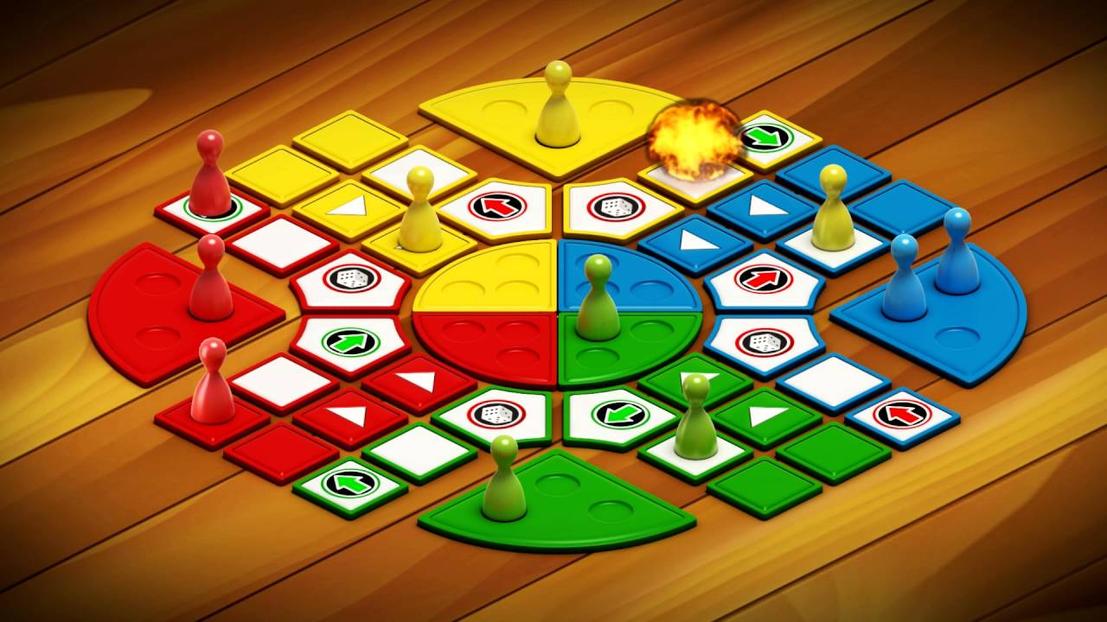

**Fig 2(a): Ludo (Example of board game)**

This game “Kashimala Paaya” is one of the traditional games of Nepal particularly speaking of Newar Community of Bhaktapur valley. In the name “Kashimala Paaya”, Kashi means ‘One’, Mala phrases as 'I need’, Paaya means “The bars thrown in the same purpose as the dice”. So all over it means that the player demands one every time he/she throws the bar. It is a very unique and strategic game quite popular among locals here.

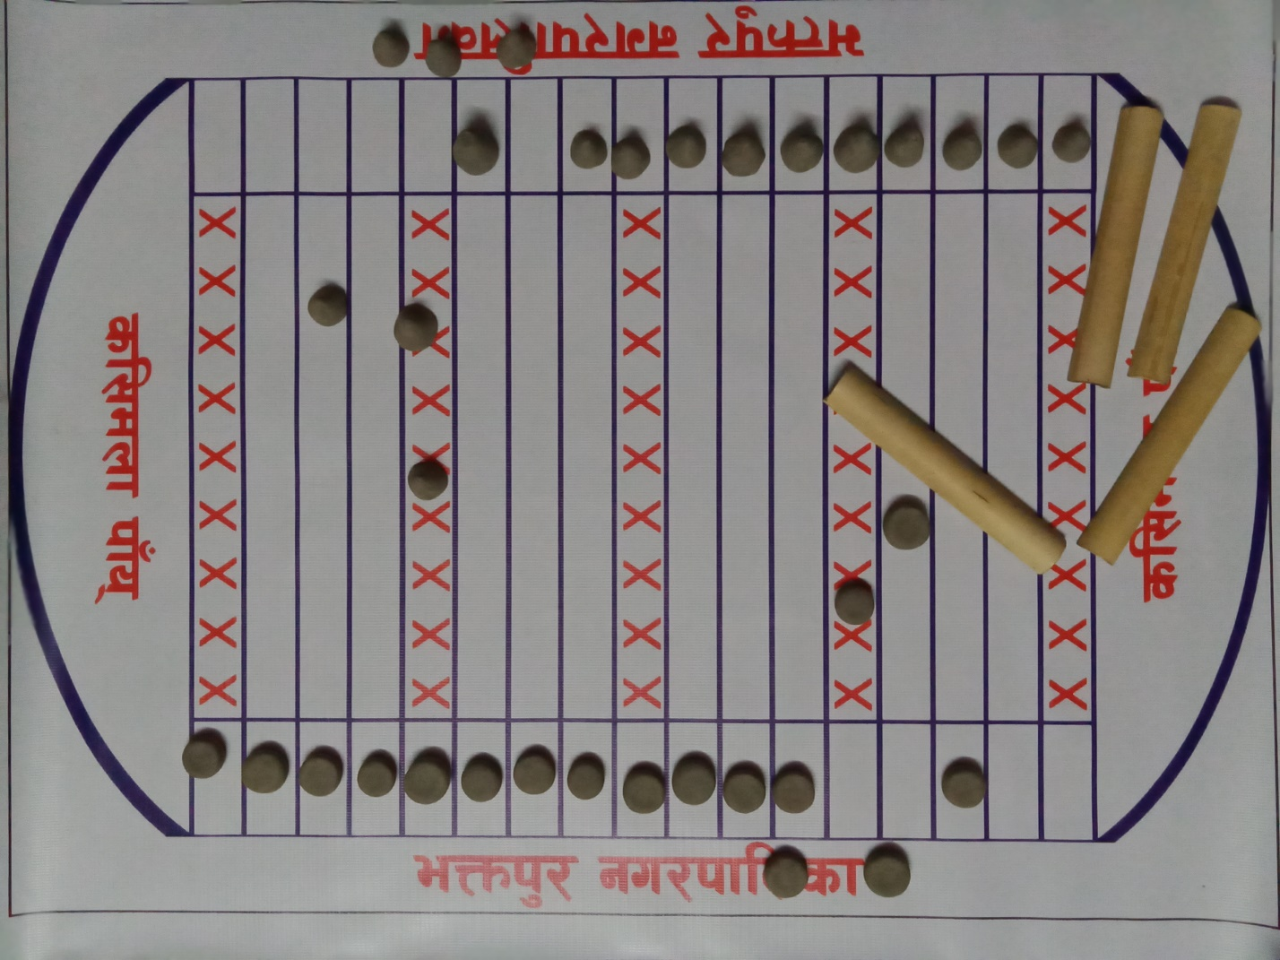

**Fig 2(b): Kashimala Paaya**

The main motive behind creating this game was to preserve this local and authentic game. This game is slowly being lost since the new generation is not known to it. Also, no digital form of this game has been developed yet. The main especiality of this game is that it has got its set of its rules. Games like Ludo and Bagchal are the modified forms that have been changed since many centuries. Also these board games do not represent any cultural affection or relation as Kashimala Paaya does.

Final words, as an engineer, we always should seek to solve authentic problems that really matters to the society. With the same spirit, may this authentic game be preserved and played till the dusk of civilization. Also we wish luck the upcoming students improvise this project**.**

**CHAPTER 3**

**METHODOLOGY**

**3.1 Overview**

Solving a problem on a computer requires a thorough analysis of the potential data. Once the problem has been analyzed, a detailed procedural solution can be developed. The program or project development process consists of three important stages, namely, program design, program coding and program testing. Aiding these three major phases, following problem solving processes were included in the development of “Kashimala Paaya”.

**3.2 Problem Analysis:**

**3.2.1 Research**

The project is totally research based since all of the details regarding the game has been collected through research. The last sports -meet held in our college inspired us to initiate this project, as **“Kashimala Paaya”** was one of the new game added to the list. Furthermore, we gathered the necessary information regarding the game through Bhaktapur municipality, Sharada Secondary School, faculty members of Computer department of Khwopa Engineering College and also interacted with the local residents of Bhaktapur to have more idea about the game.

**3.2.2 Data Collection**

Tools Used:

* Face to face communication.
* Data collection in written form.
* Field Visit

**3.2.3 Rules of the game**

1. The game begins by each player choosing a side.
2. Suppose player one is to start the game first, he shuffles the bar by dropping it vertically. If its 1, his first token gets activated. If its 4 or 5, they get a re chance to shuffle.
3. When the bars are dropped, they have two faces, black and white. If one white face is up and 3 are down, it is counted as 1 or ‘Kasi’. If two white faces are up and two are down, it is counted as 2 or ‘Dwadi’. If 3 white faces are up and one is down, it is counted as 3 or ‘Sudi’. If all white faces are up, it is counted as 4 or ‘chya’. If all black faces are up, it is counted as 5 or ‘ngha’.
4. There are total 5 safe zones in the board. Once a token reaches there, neither the opponent can eliminate it nor can the opponent’s token take the place.
5. There will be total 17 tokens for each player.
6. Unlike ludo, there is no home in here. The game gets over only when wither all tokens of a player is eliminated or one of the player quits.

**3.3 Algorithm**

1. Start
2. Shuffle
3. if bar = = 1,

Activate token or change the position.

1. Else, check if any activated token is available,

if yes, check whether the bar = = 4 or bar = =5.

1. If not available, go to change turn
2. If bar = = 4 or bar = = 5,

Move the token and shuffle.

1. If bar! = 4 or bar! = 5, just move it.
2. Now, for step-3,6,and 7, check

if position of a player’s token = = position of opponent’s token

if no, go to step 5

1. if position of a player’s token = = position of opponent’s token,

Check is the opponent’s token in a safe zone.

if yes, check for any available spare token.

Else eliminate the opponent’s token.

1. if no spare token,

go to step 5

1. if spare token available, move it and go to step 5.
2. After step 9, check is there any token left

If yes, check if opponent wish to quit.

If s/he quits, go to exit else go to step 5.

1. If there is no any token left after step 5, go to step 14.
2. Exit.

**3.4 Flowchart**

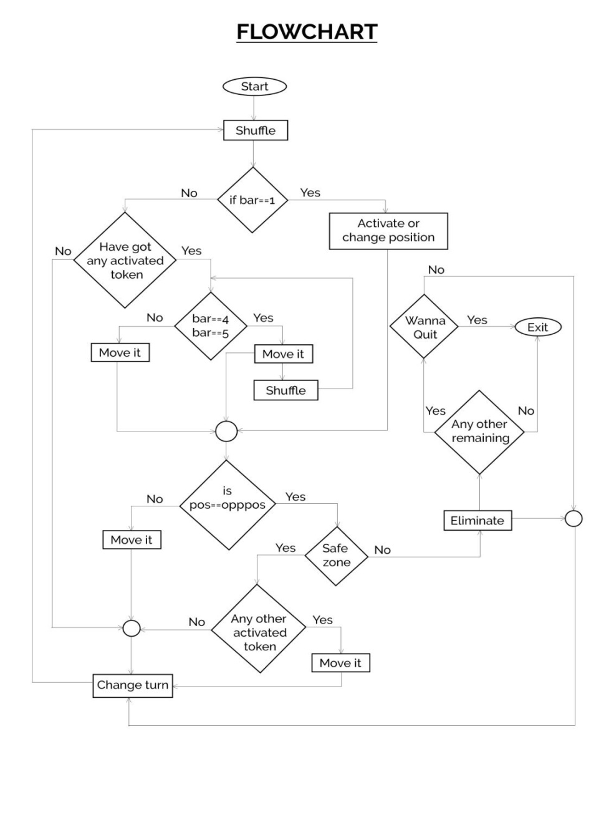

**Fig 3(a): Flowchart**

**3.5 Program Coding**

After finalizing the algorithm and flowchart, we then started coding. For that, Windows 10 OS and Turbo C IDE was used. The coding was done in many phases as parts accomplishing certain aspects of the game.

**3.6 Program Compilation and Execution**

As previously mentioned, we did the coding in chunks. Now it was the time to compile these chunks and execute to see if required output was gained or not.

**3.7 Program Debugging and testing**

During execution of the code, even during the coding phases, many errors were encountered. In this phase, we did all the debugging and finally the code was tested for its esteemed purpose.7

**3.8 Documentation**

After the completion of the project, we systematically documented all the working phases as the report alongside documenting the code for the future programmers to feel ease if they wish to take over and modify this project.

In this way, the methodology phase of the project was completed

**CHAPTER 4**

**RESULTS AND DISCUSSIONS**

**4.1 Overview**

After the continuous effort, we have completed our targeted console of "Kashimala Paaya" using C. This game is actually able to perform some major elements of game like token shuffling, random bars generation, providing a set of rules for the game, and also procedure for declaring the winner. While working in this project, we were actually able to implement the knowledge of C programming language. This project has helped us to enhance more knowledge about C languages and software development life cycle in a practical way.

**4.2 Screenshots of results**

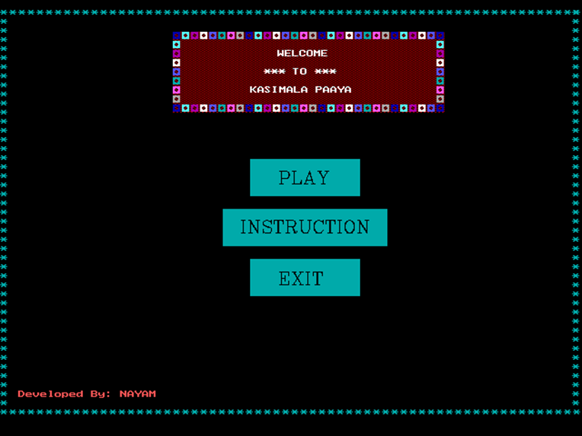

**Fig 4(a) Welcome Screen**

**4.2.1 Instructions Set**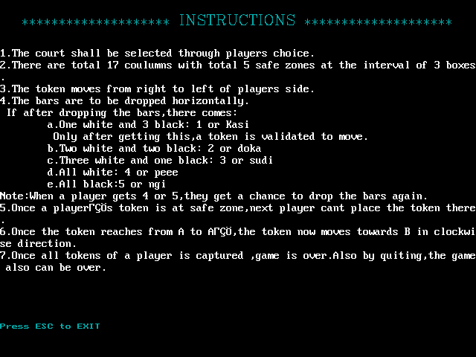

**Fig 4(b) Instruction Set**

**4.2.2 Game page**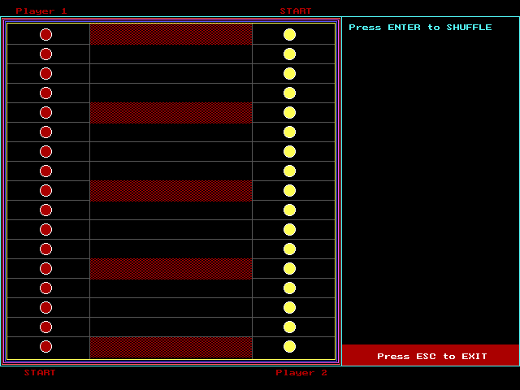

**Fig 4(c) Game page**

**4.2.3 Random Bars Generation**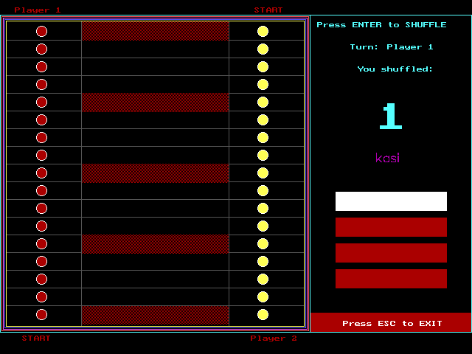

**Fig 4(d) Bars Generating 1**

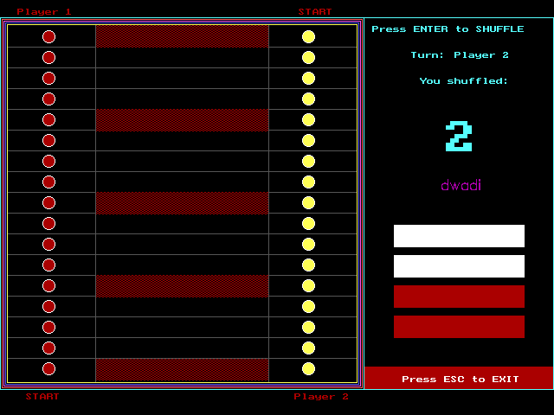

**Fig 4(e) Bars Generating 2**

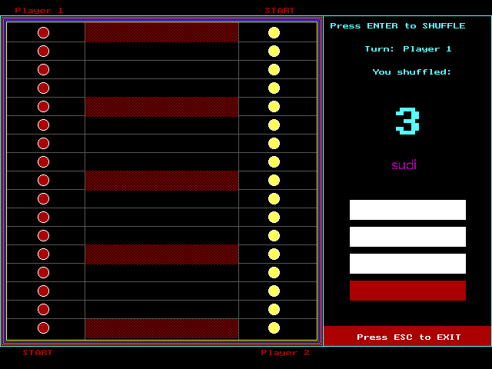

**Fig 4(f) Bars generating 3**

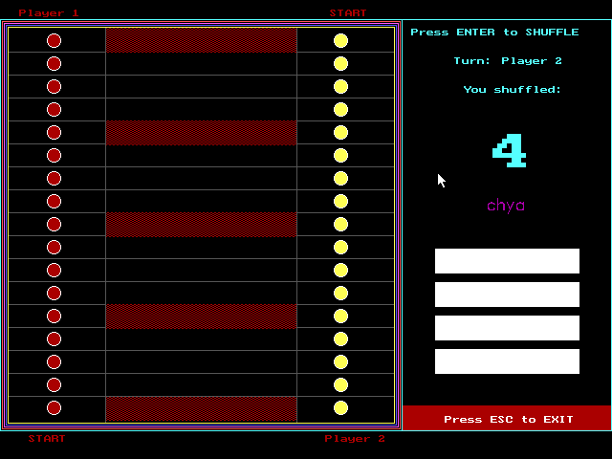

**Fig 4(g) Bars generating 4**

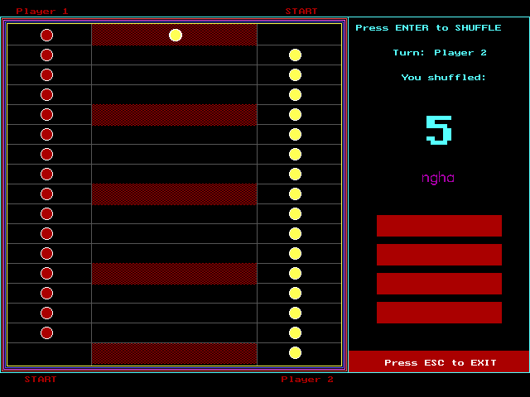

**Fig 4(h) Bars generating 5**

**4.2.4 Step-Oriented Screenshots**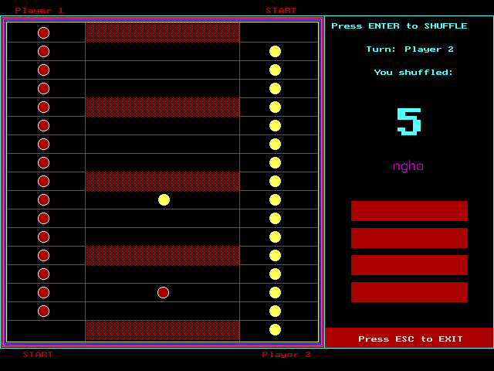

**Fig 4(i) Token Outlet I** 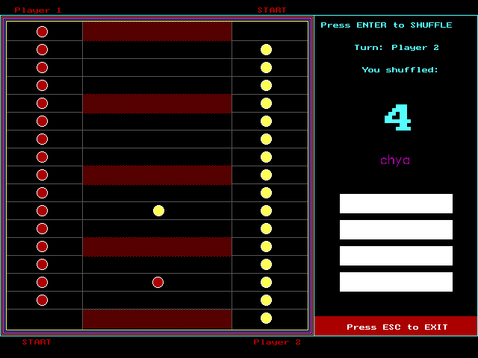

**Fig 4(j) Token Outlet II**



**Fig 4(k) Token elimination**

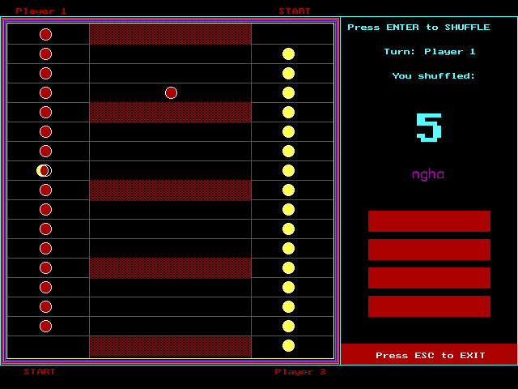**Fig 4(l) Token entering in opponent’s zone I**

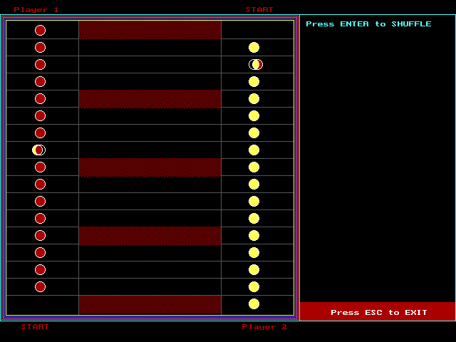

**Fig 4(m) Token entering in opponent’s zone II**

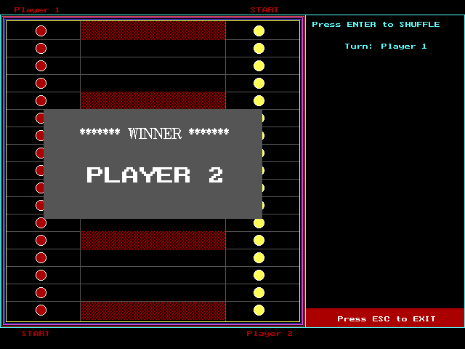

**Fig 4(n) Winner Decleration**

**CHAPTER 5**

**CONCLUSION AND RECOMMENDATION**

**5.1 Conclusion**

Hence, after the completion of this project we got more familiar with the C programming and its features. As a whole, this project has been a good learning experience for us. We have gained knowledge about the various aspects of C programming. At the same time, we have developed a deep understanding about graphics and new functions in C.

We still want to emphasize that the program is not complete by itself. There are still lots of room for improvement. More graphics may be added more to the program to make it more attractive. Also there are some set of rules that are yet to be implement which we leave on the able shoulders of future students.

**5.2 Future Enhancement**

A complete and useful project of this game can only be developed with lot of intensive effort and time. This project is done with some basic knowledge and some research of C programming languages. As a beginner and with less time, we were not able to complete our project as expected. So, there is still some improvements that can be done in our project.

1. The graphical interface may be improved.
2. Cutting the token inside home column can be implemented.
3. Effects like token hovering and bars animation can be done.

**REFERENCES**

[1] “Board game history”, https://www.wikipedia.org/wiki/Board_game_history [09/07/2020]

[2] ” Ludo reference history”, <https://en.wikipedia.org/wiki/Ludo_(board_game)>

[11/09/2020]

[3] “Ludo Project in C/C++” <https://www.youtube.com/watch?v=t3zwzQphidE>

[11/09/2020]

[4 ] <http://www.sourcecodesworld.com/source/show.asp?ScriptID=1120>

[11/09/2020]