# **Web-based Calendar Scheduler with Notification for STI College Marikina**

Submitted to the faculty of

STI College Marikina

In Partial Fulfillment of the Requirements for the

Senior High School Information and Communication Technology in Education

Cencio, Kurt Zhairol M.

Duran, Jenoah Prince D.

Fernando, Francheskca A.

Gines, Jericho L.

Guban, Ma. Janelle

Toledo, Riezl Louice V.

June 2023

# **CERTIFICATION**

**This study entitled Web-based Calendar Scheduler with Notification for STI Collage Marikina and submitted by Cencio, Kurt Zhairol M.**

**Duran, Jenoah Prince D. Fernando, Francheskca A. Gines, Jericho L. Guban, Ma. Janelle. Toledo, Riezl Louice V** **of MAWD ICTE201A** **in partial fulfillment of the requirements for Inquiries, Investigations, and Immersion has been examined, and is hereby recommended for acceptance and approval for oral examination.**

**Mr. PASCUAL GENER**

**Inquiries, Investigations, and Immersion Adviser**

**APPROVAL SHEET**

**Approved by the Panel of Examiners on Oral Examination**

**on (DATE) with a grade of ___________.**

**--------------------------------- ---------------------------------Panelist Panelist**

**Mr. FREDERIC D. YULO, M.I.M**

**Panelist**

**Accepted in partial fulfillment of the requirements for**

**Inquiries, Investigations, and Immersion.**

**Mr. FREDERIC D. YULO, M.I.M**

**Senior High School Principal / Academic Head**

**TABLE OF CONTENTS PAGE**

**Web-based Calendar Scheduler with Notification for STI College Marikina** 1

**CERTIFICATION** 2

**ABSTRACT** 6

**ACKNOWLEDGEMENTS** 7

**CHAPTER 1** 8

**INTRODUCTION** 8

**BACKGROUND OF THE PROBLEM** 8

**CURRENT STATE OF TECHNOLOGY** 10

**STATEMENT OF THE PROBLEM** 11

**General Problem** 11

**Specific Problem** 11

**OBJECTIVES OF THE STUDY** 12

**General Objective** 12

**Specific Objectives** 12

**SCOPE AND LIMITATIONS** 13

**SIGNIFICANCE OF THE STUDY** 14

**DEFINITION OF TERMS** 15

**CHAPTER 2** 17

**LITERATURE REVIEW** 17

**EVENT SCHEDULING** 17

**NOTIFICATION** 19

**EVENT BOOKING** 21

**CALENDAR** 23

**SYNTHESIS** 25

**CONCEPTUAL FRAMEWORK** 27

**CHAPTER 3** 29

**METHODOLOGY** 29

**PROJECT DESIGN** 29

**Project Flowchart** 32

**System Architecture** 36

**PROJECT DEVELOPMENT** 38

**Hardware Specifications for System Development** 38

**Software Specifications for System Development** 39

**OPERATING PROCEDURE** 40

**TESTING PROCEDURE** 41

**EVALUATE PROCEDURE** 43

**CHAPTER IV** 45

**RESULTS AND DISCUSSION** 45

**Functionality Test** 46

**User Acceptance Test** 56

**Result and Analysis** 57

**Summary** 58

**CHAPTER V** 59

**Conclusions and Recommendations** 59

**Conclusion** 59

**Recommendation** 60

**REFERENCES** 61

**APENDIX/APPENDICES** 64

**ABSTRACT**

The Web-based Calendar Scheduler with Notification (WCSN) is a research project developed to streamline and enhance event management for STI College employees. This paper presents an overview of the design, development, and implementation of the WCSN, which aims to provide an efficient and user-friendly platform for planning, organizing, and monitoring events within the college.

This research’s main objective is to address existing challenges faced by STI College in managing events, such as manual processes, lack of centralized information, and communication gaps. By leveraging modern technology and web-based solutions, the WCSN offers a comprehensive suite of features tailored to meet the specific needs of the college’s employees.

The successful implementation of the WCSN is expected to bring several benefits to STI College. First, it will streamline the event management workflow, eliminating time-consuming manual tasks and reducing the risk of errors. Second, it will improve communication and collaboration among event organizers, participants, and stakeholders through real-time notifications, updates, and feedback mechanisms. Last, the WCSN will provide comprehensive reporting and analytics capabilities, allowing administrators to monitor event performance and make data-driven decisions for future improvements.

In conclusion, the Web-based Calendar Scheduler with Notification for Employees of STI College presents a robust and user-friendly solution to streamline and enhance event management processes within the institution. The system’s successful implementation is expected to optimize event planning, improve communication, and provide valuable insights for future enhancements.

# **ACKNOWLEDGEMENTS**

The researchers, first and foremost, wish to express our gratitude and bring honor and glory to our God Almighty for giving us strength through this research journey and the courage to conduct and finish this study. Gratefulness goes as well to the STI College Marikina for allowing the researchers to conduct this study, for being the client, and for providing necessary information regarding this research. Especially, most profound gratitude to our adviser, Mr. Tristan Unabia, for the advice, encouragement, valuable comments, opinions, and suggestions for our research and system. Gratitude and appreciation also go to the researchers’ instructor in Inquiries, Investigations, and Immersion, Mr. Gener B. Pascual, for the support, guidance, encouragement, and for sharing his knowledge regarding research documentation. Heartfelt recognition and gratitude go to the research panelists, Mr. Frederic D. Yulo, M.I.M, for the constructive comments, feedback, critiques, and recommendations.

# **CHAPTER 1**

# **INTRODUCTION**

This chapter focuses on the Background of the Problem as well as the Current State of Technology, the Statement of the Problem, Objectives of the Study, Significance of the Study, Scope, and Limitations, and the last is the Definition of Terms.

## **BACKGROUND OF THE PROBLEM**

STI College Marikina has established a strong reputation for organizing a diverse range of school events, including film screenings, talent shows, sporting events, and other activities. These events attract a large number of students, teachers, and community members. However, organizing these events can be a significant challenge due to the lack of an efficient and effective scheduling process. This often leads to last-minute changes, miscommunications, and conflicts among event organizers, which can negatively impact the quality of the events and result in disappointing outcomes.

To address these issues, the implementation of a web-based calendar scheduler with notification can provide an innovative solution. By utilizing a centralized platform, all stakeholders involved in the event planning process can access a variety of features that streamline the scheduling, planning, and execution of events. The system allows organizers to schedule events and view them on a shared calendar, integrating seamlessly with other personal and organizational calendars. Moreover, it provides task management features to assign tasks, and set deadlines real-time, facilitating greater efficiency and coordination among event organizers.

The web-based calendar scheduler with notification, referred to as the (OEMIS), enhances the event planning experience for STI College Marikina personnel by eliminating time-consuming manual processes. The system offers various features for making announcements, creating activities, scheduling events, and making changes as needed. Additionally, it generates reports according to user requirements. OEMS encompasses a wide range of functionalities, including account and event administration, log-in management, and comprehensive event information. It effectively manages user data and facilitates the creation, announcement, termination, and modification of events.

The ultimate goal of implementing the web-based calendar scheduler with notification system is to provide a convenient and efficient method of communication for STI College Marikina's broad audience and to enhance stakeholder engagement with the school's diverse range of events. By utilizing this system, the planning, execution, and success of school events can be significantly enhanced, ensuring that they meet the needs and expectations of all stakeholders involved. (Ojero, Rasonabe, et al. 2018)

## **CURRENT STATE OF TECHNOLOGY**

Ms. Mary Rose Montiadora has shed light on STI College Marikina’s event management system. Firstly, the college conducts a meeting for all the club members to discuss the event’s logistics, including its flow, start time, and duration. Subsequently, the staff checks the event calendar and prepares advances accordingly.

Online scheduler technology has witnessed significant growth in recent years and continues to evolve with time. STI College Marikina employs this technology to streamline their event management. However, according to Ms. Mary Rose Montiadora, the current system lacks certain features that could enhance its functionality. For instance, it does not send alerts to users for critical events, organize daily schedules, or provide information on the staff’s activities at the college. To keep up with technological advancements and ensure optimal event management, there is a need for more advanced event handling tools that can cater to the diverse requirements of the college. Overall, STI College Marikina’s systematic approach and implementation of technology have made their event management process more organized and efficient. (Ms. Mary Rose Montiadora 2022)

## **STATEMENT OF THE PROBLEM**

### **General Problem**

How to create a WCSN platform that simplifies the scheduling process and notifies STI College Marikina about forthcoming events of the users for each room. How the academic staff members and event planners can book their events through the management system using the room that is available and the room number where they can be held, and the faculty team will be notified about it.

### **Specific Problem**

These are the issues and concerns that have been noticed and need to be resolved:

1. How could a website be developed to inform teachers or event planners of future events in each room at STI Marikina?
2. How to design a simple UI (User Interface) for WCSN?
3. How can a WCSN’s responsive features be developed?

## 

## **OBJECTIVES OF THE STUDY**

### **General Objective**

To provide a platform for WCSN that simplifies planning and notifies STI College Marikina of forthcoming events. Through the website, academic staff members and event planners can enter their upcoming events utilizing the management system using the room that is available and the room number where they can be conducted, and the teaching group will be notified about it.

### **Specific Objectives**

This is the basis for developing the online sales system that it will provide:

1. To develop a website that will guide teachers or event coordinators about upcoming events in every room at STI Marikina.
2. To design a simple UI for WCSN.
3. To develop the responsive features of WCSN.

## **SCOPE AND LIMITATIONS**

The proposed research project is focused on developing several critical features for an WCSN that will enhance the organization and participation of events at STI Marikina. These features include a login/logout module, a calendar module, a notification module. With the sign-up and login/logout module, users will be able to securely access the platform and manage their event-related tasks. The calendar module will provide users will be able to securely access the platform and manage their event-related tasks. The calendar module will give users a full view of all the events they have booked, allowing them to book, see their booked dates and time, see available dates and time, see unavailable dates and time, and see calendar holidays. The notification module will send reminders to users about upcoming events, the admin will also send approves the event booked by the user and ensures that important deadlines and scheduled activities are not missed.

The system has limitations. It is not the scope of the researcher to connect it to the systems used in STI College Marikina, such as Office 365 and eLMS; in this part, only the researcher's system is isolated. That can be done because the purpose of our system is to create features that only STI employees can use, with a more effective system dedicated only to booking upcoming STI Marikina events. The user side can only see what events the user has booked, and the user cannot see other events booked by other users in the system. The admin side's limitations are only seeing the user’s request to book an event and not seeing all the information that should be on the user’s side only. The system is intended only for booking events and reminding users of upcoming STI Marikina events. In addition, the system does not have an event management module that could further improve the event management.

## **SIGNIFICANCE OF THE STUDY**

This study will be useful to employees at STI College Marikina who have difficulty managing their time. It is an events management system where you can book, find out what available date, and time can be booked, set the schedule and have the admin arrange the next schedule coming to the school, it also reminds the employees, If the event has been approved by the admin, it will notify the user that the event has been approved successfully set and they will see the event they book.

**Employees -**  This project will be useful for the employees of STI College Marikina because it will allow them to book and see the date, time, and holidays that will be used for the events that they book, organize, and initiate the events.

**Teacher -** It will be beneficial to the teachers of STI College Marikina as they are the ones who have hectic schedules when it comes to things such as handling and making events for students such as activities with deadlines etc.

**STI College Marikina -** The proposed system would be of significant use for STI College Marikina as it can be used by its employees. It would allow them to manage their time properly and set, organize, plan, and start off events that are going to be held in schools and even outside of the school.

**Future Researchers -** This research can be a helpful source of information for future researchers. The findings in this research might be of valuable use and be a source for future researchers to improve projects such as this or projects with a similar concept to this.

## **DEFINITION OF TERMS**

**Academic Calendar -** serves as a reminder of significant occasions for staff, professors, and students throughout the academic year.

**Event Calendar -** the events to be held by the organization are simply listed in date order in this straightforward paper.

**Event Booking-** any software suite designed to help you schedule, manage, and run events.

**Event Planner** - the most important parts of planning an event can save you time, energy, and ensure you stay within budget.

**Handling Events -** it is the system that controls the event and determines what ought to take place in the case of an event.

**Implementation -** it is the application of a strategy, a method, or any model, specification, standard, or policy for carrying out a task.

**Logistics -** it describes the process of organizing, carrying out, and managing the transit of information along a supply chain, from its source to its objective.

**Log-in Module -** use sign in to describe starting a session on a computer, a device, a network, an app, or anywhere a username and password are required.

**Log-out Module** - use sign out to refer to ending a session.

**Source -** piece of academic writing materials that gather ideas and information.   
**User -** the user is the one who can access the online event management calendar.  
**UI –** user interface (UI) is anything a user may interact with to use a digital product or service. This includes everything from screens and touchscreens, keyboards, sounds, and even lights  
**Staff Scheduling** - you may create a work plan that is in line with company objectives by using employee scheduling, which entails keeping track of staffing requirements, arranging meetings, monitoring deadlines, and allocating duties.  
**STI College –** it was formerly known as Systems Technology Institute. It is a for-profit college network in the Philippines**.**  
**Streamline** - the efficiency of a certain procedure inside an organization is improved. By adopting contemporary methods and technology, it is possible to automate operations, simplify processes, or get rid of extra procedures.

# **CHAPTER 2**

# **LITERATURE REVIEW**

Chapter 2 focuses on the existing literature that is relevant to our study, we also go through the specifics of existing foreign literature, and local literature that can help us in our research, this chapter provides the synthesis and conceptual framework.

### **EVENT SCHEDULING**

Foreign research titled “Internet Calendaring and Scheduling Core Object Specification (iCALENDAR) Compatible Collaborative Calendar-Server (CCS) Web Services” discusses the need for a standardized format to address interoperability challenges in representing calendar data has led to the development of the Internet Calendaring and Scheduling Core Object Specification (iCalendar). In order to resolve these issues, a Collaborative Calendar-Server (CCS), a bridge module, and a Global Multimedia Collaboration System (GlobalMMCS) Client Module have been implemented. The CCS, based on the iCalendar specification, serves as a collection of Web Services, facilitating interoperability among different calendaring and scheduling applications. The bridge module enables communication between the CCS and various iCalendar-compliant applications, using HTTP methods for interactions. The GlobalMMCS portal interacts with the CCS for meeting scheduling and retrieval of calendar information via the GlobalMMCS Client Module (Dawoud & Dawood, 2019).

A research titled “A Service Oriented Architecture based Comprehensive Smart Calendar for scheduling and managing real-time events” discusses that effective time management is crucial for student success and project achievement. As stated by Peter F. Drucker, "Until we manage time, we can manage nothing else." However, many students struggle with this skill or aspire to improve it. Based on our experience, we encountered difficulties in keeping track of homework, quizzes, exams, and even simple reminders. Traditional handwritten notes or specialized note-taking applications proved to be ineffective. To-do lists or note apps are often random and may not capture all necessary tasks, especially those deemed too small or simple. Additionally, relying on a regular calendar requires manual input, which can be cumbersome. To address these challenges, we are developing a web application that caters to the needs of students, integrating new technology and featuring a clean and elegant user interface. By providing fast communication between students, enhancing effectiveness, and reducing costs, our project aims to reach a wider student audience. The core objective of this project is to empower students to manage their daily tasks effectively, improving their grades and personal lives by enabling them to organize their schedules, homework, and exams efficiently.(Khan, Alatiyyah and Aljadaan, 2018)

Research titled “Web-based systems for communication and scheduling” talks about today's technology-driven world, effective communication and scheduling are crucial for managing daily activities, meetings, and tasks. This paper focuses on the design and implementation of a Web-based communication and scheduling system. The primary objective was to develop a user-friendly and efficient system that enables users to stay connected through email and provides seamless access to their schedules from any web-accessible device, including both wired computers and wireless mobile devices. The study discusses the challenges encountered during the conversion process of adapting the existing web application, originally designed for wired computers, into an equivalent wireless interface, highlighting the specific issues and considerations involved in achieving a successful transition. (ElAarag and Hartfor, 2003)

### **NOTIFICATION**

The foreign research paper titled “Notification Systems for Event Management” presented a proposed notification system designed to improve event management processes, enhance communication, and reduce response time. The system’s architecture, features, and functionalities were discussed, and its performance and effectiveness were evaluated through simulations. The study concluded that the proposed notification system was successful in achieving its objectives, as it efficiently handled large volumes of event notifications and could be easily customized and integrated into existing event management systems. However, the study also identified some limitations and recommended further research directions, such as incorporating more advanced algorithms, improving scalability, and enhancing security features. The study concluded that the proposed notification system could be beneficial in various event management domains, such as emergency response, transportation, and logistics. (Heegaard, Overlier 2010)

The local research paper titled “Design and Implementation of a Notification System for Event Management in a Philippine University” aimed to develop a notification system for event management to improve communication and streamline event management processes in a Philippine university. The study implemented a notification system with features such as event creation, notification broadcasting, and feedback collection. The paper evaluated the system’s performance and usability through user feedback and testing. The conclusion of the study highlighted that the developed notification system for event management was successful in achieving its objectives. The system was found to be efficient in managing events, reducing manual work, and enhancing communication and feedback collection. The study recommended further improvements to the system, such as incorporating more advanced features, improving data security, and conducting further user testing. Overall, the developed notification system could serve as a useful tool for Philippine universities to simplify and streamline their event management processes and improve communication among stakeholders. (Salvador, Dizon 2018)

### 

### **EVENT BOOKING**

The foreign research paper titled “Design and Implementation of an Online Booking System for Event Management” aimed to develop and implement an online booking system for event management that could simplify the booking process and improve communication between stakeholders. The study developed and implemented a booking system with features such as event creation, venue reservation, and participant registration. The paper evaluated the system’s performance and usability through user feedback and testing. The conclusion of the study highlighted that the developed online booking system for event management was successful in achieving its objectives. The system was found to be efficient in managing bookings, reducing manual work, and enhancing communication and feedback collection. The system’s user feedback and testing revealed that it was easy to use and efficient, with users reporting satisfaction with its features and functionalities. The study recommended further improvements, such as incorporating more advanced features for financial management and integration with social media, to make the system more comprehensive and functional. Overall, the study concluded that the developed online booking system could serve as a useful tool for event management to simplify and streamline their booking processes and improve communication among stakeholders. (Kungpisdan, Sripimanwat 2017)

The local research paper “Development of an Online Reservation and Booking System for Event Management in a Philippine University” aimed to design and implement an online reservation and booking system for event management in a Philippine university to improve communication, streamline booking processes, and eliminate manual work. The study developed and implemented a system with features such as event creation, venue reservation, participant registration, and financial management. The paper evaluated the system’s performance and usability through user feedback and testing. The study concluded that the developed online reservation and booking system for event management was successful in achieving its objectives. The system was found to be efficient in managing bookings, reducing manual work, and enhancing communication and feedback collection. The system’s user feedback and testing revealed that it was easy to use and efficient, with users reporting satisfaction with its features and functionalities. The study recommended further improvements, such as incorporating more advanced features, data analysis, and integration with social media platforms. The study also emphasized the need to ensure data security and privacy of users. Overall, the study concluded that the developed online reservation and booking system could serve as a useful tool for Philippine universities to simplify and streamline their event management processes and improve communication among stakeholders. (Andrada, Lansigan 2018)

### **CALENDAR**

The foreign research paper titled “A Calendar-Based Event Management System for Social Networks” aimed to develop an event management system that could be integrated with social networks to provide users with a more efficient experience for event planning and management. The study developed and implemented a system with features such as event creation, attendee management, and social network integration. User feedback and testing revealed that the system was easy to use and efficient, with users reporting satisfaction with its features and functionalities. The study recommended further improvements, such as incorporating more advanced features for data analysis and incorporating feedback mechanisms for improving user experience. The study concluded that the developed event management system could serve as a useful tool for social networks to simplify their event management processes and improve communication among users. (Bhattacharya, Sarkar 2016)

The local research paper titled “Development of an Online Calendar-Based Event Management System for a Philippine University” aimed to simplify and automate event planning and management processes by designing and implementing an online calendar-based event management system for a Philippine university. The system included features such as event creation, venue reservation, attendee management, and calendar-based scheduling. The study evaluated the system’s performance and usability through user feedback and testing. Overall, the study concluded that the developed online calendar-based event management system was successful in achieving its objectives. The system was found to be efficient in managing events, reducing manual work, and enhancing communication and feedback collection. The system’s user feedback and testing revealed that it was easy to use and efficient, with users reporting satisfaction with its features and functionalities. The study recommended further improvements, such as incorporating more advanced features for data analysis and integration with social media platforms, to make the system more comprehensive and functional. Additionally, the study emphasized the importance of ensuring data privacy and security of users. (Garcia, Gadiano 2017)

## 

## **SYNTHESIS**

The researchers review and consider relevant literature and studies as they present a systematic review of data that may assist in project development. Analysis includes Event Management System. An event management system is a software tool used to organize and manage events, such as conferences, meetings, concerts, or other types of gatherings. The system usually includes a few basic features, including a calendar, booking capabilities, and notifications, which explain how the event management system flows and what happens when users set it up. Notifications are an important part of an event management system. Users may receive notifications about upcoming events, schedule changes, or other important event-related information. Notifications can be delivered via email, text message, or through the event management system itself. The Event Booking feature of an event management system allows users to reserve venues, equipment, and other resources required for the event. This feature may also include tracking attendance of attendees at an event. How accessible it is to the user and has communication for the user. A calendar is one of the important things in an event management system because the calendar function of an event management system allows users to schedule and manage events, including specifying the date, time, location, and other vital details. Users can view the calendar to see upcoming events and check availability for potential dates. The calendar shows how to organize or plan an upcoming event set by the user.

Overall, an event management system simplifies the process of planning and executing events, reducing the risk of errors or miscommunication. By providing a centralized platform for managing all aspects of an event, the system saves time and effort for organizers and attendees. An effective event booking management system should include a comprehensive calendar, an easy-to-use booking process, and a customizable notification system. These features can help event planners manage all aspects of their event, from initial planning to final execution.

## **CONCEPTUAL FRAMEWORK**

The researcher’s conceptual framework is their knowledge of how the multiple variables in their study are associated. It specifies the factors that must be included in the research. It is the researcher’s road map or plans for executing the study. The background and problems that inspired the researcher to conduct the study are described in the thesis’s problem statement. It sets up the steps that must be taken during the research. This conceptual framework is to conduct the event at STI College Marikina. By constructing this framework, we need to justify and explain the study to others and check our own understanding of the study's need, how it is conceived, and what knowledge it will add about the topic.

The conceptual model that guided the researchers of this study is shown in Figure 1.

|  |  |  |
| --- | --- | --- |
| **INPUT** | **PROCESS** | **OUTPUT** |
| * List of users * List of admins * List of upcoming Events * List of holidays | Features of the website:   * Log-in/log-out module * Calendar module * User details module * Notification Module | Web-based Calendar Scheduler with Notification for Employees of STI College Marikina |

**Figure 1 Input-Process-Output**

Figure 1 represents the conversion of inputs into outputs and the affiliated processing task. It shows how the user’s data, specifically an STI College Marikina employee would be fed into the proposed system, and the associated procedures involved in the process of converting input to output. The employee of STI College Marikina is required to log in. Upon logging into the proposed system, the employee is immediately directed to an intuitive and user-friendly dashboard. From there, the employee can easily view and manage all aspects of their scheduled events. Specifically, the employee can see detailed information about their booked schedule, including the date, and time of the event.

The dashboard provides an at-a-glance view of all available rooms and spaces where events can be held. This allows the employee to select the most appropriate room quickly and easily for their event based on availability and capacity. The employee can view the calendar on the dashboard, which includes important dates and holidays marked clearly. This feature helps the employee plan events around holidays and other important dates, ensuring that events are scheduled at the most appropriate times. The dashboard is also where the notification will pop up such as the reminder for approval request. The admin of the system will be the one responsible for handling the planned events by the employee, and it is associated with the calendar module of the system.

# 

# **CHAPTER 3**

# **METHODOLOGY**

Chapter 3 focuses on the methodologies and will include areas such as the study’s location, research design, sampling and sample size, types of data, data collection method and its management.

## **PROJECT DESIGN**

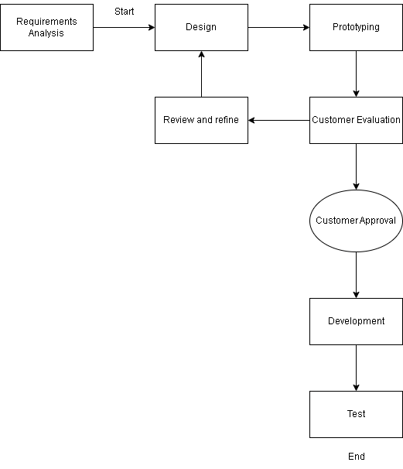 In the development of the system, all the data was gathered by conducting an interview with the employee of STI College Marikina. The developer used the prototyping methodology to involve the user and admin sides so that it was easier to know and use the processes required by the user and admin sides, as well as the module, features, and notification of an event. This allows the developer to start developing the system with minimum requirements and add additional modules, features, notifications, and processes for system development.

**Figure 2. Prototyping Model Methodology**

In the requirements, the developer conduct a interviewed to study and used information for the development of system. The developer interviewed an employee who is one of those in charge of upcoming events at STI College Marikina. The information gathered by the developer is preparation initiatives, people need to organize an event, equipment required, dates available and time to be used for the upcoming event to be held at STI College Marikina and for reminding of an event, if how many times should employees be reminded of the upcoming event. The information gathered from the person interviewed, it should be known to be used by the developer in developing a system and methods that facilitate the system. The all information gathered in the interview will allow the developer to use, know the necessary processes that need to be done and used to facilitate the creation of the system.

In the system design phase, the developer combines all the information gathered. The gathered information will be analyzed and planned to produce a system design based on the requirements needed and what else can be assessed that should be done in the system. By providing various diagrams, it helps the developer conceptualize the system. These are the diagrams contained in the data flow diagram shown as a blue print of the system that contains the processes, the project flow chart that is used to improve or find out what the steps of a system should be and to know if the workflow is correct, and the system architecture that is used to know what problems will be encountered in a system while it is being developed.

In the system prototyping phase, the plan from the previous phase is implemented. System specifications are made on a working system that is initially tested and then used. In the creation of the database, the developer uses MySQL, PHP, for the development of the function is JavaScript, the html index itself in the design of the system using CSS (Cascading Style Sheets).

In the testing phase, the developer evaluates whether the system performs the function that the system is supposed to perform; the developer performs a series of preliminary tests such as integration testing using a black box, where a module-by-module approach is taken before deploying the system to actual users to ensure that it works effectively in the system. This phase deals with issues of quality, or the proper functioning of the system, performance, and debugging or fixing a problem or malfunction of the system. The developer has tested the reliability, functionality, usability, efficiency, maintainability, security, and portability of the developed system so that users can properly test it.

The deployment release phase is the final stage of the prototyping methodology where the system passes each testing phase performed by the developer and is now ready to go live or be used by the user. The developer will install the system and conduct a new testing prototype to ensure the functionality and success of the system for STI College Marikina employees. When the installation is complete, when it’s okay, the developer will create an operating procedure that contains how the system works, in case there is an unexpected problem or issue with the system, the operating instructions will provide instructions that will help to repair the issue in the system.

The system is built of processes that are contained in other ways and requests of clients in the system. One of the things that should be considered here is the maintenance of a proper system, the developer should provide a module that contains the maintain files and procedures of the system back up that contains a copy of the system with the purpose and can be applied exciting program, so that instead of have fun or create something new, there is a ready file that can be used in the system.

## **Project Flowchart**

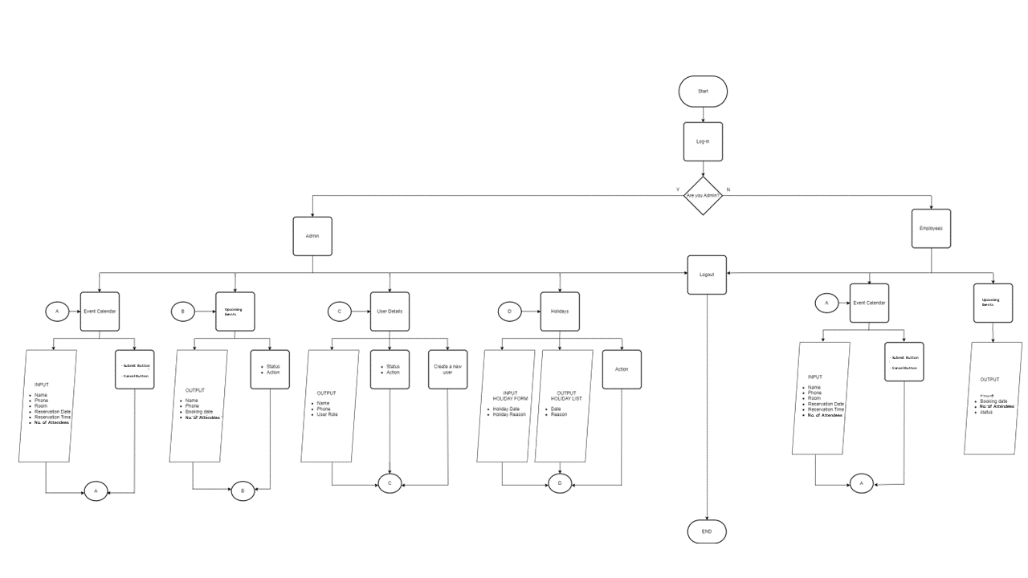

**Figure 3. Project Flow Chart of Web-based Calendar Scheduler with Notification**

Figure 3 presents a graphical representation of the logical progression of significant system events that starts with the admin logging in. The admin will log-in and provide a username and password for the employees. After successfully logging in, the admin can access various parts of the system, including the event calendar, which is used to book events. The administrator also has access to information about impending events, giving them the power to accept or reject already-booked events and to add the stated tasks. The system includes a user details section, which the admin can use to create accounts for employees.

The user details section also displays a list of employees who already have an account. The system includes a holiday section that allows the admin to add holidays to the calendar and provide a reason for the holiday. This feature is useful for keeping track of days when the office is closed. Employees can only access the event calendar to book events. Additionally, they may check the information about upcoming events, which lists the events that have received admin approval, and they can see the tasks they listed in the website’s section regarding upcoming events. This system is a practical tool for managing events and bookings within an organization, providing various levels of access and functionality to both the admin and employees.

**Data Flow Diagram**

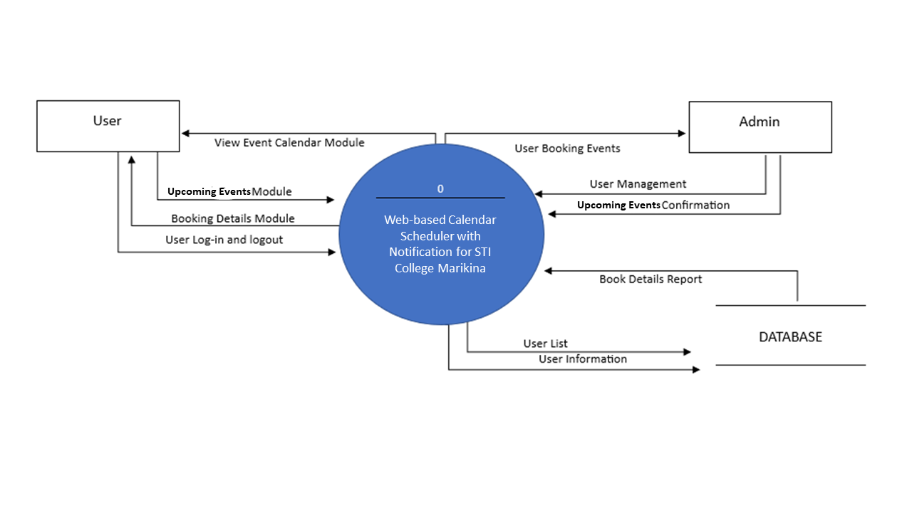

**Figure 4. Context Diagram of Development System**

**for Employees of STI College Marikina**

The data flow diagram is one of the most widely used models of the system analysis process. This is a tool that describes or presents the flow of data through a system and the work or processing performed by the system. It is used to help understand the current system and to represent the required system. Figure 4 shows the three (3) entities connected to this system web-based (level 0 context diagram) of Calendar Scheduler with Notification, the User, the Admin, and the Database. The context the diagram shows the flow of data in and out of the system to the various entities that are connected. The representative user is accessing the view event calendar module, upcoming event module, booking details module, and user log in and log out. The user can access the event calendar module when the user logs in, at the same time the user will also see the booking details where the user can request a book. In addition to the calendar that the user fills out to request or reserve an event, the user may view the upcoming event module next to it. Each user’s booked event will appear in the calendar if it has been accepted and approved by the admin. The admin can see User Booking Events, User Management, and User Booking confirmations here. The admin will manage the event booked by the user. When the user has made a request to the admin, the admin will accept it and the user will check if the user booked is available and if it is available the admin will approve it. The database contains the Booking details report, User List and User information. The database will hold the information to be entered or booked by the user.

## 

## **System Architecture**

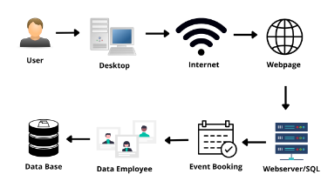

**Figure 5. System Architecture of the Web-based Calendar Scheduler with Notification**

Figure 5 illustrates the system architecture of the Online Event Management System for the SHS Expo 2022-2023 which outlines the system’s framework and functionality. Users and administrators are the only two who give users permission to utilize the system. Both users and administrators have online access to the system through their personal computers. To access the website, both the user and the administrators need the internet. By entering the right credentials in the log-in module, users and administrators can access the website.

The system’s various modules and other online services, including log-in and log-out, can be accessible after a user has logged in. The system events are listed on the webpage for users and administrators to view. The other areas of the system, such as the user details, are only visible to administrators. All the system’s sections are visible to admins. Users are positioned in the room of their choice and are only able to see the events they have set up. Lastly, a database that can be used to store, manage, and access any kind of data. To observe and analyze the data, it collected it all in one location. You can view the informational collection that has been organized in this part.

## **PROJECT DEVELOPMENT**

The Web-based Calendar Scheduler with Notification for Employees of STI College Marikina was developed in three phases, consisting of conceptual, logical, and physical design for the database. During the conceptual design, the system’s components were identified, and their interconnections described. The logical design was a translation of the conceptual design into a logical framework that included user, management/admin, and administration system components. Following the logical design, the developer created a physical database using MySQL and PHP. After completing the database, the login module was developed, requiring correct username and password credentials to access the Web-based Calendar Scheduler with Notification. The system can only be accessed by employees and the system admin. The next module of our system is booking, which is needed to have a scheduled event in the calendar. The notification module that can see the approval about the booking. System requirements were also established, as outlined in Table 2 for hardware requirements and Table 3 for software requirements, detailing the necessary components for the system to function effectively.

**Table 1.**

## **Hardware Specifications for System Development**

|  |  |
| --- | --- |
| **Hardware** | **Minimum Requirement** |
| Processor | Intel corei3 or AMD equivalent or higher |
| Memory | 8GB RAM or higher |
| Disk Space | 500GB HDD or higher |
| Display | 1024 x 768 resolution monitor or higher |
| Internet Connection | 100 mbps internet connection |

Table 1 shows the machine’s hardware specifications, which allows it to be developed as required by the Web-based Calendar Scheduler with Notification.

**Table 2**

## **Software Specifications for System Development**

|  |  |
| --- | --- |
| **Software** | **Minimum Requirement** |
| Operating System | Windows 10 |
| Database Management System | SQL |
| Run-time Environment | Visual Studio Code & XAMPP |
| Web Browser | Google Chrome |

Table 2 shows the software specification for development recommended to enable the system to be developed as required for using the Web-based Calendar Scheduler with Notification.

## **OPERATING PROCEDURE**

The functional and non-functional requirements enable the efficiency of the developed system. The developed system can be accessed by the employees, staff, and administrators. Functional requirements are enumerated based on the user role in each module of the developed system. The developed system can be accessed by the following users which are the employees, staff, and administrators. The functional requirements for the employees, staff, and administrators are the following: (1) Creating an account and logging in. Users of the system can register for an account, log in, and manage their profiles; (2) Making an event. The program may help event planners establish events and provide event specifics like date, time, place, and room number; (3) Reporting and Analytics. Event planners can use the system to give reporting and analytics features so they can monitor event performance and attendance; (4) Tasks following the event. The system can offer users tools and allow them to export user lists and other necessary information for upcoming events. The non-functional requirements for the employees, staff, and administrators are the following: (1) User-friendliness of the system. The interface is simple to use and offers users feedback and instructions in clear language; (2) Effectiveness of the system. The system can process a transaction without experiencing any major hiccups or mistakes because it is quick and responsive; (3) Accessibility of the system. Users can access the system, and it supports users of assistive technology; (4) Security of the system. The system is safe because it has safeguards in place to protect user information and deter illegal access; (5) The system’s dependability. There is a strong backup and recovery strategy in place, and the system is dependable with little downtime.

## **TESTING PROCEDURE**

Testing an Web-based Calendar Scheduler with Notification for employees is a critical aspect of ensuring that the system is secure, functional, and user-friendly. The testing procedure involves thoroughly evaluating each module of the system, starting with the login/logout module, which is essential for the system's security and usability.

The testing of the login/logout module should encompass a thorough check of its functionality, including the ability to handle different types of user inputs such as invalid usernames, incorrect passwords, and other similar scenarios. The system’s response to user authentication and authorization, including ensuring that only authorized users can access specific features and data within the system, should also be tested.

The next module to be tested would be the event management module, which allows employees to create, view, and manage events within the system. It is important to ensure that the system can handle different types of events, including their associated data such as event names, dates, descriptions, locations, and attendees. Testing this module should involve creating test events and verifying their correct display, as well as ensuring that the system can handle updates and changes to events.

The system should be evaluated for its ability to handle various types of inputs, such as long event names, large numbers of attendees, and different date formats. Additionally, the system's ability to validate inputs and prevent incorrect data entry, such as disallowing the creation of events with invalid dates or attendees, should be tested.

Another crucial component of the system to test is the notifications module, which is responsible for sending out notifications to employees about upcoming events, changes to events, and other important information. Testing should involve verifying that notifications are delivered accurately and on time, and that they contain all necessary information.

Finally, the overall usability and performance of the system should be assessed. This includes testing the system's responsiveness, load times, and user interface, as well as ensuring compatibility with different web browsers and devices. The system’s ability to handle multiple concurrent users should also be evaluated to ensure that it is scalable to accommodate increasing numbers of users and events over time. Overall, thorough testing of each module of the Web-based Calendar Scheduler with Notification can ensure that it is reliable and provides employees with a valuable tool to manage their events effectively.

## 

## **EVALUATE PROCEDURE**

The ISO Software Evaluation Criteria tool was used by the developer to assess this system’s performance for users. The developer can use this instrument to evaluate the system’s applicability for its target purposes and obtain helpful insights into its performance within its environment.

**Table 4. ISO Software Evaluation Criteria**

|  |  |  |
| --- | --- | --- |
| **Numerical Rating** | **Categorical Response** | **Verbal Interpretation** |
| 4 | Strongly Agree (SA) | Very Satisfactory |
| 3 | Agree (A) | Satisfactory |
| 2 | Disagree (D) | Needs improvement |
| 1 | Strongly Disagree (SD) | Poor |

The ISO Software Evaluation Criteria’s Table 4 displays the degree of acceptability and efficiency of the developed system, as measured on a 4-point Likert scale. The formula utilized to determine the weighted average mean is presented below:

WM = SA*4 + A*3 + D*2 +SD*1

---------

TNR

Where:

WM = Weighted Average Mean

SA = Strongly Agree SD = Strongly Disagree

A = Agree TNR = Total Number of Respondents D = Disagree

The system developed will be assessed by one (1) IT expert with expertise in mobile and web development, database management, and three (10) Employees from STI College Marikina. Additionally, a person in charge of managing events at STI College, Marikina, will also be testing the system, who will be the admin.

# 

# **CHAPTER IV**

# **RESULTS AND DISCUSSION**

Chapter IV provides a summary of the respondents’ profile, functionality test, the analysis findings, and the interpretation of the information gathered from the field-distributed questionnaires. The data collected from the respondents is presented in pie charts and tables. This chapter serves as a concise overview of the results. The SHS Mini Expo was used by the researchers to verify that the system they had designed had the capabilities and components required to function as an Web-based Calendar Scheduler with Notification. To fulfill the need to display the results of their research, every strand participated in the exposition. To access the system, they must first log in as a user or admin and enter their pass. The admin can view the user information, event calendar, and reservations for events and holidays. The event calendar and event booking information are the only parts of the website users can view. The system streamlines preparation and alerts STI College Marikina to upcoming events. Academic staff members and event organizers may register forthcoming events via the website using the management system, specifying the room that is available and the room number where they can be held, and the teaching group will be made aware of it.

## **Functionality Test**

**Table 1 Functionality Test**

|  |  |  |  |
| --- | --- | --- | --- |
| **Module** | **Testing** | **Expected Result** | **Result** |
| **Login** | Sign In = Pressed | Client will be directed to the Event Calendar View | Successful |

**Table 2 Functionality Test**

|  |  |  |  |
| --- | --- | --- | --- |
| **Module** | **Testing** | **Expected Result** | **Result** |
| **User End Dashboard** | Burger Button = Pressed | Open navigation bar | Successful |
| Logout = Pressed | Proceed to Login Module | Successful |

**Table 3 Functionality Test**

|  |  |  |  |
| --- | --- | --- | --- |
| **Module** | **Testing** | **Expected Result** | **Result** |
| **Admin End Dashboard** | Burger Button = Pressed | Open navigation bar | Successful |
| Logout = Pressed | Proceed to Login Module | Successful |

**Table 4 Functionality Test**

|  |  |  |  |
| --- | --- | --- | --- |
| **Module** | **Testing** | **Expected Result** | **Result** |
| **User Navigation Bar** | Events Calendar = Pressed | Open Event Calendar Page | Successful |
| Event Booking  = Pressed | Open  Event Booking Details | Successful |

**Table 5 Functionality Test**

|  |  |  |  |
| --- | --- | --- | --- |
| **Module** | **Testing** | **Expected Result** | **Result** |
| **Admin**  **Navigation Bar** | Events Calendar = Pressed | Open Event Calendar Page | Successful |
| Event Booking  = Pressed | Open  Event Booking Details | Successful |
| User Detail  =Pressed | Open Events User Details Table | Successful |
| Burger Button  = Pressed | Open Navigation Bar |  |

**Table 6 Functionality Test**

|  |  |  |  |
| --- | --- | --- | --- |
| **Module** | **Testing** | **Expected Result** | **Result** |
| **Event Calendar** | **ADMIN-END:** Form: (Name, Phone, Room, Reservation Time and Date, No. of People) = filled | Client must be able to fill out the form without experiencing any error in typing characters. | Successful |
| **USER-END:** Form: (Name, Phone, Room, Reservation Time and Date, No. of People) = filled | Client must be able to fill out the form without experiencing any error in typing characters. | Successful |
| Submit Button = pressed | Event will be sent to Admin side and User will be able to view the pending submission on the Event Booking | Successful |

**Table 7 Functionality Test**

|  |  |  |  |
| --- | --- | --- | --- |
| **Module** | **Testing** | **Expected Result** | **Result** |
| **Event Booking** | **ADMIN-END:**  Approve button = pressed | When admin click on approve button the request for event will be approved and will turn from orange to green | Successful |
| Decline Button  = Pressed | When admin click on decline button the request for event will be declined and will turn from orange to red | Successful |

**Table 8 Functionality Test**

|  |  |  |  |
| --- | --- | --- | --- |
| **Module** | **Testing** | **Expected Result** | **Result** |
| **User Details** | **ADMIN-END:**  Inactive button  = Pressed | Deactivate user’s account | Successful |
| Delete button  = Pressed | Deletes user’s account | Successful |
| Create a new user button  = Pressed | Takes the admin to another page in which account can be created | Successful |
|  | User Registration form: (Name, Phone, User type = filled) | Admin must be able to be filled up form without errors | Successful |
|  | Submit button  = Pressed | Allows admin to create account for user | Successful |

**Table 9 Functionality Test**

|  |  |  |  |
| --- | --- | --- | --- |
| **Module** | **Testing** | **Expected Result** | **Result** |
| **Holidays** | **ADMIN-END:**  Holiday Form: (Holiday date, holiday reason  = Filled) | Admin must be able to be filled up form without errors | Successful |
| Add holiday button  = Pressed | Adds a holiday to the event calendar | Successful |
|  | Delete button  = Pressed | Allows the admin to delete a holiday in the table of holiday list | Successful |

**Analysis of Questionnaires**

The analysis of the questionnaires involved a thorough examination of the responses gathered through a well-designed 6-question survey. This survey was carefully crafted by the researchers to collect essential information from the guests in mini expo. It began by evaluating the visual appeal of the system and then proceeded to assess the system’s ease of use and perceived functionalities. Through the analysis of these questionnaires, valuable feedback was gathered regarding the guests’ perceptions and viewpoints on the system’s visual aspects, usability, and functionalities of the system. This analysis offers insights into the overall effectiveness of the 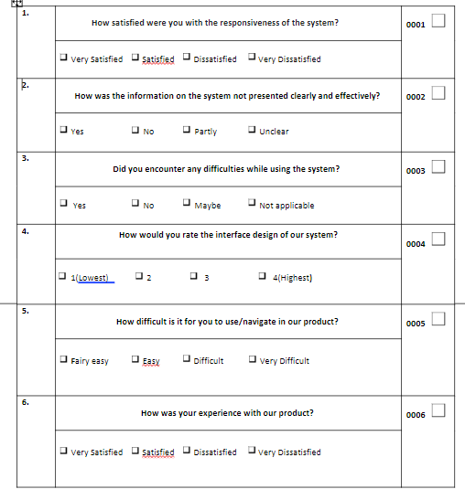system and the user experience it provides.

The guidelines were considered by the researchers when developing survey questions. To make sure we are moving toward our goal, the questions must be system related. We asked about the user’s satisfaction with the system’s response in our survey. The next question is how the system’s information was not displayed clearly and effectively, so that the researchers can make improvements and deliver the information more successfully going forward. We asked them about any challenges they encountered while using it in the third question to improve our system and address the issues users have. In the fourth question, we asked them to provide feedback on the system’s interface so we could make changes based on whether they thought it was good. In the fifth question, we asked the users about how challenging it was for them to use or navigate our system so that we might make it simpler for them to utilize. In our final questioning, we sought feedback on the users’ experiences with our system so that we could determine how to move forward with building and upgrading it.

**User Acceptance Test (According to survey)**

|  |  |  |  |  |  |
| --- | --- | --- | --- | --- | --- |
| **Features** | **5** | **4** | **3** | **2** | **1** |
| **User Interface** | ✓ |  |  |  |  |
| **Design/Aesthetic/Color** |  | ✓ |  |  |  |
| **Functionality** | ✓ |  |  |  |  |
| **Readability** | ✓ |  |  |  |  |
| **User-Friendly** | ✓ |  |  |  |  |
| **Error-Free** |  |  | ✓ |  |  |

## 

## **Result and Analysis**

Based on the survey results, the respondents found the developed system to be visually appealing. The presentation of information, its clarity, and effectiveness have received positive answers from the respondents. In addition, it can be inferred from the survey that the system’s responsiveness has satisfied the users of the product. Moreover, the functionalities of the system work as intended enabling the researchers to receive positive feedback from the users. Lastly, the system requires no difficulties or expertise to be able to use, allowing the users to be able to navigate throughout the system with ease.

## 

## **Summary**

In conclusion, this chapter comprehensively examined and evaluated the various modules of the Web-based Calendar Scheduler with Notification. The primary aim was to assess the functionality and performance of each module, ensuring their effectiveness in managing online events. Furthermore, the system’s features and capabilities were subjected to a thorough evaluation through the User Acceptance Test, which solicited feedback from clients and users. The analysis and testing conducted in this chapter provide valuable insights into the system’s strengths and weaknesses, enabling future enhancements and optimizations to align with the specific needs and expectations of users. This research contributes to the overall understanding and improvement of the Web-based Calendar Scheduler with Notification, ensuring its successful implementation and utilization in organizing and managing online events effectively.

# 

# **CHAPTER V**

# **Conclusions and Recommendations**

## **Conclusion**

Based on the data and findings collected in this study, it can be deduced that the research inquiries have been adequately addressed, and the objectives of the study have been accomplished. The development of the Web-based Calendar Scheduler with Notification, along with its constituent modules, has been deemed successful. The outcomes of numerous assessments and evaluations conducted on the system have generated favorable results. The findings of this study affirm the efficiency and effectiveness of the Web-based Calendar Scheduler with Notification, highlighting its potential in facilitating seamless and streamlined management of online events. The comprehensive analysis conducted in this study contributes to the advancement and understanding of the Web-based Calendar Scheduler with Notification, paving the way for future enhancements and optimizations to meet the specific requirements and expectations of event organizers and participants.

## 

## **Recommendation**

The list provides a thorough compilation of areas for improvement that future researchers, engaged in similar research topics, may consider incorporating into their own scholarly investigations:

1. A functionality that grants the administrator complete system control, with user-friendly settings that are easily comprehensible.

2. System that can be used to book an event what is needed for preparing an upcoming event.

3. In order to operate effectively, the system requires a consistent and dependable internet connection.

4. The system can make booking the event easier and remind the user of the upcoming event.

5. Create a smooth and intuitive interface that allows for easy event creation and management, ensuring a seamless and efficient experience.

6. An event management module which would allow users to manage events such as selecting the venue, selecting the personnel in charge, etc.

## 

## **REFERENCES**

Andrada, R. M. G., & Lansigan, R. R. (2018). Development of an Online Reservation and Booking System for Event Management in a Philippine University. International Journal of Innovative Research in Computer and Communication Engineering, 6(5). Retrieved from https://ijircce.com/upload/2018/may/26-1-IJIRCCE.pdf

Bhattacharya, N., & Sarkar, S. (2016). A Calendar-Based Event Management System for Social Networks. In Proceedings of the 2016 International Conference on Advanced Computing and Communication Systems (ICACCS). Retrieved from https://ieeexplore.ieee.org/document/7586114

Garcia, P. S., & Gadiano, R. G. (2017). Development of an Online Calendar-Based Event Management System for a Philippine University. International Journal of Engineering Research & Technology, 6(5). Retrieved from https://www.ijert.org/research/development-of-an-online-calendar-based-event-management-system-for-a-philippine-university-IJERTV6IS050337.pdf

Heegaard, P. E., & Øverlier, L. (2010). Notification Systems for Event Management. IEEE Communications Magazine, 48(11). Retrieved from https://ieeexplore.ieee.org/document/5657826

Kungpisdan, S., & Sripimanwat, K. (2017). Design and Implementation of an Online Booking System for Event Management. International Journal of Advanced Computer Science and Applications, 8(6). Retrieved from https://thesai.org/Publications/ViewPaper?Volume=8&Issue=6&Code=IJACSA&SerialNo=43

Khan, A. R., Alatiyyah, O. H., & Aljadaan, K. A. (2018). A Service Oriented Architecture based Comprehensive Smart Calendar for scheduling and managing real-time events. In Proceedings of the IEEE International Conference on Computational Intelligence and Computing Research (ICCIC) (pp. 1-4). Retrieved from https://ieeexplore.ieee.org/document/8593036

Mustacoglu, A. F., Wu, W., & Fox, G. (2003). Web-based systems for communication and scheduling. In Proceedings of the IEEE International Conference on Systems, Man, and Cybernetics (SMC) (pp. 2689-2694). Retrieved from https://ieeexplore.ieee.org/document/1245491

Mustacoglu, A. F., Wu, W., & Fox, G. (2006). Internet Calendaring and Scheduling Core Object Specification (iCALENDAR) Compatible Collaborative Calendar-Server (CCS) Web Services. In Proceedings of the IEEE International Conference on Web Services (ICWS) (pp. 83-90). Retrieved from https://ieeexplore.ieee.org/document/1644111

Salvador, K. R., & Dizon, C. D. G. (2018). Design and Implementation of a Notification System for Event Management in a Philippine University. Journal of Information Systems Engineering & Management, 3(1). Retrieved from https://www2.uet.tw/~journal/JISEM/issues/vol3/vol3_no1/05_JISEM-2018-01-005.pdf

## **APENDIX/APPENDICES**

**Appendix A: User’s Manual**

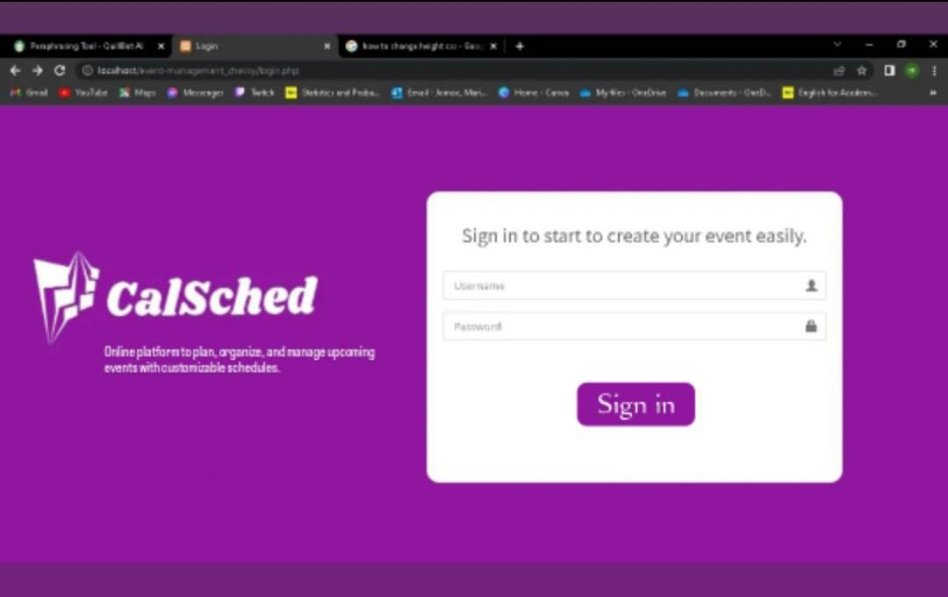

**Figure 6.1 Login/Logout Module**

The login functionality allows users to securely access a system or application by providing their credentials, typically a username and password. Once the user submits the login information. The user is granted access to the system and can proceed to use its features and resources. logout functionality allows users to end their current session and securely log out of the system.

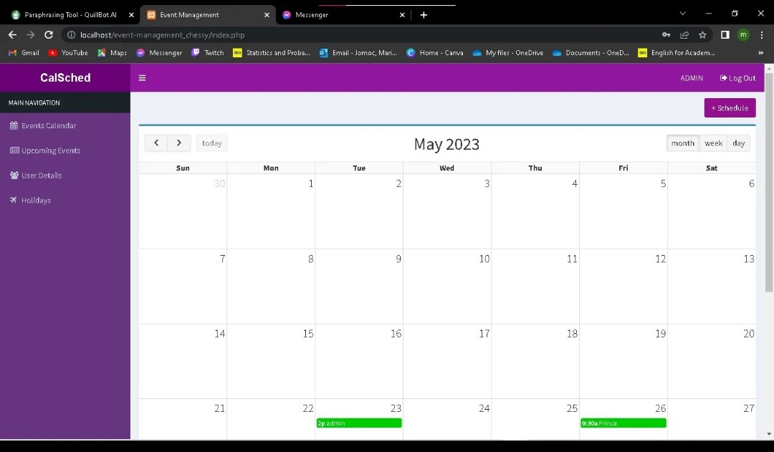

**Figure 6.2 Admin Dashboard**

This is the admin dashboard that can access the calendar where the user schedules their events.

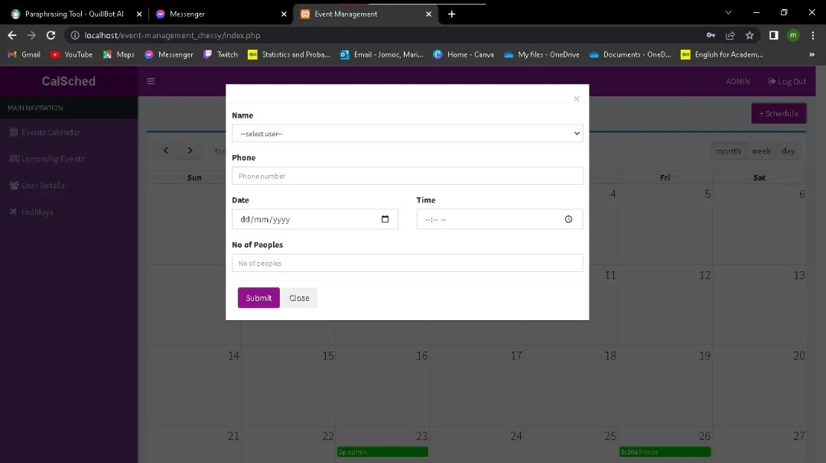

**Figure 6.3 Admin form**

This is the admin form that can create their events.

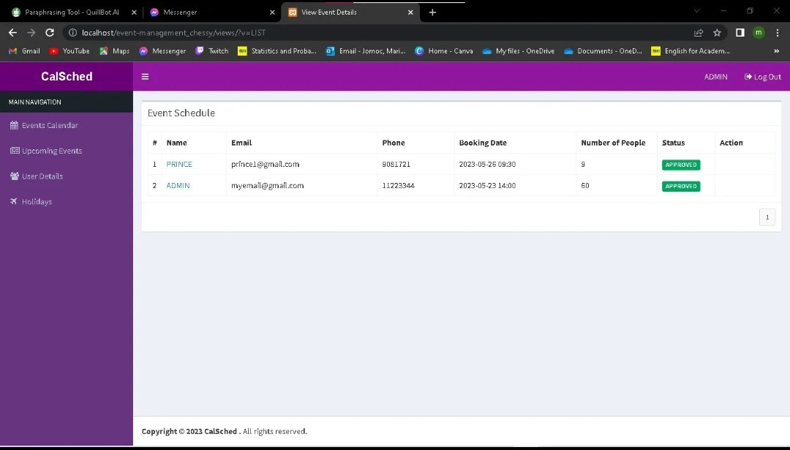

**Figure 6.4 Admin upcoming event, approve, and decline**

This is the event schedule which is approving events and decline.

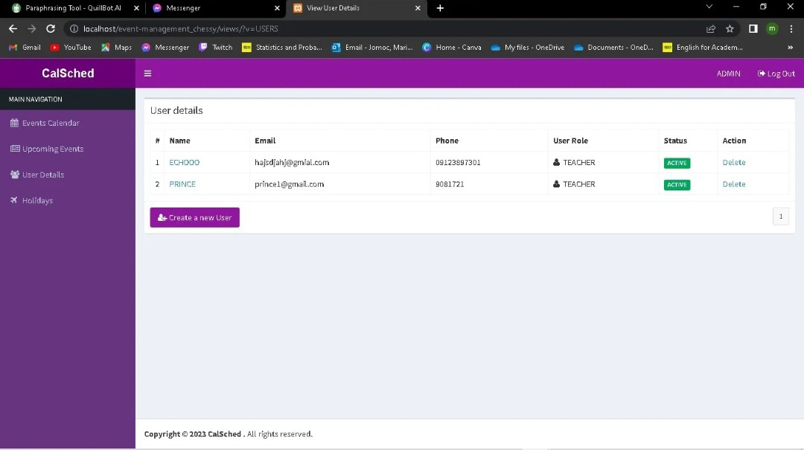

**Figure 6.5 User details**

This can access the users who are active and inactive on the website.

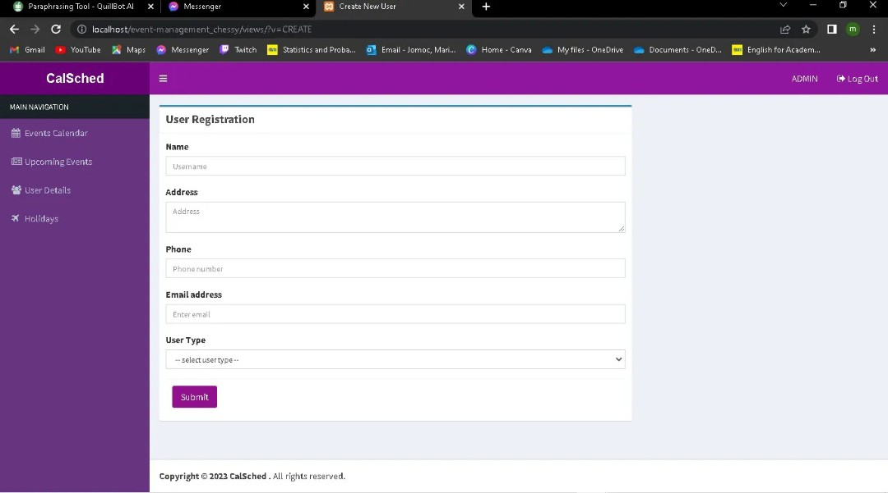

**Figure 6.6 User Registration**

Admin can create accounts for employees who want to access the website.

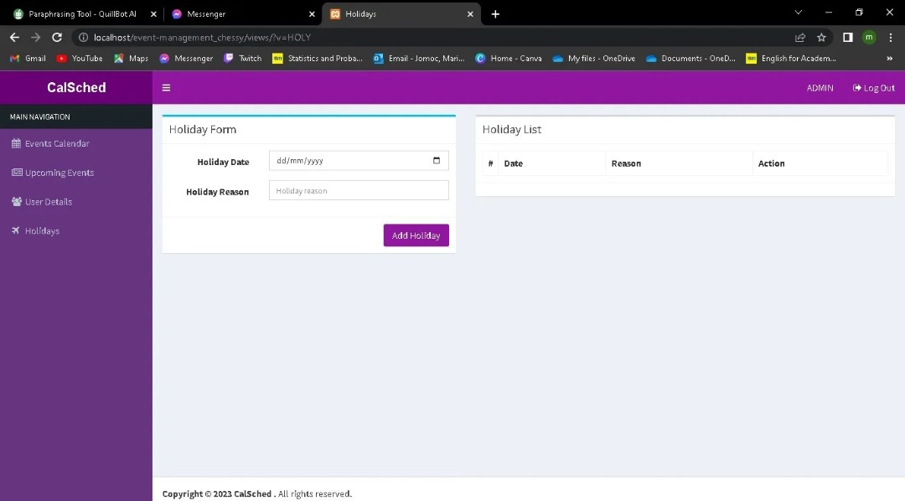

**Figure 6.7 Holiday Form**

It can set the holidays in calendar to know the user that this date is not available.

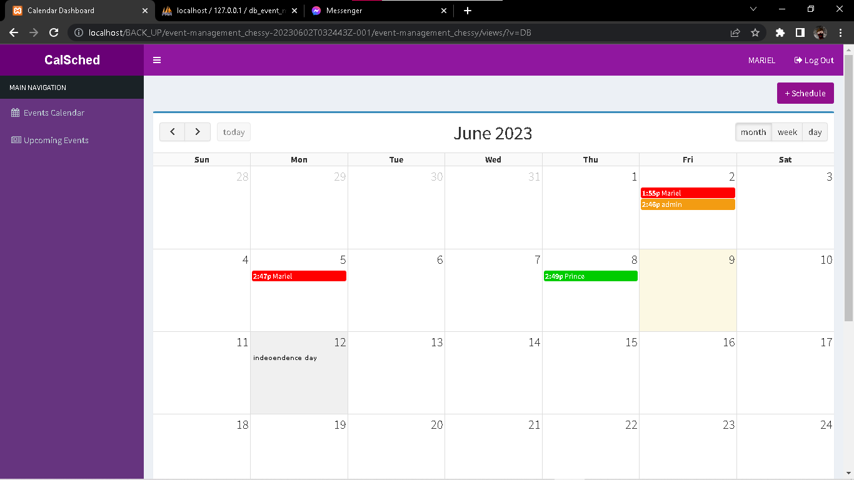

**Figure 6.8 User Dashboard**

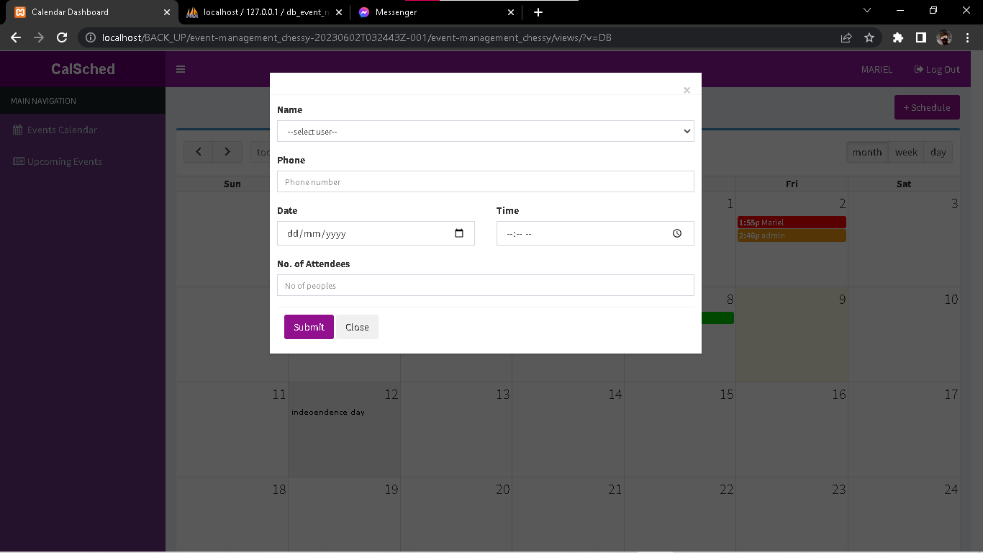Users can view the scheduled events in the calendar and holidays.

**Figure 6.9 User Form**

User can schedule their evets and meeting.

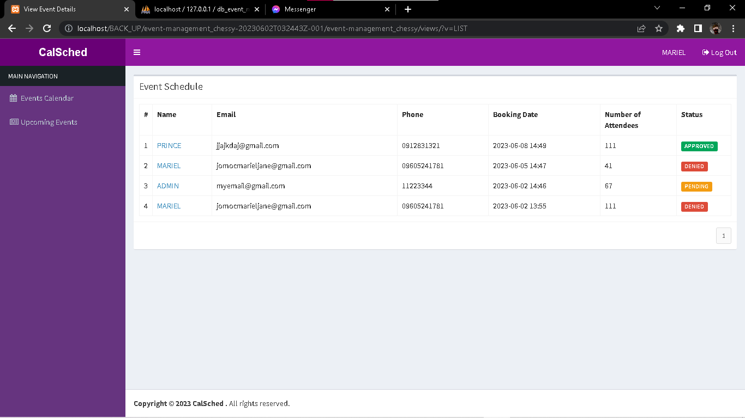

**Figure 7: User upcoming events**

They can see the upcoming events in the calendar and also the status of the events if its approve or decline.

**Appendix B: User Acceptance Test Survey**

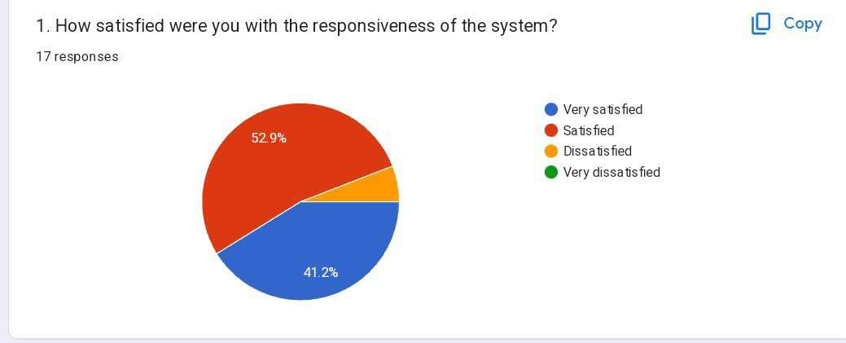

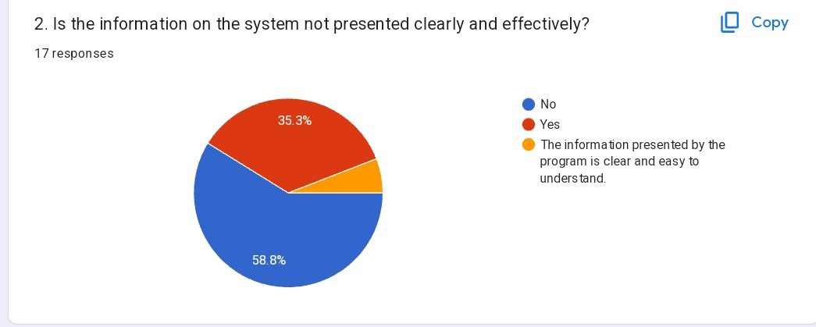

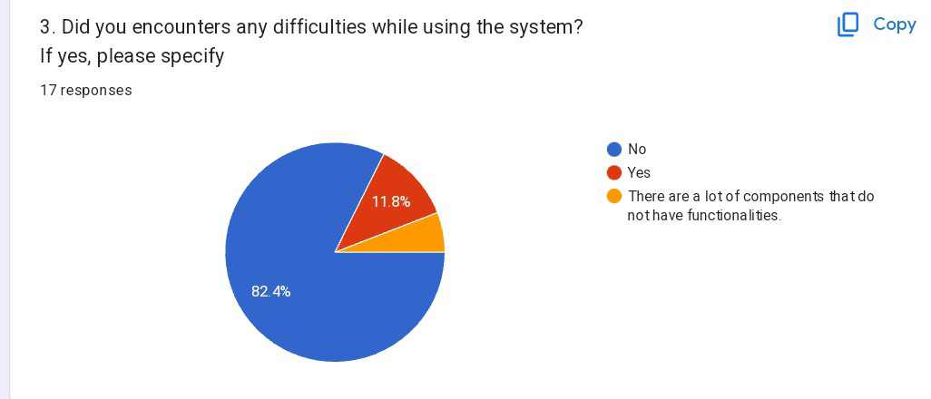

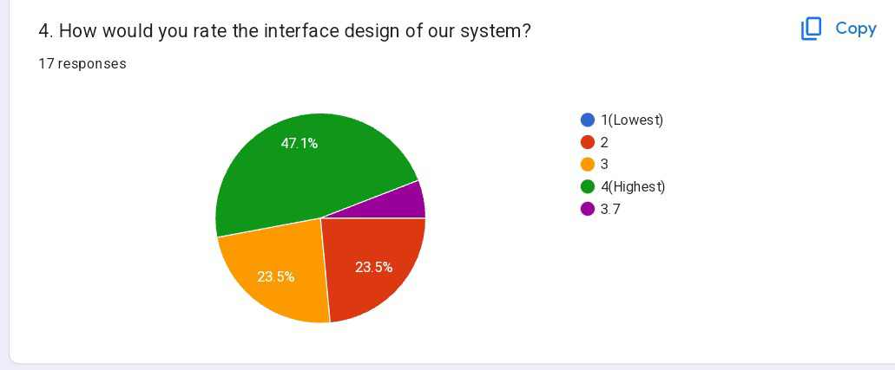

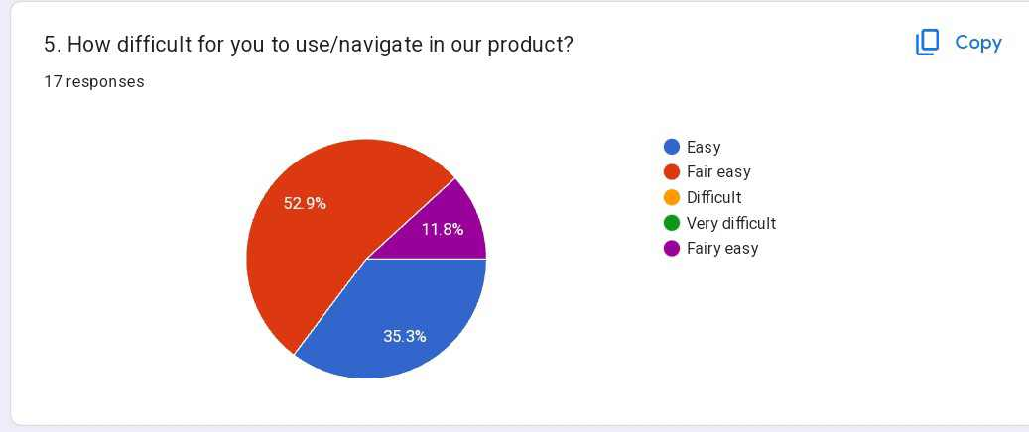

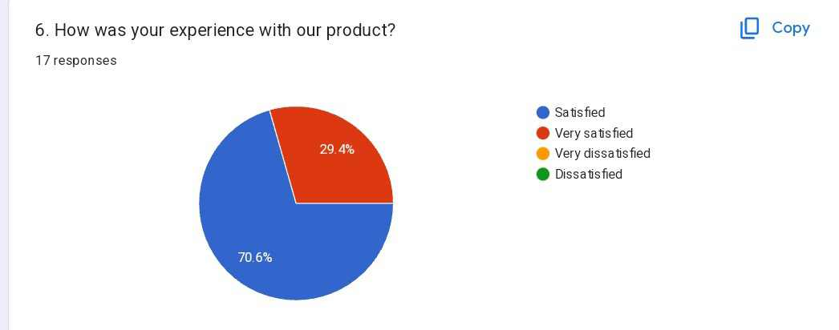

**Appendix C: Letter of Request to Test the System**

April 17, 2023

Ms. Vilma C. Caparros

School President

STI College Marikina

289 L. de Guzman St. Concepcion 1

Marikina City

Dear Ms. Caparros,

The researchers are writing to request approval for prototype testing of the Online Events Management System (OEMS) that will be used in the upcoming STI College Marikina 2023 Exposition.

The researchers have extensively developed and tested the OEMS, and the researchers believe it is ready for prototype testing. This testing will take place in STI College Marikina, allowing the researchers to identify any potential problems and make any necessary improvements prior to the upcoming STI College Marikina 2023 Exposition.

Before the official launch, the researchers would like to conduct prototype testing on a limited number of participants to ensure that the system is functioning properly and to identify any potential issues. The researchers proposed prototype testing participants are as follows:

* 10 employees from STI College Marikina

We hope that the request for prototype testing will be approved.

Thank you for your consideration.

Sincerely,

_____________ ______________ _________________

Cencio, Kurt Zhairol Duran, Jenoah Prince Fenando, Francheskca

_____________ ________________ __________________

Gines, Jericho Guban, Ma. Janelle Toledo, Riezl Louice

**Appendix D: Researchers’ compilations Development of System**

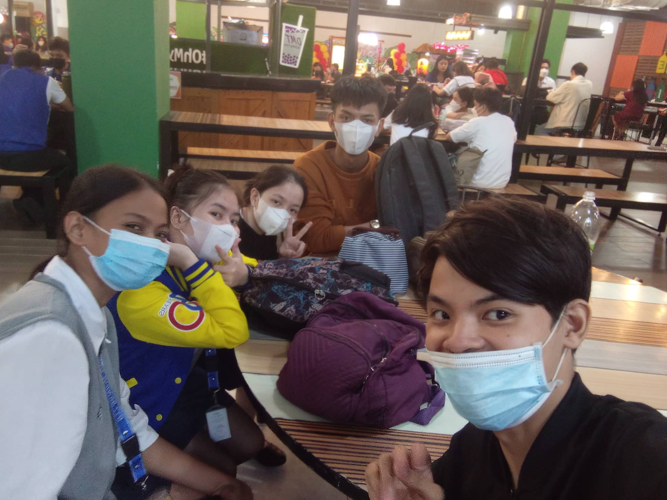

Meeting for research paper and what will be the design of our website.

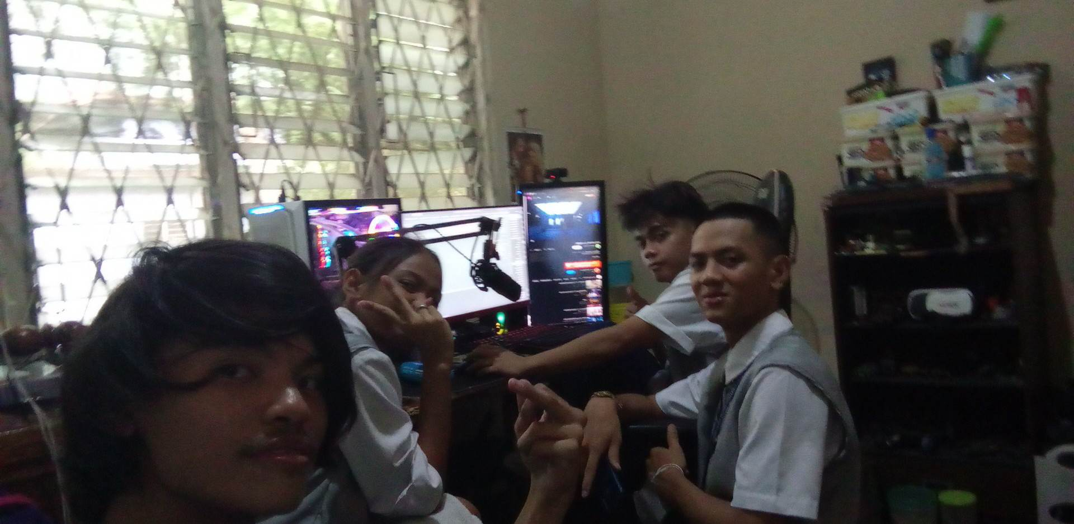

Revision of paper chapter 1-5 and our website

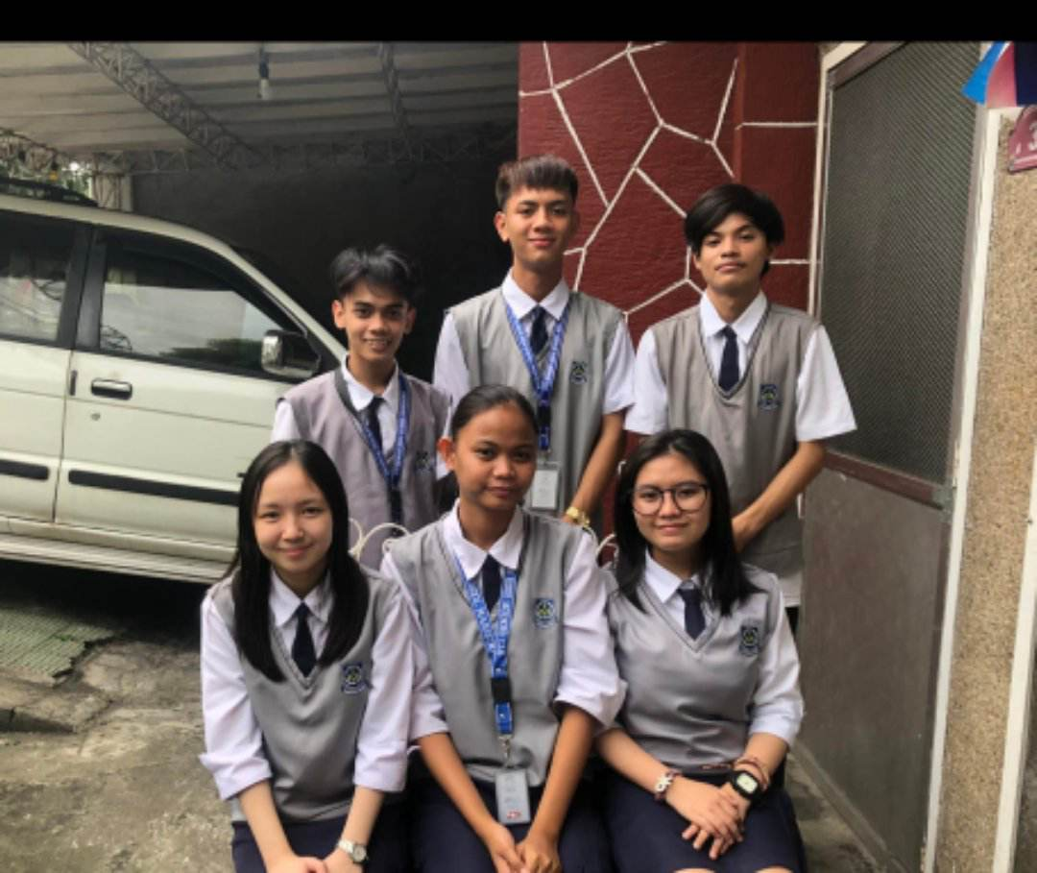

Picture for the front of our research portfolio

**Appendix E: Researchers’ compilation Senior High School Expo 2023**

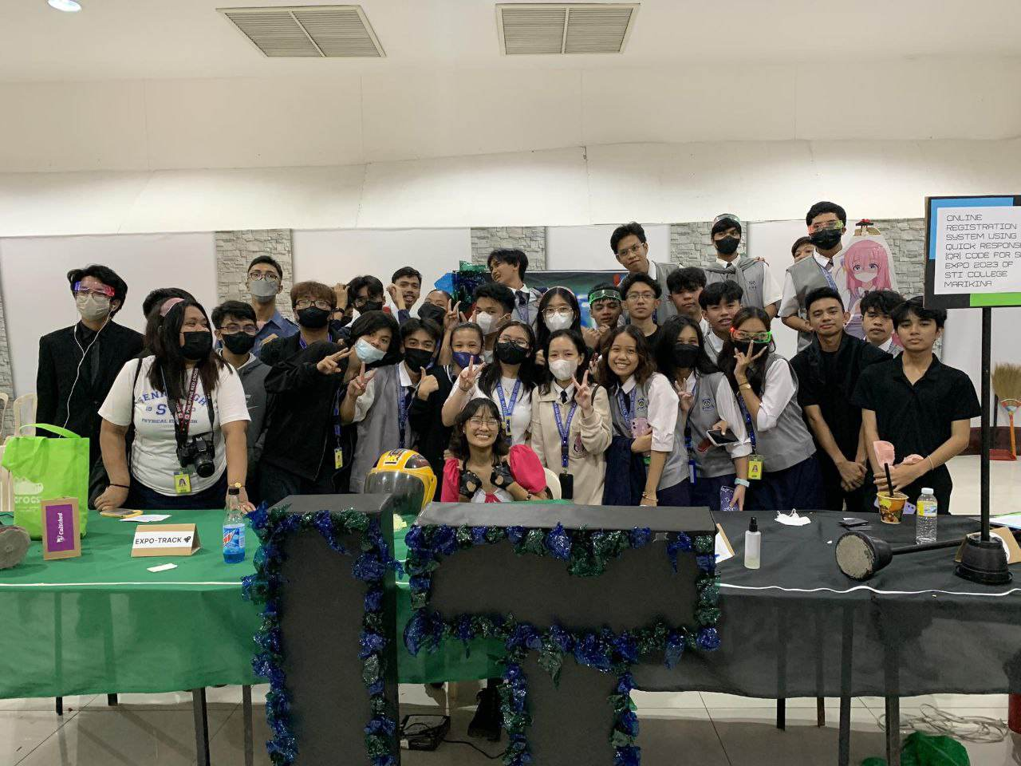

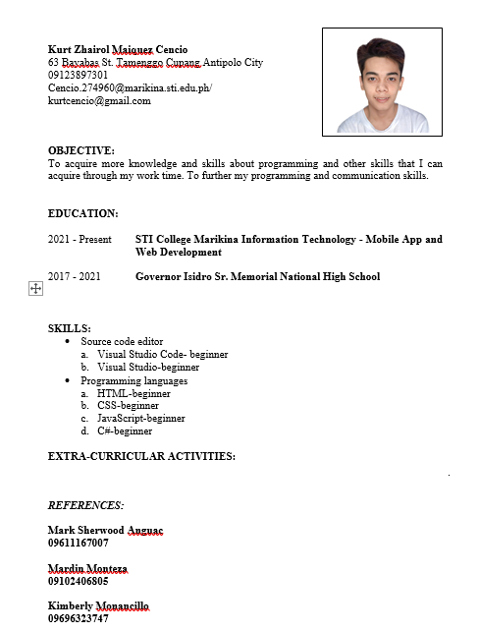**Appendix F: Resume of Researchers**

