

**UNIVERSITI MALAYSIATERENGGANU**

**Faculty of Computer Sciences and Mathematics**

**CSM3123-Native Mobile Programming Lab report 1**

**Prepared By :**

Muhammad Harith bin Zulkifli (S67335)

**Prepared For :**

Dr Rabiei Mamat

25 October 2024

Bachelor of Computer Science (Mobile Computing) with Honors

Semester I 2024/2025

Github link : [riezuuuu/CSM3123-Native](https://github.com/riezuuuu/CSM3123-Native)

Task 1

Java

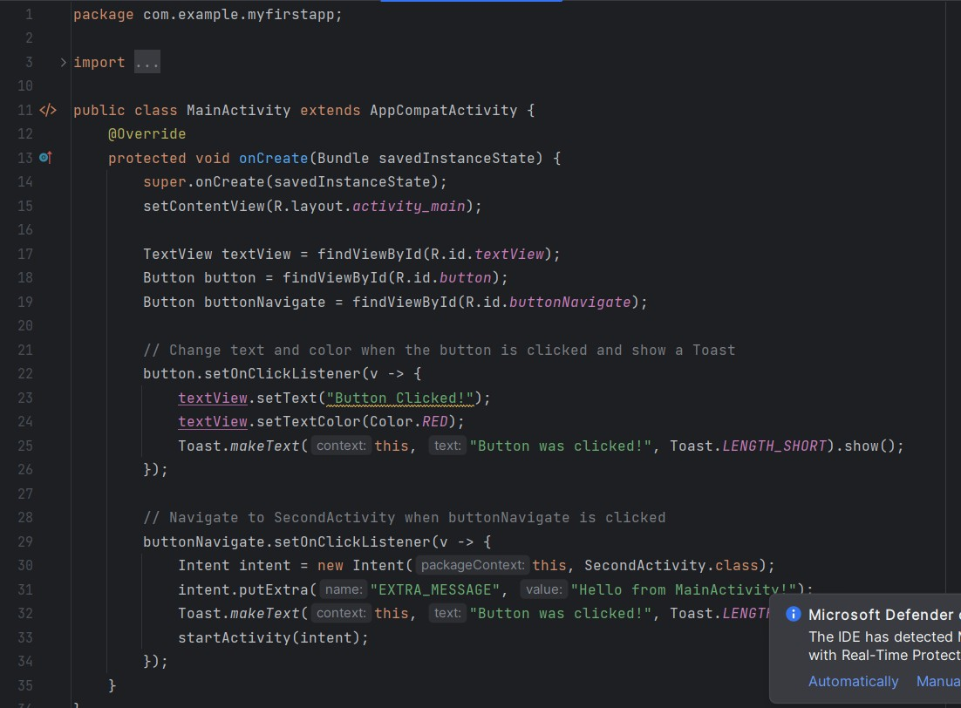

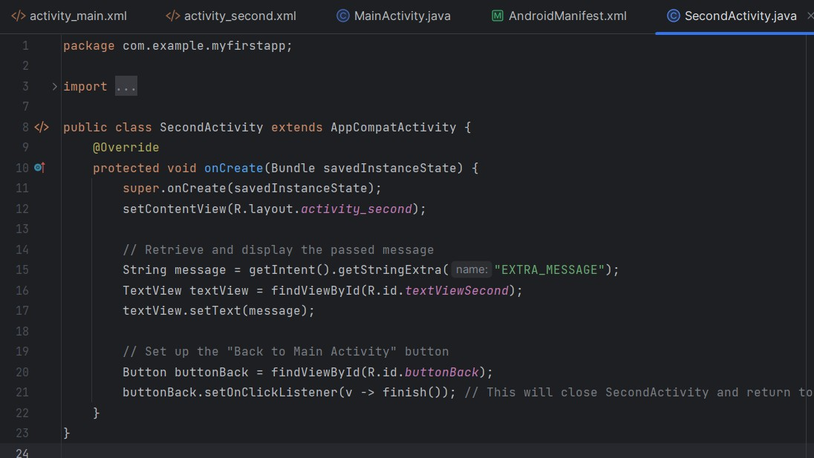

Kotlin

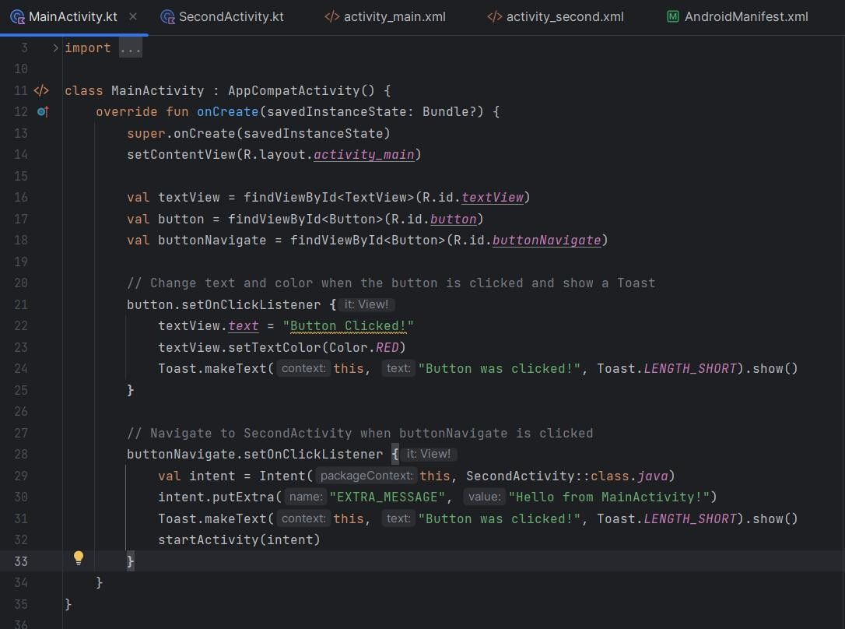

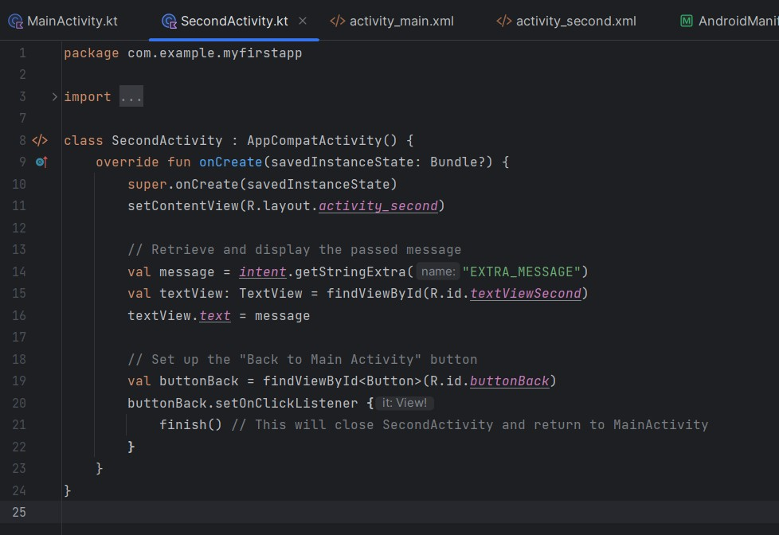

XML

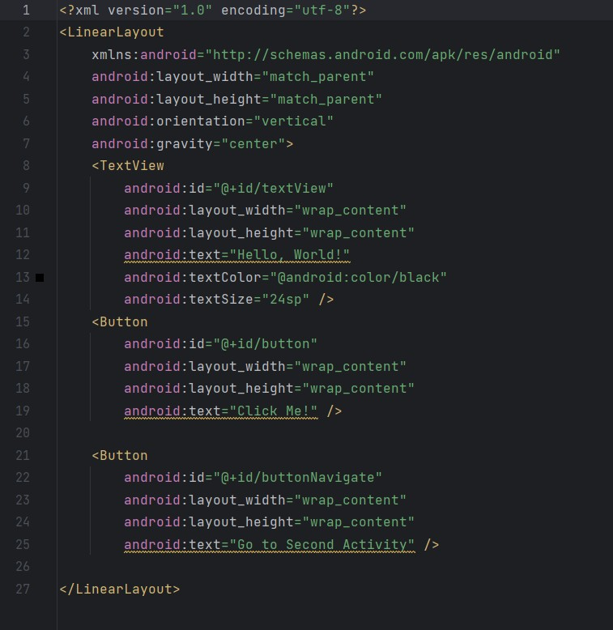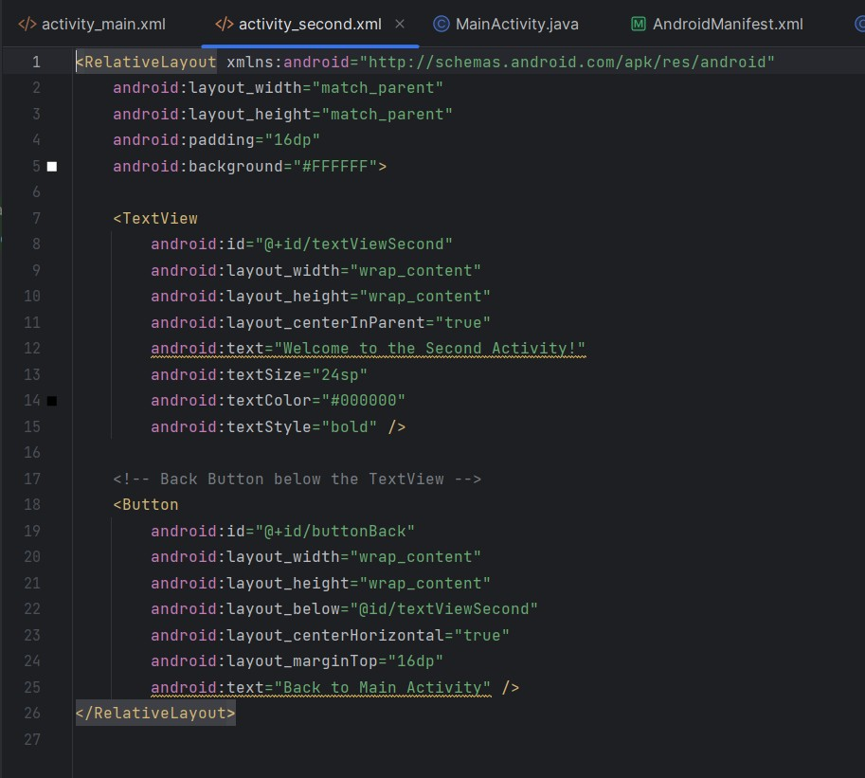

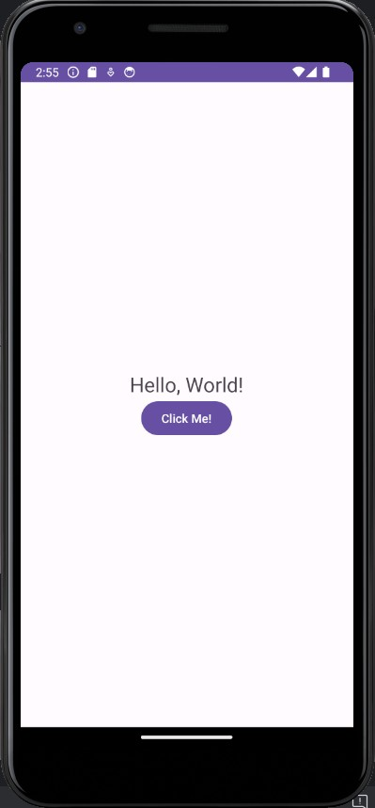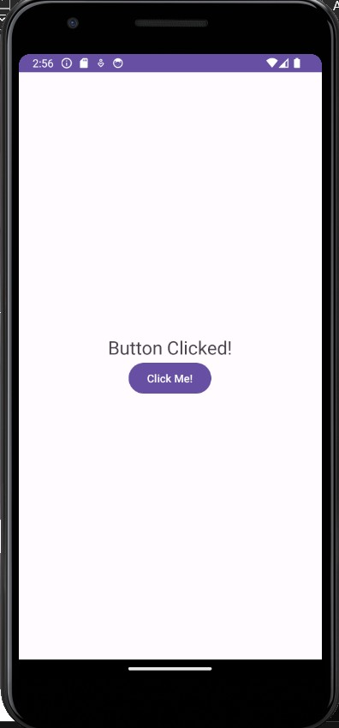

Activity 1

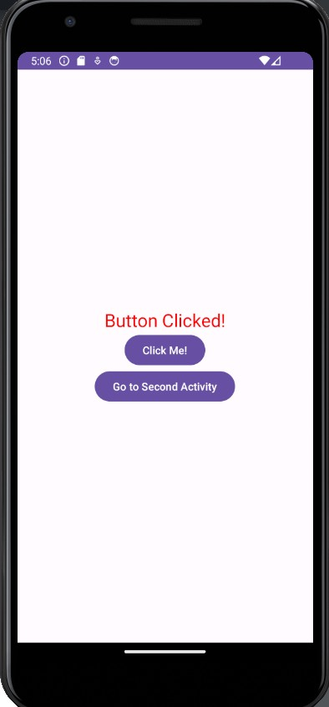

Activity 2

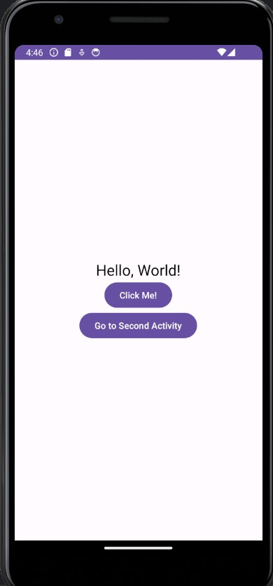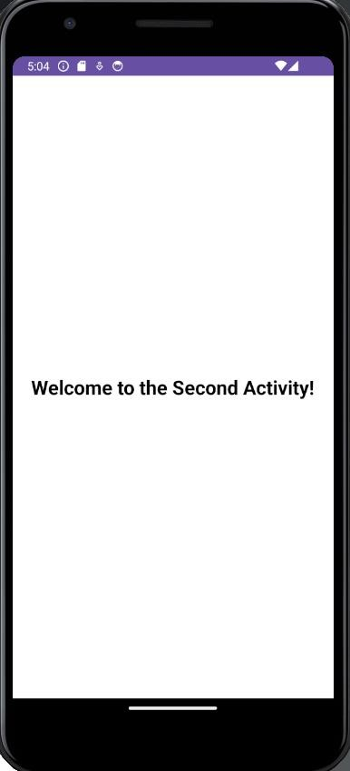

Activity 3

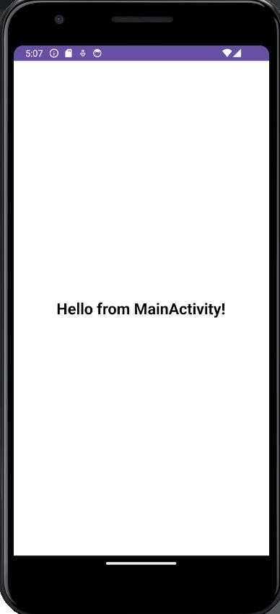

Activity 4

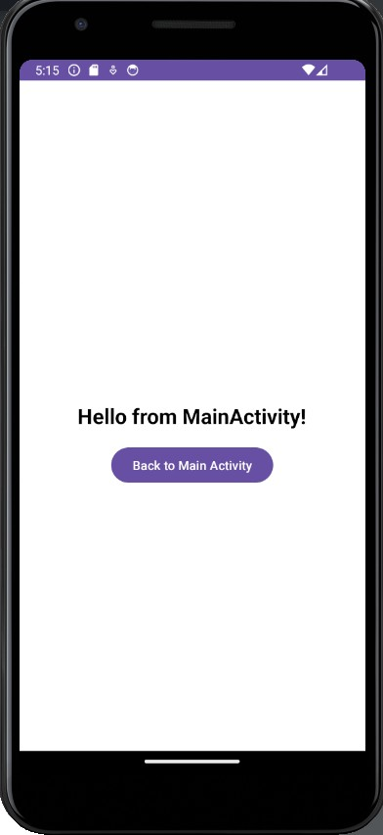

Activity 5

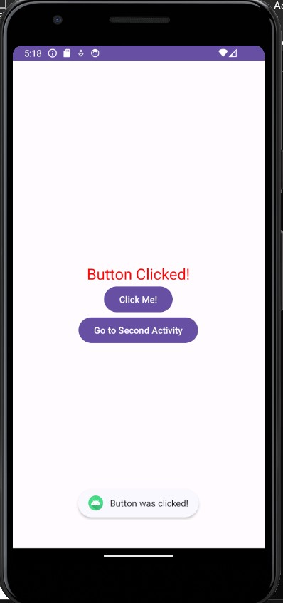

Task 2

Java

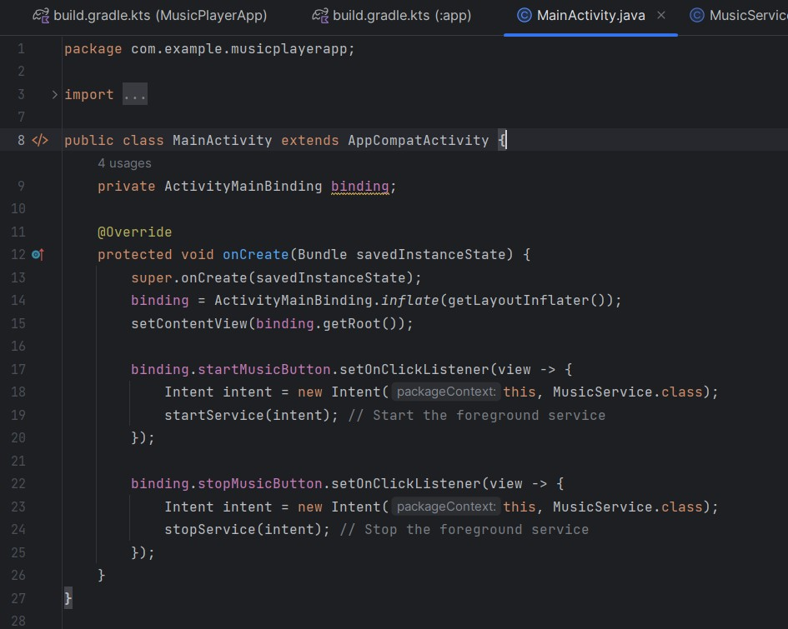

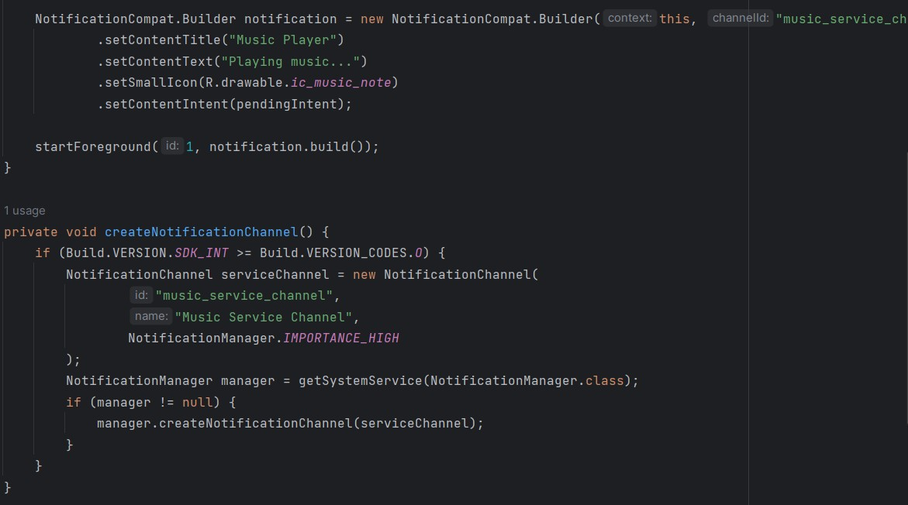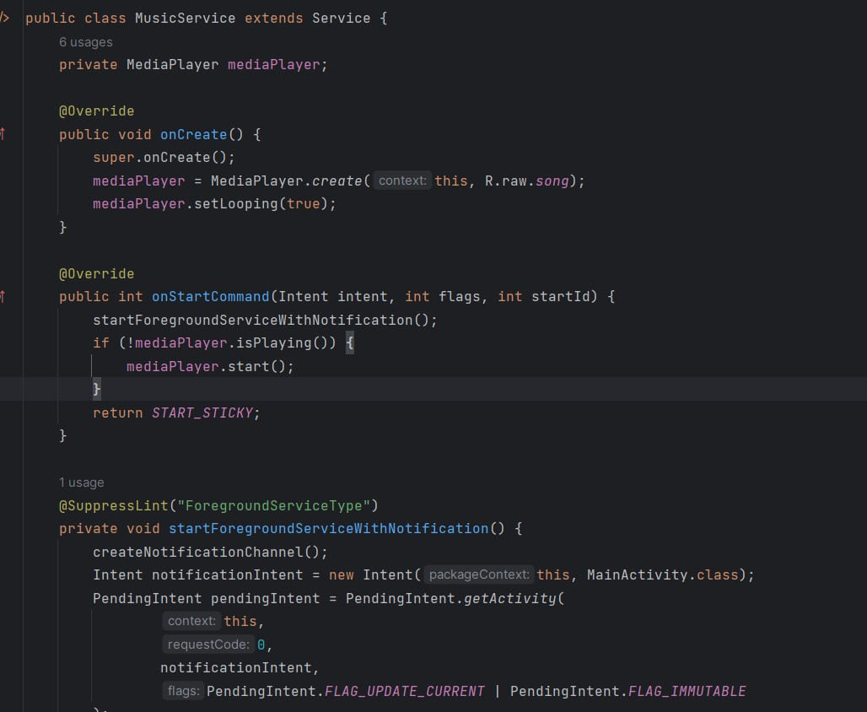

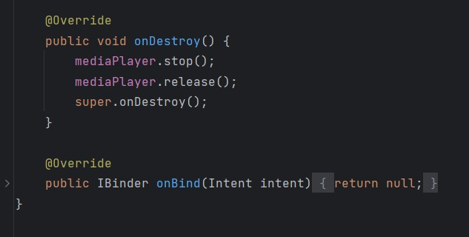

Kotlin

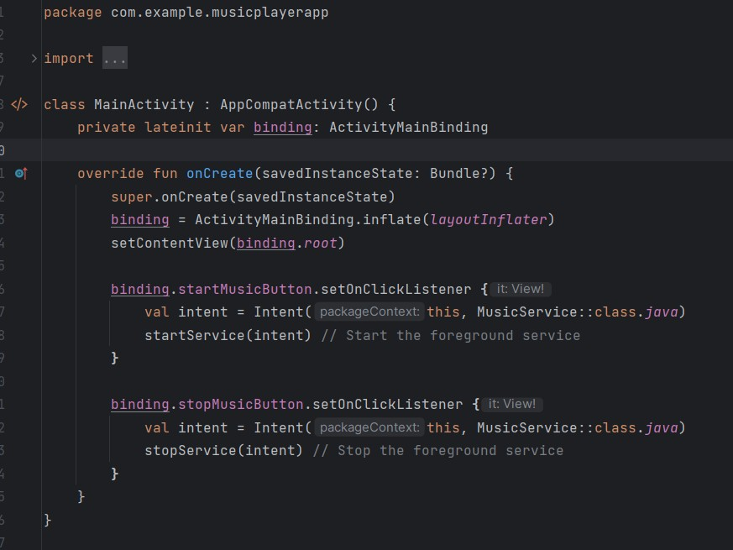

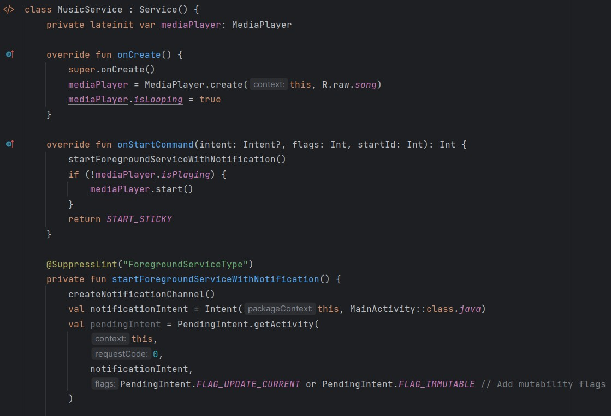

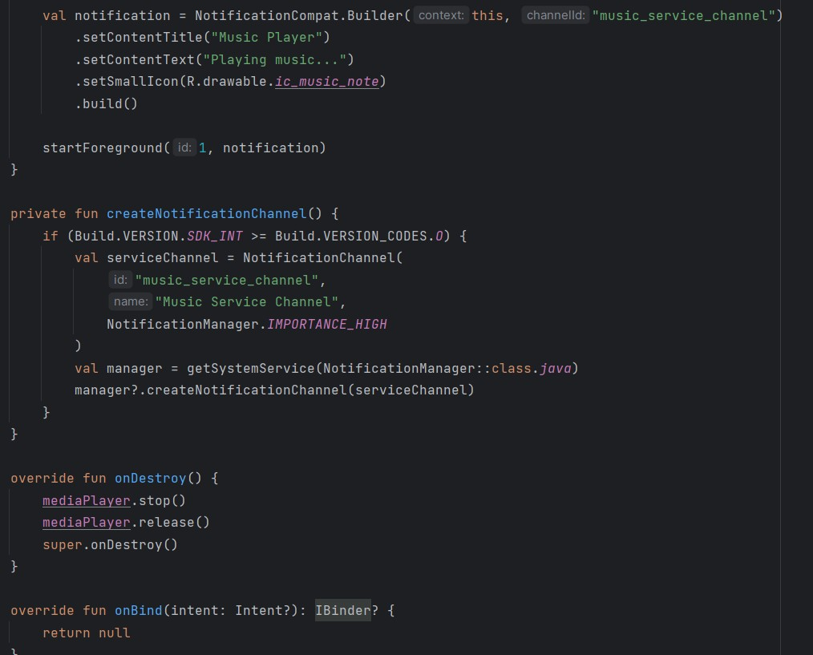

XML

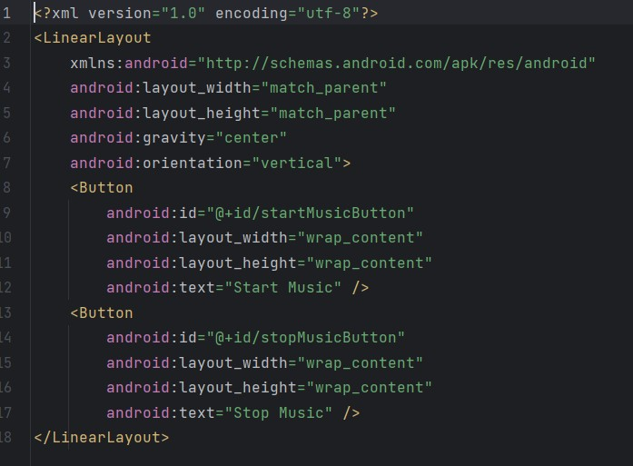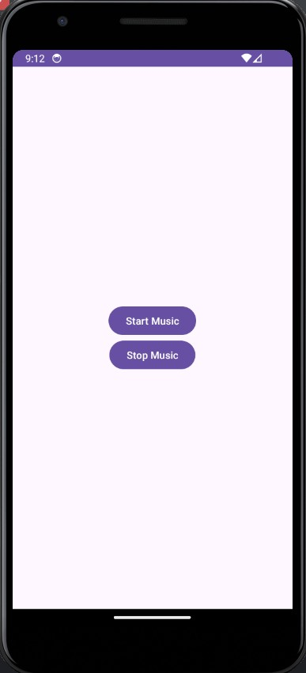

Task 3

Java

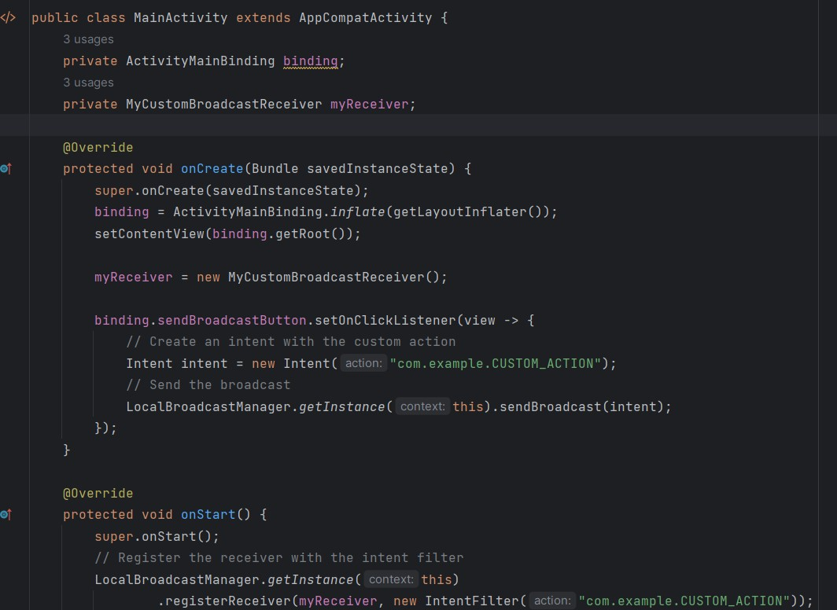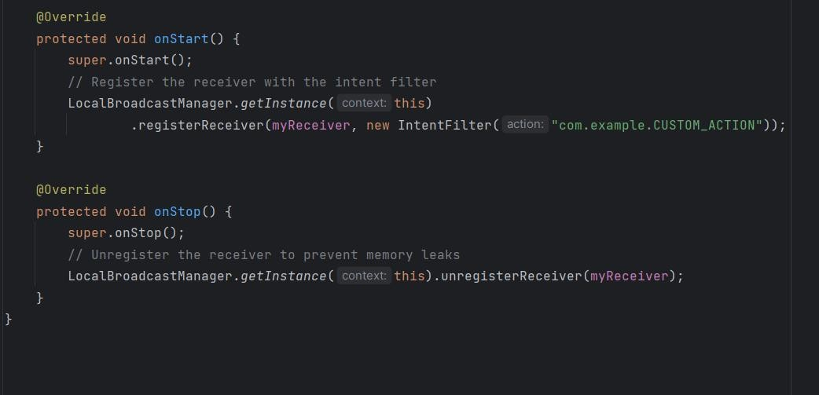

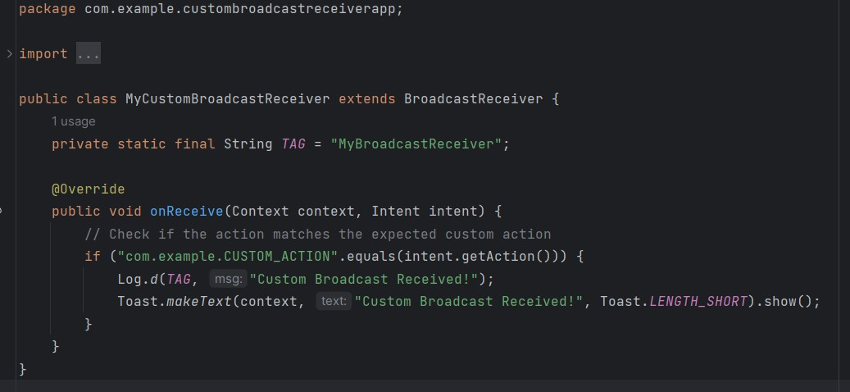

Kotlin

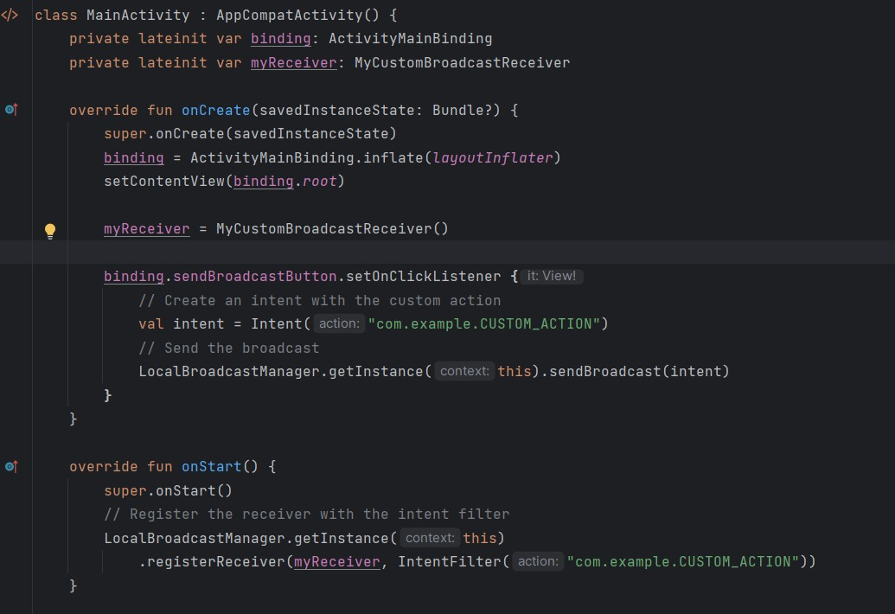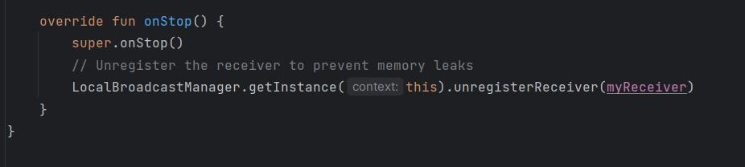

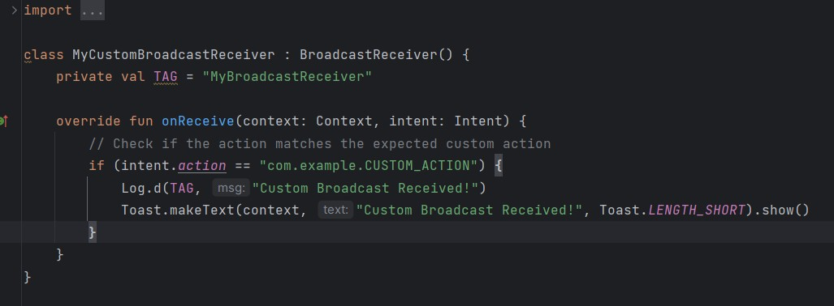

XML

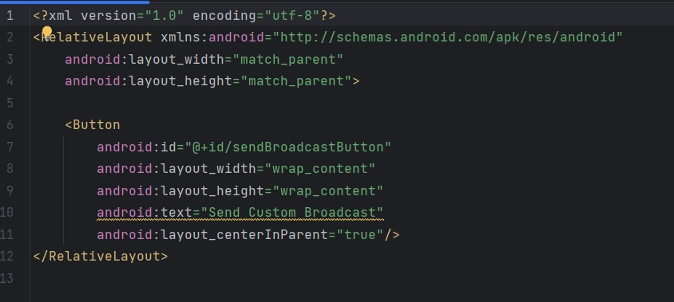

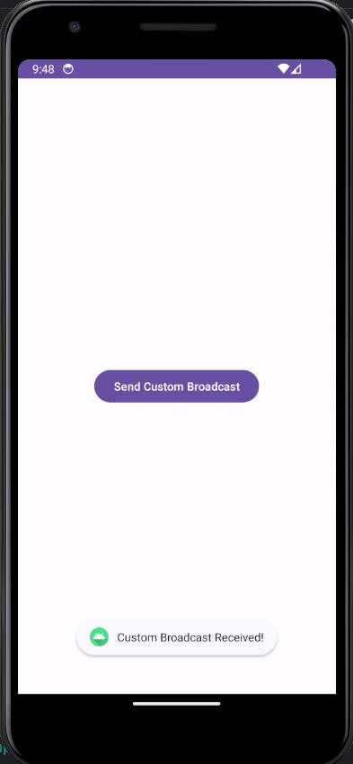

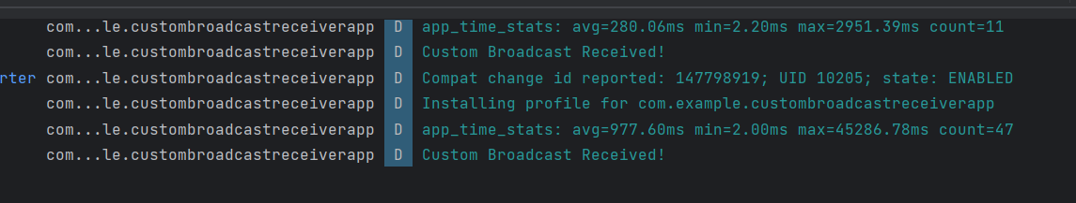

Answer the following question.

# In the provided implementation, why is the custom action string ("com.example.CUSTOM_ACTION") used? What would happen if this string were changed in one place but not another?

The custom action string "com.example.CUSTOM_ACTION" ensures that the broadcast is uniquely identified. If changed in only one place (e.g., in the broadcast but not in the receiver), the broadcast would fail, as the receiver wouldn’t recognize it.

# What are the advantages of using LocalBroadcastManager over regular broadcasts?

LocalBroadcastManager is used for sending broadcasts within an app, with several benefits over regular broadcasts:

* **Security**: Broadcasts remain within the app, reducing the risk of exposing sensitive data.
* **Efficiency**: Local broadcasts are more efficient because they don’t cross process boundaries.
* **Less Overhead**: There’s no need for permissions, simplifying broadcast communication within the app.

# Describe how you would modify the code to send a broadcast with additional data (using Intent.putExtra). Provide an example.

To send a broadcast with additional data, use Intent.putExtra to attach data to the broadcast. For example, if we wanted to send a broadcast with a user’s name, we would modify the code like this:

// Sending the broadcast with additional data val intent = Intent("com.example.CUSTOM_ACTION") intent.putExtra("username", "John Doe") // Adding extra data LocalBroadcastManager.getInstance(this).sendBroadcast(intent)

In MyCustomBroadcastReceiver, retrieve this data as follows:

override fun onReceive(context: Context, intent: Intent) { if (intent.action == "com.example.CUSTOM_ACTION") { val username = intent.getStringExtra("username") Toast.makeText(context, "Received for user: $username", Toast.LENGTH_SHORT).show() } }

# If you wanted to receive broadcasts from multiple activities, how would you modify the existing BroadcastReceiver setup?

To receive broadcasts from multiple activities, you could:

* **Register the BroadcastReceiver in each activity**: Each activity would register the same BroadcastReceiver instance, allowing them all to receive the broadcast.
* **Use a centralized registration in a parent or base activity**: If your activities extend a base activity, you could register the BroadcastReceiver in that base activity so all child activities can receive the broadcast.
* **Broadcast Data Filtering**: Use different action strings or data filters to distinguish broadcasts intended for each specific activity.