Coupling of a Surface-Vorticity Panel Method with a Structural Analysis for Fluid-Structure Interaction

Daniel Enriquez

*Altair, Troy, MI*

**Abstract goes here**

1. **Nomenclature**

*A* = amplitude of oscillation

*a* = cylinder diameter

*Cp*= pressure coefficient

*Cx* = force coefficient in the *x* direction

*Cy* = force coefficient in the *y* direction

c = chord

d*t* = time step

*Fx* = *X* component of the resultant pressure force acting on the vehicle

*Fy* = *Y* component of the resultant pressure force acting on the vehicle

*f, g* = generic functions

*h* = height

*i* = time index during navigation

*j* = waypoint index

*K* = trailing-edge (TE) nondimensional angular deflection rate

1. **Introduction**

Fluid-Structure Interactions are of interest in a variety of fields, but especially in aircraft design. In aircraft design, flight loads cause structural deformation of the vehicle components such as wings. The deformed wings behave differently than their undeformed counterpart.

1. **Background**

The validation case is that of a high-aspect-ratio highly-flexible straight wing presented in Ref [1].

1. **Numerical Modeling**

## Aerodynamic

FlightStream is used to provide the aerodynamic loads for the tool chain.

## 1D Beam Code

An open-source python-based structural solver, Anastruct, is used to perform the 1D beam analysis.

1. **Results**

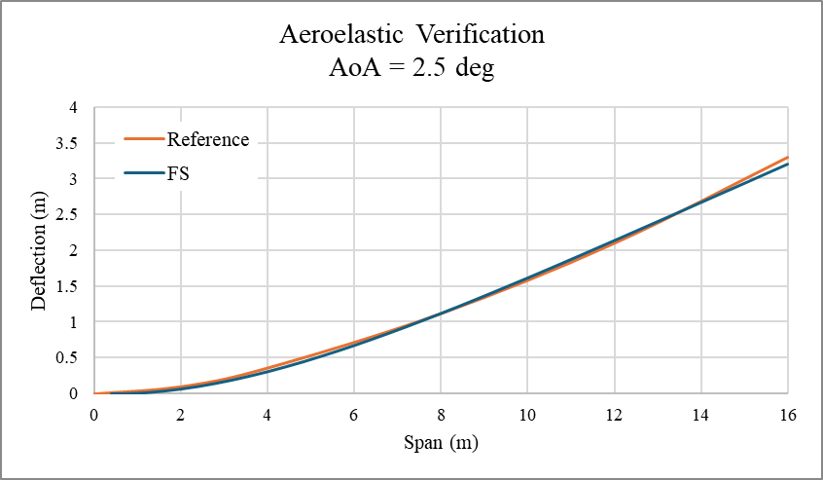

1. **Conclusion**

This validation opens the door for more complex FSI problems such as gust load analysis within FlightStream.

**Appendix**

The presented analysis and code are available upon request to Altair.

# References

|  |  |
| --- | --- |
| [1] | M. J. P. D. H. H. M. J. Smith, "CFD-Based Analysis of Nonlinear Aeroelastic Behaviour of High-Aspect Ratio Wings," in *42nd AIAA/ASME/ASCE/AHS Structures, Structural Dynamics, and Materials Conference and Exhibit*, Seattle, WA, 2001. |