CSE440 – Introduction to Artificial Intelligence

Self-Driving Car Racing Game
Project Plan

Project Idea
We want to build a 2D car racing game where the car learns to drive by itself using reinforcement learning. The project does not need to be a full driving simulator. It needs to clearly show artificial intelligence, reinforcement learning, agent-environment interaction, and training and evaluation. Everything can run on a normal laptop with no GPU.

Overall Architecture
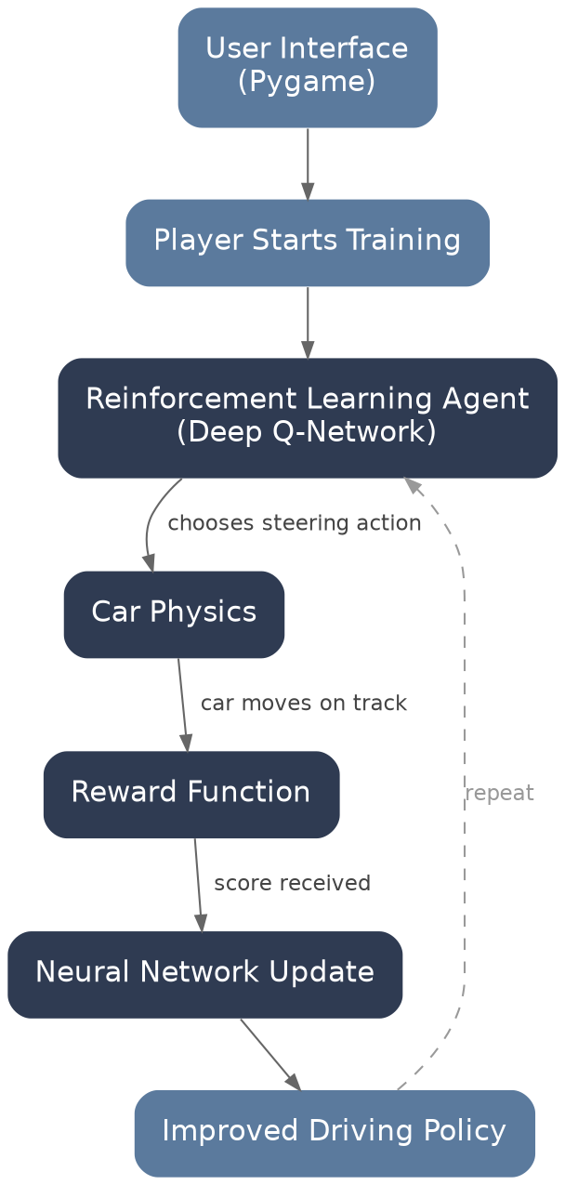
The player starts training. The agent chooses an action, the car moves, a reward is given, and the network updates. This repeats and the driving policy gets better over time.

Step 1: Choose the Technology
Part | Technology
Programming language | Python
Game engine | Pygame
AI | PyTorch
RL algorithm | Deep Q-Network (DQN)
Graphics | Simple 2D
Track | Image-based

- Python is easiest to work with.
- Pygame is beginner-friendly.
- PyTorch has many RL tutorials.
- Runs on CPU, no GPU required.

Step 2: Build the Game First
We should not start with AI. First we build a normal racing game controlled with the keyboard.
- Track
- Car
- Steering
- Acceleration
- Collision
- Finish line

Key | Action
Up arrow | Accelerate
Down arrow | Brake
Left arrow | Turn left
Right arrow | Turn right

If the car leaves the road, it is game over. At this stage there is no AI, only keyboard control.

Step 3: Car Physics
Physics should stay simple. Each car keeps track of position (x, y), speed, and direction (angle).
x += cos(angle) * speed
y += sin(angle) * speed
angle += steering
speed += acceleration

No complicated physics is needed.

Step 4: Build the Track
The simplest way is to make a track.png image. White is road, black is wall. The AI checks the pixel colour under the car. If it is black, that counts as a collision.

Step 5: Add Sensors
This is where the AI really starts. The car sends out rays in five directions, and each ray returns the distance to the nearest wall.
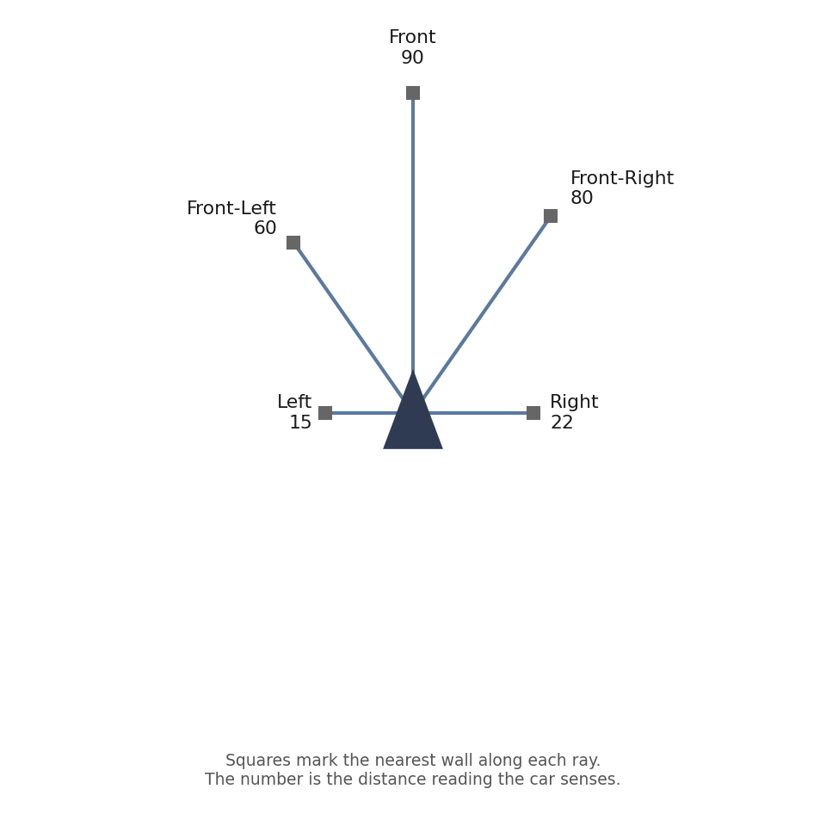
Example sensor readings: Left = 15, Front = 90, Right = 22, Front-Left = 60, Front-Right = 80.
These five numbers, plus the car's speed, become the state that the AI reads:
state = [left, front, right, front_left, front_right, speed]

Step 6: Define Actions
The AI does not control everything. It only chooses one of four actions:
- Turn left
- Turn right
- Go straight
- Brake

Step 7: Reward Function
This is the most important part. The AI learns from rewards, not from being told what to do.
Situation | Reward
Driving forward | +1
Passing a checkpoint | +20
Completing a lap | +100
Collision | -100
Driving backwards | -10
Standing still | -2

Good reward design matters more than a complicated neural network.

Step 8: Choose RL Algorithm
Algorithm | Difficulty
Q-learning | Easy
Deep Q-Network (DQN) | Easy–Medium
PPO | Medium
SAC | Hard
TD3 | Hard

We recommend DQN for this course. It is easy to implement, well known, has many tutorials, and has good academic value.

Step 9: Neural Network
The network is small on purpose, so it trains quickly on a laptop.
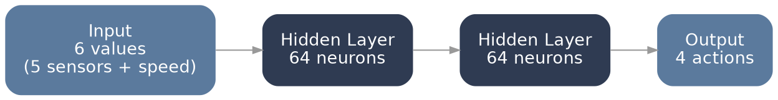
Input: 6 sensor values. Two hidden layers of 64 neurons. Output: 4 actions.

Step 10: Training Loop
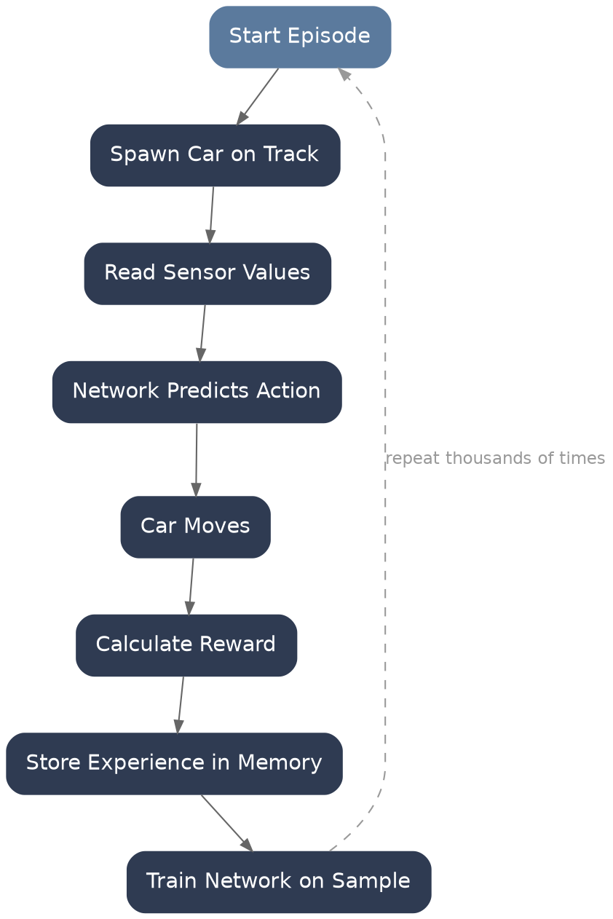
This loop repeats thousands of times during training.

Step 11: Experience Replay
Instead of learning immediately from the last step, we store state, action, reward, and next state in memory, then train on a random sample from that memory. This stabilises training.

Step 12: Epsilon-Greedy
The AI should not always follow the network. Sometimes it should take a random action instead, so it keeps exploring.
Choice | Probability
Follow the network | 90%
Random action | 10%

The random percentage gradually decreases as training goes on.

Step 13: Save Model
After training, we save the model as model.pth. Next time, we load the model and the AI can drive immediately, without retraining.

Step 14: Add Player Features
- Car colour: red, blue, green
- Track difficulty: easy, medium, hard
- Training controls: start, pause, continue
- Live view: episode, reward, lap, speed

Step 15: Add Graphs
After training, we show graphs so the AI's progress is easy to demonstrate in the presentation:
- Reward per episode
- Lap time per episode
- Collision count per episode

Folder Structure
SelfDrivingAI/
├── assets/ (track.png, car.png)
├── game/ (car.py, track.py, physics.py, sensors.py)
├── ai/ (dqn.py, replay_buffer.py, train.py)
├── models/ (model.pth)
├── utils/
├── main.py
└── requirements.txt

Development Roadmap
Week | Goal
1 | Learn basic Pygame and create the racing track
2 | Build car movement, steering, collision detection, and checkpoints
3 | Add distance sensors and define the state representation
4 | Implement the DQN model and replay buffer
5 | Train the AI agent and tune the reward function
6 | Save/load the trained model, add graphs and UI improvements, prepare the final report and presentation

What We Should Learn
- Python programming
- 2D game development with Pygame
- Basic vehicle physics
- Machine learning fundamentals
- Reinforcement learning
- Deep Q-Networks (DQN)
- Neural networks with PyTorch
- Experience replay
- Exploration vs. exploitation (epsilon-greedy)
- Reward engineering
- Model training and evaluation

Recommendation
Keep the scope focused: one AI-controlled car, one or two tracks, five distance sensors, and a DQN agent in PyTorch. This is realistic to finish on a normal laptop in one semester, it demonstrates the core AI concepts expected in this course, and it gives us clear training results we can explain in the presentation.

