CSE440

Self-Driving Car Racing Game
Using Deep Q-Network Reinforcement Learning
  - Project Report
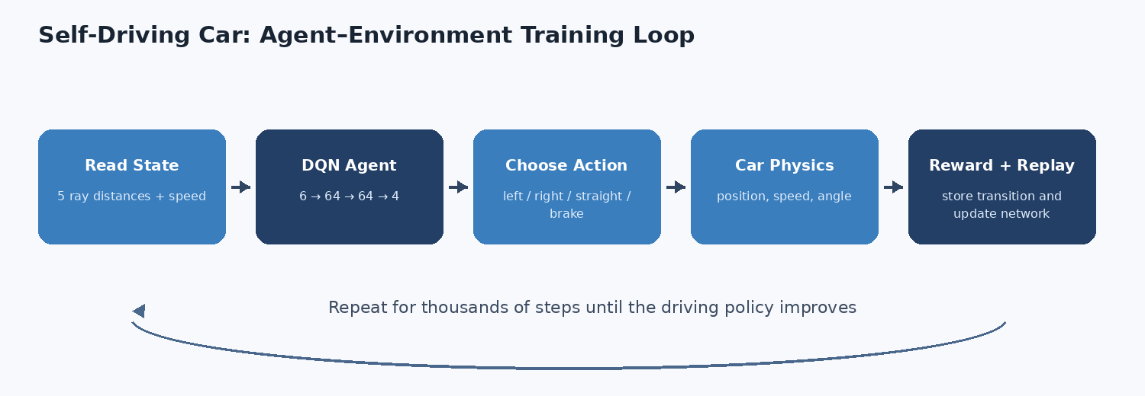
Agent-environment training loop used by the project
Course | CSE440 - Introduction to Artificial Intelligence
Students | Add names and IDs
Section | Add section
Faculty | Add faculty name
Submission date | Add date

Abstract
This project implements a two-dimensional racing game in which an artificial-intelligence agent learns to drive through interaction with a simulated environment. Pygame provides the interactive interface, Pillow and NumPy provide image-based tracks and collision masks, PyTorch implements a Deep Q-Network (DQN), and Matplotlib produces evaluation graphs. The agent observes five wall-distance sensor values and speed, then chooses turn left, turn right, go straight, or brake. It learns from rewards for forward progress, checkpoints, lap completion, collisions, backward movement, and standing still.
The completed system includes manual driving, three track difficulties, live and headless training, experience replay, epsilon-greedy exploration, a target network, checkpoint saving/loading, deterministic evaluation, and automated tests. In the included 300-episode Easy run, 110 exploratory episodes completed a lap and the final-50 mean reward was 614.7. The selected model then completed 20 of 20 greedy evaluation episodes from the standard start position with no collision and a mean lap length of 295 simulation steps. The result demonstrates that a compact CPU-based DQN can learn a reproducible driving policy in this educational environment.

1. Introduction
Reinforcement learning allows an agent to improve behavior from interaction and reward rather than from a correct action label for every situation. A racing game is an effective educational environment because the agent repeatedly senses the road, chooses an action, observes movement, receives a reward, and updates a policy.
The project is intentionally not a complete driving simulator. Its purpose is to make agent-environment interaction, state/action design, reward engineering, exploration, value approximation, training, saving, and evaluation visible and explainable on a normal laptop.

2. Objectives and Scope
1. Build a playable 2D racing game with simple vehicle physics.
2. Use image masks for road collision and five ray-distance sensors.
3. Represent the state as five sensor values plus speed.
4. Implement four discrete actions and the specified reward table.
5. Train a 6-64-64-4 DQN with replay memory and epsilon-greedy exploration.
6. Save/load models, display live metrics, and generate evaluation graphs.
7. Keep training CPU-friendly and verify behavior with automated tests.
Included scope: one car, manual and AI modes, Easy/Medium/Hard tracks, three car colors, live/headless training, saved models, raw metrics, and tests.
Excluded scope: realistic tire/suspension physics, real-road perception, multiple competing cars, and safety-critical vehicle control.

3. Technology Selection
Part | Technology | Purpose
Language | Python | Main implementation
Game interface | Pygame | Window, controls, drawing, live view
Neural network | PyTorch | DQN, optimizer, checkpoint
Numeric processing | NumPy | State arrays, geometry, sensors
Track images | Pillow | Display PNG and collision mask
Graphs | Matplotlib | Reward, lap time, collisions
Testing | Pytest | Automated verification

4. System Architecture

Figure 1. DQN agent-environment training loop
1. Reset the environment and spawn the car at the start line.
2. Read five sensor distances and current speed.
3. Choose a random or highest-Q action.
4. Update speed, heading, and position.
5. Check road pixels, progress, checkpoints, and lap completion.
6. Calculate reward and store the transition in replay memory.
7. Sample a random batch and update the policy network.
8. Periodically synchronize the target network and repeat.

5. Game Environment

5.1 Vehicle physics
The car stores position (x, y), heading angle, speed, and total distance. The screen uses positive x to the right and positive y downward.
x(t+1) = x(t) + cos(theta(t)) * v(t)
y(t+1) = y(t) + sin(theta(t)) * v(t)
theta(t+1) = theta(t) + steering * steering_rate
v(t+1) = clip(v(t) + acceleration - braking - friction, 0, v_max)

5.2 Image-based tracks and collision
Each difficulty has a colored display PNG, a grayscale white-road/black-wall mask, and JSON metadata containing a 720-point centerline, twelve checkpoints, start pose, and road width. Nine probes around the rotated car body must remain on white road pixels.
Easy  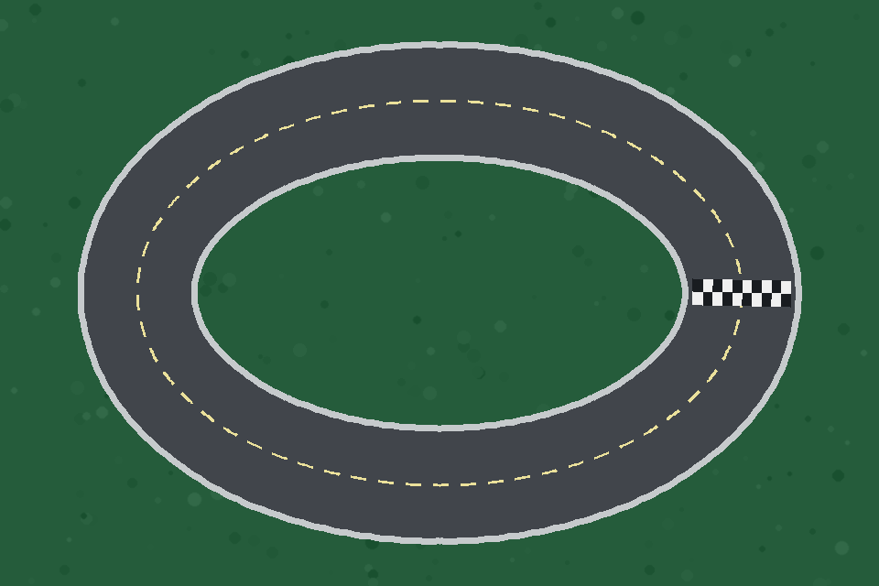 | Medium  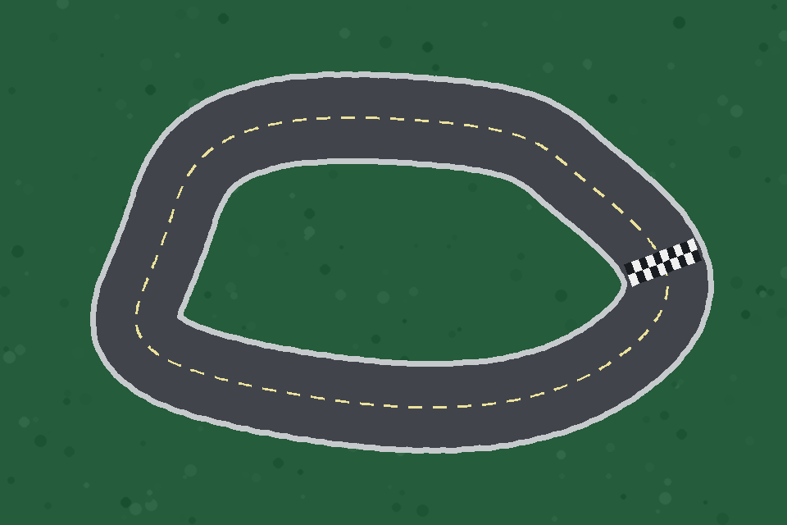 | Hard  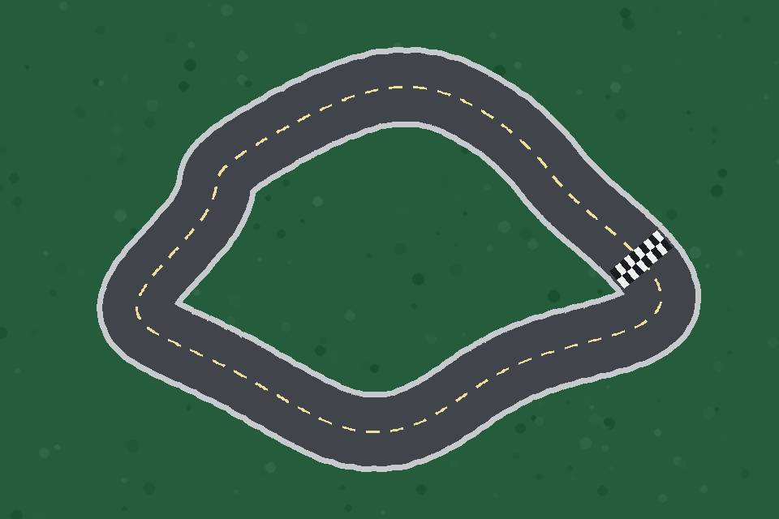
Figure 2. Procedurally generated display tracks

5.3 Progress and checkpoints
The environment performs a local nearest-centerline search around the previous index. This prevents a collision near another section from producing an impossible progress jump. Ordered absolute checkpoint targets prevent repeated reward from oscillating across one line.

6. State, Actions, and Rewards

6.1 State
Five rays are cast at -90, -45, 0, +45, and +90 degrees relative to the car. Each distance and the speed are normalized to [0, 1].
state = [left, front_left, front, front_right, right, speed]
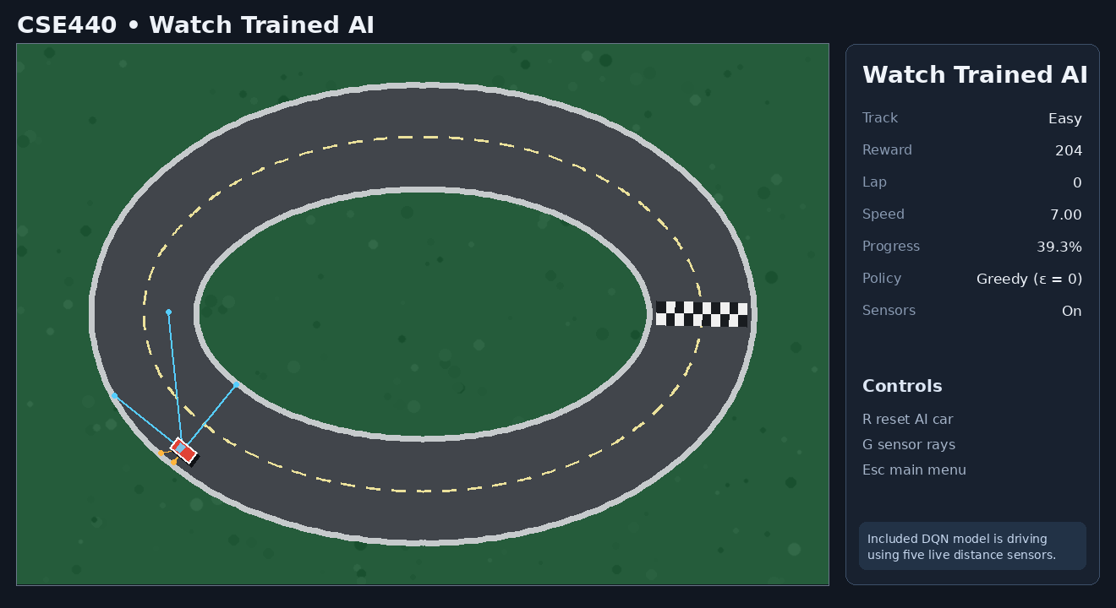
Figure 3. Trained car using five live distance sensors

6.2 Actions
Index | Action | Throttle | Steering | Brake
0 | Turn left | 1 | -1 | 0
1 | Turn right | 1 | +1 | 0
2 | Go straight | 1 | 0 | 0
3 | Brake | 0 | 0 | 1

6.3 Reward function
Situation | Reward
Driving forward | +1
Passing a checkpoint | +20
Completing a lap | +100
Collision | -100
Driving backwards | -10
Standing still | -2

Reward engineering provides both local guidance and long-term goals. Forward progress encourages movement, checkpoints reduce reward delay, lap completion represents success, and penalties discourage collision, reverse progress, and inactivity.

7. Deep Q-Network
The policy network has six inputs, two hidden ReLU layers of 64 units, and four Q-value outputs. A separate target network stabilizes the Bellman target.
6 inputs -> 64 ReLU -> 64 ReLU -> 4 Q-values
For transition (s, a, r, s', done), the target is:
y = r + gamma * (1 - done) * Q_target(s', argmax Q_policy(s', a'))
- Experience replay stores transitions and trains from random mini-batches.
- Epsilon-greedy exploration decreases from 1.00 to 0.05.
- Smooth L1 (Huber) loss limits sensitivity to large temporal-difference errors.
- Adam updates the policy network and gradient norm is clipped.
- Target weights are synchronized periodically.

8. Training Configuration
Hyperparameter | Value
Episodes | 300
Discount factor | 0.99
Learning rate | 0.001
Batch size | 64
Replay capacity | 50,000
Replay warm-up | 500 transitions
Target update | 600 environment steps
Epsilon | 1.00 to 0.05
Epsilon decay | 25,000 steps
Device / seed | CPU / 440

The exact run configuration is stored with the result data. Headless training uses the same environment as the Pygame interface but avoids rendering overhead.

9. Results

9.1 Training summary
Measurement | Result
Training episodes | 300
Exploratory lap completions | 110 (36.7%)
Best exploratory reward | 653.0
Final-50 mean reward | 614.7
Mean completed training lap time | 4.51 s
Training collisions | 190

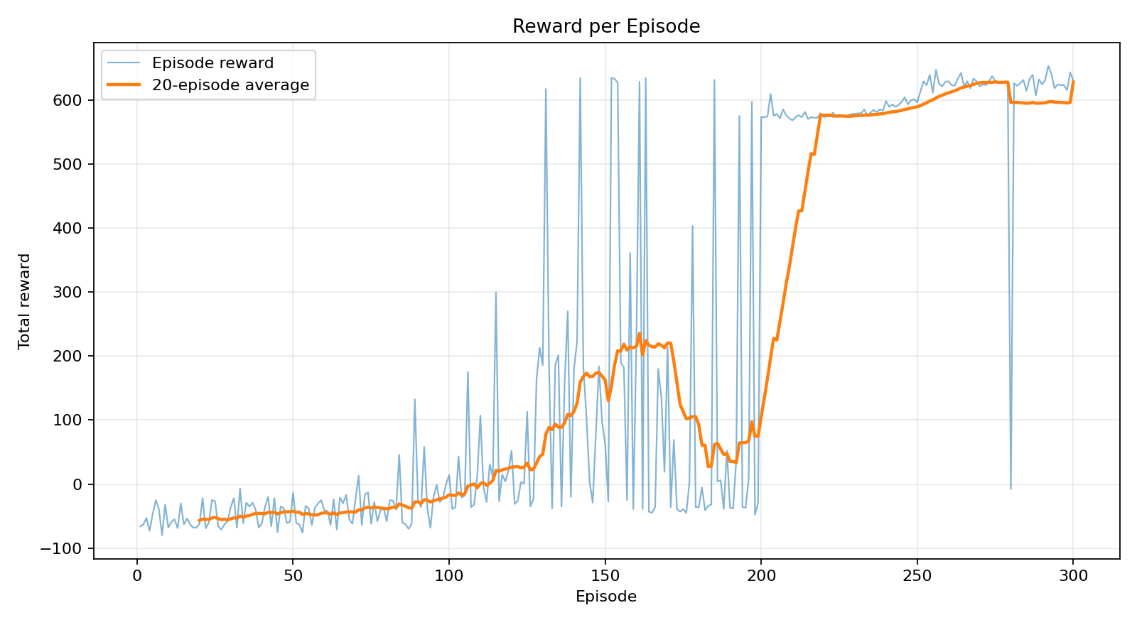
Figure 4. Reward per training episode with rolling average

9.2 Lap time and collision behavior
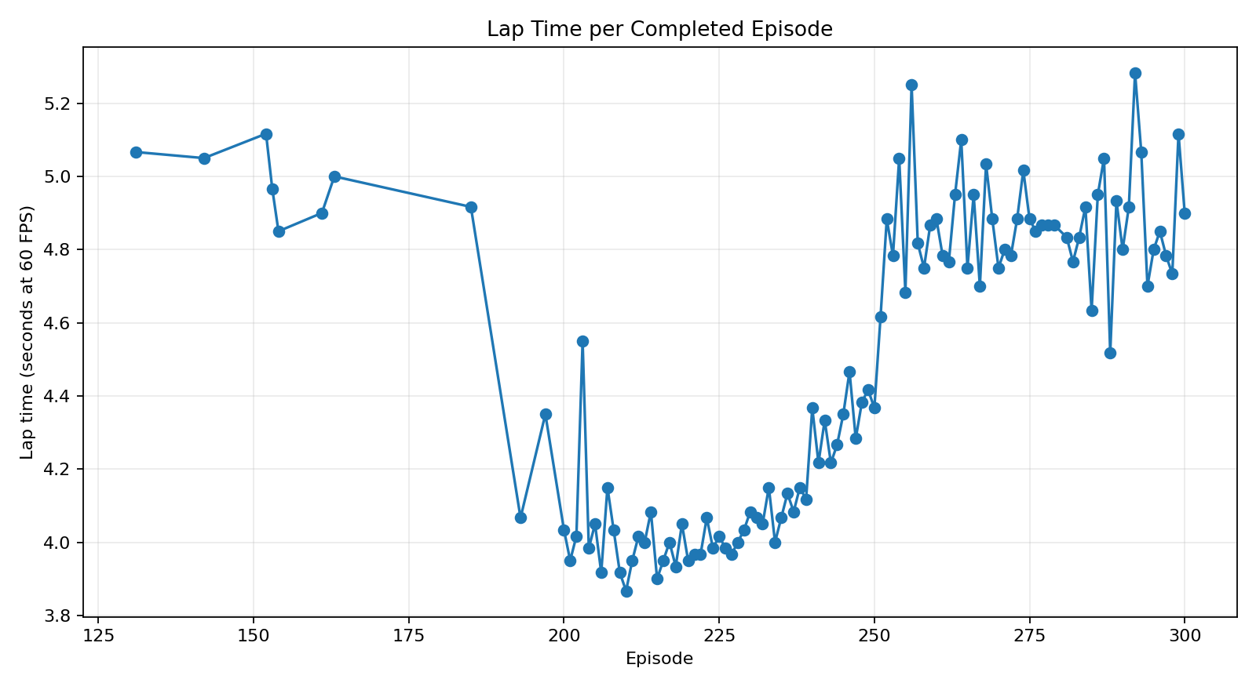
Figure 5. Lap time per completed training episode
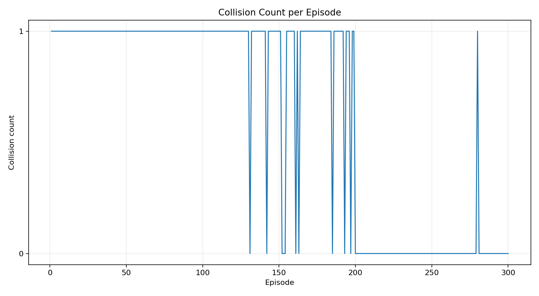
Figure 6. Collision count per training episode

9.3 Greedy evaluation
Track | Episodes / laps | Success | Collisions | Mean reward | Mean lap steps
Easy | 20 / 20 | 100% | 0 | 631.0 | 295
Medium | 20 / 20 | 100% | 0 | 576.0 | 241
Hard | 20 / 20 | 100% | 0 | 593.0 | 259

Training success includes exploratory random actions, while evaluation uses epsilon = 0. Each packaged best checkpoint completed 20 of 20 deterministic episodes from its track's standard start with zero collisions. Medium and Hard use curriculum continuation from easier checkpoints, so these results do not claim independent from-scratch convergence, arbitrary-start generalization, or unseen-track generalization.

10. User Interface and Model Reuse
- Main menu with Manual, Train, Watch, Evaluate, Settings, and Quit.
- Live episode, reward, lap, speed, epsilon, loss, and simulation speed.
- Pause/continue, training-speed adjustment, immediate save, sensor toggle, and reset.
- Selectable track difficulty and red/blue/green car colors.
- Best and latest .pth checkpoints for playback and resume.
A checkpoint stores policy and target weights, optimizer state, architecture, training configuration, step counters, loss, and run metadata. A saved model can drive immediately without retraining.

11. Testing and Reliability
Twenty automated tests cover tracks, masks, physics, sensors, state/action contracts, exact rewards, complete-lap behavior, network dimensions, replay sampling, optimization, checkpoint round trips, training output generation, the included model completing a lap without collision, and shutdown checkpoint-error handling.
20 passed

12. Discussion
The packaged checkpoints produce repeatable standard-start policies on Easy, Medium, and Hard from compact sensor inputs. Easy was trained directly; Medium and Hard use curriculum continuation from easier checkpoints. Stability improved through local progress tracking, ordered checkpoints, experience replay, a target network, gradient clipping, and a deliberate separation between exploratory training and greedy evaluation. Raw CSV/JSON outputs make the reported results inspectable rather than merely asserted.

13. Limitations
- Packaged checkpoint evaluation uses one standard start pose per track; random-start generalization is not established.
- Vehicle physics are educational rather than realistic.
- The state has no temporal memory or camera images.
- Medium and Hard use curriculum continuation from an easier checkpoint rather than independent from-scratch training.
- The system is not intended for real vehicle control.

14. Future Work
- Benchmark from-scratch versus curriculum training on Medium and Hard.
- Randomize start positions, speeds, and headings.
- Compare alternative curriculum schedules and prioritized replay.
- Compare DQN with PPO.
- Add obstacles, multiple cars, or camera-image input.
- Create richer model-comparison dashboards and training videos.

15. Conclusion
The project connects the full reinforcement-learning pipeline - state, action, reward, replay, exploration, network update, checkpointing, and evaluation - to a visible Pygame racing application. The included Easy, Medium, and Hard checkpoints and raw evaluations provide reproducible evidence that the compact DQN can complete each packaged track from its standard start pose on CPU.

16. Team Contributions
Member | ID | Contributions
Add name | Add ID | Add truthful contribution
Add name | Add ID | Add truthful contribution
Add name | Add ID | Add truthful contribution

References
1. V. Mnih et al., 'Human-level control through deep reinforcement learning,' Nature, 2015.
2. R. S. Sutton and A. G. Barto, Reinforcement Learning: An Introduction, 2nd edition.
3. PyTorch documentation: neural networks, optimization, and model serialization.
4. Pygame documentation: display, event, keyboard, surface, and drawing modules.

Appendix A - Reproduction Commands
python -m pip install -r requirements.txt
python main.py gui
python main.py train --track easy --episodes 500
python main.py evaluate --track easy --model models/easy_best.pth --episodes 20
pytest -q

