CROP RECOMMENDATION SYSTEM
MACHINE LEARNING USING PYTHON

INDUSTRIAL INTERNSHIP REPORT

Submitted by
MOHAMMED RIFAE S (Reg. No : 921723102091)

In the partial fulfillment of the award for the degree
of

BACHELOR OF ENGINEERING
in
COMPUTER SCIENCE AND ENGINEERING
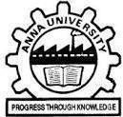


SETHU INSTITUTE OF TECHNOLOGY
(An Autonomous Institution | Accredited with ‘A++’ Grade by NAAC)
PULLOOR, KARIAPATTI - 626 115

OCTOBER 2026

SETHU INSTITUTE OF TECHNOLOGY
(An Autonomous Institution)

PULLOOR, KARIAPATTI - 626 115

BONAFIDE CERTIFICATE

Certified that this internship report entitled “Crop Recommendation System” is the bonafide work of “Mohammed Rifae S”, who carried out the internship work under my supervision.

SIGNATURE SIGNATURE

Mrs. K. Priyadharsini, B.E., M.E., (Ph. D) Dr. B. Lalitha, B.E., M.E., Ph. D
CO-ORDINATOR HEAD OF THE DEPARTMENT
Internship Work Presentation held on

INTERNAL EXAMINER EXTERNAL EXAMINER

ACKNOWLEDGEMENT

I am very thankful to WILTECH SOLUTIONS for giving me this opportunity at their prestigious organization. It was a valuable learning experience for me, as the training provided practical exposure to Machine Learning and various programming concepts, along with different development practices and challenges.

I would like to convey my heartiest thanks to the Managing Director of WILTECH SOLUTIONS, who kindly provided me with the opportunity to undergo this internship. I am grateful for the guidance, encouragement, and support provided throughout the internship, which helped me gain a better understanding of the concepts and practical aspects of Machine Learning.

I would like to thank all the trainers and staff members of WILTECH SOLUTIONS for giving their precious time and valuable guidance during my internship training. Their support and suggestions helped me improve my technical knowledge and practical skills.

Last but not the least, I would like to thank my Head of the Department, Dr. B. Lalitha, and my Coordinator, Mrs. K. Priyadharsini, for allowing me to attend such a valuable training program and for their continuous support and encouragement throughout the internship.

ABSTRACT

This report presents the learning experience gained during the Machine Learning internship at WilTech Solutions, Madurai. The internship provided an introduction to the fundamentals of Machine Learning using Python and covered important concepts such as data handling, data preprocessing, exploratory data analysis, data visualization, feature selection, model training, prediction, and model evaluation.

Python libraries including NumPy, Pandas, Matplotlib, Seaborn, and Scikit-learn were used for implementing various data analysis and Machine Learning tasks.

As a practical application of the concepts learned during the internship, a Crop Recommendation System using Machine Learning was developed. The system analyzes parameters such as nitrogen, phosphorus, potassium, temperature, humidity, soil pH, and rainfall to predict a suitable crop.

Different classification algorithms including Decision Tree, Random Forest, K-Nearest Neighbors, and Support Vector Machine were studied and evaluated. The performance of the models was compared using appropriate evaluation metrics.

The internship provided practical exposure to the Machine Learning workflow and helped improve programming, analytical, and problem-solving skills.

TABLE OF CONTENTS

CHAPTER NO. | CONTENTS | PAGE NO.
CHAPTER 1 | INTRODUCTION | 1
CHAPTER 2 | COMPANY PROFILE  2.1 DESCRIPTION ABOUT WILTECH SOLUTIONS | 3
CHAPTER 3 | INTERNSHIP ACTIVITIES  3.1 OBJECTIVE  3.2 INTERNSHIP OVERVIEW  3.3 TECHNOLOGIES AND TOOLS USED | 4
CHAPTER 4 | DESCRIPTION OF TECHNICAL ASPECTS  4.1 INTRODUCTION TO MACHINE LEARNING  4.2 TYPES OF MACHINE LEARNING  4.3 PYTHON FOR MACHINE LEARNING  4.4 PYTHON LIBRARIES FOR MACHINE LEARNING  4.5 MACHINE LEARNING WORKFLOW | 6
CHAPTER 5 | SCREENSHOTS | 11
CHAPTER 6 | CONCLUSION | 15
 | INTERNSHIP CERTIFICATE | 16

CHAPTER 1
INTRODUCTION

Machine Learning is a branch of Artificial Intelligence that enables computers to learn patterns from data and make predictions or decisions based on the information provided.

The internship at WilTech Solutions, Madurai provided an opportunity to understand the basic concepts and practical applications of Machine Learning using Python.

During the internship, various stages of the Machine Learning process were studied, including data collection, data preprocessing, exploratory data analysis, visualization, feature selection, model training, prediction, and evaluation.

Python was used as the primary programming language because of its simple syntax and availability of powerful libraries for data science and Machine Learning.

As a practical application, a Crop Recommendation System was developed using Machine Learning. The system uses soil and environmental parameters to recommend a suitable crop.

The internship helped in improving programming skills, logical thinking, analytical abilities, and understanding of Machine Learning techniques.

CHAPTER 2
COMPANY PROFILE
2.1 DESCRIPTION ABOUT WILTECH SOLUTIONS

WilTech Solutions is a technology-oriented organization based in Madurai, Tamil Nadu, providing IT solutions and technology services. The organization focuses on helping businesses adopt modern technologies and improve their operational efficiency through innovative digital solutions.

According to its official website, WilTech Solutions focuses on cloud and AI-based solutions, with a mission to deliver scalable cloud applications and AI-driven services that support digital transformation and sustainable growth. The organization also provides technology services related to DevOps and Continuous Integration/Continuous Deployment (CI/CD).

WilTech Solutions is located at Karpaga Complex, Goods Shed Street, near TVS Community College, Madurai Main, Madurai, Tamil Nadu – 625001.

The organization also provides opportunities for students to gain practical exposure to various technology domains. During my internship, I underwent training in Machine Learning, where I gained knowledge of Python programming, data analysis, data preprocessing, visualization, Machine Learning algorithms, model training, and model evaluation.

The internship provided an opportunity to understand how theoretical concepts can be applied to practical Machine Learning problems and helped improve my technical and analytical skills.

CHAPTER 3
INTERNSHIP ACTIVITIES
3.1 OBJECTIVE

The main objective of the internship was to gain fundamental and practical knowledge of Machine Learning using Python.

The major objectives were:
- To understand the fundamentals of Machine Learning.
- To learn Python programming for Machine Learning.
- To understand different types of Machine Learning.
- To learn how to handle datasets using Python.
- To perform data preprocessing.
- To understand exploratory data analysis.
- To learn data visualization techniques.
- To understand feature selection.
- To learn the process of training Machine Learning models.
- To evaluate Machine Learning models using suitable metrics.
- To develop a simple Machine Learning application.

3.2 INTERNSHIP OVERVIEW

The internship was completed at WilTech Solutions, Madurai, in the domain of Machine Learning from 23.05.2026 to 06.06.2026.

During the internship, the fundamentals of Machine Learning and Python-based data analysis were studied.
The learning process covered dataset handling, data preprocessing, exploratory data analysis, visualization, feature selection, model training, and model evaluation.

Different Machine Learning classification algorithms were explored to understand how predictive models can be developed using structured datasets.

As a practical application, a Crop Recommendation System was implemented using Machine Learning techniques. The system uses soil and environmental parameters to predict a suitable crop.

3.3 TECHNOLOGIES AND TOOLS USED

Programming Language
Python

Libraries
- NumPy
- Pandas
- Matplotlib
- Seaborn
- Scikit-learn

Development Environment
Visual Studio Code

Dataset Format
CSV

CHAPTER 4
DESCRIPTION OF TECHNICAL ASPECTS

4.1 INTRODUCTION TO MACHINE LEARNING

Machine Learning is a field of Artificial Intelligence that allows computers to learn from data and identify patterns for making predictions or decisions.

Instead of explicitly programming every possible situation, Machine Learning algorithms learn relationships from existing data.

4.2 TYPES OF MACHINE LEARNING
Machine Learning is generally classified into three main types: Supervised Learning, Unsupervised Learning, and Reinforcement Learning.

Supervised Learning uses labelled data, where the input data is provided along with the expected output, and it is mainly used for classification and regression tasks.

Unsupervised Learning works with unlabelled data and identifies hidden patterns, relationships, or groups within the data, with clustering being a common example.

Reinforcement Learning is a learning approach in which an agent interacts with an environment and learns by receiving rewards or penalties based on its actions.

These three approaches are widely used for developing intelligent systems and solving different real-world problems.
4.3 PYTHON FOR MACHINE LEARNING

Python is widely used for Machine Learning because of its simple syntax and extensive collection of libraries.

Python was used during the internship for:
- Dataset handling
- Data preprocessing
- Data analysis
- Visualization
- Machine Learning model development
- Prediction
- Model evaluation

4.4 PYTHON LIBRARIES FOR MACHINE LEARNING

Python provides a wide range of libraries that simplify data analysis, visualization, and Machine Learning development.
During the internship, NumPy, Pandas, Matplotlib, Seaborn, and Scikit-learn were used for different stages of the Machine Learning process.

NumPy is used for numerical computing, arrays, and mathematical operations.

Pandas is used for handling and analyzing structured datasets, including reading CSV files, checking missing values, removing duplicates, and manipulating data.

Matplotlib is used to create graphs and charts for visualizing data and results.

Seaborn is a statistical visualization library used to create informative graphs such as count plots, correlation heatmaps, and confusion matrices.

Scikit-learn provides tools for Machine Learning tasks such as data splitting, feature scaling, classification, model training, prediction, and evaluation.
These libraries work together to provide a complete environment for developing and implementing Machine Learning applications using Python.

4.5 MACHINE LEARNING WORKFLOW

The project followed the following workflow:

Dataset
↓
Data Understanding
↓
Data Preprocessing
↓
Exploratory Data Analysis
↓
Feature and Target Selection
↓
Train-Test Split
↓
Feature Scaling
↓
Model Training
↓
Model Evaluation
↓
Best Model Selection
↓
Crop Prediction

4.5.1 Dataset Collection

A crop recommendation dataset containing soil and environmental parameters was used for the practical implementation.

The dataset contains information about:
- Nitrogen
- Phosphorus
- Potassium
- Temperature
- Humidity
- Soil pH
- Rainfall
- Crop label

4.5.2 Data Preprocessing

The dataset was examined before training the Machine Learning models.

The following checks were performed:
- Dataset structure
- Missing values
- Duplicate records
- Data types
- Statistical information

4.5.3 Model Training

The following classification algorithms were implemented:
- Decision Tree
- Random Forest
- K-Nearest Neighbors
- Support Vector Machine

Each model was trained using the training dataset.

4.5.4 Model Evaluation
The Machine Learning models were evaluated using:
- Accuracy
- Precision
- Recall
- F1-score
- Confusion Matrix

The performance of the models was compared to identify the best-performing model for the final prediction system.

SCREENSHOTS

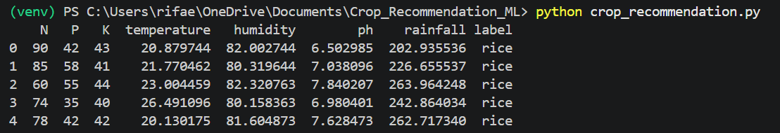
Figure 5.1 — Dataset Overview

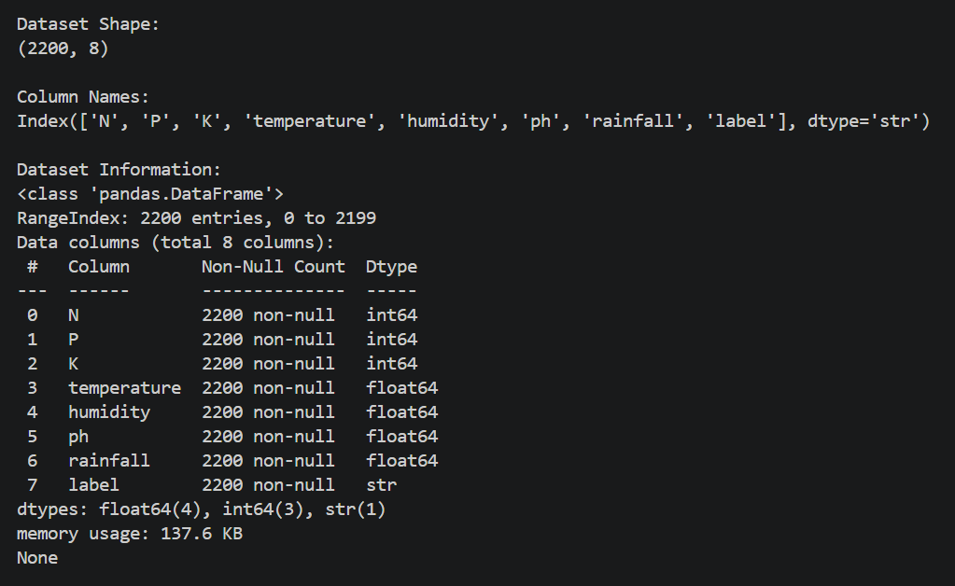
Figure 5.2 — Dataset Information

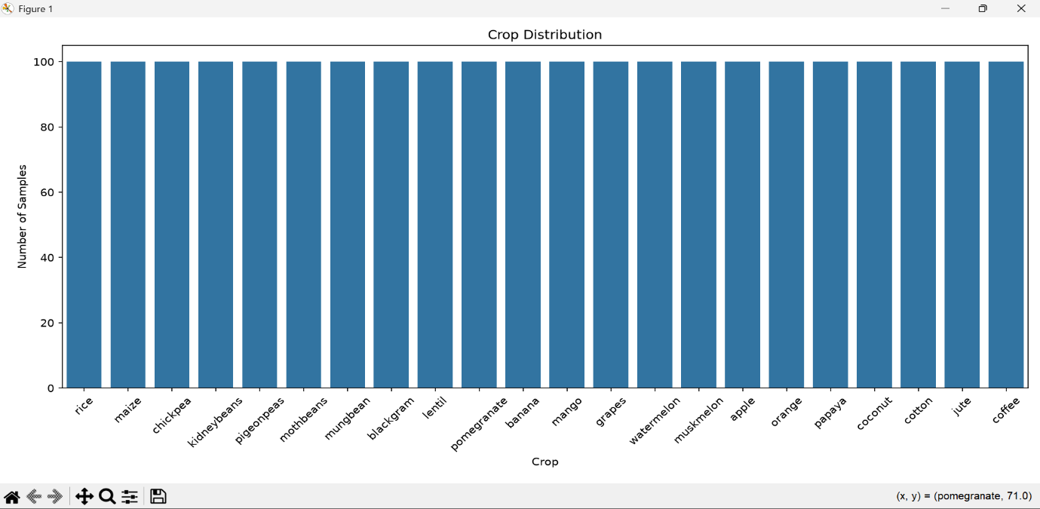
Figure 5.3 — Crop Distribution

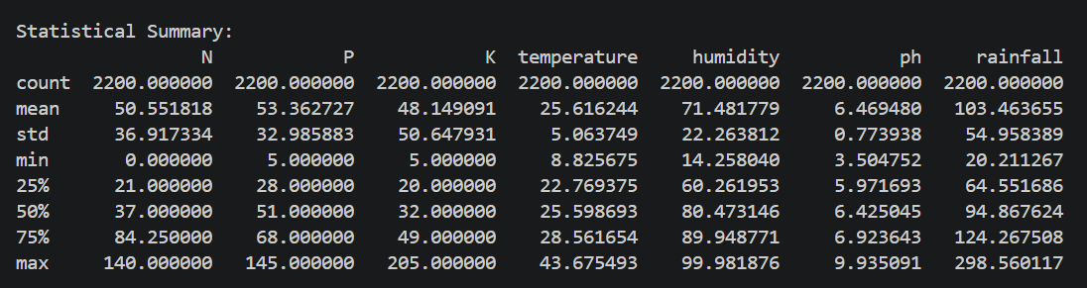
Figure 5.4 — Statistical Summary

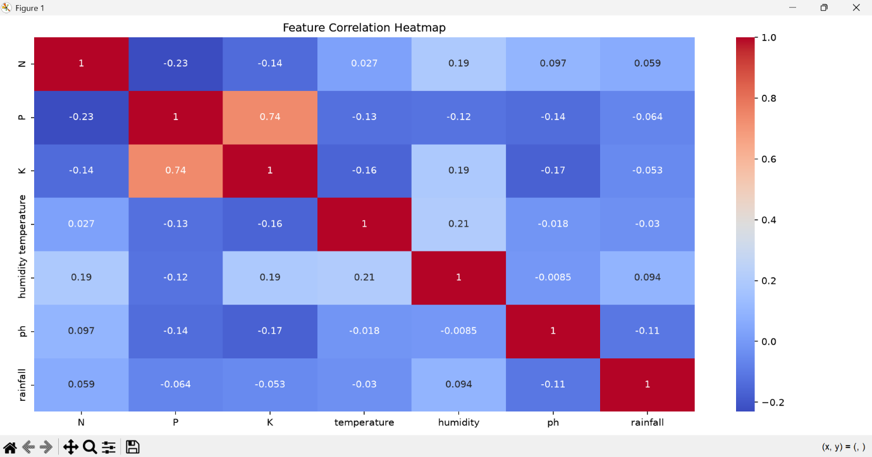
Figure 5.5 — Correlation Heatmap
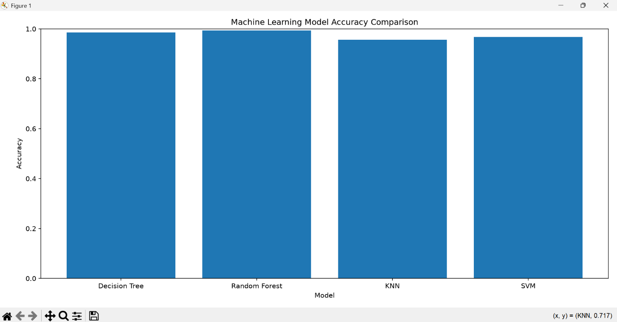
Figure 5.6 — Model Accuracy Comparison

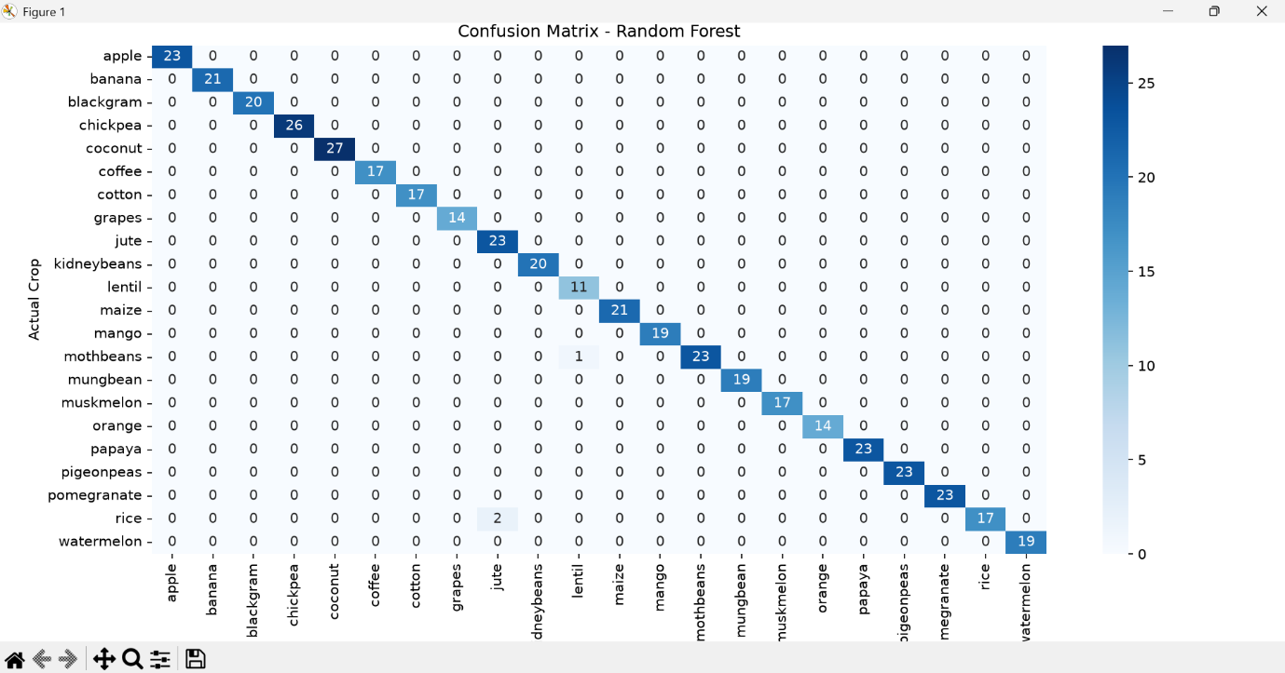
Figure 5.7 — Confusion Matrix

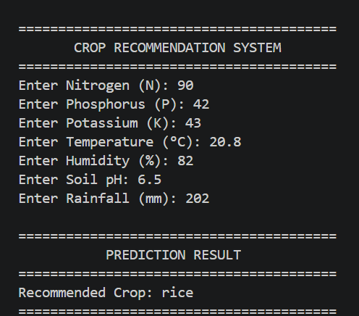
Figure 5.8 — Crop Recommendation

CHAPTER 5
CONCLUSION

The Machine Learning internship at WilTech Solutions, Madurai provided valuable exposure to the fundamentals and practical applications of Machine Learning using Python.

During the internship, I gained knowledge of data handling, data preprocessing, exploratory data analysis, visualization, feature selection, model training, and model evaluation.

As a practical application of the concepts learned, a Crop Recommendation System was developed using Machine Learning. The system uses soil and environmental parameters to predict a suitable crop.

Different classification algorithms were implemented and their performance was compared using evaluation metrics. This practical work helped strengthen my understanding of the Machine Learning workflow and improved my Python programming, analytical thinking, and problem-solving skills.
.
Overall, the internship provided a strong foundation for further learning in Machine Learning, Artificial Intelligence, and Data Science.

INTERNSHIP CERTIFICATE
