**2nd March, 2025**

API  
BASIC Introduction

**___**

By Rifah Sajida Deya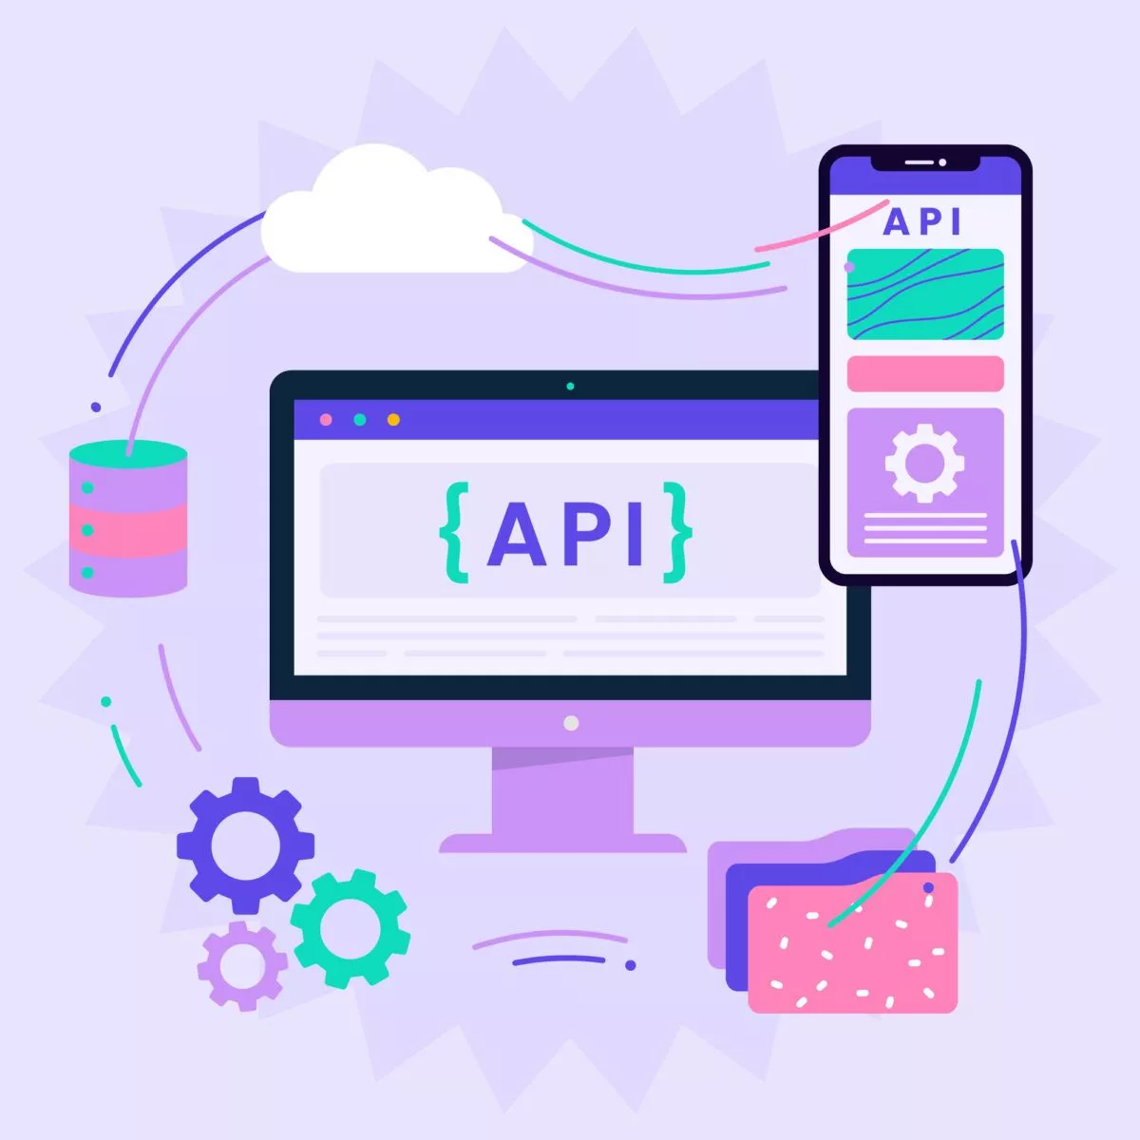

### Introduction

An API (Application Programming Interface) is a way for different programs to communicate with each other (a contract that allows code to talk to other code). It acts like a set of rules that let one piece of software work with another. APIs are important because they help apps, companies, and devices share resources and services easily (this is why APIs are the building blocks of modern software).

## Why are APIs important?

1. **APIs make development easier** – Instead of building everything from scratch, developers can use existing APIs.

Example: A Weather API lets you get weather updates without launching your own weather balloons.

1. **APIs help businesses** – Companies can allow others to use their services to create new features faster.

Example: Apps can post tweets or read messages using Twitter or Meta APIs.

1. **APIs can be products** – Some businesses sell APIs as services.

Example: Stripe's payment API and Twilio’s messaging API help companies handle payments and communication.

### Who works with APIs?

APIs aren’t just for developers. A survey by Postman found that many people in non-developer roles, like managers, analysts, educators, and researchers, also use APIs. They help by providing easy access to standardized data.

APIs are used in many industries, not just in technology. While tech, business, IT, and banking use them the most, any industry can benefit. APIs make processes smoother and help connect the services we use every day, making life easier for everyone.

### APIs - As A Digital Restaurant

We can think of API as a waiter in a resturant. Where the client sends a request, the API takes the request and passes it to the server and server responses. The API then passes the response to the server. This is how API works and connects the client and server.

| Networking term | Description | Restaurant analogy |
| --- | --- | --- |
| Client | The requester. Ex: browser, web app, mobile app | Customer |
| API | Simplified interface for interacting with the backend | Waiter |
| Server | The backend where the processing happens | KItchen |

Here is an image to show how it works (image collected from https://www.cleveroad.com/images/article-previews/what-s-an-api-13-3x.webp)

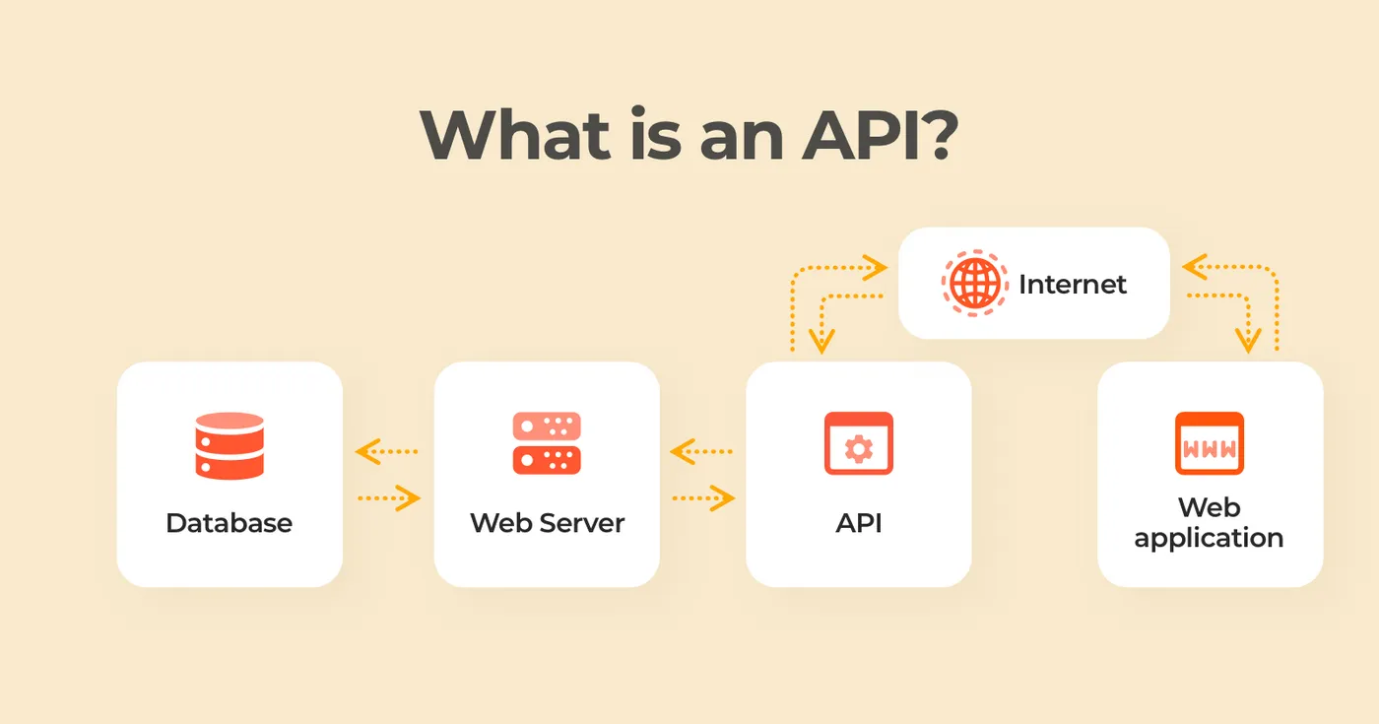

### Types of APIs

There are many types of APIs. Let us know about some of them:

1. **Hardware APIs**: Let software communicate with hardware.

Example: Your phone's camera interacts with the operating system through a hardware API.

1. **Software Library APIs**: Allow one piece of code to use functions from another codebase.

Example: Importing a library in your app to use its built-in methods.

1. **Web APIs**: Enable communication between different programs over the internet.

Example: Getting live stock prices from a financial API.

Many APIs work together to complete a task. For example, when you upload a photo to Instagram:

1. A hardware API connects the app to your camera.
2. A software library API applies filters to your image.
3. A web API sends the photo to Instagram's servers so others can see and like it.

### Architectures

There are multiple ways to build and consume APIs. Some architecture types you may come across are:

1. REST (Representational State Transfer)
2. GraphQL
3. WebSockets
4. webhooks
5. SOAP (Simple Object Access Protocol)
6. gRPC (Google Remote Procedure Call)
7. MQTT (MQ Telemetry Transport)

### 

### REST API

Some key features of REST APIs include **not saving** session data between requests, supporting **caching**, and allowing different types of data to be sent and received.

### Access

APIs also vary in the scope of who can access them.

1. **Public APIs (aka Open APIs):** Consumed by anyone who discovers the API
2. **Private APIs:** Consumed only within an organization and not made public
3. **Partner APIs:** Consumed between one or more organizations that have an established relationship.