Edrak!
Software Requirements Specification (SRS)
Version 1.5 · October 2026

1. Introduction
Edrak! (code name QuoteIt) is a website where anyone can read quotes shared by others, and registered users can share quotes with a mood and like, edit, or delete them. This SRS describes the final version that was built, including the added features (likes, mood compass, Insight of the Day, quote cards, and calm session), and is the team's reference for the next stages.

2. Problem Description
People who love quotes keep them scattered in notes, screenshots, and chats, and have no simple place to share them or read what others like.
Edrak! gives everyone one place to browse quotes by mood, and lets registered users share their own and keep them up to date.

3. System Scope
The built version covers browsing quotes, accounts, and managing your own quotes.
In scope | Out of scope
View all users' quotes without logging in | Following other users
Sign up, log in, log out | Sharing quotes outside the website (e.g. social media)
Share a quote | Images or videos on quotes
Edit own quotes | Comments on quotes
Delete own quotes | Direct messages between users
Like and unlike a quote | Searching quotes by keyword or meaning
Choose a mood for a quote and filter quotes by mood | AI analysis of quotes (tags and tone)
Insight of the Day | A bookshelf linking quotes to books
Turn a quote into a downloadable image card | A page of personally saved quotes
Calm session (full-screen quotes) | A mobile app

4. Users
The system has two types of users.
User | Description | Main goals
Guest | Visits the website without logging in | Read all shared quotes, filter them by mood, make quote cards; sign up or log in
Registered user | Has an account and is logged in | Read all quotes; share (with a mood), like, edit, and delete their own quotes

5. Functional Requirements
Each requirement states what the system shall do; priority uses Must / Should / Could.
ID | Requirement | Priority
FR-01 | The system shall show all users' quotes to anyone, including guests, with the quote text, the name of who shared it, the date, its mood, and the number of likes. | Must
FR-02 | The system shall let a guest create an account with name (2–50 letters), email, and password (at least 8 characters). | Must
FR-03 | The system shall let a registered user log in with email and password. | Must
FR-04 | The system shall let a logged-in user log out. | Must
FR-05 | The system shall let a logged-in user share a quote of 3 to 155 characters and choose one mood for it (Hope, Calm, Philosophy, or Motivation). | Must
FR-06 | The system shall let a user edit only their own quotes. | Must
FR-07 | The system shall let a user delete only their own quotes. | Must
FR-08 | The system shall let a logged-in user like any quote, and press again to remove their like. A user can like a quote only once. | Should
FR-09 | The system shall show the number of likes on every quote to anyone, including guests. | Should
FR-10 | The system shall let anyone filter the quotes by mood, or show all, without reloading the page. | Should
FR-11 | The system shall show one "Insight of the Day" at the top of the page: a quote picked at random once a day, the same for all visitors, with a button to copy it. | Should
FR-12 | The system shall let anyone turn a quote into a card, choose its color and font, and download it as a PNG image. | Could
FR-13 | The system shall let anyone start a calm session: a full-screen view that shows quotes one after another and can be closed with Esc. | Could

6. Non-Functional Requirements
These describe how well the system must work, not what it does.
ID | Category | Requirement
NFR-01 | Performance | The quotes page shall load within 3 seconds.
NFR-02 | Security | Passwords shall be stored hashed, never as plain text.
NFR-03 | Security | Only the owner of a quote can edit or delete it; everyone else can only read it.
NFR-04 | Usability | A new user shall be able to share their first quote in under 1 minute without help.
NFR-05 | Usability | Each form field shall show a short hint of what is allowed (e.g. "At least 8 characters").
NFR-06 | Data integrity | The database shall prevent the same user from liking the same quote twice.
NFR-07 | Usability | Filtering by mood and starting a calm session shall work without reloading the page.
NFR-08 | Usability | The design shall use soft pastel colors with dark text so that the text stays easy to read.

7. User Stories and Acceptance Criteria
Each story follows the format "As a ___, I want ___, so that ___", with criteria the team can test.
US-01 — View all quotes as a guest (FR-01)
As a guest, I want to see the quotes people shared, so that I can get inspired before signing up.
- When I open the website without logging in, then I see all users' quotes, each with the quote text, the name of who shared it, the date, its mood, and the number of likes.
- As a guest, I do not see any edit or delete options.
- When I press "Log in to share a quote", then I am taken to the Log In page.
US-02 — Sign up (FR-02)
As a guest, I want to create an account, so that I can share my own quotes.
- Given a name of 2–50 letters, a valid email, and a password of at least 8 characters, when I press Sign Up, then my account is created.
- Given a name with numbers or symbols, an invalid email, or a password shorter than 8 characters, then I see an error under that field.
- Given an email that is already registered, then I see an error message.
- When I press "Log In" under the form, then I go to the Log In page.
US-03 — Log in (FR-03)
As a registered user, I want to log in, so that I can share and manage my quotes.
- Given a correct email and password, when I press Log In, then I see the quotes page with my name and picture at the top.
- Given a wrong email or password, then I see an error and stay on the Log In page.
US-04 — Log out (FR-04)
As a registered user, I want to log out, so that no one else can use my account.
- When I press Log Out, then I return to the guest view and can no longer share, edit, or delete quotes.
US-05 — Share a quote (FR-05)
As a registered user, I want to share a quote, so that others can read it.
- When I press the + button, then a "Share a quote" box opens.
- Given text between 3 and 155 characters, when I press Send, then the quote appears in the list with today's date.
- Given text shorter than 3 or longer than 155 characters, then the quote is not sent.
- Given I did not choose a mood, when I press Send, then the quote is not added.
- When I press X, then the box closes without sharing.
US-06 — Edit my quote (FR-06)
As a registered user, I want to edit my quote, so that I can fix mistakes.
- When I press the edit icon, then the quote turns into a text box with Save and Cancel buttons.
- When I change the text and press Save, then the card shows the updated quote.
- When I press Cancel, then the quote stays as it was.
US-07 — Delete my quote (FR-07)
As a registered user, I want to delete my quote, so that I can remove ones I no longer want.
- When I press the delete icon, then the quote is removed from the list right away, for me and for everyone.
US-08 — Like a quote (FR-08, FR-09)
As a registered user, I want to like quotes I enjoy, so that I can show appreciation and see which quotes are liked most.
- When I press the heart under a quote, then the heart turns red and the number of likes goes up by one.
- When I press the red heart again, then my like is removed and the number goes down by one.
- Each user can like a quote only once.
- As a guest, I see the number of likes on each quote but I cannot press the heart.
US-09 — Filter quotes by mood (FR-10)
As a user, I want to pick a mood, so that I see the quotes that match how I feel.
- When I press a mood button (Hope, Calm, Philosophy, or Motivation), then only quotes with that mood stay on the page, without reloading.
- When I press "All", then all quotes are shown again.
- Quotes shared before moods existed have no mood and appear only under "All".
US-10 — See the Insight of the Day (FR-11)
As a user, I want to see one highlighted quote each day, so that I get a thought to start with.
- When I open the website, then I see a highlighted quote at the top of the page.
- When I come back later the same day, then I see the same quote; on the next day it can be different.
- When I press Copy, then the quote text is copied and the button shows "Copied".
US-11 — Make a quote card (FR-12)
As a user, I want to turn a quote into an image, so that I can share it outside the website.
- When I press Card under a quote, then a preview card opens with the quote, its author, and the Edrak! mark.
- When I choose another color or font, then the preview changes right away.
- When I press Download PNG, then an image file of the card is saved to my device.
US-12 — Calm session (FR-13)
As a user, I want a quiet full-screen view of quotes, so that I can pause and clear my mind.
- When I press "Start a calm session", then a full-screen page shows one quote at a time.
- The quote changes by itself every 8 seconds, and Next shows the next one right away.
- When I press Esc or the close button, then I return to the quotes page.

8. Use Case Diagram
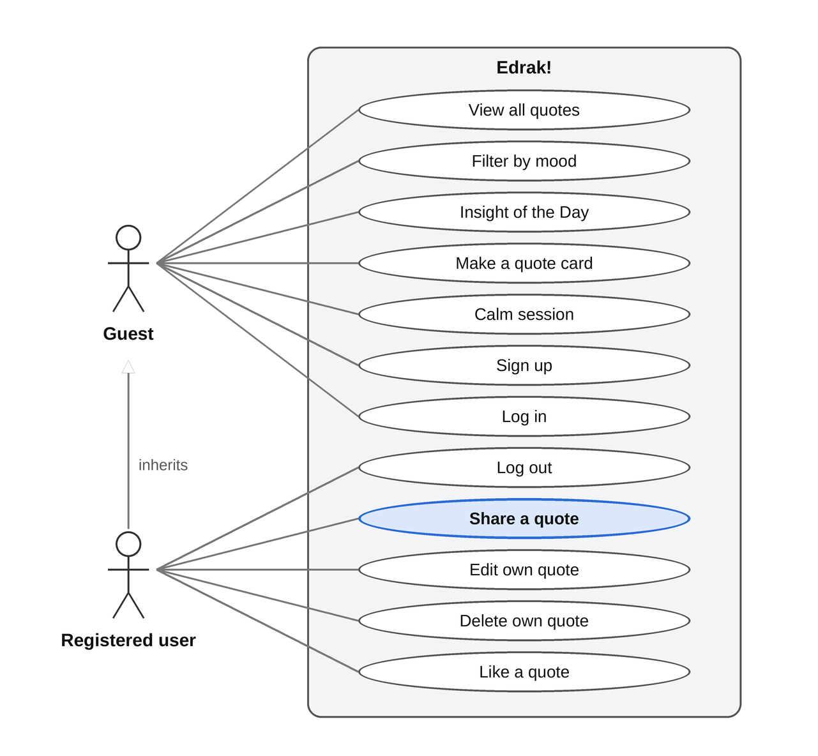
A guest can view all quotes, filter them by mood, see the Insight of the Day, make quote cards, start a calm session, sign up, and log in. A registered user can do everything a guest can, plus log out, share quotes, like or unlike any quote, and edit or delete their own. Sharing a quote is the core use case.

9. Assumptions and Constraints
Assumptions
- The user is connected to the internet while using the website.
- The user has a valid email address to sign up.
- Each account is used by one person only.
- Users are responsible for the quotes they share.
- The user opens the website from an up-to-date web browser.
Constraints
- All shared quotes are public; anyone visiting the website can read them.
- A quote is text only, between 3 and 155 characters.
- Sign up asks only for name, email, and password; the name must be 2–50 letters only.
- Deleting a quote happens immediately with no confirmation, and a deleted quote cannot be recovered.
- The website runs in the browser only; there is no app to download.
- The system is built with Laravel (PHP) and a MySQL database, using Laravel Breeze for sign up and log in, and Alpine.js with Tailwind CSS for the interface.
- Only logged-in users can like a quote; guests can only see the number of likes.
- The look follows the Edrak! identity and the Tuwaiq Club theme: soft pastel colors, the Edrak! logo next to the Tuwaiq logo, and one fixed profile picture shown for every user.
- Each quote has one mood: Hope, Calm, Philosophy, or Motivation. Quotes shared before moods existed have no mood.
- The Insight of the Day is picked once per day and kept for that day, so all visitors see the same quote.

