Nama : Mokh Rifan Ardiansyah
NIM : 16/394089/PA/17180

Tugas 3 : SLP from scracth implementation

link code : https://github.com/rifansyah/single-layer-perceptron

Output :
epoch = 5, k = 5, alpha = 0.1
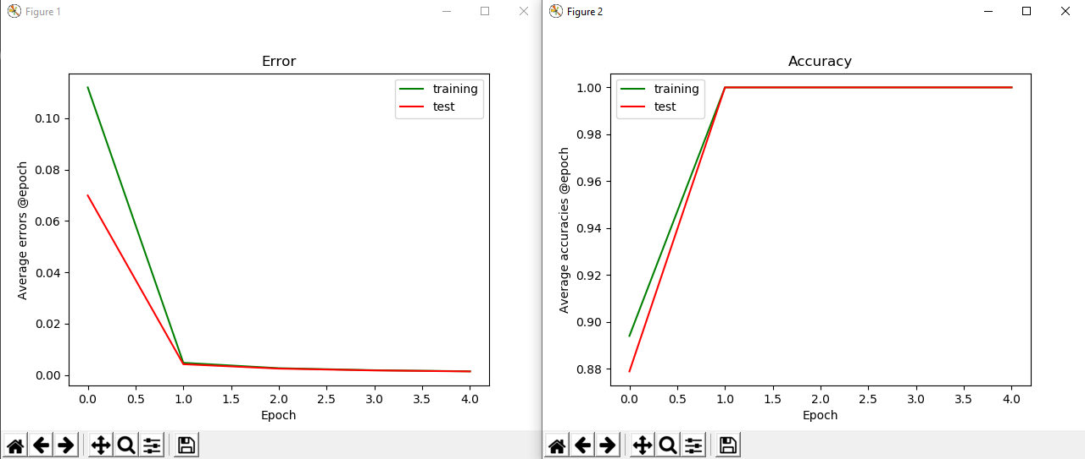
epoch = 5, k = 5, alpha = 0.8
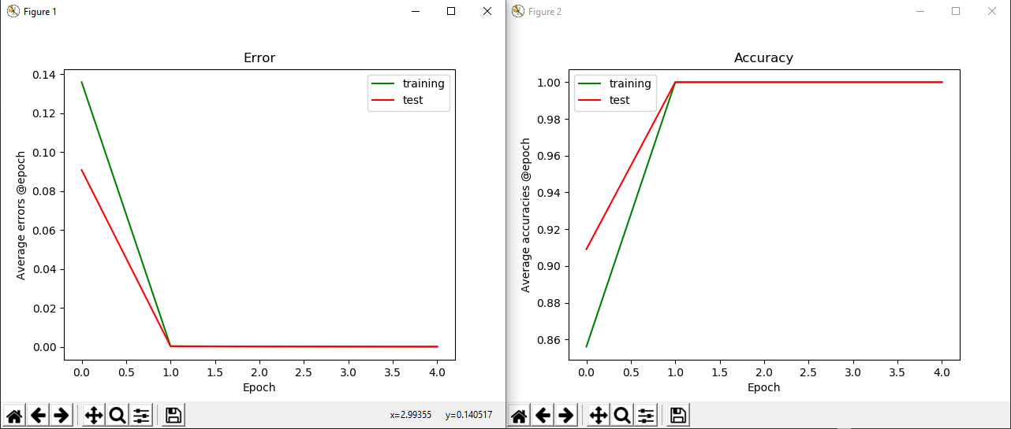

epoch = 300, k = 5, alpha = 0.1
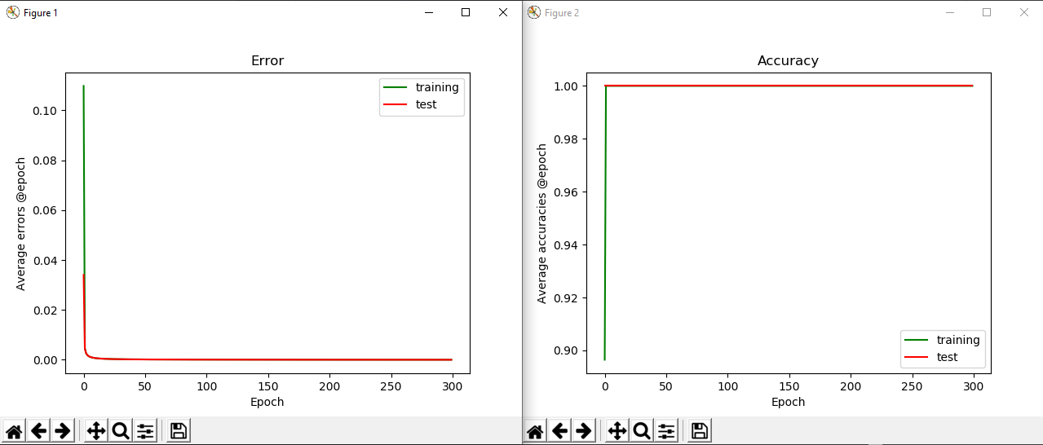
epoch = 300, k = 5, alpha = 0.8
