

**Project Report**

Course Title: Web Engineering

Course code: CSE 415

**Submitted By:**

**Sajidur Rahman Sajid**

ID: 201-15-13694

Section: **E**

Batch: 55

Department of Computer Science and engineering

**Submitted To:**

**Johora Akter Polin**

Lecturer

Department of CSE

Daffodil International university

**Project Title:**  **Char Dame Juice**

**Introduction:**

Our web application is a haven for those seeking an oasis of wellness and natural indulgence. Whether you're a health enthusiast, a juice lover, or simply someone looking to enhance your well-being, we have something extraordinary in store for you. Our meticulously crafted juices are a symphony of fresh fruits, invigorating vegetables, and exotic superfoods, carefully blended to perfection. With our web application, we aim to make your experience with Char Dame Juice seamless, convenient, and inspiring. Explore our extensive menu featuring an array of vibrant concoctions designed to invigorate your senses. From zesty citrus infusions to rejuvenating green elixirs, our offerings cater to all tastes and nutritional needs.

**Objective:**

The objective of the Char Dame Juice web application is to provide an exceptional online platform that promotes a healthy lifestyle and offers a convenient and delightful experience for customers seeking high-quality, nourishing juices.

**It will provide:**

* Seamless Ordering Experience
* Extensive Menu Selection
* Emphasis on Quality Ingredients
* Health and Wellness Resources
* Convenience and Flexibility

**Function**:

* Home page
* Product search
* Suggest Product
* Product details
* Buy product
* Payment option (card)
* Size chose
* About us
* Contact us

**Language:**

* HTML
* CSS
* JavaScript
* PHP
* Database (MySQL)

**Project Description:**

**Code File Drive Link:**

**( https://drive.google.com/drive/folders/1xMlf6QDXYifohcTwlOayujOqWPXfHISz?usp=sharing )**

First, we have designed our website using html and css then we have added JavaScript for validation then we also created database with MySQL to store customer information.

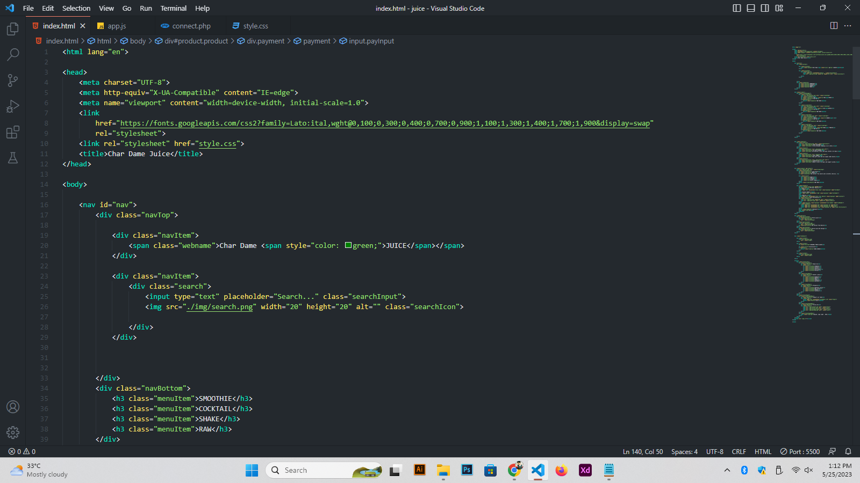

This is our HTML code as a format of “index.html”

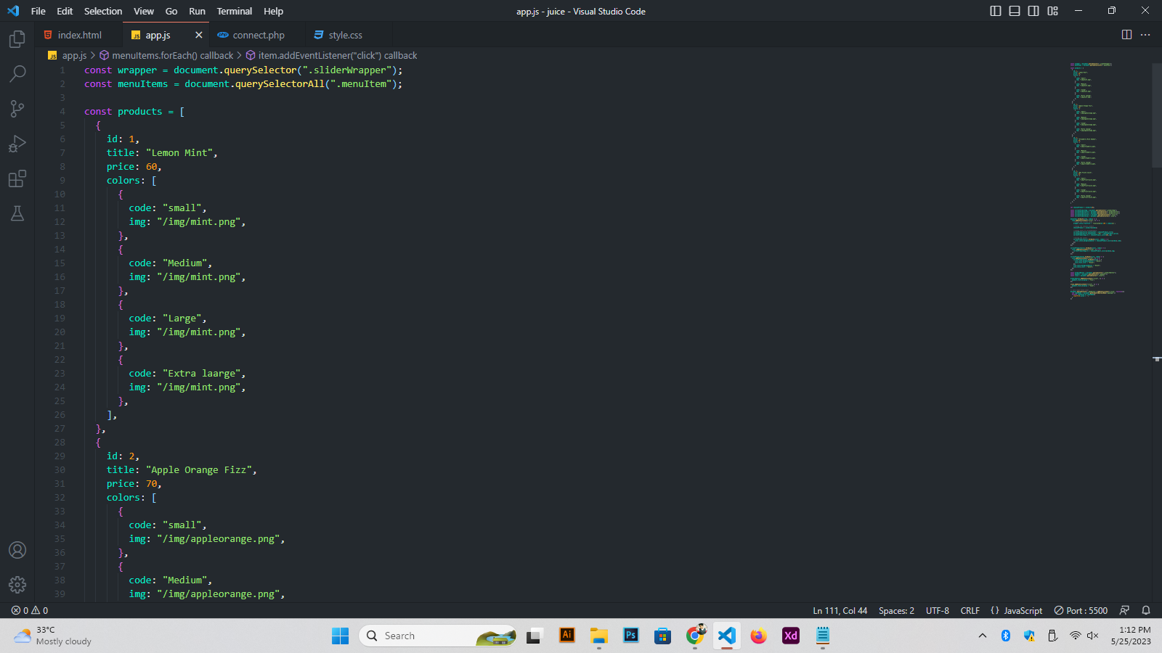

This is our JavaScript code for validation as a format of “app.js”

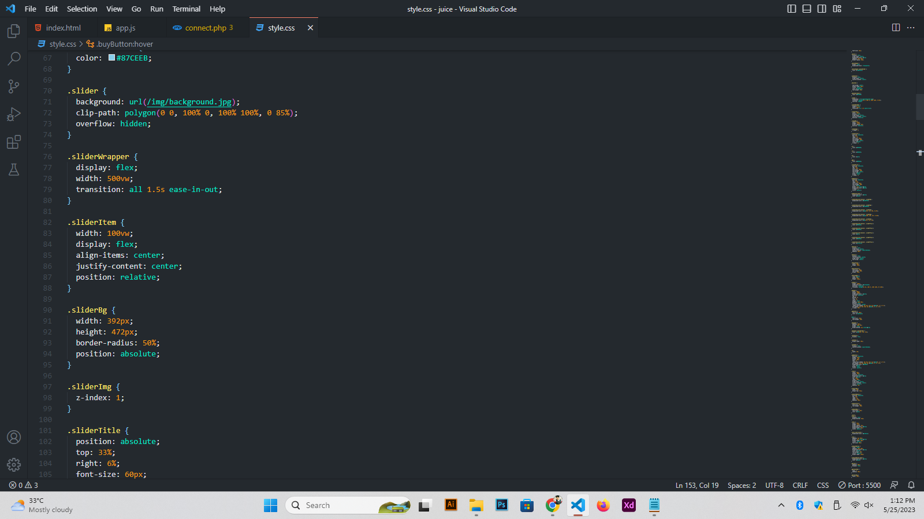This is our css file as a format of “style.css”

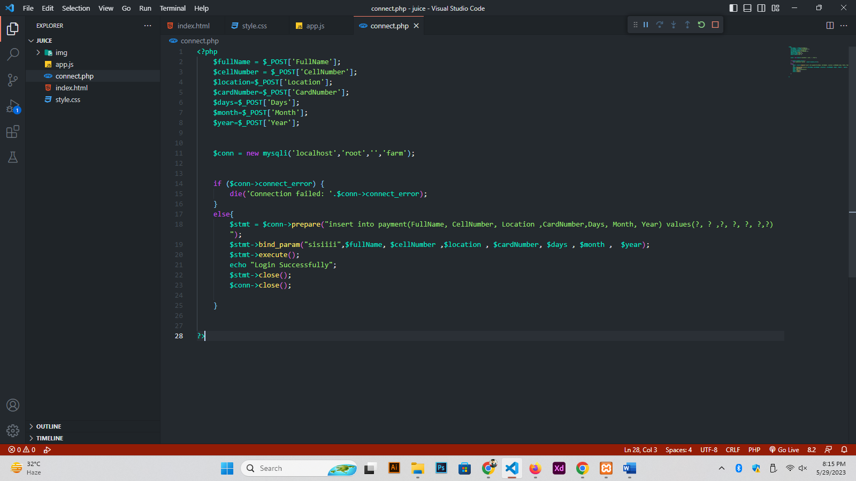

This is the PHP code for connecting the database and this code is as a format of “connect.php”

**Output:**

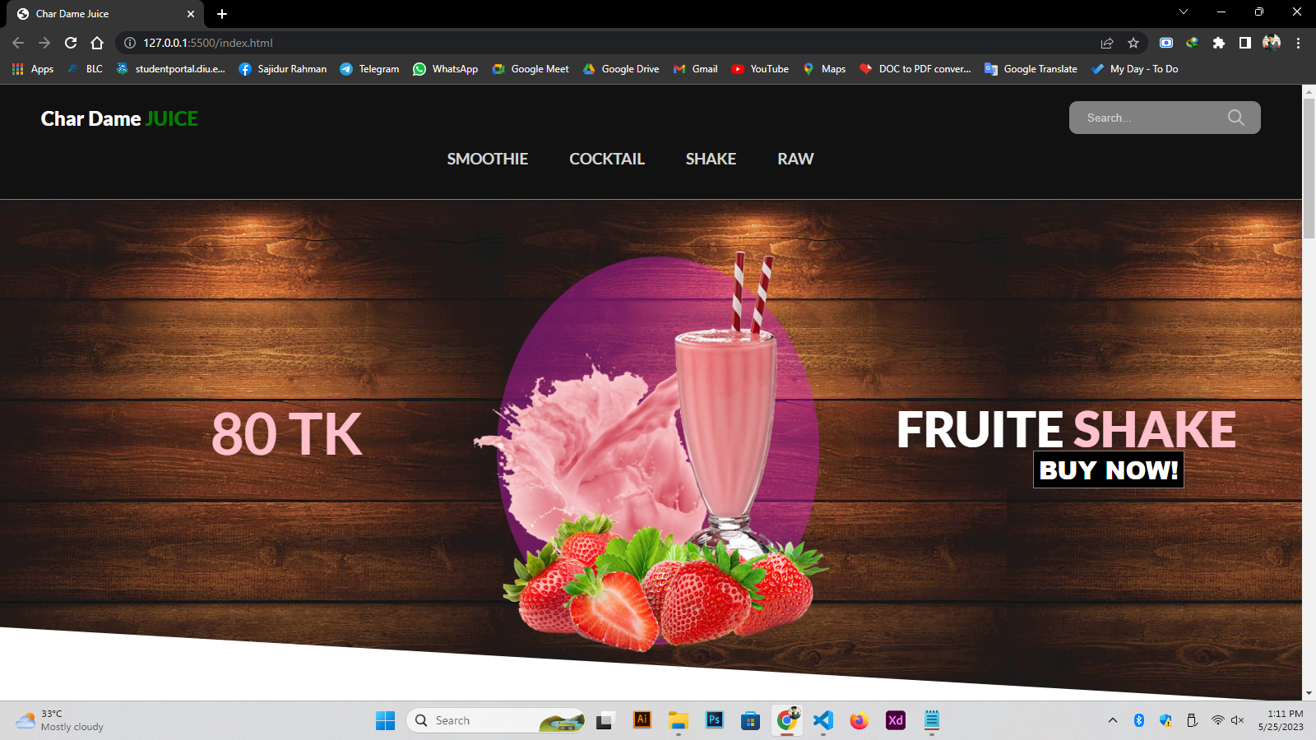

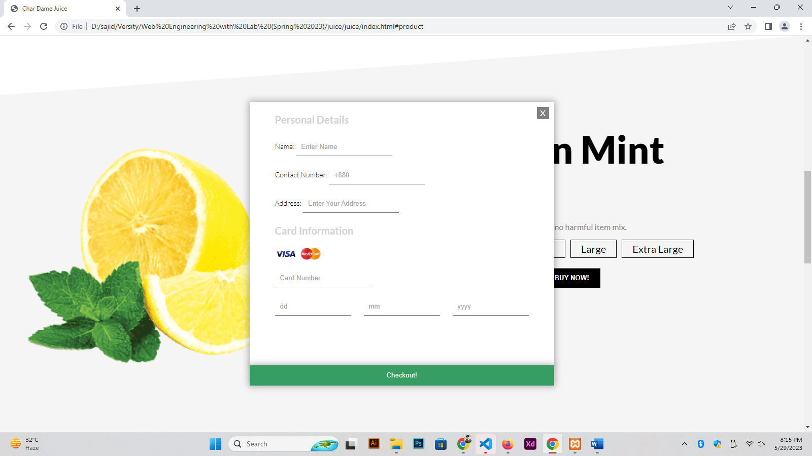

**Conclusion:**

Our user-friendly web application allows you to effortlessly browse through our menu, customize your order, and place it for pickup or delivery, right at your fingertips. We understand that your time is valuable, and we strive to provide a seamless online experience that allows you to prioritize your health and convenience.

**Reference:**

1. Smith, A. (2022). The Juice Industry: Trends, Challenges, and Opportunities. Journal of Beverage Business Research, 15(3), 45-62.

2. Johnson, M. (2023). The Selling Industry: Trends, Challenges, and Opportunities. Journal of Sales Research, 20(2), 78-95.