Source Code

//quad shape (10,10),(20,8),(17,16),(12,16)

//triangle shape (17,17),(27,15),(24,23)

#include<GL/gl.h>

#include<GL/glu.h>

#include<GL/glut.h>

void display();

void init();

int main(int argc, char** argv) {

glutInit(&argc, argv);

glutInitDisplayMode(GLUT_RGB);

glutInitWindowPosition(300, 100);

glutInitWindowSize(500, 500);

glutCreateWindow("window");

glutDisplayFunc(display);

init();

glutMainLoop();

}

void display(){

glClear(GL_COLOR_BUFFER_BIT);

glLoadIdentity();

glColor3f(1,1,0);

glBegin(GL_QUADS);

glVertex2i(10,10);

glVertex2i(20,8);

glVertex2i(17,16);

glVertex2i(12,16);

glEnd();

glColor3f(1,0,1);

glBegin(GL_TRIANGLES);

glVertex2i(17,17);

glVertex2i(27,17);

glVertex2i(22,23);

glEnd();

glFlush();

}

void init() {

glClearColor(1,1,1,0);

glMatrixMode(GL_PROJECTION);

glLoadIdentity();

gluOrtho2D(0,40,0,40);

glMatrixMode(GL_MODELVIEW);

}

OutPut

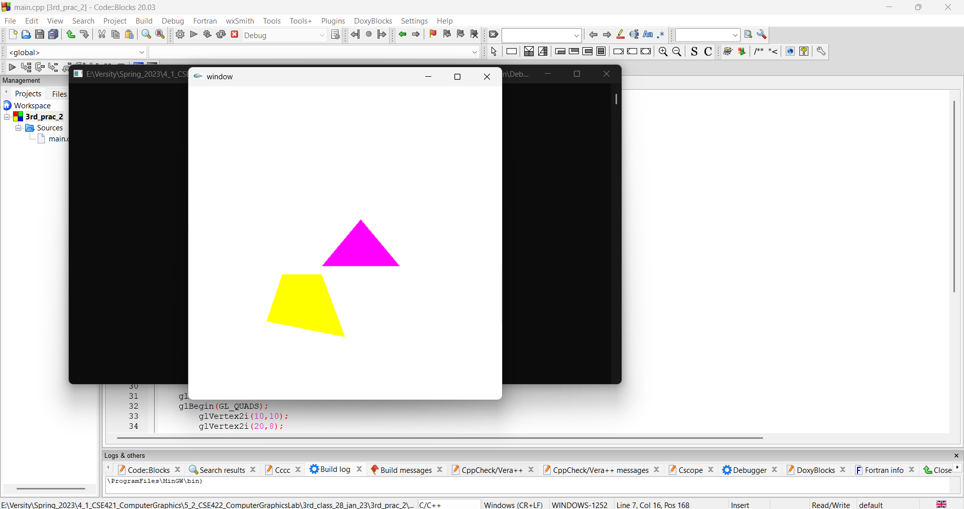

Discussion

**The display() function:**

Clears the color buffer using glClear(GL_COLOR_BUFFER_BIT)

Resets the current matrix using glLoadIdentity()

Sets the color to yellow using glColor3f(1,1,0)

Draws a quadrilateral using the glBegin(GL_QUADS) and glEnd() functions, with the vertices defined using glVertex2i(x,y)

Sets the color to magenta using glColor3f(1,0,1)

Draws a triangle using the glBegin(GL_TRIANGLES) and glEnd() functions, with the vertices defined using glVertex2i(x,y)

Forces the execution of the previous graphics operations using glFlush()

**The init() function:**

Sets the background color to white using glClearColor(1,1,1,0)

Sets the projection mode to be orthographic 2D using glMatrixMode(GL_PROJECTION), glLoadIdentity(), and gluOrtho2D(0,40,0,40)

Resets the current matrix mode to be the model view using glMatrixMode(GL_MODELVIEW)

**The main function:**

Initializes the GLUT library using glutInit(&argc, argv)

Sets the display mode to RGB using glutInitDisplayMode(GLUT_RGB)

Sets the window position using glutInitWindowPosition(300, 100)

Sets the window size using glutInitWindowSize(500, 500)

Creates a window with the title "window" using glutCreateWindow("window")

Registers the display function as the display callback using glutDisplayFunc(display)

Calls the init function to initialize the graphics

Starts the main event loop of the program using glutMainLoop()