Source Code

#include <GL/gl.h>

#include <GL/glu.h>

#include <GL/glut.h>

void display();

void init();

int main(int argc, char** argv) {

glutInit(&argc, argv);

glutInitDisplayMode(GLUT_RGB);

glutInitWindowPosition(300, 100);

glutInitWindowSize(700, 500);

glutCreateWindow("PC-E Section");

glutDisplayFunc(display);

init();

glutMainLoop();

return 0;

}

void display() {

glClear(GL_COLOR_BUFFER_BIT);

glLoadIdentity();

for(int i=1;i<=13;i++){

glColor3ub(191, 201, 202);

glLineWidth(i);

glBegin(GL_LINES);

glVertex2f(8, i+9);

glVertex2f(32, i+9);

glEnd();

}

glFlush();

}

void init() {

glClearColor(0.0, 0.0, 0.0, 0.0);

glMatrixMode(GL_PROJECTION);

glLoadIdentity();

gluOrtho2D(0.0, 40.0, 0.0, 40.0);

glMatrixMode(GL_MODELVIEW);

}

OutPut

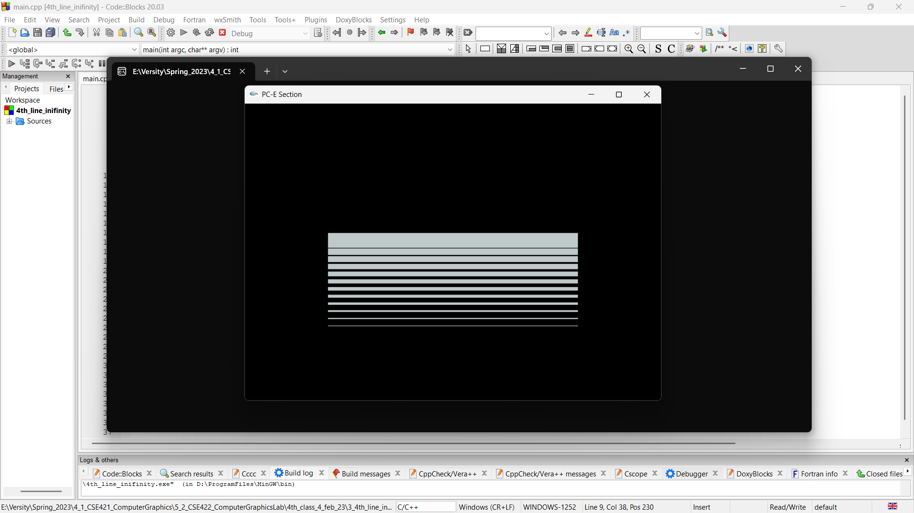

Discussion

By the above code I create a window using the GLUT library for OpenGL graphics, and draw a series of 13 parallel lines on the window. The lines are drawn using the **glBegin(GL_LINES)** function, which specifies that a series of lines will be drawn. The **glVertex2f** function is used to specify the start and end points of each line. The color of the lines is set to a light gray color using the **glColor3ub** function, and the width of each line is set using the **glLineWidth** function.

The **init** function sets up the display environment by setting the clear color to black, setting up an orthographic projection, and specifying the modelview matrix. The **glutDisplayFunc** function sets the **display** function as the function to be called for rendering the window. The **glutMainLoop** function starts the main event processing loop, which is responsible for handling window events and redrawing the window as necessary.