Part 1:  
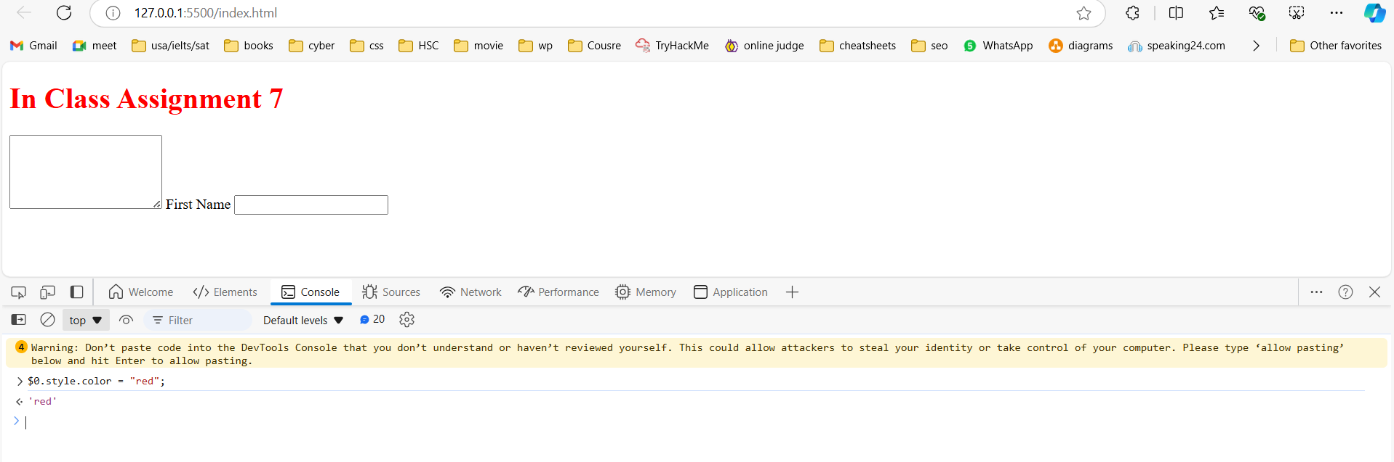

Part 3:  
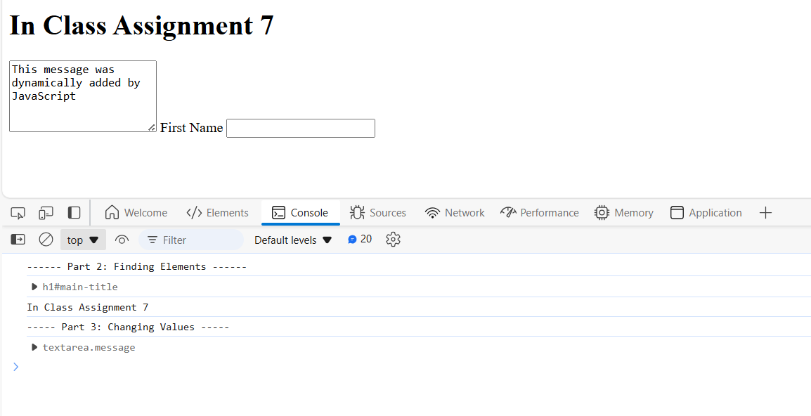

Part 4:  
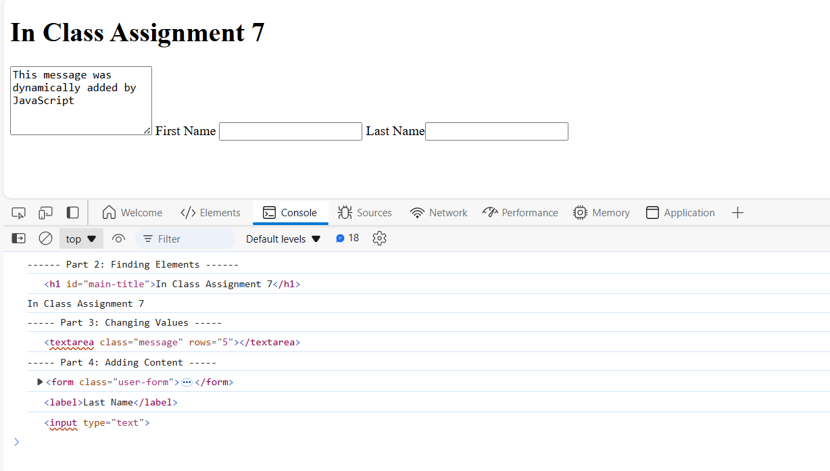

Part 5:  
All input elements now have the 'highlighted' class, which changes their background color to #86f1ff as defined in the CSS.

