Part 1: The 2 values are different because the first one takes another value that we gave, while the second one shows the default value.   
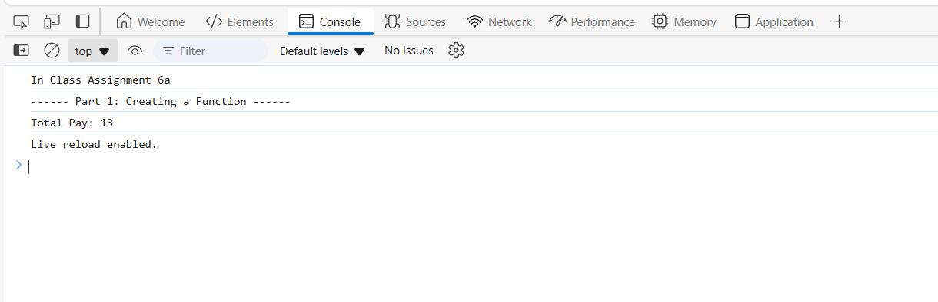  
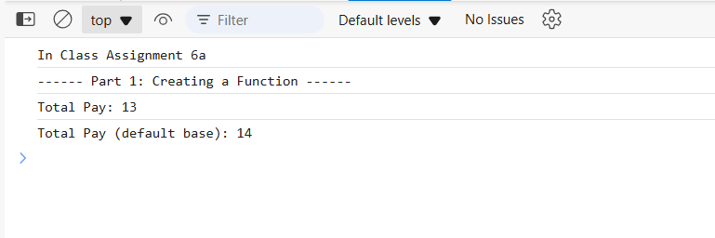  
Part 2 :

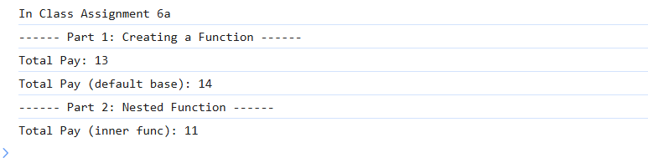  
  
Part 3:  
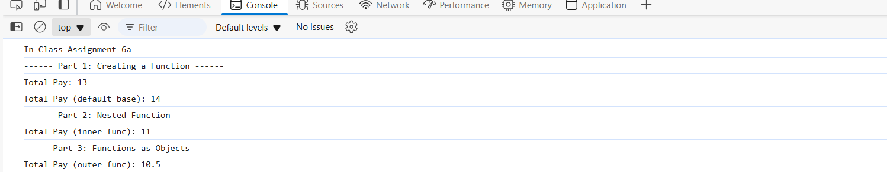

Bonus:  
