Part 1 : 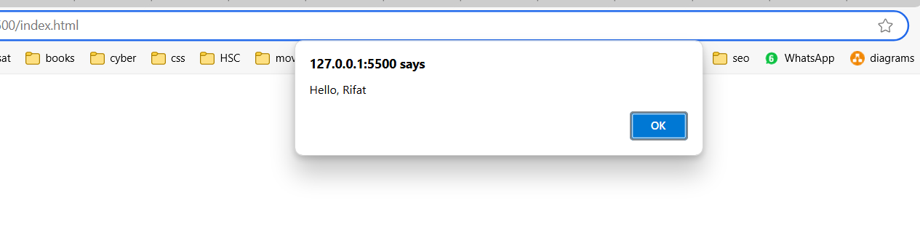  
  
Part 2 :  


**Bonus:**   
The inner parentheses are important because they ensure the subtraction operation is performed before the string concatenation. Without the parentheses, JavaScript may interpret it as a series of string concatenations, which would result in incorrect output.