class nconv
forward(self,x, A): x.A ('ncvl,vw->ncwl')
class linear(nn.Module): (self,c_in,c_out):
forward(self,x):
class gcn(self,c_in,support_len=3,order=2):
forward(self,x,support):
class learnEmbedding(self, d_model):
forward(self, x):--- return torch.cat([v1, v2], -1) v1= bt, f->btf'
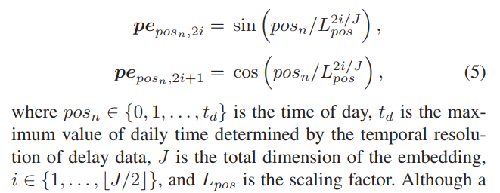
class ATT(self,c_in, d = 16, device = 'cuda'):
qm = nn.Linear(in_features = c_in, out_features = d, bias = False)
forward(self,x, y):
query = qm(y), key = km(x)
attention = torch.einsum('btf,bpf->btp', query, key)/sqrt(d) F.softmax(attention, dim=-1)
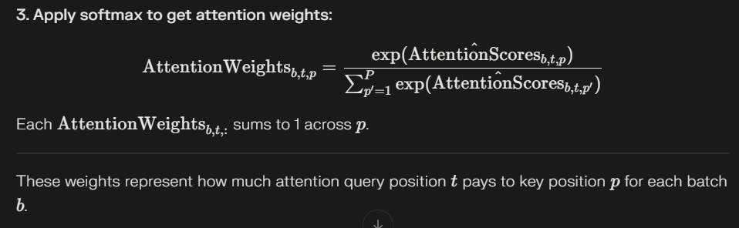

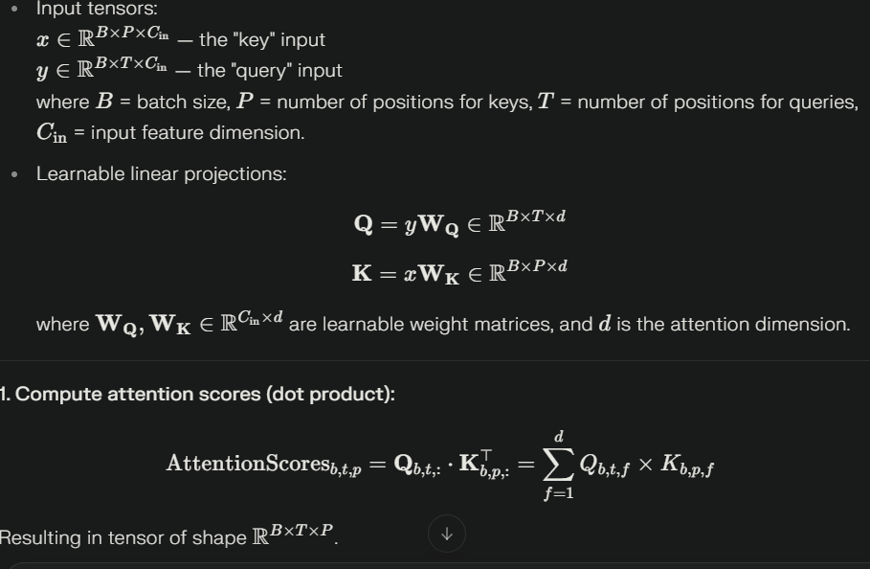

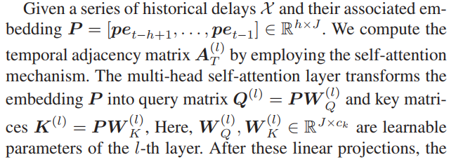

class STMH_GCNN_layer(self, in_channels, out_channels, emb_size, dropout, time_d = 16, heads = 4, support_len = 1, order = 2, final_layer = False):

- x: Graph sequence data, shape (N, in_channels, V, T_in)
  - N: batch size, in_channels: features per node (like “temperature,” “speed”, etc.)
  - V: number of nodes in the graph (e.g., stations, sensors, intersections)
  - T_in: input sequence length (e.g., time steps)
- supports: a list of adjacency/random walk matrices, each (V, V)
- t_in: time labels for input, shape (N, T_in)
- t_out (optional): time labels for the output sequence, shape (N, T_out)
Output: Tensor of shape (N, out_channels, V, T_out)
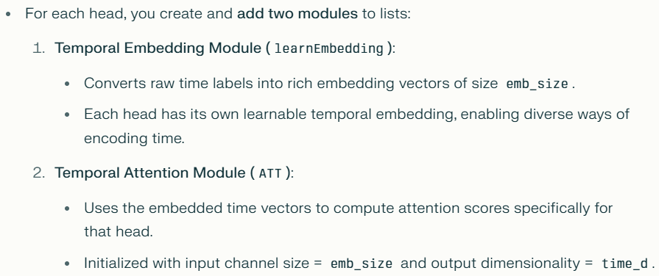

forward(self, x, t_in, supports, t_out = None):
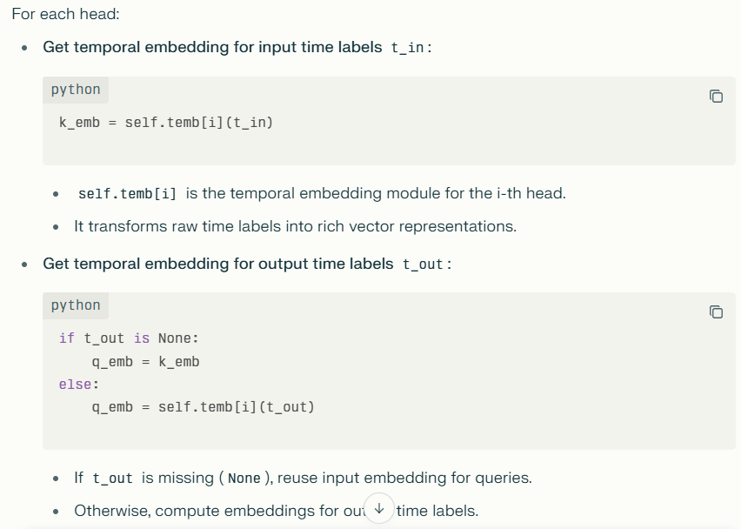
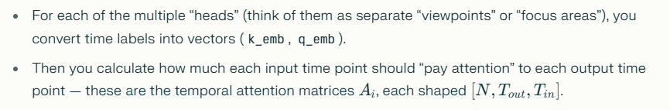
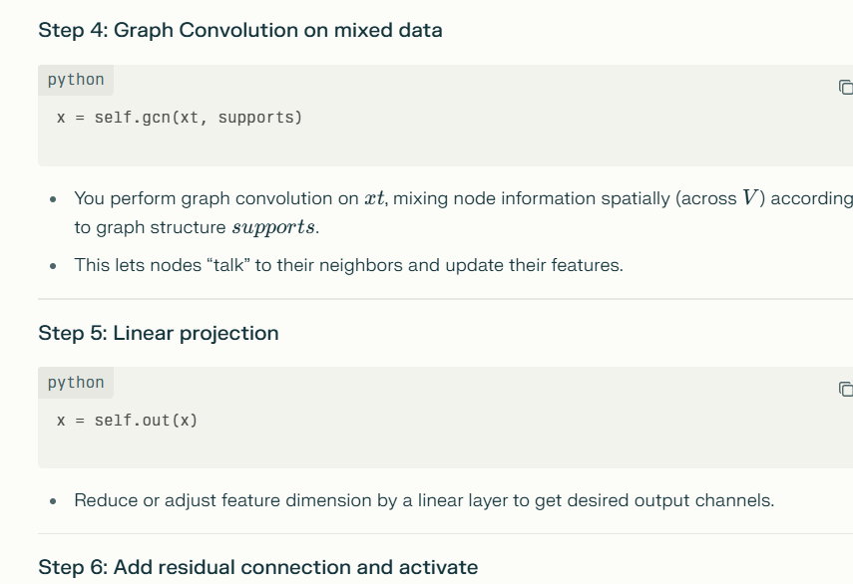
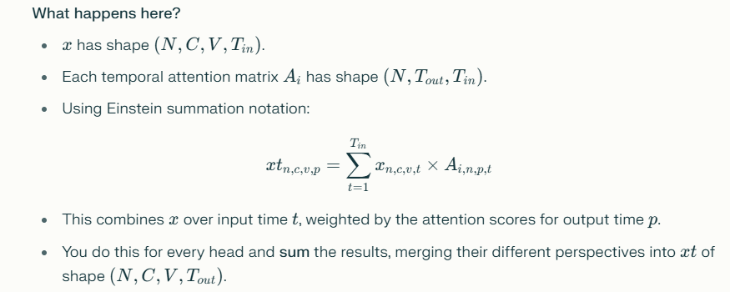
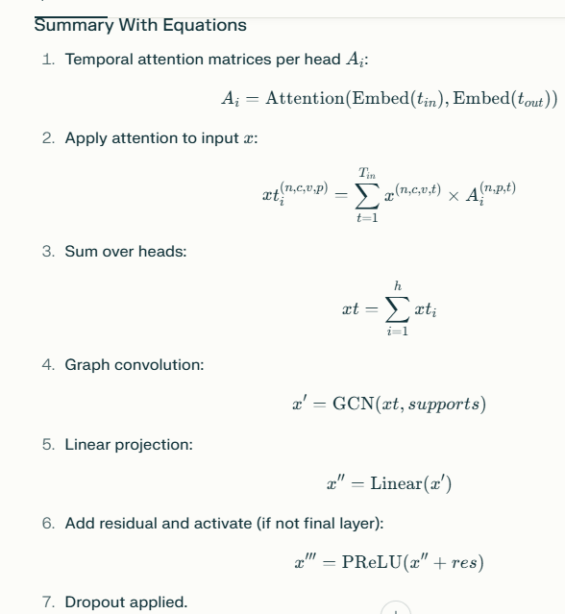
STPN: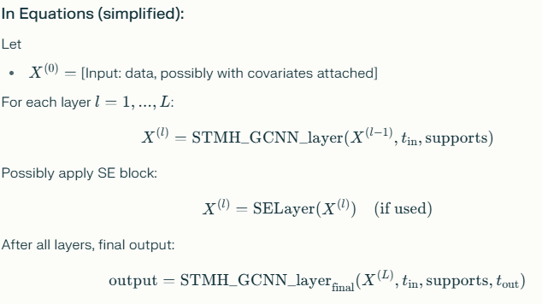
STPN( self, h_layers, in_channels, hidden_channels, out_channels, emb_size, dropout, wemb_size = 4, time_d = 4, heads = 4, support_len = 3, order = 2, num_weather = 8, use_se = True, use_cov = True):

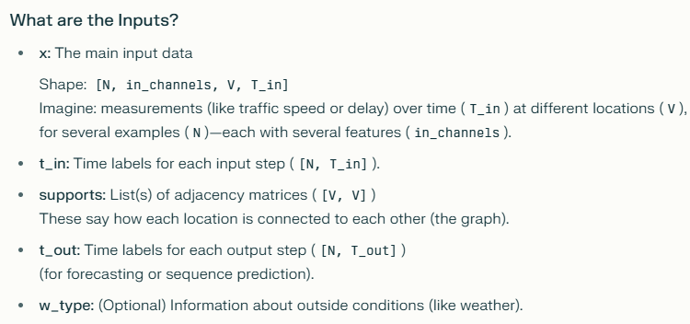
h_layers: number of hidden STS GCNs
- in_channels: num = 2 for delay prediction
- hidden_channels: a list of dimensions for hidden features
- out_channels: num = 2 for delay prediction
wemb_size: covariate embedding size
time_d: d for self attention model
supports_len: number of spatial adjacency matrix
order: order of diffusion convolution

