INVOICE
Kepada / To : Invoice Number : INV/Log/006/IV/2026
NETRAL NET Invoice Date : 06 April 2026
LAMPISI

Payment Information
1. Payment to Account: BANK BCA 619-592-6666
a/n : PT. INDO TUNGKAL NET
2. Please include the company name and invoice number on the proof of transfer.

PT.INDO TUNGKAL NET
Komisaris Keuangan dan Bisnis
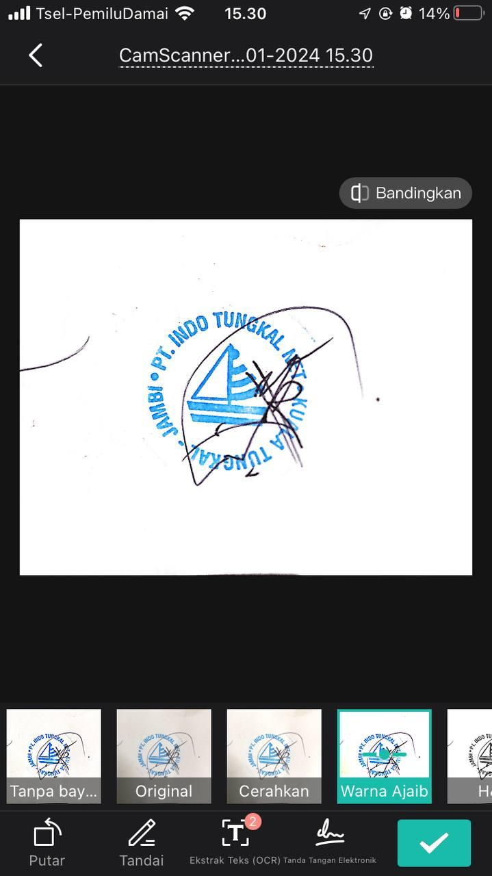

SOPIANSYAH

