**Nama : Rifki Azizi  
NIM : 18090020  
Kelas : 5A**

1. **Source Code**

Latihan1.php : application/controllers

Latihan2.php : application/controllers

Model_latihan1.php : application/models

view-latihan1.php : application/views

1. **URL**

[**http://localhost/pustaka_booking/index.php/latihan1**](http://localhost/pustaka_booking/index.php/latihan1)

[**http://localhost/pustaka_booking/index.php/latihan1/penjumlahan/4/4**](http://localhost/pustaka_booking/index.php/latihan1/penjumlahan/4/4)

[**http://localhost/pustaka_booking/index.php/latihan2/penjumlahan/5/5**](http://localhost/pustaka_booking/index.php/latihan2/penjumlahan/5/5)

1. **Capture Hasil**

**Latihan1 :**

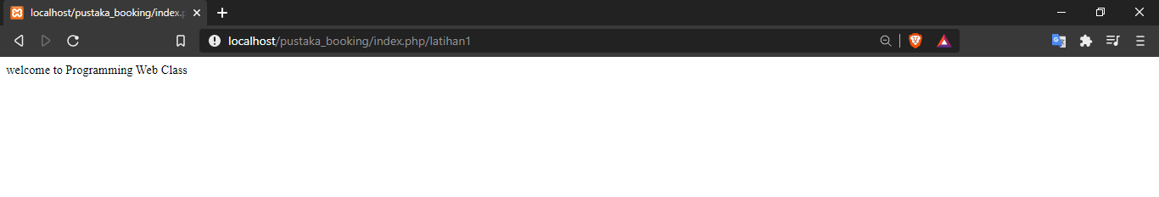

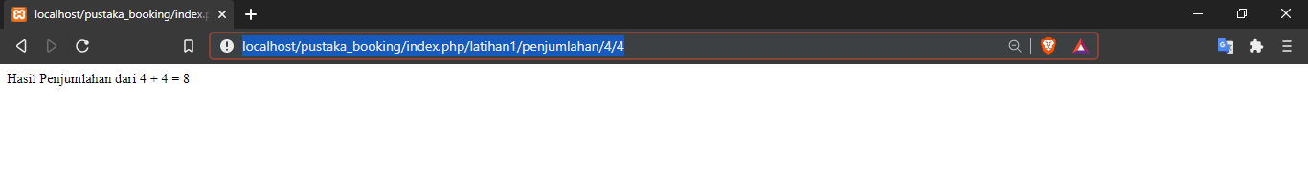

**Latihan2 :**

