**Nama : Rifki Azizi  
NIM : 18090020  
Kelas : 5A**

1. **Source Code**

Matakuliah.php : application/controllers

form-matakuliah.php : application/views

data-matakuliah.php : application/views

config.php : application/config

autoload.php : application/config

routes.php : application/config

.htaccess : pustaka_booking

1. **URL**

[**http://localhost/pustaka_booking/matakuliah**](http://localhost/pustaka_booking/matakuliah)

[**http://localhost/pustaka_booking/matakuliah/cetak**](http://localhost/pustaka_booking/matakuliah/cetak)

1. **Capture Hasil**

**Latihan1 :**

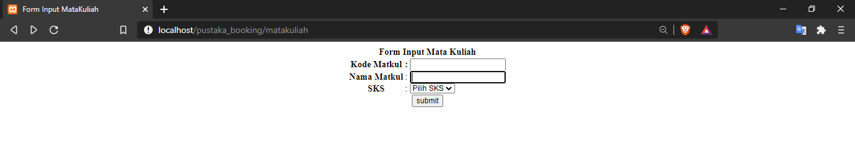

**Latihan2 :**

