Practicum Final Exam – Odd Semester Year 2021/2022
Subject |  |  | COMP6708016 – Object Oriented Programming |  |  | 
Class | : | BG01 / BH01 / BI01 / BJ01 / BW01 / BX01 |  | Start Date | : 17 June 2022
Lecturer | : | D3174 - Dr. Budi Yulianto, S.Kom., M.M., CBA.  D4689 - Rulyna, S.Kom., M.M. |  | Start Time | : 17:20
Lecturer | : |  |  | End Date | : 17 June 2022
Lecturer | : |  |  | End Time | : 19:20

PERATURAN UJIAN:
Exam Regulations:
- Mahasiswa tidak diperbolehkan berdiskusi dan/atau bekerja sama dengan peserta ujian lainnya
Student is not allowed to discuss and/or work together with other exam participants
- Mahasiswa tidak diperbolehkan untuk membuka dan menyalin dari BUKU atau CATATAN, VIDEO dari pengajar (recording kelas, VBL, Youtube, dsb) dan REFERENSI lainnya
Student isn't allowed to open and copy from any resources such as notes, videos (class recording, VBL, Youtube, etc) and other references
- Mahasiswa tidak diperbolehkan membuka dan menyalin jawaban dari internet (google, stackoverflow, dsb)
Student isn't allowed to open and copy answer from the internet (google, stackoverflow, etc)
- Asisten BERHAK memberi nilai 0 (NOL) bagi peserta ujian yang melakukan segala bentuk kecurangan
Assistant is able to give 0 (ZERO) score for exam participant who does any cheating actions
- Kumpulkan jawaban tepat pada waktunya, apabila terlambat mengumpulkan maka jawaban tidak akan dikoreksi dan nilai mahasiswa adalah 0
Submit the answer on time, if not, then the answer will not be checked, and the students will receive 0 (ZERO)
- Bila Anda tidak membaca peraturan ini, maka Anda dianggap telah membaca dan menyetujuinya
If you have missed to read these regulations, so you are considered to have read and agreed on it

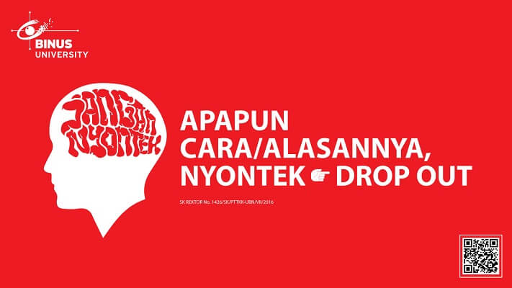

SOFTWARE YANG DIGUNAKAN:
Software will be used:
- Eclipse 2020.6
- Java 8
- MySQL Java Connection Library 8.0.24
- XAMPP 8.0.7

FILE YANG DIKUMPULKAN:
File must be collected:
- JAVA
- CLASS
- SQL

PERHATIAN!
Attention!
- Bagi yang mengerjakan tidak sesuai dengan soal, maka akan diberikan nilai NOL (0)
For those who do not work in accordance with the exam case will be marked as ZERO (0)
- Bagi yang mengerjakan tidak sesuai dengan software dan versi yang telah ditetapkan, maka akan tetap dikoreksi dengan software dan versi yang telah ditetapkan
For those who do not work in accordance with the software and specific version will be corrected by the predefined software and version
- Kompres semua jawaban yang akan diunggah. Pastikan format pengumpulan nama file dan ekstensi sesuai dengan format berikut: [NIM]-[NAMA].zip
Compress all file that will be uploaded. Make sure the format for collecting file name and extension according to the following format: [NIM]-[NAME].zip

Soal
Case
masKZ
Criteria :
- Database Operation
Perform database operation from given sql file (“maskz.sql”) in Java application
- Abstract Class
Design at least three classes, consisting of one abstract class and two concrete class. Abstract class consists of all common attributes and behaviour that both of the concrete class had. Concrete class consist of specific attribute and behaviour that is not common between the concrete classes
- Encapsulation
Attributes of the class must be encapsulated in order to prevent illegal direct access, and can only be accessed using accessor and mutator that may perform validation before accessing the encapsulated attribute
- Inheritance
Concrete classes must inherit all attributes and behaviours from the abstract class
- Polymorphism
Concrete class may override behaviour inherited from abstract class according to their specific implementation

masKZ is a retailer brand established by Mrs. Kejia. In accordance to the quality of the mask itself, the brand gain popularity in Indonesia. Given massive growth development, he asked his acquaintance Mr. Lele to develop a program using Java as base and MySQL for its storage data. Due to some circumstances, Mr. Lele assigned the project to you. To help with the programming, Mr. Lele some design and notes regarding the database, which as shown below :
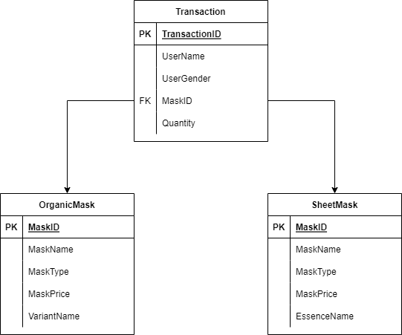
Figure 1. ERD of masKZ database
Connection String | jdbc:mysql://localhost:3306/masKZ
Username | root
Password
Driver Class | com.mysql.cj.jdbc.Driver

The default port number is 3306. If you have changed the port number for MySQL in your XAMPP then feel free to change the 3306 into your port number.
- At the start of program, there will be 4 menus :
- View All Transaction
- Buy Mask
- Delete Transaction
- Exit
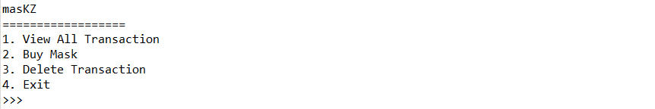
Figure 2. main menu
- If user choose menu 1 (“View All Transactions”), then the program will :
- Retrieve data from “transaction” table in the database
- If data is empty, display the following message
Figure 3. no transaction message
- Otherwise, display all transaction details
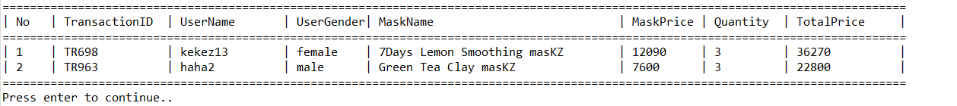
Figure 4. list of transaction details
- If user choose menu 2 (“Buy Mask”), then the program will :
- Prompt user to input user name. Validate the input must be alphanumeric
- Prompt user to input user gender. Validate the input be “Female” or “Male” (Case Insensitive)
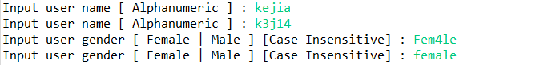
Figure 5. user validation input
- Then, display all mask from both “organicmask” and “sheetmask” table in the database
Organic Mask | Sheet Mask
5% | 7%
- Display mask price section by reducing the initial price with a discount according to the formula below

- Display mask ingredients section according to the formula below
Type | Mask Ingredients
Organic Mask | Variant Name
Sheet Mask | Essence Name

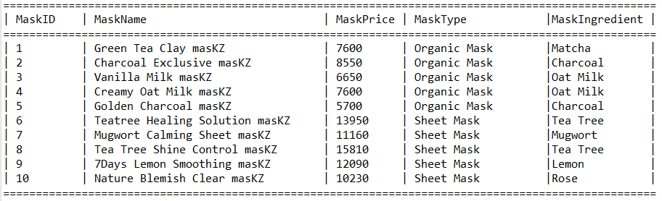
Figure 6. list of sheet masks and organic masks
- Prompt user to input mask choice. Validate the input must be between 1 – total existing mask(s)
- Prompt user to input quantity. Validate the input must be more than 0
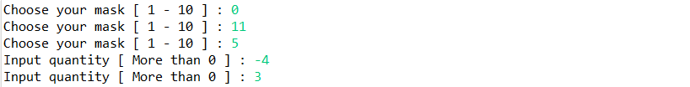
Figure 7. mask validation input
- Then insert the transaction data into the database with the following id format and redirect the user back to the main menu.

TRXXX
Where:
X: Random number (0-9)
Example: TR013, TR243, TR738

- Finally, display details of mask and add data to the “transaction” table in the database
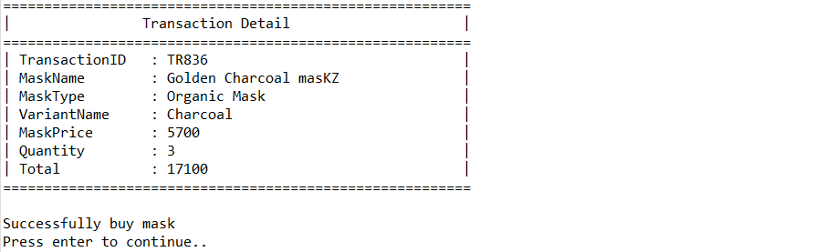
Figure 8. detail mask transaction
- If user choose menu 3 (“Delete Transaction”), then the program will :
- Retrieve data from “transaction” table in the database
- If data is empty, display the following message
Figure 9. no transaction message
- Otherwise, display all transaction details
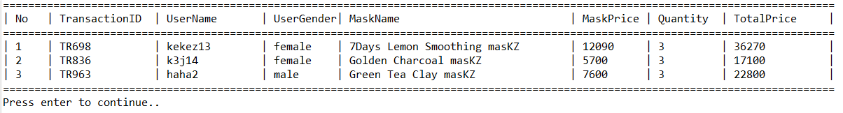
Figure 10. list of transaction details
- Prompt user to input deletion choice. Validate the input must be between 1 and total existing transactions
Figure 11. deletion input
- Finally, display information regarding the deleted data
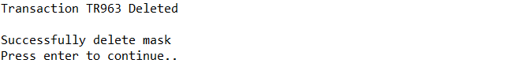
Figure 12. deletion information
- If user choose menu 4 (“Exit”), then the program will close

