LAPORAN PENGERJAAN UJI KOMPETENSI KEJURUAN SMK MAHARDHIKA BATUJAJAR

TAHUN PELAJARAN 2022-2023

KOMPETENSI KEAHLIAN : Rekayasa Perangkat Lunak KELAS : XII RPL 2

NAMA LENGKAP : Muhamad Rifki Rifki Ramadani

NIS :

PAKET SOAL : Pengaduan Masyarakat

JENIS APLIKASI : Web

ALOKASI WAKTU : 24 jam

# PENJADWALAN KEGIATAN

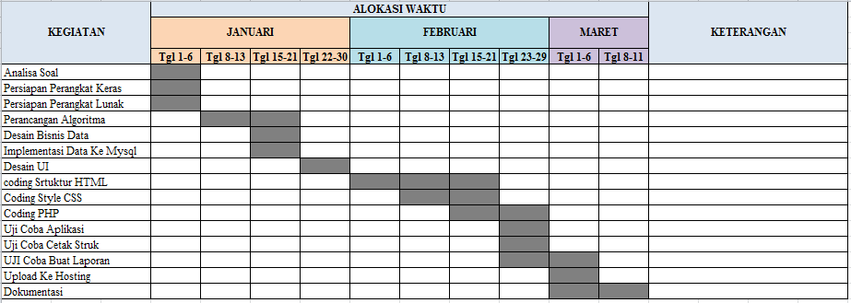

# PERSIAPAN PERANGKAT KERAS

*- Processor : Intel(R) Core(TM) i5-4590 CPU @ 3.3GHz (4CPUs), ~3.3GHz*

*- Memory : 8129MB RAM*

# PERSIAPAN PERANGKAT LUNAK

*a. Os Windows 7 ultimate 64-bit*

*b. Xampp*

*c. Visual studio code*

*d. Astah*

*e. Excel*

*f. Word*

*g. Google chrome*

*h. Balsamiq*

# PERANCANGAN ALGORITMA APLIKASI

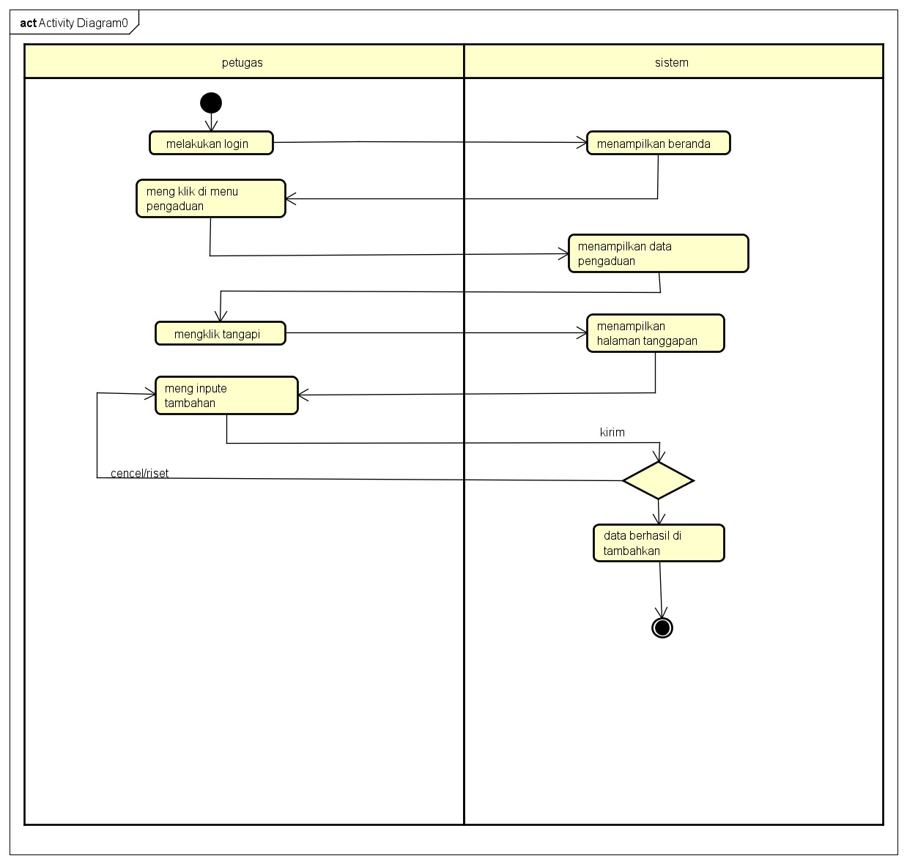 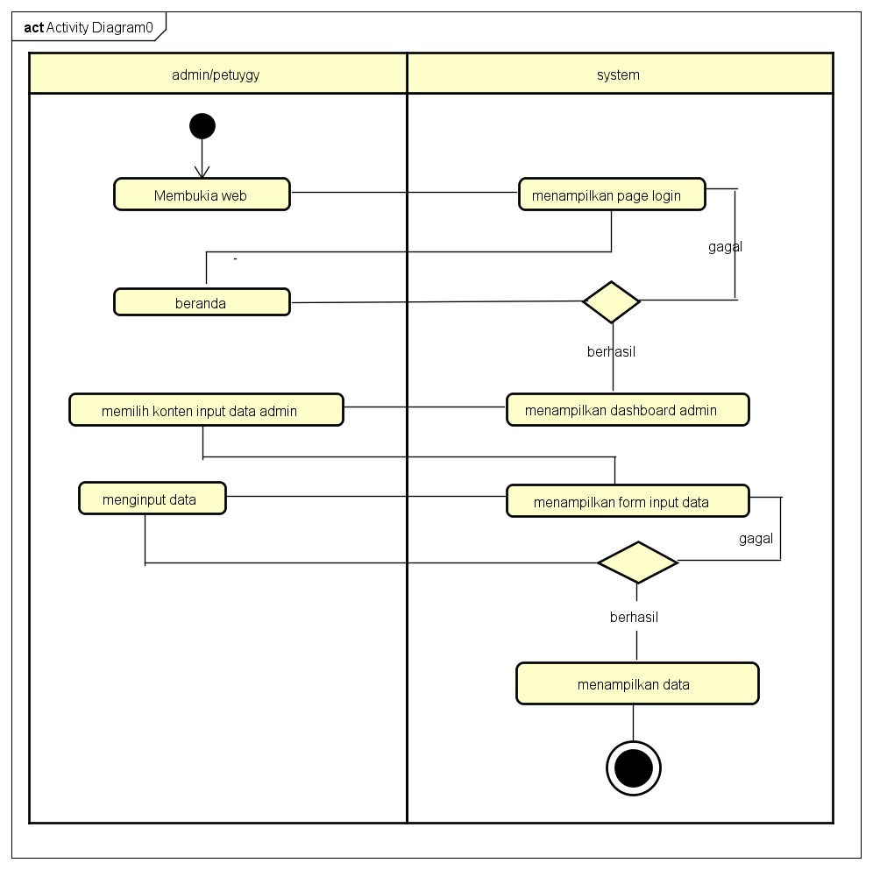 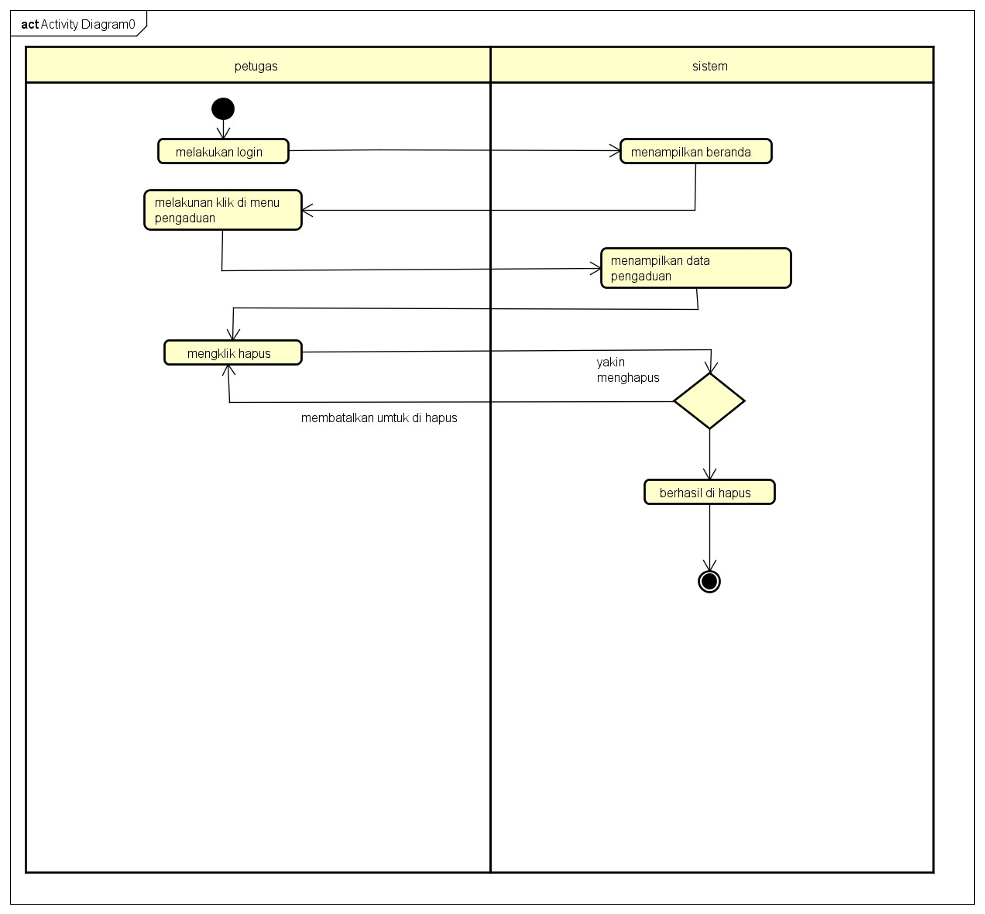 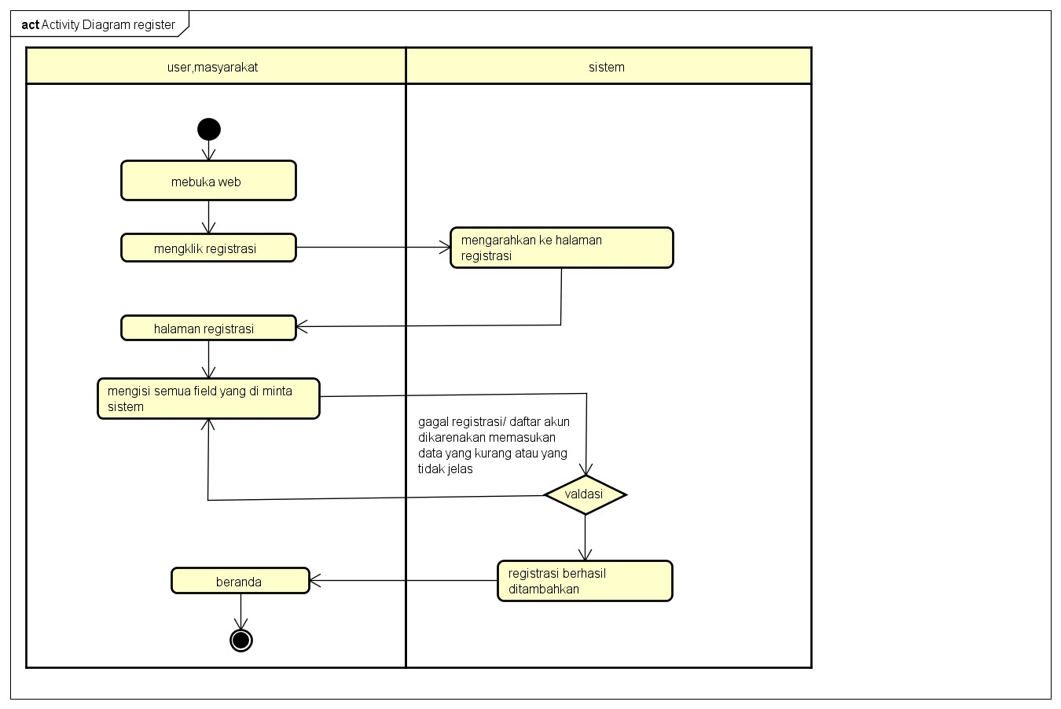 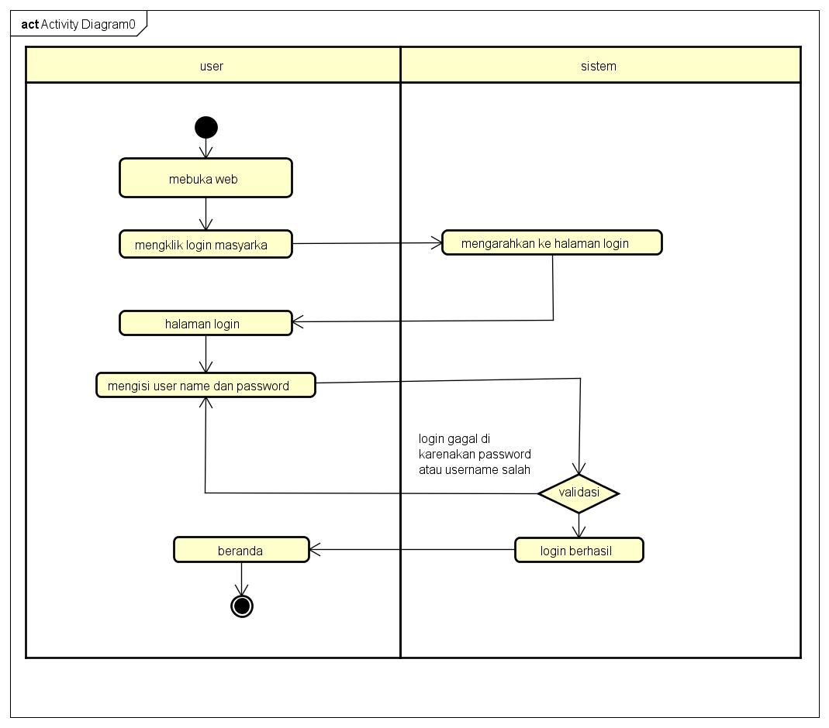

# PERANCANGAN DESAIN BASIS DATA

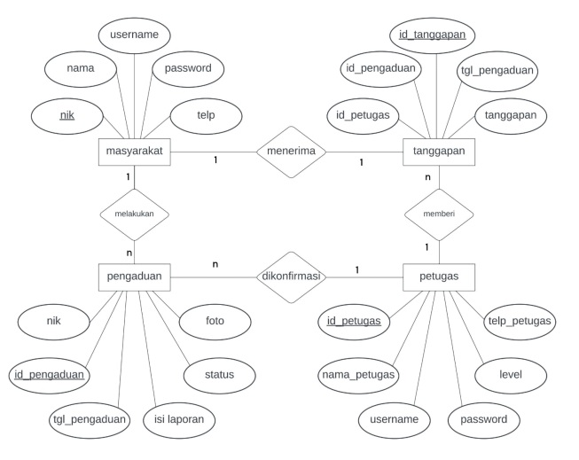

# DUMMY DATA

# 

|  |  |  |  |  |  |
| --- | --- | --- | --- | --- | --- |
| Id_petugas | Nama_petugas | Usename | passwod | Tel_petugas | Level |
| 12345136 | Apriansah | Aping | Apingg | 0826345678292 | Admin |
| 12544378 | Rohman | Rohman | Rohmann | 0876854789243 | Petugas |

# 

|  |  |  |  |  |
| --- | --- | --- | --- | --- |
| Nama | Username | Password | Telp | Nik |
| Joko nugroho | Joko | Jokoo | 0827835648936 | 123456789 |
| Agus amsudin | agus | aguss | 8037849087256 | 1729876389 |
| rifkiramdani | rifki | rifkii | 02554747774 | 90789687575 |
| anisa | jila | 9039837 | 6497463554547 | 9289283 |

# 

# 

|  |  |  |  |  |  |
| --- | --- | --- | --- | --- | --- |
| Id_pengaduan | Tgl_pengadun | Nik | Isi_laporan | Foto | Status |
| 6 | 2023-02-09 | 0092363789 | macet | 090220234520aduh.jpg | Selesai |
| 7 | 2023-02-09 | 0038946748 | Cantik | 090220235313nunga.jpg | Proses |
| 13 | 2023-30-08 | 0098468393 | Malam hari | 080320230017kota.jpg | selesai |

# 

|  |  |  |  |  |
| --- | --- | --- | --- | --- |
| Id _tanggapan | Id _pengaduan | Tgl_tamnggapan | Tanggapam | Id_petugas |
| 2 | 6 | 2023-02-09 | Sabarr | 11263537 |
| 3 | 14 | 2023-03-08 | Iya siap | 12537388 |
| 4 | 15 | 2023-03-09 | Iya siap | 23735386 |
| 5 | 13 | 2023-03-09 | Di tunngu | 33267393 |

# PEMBUATAN BASIS DATA (MySQL Code)

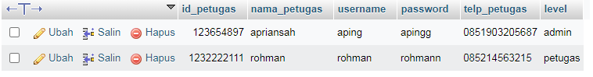

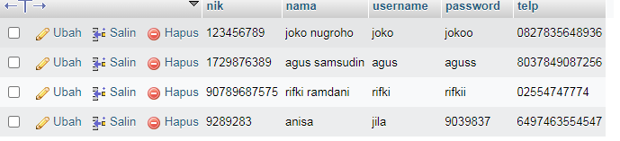

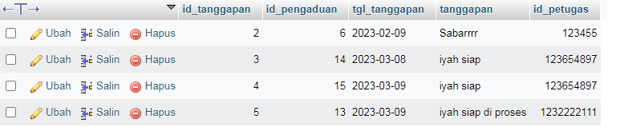

# PERANCANGAN TAMPILAN ANTARMUKA (UI) WEB

* + **Aplikasi pengaduan masyarakat**

1. *Silahkan gambarkan use case diagram aplikasi yang kamu buat*

1. Admin dashboard

|  |
| --- |
| C:\xampp\htdocs\mockup\login.png C:\xampp\htdocs\mockup\dashboard .png C:\xampp\htdocs\mockup\dashboad user.png |

1. Tampilan Petugas

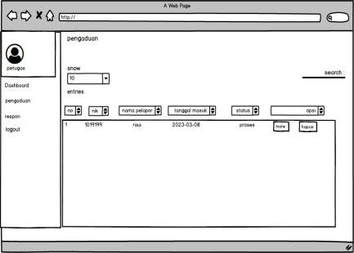 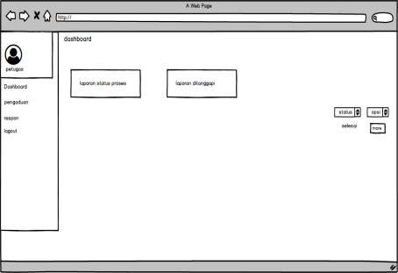 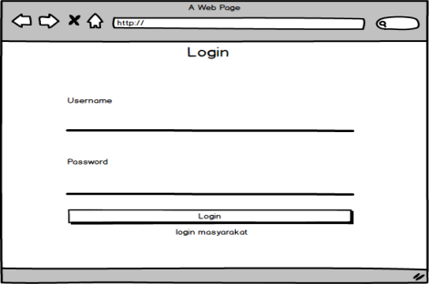

1. Tampilan masyarakat

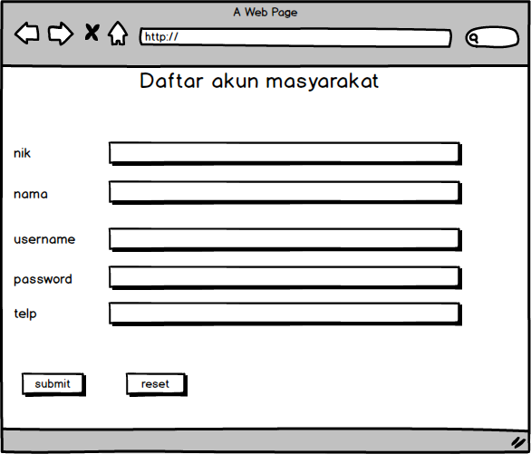 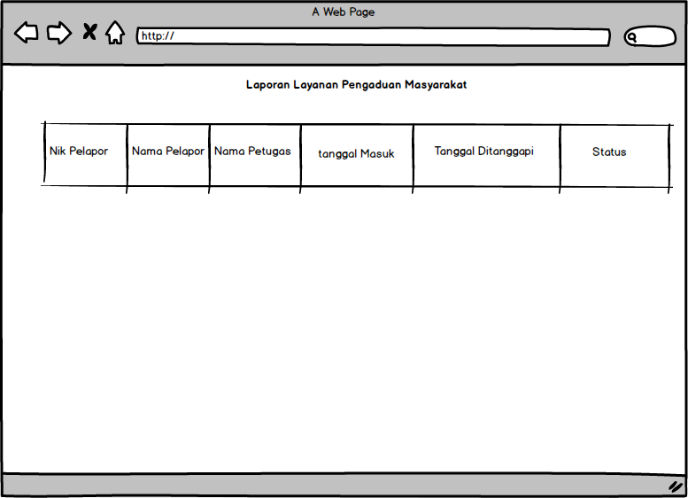

1. Pembuatan Stuktur Web (htm)

|  |
| --- |
| <?php  session_start();  include '../conn/koneksi.php';  if(!isset($_SESSION['username'])){  header('location:../index.php');  }  elseif($_SESSION['data']['level'] != "admin"){  header('location:../index.php');  }  ?>  <!DOCTYPE html>  <html>  <head>  <title>Aplikasi Pengaduan masyarakat</title>  <!--Import Google Icon Font-->  <link href="https://fonts.googleapis.com/icon?family=Material+Icons" rel="stylesheet">  <!--Import materialize.css-->  <link type="text/css" rel="stylesheet" href="../css/materialize.min.css" media="screen,projection"/>  <!-- Compiled and minified CSS -->  <link rel="stylesheet" href="https://cdnjs.cloudflare.com/ajax/libs/materialize/1.0.0/css/materialize.min.css">  <!-- Compiled and minified JavaScript -->  <script src="https://cdnjs.cloudflare.com/ajax/libs/materialize/1.0.0/js/materialize.min.js"></script>  <script src="https://ajax.googleapis.com/ajax/libs/jquery/3.4.1/jquery.min.js"></script>  <!--Let browser know website is optimized for mobile-->  <meta name="viewport" content="width=device-width, initial-scale=1.0"/>  <link rel="stylesheet" type="text/css" href="https://cdn.datatables.net/1.10.19/css/jquery.dataTables.css">    <script src="https://ajax.googleapis.com/ajax/libs/jquery/3.4.1/jquery.min.js"></script>    <script type="text/javascript" charset="utf8" src="https://cdn.datatables.net/1.10.19/js/jquery.dataTables.js"></script>      <script type="text/javascript">  $(document).ready( function () {  $('#example').DataTable();  $('select').formSelect();  } );    </script>  </head>  <body style="background:url(../img/kamu.jpg); background-size: cover;">  <div class="row">  <div class="col s12 m3">  <ul id="slide-out" class="sidenav sidenav-fixed">  <li>  <div class="user-view">  <div class="background">  <img src="../img/gambar_2.jpg">  </div>  <a href="#user"><img class="circle" src="../img/rifki_1.jpg"></a>  <a href="#name"><span class="black-text name"><?php echo ucwords($_SESSION['data']['nama_petugas']); ?></span></a>  </div>  </li>  <li><a href="index.php?p=dashboard">Dashboard</a>  <li><a href="index.php?p=registrasi">Registrasi</a>  <li><a href="index.php?p=pengaduan">Pengaduan</a>  <li><a href="index.php?p=respon">Respon</a></li>  <li><a href="index.php?p=user">User</a>  <li><a href="index.php?p=laporan">Laporan</a>  <li>  <div class="divider"></div>  </li>  <li><a class="waves-effect" href="../index.php?p=logout">Logout</a>  </ul>  <a href="#" data-target="slide-out" class="btn sidenav-trigger"><i class="material-icons">menu</i></a>  </div>  <div class="col s12 m9">    <?php  if(@$_GET['p']==""){  include_once 'dashboard.php';  }  elseif(@$_GET['p']=="dashboard"){  include_once 'dashboard.php';  }  elseif(@$_GET['p']=="registrasi"){  include_once 'registrasi.php';  }  elseif(@$_GET['p']=="regis_hapus"){  $query = mysqli_query($koneksi,"DELETE FROM masyarakat WHERE nik='".$_GET['nik']."'");  if($query){  header('location:index.php?p=registrasi');  }  }  elseif(@$_GET['p']=="pengaduan"){  include_once 'pengaduan.php';  }  elseif(@$_GET['p']=="pengaduan_hapus"){  $query=mysqli_query($koneksi,"SELECT * FROM pengaduan WHERE id_pengaduan='".$_GET['id_pengaduan']."'");  $data=mysqli_fetch_assoc($query);  unlink('../img/'.$data['foto']);  if($data['status']=="proses"){  $delete=mysqli_query($koneksi,"DELETE FROM pengaduan WHERE id_pengaduan='".$_GET['id_pengaduan']."'");  header('location:index.php?p=pengaduan');  }  elseif($data['status']=="selesai"){  $delete=mysqli_query($koneksi,"DELETE FROM pengaduan WHERE id_pengaduan='".$_GET['id_pengaduan']."'");  if($delete){  $delete2=mysqli_query($koneksi,"DELETE FROM tanggapan WHERE id_pengaduan='".$_GET['id_pengaduan']."'");  header('location:index.php?p=pengaduan');  }  }  }  elseif(@$_GET['p']=="more"){  include_once 'more.php';  }  elseif(@$_GET['p']=="respon"){  include_once 'respon.php';  }  elseif(@$_GET['p']=="tanggapan_hapus"){    $query = mysqli_query($koneksi,"DELETE FROM tanggapan WHERE id_tanggapan='".$_GET['id_tanggapan']."'");  if($query){  header('location:index.php?p=respon');  }  }  elseif(@$_GET['p']=="user"){  include_once 'user.php';  }  elseif(@$_GET['p']=="user_input"){  include_once 'user_input.php';  }  elseif(@$_GET['p']=="user_edit"){  include_once 'user_edit.php';  }  elseif(@$_GET['p']=="user_hapus"){  $query = mysqli_query($koneksi,"DELETE FROM petugas WHERE id_petugas='".$_GET['id_petugas']."'");  if($query){  header('location:index.php?p=user');  }  }  elseif(@$_GET['p']=="laporan"){  include_once 'laporan.php';  }  ?>  </div>  </div>  <!--JavaScript at end of body for optimized loading-->  <script type="text/javascript" src="../js/materialize.min.js"></script>  <script type="text/javascript" src="https://cdnjs.cloudflare.com/ajax/libs/materialize/1.0.0/js/materialize.min.js"></script>  <script type="text/javascript">  document.addEventListener('DOMContentLoaded', function() {  var elems = document.querySelectorAll('.sidenav');  var instances = M.Sidenav.init(elems);  });  document.addEventListener('DOMContentLoaded', function() {  var elems = document.querySelectorAll('.modal');  var instances = M.Modal.init(elems);  });  </script>  </body>  </html> |

10.PEMBUATAN STYLE WEB (CSS)

|  |
| --- |
| /*  * This combined file was created by the DataTables downloader builder:  * https://datatables.net/download  *  * To rebuild or modify this file with the latest versions of the included  * software please visit:  * https://datatables.net/download/#dt/dt-1.10.18  *  * Included libraries:  * DataTables 1.10.18  */  table.dataTable{width:100%;margin:0 auto;clear:both;border-collapse:separate;border-spacing:0}table.dataTable thead th,table.dataTable tfoot th{font-weight:bold}table.dataTable thead th,table.dataTable thead td{padding:10px 18px;border-bottom:1px solid #111}table.dataTable thead th:active,table.dataTable thead td:active{outline:none}table.dataTable tfoot th,table.dataTable tfoot td{padding:10px 18px 6px 18px;border-top:1px solid #111}table.dataTable thead .sorting,table.dataTable thead .sorting_asc,table.dataTable thead .sorting_desc,table.dataTable thead .sorting_asc_disabled,table.dataTable thead .sorting_desc_disabled{cursor:pointer;*cursor:hand;background-repeat:no-repeat;background-position:center right}table.dataTable thead .sorting{background-image:url("DataTables-1.10.18/images/sort_both.png")}table.dataTable thead .sorting_asc{background-image:url("DataTables-1.10.18/images/sort_asc.png")}table.dataTable thead .sorting_desc{background-image:url("DataTables-1.10.18/images/sort_desc.png")}table.dataTable thead .sorting_asc_disabled{background-image:url("DataTables-1.10.18/images/sort_asc_disabled.png")}table.dataTable thead .sorting_desc_disabled{background-image:url("DataTables-1.10.18/images/sort_desc_disabled.png")}table.dataTable tbody tr{background-color:#ffffff}table.dataTable tbody tr.selected{background-color:#B0BED9}table.dataTable tbody th,table.dataTable tbody td{padding:8px 10px}table.dataTable.row-border tbody th,table.dataTable.row-border tbody td,table.dataTable.display tbody th,table.dataTable.display tbody td{border-top:1px solid #ddd}table.dataTable.row-border tbody tr:first-child th,table.dataTable.row-border tbody tr:first-child td,table.dataTable.display tbody tr:first-child th,table.dataTable.display tbody tr:first-child td{border-top:none}table.dataTable.cell-border tbody th,table.dataTable.cell-border tbody td{border-top:1px solid #ddd;border-right:1px solid #ddd}table.dataTable.cell-border tbody tr th:first-child,table.dataTable.cell-border tbody tr td:first-child{border-left:1px solid #ddd}table.dataTable.cell-border tbody tr:first-child th,table.dataTable.cell-border tbody tr:first-child td{border-top:none}table.dataTable.stripe tbody tr.odd,table.dataTable.display tbody tr.odd{background-color:#f9f9f9}table.dataTable.stripe tbody tr.odd.selected,table.dataTable.display tbody tr.odd.selected{background-color:#acbad4}table.dataTable.hover tbody tr:hover,table.dataTable.display tbody tr:hover{background-color:#f6f6f6}table.dataTable.hover tbody tr:hover.selected,table.dataTable.display tbody tr:hover.selected{background-color:#aab7d1}table.dataTable.order-column tbody tr>.sorting_1,table.dataTable.order-column tbody tr>.sorting_2,table.dataTable.order-column tbody tr>.sorting_3,table.dataTable.display tbody tr>.sorting_1,table.dataTable.display tbody tr>.sorting_2,table.dataTable.display tbody tr>.sorting_3{background-color:#ff0000}table.dataTable.order-column tbody tr.selected>.sorting_1,table.dataTable.order-column tbody tr.selected>.sorting_2,table.dataTable.order-column tbody tr.selected>.sorting_3,table.dataTable.display tbody tr.selected>.sorting_1,table.dataTable.display tbody tr.selected>.sorting_2,table.dataTable.display tbody tr.selected>.sorting_3{background-color:#acbad5}table.dataTable.display tbody tr.odd>.sorting_1,table.dataTable.order-column.stripe tbody tr.odd>.sorting_1{background-color:#f1f1f1}table.dataTable.display tbody tr.odd>.sorting_2,table.dataTable.order-column.stripe tbody tr.odd>.sorting_2{background-color:#f3f3f3}table.dataTable.display tbody tr.odd>.sorting_3,table.dataTable.order-column.stripe tbody tr.odd>.sorting_3{background-color:whitesmoke}table.dataTable.display tbody tr.odd.selected>.sorting_1,table.dataTable.order-column.stripe tbody tr.odd.selected>.sorting_1{background-color:#a6b4cd}table.dataTable.display tbody tr.odd.selected>.sorting_2,table.dataTable.order-column.stripe tbody tr.odd.selected>.sorting_2{background-color:#a8b5cf}table.dataTable.display tbody tr.odd.selected>.sorting_3,table.dataTable.order-column.stripe tbody tr.odd.selected>.sorting_3{background-color:#a9b7d1}table.dataTable.display tbody tr.even>.sorting_1,table.dataTable.order-column.stripe tbody tr.even>.sorting_1{background-color:#fafafa}table.dataTable.display tbody tr.even>.sorting_2,table.dataTable.order-column.stripe tbody tr.even>.sorting_2{background-color:#fcfcfc}table.dataTable.display tbody tr.even>.sorting_3,table.dataTable.order-column.stripe tbody tr.even>.sorting_3{background-color:#fefefe}table.dataTable.display tbody tr.even.selected>.sorting_1,table.dataTable.order-column.stripe tbody tr.even.selected>.sorting_1{background-color:#acbad5}table.dataTable.display tbody tr.even.selected>.sorting_2,table.dataTable.order-column.stripe tbody tr.even.selected>.sorting_2{background-color:#aebcd6}table.dataTable.display tbody tr.even.selected>.sorting_3,table.dataTable.order-column.stripe tbody tr.even.selected>.sorting_3{background-color:#afbdd8}table.dataTable.display tbody tr:hover>.sorting_1,table.dataTable.order-column.hover tbody tr:hover>.sorting_1{background-color:#eaeaea}table.dataTable.display tbody tr:hover>.sorting_2,table.dataTable.order-column.hover tbody tr:hover>.sorting_2{background-color:#ececec}table.dataTable.display tbody tr:hover>.sorting_3,table.dataTable.order-column.hover tbody tr:hover>.sorting_3{background-color:#efefef}table.dataTable.display tbody tr:hover.selected>.sorting_1,table.dataTable.order-column.hover tbody tr:hover.selected>.sorting_1{background-color:#a2aec7}table.dataTable.display tbody tr:hover.selected>.sorting_2,table.dataTable.order-column.hover tbody tr:hover.selected>.sorting_2{background-color:#a3b0c9}table.dataTable.display tbody tr:hover.selected>.sorting_3,table.dataTable.order-column.hover tbody tr:hover.selected>.sorting_3{background-color:#a5b2cb}table.dataTable.no-footer{border-bottom:1px solid #111}table.dataTable.nowrap th,table.dataTable.nowrap td{white-space:nowrap}table.dataTable.compact thead th,table.dataTable.compact thead td{padding:4px 17px 4px 4px}table.dataTable.compact tfoot th,table.dataTable.compact tfoot td{padding:4px}table.dataTable.compact tbody th,table.dataTable.compact tbody td{padding:4px}table.dataTable th.dt-left,table.dataTable td.dt-left{text-align:left}table.dataTable th.dt-center,table.dataTable td.dt-center,table.dataTable td.dataTables_empty{text-align:center}table.dataTable th.dt-right,table.dataTable td.dt-right{text-align:right}table.dataTable th.dt-justify,table.dataTable td.dt-justify{text-align:justify}table.dataTable th.dt-nowrap,table.dataTable td.dt-nowrap{white-space:nowrap}table.dataTable thead th.dt-head-left,table.dataTable thead td.dt-head-left,table.dataTable tfoot th.dt-head-left,table.dataTable tfoot td.dt-head-left{text-align:left}table.dataTable thead th.dt-head-center,table.dataTable thead td.dt-head-center,table.dataTable tfoot th.dt-head-center,table.dataTable tfoot td.dt-head-center{text-align:center}table.dataTable thead th.dt-head-right,table.dataTable thead td.dt-head-right,table.dataTable tfoot th.dt-head-right,table.dataTable tfoot td.dt-head-right{text-align:right}table.dataTable thead th.dt-head-justify,table.dataTable thead td.dt-head-justify,table.dataTable tfoot th.dt-head-justify,table.dataTable tfoot td.dt-head-justify{text-align:justify}table.dataTable thead th.dt-head-nowrap,table.dataTable thead td.dt-head-nowrap,table.dataTable tfoot th.dt-head-nowrap,table.dataTable tfoot td.dt-head-nowrap{white-space:nowrap}table.dataTable tbody th.dt-body-left,table.dataTable tbody td.dt-body-left{text-align:left}table.dataTable tbody th.dt-body-center,table.dataTable tbody td.dt-body-center{text-align:center}table.dataTable tbody th.dt-body-right,table.dataTable tbody td.dt-body-right{text-align:right}table.dataTable tbody th.dt-body-justify,table.dataTable tbody td.dt-body-justify{text-align:justify}table.dataTable tbody th.dt-body-nowrap,table.dataTable tbody td.dt-body-nowrap{white-space:nowrap}table.dataTable,table.dataTable th,table.dataTable td{box-sizing:content-box}.dataTables_wrapper{position:relative;clear:both;*zoom:1;zoom:1}.dataTables_wrapper .dataTables_length{float:left}.dataTables_wrapper .dataTables_filter{float:right;text-align:right}.dataTables_wrapper .dataTables_filter input{margin-left:0.5em}.dataTables_wrapper .dataTables_info{clear:both;float:left;padding-top:0.755em}.dataTables_wrapper .dataTables_paginate{float:right;text-align:right;padding-top:0.25em}.dataTables_wrapper .dataTables_paginate .paginate_button{box-sizing:border-box;display:inline-block;min-width:1.5em;padding:0.5em 1em;margin-left:2px;text-align:center;text-decoration:none !important;cursor:pointer;*cursor:hand;color:#333 !important;border:1px solid transparent;border-radius:2px}.dataTables_wrapper .dataTables_paginate .paginate_button.current,.dataTables_wrapper .dataTables_paginate .paginate_button.current:hover{color:#333 !important;border:1px solid #979797;background-color:white;background:-webkit-gradient(linear, left top, left bottom, color-stop(0%, #fff), color-stop(100%, #dcdcdc));background:-webkit-linear-gradient(top, #fff 0%, #dcdcdc 100%);background:-moz-linear-gradient(top, #fff 0%, #dcdcdc 100%);background:-ms-linear-gradient(top, #fff 0%, #dcdcdc 100%);background:-o-linear-gradient(top, #fff 0%, #dcdcdc 100%);background:linear-gradient(to bottom, #fff 0%, #dcdcdc 100%)}.dataTables_wrapper .dataTables_paginate .paginate_button.disabled,.dataTables_wrapper .dataTables_paginate .paginate_button.disabled:hover,.dataTables_wrapper .dataTables_paginate .paginate_button.disabled:active{cursor:default;color:#666 !important;border:1px solid transparent;background:transparent;box-shadow:none}.dataTables_wrapper .dataTables_paginate .paginate_button:hover{color:white !important;border:1px solid #111;background-color:#585858;background:-webkit-gradient(linear, left top, left bottom, color-stop(0%, #585858), color-stop(100%, #111));background:-webkit-linear-gradient(top, #585858 0%, #111 100%);background:-moz-linear-gradient(top, #585858 0%, #111 100%);background:-ms-linear-gradient(top, #585858 0%, #111 100%);background:-o-linear-gradient(top, #585858 0%, #111 100%);background:linear-gradient(to bottom, #585858 0%, #111 100%)}.dataTables_wrapper .dataTables_paginate .paginate_button:active{outline:none;background-color:#2b2b2b;background:-webkit-gradient(linear, left top, left bottom, color-stop(0%, #2b2b2b), color-stop(100%, #0c0c0c));background:-webkit-linear-gradient(top, #2b2b2b 0%, #0c0c0c 100%);background:-moz-linear-gradient(top, #2b2b2b 0%, #0c0c0c 100%);background:-ms-linear-gradient(top, #2b2b2b 0%, #0c0c0c 100%);background:-o-linear-gradient(top, #2b2b2b 0%, #0c0c0c 100%);background:linear-gradient(to bottom, #2b2b2b 0%, #0c0c0c 100%);box-shadow:inset 0 0 3px #111}.dataTables_wrapper .dataTables_paginate .ellipsis{padding:0 1em}.dataTables_wrapper .dataTables_processing{position:absolute;top:50%;left:50%;width:100%;height:40px;margin-left:-50%;margin-top:-25px;padding-top:20px;text-align:center;font-size:1.2em;background-color:white;background:-webkit-gradient(linear, left top, right top, color-stop(0%, rgba(255,255,255,0)), color-stop(25%, rgba(255,255,255,0.9)), color-stop(75%, rgba(255,255,255,0.9)), color-stop(100%, rgba(255,255,255,0)));background:-webkit-linear-gradient(left, rgba(255,255,255,0) 0%, rgba(255,255,255,0.9) 25%, rgba(255,255,255,0.9) 75%, rgba(255,255,255,0) 100%);background:-moz-linear-gradient(left, rgba(255,255,255,0) 0%, rgba(255,255,255,0.9) 25%, rgba(255,255,255,0.9) 75%, rgba(255,255,255,0) 100%);background:-ms-linear-gradient(left, rgba(255,255,255,0) 0%, rgba(255,255,255,0.9) 25%, rgba(255,255,255,0.9) 75%, rgba(255,255,255,0) 100%);background:-o-linear-gradient(left, rgba(255,255,255,0) 0%, rgba(255,255,255,0.9) 25%, rgba(255,255,255,0.9) 75%, rgba(255,255,255,0) 100%);background:linear-gradient(to right, rgba(255,255,255,0) 0%, rgba(255,255,255,0.9) 25%, rgba(255,255,255,0.9) 75%, rgba(255,255,255,0) 100%)}.dataTables_wrapper .dataTables_length,.dataTables_wrapper .dataTables_filter,.dataTables_wrapper .dataTables_info,.dataTables_wrapper .dataTables_processing,.dataTables_wrapper .dataTables_paginate{color:#333}.dataTables_wrapper .dataTables_scroll{clear:both}.dataTables_wrapper .dataTables_scroll div.dataTables_scrollBody{*margin-top:-1px;-webkit-overflow-scrolling:touch}.dataTables_wrapper .dataTables_scroll div.dataTables_scrollBody>table>thead>tr>th,.dataTables_wrapper .dataTables_scroll div.dataTables_scrollBody>table>thead>tr>td,.dataTables_wrapper .dataTables_scroll div.dataTables_scrollBody>table>tbody>tr>th,.dataTables_wrapper .dataTables_scroll div.dataTables_scrollBody>table>tbody>tr>td{vertical-align:middle}.dataTables_wrapper .dataTables_scroll div.dataTables_scrollBody>table>thead>tr>th>div.dataTables_sizing,.dataTables_wrapper .dataTables_scroll div.dataTables_scrollBody>table>thead>tr>td>div.dataTables_sizing,.dataTables_wrapper .dataTables_scroll div.dataTables_scrollBody>table>tbody>tr>th>div.dataTables_sizing,.dataTables_wrapper .dataTables_scroll div.dataTables_scrollBody>table>tbody>tr>td>div.dataTables_sizing{height:0;overflow:hidden;margin:0 !important;padding:0 !important}.dataTables_wrapper.no-footer .dataTables_scrollBody{border-bottom:1px solid #111}.dataTables_wrapper.no-footer div.dataTables_scrollHead table.dataTable,.dataTables_wrapper.no-footer div.dataTables_scrollBody>table{border-bottom:none}.dataTables_wrapper:after{visibility:hidden;display:block;content:"";clear:both;height:0}@media screen and (max-width: 767px){.dataTables_wrapper .dataTables_info,.dataTables_wrapper .dataTables_paginate{float:none;text-align:center}.dataTables_wrapper .dataTables_paginate{margin-top:0.5em}}@media screen and (max-width: 640px){.dataTables_wrapper .dataTables_length,.dataTables_wrapper .dataTables_filter{float:none;text-align:center}.dataTables_wrapper .dataTables_filter{margin-top:0.5em}} |

11.pembuatan code web (php/js)

File index.php

|  |
| --- |
| <?php  session_start();  error_reporting(0);  include '../conn/koneksi.php';  if(!isset($_SESSION['username'])){  header('location:../index.php');  }  elseif($_SESSION['level'] != "masyarakat"){  header('location:../index.php');  }  ?>  <!DOCTYPE html>  <html>  <head>  <title>Aplikasi Pengaduan masyarakat</title>  <!--Import Google Icon Font-->  <link href="https://fonts.googleapis.com/icon?family=Material+Icons" rel="stylesheet">  <!--Import materialize.css-->  <link type="text/css" rel="stylesheet" href="../css/materialize.min.css" media="screen,projection"/>  <!-- Compiled and minified CSS -->  <link rel="stylesheet" href="https://cdnjs.cloudflare.com/ajax/libs/materialize/1.0.0/css/materialize.min.css">  <!-- Compiled and minified JavaScript -->  <script src="https://cdnjs.cloudflare.com/ajax/libs/materialize/1.0.0/js/materialize.min.js"></script>  <script src="https://ajax.googleapis.com/ajax/libs/jquery/3.4.1/jquery.min.js"></script>  <!--Let browser know website is optimized for mobile-->  <meta name="viewport" content="width=device-width, initial-scale=1.0"/>  <link rel="stylesheet" type="text/css" href="https://cdn.datatables.net/1.10.19/css/jquery.dataTables.css">    <script src="https://ajax.googleapis.com/ajax/libs/jquery/3.4.1/jquery.min.js"></script>    <script type="text/javascript" charset="utf8" src="https://cdn.datatables.net/1.10.19/js/jquery.dataTables.js"></script>      <script type="text/javascript">  $(document).ready( function () {  $('#example').DataTable();  $('select').formSelect();  } );    </script>  </head>  <body style="background: url(../img/gambar_2.JPG); background-size: cover;">  <div class="row">  <div class="col s12 m3">  <ul id="slide-out" class="sidenav sidenav-fixed">  <li>  <div class="user-view">  <div class="background">  <img src="../img/kamu.JPG">  </div>  <a href="#user"><img class="circle" src="../img/rifki_1.JPG"></a>  <a href="#name"><span class="blue-text name"><?php echo ucwords($_SESSION['data']['nama_petugas']); ?></span></a>  </div>  </li>  <li><a href="index.php?p=dashboard">Dashboard</a>  <li>  <div class="divider"></div>  </li>  <li><a class="waves-effect" href="../index.php?p=logout">Logout</a>  </ul>  <a href="#" data-target="slide-out" class="btn sidenav-trigger"><i class="material-icons">menu</i></a>  </div>  <div class="col s12 m9">    <?php  if(@$_GET['p']==""){  include_once 'dashboard.php';  }  elseif(@$_GET['p']=="dashboard"){  include_once 'dashboard.php';  }  elseif(@$_GET['p']=="pengaduan_hapus"){  $query=mysqli_query($koneksi,"SELECT * FROM pengaduan WHERE id_pengaduan='".$_GET['id_pengaduan']."'");  $data=mysqli_fetch_assoc($query);  unlink('../img/'.$data['foto']);  if($data['status']=="proses"){  $delete=mysqli_query($koneksi,"DELETE FROM pengaduan WHERE id_pengaduan='".$_GET['id_pengaduan']."'");  header('location:index.php?p=dashboard');  }  elseif($data['status']=="selesai"){  $delete=mysqli_query($koneksi,"DELETE FROM pengaduan WHERE id_pengaduan='".$_GET['id_pengaduan']."'");  if($delete){  $delete2=mysqli_query($koneksi,"DELETE FROM tanggapan WHERE id_pengaduan='".$_GET['id_pengaduan']."'");  header('location:index.php?p=dashboard');  }  }  }  elseif(@$_GET['p']=="more"){  include_once 'more.php';  }  ?>  </div>  </div>  <!--JavaScript at end of body for optimized loading-->  <script type="text/javascript" src="../js/materialize.min.js"></script>  <script type="text/javascript" src="https://cdnjs.cloudflare.com/ajax/libs/materialize/1.0.0/js/materialize.min.js"></script>  <script type="text/javascript">  document.addEventListener('DOMContentLoaded', function() {  var elems = document.querySelectorAll('.sidenav');  var instances = M.Sidenav.init(elems);  });  document.addEventListener('DOMContentLoaded', function() {  var elems = document.querySelectorAll('.modal');  var instances = M.Modal.init(elems);  });  </script>  </body>  </html> |

File koneksi.php

|  |
| --- |
| <?php $koneksi=mysqli_connect("localhost","root","","pengaduan_windi"); ?> |

CRUD file

1. UJI COBA
2. REVISI
3. PENENTUAN DOMAIN DAN HOSTING
4. UPLOAD WEB KE HOSTING
5. UPLOAD WEB KE GITHUB
6. PEMBUATAN USER GUIDANCE