Nama : Rifqi Ramadhan
Nim : 2305101030
Kelas : 6B

Sistem Rekomendasi Pelatihan

No | Fitur | URL | Screenshots
1. | User Login | http://127.0.0.1:8000/user/login | 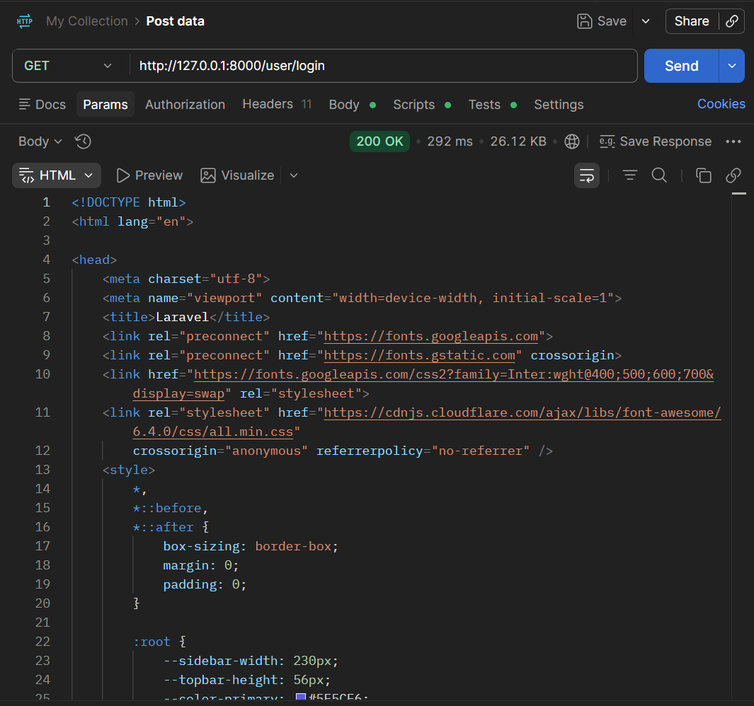
2. | User Registrasi | http://127.0.0.1:8000/user/register | 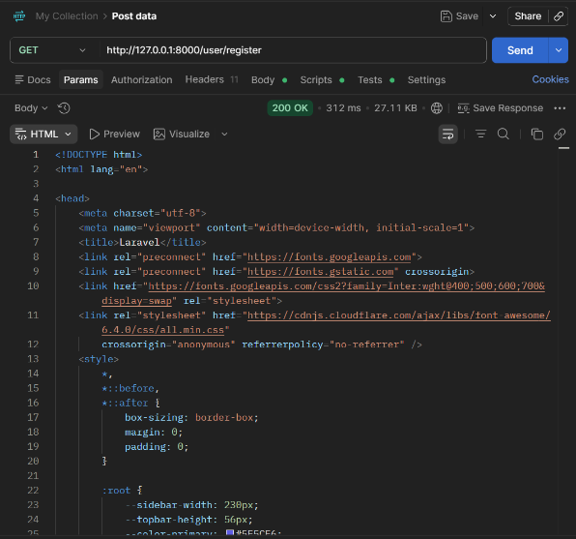
3. | User Dashboard | http://127.0.0.1:8000/user/dashboard | 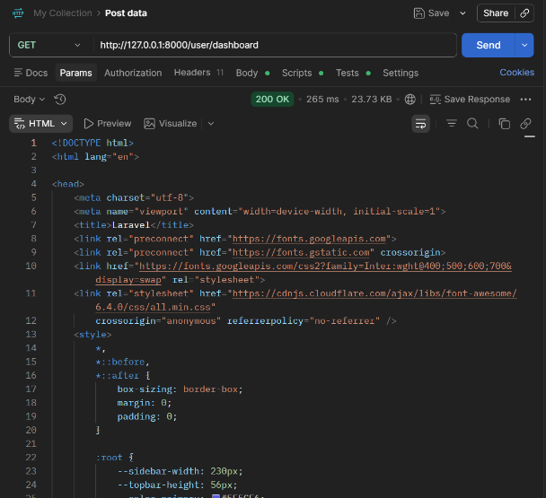
4. | Admin Login | http://127.0.0.1:8000/admin/login | 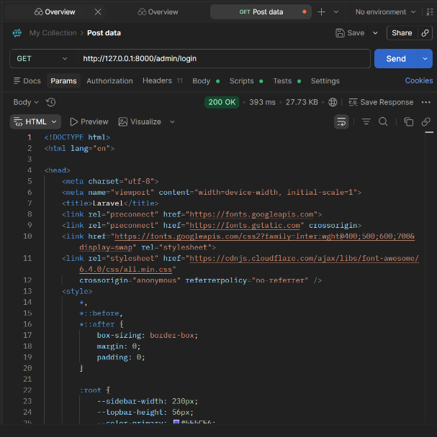
5. | Admin Dashboard | http://127.0.0.1:8000/admin/dashboard | 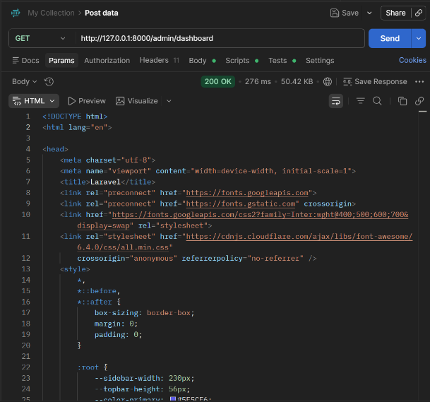
6. | Admin Pelatihan Create | http://127.0.0.1:8000/admin/pelatihan/create | 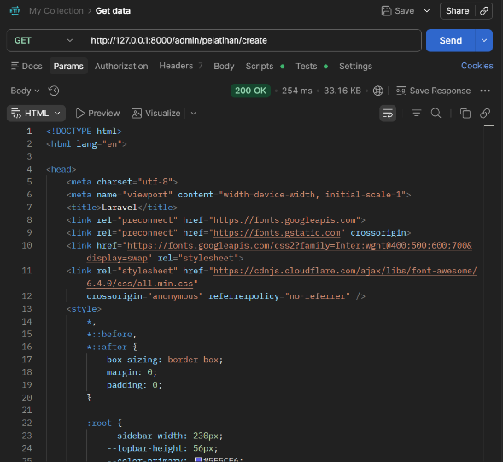
7. | Admin Mentor Create | http://127.0.0.1:8000/admin/mentor/create | 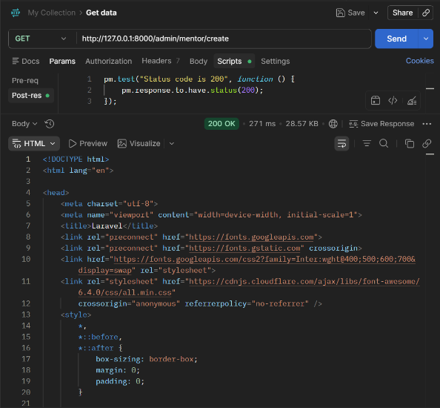
8. | Admin Peserta Create | http://127.0.0.1:8000/admin/peserta/create | 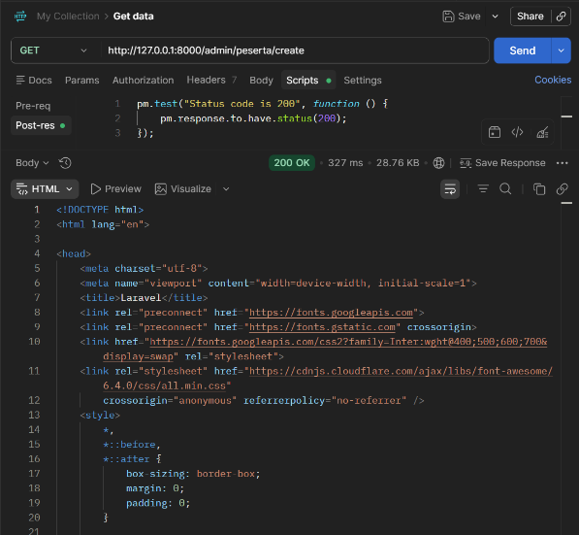
9. | Admin Pendaftaran Create | http://127.0.0.1:8000/admin/pendaftaran/create | 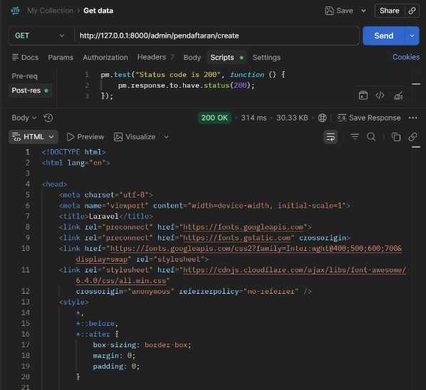
10. | Admin Edit Pelatihan | http://127.0.0.1:8000/admin/pelatihan/edit?id=12 | 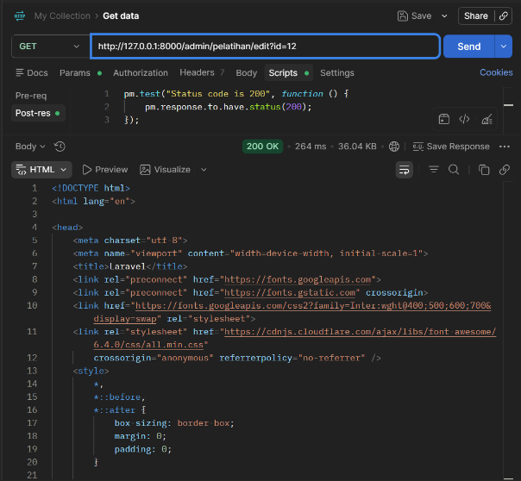
11. | Admin Edit Mentor | http://127.0.0.1:8000/admin/mentor/edit?id=10 | 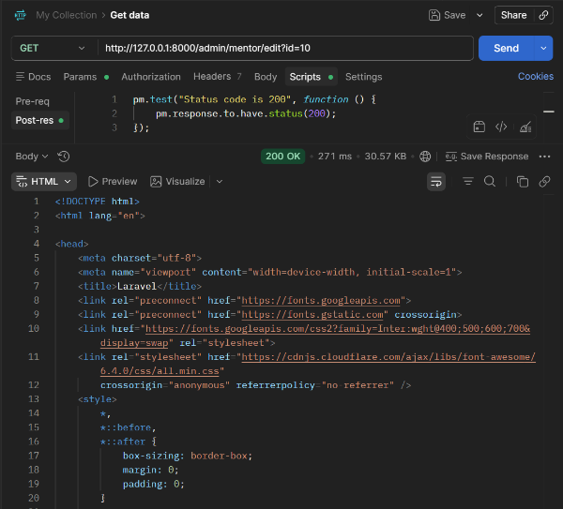
12. | Admin Edit Peserta | http://127.0.0.1:8000/admin/peserta/edit?id=1 | 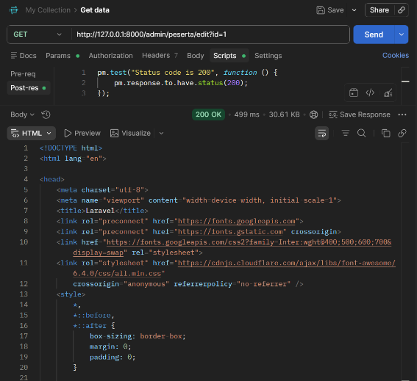
13. | Admin Peserta Riwayat | http://127.0.0.1:8000/admin/peserta/riwayat?id=1 | 