ICMP ATTACK LAB REPORT
(ICMP Flood & Smurf Attack)
Detection and Mitigation Using iptraf-ng, nload, and iptables

Technical Report / Group Assignment Documentation

Source Material: ICMP Attack Slide Deck (6_ICMP_attack.pptx)
Date: 14 December 2025
Prepared by:
Damar Ali Maulana
Muhammad Rifky Pratama
Yazid Arri Firmansyah
Class / Section:
M IT-2024 Artificial Intelligence Class 3
Subject:
ICMP Attack (Week 6) – Network Security

Executive Summary
This report documents a controlled laboratory exercise focused on ICMP-based denial-of-service (DoS) scenarios, specifically ICMP echo-request flooding (Ping Flood) and Smurf-style amplification behavior. The lab uses two Linux systems connected on the same network segment. The target (server) monitors traffic using iptraf-ng and nload, while basic firewall controls are applied with iptables. Evidence screenshots demonstrate a clear difference between baseline conditions and attack conditions, where bandwidth and packet activity increase sharply during simulated flood traffic.
Ethical & Safety Note: This report is written for authorized lab/educational use. Do not perform traffic flooding, spoofing, or packet crafting on networks you do not own or without explicit written permission

- Introduction
The Internet Control Message Protocol (ICMP) is commonly used for diagnostics (e.g., ping) and network troubleshooting. However, ICMP can also be abused to degrade availability through excessive echo-request traffic. A denial-of-service (DoS) attack attempts to disrupt normal service by overwhelming a target's resources (bandwidth, CPU, or packet queues). In ICMP flood attacks, attackers generate large volumes of ICMP echo requests so the target must spend resources processing and replying to them. In Smurf-type scenarios, ICMP requests are sent to a broadcast address using a spoofed source address, causing multiple hosts to reply and amplify traffic toward the victim.

- Objectives
- Build a working network connection between two Linux systems (server and peer/attacker).
- Observe baseline traffic behavior using iptraf-ng and nload on the server.
- Simulate abnormal ICMP traffic in a controlled lab environment (ICMP flood and Smurf-style behavior).
- Analyze the impact using monitoring evidence (bandwidth and packet activity).
- Apply defensive controls using iptables (blocking or rate limiting ICMP), then document recommendations.

- Environment and Topology
The lab topology consists of two Linux systems on the same network segment. The connection can be achieved using a local hotspot/tethering network or a standard LAN. In many VirtualBox setups, a bridged adapter is used so the VM appears as a normal device on the shared network. Evidence screenshots in this project indicate the server IP is 10.35.226.27 and the peer/attacker IP is 10.35.226.188, with monitoring performed on interface enp0s3.

Figure 1 illustrates the logical topology used in the experiment.
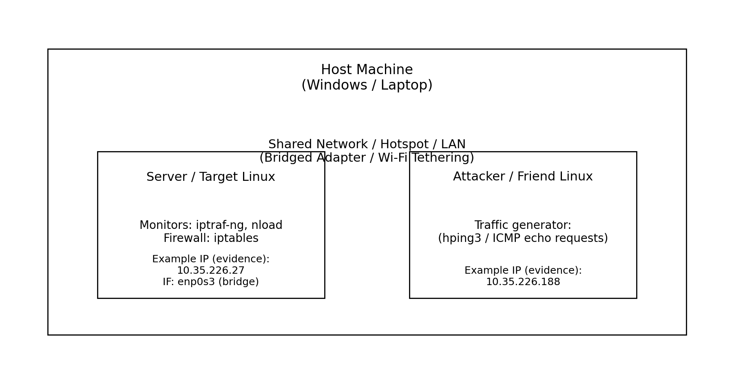
Figure 1. Logical topology for ICMP attack simulation (shared network via bridge/hotspot).

- Tools and Technologies
The following tools are used in the lab. Monitoring tools run on the server/target, while a traffic generation tool is used on the peer/attacker side. Defensive controls are applied on the server.
Tool | Purpose | Where Used
iptraf-ng | Console-based traffic monitoring (flows, packets) | Server/Target
nload | Bandwidth usage monitoring (in/out graphs) | Server/Target
iptables | Host firewall / packet filtering and rate control | Server/Target
hping3 (or equivalent) | Custom ICMP/UDP/TCP packet generation for testing | Peer/Attacker (lab only)
- Setup and Validation
  - Network Validation (Ping)
Before running any simulations, confirm that both hosts can reach each other. Figures 2 and 3 show example ping results, indicating connectivity with 0% packet loss.
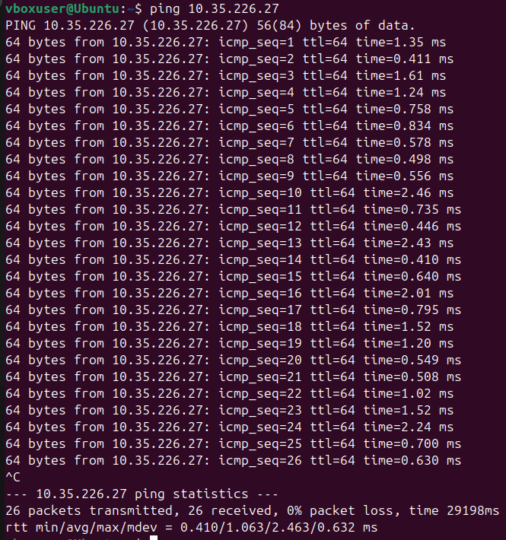
Figure 2. Peer/attacker pinging the server (evidence screenshot).
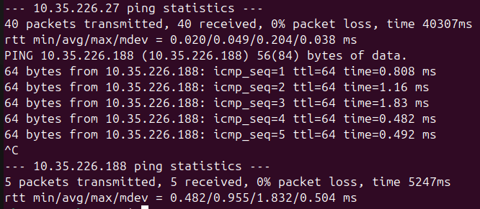
Figure 3. Server ping statistics and peer reachability (evidence screenshot).

5.2 Monitoring Baseline (iptraf-ng and nload)
Baseline measurements are collected on the server to capture normal traffic behavior. iptraf-ng displays active flows and protocol activity, while nload summarizes bandwidth in real-time for the selected interface.

Figure 4 shows a baseline iptraf-ng view with a low 'Packets captured' count.
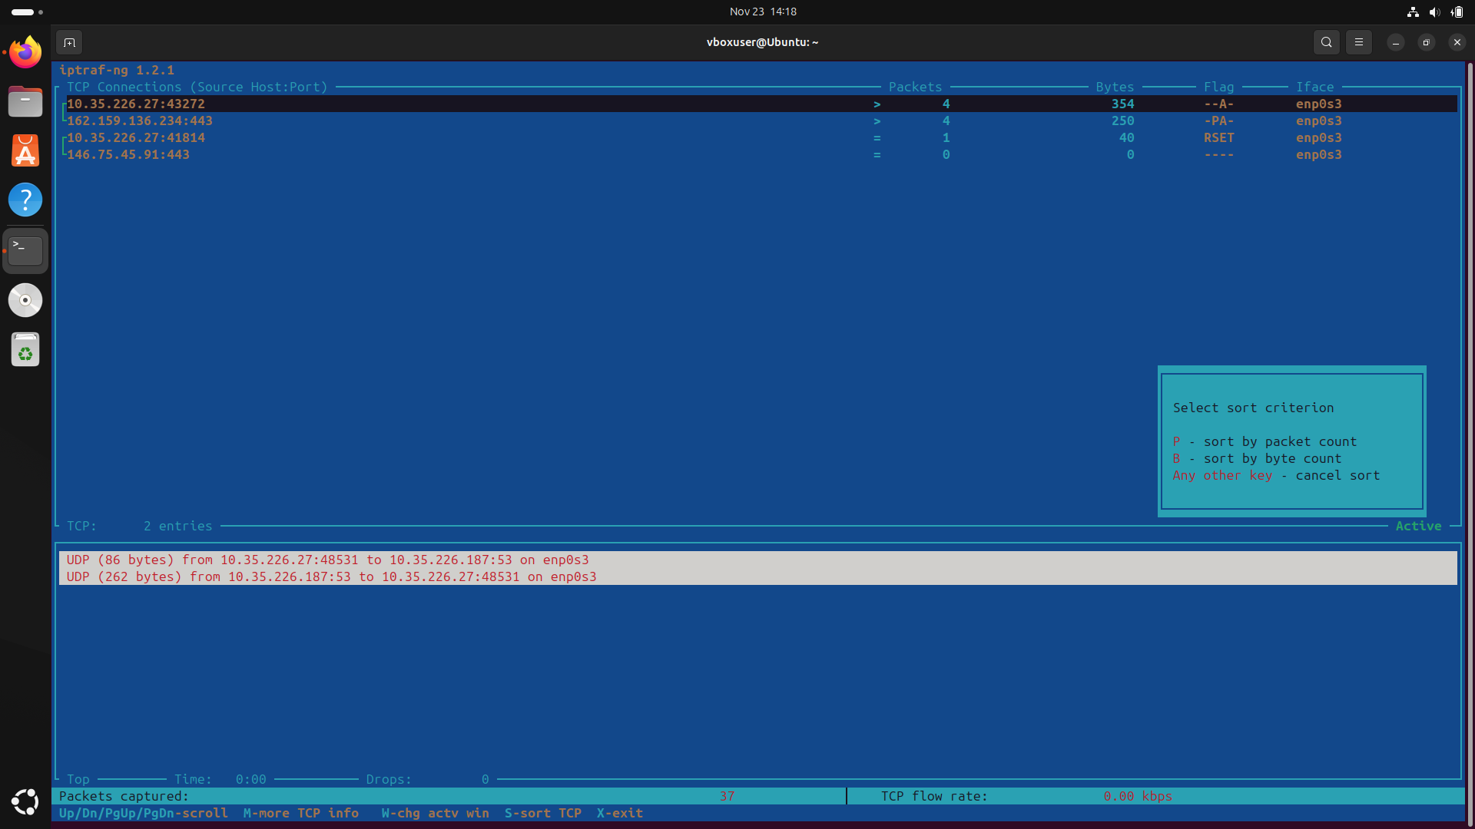
Figure 4. Baseline iptraf-ng view on the server (evidence screenshot).
Figure 5 shows baseline nload bandwidth on interface enp0s3 for the server (10.35.226.27).
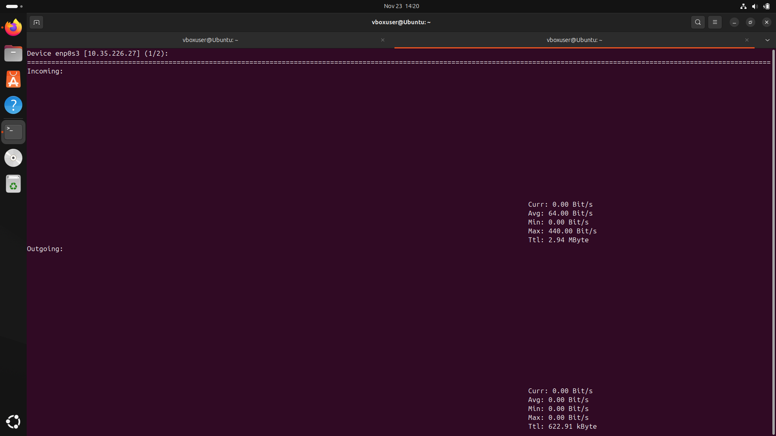
Figure 5. Baseline bandwidth in nload (evidence screenshot).
Figure 6 shows an iptraf-ng view during normal ICMP ping activity (not a flood), where ICMP echo requests and replies are visible between 10.35.226.27 and 10.35.226.188 on interface enp0s3.
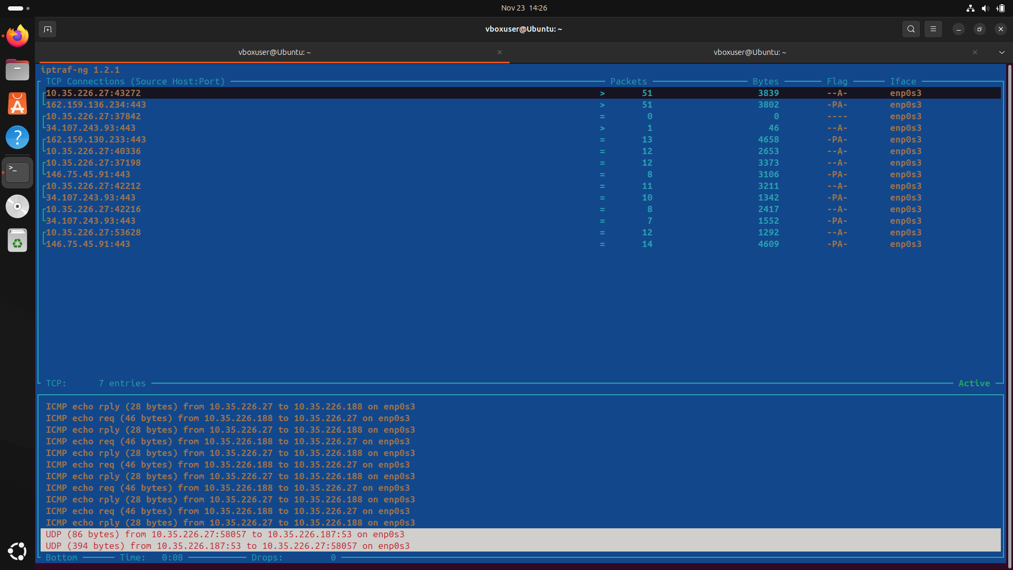
Figure 6. Normal (non-flood) ICMP activity visible in iptraf-ng (evidence screenshot).

- Attack Simulation (Lab Demonstration)
Two ICMP-based scenarios are demonstrated in the lab
- ICMP Flood (Ping Flood): sustained high-rate ICMP echo requests toward the server.
- Smurf-style behavior: ICMP echo requests involving broadcast addressing and spoofed sources (amplification concept).
This report focuses on detection indicators (traffic volume, packet activity) and mitigation (iptables controls).

6.1 ICMP Flood Evidence
Figures 7 and 8 provide evidence during the ICMP flood condition. iptraf-ng shows repeated ICMP echo request/reply lines, while nload shows a sharp increase in bandwidth usage.
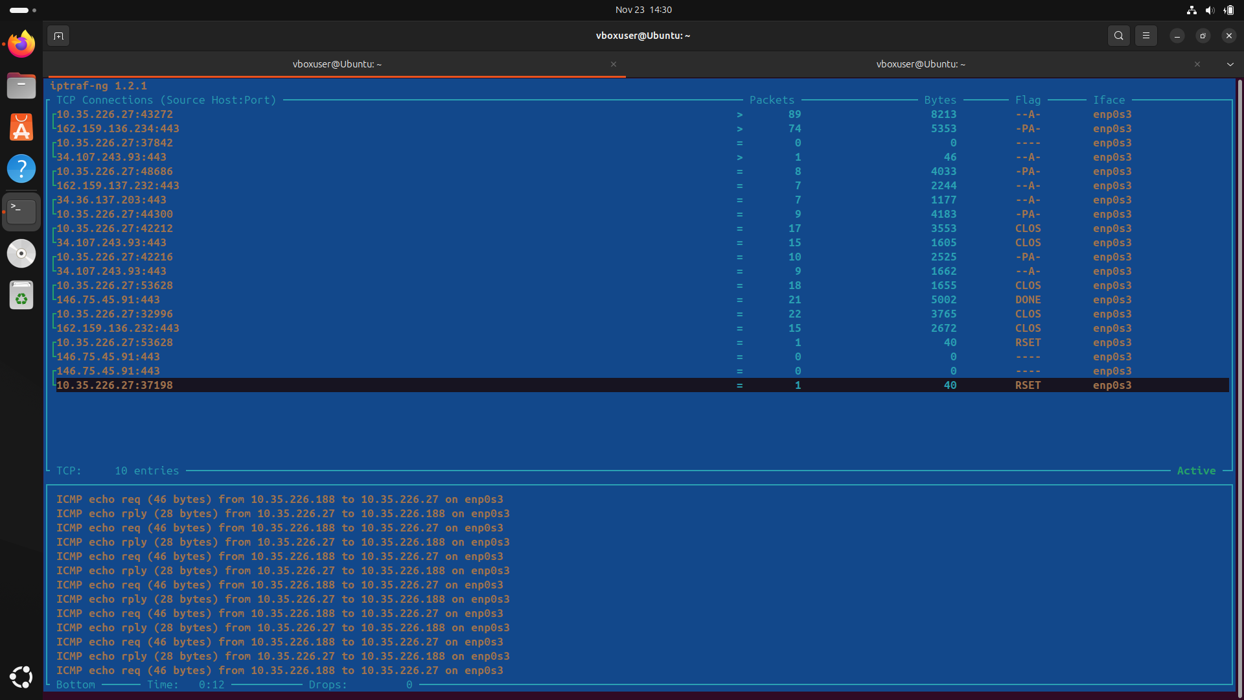
Figure 7. iptraf-ng view during ICMP flood condition (evidence screenshot).
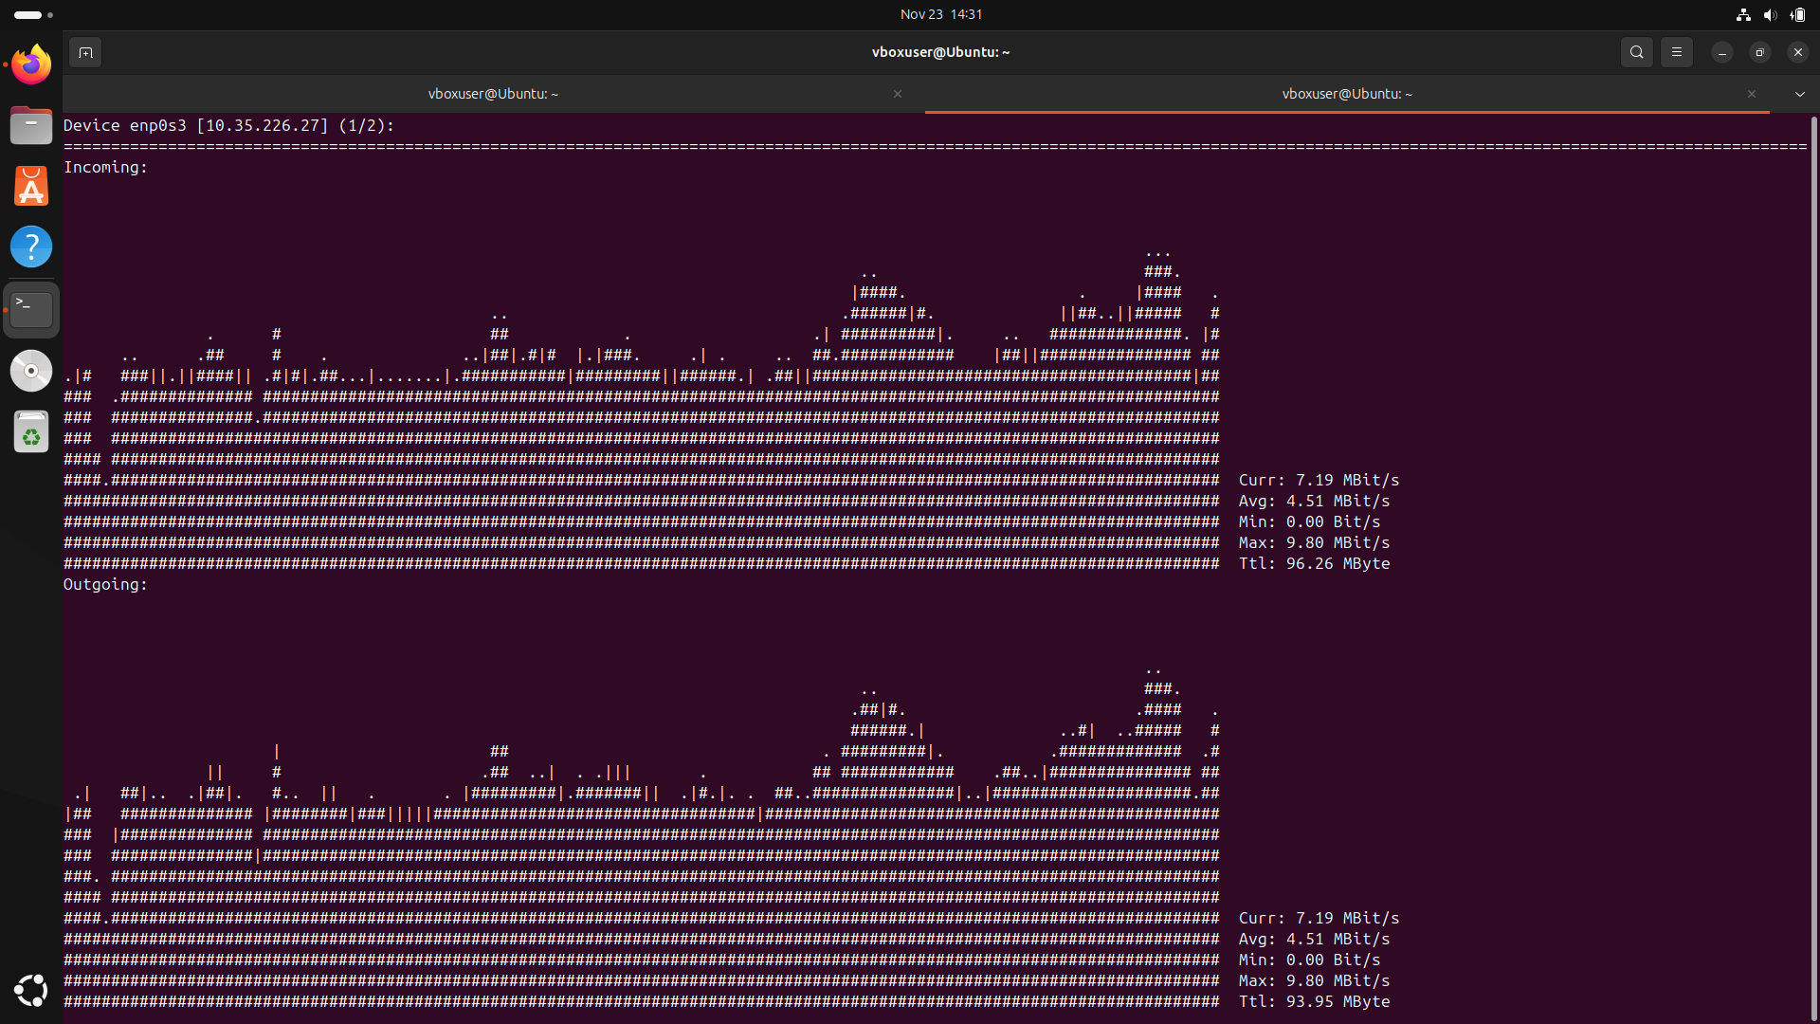
Figure 8. nload bandwidth spike during ICMP flood condition (evidence screenshot).

6.2 Smurf-Style Evidence
Figure 9 shows the bandwidth behavior during the Smurf-style demonstration. The key characteristic of Smurf is traffic amplification: multiple devices may reply to ICMP broadcast requests, which can increase the volume seen by the victim.
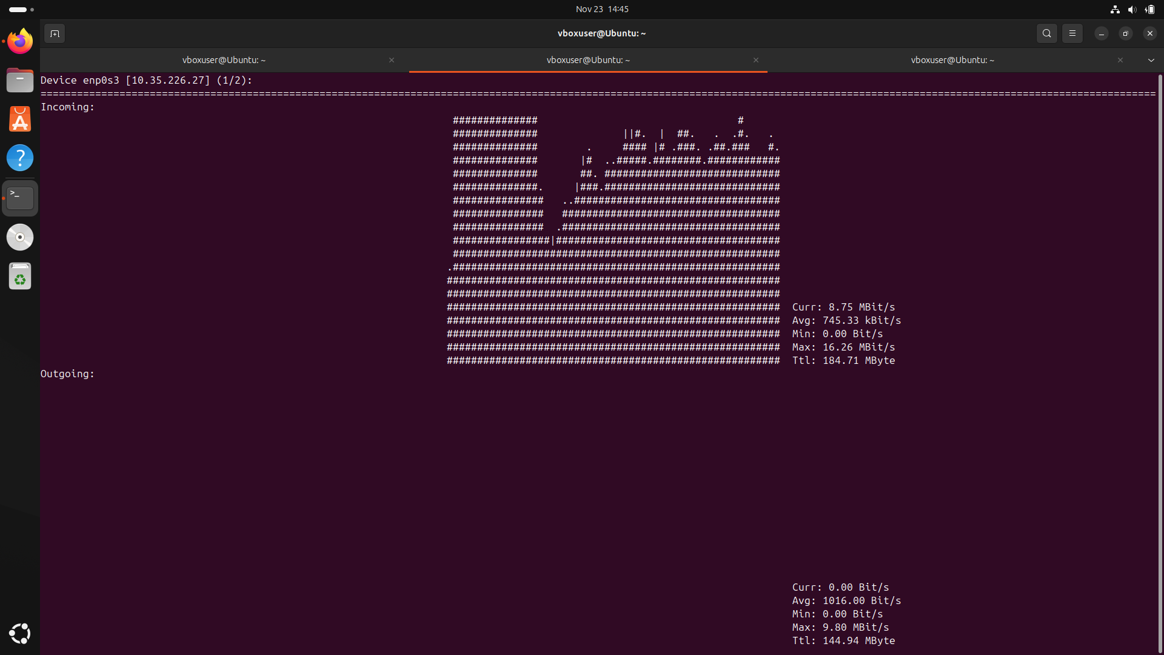
Figure 9. nload bandwidth during Smurf-style demonstration (evidence screenshot).

- Results and Analysis
The evidence indicates a substantial difference between baseline and attack conditions. Under baseline, traffic is near idle. Under ICMP flood and Smurf-style conditions, the bandwidth rises to multiple megabits per second and the total data transferred increases significantly.

  - Quantitative Comparison (nload)
Table 1 summarizes key bandwidth indicators observed in nload screenshots (Figures 5, 8, and 9). Values are taken as displayed at the time of each screenshot.
Condition | Evidence | Current | Max | Total (Incoming)
Baseline | Figure 5 | 0.00 Bit/s | 440.00 Bit/s | 2.94 MByte
ICMP Flood | Figure 8 | 7.19 MBit/s | 9.80 MBit/s | 96.26 MByte
Smurf-style | Figure 9 | 8.75 MBit/s | 16.26 MBit/s | 184.71 MByte

  - Detection Indicators
Common indicators of ICMP-based DoS attempts include:
Bandwidth spikes and sustained high-rate incoming/outgoing traffic on the server interface.
High frequency of ICMP echo requests and replies visible in iptraf-ng.
Reduced responsiveness of the server (higher latency, packet drops, CPU/network queue saturation) during sustained traffic.

- Mitigation and Controls (iptables)
In Linux, iptables can be used to filter or rate-limit ICMP echo requests. Defensive controls are commonly implemented in the INPUT chain (traffic destined for the server). The approach can be either strict blocking (DROP) or controlled allowance (rate limiting).

  - Block ICMP From a Known Malicious Source
If a specific attacker IP is identified, ICMP from that source can be blocked. Replace <attacker_ip> and <interface> with the correct values for the lab environment.
sudo iptables -A INPUT -p icmp -i <interface> -s <attacker_ip> -j DROP

  - Rate-Limit ICMP Echo Requests
Rate limiting can reduce the impact of floods while still allowing limited diagnostic pings. The following example shows a common pattern: allow echo-request at a controlled rate (e.g., 1 per second) and drop excess traffic.
sudo iptables -A INPUT -p icmp --icmp-type echo-request -m limit --limit 1/second -j ACCEPT
sudo iptables -A INPUT -p icmp --icmp-type echo-request -j DROP
  - Smurf Mitigation Considerations
Smurf attacks rely on broadcast amplification. In addition to host firewall rules, recommended mitigations include:
• Disable ICMP responses to broadcast addresses and prevent directed broadcast forwarding on routers.
• Block ICMP echo requests sent to broadcast addresses at network boundaries.
• Use network segmentation and avoid unnecessary broadcast exposure.

- Discussion and Limitations
This lab uses a simplified network environment (shared hotspot/LAN and/or bridged adapter). In real enterprise networks, switch and router configurations, IDS/IPS systems, and rate-limiting policies are typically applied at multiple layers. Additionally, high traffic can be caused by legitimate activity (updates, streaming, backups), so detection should correlate bandwidth spikes with protocol-level evidence (e.g., ICMP flood patterns) and logs.
- Conclusion
The ICMP flood and Smurf-style demonstrations show that availability can be degraded through excessive ICMP traffic. Monitoring tools (iptraf-ng and nload) provide clear visibility into abnormal behavior, while iptables offers practical host-level controls for blocking or rate limiting ICMP. Combining monitoring with layered defenses (host and network) is recommended for effective mitigation.

- Group Assignment Notes and Answers
The slide deck includes a group assignment checklist. This report covers the required evidence screenshots and provides defensive controls for ICMP flood and Smurf-style traffic.
Suggested division of work (max 3 students):
Member 1 – Network/VM setup and connectivity validation (gateway check, ping evidence).
Member 2 – Baseline monitoring (iptraf-ng and nload), collect screenshots.
Member 3 – Attack impact analysis (compare baseline vs attack evidence).

Answer: Control/command to handle Smurf attack (defensive).
Use network controls to block directed broadcasts and prevent ICMP to broadcast addresses, and apply host firewall rules to limit or drop suspicious ICMP echo requests. In Linux iptables, ICMP echo-request rate limiting is a practical host-level control.
Answer: Request ping with ~1000-byte payload (lab/diagnostic use).
Use a diagnostic ping with a specified payload size. On Linux 'ping', a common option is to set the payload size; for packet crafting tools, use the tool’s payload/data-size option to approximate a 1000-byte echo request. Always test only in an authorized environment.

- Cleanup (Optional)
Remove tools after completing the lab (optional):
sudo apt remove iptraf-ng nload hping3 iptables-persistent -y # packages may vary by distro
sudo apt autoremove -y
sudo apt clean

Appendix A – Command Reference (Monitoring & Defense)
Install monitoring tools (server):
sudo apt update
sudo apt install iptraf-ng nload -y
Run monitoring:
sudo iptraf-ng
nload -a 300 # averages over 300 seconds
Defensive iptables examples:
sudo iptables -A INPUT -p icmp -i <interface> -s <attacker_ip> -j DROP
sudo iptables -A INPUT -p icmp --icmp-type echo-request -m limit --limit 1/second -j ACCEPT
sudo iptables -A INPUT -p icmp --icmp-type echo-request -j DROP

Appendix B – Evidence Index
- Figure 2 – Peer/attacker pinging the server
- Figure 3 – Server ping statistics
- Figure 4 – Baseline iptraf-ng
- Figure 5 – Baseline nload
- Figure 6 – iptraf-ng showing normal ICMP ping (non-flood)
- Figure 7 – iptraf-ng during ICMP flood condition
- Figure 8 – nload during ICMP flood condition
- Figure 9 – nload during Smurf-style demonstration

Appendix C – Source Material
Slide deck: ICMP attack (file: 6_ICMP_attack.pptx)
hping3 manual reference (as listed in the slide deck):
https://linux.die.net/man/8/hping3

