NETWORK SNIFFING DETECTION
USING IPTraf-ng
(2‑VM Setup on VirtualBox)

Technical Report / Lab Documentation

GitHub Repository: https://github.com/rifxonly-tech/SniffDetection
Date: 14 December 2025
Prepared by:
Damar Ali Maulana
Muhammad Rifky Pratama
Yazid Arri Elvansyah
Class:
M IT-2024 Artificial Intelligence
Subject:
Group Assignment (Week 4) – Network Security

Executive Summary
This report documents a controlled laboratory experiment that demonstrates how packet sniffing activity can produce observable traffic anomalies and how these anomalies can be identified with iptraf-ng. The environment uses two Ubuntu virtual machines connected via VirtualBox Internal Network (intnet): a Client/Target VM for monitoring and an Attacker VM for sniffing simulation. Baseline traffic is observed first, followed by a sniffing simulation using tcpdump.
Based on included evidence screenshots, iptraf-ng on the Client VM shows a marked increase in observed packet activity after the sniffing simulation begins. For example, the 'Packets captured' counter rises from 43 (baseline) to 741 (post-attack) at the time the screenshots were captured, which is an increase of 698 packets (≈17.2×). Such changes are treated as indicators requiring further investigation.
Ethical & Safety Note: All procedures are intended strictly for authorized educational/lab environments. Do not use sniffing or spoofing tools on networks you do not own or without explicit written permission.

- Introduction
Network sniffing is the capture and inspection of packets traversing a network interface. Sniffing is widely used for legitimate troubleshooting, performance analysis, and incident response; however, it can also be misused to intercept data when performed without authorization. Although switched networks reduce passive sniffing, attackers may still attempt interception through misconfiguration, ARP-based manipulation, or by monitoring broadcast traffic. Therefore, visibility tools that highlight abnormal traffic patterns are valuable during detection and investigation.
This project uses iptraf-ng to monitor traffic and illustrate how a sniffing scenario can be associated with abnormal changes in observed packet behavior.

- Objectives
- Create a two-VM internal network topology using VirtualBox.
- Configure static IP addressing using Netplan on the internal interface(s).
- Establish a baseline view of traffic using iptraf-ng on the Client VM.
- Simulate sniffing activity using tcpdump on the Attacker VM.
- Compare baseline and post-simulation observations and document findings, limitations, and recommendations.

- Environment and Topology
The experiment runs on a Windows host with VirtualBox. Two Ubuntu VMs are attached to a VirtualBox Internal Network named 'intnet'. Internal Network mode isolates the lab from external traffic and confines communication to participating VMs, making it suitable for controlled security demonstrations.

Figure 1 illustrates the logical topology used.
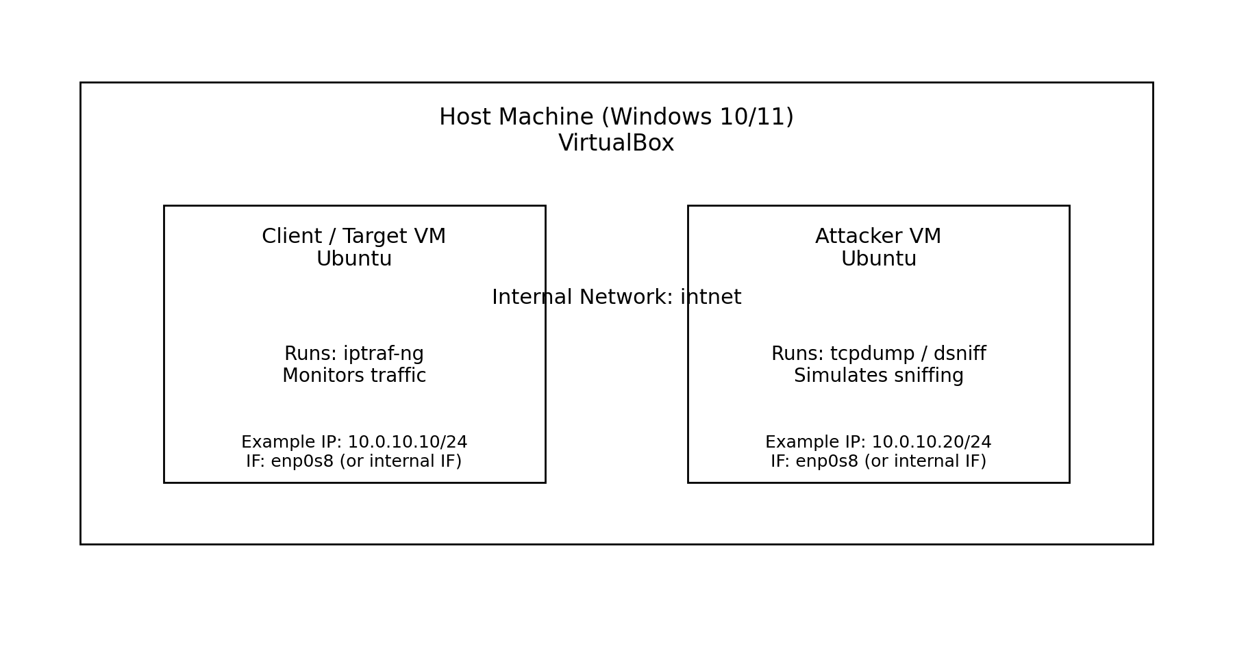
Figure 1. Logical topology for the 2‑VM sniffing detection experiment (VirtualBox Internal Network).

Virtual Machines and Roles
Component | Operating System | Role in Experiment | Key Software
Client / Target VM | Ubuntu 20.04/22.04 | Monitors and records traffic | iptraf-ng
Attacker VM | Ubuntu 20.04/22.04 | Runs controlled sniffing simulation | tcpdump, (optional) dsniff/arpspoof
- System Requirements
- Host OS: Windows 10/11
- VirtualBox installed
- Ubuntu ISO image (20.04 or 22.04)
- Minimum recommended resources: 2 GB RAM per VM (more recommended for smoother performance)

- Setup and Configuration
  - VirtualBox Configuration
- Create the first Ubuntu VM and complete the installation.
- Clone the VM (Full Clone) to create the second VM.
- For both VMs: Settings → Network → Adapter 1 → Attached to: Internal Network → Name: intnet.
  - Static IP Addressing with Netplan
- Static IPs provide consistent connectivity and simplify troubleshooting. The assignment recommends using a single internal interface (commonly enp0s8). If your VM uses a different name (e.g., enp0s3), apply the configuration to the correct internal interface.

Client/Target VM
sudo nano /etc/netplan/01-netcfg.yaml
network:
version: 2
renderer: networkd
ethernets:
enp0s8:
addresses:
- 10.0.10.10/24
sudo netplan apply
Attacker VM
sudo nano /etc/netplan/01-netcfg.yaml
network:
version: 2
renderer: networkd
ethernets:
enp0s8:
addresses:
- 10.0.10.20/24
sudo netplan apply
Figures 2 and 3 show example Netplan screenshots included with the project assets, demonstrating a multi-interface configuration. Multi-interface configurations are acceptable as long as the internal network adapter is correctly configured and both VMs share the same subnet for the experiment.
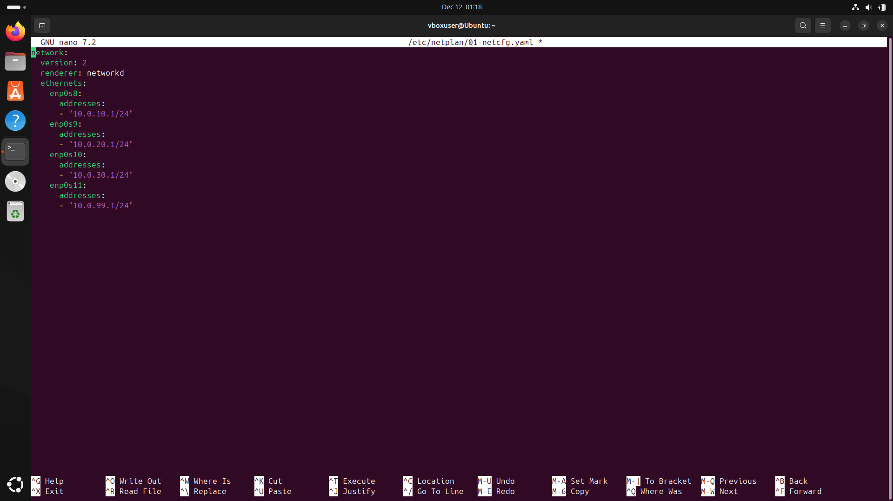
Figure 2. Client VM Netplan configuration (evidence screenshot).
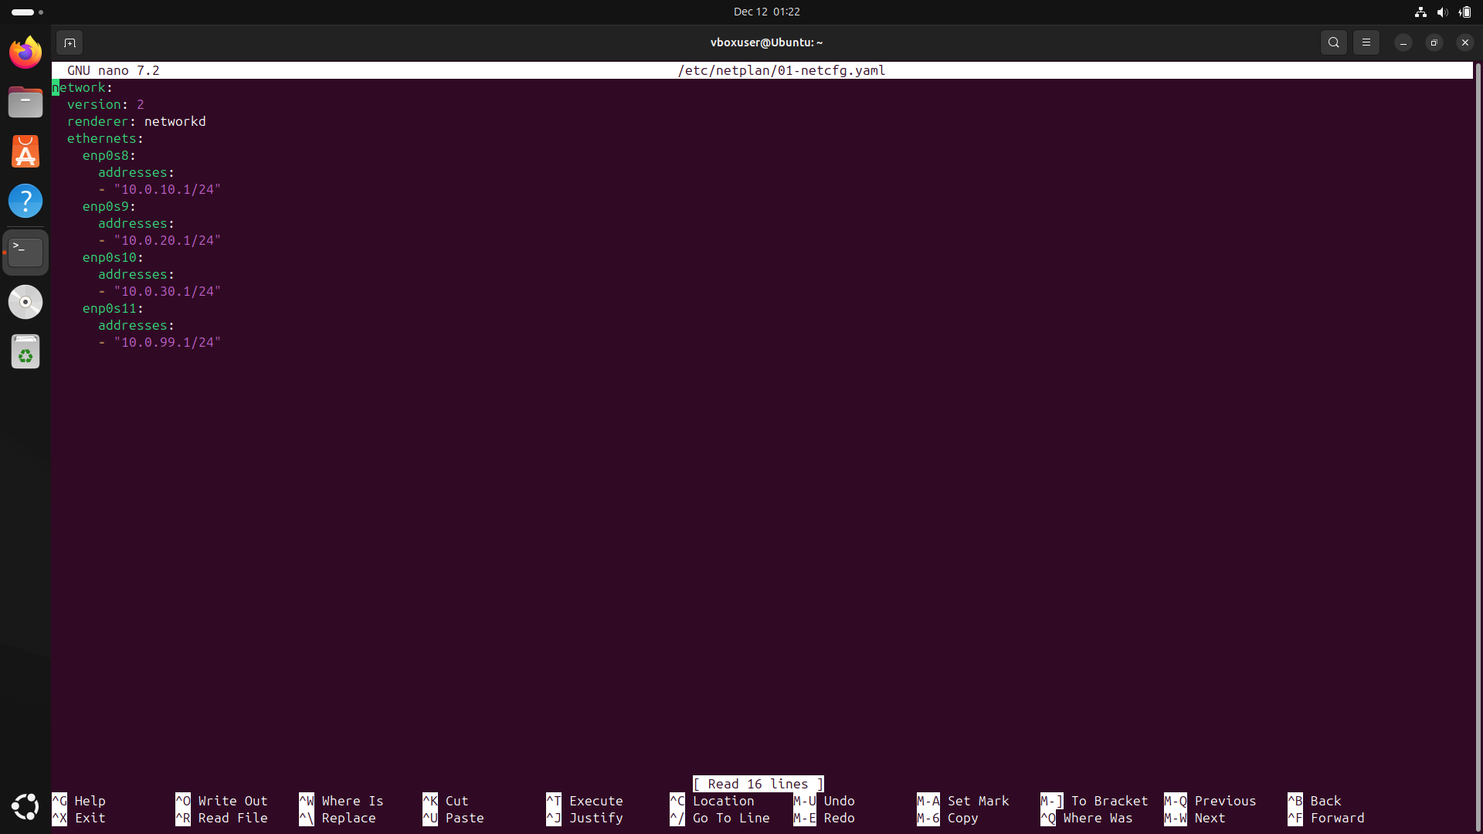
Figure 3. Attacker VM Netplan configuration (evidence screenshot).

  - Connectivity Validation
Validate connectivity between the VMs with ping. A successful ping indicates that both VMs can communicate over the internal network.
ping <peer-vm-ip-address>
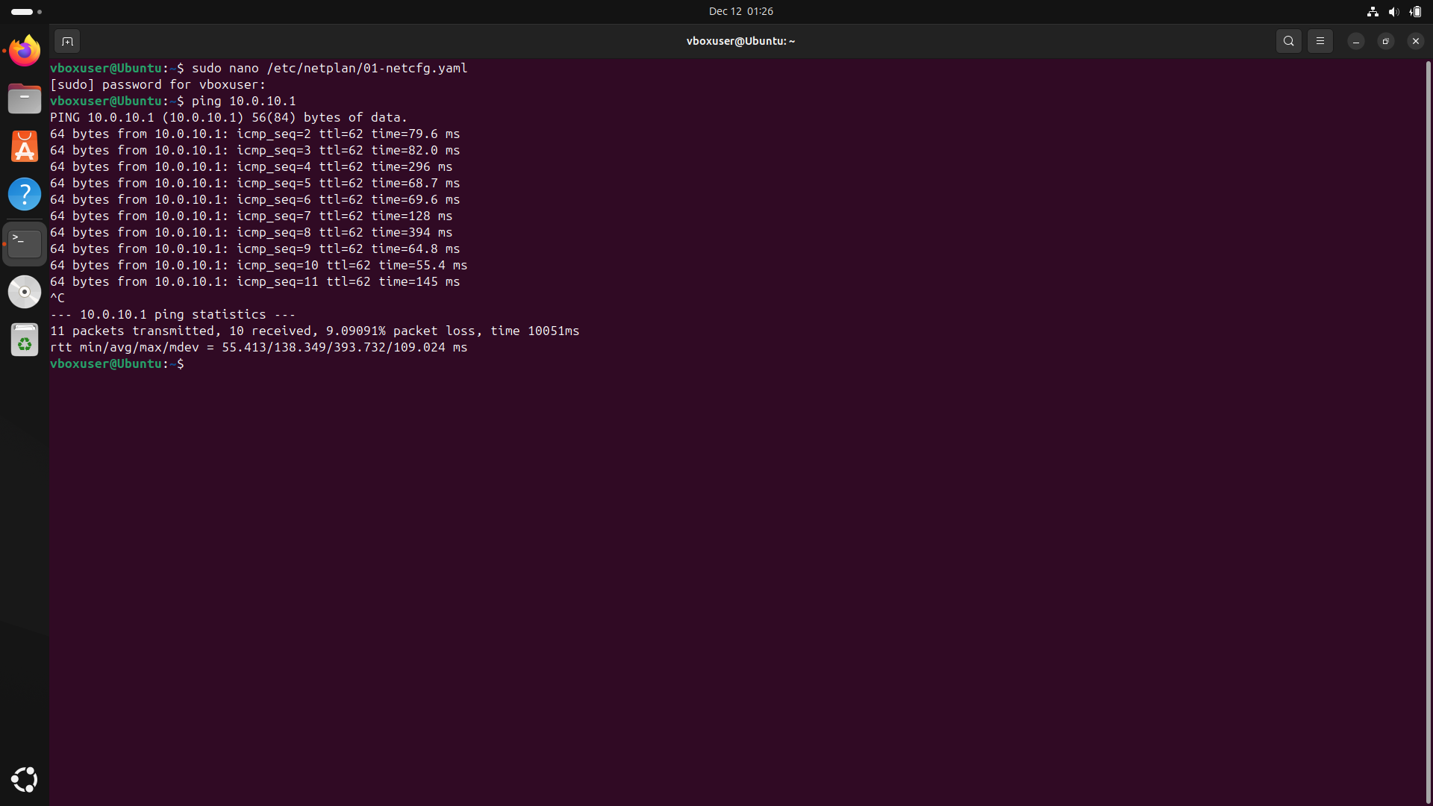
Figure 4. Ping test output (evidence screenshot).

- Tools and Installation
  - iptraf-ng (Client/Target VM)
Install and run iptraf-ng:
sudo apt update
sudo apt install iptraf-ng -y
sudo iptraf-ng
Recommended view: 'IP traffic monitor' or 'TCP/UDP statistics' to examine active flows and packet counts.
  - tcpdump and Optional Tools (Attacker VM)
Install tcpdump (required) and optionally dsniff:
sudo apt update
sudo apt install tcpdump -y
sudo apt install dsniff -y # optional
7. Methodology
7.1 Baseline Monitoring
Start iptraf-ng on the Client VM. 2) Observe the baseline conditions before any
simulation begins. Baseline conditions commonly show fewer active connection
and lower packet capture counts.
Figure 5 shows the baseline state captured during the lab.
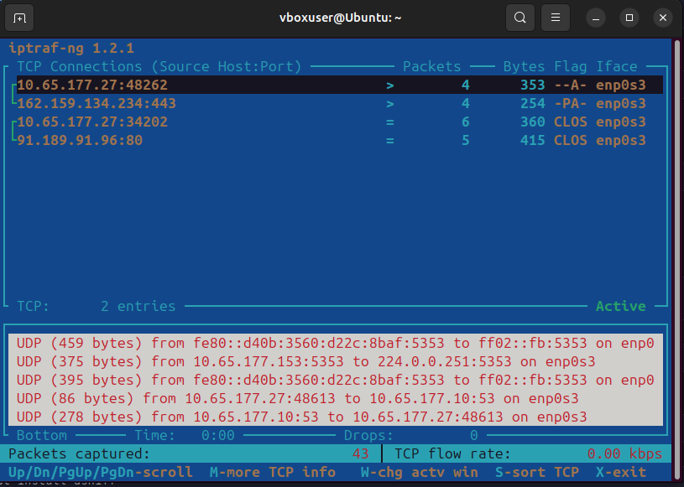
Figure 5. Baseline traffic view in iptraf-ng on the Client VM (evidence screenshot).
7.2 Sniffing Simulation (tcpdump)
Start tcpdump on the Attacker VM using the internal interface. This simulates an
attacker attempting to capture packets. Use the interface that corresponds to the
VirtualBox Internal Network.
sudo tcpdump -i <internal-interface>
Important: The README draft originally referenced enp0s3 in one command
snippet; in the simplified setup the internal interface is typically enp0s8. Always
verify the correct interface name with 'ip a'.
ip a # identify the internal interface name

7.3 Post-Simulation Monitoring
Return to the Client VM and observe iptraf-ng again while tcpdump is running.
Capture evidence for comparison.
Figure 6 shows increased activity after the simulation. In the evidence provided, the 'Packets captured' counter increases from 43 (baseline) to 741 (post-simulation) at the time of capture, which is an increase of 698 packets (≈17.2×).
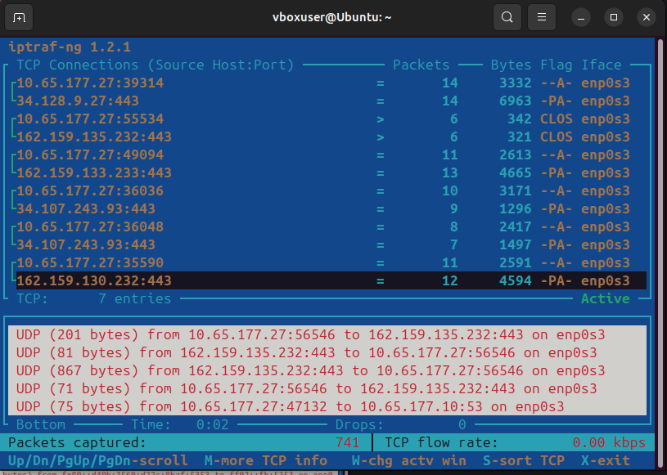
Figure 6. iptraf-ng view after sniffing simulation begins (evidence screenshot).
- Results and Analysis
The comparison between baseline and post-simulation evidence indicates a clear increase in observed packet activity. While sniffing can be passive, in practice the lab environment may show increased packet processing, additional visible flows, and changes in traffic composition.

8.1 Observation Summary
Condition | Evidence | Observed Indicator | Notes
Baseline | Figure 5 | Packets captured: 43 | Lower activity at time of baseline screenshot.
Post-Simulation | Figure 6 | Packets captured: 741 (Δ=698, ≈17.2×) | Higher activity after sniffing simulation began.
8.2 Interpretation
A higher packet capture count alone does not confirm sniffing, but it is an anomaly that should be correlated with other indicators such as abnormal ARP/broadcast patterns, new/unexpected connections, and process activity on endpoints. In operational settings, such observations should trigger deeper investigation with logs and packet captures on the affected segments.

- Discussion
  - Why iptraf-ng Helps During Detection
iptraf-ng is primarily a visibility tool. It supports detection workflows by making suspicious patterns easier to notice, including:
- Sudden increases in packet counts or connection entries.
- Unusual bursts of broadcast or ARP frames (common in reconnaissance and ARP-based manipulation).
- Unexpected endpoints or protocols appearing in active-flow views.
  - Limitations
- iptraf-ng does not directly identify a remote interface operating in promiscuous mode. Legitimate traffic (updates, service discovery, web browsing) can also increase packet counts. Therefore, iptraf-ng should be used with other controls such as switch security features, host-based monitoring, and intrusion detection systems.

- Recommendations
Recommended defensive practices to reduce sniffing risks include:
- Use encryption (HTTPS/TLS, SSH) to protect data confidentiality even if packets are captured.
- Limit broadcast domains using VLANs and proper network segmentation.
- On managed switches: enable DHCP snooping and Dynamic ARP Inspection where available.
Monitor ARP tables and watch for frequent changes or duplicate IP/MAC mappings.
- Maintain a baseline of expected traffic, then investigate deviations using packet captures an logs

- Group Task Division (3 Members)
A suggested division of work for group submission:
- Member 1 – VM Handler
  - Create/clone VMs, configure internal networking, apply IP settings, install tools, capture evidence screenshots.
- Member 2 – Analyst
  - Compare baseline vs. post-simulation results, interpret anomalies, and explain the security relevance.
- Member 3 – Report Writer
  - Consolidate documentation, refine formatting, produce conclusions, and prepare final submission.

- Cleanup
To remove installed tools after completing the lab:
sudo apt remove iptraf-ng tcpdump dsniff -y
sudo apt autoremove -y
sudo apt clean

Appendix A – Command Reference
A.1 Tool Installation
sudo apt update
sudo apt install iptraf-ng -y
sudo apt install tcpdump -y
sudo apt install dsniff -y # optional
A.2 Run Commands
sudo iptraf-ng
sudo tcpdump -i <internal-interface>
A.3 Netplan Apply
sudo netplan apply

Appendix B – Evidence Index
Embedded evidence used in this report:
- Figure 1 – Topology diagram (generated)
- Figure 2 – Client VM Netplan configuration (screenshot)
- Figure 3 – Attacker VM Netplan configuration (screenshot)
- Figure 4 – Ping test output (screenshot)
- Figure 5 – Baseline iptraf-ng view (screenshot)
- Figure 6 – Post-simulation iptraf-ng view (screenshot)
Appendix C – Repository Link
- GitHub repository used for this project:
https://github.com/rifxonly-tech/SniffDetection

References
- iptraf-ng (man page / distribution package documentation).
- tcpdump (man page).
- Netplan documentation (Ubuntu).
- VirtualBox documentation (Oracle).

