## MODULE SERVER

### CONTENTS

**This module has the following files:**

* MODULE_SERVER.doc
* MODULE_SERVER_MEDIA.zip

### INTRODUCTION

PT. XYZ decided to create simple anonymous voting system called **YukPilih**. This system will be used for asking some company decisions to their employees. Your task is to implement the backend with Laravel PHP Framework. The detail description and tools that you can use will be described below.

### DESCRIPTION OF PROJECT AND TASKS

The complete **YukPilih** system should cover the following requirement:

|  |  |
| --- | --- |
| **Menu** | **Detail** |
| Login | * The system’s role can be an Admin or a User * The user (admin or user) can login (and logout) into the system on the start page of the application * After login, if admin or user still using default password, frontend will be redirected to change password page. Else, redirect to poll page. * After login, admin will have menu (Management Poll, Management Users, Management Division, Suggest Poll, Logout) * After login, user will have menu (All poll, My Poll, Update Data, Suggest Poll, Logout) |
| Change Password | * After login, if admin or user still using default password, frontend will be redirected to change password page * On this page, user will be asked to input old password, new password, and confirm new password. Validate new password and confirm new password must be match before hitting reset_password backend endpoint. * After success resetting password, redirect to login page. |
| Poll | * Username and logout button will be displayed on the menu. Admin or user can use the button for logging out. * Admin will have menu Management Poll to view, add, update and delete poll * Admin cannot do vote. Admin always seeing the poll results. * Admin can delete polls. * User can do vote only once per poll. * User only seeing poll results only if the poll already deadline or user already voted for that poll. * Polls sorted by created_at descending. * Poll results will be shown as percentage with following formula: * Choice’s percentage = choice’s point / [total of all points] x 100% |
| Create Poll | * If admin click the add new poll button, this page will be shown. * Admin asked to fill title (string), description (string, can be multiline), deadline (use date time picker, default value is current time, division (can one division or all division)), and choices. * There is a cancel button to close this dialog without creating poll. |
| Register User | * User can registration with following data : (Name, Username, Division) * Password will be default to 12345 |
| Management Division | * Admin can view, add, edit and delete division * If division has user, admin cannot delete division |
| Management User | * Admin can view, add, edit and delete user |
| Suggest Poll | * User can suggest poll to admin * Admin can see suggest poll |

**YukPilih Point Calculation Simulation**

**Simulation 1:**

This poll having 2 choices (WFO or WFH).

* Two users from payment division already vote. All of them choosing WFO. WFO win on this division, one point for WFO.
* One user from procurement division choosing WFO. WFO win on this division, one point for WFO.
* Six users from IT division already vote. 1 choosing WFO, 5 choosing WFH. WFH win on this division, one point for WFH.
* Three users from finance division already vote. All of them choosing WFH. WFH win on this division, one point for WFH.

Result: WFO 2 points. WFH 2 points. 50% percentage for each option will be displayed on the frontend.

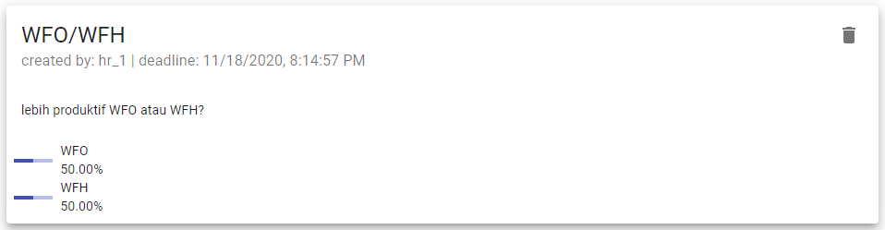

**Simulation 2:**

This poll having 3 choices (‘senin’, ‘rabu’, or ‘jumat’).

* All users from payment division already vote. All of them choosing ‘rabu. ‘rabu’ win on this division, one point for ‘rabu’.
* Three users from procurement division voted. 1 choosing ‘senin’, 1 choosing ‘rabu’, 1 choosing ‘jumat’. We have 3 winners on this division. 1/3 point will be given for each option.
* Five users from IT division voted. 2 choosing ‘senin’, 2 choosing ‘rabu’, 1 choosing ‘jumat’. We have 2 winners on this division. 1/2 point will be given for ‘senin’ and ‘rabu’.
* No user from finance division voted. No point given from this division yet.

Result: ‘senin’ 0.8333 points. ‘rabu’ 1.8333 points. ‘jumat’ 0.3333 points.

Percentage calculation:

‘senin’ = 0.8333 / (0.8333 + 1.8333 + 0.3333) * 100% = 27.78%

‘rabu’ = 1.8333 / (0.8333 + 1.8333 + 0.3333) * 100% = 61.11%

‘jumat’ = 0.3333 / (0.8333 + 1.8333 + 0.3333) * 100% = 11.11%

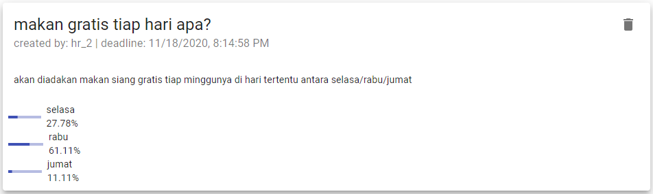

**ERD**

You can use and improve ERD below:

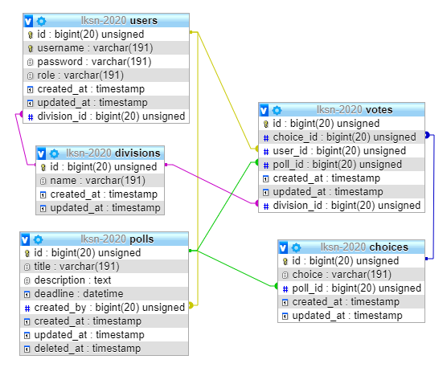

### division

* Payment
* Design
* Developer

### user

* Admin (username : admin, pass : admin, role : admin)
* User (username : user, pass : user, role: user)**INSTRUCTIONS TO THE COMPETITOR**
* Save your files in your root directory on the server called "**xx_module_server**"

## Create/generate a DB-diagram named “db-diagram.xxx” (xxx is the extension/type of the file eg. pdf or jpg) and put it into the directory mentioned above. Example:

## For this module, you must use one of the three available frameworks provided. Applications developed without use of any of these frameworks will not be considered. You should take advantage of the framework as much as possible.