# SPEEDTEST MODULE

# Part A: Website Design

**UI-kit using design tools**

Create a UI-kit of the following elements: text box, button, drop-down list, checkbox, radio button, label with checkbox, label with radio button, drop-down calendar input, range, progress bar

# Part B: Layout

**CSS Grid**

Please implement the following layout in CSS grid. And make it responsive.

Resolution > 720px.

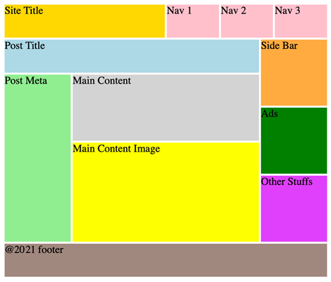

Resolution < 720px.

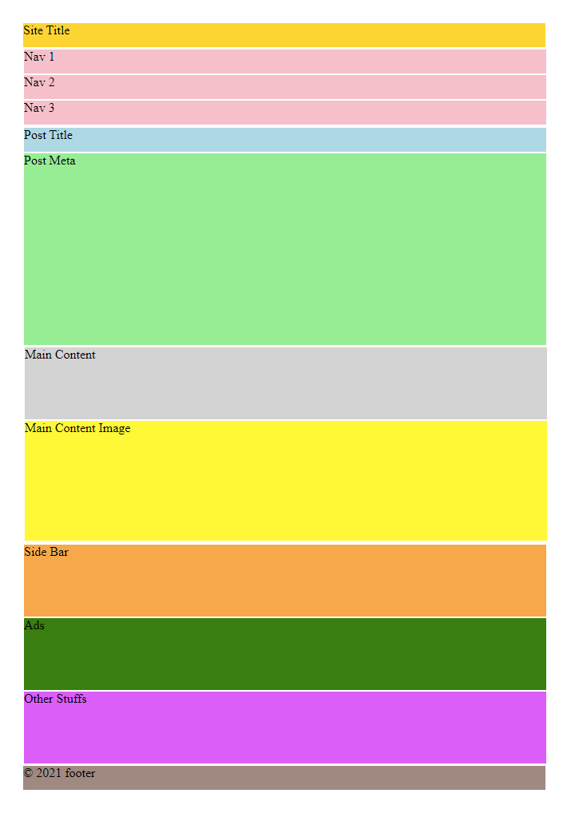

# Part C: Front-End Development

**RGB Slider**

Please implement an RGB slider as following. There are 4 sliders for adjusting values of red, green, blue and alpha.

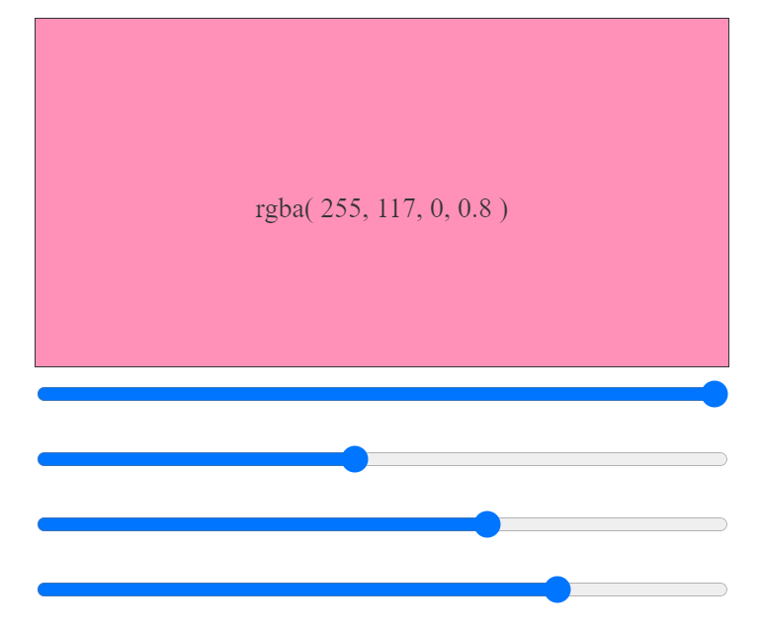

# Part D: Back-End Development

**PHP Verification captcha**

Please use PHP to produce verification code image (captcha), which must comply the following rules (please see the provided images):

1. It randomly generates four characters, consisting of English Alphabet (A-Z) or digit numbers (0-9).
2. The four characters must be slightly rotated.
3. The four characters must not be located at the same row.
4. The image contains at least 3 random lines.
5. At least 3 mixed noise points.
6. Captcha must be work when submit (show error and success messages)

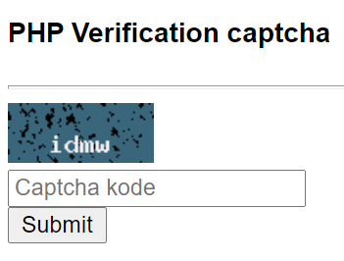

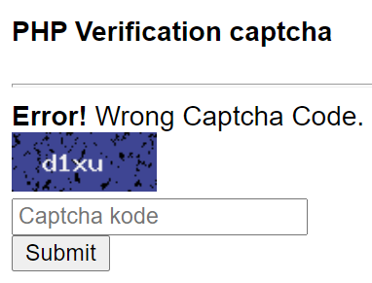

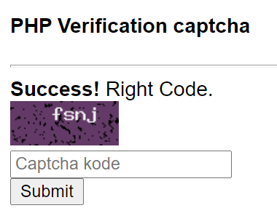

# Instruction for Competitors

Save your files in your root directory on the server called ***"xx_module_speedtest"***. Inside that folder create a folder for each part (A-D).