Kevin Riggs Module 3 Assignment Write Up

# Requirements:

Design and implement a TicTacToe game in C++. Unless you want to learn MFC or some

other GUI on your own, the game is a Console application and redraws the board at the

beginning and again after each move.

The board is a 3x3 grid of horizontal and vertical lines

The user is the person playing TicTacToe and the game automatically determines and plays

moves. The user always plays first as “X” and selects the location by the row and col and the

game plays by placing an “O” in a cell. There is no requirement for the game to have any

“smarts” as to where to place the “O”, although you might have it loop looking for any move

that would “win” or otherwise select a random unoccupied cell.

For example,

1 3

Would place the users “X” in the first row, third column

The game determines the next move and places it’s “O” at the location determined

The game evaluates if either player has won at the completion of each move

If either player has won, the winner is displayed and the game ends

The game determines if all squares are filled at the completion of each move

If all squares are filled

A “Tie” is displayed, and the game ends

# Demo:

I only checked these with Google Chrome and Firefox.

<http://oopcpp.rpkdesign.tech/TicTac/TicTac.html>

<http://oopcpp.rpkdesign.tech/statistics/statistics.html>

(I didn’t put a link the statistics app in the last write up. The statistics app can be passed a text file, or csv, of doubles separated by newlines, not commas, only splitting on newlines. See ~/statistics/dist.txt for an example file)

# Design:

Notice, I apologize for the bad design. This was intended to just be a spike but I did not have time this week to reimplement the code properly.

I built off a Qt Designer plugin example which are designed to be built, saved in a folder Qt creator can access, and are linked to for building GUIs. They are supposed to be reused.

Interestingly, I did find a glaring fatal error in the original example implementation. Essentially the original example implementation set the turn number to 9 without having initialized the string that saves the state of the game. It then tried to iterate through positions 0 to 8 on that empty string. This only failed when running a debug build.

Big flaw current implementation. The paint event handler is taking responsibility for determining whether someone has won the game. All it should do is paint the board given information from the state of the game. This causes quirks when playing the game.

For testing purposes, I set the computer player to mark the next available square, not a random move or intelligent move. If I set it to random, I would not be able to easily reproduce results when testing manually. If I had an intelligent design it would have been more reproducible but I did not have time to implement it.

# Test Design and Output:

I did purely exploratory manual testing.

Results –

QMessageBox does not work correctly targeting web assembly. We get a notification that the game is over and we can click out of it, but the text does not display who won/tie. Works as intended when targeting traditional platforms like windows and linux.

Due to the coupling of state with painting, we can reproduce scenarios where visually we get two winners but the message box displays who one first. This is a consequence of not de-spiking after the proof of concept.

# Lessons learned:

Not so much lessons learned but obvious ways to reimplement this program.

First, I should fully de-spike and include a testing framework.

Next, implementation-wise I just need to take the winner check logic out of the paint function. I can stick that in the mouse click event handler.

Last, I want a proper message to display when there is a winner. Clearly QMessageBox doesn’t work with WASM, so I should just add a header with a lineedit that updates given the state of the game(x’s turn, o’s turn, x wins, tie etc). This will work with WASM.

# Doxygen Output:

I’m not sure how the best way is to share the output in a pdf, took a screenshot of the html folder:

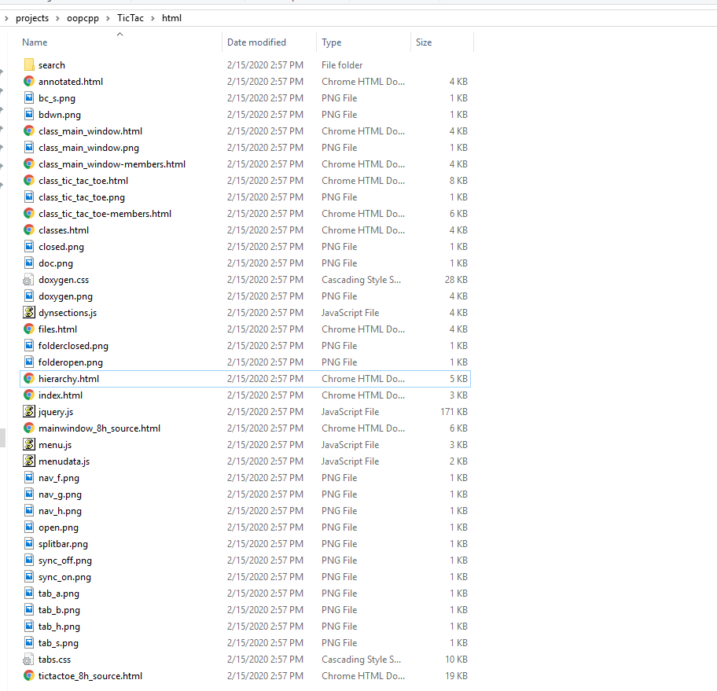

# Source Code:

<https://github.com/riggskevinp/oopcpp/tree/master/TicTac>

/****************************************************************************

**

** Copyright (C) 2016 The Qt Company Ltd.

** Contact: https://www.qt.io/licensing/

**

** This file is part of the examples of the Qt Toolkit.

**

** $QT_BEGIN_LICENSE:BSD$

** Commercial License Usage

** Licensees holding valid commercial Qt licenses may use this file in

** accordance with the commercial license agreement provided with the

** Software or, alternatively, in accordance with the terms contained in

** a written agreement between you and The Qt Company. For licensing terms

** and conditions see https://www.qt.io/terms-conditions. For further

** information use the contact form at https://www.qt.io/contact-us.

**

** BSD License Usage

** Alternatively, you may use this file under the terms of the BSD license

** as follows:

**

** "Redistribution and use in source and binary forms, with or without

** modification, are permitted provided that the following conditions are

** met:

** * Redistributions of source code must retain the above copyright

** notice, this list of conditions and the following disclaimer.

** * Redistributions in binary form must reproduce the above copyright

** notice, this list of conditions and the following disclaimer in

** the documentation and/or other materials provided with the

** distribution.

** * Neither the name of The Qt Company Ltd nor the names of its

** contributors may be used to endorse or promote products derived

** from this software without specific prior written permission.

**

**

** THIS SOFTWARE IS PROVIDED BY THE COPYRIGHT HOLDERS AND CONTRIBUTORS

** "AS IS" AND ANY EXPRESS OR IMPLIED WARRANTIES, INCLUDING, BUT NOT

** LIMITED TO, THE IMPLIED WARRANTIES OF MERCHANTABILITY AND FITNESS FOR

** A PARTICULAR PURPOSE ARE DISCLAIMED. IN NO EVENT SHALL THE COPYRIGHT

** OWNER OR CONTRIBUTORS BE LIABLE FOR ANY DIRECT, INDIRECT, INCIDENTAL,

** SPECIAL, EXEMPLARY, OR CONSEQUENTIAL DAMAGES (INCLUDING, BUT NOT

** LIMITED TO, PROCUREMENT OF SUBSTITUTE GOODS OR SERVICES; LOSS OF USE,

** DATA, OR PROFITS; OR BUSINESS INTERRUPTION) HOWEVER CAUSED AND ON ANY

** THEORY OF LIABILITY, WHETHER IN CONTRACT, STRICT LIABILITY, OR TORT

** (INCLUDING NEGLIGENCE OR OTHERWISE) ARISING IN ANY WAY OUT OF THE USE

** OF THIS SOFTWARE, EVEN IF ADVISED OF THE POSSIBILITY OF SUCH DAMAGE."

**

** $QT_END_LICENSE$

**

****************************************************************************/

#ifndef TICTACTOE_H

#define TICTACTOE_H

#include <QWidget>

QT_BEGIN_NAMESPACE

class QRect;

class QSize;

QT_END_NAMESPACE

//! [0]

// Holds the state and visualisation

// for a tictactoe game

class TicTacToe : public QWidget

{

Q_OBJECT

Q_PROPERTY(QString state READ state WRITE setState)

public:

// Constructor for the object

explicit TicTacToe(QWidget *parent = nullptr);

// Used for painting,

// window will want to know what to set

// the size to.

QSize minimumSizeHint() const override;

QSize sizeHint() const override;

// update the state of the game

void setState(const QString &newState);

// return the state of the game

QString state() const;

// reset the game

void clearBoard();

protected:

// handle when a click is received on the widget

void mousePressEvent(QMouseEvent *event) override;

// how to paint the board

void paintEvent(QPaintEvent *event) override;

private:

// char used to denote the state of the game

enum : char { Empty = '-', Cross = 'X', Nought = 'O' };

// Used to calculate how big to make visuals on the

// board.

QRect cellRect(int row, int col) const;

int cellWidth() const { return width() / 3; }

int cellHeight() const { return height() / 3; }

// data that holds the state of the game.

QString myState;

int turnNumber = 0;

int winnerPosition = -1;

};

//! [0]

#endif

/****************************************************************************

**

** Copyright (C) 2016 The Qt Company Ltd.

** Contact: https://www.qt.io/licensing/

**

** This file is part of the examples of the Qt Toolkit.

**

** $QT_BEGIN_LICENSE:BSD$

** Commercial License Usage

** Licensees holding valid commercial Qt licenses may use this file in

** accordance with the commercial license agreement provided with the

** Software or, alternatively, in accordance with the terms contained in

** a written agreement between you and The Qt Company. For licensing terms

** and conditions see https://www.qt.io/terms-conditions. For further

** information use the contact form at https://www.qt.io/contact-us.

**

** BSD License Usage

** Alternatively, you may use this file under the terms of the BSD license

** as follows:

**

** "Redistribution and use in source and binary forms, with or without

** modification, are permitted provided that the following conditions are

** met:

** * Redistributions of source code must retain the above copyright

** notice, this list of conditions and the following disclaimer.

** * Redistributions in binary form must reproduce the above copyright

** notice, this list of conditions and the following disclaimer in

** the documentation and/or other materials provided with the

** distribution.

** * Neither the name of The Qt Company Ltd nor the names of its

** contributors may be used to endorse or promote products derived

** from this software without specific prior written permission.

**

**

** THIS SOFTWARE IS PROVIDED BY THE COPYRIGHT HOLDERS AND CONTRIBUTORS

** "AS IS" AND ANY EXPRESS OR IMPLIED WARRANTIES, INCLUDING, BUT NOT

** LIMITED TO, THE IMPLIED WARRANTIES OF MERCHANTABILITY AND FITNESS FOR

** A PARTICULAR PURPOSE ARE DISCLAIMED. IN NO EVENT SHALL THE COPYRIGHT

** OWNER OR CONTRIBUTORS BE LIABLE FOR ANY DIRECT, INDIRECT, INCIDENTAL,

** SPECIAL, EXEMPLARY, OR CONSEQUENTIAL DAMAGES (INCLUDING, BUT NOT

** LIMITED TO, PROCUREMENT OF SUBSTITUTE GOODS OR SERVICES; LOSS OF USE,

** DATA, OR PROFITS; OR BUSINESS INTERRUPTION) HOWEVER CAUSED AND ON ANY

** THEORY OF LIABILITY, WHETHER IN CONTRACT, STRICT LIABILITY, OR TORT

** (INCLUDING NEGLIGENCE OR OTHERWISE) ARISING IN ANY WAY OUT OF THE USE

** OF THIS SOFTWARE, EVEN IF ADVISED OF THE POSSIBILITY OF SUCH DAMAGE."

**

** $QT_END_LICENSE$

**

****************************************************************************/

#include "tictactoe.h"

#include <QMouseEvent>

#include <QPainter>

#include <QMessageBox>

// When the game has just started, no Xs or Os

static inline QString defaultState() { return QStringLiteral("---------"); }

// Constructor, parent widget will give responsibility to the main window.

TicTacToe::TicTacToe(QWidget *parent)

: QWidget(parent)

{

turnNumber = 0;

myState = defaultState();

}

// size hints for initial size

QSize TicTacToe::minimumSizeHint() const

{

return QSize(200, 200);

}

// size hints for initial size

QSize TicTacToe::sizeHint() const

{

return QSize(200, 200);

}

// Given a new state, update the current state accordingly

void TicTacToe::setState(const QString &newState)

{

turnNumber = 0;

myState = defaultState();

int position = 0;

while (position < 9 && position < newState.length()) {

QChar mark = newState.at(position);

if (mark == Cross || mark == Nought) {

++turnNumber;

myState.replace(position, 1, mark);

}

position++;

}

update();

}

// Return the current state

QString TicTacToe::state() const

{

return myState;

}

// Reset the game

void TicTacToe::clearBoard()

{

myState = defaultState();

turnNumber = 0;

update();

}

// Handle mouse clicks

// Logic includes checking for a winner in order to display a message

// Displaying a QMessageBox doesn't work as intended targeting WASM

void TicTacToe::mousePressEvent(QMouseEvent *event)

{

if (turnNumber == 9) {

if(winnerPosition >= 0){

QString winner = myState.at(winnerPosition);

clearBoard();

update();

QMessageBox::information(this->parentWidget(), tr("Game Over"), tr("%1 wins").arg(winner), QMessageBox::Ok | QMessageBox::Close);

} else{

clearBoard();

update();

QMessageBox::information(this->parentWidget(), tr("Game Over"), tr("Result: tie"), QMessageBox::Ok | QMessageBox::Close);

}

} else {

for (int position = 0; position < 9; ++position) {

QRect cell = cellRect(position / 3, position % 3);

if (cell.contains(event->pos())) {

if (myState.at(position) == Empty) {

// modify to just be cross when computer plays Nought

if (turnNumber % 2 == 0)

myState.replace(position, 1, Cross);

else

myState.replace(position, 1, Nought);

++turnNumber;

update();

}

}

}

for (int position = 0; position < 9; ++position) {

if(myState.at(position) == Empty){

myState.replace(position, 1, Nought);

++turnNumber;

update();

break;

}

}

}

}

// Logic for painting the board

// Notice there is too much responsibility in this class

// It currently decides who won.

void TicTacToe::paintEvent(QPaintEvent * /* event */)

{

QPainter painter(this);

painter.setRenderHint(QPainter::Antialiasing);

painter.setPen(QPen(Qt::darkGreen, 1));

painter.drawLine(cellWidth(), 0, cellWidth(), height());

painter.drawLine(2 * cellWidth(), 0, 2 * cellWidth(), height());

painter.drawLine(0, cellHeight(), width(), cellHeight());

painter.drawLine(0, 2 * cellHeight(), width(), 2 * cellHeight());

painter.setPen(QPen(Qt::darkBlue, 2));

for (int position = 0; position < 9; ++position) {

QRect cell = cellRect(position / 3, position % 3);

if (myState.at(position) == Cross) {

painter.drawLine(cell.topLeft(), cell.bottomRight());

painter.drawLine(cell.topRight(), cell.bottomLeft());

} else if (myState.at(position) == Nought) {

painter.drawEllipse(cell);

}

}

painter.setPen(QPen(Qt::yellow, 3));

for (int position = 0; position < 9; position = position + 3) {

if ((myState.at(position) == Cross || myState.at(position) == Nought)

&& myState.at(position + 1) == myState.at(position)

&& myState.at(position + 2) == myState.at(position)) {

int y = cellRect((position / 3), 0).center().y();

painter.drawLine(0, y, width(), y);

turnNumber = 9;

winnerPosition = position;

}

}

for (int position = 0; position < 3; ++position) {

if ((myState.at(position) == Cross || myState.at(position) == Nought)

&& myState.at(position + 3) == myState.at(position)

&& myState.at(position + 6) == myState.at(position)) {

int x = cellRect(0, position).center().x();

painter.drawLine(x, 0, x, height());

turnNumber = 9;

winnerPosition = position;

}

}

if ((myState.at(0) == Cross || myState.at(0) == Nought) && myState.at(4) == myState.at(0)

&& myState.at(8) == myState.at(0)) {

painter.drawLine(0, 0, width(), height());

turnNumber = 9;

winnerPosition = 0;

}

if ((myState.at(2) == Cross || myState.at(2) == Nought) && myState.at(4) == myState.at(2)

&& myState.at(6) == myState.at(2)) {

painter.drawLine(0, height(), width(), 0);

turnNumber = 9;

winnerPosition = 2;

}

}

// Figure out how big the boxes are.

QRect TicTacToe::cellRect(int row, int column) const

{

const int HMargin = width() / 30;

const int VMargin = height() / 30;

return QRect(column * cellWidth() + HMargin,

row * cellHeight() + VMargin,

cellWidth() - 2 * HMargin,

cellHeight() - 2 * VMargin);

}