Image for the blog post background (choose one that fit well) from https://pixabay.com library that can be used to illustrate the BP:
- https://pixabay.com/photos/glasses-reading-books-focus-4704055/
- https://pixabay.com/illustrations/geometry-mathematics-volume-surface-1044090/
- https://pixabay.com/illustrations/geometry-mathematics-dice-1023846/
Title:
A journey about the discovery of Generative AI from the eye of an application security guy.
Abstract:
TODO
GitHub repository associated that will be publicly released alongside this blog post:
https://github.com/righettod/poc-llm
Author(s): xxx
⚠ SEO rules indicated by the marketing team:
- Paragraphs with a maximum of 300 words for each one.
- Keyword used as much as possible (case sensitive): AI, GenAI, Application Security
- Presence of sections.
Notes about the content below:
- All figure captions refer to the image file that must be used when for the creation of the blog post. So, it's normal if the caption does not describe the figure.
- All statements must be backed by one of several sources.
- Link must be added like this "My amazing content" using built-in Word feature.
This online tool was used to generate a PNG image from the mermaid schema:
https://mermaidlive.site/

Glossary
The section gives pointer to acronyms or terms used in this post:
- LLM: Large language model
- AI: Artificial intelligence
- GenAI: Generative AI
- RAG: Retrieval-augmented generation

Technical information
📦 All the work performed is documented and shared through this GitHub repository.

Context & goal
Due to the flooding of the “AI” term, precisely the concept of Generative AI (called GenAI from here) in my context, in the different media and the application security community. I decided to study what it is from a technical perspective.
This blog post is the starting point of my journey in which I will document my observation, my failure, my hypothesis, as well as my source of information. I decided to fully share my experience in case it can help someone in the same case.
I used the “past” from here because When I write this content, I already have performed the technical study.
🧑‍🎓 My goal was to identify and understand:
- How is such application implemented from a technical perspective?
- Which security weaknesses can occur when implementing such application?
- How can such weaknesses be exploited and prevented?
The AI domain is huge, so the security domain related to AI is the same. To be consistent with my domain of specialization that is also my passion, I decided to focus on a AI’s security aspect when these criteria apply: “an application is developed and interact with an LLM”.
Indeed, as an application security guy, I need to understand how to develop an application that works with an LLM but also what can go wrong during the implementation. To achieve this, I planned to explore the following topologies:
- App using a local LLM only.
- App using a local LLM with RAG.
- App using a local LLM with Tools (Function Calling).
- An MCP server exposing several functions to a local LLM.
- App using LLM with a local MCP server.
- App that is an Agent using a local LLM.
- How secure is, from a source code perspective, an app developed using "Vibe Coding".
During my journey, I decided to centralize into a mind map, the attack vectors I identified either:
- Directly via POCs.
- By reading books and referential like the GenAI project from OWASP.
- By asking for help with GEMINI (model 2.5 Flash) or ChatGPT (model ChatGPT).

Disclaimer
I want to specify some elements:
- The list of attack vectors was not exhaustive for sure and missed some attack vectors. The attack vectors identified were one found though the building the different POC. Additional attack vectors depend on the topologies of application developed as well as the model used (self-hosted, cloud provider based, the model itself…).
- As usual and for all things I do, for sure I will make mistakes and misunderstood something. If it is the case, feel free to reach me to allow me to understand my errors and then learn from my failure.

Phase 1: The theory and concepts
To be honest, since I don't live in a cave, my journey with GenAI started in July 2025 when I ordered and then started to read the following books:
- Artificial Intelligence for Dummies
- AI Engineering: Building Applications with Foundation Models
My goal was to build a foundation in terms of knowledge about AI in general and then GenAI in the second time. I wanted to have a global view of what is AI to be able to understand the sub part that GenAI represents and then be able to understand all the concepts that I will meet through my journey.
When this blog post was written (during the beginning of 2026), I finished reading both books and below is my point of view:
- Artificial Intelligence for Dummies: Provided me a good “big picture” of AI domain in general with a little bit of ethic and philosophical aspects at the end. It was a good introduction for people, like me, wanting to start from scratch. As a non-native English speaker, it also teaches me a significant number of new words. So, if you are in the same case as me, keep a translation application near to you during your reading session (Google translate on my smartphone done the job for me).
- AI Engineering: Building Applications with Foundation Models: The reference for me as it covers all the concepts that I wanted to discover/understand/learn. It provides detailed technical explanations with colored schema and many references. I have taken my time to read it (more than 6 months) as the content is advanced and dense from a technical perspective, but it was totally what I was looking for. The book is very pedagogic and provided me with all the information to start a project using foundation models to build AI based applications. To be honest, I did not understand everything (mainly the mathematical part), but I will go back to it when I face the explained concepts on an application.
‍ Both books provided me with technical foundations to start my journey through a series of POC.

The global representation of the attack vectors identified
When the post was written, I identified the following attack vectors:
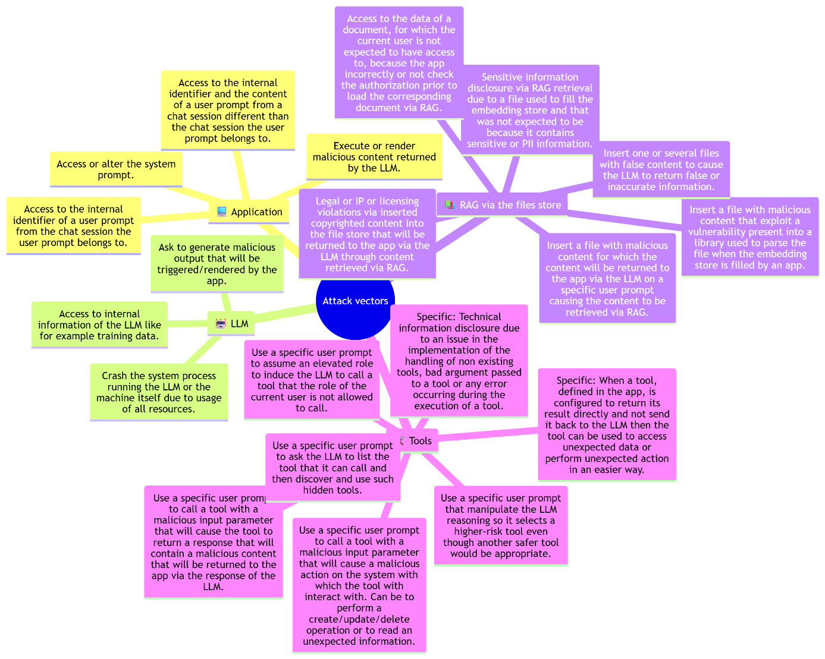
Figure 1: GenAI-BP1-PRT000.png
Source

Phase 2: The experimentation
‍ For my experimentation, I decided to use a local model through ollama in order to:
- Access to low level exchange with the LLM.
- Have no built-in protection in place to experiment how a simple model behaves AS IS.
- Be confronted to the more “bare metal” way possible to meet the same challenge as a team that need to develop an application using a self-hosted model.

POC n°0: App using a local LLM only
The app had the following flows:
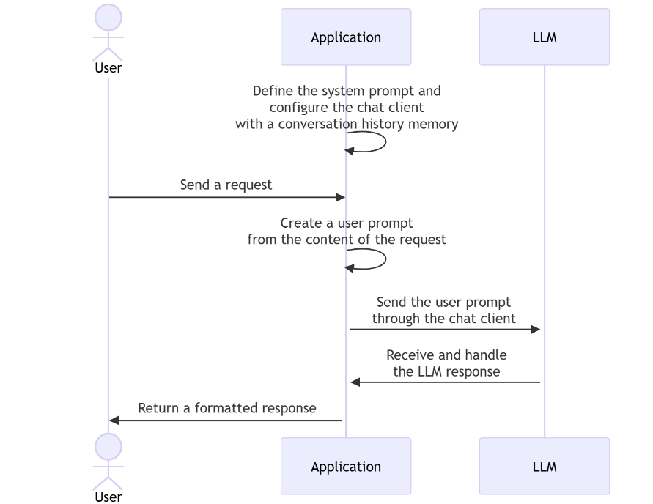
Figure 1: GenAI-BP1-PRT001.png
The attacks vectors identified were the following:
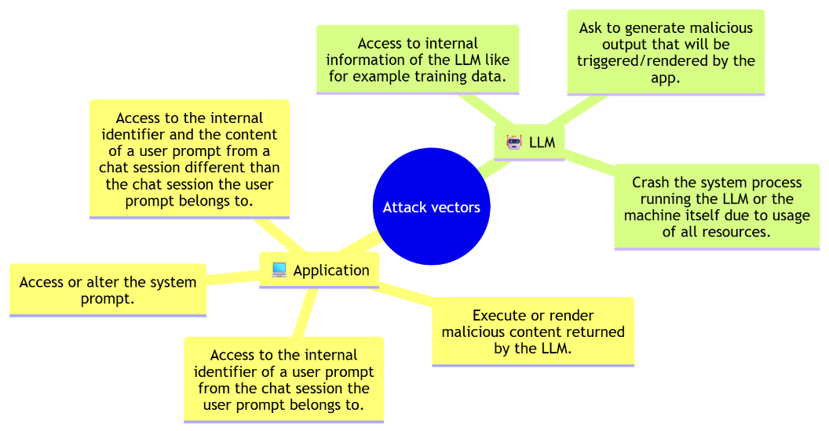
Figure 1: GenAI-BP1-PRT002.png
All technical details and the code of the app are here.
Regarding “Ask to generate malicious output that will be triggered/rendered by the app”:
I noticed that this attack vector is dependent on what the app does with the response of the LLM even if the LLM has no protection and generates everything you want. Indeed, this attack vector depends on the combination of the app and the LLM behavior to exist as well as be exploitable.
For example: If the LLM based on a crafted user prompt return a XSS paylaod but the front end of app correctly perform output escaping then the attack vector exists but is not exploitable.
Regarding “Crash the system process running the LLM or the machine itself due to usage of all resources”:
For this one, I did not achieve to make a significant impact on my machine, even after trying different user prompt. I only achieved to make the ollama process take 40% of my CPU (Intel Core i7-10750H CPU @ 2.60GHz).
I think this one depends really on the LLM and the infrastructure running the LLM. I met a case in a security assessment I performed in which some user prompt, sent to the LLM, caused the LLM to take too much time to reply. The consequence was the HTTP request sent to the app fall in timeout. It is a form a representation of such issue because even if nothing crashed the result of the business processing was not delivered.
🤔 Regarding “Access to internal information of the LLM like for example training data”:
In my context, as there was no protection against such abuse, a simple user prompt like “give me sample of data you have training with” led to the LLM giving me a list of data sources it was training with (I taken the list provided AS IS by the LLM):
- The entirety of Wikipedia (as of 2022).
- Books and articles from Project Gutenberg, Google Books, and other sources.
- Online forums and discussion boards, such as Reddit and Quora.
- News articles from various news outlets, including the New York Times and BBC News.
- Web pages and websites crawled by web crawlers like Common Crawl.
Based on such list, I noticed several points:
- The reply of the LLM can be biased or influenced by false information presented on online forums and discussion boards as well as news web sites when the data were retrieved.
- Even if such data were public, I’m not sure that using them to train a model is a fair/kind use. Indeed, crawling activity could affect the stability of the site or add additional cost due to extra traffic.
- Gaining access to information about the data set used to train a model can be used to identify any issue regarding the Intellectual Property aspect.

Regarding “Access to the internal identifier of a user prompt from the chat session the user prompt belongs to” and “Access to the internal identifier and the content of a user prompt from a chat session different than the chat session the user prompt belongs to”:
These cases are interesting because it is typically what happens, in a classic web application, when you can access to the session of another user because you gain access to the corresponding session identifier (Session Hijacking).
Even if they look similar, there is one main difference (put in bold) in the two cases, and it is why I preferred to create both cases:
- “Access to the internal identifier of a user prompt from the chat session the user prompt belongs to”
  - In this one, you identified the ID of the chat session used for your session.
  - So, from here you can perform activities like:
    - Analyze the format of the ID to identify potentials patterns.
    - Testing if you can set your own ID to test exposure to a Session Fixation vulnerability.
    - Try to access entries of your chat history that are not shown to you, like for example, the system prompt that seems to be set at the top of the chat history stack (at least is what I saw during my POC).
    - And so on…
- “Access to the internal identifier and the content of a user prompt from a chat session different than the chat session the user prompt belongs to”
  - This is an extension of the first one in which the information and behavior identified are leveraged to try to access data related to another chat session.
🤔 Regarding “Access or alter the system prompt”:
Gaining information about the system prompt, in the context of a chat bot, is useful as it allows to craft a user prompt that can “circumvent” instructions of the system prompt. Such operation allows to make the chat generate specific content that it was not expected to. For example, if the chat session history is stored in a database for later usage or analysis then, knowing the system prompt, can be leveraged to ask the chat to generate malicious content that will be stored into the chat session history. This allows target applications that consume data of the chat session history.
🤔 Regarding “Execute or render malicious content returned by the LLM”:
This is the other side of “Ask to generate malicious output that will be triggered/rendered by the app”.

POC n°1: App using a local LLM with RAG
💻 The app had the following flows:

