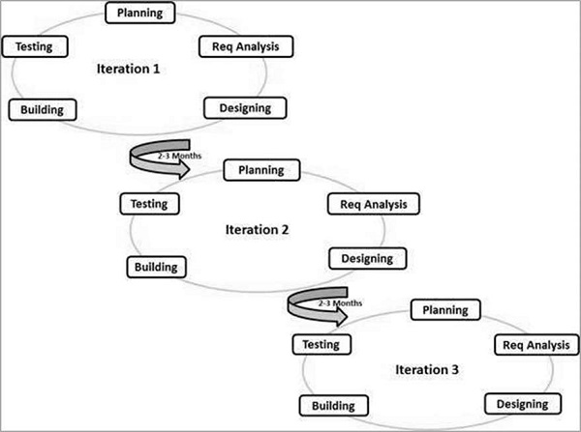

The researchers used the agile model in creating and understanding this study because this model believes that every project needs to be handled differently and the existing methods need to be tailored to best suit the project requirements. This is suitable for the researchers because this is the first time they create this kind of system. This model will help the researchers to easily create and understand on how to finish the study.