InorgChem – Nitrogen

Nitrogen

Nitrogen:
- Group V element with the electronic configuration 1s²2s²2p³
- Nitrogen can form large number of compounds
- Oxidation state: –3 to +5
- Example: NH₃, Nitride (N^{3–}), Hydrazine (N₂H₄), N₂O, N₂O₄, N₂O₅

Reactions of Nitrogen:
- N₂ has a triple bond and the bond enthalpy is very high (944 kJ mol^{–1})
- Activation energy is high for N₂ reacts
- Haber process: 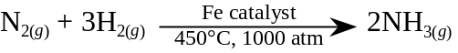
- Nitrogen reacts with reactive metal under heating:
- 6 Li_{(s)} + N_{2(g)} ⎯→ 2 Li₃N_{(s)}
- 3 Mg_{(s)} + N_{2(g)} ⎯→ Mg₃N_{2(s)}
- Nitrogen can react with oxygen in some conditions like lightening:
- Lightening: N_{2(g)} + O_{2(g)} ⎯→ NO_{(g)}
2NO_{(g)} + O_{2(g)} ⎯→ 2NO_{2(g)}
- The reaction also occur in car engines
- When NO₂ exposed to sunlight, 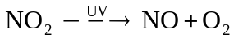
- Two NO₂ will combine to form N₂O₄: 2NO_{2(g)} N₂O_{4(g)}
- NO₂ and NO will combine to form N₂O₃: NO_{(g)} + NO_{2(g)} N₂O_{3(g)}

Ammonia

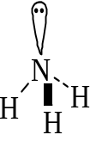Ammonia:
- NH₃: A colorless, pungent gas
- Polar trigonal pyramid molecule
- Very soluble in water
- Weakly alkaline in aqueous solution
- Ammonia is made by Haber process
- Nitrogen & hydrogen are mixed in 1:3 ratio
- N_{2(g)} + 3H_{2(g)} 2NH_{3(g)} ΔH = –92 kJ mol
- High pressure of 200atm is used to increase the yield
- Since the synthesis is exothermic, a low temperature may favor the reaction
- Too low temperature causes the reaction carried out slowly
- Fe catalyst and 500°C is used
- Yield of production: About 15%
- Flow diagram for Haber process:
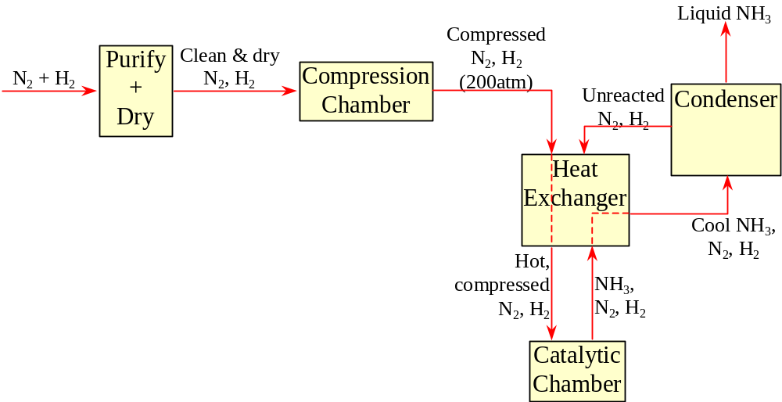

Chemical properties of NH₃:
- NH₃ is weakly alkaline as it reacts with water and gives hydroxide ions:
NH_{3(g)} + H₂O_{()} NH₄⁺_{(aq)} + OH–_{(aq)}
- Ammonia solution neutralizes acid and gives ammonium salt:
NH_{3(aq)} + HNO_{3(aq)} ⎯→ NH₄NO_{3(aq)}
NH_{3(aq)} + H₂SO_{4(aq)} ⎯→ (NH₄)₂SO_{4(aq)}
- Ammonia solution can precipitate metal hydroxides:
- CaSO_{4(aq)} + 2NH_{3(aq)} + 2H₂O_{()} ⎯→ Ca(OH)_{2(s)} + (NH₄)₂SO_{4(aq)} White
- ZnSO_{4(aq)} + 2NH_{3(aq)} + 2H₂O_{()} ⎯→ Zn(OH)_{2(s)} + (NH₄)₂SO_{4(aq)} White
- Pb(NO₃)_{2(aq)} + 2NH_{3(aq)} + 2H₂O_{()} ⎯→ Pb(OH)_{2(s)} + 2NH₄NO_{3(aq)} White
- CuSO_{4(aq)} + 2NH_{3(aq)} + 2H₂O_{()} ⎯→ Cu(OH)_{2(s)} + (NH₄)₂SO_{4(aq)} White
- FeSO_{4(aq)} + 2NH_{3(aq)} + 2H₂O_{()} ⎯→ Fe(OH)_{2(s)} + (NH₄)₂SO_{4(aq)} White
- Fe(SO₄)_{3(aq)} + 6NH_{3(aq)} + 6H₂O_{()} ⎯→ 2Fe(OH)_{3(s)} + 3(NH₄)₂SO_{4(aq)} White
- Excess ammonia may cause complex formed and the ppt redissolves:
Cu(OH)₂ + 4NH₃ ⎯→ Cu(NH₃)₄²⁺ + 2OH–
Zn(OH)₂ + 4NH₃ ⎯→ Zn(NH₃)₄²⁺ + 2OH–

Reducing Properties of NH₃:
- Ammonia can be a reducing agent, particularly at high temperature
- 4NH_{3(g)} + 3O_{2(g)} ⎯→ 2N_{2(g)} + 6H₂O_{()}
- Burning of ammonia in pure oxygen
- Catalytic oxidation of ammonia
- Red hot platinum catalyst at 800°C to 900°C is used
- Passing NH₃ over heated CuO, ammonia is oxidized:
2NH_{3(g)} + 3CuO_{(s)} ⎯→ 3Cu_{(s)} + N_{2(g)} + 3H₂O_{(g)}

Nitric Acid

Nitric(V) Acid:
- Nitric(V) acid, HNO₃, is a very strong acid
- HNO₃ itself will undergo decomposition:
4HNO₃ ⎯→ 4NO₂ + 2H₂O + O₂
- Light will speed up decomposition
- Nitric(V) acid is made industrially by Ostward process
- Firstly, NO_{(g)} is produced by catalytic oxidation of NH_{3(g)}
- Secondly, the NO_{(g)} produced reacts with O_{2(g)} to give NO_{2(g)}
- A brown gas: 2NO_{(g)} + O_{2(g)} ⎯→ 2NO_{2(g)}
- Thirdly, dissolve NO₂ with excess O₂ in water:
4NO_{2(g)} + O_{2(g)} +2H₂O_{()} ⎯→ 4HNO_{3(aq)}

Oxidizing property:
- HNO₃ is strongly oxidizing as NO₃– in the presence of H⁺ behaves as electron acceptor
- Reduces dil. HNO₃ will give NO_{(g)}:
8HNO_{3(aq)} + 6e– ⎯→ 6NO₃–_{(aq)} + 4H₂O_{()} + 2NO_{(g)}
2NO₃–_{(aq)} + 8H⁺_{(aq)} + 6e– ⎯→ 2NO_{(g)} + 4H₂O_{()}
- NO_{(g)} formed will normally further oxidized by O_{2(g)} in air to NO_{2(g)}
- Reduces conc. HNO₃ will give NO_{2(g)}
4HNO_{3(aq)} + 2e– ⎯→ 2NO₃–_{(aq)} + 2H₂O_{()} + 2NO_{2(g)}
2NO₃–_{(aq)} + 4H⁺_{(aq)} + 2e– ⎯→ 2NO_{(g)} + 2H₂O_{()}
- HNO₃ can react with copper:
- Conc: 4HNO_{3(aq)} + Cu_{(s)} ⎯→ Cu(NO₃–)_{2(aq)} + 2H₂O_{()} + 2NO_{2(g)}
- Dil.: 8HNO_{3(aq)} + 3Cu_{(s)} ⎯→ 3Cu(NO₃–)_{2(aq)} + 4H₂O_{()} + 2NO_{(g)}
- Concentrated HNO₃ can oxidize Fe²⁺ to Fe³⁺:
3Fe²⁺_{(aq)} + NO₃–_{(g)} + 4H⁺_{(aq)} ⎯→ 3Fe³⁺_{(aq)} + NO_{(g)} + 2H₂O_{()}
NO_{(g)} + O_{2(g)} ⎯→ NO_{2(g)}
- Hot conc. HNO₃ can react with sulphur:
S_{(s)} + 6HNO_{3(aq)} ⎯→ H₂SO_{4(aq)} + 6NO_{2(g)} + 2H₂O_{()}

Nitrate:
- Very dilute HNO₃ react with metal / metal oxide / metal hydroxide / metal carbonate will give metal nitrate(V)
- Acid-Base reaction
- No NO_{2(g)} or NO_{(g)} formed
- Mg_{(s)} + 2HNO_{3(aq)} ⎯→ Mg(NO₃)_{2(aq)} + H_{2(g)}
CuO_{(s)} + 2HNO_{3(aq)} ⎯→ Cu(NO₃)_{2(aq)} + H₂O_{()}
- Conc. HNO₃ will react with metal and give nitrates:
Mg + 4HNO₃ ⎯→ Mg(NO₃)₂ + 2H₂O + 2NO₂
- When heating potassium or sodium nitrates(V), it reduces to nitrate(III):
2NaNO₃ ⎯→ 2NaNO₂ + O₂
- When heating nitrate(V) of Ca, Mg, Al, Zn, Fe, Pb, Cu, it reduces to metal oxide:
2Ca(NO₃)₂ ⎯→ 2CaO + 4NO₂ + O₂
- When heating nitrate(V) of Hg, Ag, metal recovers:
Mg(NO₃)₂ ⎯→ Hg + 2NO₂ + O₂
- When heating ammonium nitrate, dinitrogen oxide formed:
NH₄NO₃ ⎯→ N₂O + 2H₂O

