InorgChem – Sulphur

Sulphur

Sulphur:
- Group VI element with the electronic configuration 1s²2s²2p⁶3s²3p⁴
- Sulphur has low MP (113°C) but high BP (445°C)
- Burning sulphur in air gives a dull blue flame and sulphur dioxide as product:
S_{(s)} + O_{2(g)} ⎯→ SO_{2(g)}

Sulphur dioxide:
- Sulphur dioxide is a colorless gas with pungent choking smell
- Sulphur dioxide is very soluble in water
- Gives H₂SO_{3(aq)}, H⁺_{(aq)}, HSO₃–_{(aq)}, SO₃^{2–}_{(aq)}
- Sulphur dioxide may be oxidized to sulphur trioxide when contact with oxygen:
SO₂ + O₂ ⎯→ SO₃
- SO₃ dissolve will give H₂SO₄

Oxidizing properties:
- Sulphur dioxide can be an oxidizing agent:
SO_{2(g)} + 4e– ⎯→ S_{(s)} + 2O^{2–}_{(s)}
SO_{2(g)} + 4H⁺_{2(aq)} + 4e– ⎯→ S_{(s)} + 2H₂O_{()}
- 2Mg_{(s)} + SO_{2(g)} ⎯→ 2MgO_{(s)} + S_{(s)}
- 2H₂S_{(g)} + SO_{2(aq)} ⎯→ 2H₂O_{()} + 3S_{(s)}

Reducing properties:
- Sulphur dioxide is a reducing agent:
SO_{2(g)} + 2H₂O_{()} ⎯→ SO₄^{2–}_{(aq)} + 4H⁺_{(aq)} + 2e–
- Sulphate(IV) ion in water is also reducing:
SO₃^{2–}_{(aq)} + H₂O_{()} ⎯→ SO₄^{2–}_{(aq)} + 2H⁺_{(aq)} + 2e–
- Permanganate solution (Manganate(VII), MnO₄–) in acidic medium will react with SO₃^{2–}_{(aq)}:
2× | MnO₄–_{(aq)} + 8H⁺_{(aq)} + 5e– | ⎯→ |  | Mn²⁺_{(aq)} + 4H₂O_{()}
5× | SO₃^{2–}_{(aq)} + H₂O_{()} | ⎯→ |  | SO₄^{2–}_{(aq)} + 2H⁺_{(aq)} + 2e–
2MnO₄–_{(aq)} + 5SO₃^{2–}_{(aq)} + 6H⁺_{(aq)} |  |  | ⎯→ |  | 2Mn²⁺_{(aq)} + 5SO₄^{2–}_{(aq)} + 3H₂O_{()}
- Purple color of permanganate decolorizes
- Dichromate(VI) solution will oxidize SO₃^{2–}_{(aq)}:
 | Cr₂O₇^{2–}_{(aq)} + 14H⁺_{(aq)} + 6e– | ⎯→ | 2Cr³⁺_{(aq)} + 7H₂O_{()}
3× | SO₃^{2–}_{(aq)} + H₂O_{()} | ⎯→ | SO₄^{2–}_{(aq)} + 2H⁺_{(aq)} + 2e–
Cr₂O₇^{2–}_{(aq)} + 3SO₃^{2–}_{(aq)} + 8H⁺_{(aq)} |  | ⎯→ | 2Cr³⁺_{(aq)} + 3SO₄^{2–}_{(aq)} + 4H₂O_{()}
- Bromine water reacts with SO₃^{2–}_{(aq)}:
 | Br_{2(aq)} + 2e– | ⎯→ | Br–_{(aq)}
3× | SO₃^{2–}_{(aq)} + H₂O_{()} | ⎯→ | SO₄^{2–}_{(aq)} + 2H⁺_{(aq)} + 2e–
Br_{2(aq)} + SO₃^{2–}_{(aq)} + H₂O_{()} |  | ⎯→ | 2Br–_{(aq)} + SO₄^{2–}_{(aq)} + 2H⁺_{()}

Sulphuric Acid

Sulphuric acid:
- Sulphuric(VI) acid (H₂SO₄) is a corrosive, colorless, oily liquid
- Strong dibasic acid
- Pure H₂SO₄ will decomposes at 340°C:
H₂SO_{4()} ⎯→ SO_{3(g)} + H₂O_{(g)}

Manufacture of H₂SO₄:
- H₂SO₄ is manufactured by contact process
- SO_{2(g)} is produced by burning sulphur or sulphide in air and then purified and dried
- SO_{2(g)} is then converted to sulphur trioxide:
SO₂ + O₂ SO₃
- At 450°C and vanadium(V) oxide, V₂O₅, catalyst is required
- The sulphur trioxide is then dissolved in concentrated sulphuric acid:
SO_{3(g)} + H₂SO_{4()} ⎯→ H₂S₂O_{7()}
- Oleum / Fuming sulphuric acid is produced
- The oleum is then diluted by correct amount of water to give out conc. H₂SO₄ (98%):
H₂S₂O_{7()} + H₂O_{()} ⎯→ 2H₂SO_{4()}
- Flow diagram for contact process:
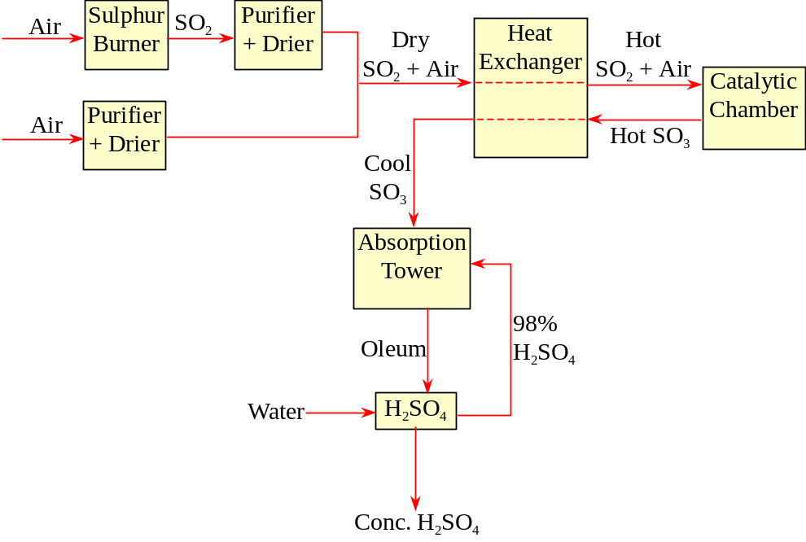

Properties of H₂SO₄:
- H₂SO₄ can completely ionized in water
- Gives sulphate(VI), hydrogensulphate(VI) and hydrogen ions:
H₂SO_{4(aq)} + H₂O_{()} ⎯→ H₃O⁺_{(aq)} + HSO₄–_{(aq)}
H₂SO_{4(aq)} + 2H₂O_{()} ⎯→ 2H₃O⁺_{(aq)} + SO₄^{2–}_{(aq)}
- Dilute H₂SO₄ is an acid
- Reacts with metal, oxides, hydroxides, carbonates, etc.
- H₂SO₄ can also act as an oxidizing agent in conc.
- Oxidation number of S dec. from +6 to +4 or +2
- With metal: Cu + 2H₂SO₄ ⎯→ CuSO₄ + SO₂ + 2H₂O
- Non-metal: C + 2H₂SO₄ ⎯→ CO₂ + 2SO₂ + 2H₂O
S + 2H₂SO₄ ⎯→ 3SO₂ + 2H₂O
- Hydrogen halide: 2HBr + H₂SO₄ ⎯→ Br₂ + SO₂ + 2H₂O
8HI + H₂SO₄ ⎯→ 4I₂ + H₂S + 4H₂O
- Concentrated H₂SO₄ has a strong affinity for water
- It can dehydrate the hydrated salts:
CuSO₄⋅5H₂O_{(s)} ⎯→ CuSO_{4(s)} + 5H₂O_{()}
- It can dehydrate organic cpds:
C₁₂H₂₂O₁₁ ⎯→ 12C + 11H₂O
CH₃CH₂OH ⎯→ CH₂=CH₂ + H₂O
- The presence of SO₄^{2–} ion can be tested by adding BaCl_{2(aq)} and nitric acid:
- SO₄^{2–} react with Ba²⁺ ion to form white ppt:
SO₄^{2–}_{(aq)} + Ba²⁺_{(aq)} ⎯→ BaSO_{4(s)}
- If the white ppt is not SO₄^{2–}, e.g. CO₃^{2–} or SO₃^{2–}, it will be reacted by HNO₃ and redissolves:
BaCO_{3(s)} + 2HNO_{3(aq)} ⎯→ Ba(NO₃)_{2(aq)} + H₂O_{()} + CO_{2(g)}
BaSO_{3(s)} + 2HNO_{3(aq)} ⎯→ Ba(NO₃)_{2(aq)} + H₂O_{()} + SO_{2(g)}

