OrgChem – Organic Compounds

Organic Chemistry
Organic Chemistry is the study of cpd based on carbon chains
- Inorganic carbon cpd: CO, CO₂, H₂CO₃, Metal carbides, CO₃^{2–}, HCO₃–

Organic Compounds:
- Generally covalent gases, volatile liquids, or low MP solids
- Carbon is capable to form strong covalent bonds w/C, H, O, N, X
- Org. molecules are usually classified by functional groups
- Fn gp reps the part of molecules which confers a characteristic type of reactivity upon the cpd
- Determines the cpd’s chemical & physical properties

Functional Groups
Family | Gen Formula | Functional Group | Naming
Alkane | RH | CH, C–C bonds only | -ane
Alkene | RCH=CH₂  RCH=CHR  R₂C=CHR  R₂C=CR₂ | 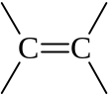 | -ene
Alkyne | RC≡CH  RC≡CR | –C≡C– | -yne
Aromatic  hydrocarbon | ArH | Aromatic ring, 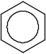
Haloalkane | RX | 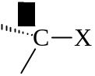 | halogeno-
Alcohol | ROH | 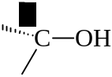 | -ol
Ether | ROR | 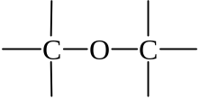 | -oxy –ane
Amide | RNH₂  R₂NH  R₃N | 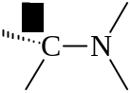 | -anamine  -ylamine
Aldehyde | 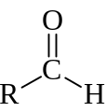 | 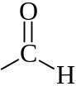 | -al
Ketone | 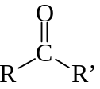 | 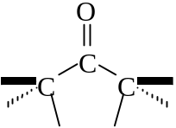 | -one
Carboxylic  acid | 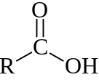 | 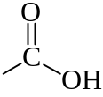 | -oic acid
Ester | 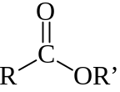 | 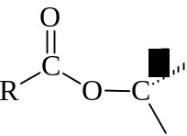 | -yl -oate
Amide | 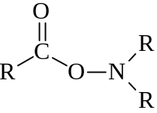 | 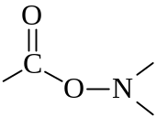 | -anamide
Acid  anhydride | 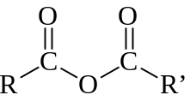 | 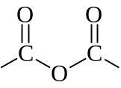 | -oic anhydride

Homologous Series
Homologous series is a series of cpds w/adjacent members differing by –CH₂– unit
- Cpds of same fn gp ≠ Same homologous series

Hydrocarbons
- Alkane
- Saturated hydrocarbons
- Chemical inertness
- Carbon utilize all 4 valence e– to form 4 single bonds
- Alkene
- Unsaturated hydrocarbons
- Liable to react to attain the maximum covalency of 4
- Two of C share 2 pairs of e– to form C=C double bond
- Rigid C=C double bond prevents rotation of gps joined to the carbons
- Alkyne
- Unsaturated
- Contains C≡C triple bond
- –C≡C– is a linear structure
- Bond angle = 180°
- Aromatic hydrocarbons
- Cyclic hydrocarbons

Primary carbon is the carbon atom that attached to one C atom only
- 1° Carbon: 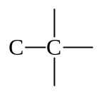
Secondary carbon is the carbon atom that attached to two C atoms only
- 2° Carbon: 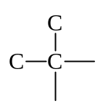
Tertiary carbon is the carbon atom that attached to three C atoms only
- 3° Carbon: 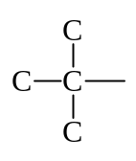

Hydroxyl Compound (–OH)
- Alcohol
- Hydroxyl derivatives of alkane
- R–H ⎯→ R–OH
- Alkyl derivatives of water
- H–O–H ⎯→ R–OH
- 1°, 2°, 3° alcohol are alcohol w/–OH attached to 1°, 2°, 3° carbon respectively
- Phenols
- Hydroxyl derivatives of benzene
- 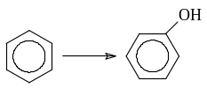

Ethers
- Water derivatives w/all H replaced by alkyl group
- H–O–H ⎯→ R–O–R
- R–O–R bond angle (110°) is slightly greater than H–O–H (105°)

Carbonyl Compound (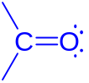)
- Aldehyde
- Carbonyl groups held at least one H atoms
- 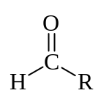 or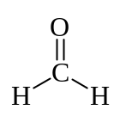
- Ketone
- Carbonyl groups attached to all alkyl groups
- 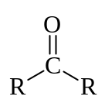

Carboxylic Acids & Derivatives
- Carboxylic acid: Have the carboxy group 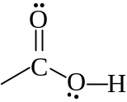
- Acyl halide: 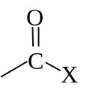
- Acid anhydride: 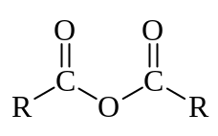
- Ester: 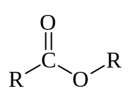
- Amide: 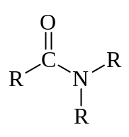

Halogenocarbon
- Substituting any –H of the carbon chain by halogens

Amines
- Organic derivative of ammonia
- 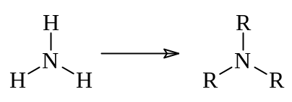
- N attached to 1, 2, or 3 alkyl groups is 1°, 2°, or 3° amide respectively

Nomenclature

Nomenclature system:
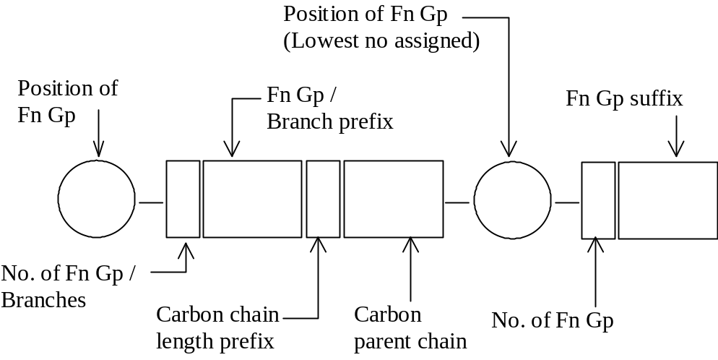

Rules
- Sec. Prefix + Pri. Prefix + Root + Pri. Suffix + Sec. Suffix
- Root is the basic unit that designates the linear carbon parent chains of any desired length

- 1 C = metha-
- 2 C = etha-
- 3 C = propa-
- 4 C = buta-
- 5 C = penta-
- 6 C = hexa-
- 7 C = hepta-
- 8 C = octa-
- 9 C = nona-
- 10 C = deca-

- Primary suffix designates the unsaturation in the carbon chain
- Saturated: -ane
- C=C: -ene
- C≡C: -yne
- Secondary suffix designates the functional group
- Multiple functional groups or alkyl branches are labeled with numerical prefixes:
- 2 gps: di-
- 3 gps: tri-
- 4 gps: tetra-
- 5 gps: penta-
- Position of attachment on the carbon chain is indicated by numbering the carbons of the chain
- Comma ( , ) is used to separate the whole numbers
- Hyphen ( - ) is used to separate the numbers and letters
- No space, comma, nor hyphen is used between letters
- If two or more prefixes is needed, the prefixes are placed in alphabetical order, regardless the multiplying prefixes (di-, tri-, etc.)
- Prefix cyclo- is added to the cyclic hydrocarbons
- Multiple bond in a cyclic hydrocarbon assigns the numbers 1 and 2

Prefixes & Suffix
Functional groups with decreasing order of priority:

Group | Systematic name | Gen Formula | Suffix | Prefix
Carboxylic acid | Alkanoic acid | RCOOH  R(C)OOH | -carboxylic acid  -oic acid | carboxy-
Salts |  | RCOOM  R(C)OOM | metal –carboxylate  metal –oate
Ester | Alkyl alkanoate | RCOOR’  R(C)OOR’ | -yl –carboxylate  -yl –oate | R-oxycarbonyl
Acyl halide | Alkanoyl halide | RCOX  R(C)OX | -carbonyl halide  -oyl halide | haloformyl-
Amide | Alkanamide | RCONH₂  R(C)ONH₂ | -carboxamide  -amide | carbamoyl-
Nitrile | Alkanenitrile | RCN  R(C)N | -carbonitrile  -nitrile | cyano-
Aldehyde | Alkanal | RCHO  R(C)HO | -carbaldehyde  -al | formyl-
Ketone | Alkanone | R(C)OR’ | -one | oxo-
Alcohol / Phenol | Alkanol | ROH | -ol | hydroxy-
Amine | Alkanamine | RNH₂ | -amide | amino-
Ether |  | ROR |  | R-oxy-
Acid anhydride | Alkanoic anhydride | RCO–O–OCR’ | -oic anhydride

Physical Properties of Organic Compound

Hydrocarbons
- The larger the carbon chain, the higher the BP
- Heavier molecular mass
- Stronger induced dipole-induced dipole interactions btw molecules
- Branched molecules have lower BP
- Smaller areas of contact across which induced dipole-induced dipole forces can operate
- 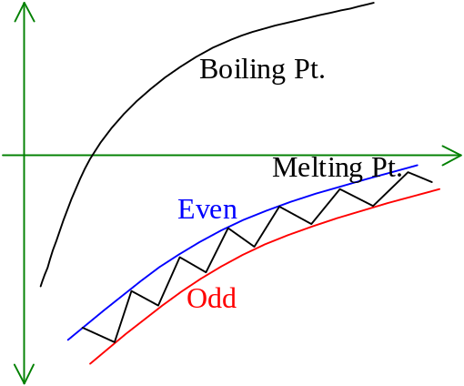MP of alkane chain have general increase w/fluctuations
- Even-numbered carbon molecules are packed closer
- Asymmetry of charge cloud in odd number carbon molecules
- Greater temporary polarization
- Alkenes:
- BP: cis-alkene > trans-alkene
- MP: cis-alkene < trans-alkene

Halogenoalkanes
- MP, BP are higher than that of alkane
- Halogen: High electronegativity
- Permanent dipole
- High Van der Waal’s force
- MP, BP inc. as EN dec.
- Larger, more polarizable halogen can have a stronger induced dipole-induced dipole interaction
- MP & BP: R–F < R–Cl < R–Br < R–I

Amines
- Polar –^{δ−}NH^{δ+} bond
- Less polar than –^{δ−}OH^{δ+} in alcohol as EN of O > EN of N
- 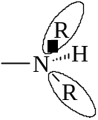Amines have lower BP than alcohol
- Alkyl group decreases H-bond capacity
- Separate further apart to form H-bond
- 2° amines have lower BP & solubility in water than 1° amine
- 3° amine even lower

Aldehydes & Ketones
- Contains strongly polar carbonyl group 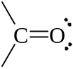
- Aldehyde & ketone: Higher BP than hydrocarbon of similar molecular mass
- Easily form strong intermolecular H-bond w/water
- Low molecular mass aldehyde & ketone have appreciable solubility in water

Carboxylic acid
- Capable of intermolecular H-bond
- High BP & water solubility
- Possess both hydrogen donor & acceptor
- More extensive intermolecular H-bond
- In vapor, usually exists as dimers
- Can form dimeric & polymeric hydrogen-bonded structure in solutions
- Dimer: 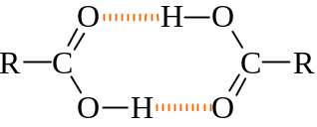
- Polymeric structure: 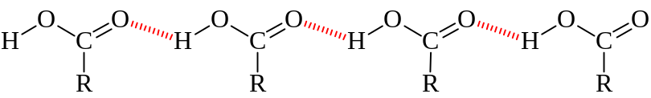

Amino acid
- 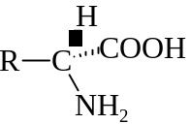
- Usually exists in dipolar form: 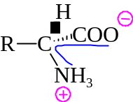
- Zwitterions
- Strong electrostatic ionic bond held btw zwitterions
- High MP
- Insoluble in non-polar solvents
- Soluble in strongly polar solvents

