OrgChem – Isomerism

Structural isomerism
Isomerism happens in certain cpds having same molecular formula but exists in different forms on account of their different arrangement of atoms.

Structural isomerism:
- Structural isomers are cpds that have identical molecular formulae but differ in the order in which the atoms are join together.
- Chain isomerism
- Different arrangement of carbon atoms
- e.g.: 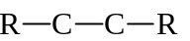 and 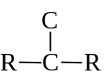
- Position isomerism
- Same carbon skeleton & functional gp, but position of functional gp is different
- e.g.: 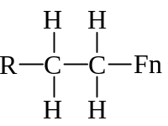 and 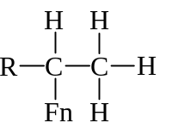
- Functional group isomerism
- Same molecular formula but w/different fn. gp.
- e.g.: CH₃CH₂OH and CH₃–O–CH₃

Stereoisomerism
Stereoisomers are cpds that their constituent atoms joined in the same order but differs in the way arranged in space.

Geometrical isomerism:
- Spatial arrangement of atoms is different because of restricted rotation of a covalent bond.
- Usually occur in cyclic cpd or 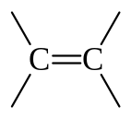
- e.g.: 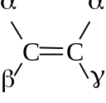 and 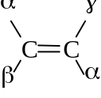
- cis-: prefix for geometrical isomers that have the same gp on the same side
- trans-: prefix for geometrical isomers that have the same gp on the different side
- Bulkier gp are further apart
- More stable
- Lower intrinsic energy
- Geometrical isomers will gave considerable difference in MP
- trans-isomers:
- Regular & symmetrical structure
- Compactly packed in solid
- High MP
- cis-isomers:
- Polar effect on one side and not cancelled
- Permanent dipole-dipole interaction
- High BP

Optical isomerism
- Occur in 4 different gps bonded to a sp³ hybridized carbon
- Asymmetric
- Not superimposible on its mirror image
- Chiral: Objects that is not superimposible on its mirror image
- Enantiomers: Stereoisomers of optical isomerism
- Identical intrinsic energies
- Identical physical & chemical properties
- Melting pt. depression occurs in mixtures of enantiomers
- Racemic mixture: Mixture of (+) & (–) enantinomers in 1:1 ratio
- Overall optically inactive

