OrgChem – Organic Reaction

Fission of Carbon Covalent Bond

Homolysis
- 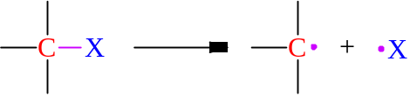
- Symmetrical bond fission
- Free radicals w/unpaired electrons formed
- Carbon free radical 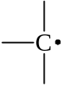 is given out.

Heterolysis
- 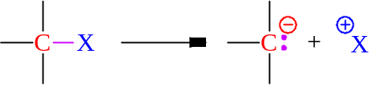 or
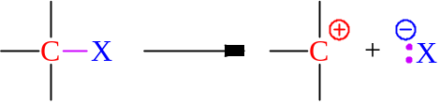
- Asymmetric bond fission
- One atom may hold all 2 bond pair electrons, leaving none to another
- Formation of cations & anions
- Carbocation 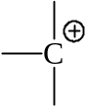 or carbanion 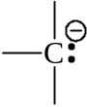is given out.
- If EN of X EN of C, carbocation is formed
- If EN of X  EN of C, carbanion is formed

Reactive species
- Carbon free radical, carbocation & carbanion are highly reactive species
- w/relatively high intrinsic energy
- Unstable species
- Seeking other organic cpd to attack until a stable product is formed
- Electrophiles: Electron deficient species
- Cations & free radicals
- Seeking for an electron rich center for reaction
- Nucleophiles: Electron rich reagents
- Anions & molecules w/lone pair electrons
- Seeking for a proton or positively charged center for reaction

Organic Reactions

Substitution reactions:
- Involving the direct displacement of a group in a molecule by another group
- Nucleophilic substitution at saturated carbon
- Nucleophile seeks an electron deficient, saturated carbon centre to attach
- Displacing out a group formerly bonded to the carbon
- 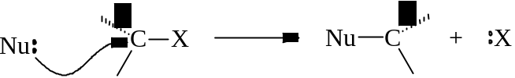
- Unimolecular nucleophilic substitution (S_{N}1):
- 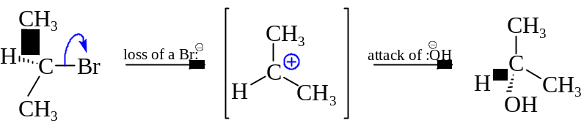
- C₃H₇Br losing Br as a leaving group and becomes an electrophile
- Electrophile attack of the OH nucleophile
- Bimolecular nucleophilic substitution (S_{N}2):
- 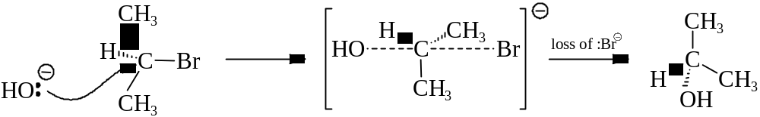
- Nucleophile :OH attack on the reactive site
- Bond making with :OH and bond breaking with Br: occur simultaneously
- Forming a negatively charged intermediate
- Free radical substitution of saturated hydrocarbons
- Occurs in saturated hydrocarbons that have relatively non-polar covalent bonds
- Reaction is initiated by homolytic fission: 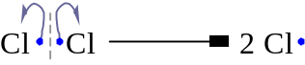
- Cl₂ undergo homolytic bond fission under the ultraviolet irradiation
- The electrophilic free radicals Cl⋅ formed
- Seeking for electron rich center for reaction
- Cl ⋅ then attacks a methane molecule and abstract a H from CH₄:
Cl ⋅ + CH₄ ⎯⎯→ ⋅CH₃ + HCl
- A methyl radical is formed
- The methyl radical attacks another chlorine molecule: ⋅CH₃ + Cl⋅⋅Cl ⎯⎯→ CH₃Cl + ⋅Cl
- Another Cl⋅ radical is given out
- Chain reaction is propagated
- The chain reaction terminated if any two free radicals meet:
Cl⋅ + ⋅CH₃ ⎯⎯→ CH₃Cl
Cl⋅ + ⋅Cl ⎯⎯→ Cl₂
CH₃⋅ + ⋅CH₃ ⎯⎯→ CH₃CH₃

Addition reactions:
- Addition of atoms or groups of atoms to a molecule
- Reaction occurs readily in molecules having a center of unsaturation
- 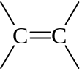, 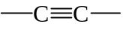, 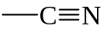, 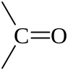, etc.
- Nucleophilic addition at C=O bond
- The nucleophile seeks the electron deficient carbon on polarized ^{δ+}C=O^{δ−} bond for attack:
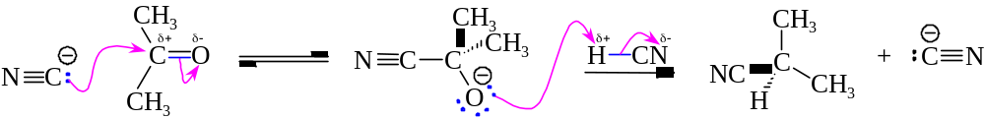
- Electrophilic addition at C=C bond
- Attacking species are non-polar molecules like Br₂
- Outer e– cloud is loosely held by nuclei
- Electron cloud is readily polarized by the protruding π cloud of the C=C bond
- A site in Br–Br is electron deficient as the result of polarization
- The C=C π cloud is the electron rich center
- 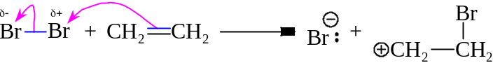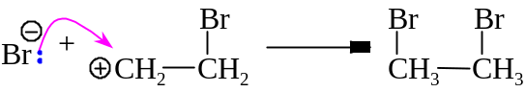
- Free radical addition at C=C bond
- Initiated by the homolytic fission of non-polar bond like RO–OR under UV radiation
- 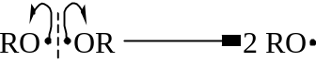
- Free radical RO⋅ formed
- Electrophilic RO⋅ radical attacks the C=C π cloud:
RO⋅ + CH₂=CH₂ ⎯⎯→ RO–CH₂–CH₂⋅
RO–CH₂–CH₂⋅ + CH₂=CH₂ ⎯⎯→ RO–CH₂–CH₂–CH₂–CH₂⋅
- New bond formed by addition of free radicals

Homolysis = Homolytic fission
Heterolysis = Heterolytic fission

