OrgChem - Hydrocarbons

Alkane

Alkane
- Homologous series of saturated hydrocarbon
- Contains only C–C single bonds & C–H bonds only
- Open-chain alkane: Aliphatic / Acyclic cpds
- General formula: C_{n}H_{2n+2}
- Cyclo-alkane: Alicyclic cpds
- General formula: C_{n}H_{2n}

Reactions
- Alkane consists of a saturated carbon skeleton encased in a sheath of C–H bonds
- Limited possibilities for reactions
- Saturated alkane molecules are generally unreactive towards polar or ionic reagents
- Alkane can react w/O₂ to from CO₂ & H₂O
- Combustion, highly exothermic
- H is more combustible than C
- Alkane w/large H:C ratio would more readily to give a blue flame in complete combustion
- Small H:C ratio would more readily to give a yellow smoky flame in incomplete combustion

- Alkane can react w/halogens to form halogenoalkane
- Halogenation, a free radical substitution
- CH_{4(g)} + Cl_{2(g)} ⎯⎯→ HCl_{(g)} + CH₃Cl_{(g)}
- Initiation: 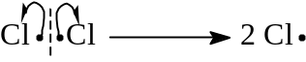
- UV or 450°C is required to initiate the reaction
- Propagation: 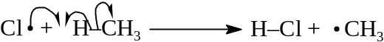
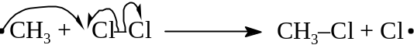
- Each Cl⋅ radical attacks a neutral CH₄ substrate to generate ⋅CH₃ free radical
- ⋅CH₃ attacks a further neutral Cl₂ molecule, generating another Cl⋅ radical
- Cl⋅ radical can attack further CH₄ substrate
- Termination: The chain reaction terminates if two free radicals combine to form a neutral molecule
- A mixture of product is often found
- If CH₄ is in excess, CH₃Cl predominates
If Cl is in excess, CCl₄ predominates

Alkene

Alkene
- Contain C=C double bond
- Unsaturated
- C is sp² hybridized
- Carbons are joined axially by a σ bond and laterally by a weaker π bond

Reactions
- π bond e– are more diffuse & less-firmly held to C nuclei
- Susceptible to attack by electrophilic agents
- Resulting in addition reactions
- The cation & neutral reagents induce heterolytic fission of π bond
- Generally exothermic reaction
- Electrophilic addition of C=C double bond
- Alkene react by attracting electrophiles
- A new bond is formed from a C to the electrophile proton
- Leaving a single C–C bond
- Carbocation is formed
- The reaction is complete by attack of an anion on the carbocation
- 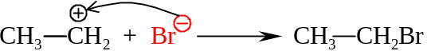
- Apart from ions, alkene also react with +ve end of a dipole like HBr or other Hydrogen halides
- The non-polar Br₂ molecules can also be added once it has a temporary or induced dipole
- Mechanism: 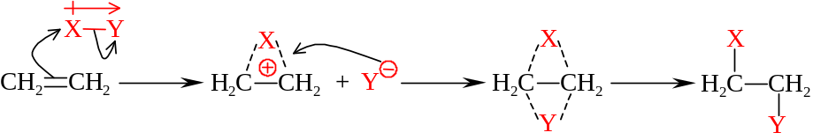
- If Br_{2(aq)} solution is used, CH₂Br–CH₂OH is formed instead:
- 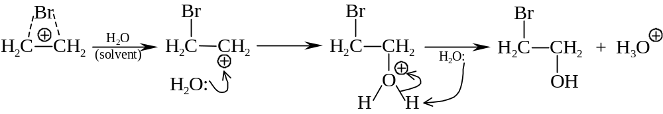
- Conc. H₂SO_{4(aq)} reacts with C=C to give 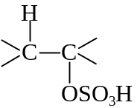
- All the above reactions are formed by trans-attack

- Catalytic hydrogenation
- H_{2(g)} will be added to the C=C double bond
- Involves the action of heterogeneous catalyst of Ni, Pt, Pd, Ru, Rh
- Reaction occur at RTP
- Hydrogenation takes place on the metal surface
- Stereoselectively forms cis-isomers
- Hydrogenation can be used to produce margarine
- Animal fat: Saturated fat (triester in saturated carboxylic acids)
- Solids
- Vegetable oil: Unsaturated fat (with C=C bond in molecules)
- Liquids
- Vegetable oil is converted into semisolid by hydrogenating some C=C bonds
- Partial hydrogenation
- Decreasing the degree of unsaturation
- Harden the oil

- Oxidation
- Potassium manganate(VII) in alkaline solution is a weak oxidizing agent
- Alkene can be oxidized by KMnO₄ / OH– to form diols
- 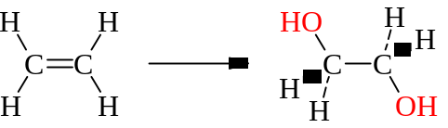
- Purple color of KMnO₄ fades out and brown suspension of MnO₂ appears
- Alkaline medium is req’d to prevent the diol further oxidized to form carboxylic acid

- Ozonolysis
- Reacting alkenes with ozone (O₃)
- O₃: Highly reactive electrophile
- O₃ reacts with C=C to form a five-members ring as an intermediate
- It rearranges with rupture of C–C bond due to low stability
- Forms ozonide
- The ozonide w/Zn in acid cleaves to form aldehydes or ketones
- 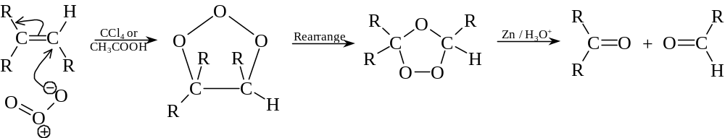
- Ozonolysis is used to determine the position of C=C bonds
- Parent alkene can be reconstructed by recombining the fragments w/a double bond at the carbonyl carbons
- After ozonolysis,
- Di-substituted carbon at C=C bond gives ketone
- Mono-substituted carbon at C=C bond gives aldehydes
- The =CH₂ group terminal gives CO₂ or HCHO

- Polymerization
- Alkenes undergo addition polymerization usually
- Same percentage composition as the reactant monomers in the resulting polymers
- Poly(ethene): (Low density) made by ICI high-pressure process w/molecular mass 50k to 300k
- Initiation: 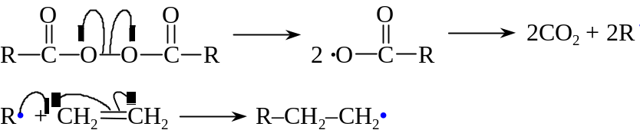
- Propagation:
- Termination: 2 R(CH₂CH₂)_{n}CH₂CH₂• R–(CH₂CH₂)_{n}–CH₂CH₂–CH₂CH₂–(CH₂CH₂)_{n}–R
2 R(CH₂CH₂)_{n}CH₂CH₂• R(CH₂CH₂)_{n}CH₂CH₃ + R(CH₂CH₂)_{n}CH=CH₂
- Using Peroxide radical:
- Initiation: 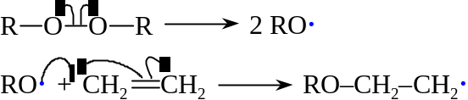
- Propagation:
- Termination: 2 RO(CH₂CH₂)_{n}CH₂CH₂ · RO(CH₂CH₂)_{n}CH₂CH₂CH₂CH₂(CH₂CH₂)_{n}OR
- Poly(ethene): (High density) made by Ziegler-Natta process w/molecular mass 3M
- Poly(propene):
- Using Ziegler-Natta catalyst to polymerize the propene
- 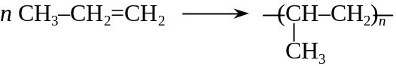
- Rigid, High mechanical strength, Strong resistance to abrasion
- Polymer have a isotartic structure
- All the methyl groups are arranged on one side of the carbon chain
- Poly(phenylethene):
- Phenylethene: 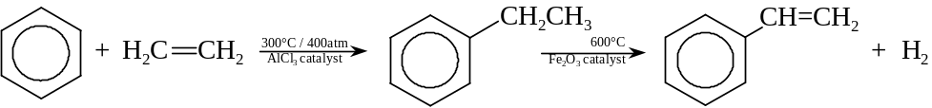
- Polymerization: 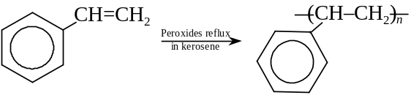

Markovnikov’s Rule
- Addition will take place so as to give the most stable intermediate carbocation
- The more the electron-releasing groups (R–) is attached to the carbocation, the more stable the carbocation is.
- Electron-releasing groups tends to disperse the positive charge
- Alkyl group (R–) is said to be electron-releasing due to inductive effect
- 3° Carbocation 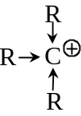 > 2° Carbocation 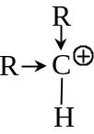 > 1° Carbocation 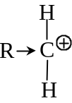 > 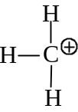

Benzene

Arenes
- Benzene, and its derivatives
- Contain a ring of carbons that are all sp² hybridized
- π bonding orbitals are delocalized
- Negative charges of π electrons concentrated above and below
- Highly unsaturated, but stable
- Aromatic stabilization
- A considerable amount of energy is involved to activate the ring before any reactions occur
- Delocalization energy of stabilization

Reactions
- Benzene undergoes substitution rather than addition reactions
- Aromatic sextet of π electrons can be regenerated
- Preserve the delocalization of π electrons

- Nitration:
- Heating benzene w/conc. HNO3_{(aq)} and conc. H₂SO_{4(aq)}
- A ring hydrogen is substituted by a nitro group (–NO₂)

- Sulphonation:
- Reflux w/conc. conc. H₂SO_{4(aq)} or warmed w/fuming H₂SO_{4(aq)}
- A ring hydrogen is substituted by a –SO₃H group, forming bezenesulphonic acid
- 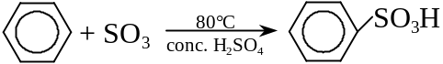
- Reaction reversed when bezenesulphonic acid solution is heated above 100°C
- 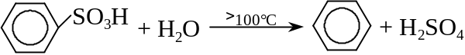

- Halogenation / Alkylation:
- Cl₂ or Br₂ replaces a ring hydrogen
- AlCl₃, FeCl₃ or FeBr₃ are added as a catalyst
- 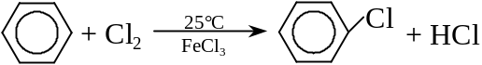
- Benzene reacts w/halogenoalkane to give alkylbenzene
- Aluminum halide acted as a catalyst
- 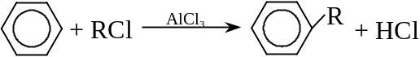
- Oxidation of alkylbenzene:
- Side chains of alkylbenezene are susceptible to oxidation
- Strong oxidizing agents required
- Benzoic acid given out
- 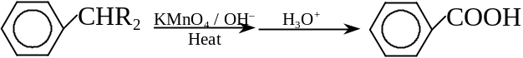
- Double bond in the side chain like 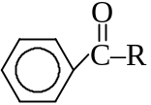 will also be broken down
- A phenylmethyl hydrogen is required in oxidation
- 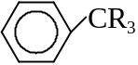 resistant to side-chain oxidation

Margarine: A butter replacement made from vegetable oil instead of animal fat

