OrgChem – Halogeno-Compounds

Halogeno-compounds

Characteristics
- Halobenzene: Halogen atom bonded directly to a benzene ring
- Halogenoalkanes: Have one or more H replaced by halogen in the alkane skeleton
- Halogen is bonded to a saturated sp³ carbon
- 1°: 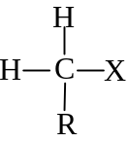 2°: 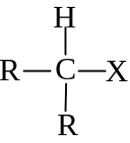 3°: 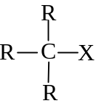

Reactions
- Undergoes Nucleophilic substitution and Elimination
- The ^{δ+}C–X^{δ−} bond is highly polarized
- Breaks heterolytically to give halide anions X–
- S_{N}: Halogen is replaced by a nucleophile
- Nucleophile attacks the electropositive carbon by donating an electron pair to it
- Elimination: A base removes a proton on the β carbon
- Forms double bond

Nucleophilic substitutions

Bimolecular (S_{N}2):
- Applies to methyl and 1° haloalkanes
- 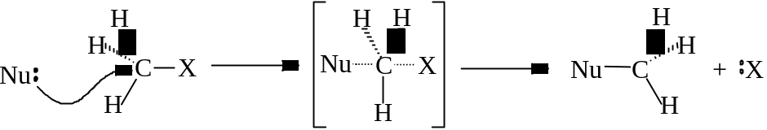
- Energy Profile: 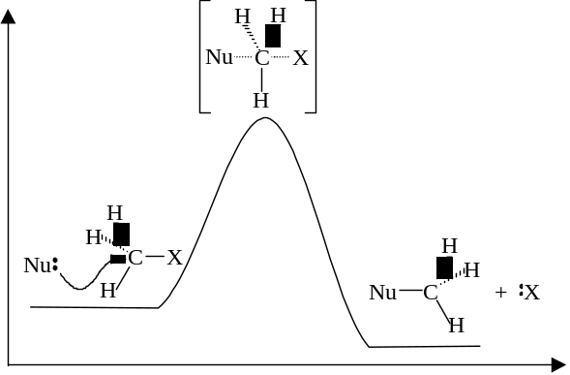

Unimolecular (S_{N}1):
- Applies mostly to 3° haloalkanes
- The haloalkane ionizes spontaneously in solution forming a carbocation and a halide ion
- 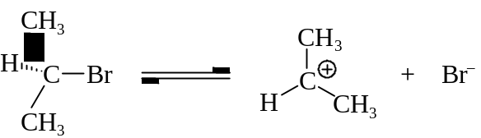
- The carbocation formed is reactive and readily attacked by other nucleophiles
- 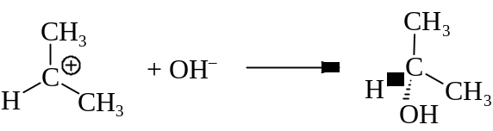
- If water (HOH) present, carbocation becomes alcohol (R–OH)
- If alcohol (ROH) present, carbocation becomes ether (R’–OR)
- Energy Profile: 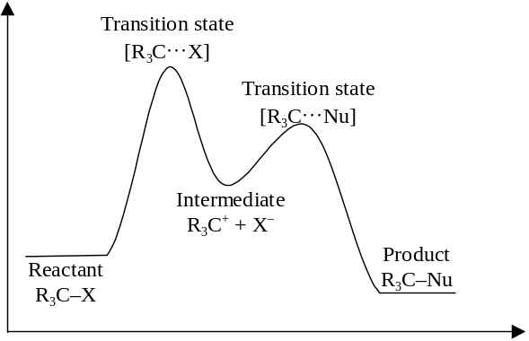

Forming C–C
- When haloalkane refluxed with KCN, a nitrile is formed:
R–CH₂–Br + KCN ⎯→ R–CH₂–C≡N + KBr
- Alkylation
- The alkane is lengthen by 1 C
- The reactants are put in ethanol, a co-solvent
- When the nitrile meets acid, an alkanoic acid is formed:
R–CH₂–C≡N ⎯→ R–CH₂–COOH

Forming C–O
- Haloalkane reflux with NaOH_{(aq)}, alcohol is formed:
R–CH₂–Br + NaOH ⎯→ R–CH₂OH
- Tertiary haloalkanes can be hydrolyzed by water:
R₃C–Br + H₂O ⎯→ R₃C–OH + HBr
- Haloalkane reflux with sodium alkoxide in the corresponding alcohol, ether is formed:
R–CH₂–Br + R’O–Na⁺ ⎯→ R–CH₂–O–R’ + NaBr
- The metal alkoxide is prepared by dissolving metal in alcohol:
2 ROH + 2 M ⎯→ 2 RO– + 2 M⁺ + H₂

Forming C–N
- Heating haloalkane w/conc. ammonia under pressure, amines is formed
R–I + conc. NH₃ ⎯→ R–NH₂ + HI
R–I + R–NH₂ ⎯→ R₂–NH + HI
R–I + R₂–NH ⎯→ R₃–N + HI
R–I + R₃–N ⎯→ (R₄–N)⁺I–
- Amine can also be formed by reducing nitriles with LiAlH₄ or adding H₂ by Ni catalyst
R–C≡N + 4[H] ⎯→ R–CH₂–NH₂

Factors influencing S_{N}1 and S_{N}2 reactions
- Structure around the saturated carbon
- RDS of S_{N}1 is the formation of carbocation
- Halomethyl benzene is reactive to S_{N}1 reaction
- Delocalization of electrons from the benzene ring stabilized the carbocation
- Mesomeric effect
- 3° halogenoalkanes is reactive to S_{N}1 reaction
- Electron releasing inductive effect of alkyl groups stabilize the carbocation

- S_{N}2 reaction involve transition state w/a carbon attached to five groups
- Methyl halide goes onward to 1°, 2° and 3° halides:
- Size of groups attached to carbon inc.
- Steric hindrance of carbon inc.
- Energy of the transition state inc.
- Reaction rate lowered
- Halomethylbenzenes are sterically unhindered
- More reactive than methyl halides

- Concentraction and reactivity of the attacking nucleophile
- S_{N}1 is unaffected by the conc. or types of the nucleophile
- S_{N}2 reaction’s rate is dependent on the conc., strength and identity of the nucleophile
- Negatively charged nucleophile are stronger than uncharged nucleophiles
- Order of nucleophilicity roughly follows the order of basicity:
RO– > HO– ROH > H₂O

- Nature of leaving group
- Best leaving group are those that can become most stable species
- Halogens: I– > Br– > Cl– > F–
- Uncharged molecules are better than charged ones: H₂O HO– > RO–

Elimination

Dehydrohalogenation
- When halogenoalkane refluxed with strong base, a H and a X is eliminated
- Halogenoalkane becomes alkene
- Dehydrohalogenation occur after the formation of carbocation of S_{N}1 reaction
- 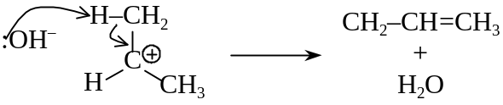
- Halide are dehydrohalogenated to form alkene
- Di-halide are dehydrohalogenated to form alkyne
- Two H and two halides are detached, forming two π bonds

Elimination vs Substitution
- Elimination and S_{N}1 reactions are favored by weak nucleophiles
- High temperature favors the elimination mechanism
- Strong base forces an elimination reaction take place instead of substitution
- 2° and 3° haloalkanes prefer to have elimination owing to steric hindrance
- Reaction pathways:
- Methyl: S_{N}2 reactions only
- Primary: Mainly S_{N}2, if hindered or strong base present, Elim
- Secondary: Mainly S_{N}2 if weak bases present, Elim if strong bases present
- Tertiary: Hydrolysis: S_{N}1 and Elim;
Low temperature: S_{N}1 predominates
High temperature: Elim predominates

