OrgChem – Hydroxy Compounds

Alcohol

Reaction of hydroxy group:
- Reaction at the hydroxy group may involve:
- Breakage of the C–O bond:
- 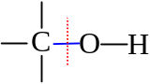
- Alkyl hydroxy fission
- Breakage of the O–H bond:
- 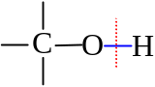
- Alkoxy hydrogen fission
- In alcohol, the –OH group is attached to an sp³ carbon
- In phenol, the –OH group is attached to the benzene ring
- Delocalization effect modifies the reactivity of the –OH group

Cleavage of C–O bond:
- Intramolecular dehydration:
- Alkene formation
- The –OH group and a –H detached
- A C=C bond formed
- Gives a H₂O
- Ease of intramolecular dehydration: 3° > 2° > 1°
- Primary alcohol: 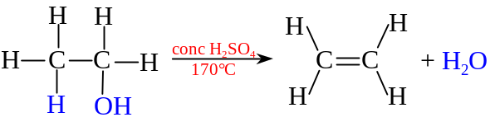
- It can also be done by passing alcohol vapor over alumina catalyst at 350°C
- Secondary alcohol: 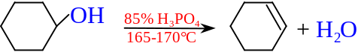
- Tertiary alcohol: 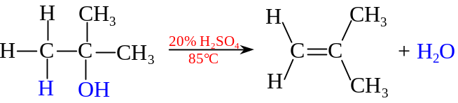
- Saytzeff rule: Alcohol dehydrations generally produce the more highly substituted alkenes
- The one w/more alkyl groups attached to the double bond is more substituted

- Intermolecular dehydration
- Ether (alkoxyalkane) formation
- Dehydration by conc. H₂SO₄ at 140°C w/excess alcohol

- Halogenoalkane formation by HX
- Reacting alcohol with hydrogen halide heating
- Nucleophilic substitution:
- Primary Alcohol: 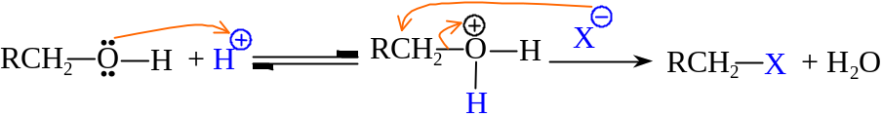
- S_{N}2 Mechanism
- Tertiary alcohol: 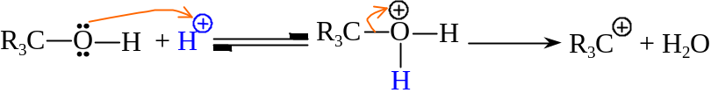
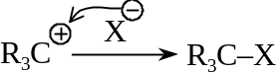
- Carbocation forms, Ensembles S_{N}1 Mechanism
- Profile: 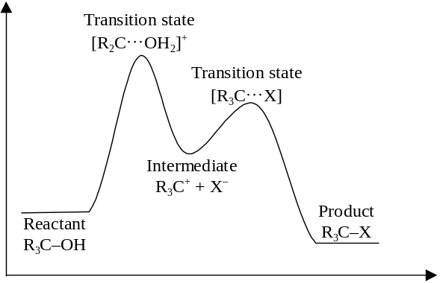
- All involve the first step of forming protonated alcohol

- Halogenoalkane formation by PX₃
- Reacting alcohol with phosphorus trihalide (PI₃, PCl₃ or PBr₃) on heating
- H₃PO₃ given out
- 3 R–OH + PBr₃ ⎯→ 3 R–Br + H₃PO₃
- 3 R–OH + PCl₃ ⎯→ 3 R–Cl + H₃PO₃
- 3 R–OH + PI₃ ⎯→ 3 R–I + H₃PO₃
- PCl₅ or SOCl₂ can react w/alcohol to give chloroalkane in room temperature
- R–OH + PCl₅ ⎯→ R–Cl + POCl₃ + HCl
- R–OH + SOCl₂ ⎯→ R–Cl + SO₂ + HCl

Cleavage of O–H bond:
- Alkoxide formation
- Alkoxide ion: R–O–
- 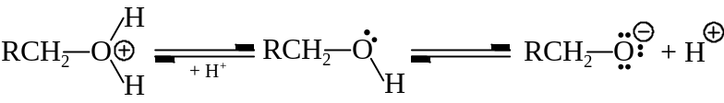
- Breaks the strong O–H bond heterolytically to give out a proton
- Difficult to break as R– pushes e– toward O
- Alcohol is a very weak acid
- The RO– ion is not stabilized by delocalization of the charge
- Na can be used to test for the presence of –OH:
2 CH₃CH₂OH + 2 Na ⎯→ 2 (CH₃CH₂O–)(Na⁺) + H₂
- Alcohol is regenerated when water is added:
(CH₃CH₂O–)(Na⁺) + H₂O ⎯→ CH₃CH₂OH + NaOH

- Esterification
- Reflux alcohols with carboxylic acid in the presence of an acid catalyst
- 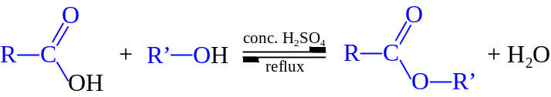
- Ester can also be formed by reacting alcohol w/acyl chlorides and acid anhydrides:
Acyl Chloride: 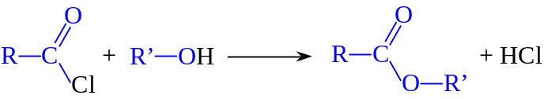
Acid anhydride: 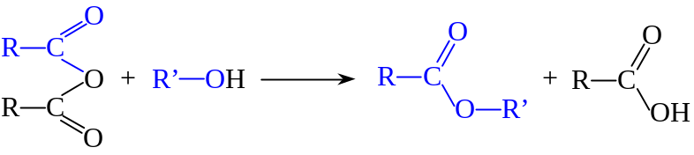
- Oxidation
- Primary alcohol:
- Oxidized to carboxylic acid through aldehydes by acidified K₂Cr₂O₇ or KMnO₄
- Cr₂O₇^{2–} oxidize sequentially
- MnO₄– is too strong that unable to stop at the aldehydes
- 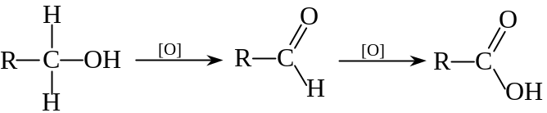
- Secondary alcohol:
- Oxidized to ketones under normal conditions
- Ketones can undergo prolonged drastic treatment to break down into acids w/smaller number of C
- 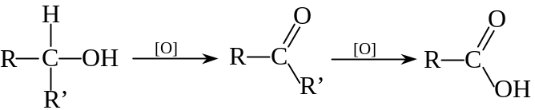
- Tertiary alcohol:
- Normally resistant to oxidation in neutral of alkaline medium
- Involve the breakage of strong C–C bond
- In acidified KMnO₄, it gives a mixture of ketone and acid both w/fewer C:
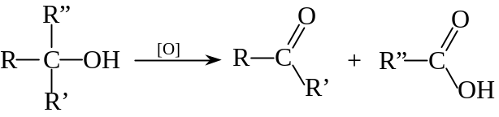

- Iodoform test
- Reacts iodine w/alcohols with 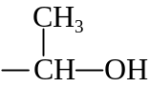 group
- 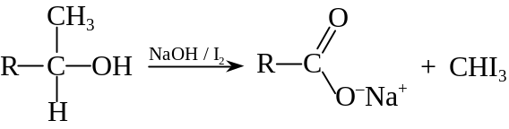
- The secondary alcohol is oxidized by iodine in sodium hydroxide
- Triiodomethane (iodoform) is given out as a yellow crystalline w/characteristic odor

Phenol

Characteristics:
- Phenol is a much stronger acid than aliphatic alcohols
- 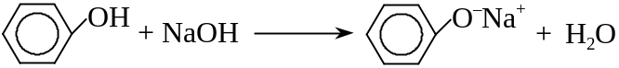
- Phenol ionizes to a stable phenoxide ion:
- Lone pair e– on O of phenol become partially incorporated in the delocalized system of the benzene ring
- The C–O bond is strengthen, and have the partial double bond character
- Electron withdrawn from the oxygen makes it slightly electron deficient
- Weakening the O–H bond and facilitating the loss of a proton
- The phenoxide ion is stabilized by delocalization of the negative charge throughout the benzene ring system
- Phenol is less acidic compared with carboxylic acid
- Phenol does not react with NaHCO_{3(aq)}

Reaction of –OH group:
- Displacement of –OH group in phenol is more difficult than alcohol
- Only occurs in somewhat more extreme conditions
- Owing to strengthen C–O bond, oxidation of phenol does not give breakdown products
- Phenol can be oxidized to form complex polymers
- Phenol does not undergo elimination reactions
- Esterification of phenol is less readily occur
- Lone pair e– in O is less readily available to attack the C=O group of carboxylic acids
- Esterification occurs by the reaction of negatively charged phenoxide ion

